Stepping Feet Walking School Bus Scheme: Project Proposal

Purpose of Project
From the previously conducted Maesteg Community Needs Assessment, it was clear that there was a significant need for the implementation of traffic and transport safety measures. The problem arose from the initial opening of Maesteg Comprehensive school in 2008. The school traffic arrangements were not sufficiently discussed or investigated. Tragically due to this in 2014 there was a fatal incident resulting in the death of a pupil at the school, caused by an overcrowded bus bay. The school currently has eight coaches dropping off and picking up pupils but with only five bus bays available this proves a very dangerous parking and loading scenario within the school grounds. The local authority Bridgend County Council was prosecuted and found guilty of failing to meet health and safety standards. Despite this no significant changes or safety measures have been made to the parking and loading areas of the school grounds. The purpose of this proposal is to outline key features of Stepping Feet Walking School Bus Scheme (SFWSB), including the potential benefits, logistical arrangements, staffing, funding and any potential negative effects and barriers.

Stepping Feet Walking School Bus Scheme
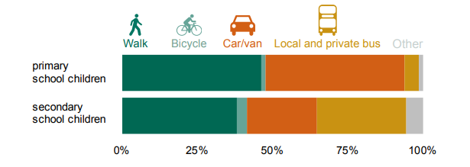
A walking school bus is a scheme that has been implemented across the world on a global scale in a bid to make the commute to school safer and also more enjoyable. The idea of this project is to tackle the traffic and transport issues faced by Maesteg Comprehensive whilst also tackling attendance, health and well-being and community engagement. A walking school bus is quite simply an organised walk to school from your home each day supervised by an appropriate adult (SafeRoutes.org, 2019). Despite its simplicity the effects of this project can be vast. In the current economical climate fewer children are walking to school and often commute to school via parents driving them or the use of public transport along side the use of school buses. A survey published in 2014 notes that the three main modes of transport used to get to school by children in secondary school are walking, car and bus. Despite walking being found to be the most popular choice of transport for school children (38%), the combined percentage of car and bus was found to be larger at 52% (Department for Transport, 2014).
The main aim of this project is to turn these figures around. The SFWSB intends to have these figures significantly change in the next five years. The project will be inclusive to all pupils and intends to make the route to and from school as accessible as possible. It is vitally important that along with reducing the amount of school traffic in the area it also manages this in a safe inclusive environment. Maesteg is located in a fairly rural area with ideal walkways already in place to support the safety aspect of the project. The SFWSB would run Monday to Friday and accommodate the walk to school and the walk home from school. In time there is also a possibility with partnership with Maesteg Comprehensive to organise a third walking bus time to accommodate afterschool activities.

Benefits of the Scheme:

Reducing Traffic & Parking Issues
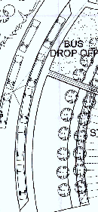
The main influence for this scheme is tragically the death of a school child in 2014 due to the unsafe traffic conditions at Maesteg Comprehensive at drop off and pick up times. Since the incident very little has been done by Bridgend County Council and Maesteg Comprehensive in order to rectify the ongoing traffic build up around these key times of the school day. This is mainly due to the costly nature to alter the road and school grounds. SFWSB intends to overcome this problem with a simple and cost-effective manner. As it currently stands the school grounds of Maesteg Comprehensive can accommodate five school buses in its bays.

(Maesteg School Grounds, 2008)

As seen in the image above there are five bus bays allocated in a layby on the school side of the road. The remaining three buses are forced to park on the road opposite to the layby. SFWSB plans to reduce the number of buses needed by the school. The five routes that are currently used are:
B19 – Blaencaerau B20 – Caerau Square
B21 - Caerau Park B22 – Coegnant Road
B23 - Duffryn Road B24 - Llangynwyd Upper
B25 - Llangynwyd Square

Routes B19 – B22 are all within a 2mile radius. If the number of pupils using these services are significantly reduced then there is no reason why the services cannot be combined, thus reducing the number of bays used at the school for bus parking.
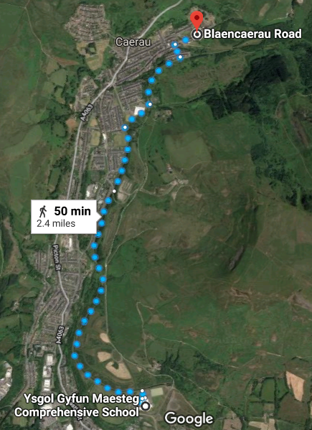
Conveniently in place is the National Cycle Network Route 885 as pictured below.

The route named The Llynfi Valley Trail is 2.4miles from the first pick up point of the original school bus route in Blaencaerau Road. The estimated walk time from the furthest point to the school is 50mins. The trail is completely tarmacked and has recently been renovated by Bridgend County Council (Sustrans, 2018). This trail would be the initial walkway that the SFWSB would use.

Improved Attendance & Attainment
Along with reducing traffic problems there are also reports of walking school busses improving attendance across the country. A primary school located in Fife, Scotland has noted a large decline in the number of pupils arriving late or being absent due to its implementation of a walking school bus. Much like Maesteg the catchment area for the school is a small mining village that is a highly deprived area (McIvor, 2017). In order to raise attendance, the school bus stops, at known areas where the children are usually late or absent. Having the walking school bus in the close proximity encourages the children to want to take part in the activity. The walking school bus transforms the bus from a mode of transport to an opportunity for the children to engage with each other and take part in a community project.

LivingStreets (2019) noted that behaviour and concentration levels are vastly improved as a product of routine exercise. In a 2014 Public Health review its was noted by Brooks that schools with higher attainment levels have equally high levels of attendance in sports and participation in physical activities compared to lower achieving schools. It is also stated that almost 50% of the parents and teachers surveyed had noticed an improvement in children’s behaviour after taking part in physical exercise (LivingStreets, 2019). Medina et al (2010) noted that the effects of physical exercise are predominantly noticeable in children with additional learning needs such as attention deficit hyperactivity disorder (ADHD). It was noted that something as small as a twenty-minute walk can have vastly positive repercussions in concentration levels for children with ADHD.

Health & Wellbeing
A third benefit of The SFWSB is the promotion of pupil health and wellbeing. Physical activity has been linked with numerous health benefits. The British Heart Foundation published a report in 2015 that indicated that approximately 30% of British children are overweight or obese. The report also noted that only 21% of boys and 16% of girls currently meet the currently recommended 60 minutes of exercise each day. It also went on to highlight that 79% of parents of children with weight problems do not even recognise that the child has an issue. The SFWSB wants to combat this issue with a safe fun activity that is proven to have positive results.

Studies show that the more physical activity partaken in the greater the health benefit. Results from this study revealed that even the smallest amount of exercise can have great health benefits in higher risk children. The concluding outcomes of the study realised that children at secondary school age should complete at least 60minutes of exercise per day (Janssen & LeBlanc, 2010). The SFWSB will play a vital role in providing this exercise, both at the beginning of the school day and the end. Healthcare organisation Bupa report that reduction in the development of conditions such as high blood pressure, diabetes and heart and lung problems all as a result of walking on a regular basis (Atkins,2018).
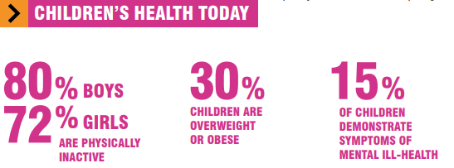
(LivingStreets, 2018)

Physical activity not only has benefits to children’s physical health but also their mental health. It has been reported that benefits of physical activity are reduced depression, reduced anxiety and higher levels of self-esteem (Biddle & Asare, 2011). LivingStreet (2018) support the SFWSB scheme again by noting that encouraging children to walk to school can not only support their mental health but also achieve higher objectives around all aspects of their physical and mental health.

Community Engagement
A fundamental corner stone of the SFWSB is its engagement with the community. The project relies on the support from the town of Maesteg and its residents. The route of the SFWSB falls along the Llynfi Valley Trail. Maesteg Comprehensive is the start of the trail, shortly beyond the schools playing fields the trail is home to new land artwork. The idea behind the artwork is to attract new biodiversity in the local area. The area of artwork is a reclaimed hectare of land that covers the former Maesteg Washery site.

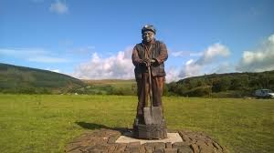
The artwork consists of a wetland area with walkways, a 9ft stone and iron sculpture of a Maesteg miner. The Maesteg community also planted an array of flowers and shrubs along with birch tree plantings. The land artwork also hosts a hand carved system of oak benches.

The children of Maesteg Comprehensive contributed to the artwork on the Llynfi Valley Trail. The children teamed up with local poets to produce poems about the local heritage and landscapes, these poems where them inscribed on Ewenny limestone and placed along the trail. Stepping Feet Walking School Bus would like to continue on with this project and introduce new artwork by the children of the school along the entire trail and school route. Maesteg is a community rich in art and culture and SFWSB would encourage a strong link between themselves and the artistic community in Maesteg. SFWSB sees the importance of community engagement and socialisation and networking between local groups and businesses.

How SFWSB will work:

Logistical Arrangements
As previously stated the scheme will run Monday to Friday to accommodate the school drop off and pick-ups. The SFWSB will compromise of one adult to eight children ratio, with the allowance of a 1:1 staffing level if the child has a disability or additional learning need as stipulated in their Education, Health and Care Plan. It is vitally important to SFWSB that the service remains accessible to all students. This is why the route chosen is fully tarmacked and accessible to wheelchair uses. Parents/ Care providers are required to drop off their child at a designated walking bus stop along the route. In order to help streamline the organisation of the SFWSB a partnership with an app development agency ‘Crocodile’ is in place. Crocodile is an app that can be downloaded onto smart phones and tablets and accessed via a pc online. This can be used by the pupils, parents and the school. The app serves as an engagement tool, it offers a range of games and rewards for every challenge completed. Challenges could be set for individual pupils, classes or even whole year groups or school houses. Crocodile also creates useful analytics and statistics based on the pupil activity in order for SFWSB and Maesteg Comprehensive to understand trends and monitor activity of the walking bus. Example of the app can be seen below.

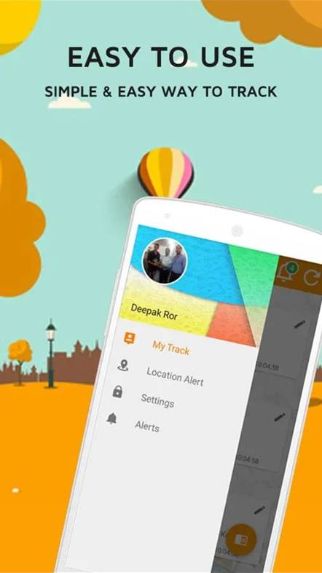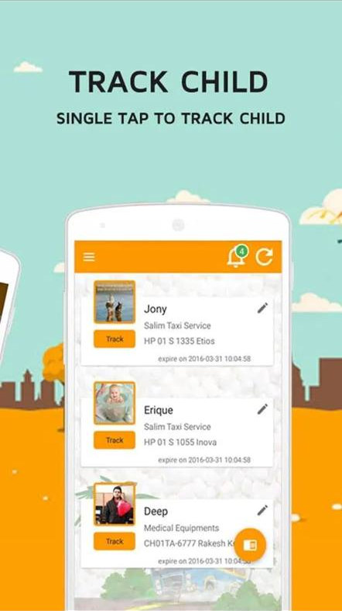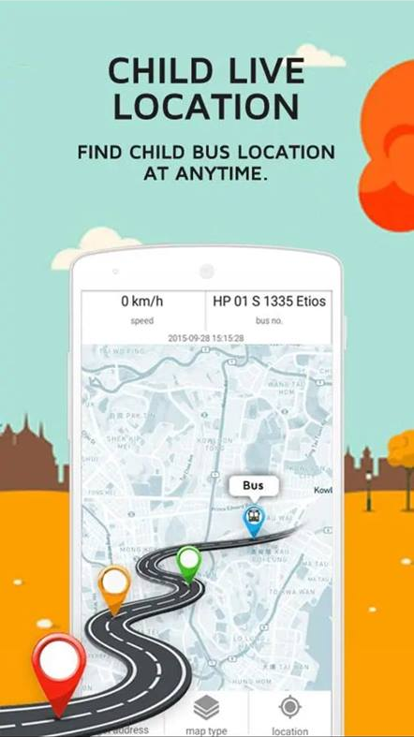

Parents will need too book their child onto the SFWSB the last day of the school week in preparation for the oncoming week. This will allow for adequate staffing levels. The app will cater for this and has an easy to use ‘book on’ page.

Safety is key to providing a successful service and is something SFWSB takes very seriously. The route used by the ‘bus’ will be routinely checked for hazards and changes to environment. It is a strict rule that any person using, or part of the ‘bus’ must wear a high visibility safety vest. These vests will be provided by SFWSB on arrival to bus stops and collected by a staff member at designated drop off points.
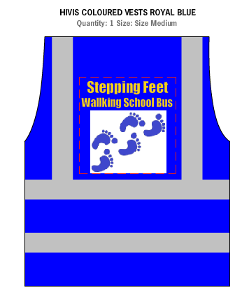
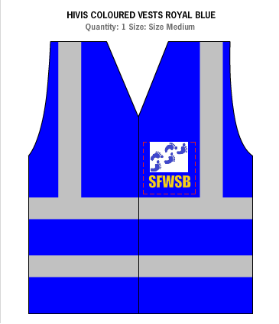

Alongside safety vests SFWSB also believes it is vitally important that children understand the importance of road safety and this will be incorporated into its walks. LivingStreets (2019) surveyed parents of school children and found some of the biggest worries of these parents to traffic related problems such as speed, unsafe parking and overcrowding of traffic around schools. SFWSB eliminates these issues. With the exception of the walking bus stops the route is a NCN trail and have no traffic or motor vehicles.

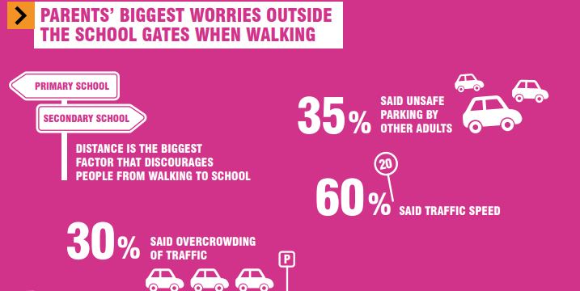
Staffing
Staffing requirements of the SFWSB will alter as the scheme grows in popularity over time. The starting ratio of staff to children will be 1:8. As aforementioned 1:1 staffing will be made available to children with EHCP’s in place. There will be various staff roles within the project as follows:

Driver: this person will be the most senior member of staff on the bus. This person will head the front of the bus and direct the route. The driver will oversee the other staff members and will liaise with school staff and parents. They will ensure that the Walking School Bus schedule is strictly followed and follow the safety and emergency protocols. The driver will also ensure that any new children joining the bus have been provided with the SFWSB guidelines and parents have completed a consent form. The driver will also maintain a SFWSB register that can be monitored using the Crocodile App.

Conductors: these will consist of voluntary parents and paid staff that will support the pupils on their walk to school. They will remind children of the behavioural requirements of SFWSB. They will also engage with the children and the environment around them allowing the children to experience new surroundings and opportunities. Like the driver of the bus they will have will follow the safety and emergency protocols.

All parental volunteers and paid staff will be equipped with SFWSB training compromising of basic first aid, road safety and safeguarding of young people. All staff will also be required to pass a Disclosure and Barring Police Check prior to starting their role as a Driver or Conductor. It is also key to note that all Drivers and Conductors are required to carry a mobile phone with them in case of emergencies or injuries along with the use of the SFWSB smartphone. SFWSB will also host monthly meetings with staff, which will cover emergency response plans and ensure all staff are up to date with any guideline and policy changes.

Funding
The main drawback to any previous attempt to relieve traffic and transport problems was its cost. Stepping Feet Walking School Bus is a very cost effective yet resourceful project. The biggest cost of the project will be staffing. However, with the reduction of busses needed to transport pupils to school there is a significant amount of funding freed up. Also, as stated in the previously conducted Maesteg Community Needs Assessment, Bridgend County Council was allocated a sum of £860,500 as part of a Local Transport Fund. First Minister Carwyn Jones discussed Wales funding of active transport in May 2018 and stated;

This funding - £60 million over the next three years - signals a step change in the Welsh Government’s approach to Active Travel. Funding levels for walking and cycling has fluctuated year to year, but this is a clear commitment to prioritise this work.

The Welsh Government describe this funding boost as the largest ever for active travel schemes within Wales. The funding equates to an average of £20 extra per head of the Welsh population.

SFWSB is an inclusive project and is based in a significantly deprived area of Wales. It will keep its cost of service low. Bridgend County Borough Council provide free school transport for pupils who live over a three-mile safe walking distance from the school. The route SFWSB will take covers a 2.4mile stretch thus meaning transport will not be provided for children in this area. The current cost of school transport for these pupils is £1.90 per day per child. In total that equates to £361 per annum per child. With the aid of the grants previously mentioned and the saving from using the external bus company, SFWSB would offer the service for a small fee of £3 per week per child. With a discount of £1 per extra sibling. Which equates to a saving of £247 per annum on school transport for parents of a 1 child household.

Potential Barriers
The SFWSB scheme will not come without barriers and teething problems much like other schemes. SFWSB will strive to eliminate as many of these as feasible prior to start up however. A large environmental barrier will be weather conditions. For residents in Wales rain is a normal everyday occurrence. SFWSB guidelines will outline a policy and procedure regarding severe weather conditions and replacement transport will be provided in the form of shuttle vehicles to and from the school (in extreme cases). There is no significant evidence that rain negatively effects a child’s experience or behaviour whilst outdoors and rain showers should not provide a hinderance to the scheme on a day to day basis. As per the guidelines, children will also be expected to join the bus in appropriate clothing for the weather conditions (Waterproof coats & shoes, hats, gloves, scarfs in cold weather – Hats, sunglasses, sun lotion & water bottle in warm weather). Umbrellas and waterproof plastic ponchos will be made available also by staff. Children who are not adequately dressed will not be collected from parents.

Another potential barrier is the time it takes to walk to school in relation to the start of the school day. Registration begins at 0845 in Maesteg Comprehensive. The walk from its furthest point takes 50minutes to the school. The time of the first pick up point in Blaencarau would be at 0740 to allow for extra time if needed. In order to streamline services Conductors would join the bus at allocated stops. This way children can be handed over to conductors from parents in preparation for the arrival of the bus. The number of conductors needed at each stop will be calculated using the number of children booked on to each stop by parents using the Crocodile app. No new project or scheme is without small problems, SFWSB is aware that there will be barriers to overcome as time goes on, however the scheme is keen to defeat them in the most efficient way available.

Conclusion
To conclude this proposal it would be key to summarise to points made in this document.
Purpose: To reduce traffic and transport issues in and around school grounds, promote attainment levels alongside improving children’s health and wellbeing. SFWSB would also like to involve an aspect of community engagement into the project.
Outline of Scheme: A walking school bus with the main aim of transporting children to and from Maesteg Comprehensive School as safely and cost effectively as possible.
Staffing: To be staffed using a range of volunteers/parents alongside paid childcare workers.
Funding: Use grants issued by Welsh Government to Bridgend County Borough Council for The Local Transport Fund and use backing from Welsh Government’s Active Travel fund.

The Stepping Feet Walking School Bus not only provides transport to school for pupils but offers a wide variety of opportunities for pupils of Maesteg. The scheme aims to be running by the start of the 2019/2020 school year and looks forward to your backing.

Stepping Feet – One small step for a child, one large step for a community.

References
Beta.gov.wales. (2018). Local transport fund: grants awarded 2018 to 2019. [online] Available at: https://beta.gov.wales/sites/default/files/publications/2018-04/local-transport-fund-grants-awarded-2018-to-2019.pdf [Accessed 10 Jan. 2019].

Biddle, S.J. and Asare, M., 2011. Physical activity and mental health in children and adolescents: a review of reviews. British journal of sports medicine, 45(11), pp.886-895.

Brooks, F. (2014). The link between pupil health and wellbeing and attainment A briefing for head teachers, governors and staff in education settings. [online] Assets.publishing.service.gov.uk. Available at: https://assets.publishing.service.gov.uk/government/uploads/system/uploads/attachment_data/file/370686/HT_briefing_layoutvFINALvii.pdf [Accessed 18 Jan. 2019].

Department for Transport (2014). National Travel Survey. [online] Available at: https://assets.publishing.service.gov.uk/government/uploads/system/uploads/attachment_data/file/476635/travel-to-school.pdf [Accessed 18 Jan. 2019].

Janssen, I. and LeBlanc, A.G., 2010. Systematic review of the health benefits of physical activity and fitness in school-aged children and youth. International journal of behavioral nutrition and physical activity, 7(1), p.40.

Livingstreets.org.uk. (2019). ARRIVE TO SCHOOL, READY TO LEARN. [online] Available at: https://www.livingstreets.org.uk/media/3618/ls_school_run_report_web.pdf [Accessed 18 Jan. 2019].

Maesteg School Grounds. (2008). [Online Blueprint] Maesteg.

McIvor, J. (2019). School walking bus tackles lateness and absenteeism. BBC News Online. [online] Available at: https://www.bbc.co.uk/news/uk-scotland-edinburgh-east-fife-38738606 [Accessed 18 Jan. 2019].

Medina, J.A., Netto, T.L., Muszkat, M., Medina, A.C., Botter, D., Orbetelli, R., Scaramuzza, L.F., Sinnes, E.G., Vilela, M. and Miranda, M.C., 2010. Exercise impact on sustained attention of ADHD children, methylphenidate effects. ADHD Attention Deficit and Hyperactivity Disorders, 2(1), pp.49-58.

Saferoutesinfo.org. (2019). SRTS Guide: The Walking School Bus: Combining Safety, Fun and the Walk to School. [online] Available at: http://guide.saferoutesinfo.org/walking_school_bus/ [Accessed 18 Jan. 2019].

Sustrans. (2018). Llynfi Valley Trail - Map. [online] Available at: https://www.sustrans.org.uk/ncn/map/route/llynfi-valley-trail [Accessed 18 Jan. 2019].

