Fundamentals of Construction Technology

Site Investigation Case study

Client: City and County of Swansea

Date: 2nd of November 2020

Table of Contents
Introduction 2
Desk Study 3
History 4
Coal Mining 6
Topography 6
Services 7
Ecology 7
Subsidence 7
Made Ground 8
Contamination 8
Gas 8
Geology from Boreholes 9
Foundation Design 11
Soil sampling 11
Site Investigation 12
References 12

Introduction

Marriot Hotels have decided to create a new restaurant and ice-cream parlour at Swansea foreshore. The building is to contain the restaurant, café bar, ice-cream parlour, kitchen, food-stores etc. The aim is to look at the desktop study information, and provide a better understanding of the ground conditions, which will assist with identifying potential risks and recommendation.

Desk Study
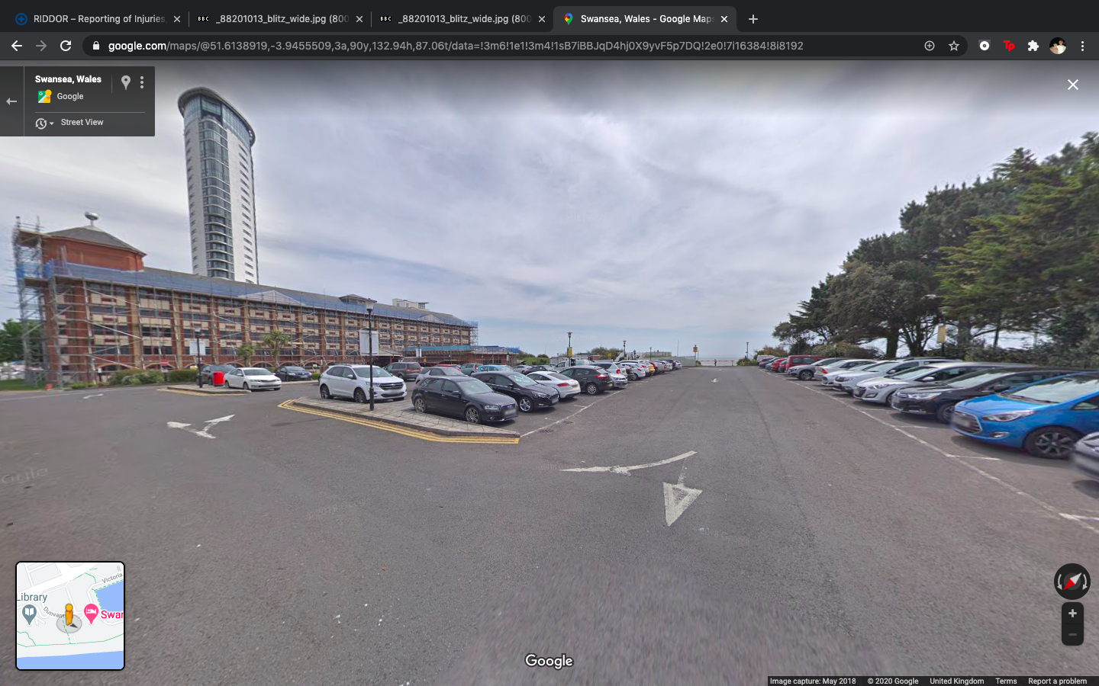
Image from Google Maps https://www.google.com/maps/@51.6138919,-3.9455509,3a,90y,132.94h,87.06t/data=!3m6!1e1!3m4!1sB7iBBJqD4hj0X9yvF5p7DQ!2e0!7i16384!8i8192

The Site is based on the Swansea foreshore, next to the County Hall and the Marriot Hotel. The building, which is to share parts of the car park of both of the existing adjacent facilities, is to have a Gross Internal Area at ground floor level of approximately 300 square metres. The building is to be a two-storey structure, the ground floor a new restaurant and ice-cream parlour and at the second-floor level, a self-contained manager’s apartment and staff welfare facilities. While building this structure it’s important to ensure there is still an ample parking area. The site is accessible from the road Dunvant Pl, as the current car park is.

A Desk Study investigation and site investigation was carried out in order to evaluate the potential hazards on the site and prepare a risk assessment for further thought.

The site is situated directly opposite the sea (Facing South), with the County Hall and the Marriot Hotel on either side. Trees are also present to the outside edge of the site.
The site is currently used as a car park for people visiting/working at the Mariott Hotel.

Site constraints should be considered, as they can influence the type of equipment and methods used to plan the site investigation. Ground conditions and obstructions on the site and accesses to the site should be considered in the planning of investigations.
The area around the investigation positions should include adequate space for working,
storing tools and stockpiling excavated materials.

History
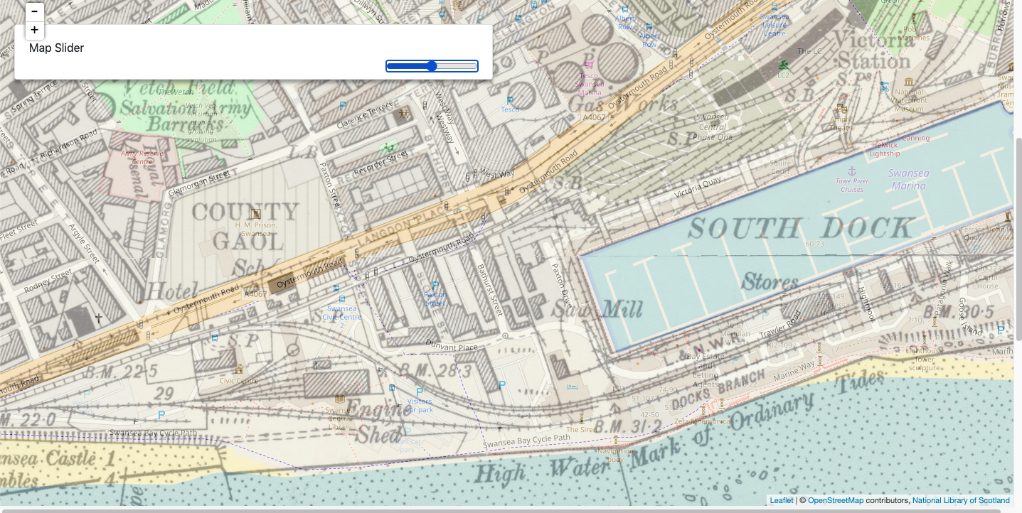

From historical mapping, it is understood the area has been used industrially as it is situated by the South Dock, more specifically near the Saw Mill. The 1888 map reveals Buthhurst Street which lays north of our site boundary and Sloane Street that’s based North East from the site. It also shows the presence of three railway lines on the southern area of the site. There are also two structures mapped at either side of the site, one North West and another at the North East.
The 1955-1961 map identifies the A483, a main road North of our site, this has now been replaced by the A4067 Oystermouth Road. The two buildings in the map of 1888 are no longer in place, and there is also a railway line running directly through the southern area of the site.
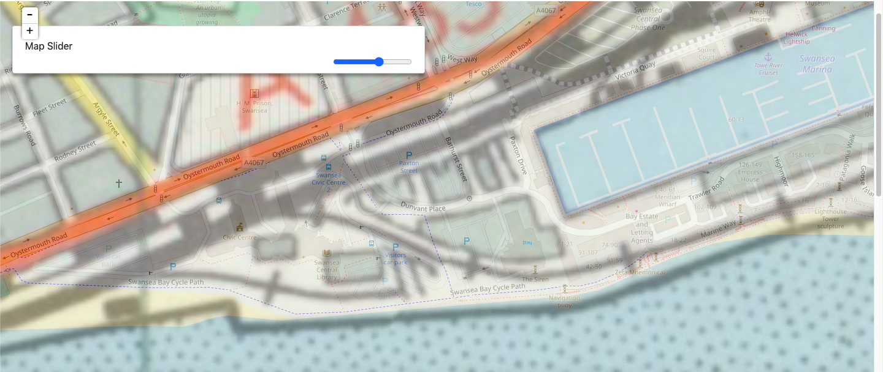
Current maps now indicate all railway lines mentioned above are not in place anymore, Bathhurst Street is still in place, and Dunvant Road has now been built. Swansea’s Mariott Hotel is built on the East of the site, Swansea’s Civic Centre and car park is built to the West of our site.
Attention must be made to the land’s previous uses; a more in-depth investigation will be required. This will ensure no previous rooms/basements still exist beneath the site and to fully assess potential damages the sites ground.
Historic Maps - Archiuk, 2020
https://www.archiuk.com/cgi-bin/build_nls_historic_map.pl?map_location=SA1%203SS%20SA13SS%20in%20Swansea&search_location=SA1%203SS,%20SA13SS%20in%20Swansea,%20Swansea,%20West%20Glamorgan,%20Wales&os_series=1&is_sub=&pwd=&latitude=51.613751&longitude=-3.944151&postcode=SA1%203SS
https://www.archiuk.com/cgi-bin/build_nls_historic_map.pl?map_location=SA1%203SS%20SA13SS%20in%20Swansea&search_location=SA1%203SS,%20SA13SS%20in%20Swansea,%20Swansea,%20West%20Glamorgan,%20Wales&os_series=7&is_sub=&pwd=&latitude=51.613751&longitude=-3.944151&postcode=SA1%203SS

Due to previous heavy industrial uses, provisions must be made to identify past foundations, engine sheds, pits, chambers, underground storage tanks etc. Coming across these during construction unexpectedly will cause numerous problems.

https://www.swansea.gov.uk/article/57405/The-Three-Nights-Blitz
Please see below a map of the targeted areas in Swansea:

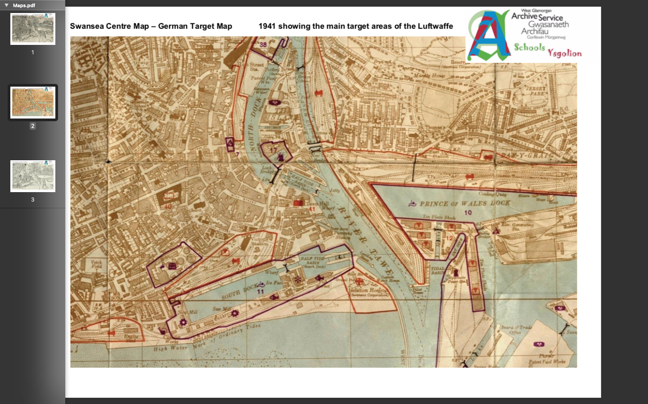
Image from West Glamorgan Archive Service

On the 19th of February 1941 Swansea endured three nights of continuous bombings, during the second world war. (Swansea Gov, 2020)

Unexploded ordnance (UXO) is any military ammunition that has failed to function as intended. Due to the bombings near our site in World War Two, there may be possibility of buried munitions.
The image below states that the proposed site poses high risk for potential UXO to be present due to the World war two bombings. This should be addressed in the site investigation taking place, and if necessary will require an UXO survey from a suitable UXO contractor.
The survey processes consist of of scanning and probing terrain to evaluate if any un-exploded materials are found underneath the ground of the site. This makes sure any planned construction work can be carried out safely with no concern regarding the risks involved.

https://zeticauxo.com/downloads-and-resources/risk-maps/

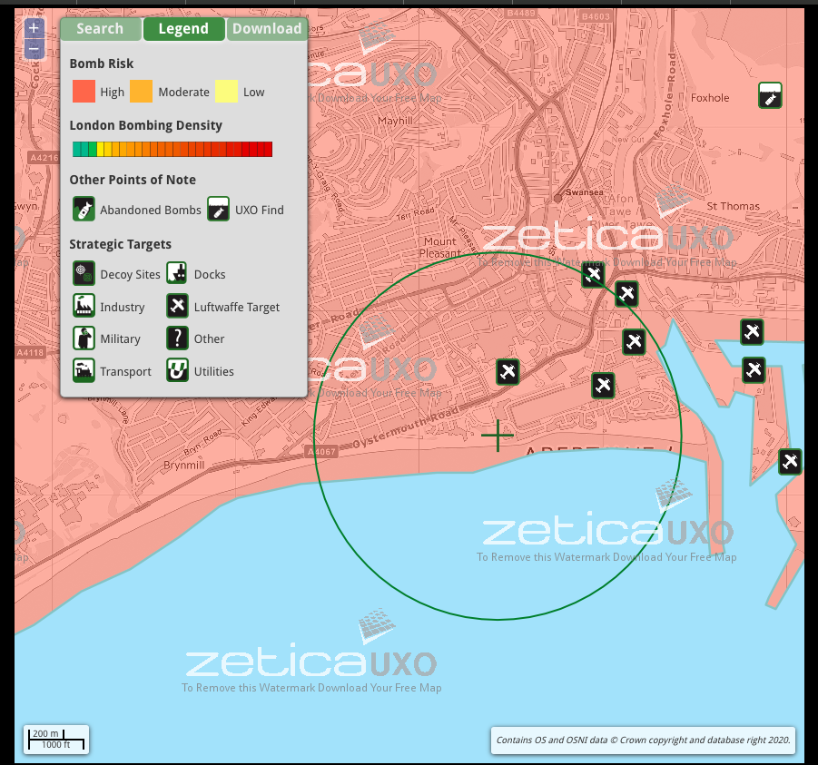

Coal Mining

Since the site was heavily industry based there may be presence of coal mining in the past. The Coal Authority stores material on past and present coal mining in a database. By reviewing the information this will educate us on the presence of mining in the area. Land stability and other safety risks are associated with coal mining activities are described as high-risk areas. The High-risks areas include known or suspected coal mining.
The Coal Authority is a consultee for any planning application within a high-risk area. A coal mining risk assessment will be required for any development within the site if designated a high-risk area.
information from HSE,2020 (Health & Safety Executive)
https://www.hse.gov.uk/foi/internalops/ocs/600-699/693_7/

Topography

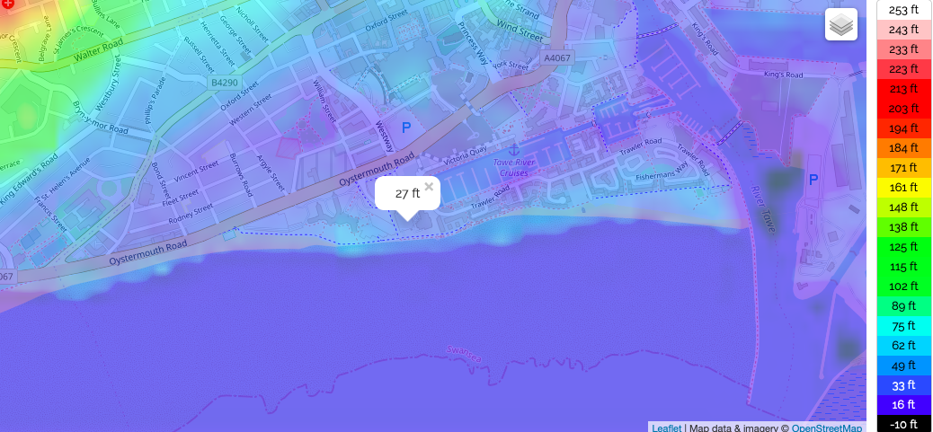

Image from www.topographicmap.com
https://en-gb.topographic-map.com/maps/dr1/Swansea/
This image above shows our site is 27ft above sea level.
The area the site lays on is flat and surrounded with man-made structures, it is in close proximity of the sea with a low height above sea level causing potential risk of storm surges.
Due to being in close proximity of the sea, coastal erosion may also be something to factor in the site investigation.

Services

Attention will need to be made locating underground services, to request service drawings from the utility providers, to gain an understanding of the area, and type of services present on site. A physical site inspection, looking for signs of services (e.g. manhole covers, telecoms boxes etc). The in-depth survey will use detection tools to get a more accurate idea of existing service locations. Underground utility detection of detail should be carried out in accordance with PAS 128.
Utilities inside the top two metres of ground are usually searched for using inspection pits, cable avoidance tool (CAT) scanning and ground probing radar (GPR). For deeper structures, such as many sewers and tunnels, these methods aren’t appropriate, and may not be effective or shown on an Ordnance Survey.

Ecology

Ecology concerns relationships between organisms and their environment hence when constructing this building it is very important that we bear ecology in mind. If we ensure we build using eco-friendly materials and designs, it will have less of a negative effect.
We can also avoid developing in areas where key habitats of important species are located to avoid the direct impact on the ecology. It is possible to enhance ecology onsite by creating new habitats and landscape features.
From conducting a desktop study, the main ecologic factor is the trees on the edge of the proposed development, by keeping these in place it will keep the ecological quality in place. The sites current use is a public car park, therefore doesn’t have many ecological areas.
BS42020: 2013 Biodiversity: Code of Practice for Planning and Development, the standard was put out to assist concerns with ecological issues throughout the planning process.

Subsidence

Due to the large amount of Clay soils present in the bore hole sample it is important to bear in mind subsidence on the site, changing weather conditions will cause shrinkage and swelling of the clay the site lays on. Trees are currently present at the north and west boundaries of the site, they will need to be considered in the planning stage as the roots can enter the shrinkable clay soil. They can absorb enough moisture to cause the clay to shrink, this causing foundations in close proximity to be affected possibly causing subsidence.
Image from Google images
https://www.google.co.uk/maps/place/Swansea+Marriott+Hotel/@51.6139062,-3.9451432,620m/data=!3m1!1e3!4m18!1m9!3m8!1s0x0:0x927675fd7a0f0c1b!2sSwansea+Marriott+Hotel!5m2!4m1!1i2!8m2!3d51.613713!4d-3.9442742!3m7!1s0x0:0x927675fd7a0f0c1b!5m2!4m1!1i2!8m2!3d51.

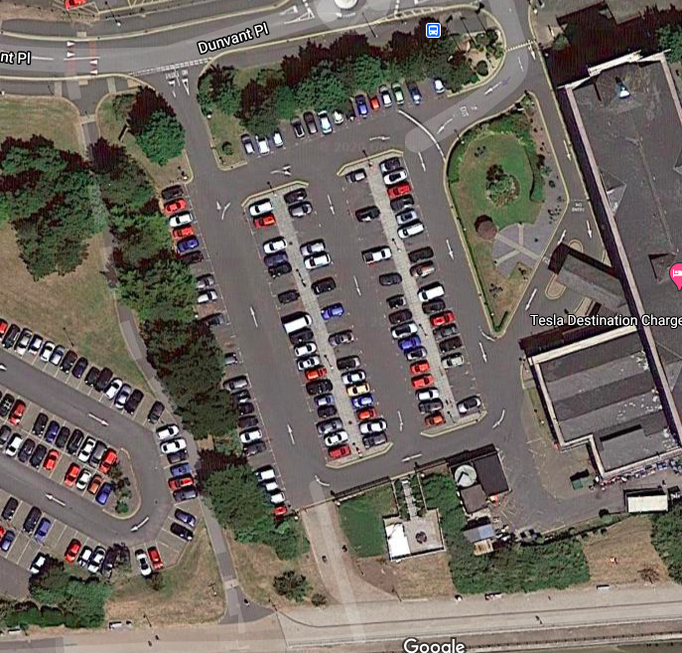

Made Ground

In the exploratory hole near the site, the ground was largely made of clays sands and bricks down to 4.95 meters. Gravel was also found within the made ground deposits. These areas of made ground may contain voids or contaminated soil, due to previous industrial use. The areas could have to be cleared, the extent and level of such contamination will be noted and will be put in a Safety Plan. The contractors may then assess the risks to health and the precautions that may be necessary.

Contamination

Sources of contamination have not been confirmed at the site or adjoining. areas. The site is currently being used as a car park for the hotel adjacent. Due to the lands previous industrial uses we will expect to see contamination, within the soil and water. Samples will need to be taken by the specialist geotechnical contractor. Any waste that requires special treatment needs special treatment under guidelines (BS 10175 and BS 8576).

Gas

Ground gas will need to be inspected during the site investigation, to determine the levels of oxygen, carbon dioxide, methane and other gases that can be produced by made ground. Levels of gases may exist naturally within the ground, they can occur as a result of infilled / contaminated ground. If potential for gas on site is likely, a ground gas assessment will be a necessary part of the report.
Guidance on site safety issues to be addressed in any investigation involving contaminated land or gas affected sites should be obtained from BS 10175 (in particular Annex C of that standard), BS ISO 10381-3 and industry guidance.

Geology from Boreholes

Please refer to the attached borehole sample taken nearby.
(BGS, British Geological Survey 2020)
Page 1
http://scans.bgs.ac.uk/sobi_scans/boreholes/370246/images/10677923.html
Page 2
http://scans.bgs.ac.uk/sobi_scans/boreholes/370246/images/10677924.html
Page 3
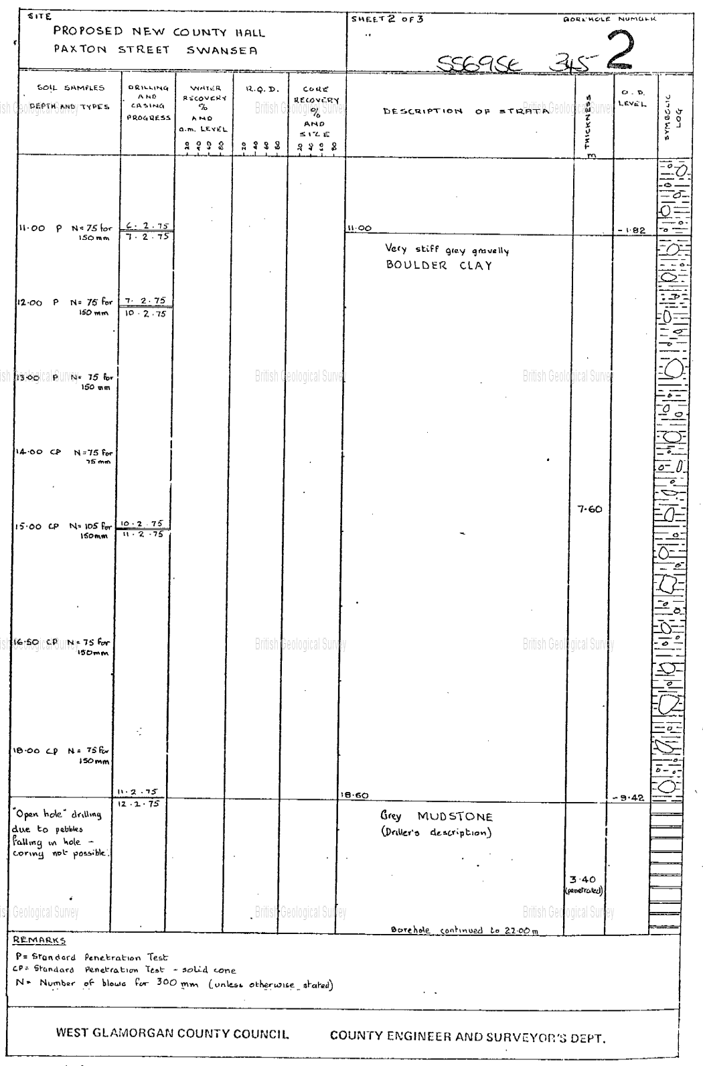
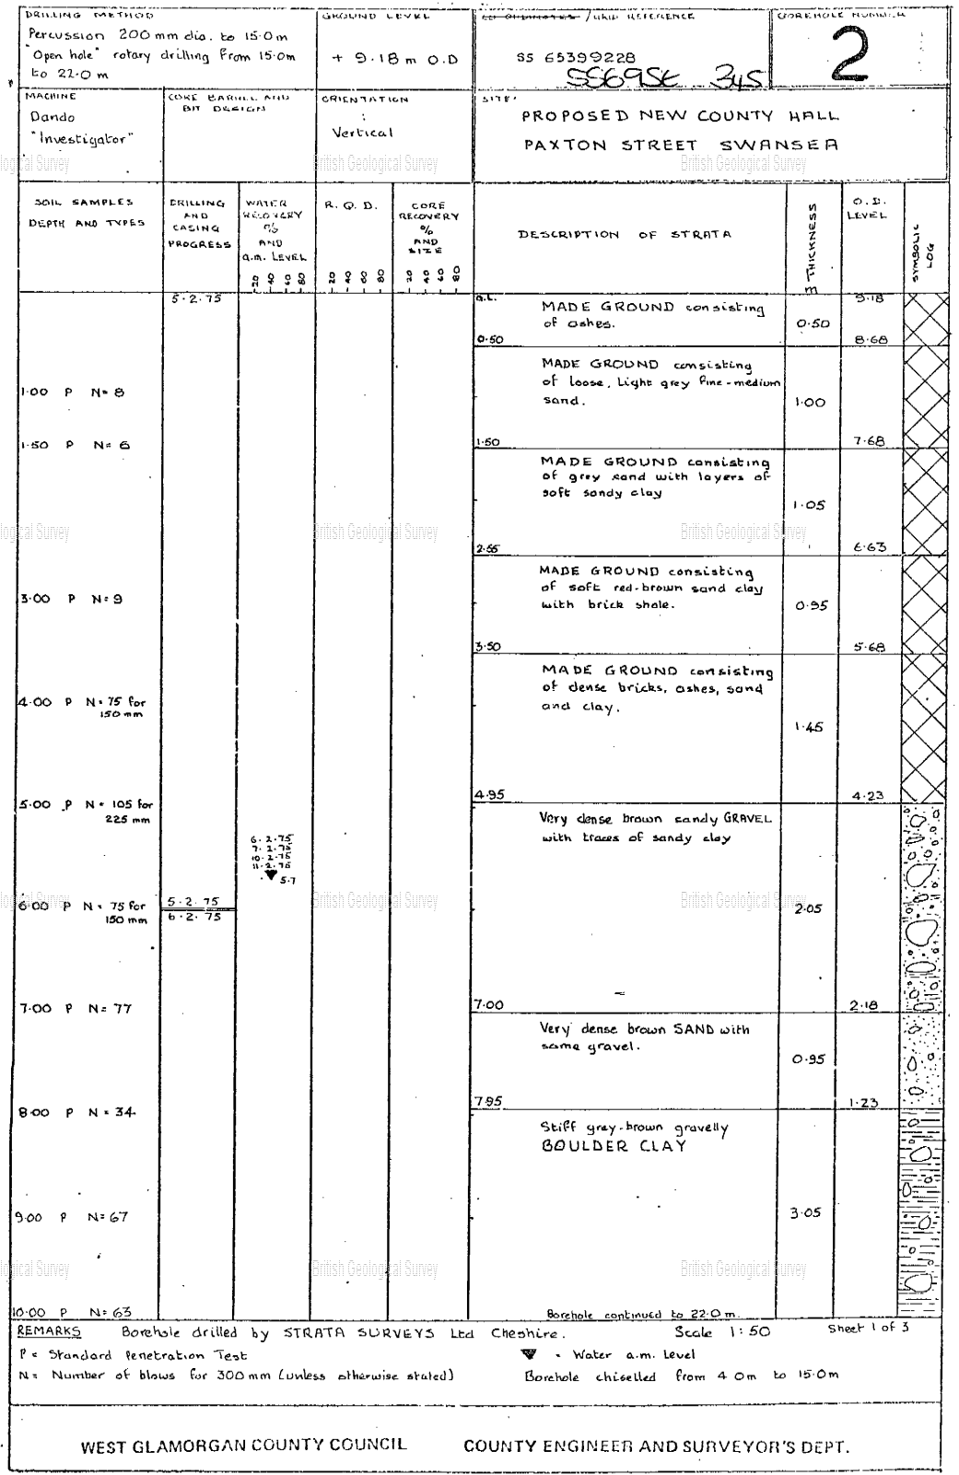
http://scans.bgs.ac.uk/sobi_scans/boreholes/370246/images/10677925.html

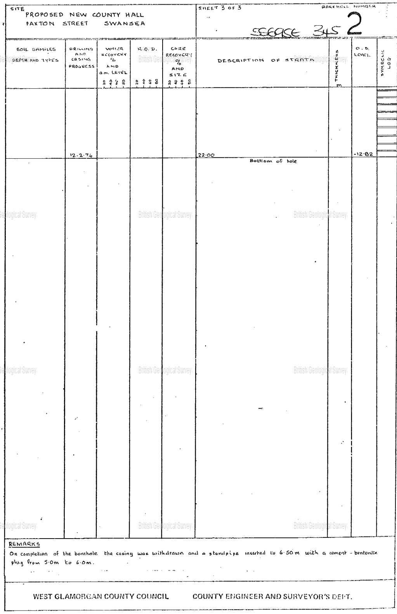

This borehole log sample displays strata evidence briefly consisting of:

- Sandy, ashy made ground from the surface level down to 4.95 meters.

- Water that was met with very dense brown sandy gravel with traces of sandy clay at 6.00 meters.

- Stiff grey-brown gravelly boulder clay from 7.05 to 11.00 meters.

- Very stiff grey gravelly boulder clay from 11.00 to 18.60 meters.

- Grey mudstone from 18.60 to 22.00 meters, the bottom of the sample.

No evidence of man-made ground and a solid presence of clay create a good bearing layer for our building after 7.00 meters. During this sample, it continued to 22.00 meters but there wasn’t evidence of any bedrock geology. This will be crucial to our decision of foundation design. The sandy ashy grounds are not self-supporting, when carrying out further boreholes they will most likely need to be lined with temporary casings. Excavations will also tend to collapse unless trench sheets or other supports are in place.

Foundation Design

The borehole example at hand encountered a particularly weak and compressible shallow sample continuing beyond the usual depth for traditional strip, raft or pad foundations to a structure. These grounds are considered not to be suitable for traditional strip, raft or pad foundations due to having a poor bearing capacity and poor quality of soils.
In this scenario pile foundations tend to be better suited, as they’re used to transfer loads from buildings through weak and compressible strata down into a more compact, stiffer strata.

Piled foundations example:

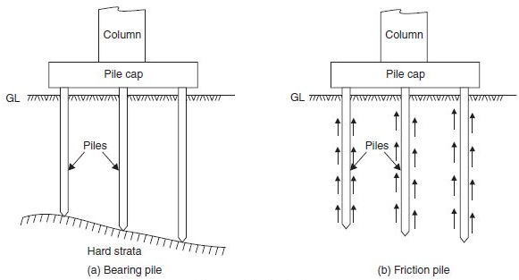
image from:
https://www.civilengineeringx.com/foundations/pile-foundations/

Out of the two popular forms of piled foundation, the friction pile is better suited to this particular site as they develop the majority of their load-bearing capability by shear stresses on the sides of the pile. These foundations are suited where the hard layers are too deep to reach economically. The end bearing piles require the end of the pile to rest on a layer of particularly strong rock or soil, the sample was taken to the depth of 22 meters with no result of strong rock or soil as such.

Soil sampling

Whilst collecting samples, there’s will be two types. Disturbed and undisturbed samples. The important properties required for foundation designs include the strength, compressibility and permeability. Good estimates of the properties will be made by conducting laboratory test on undisturbed samples. Undisturbed samples as such are almost impossible to achieve, therefore an undisturbed sample is where precautions have been taken to minimise disturbance.
A disturbed sample will not retain the properties of the soil before the collection process. An Engineer will not consider these samples to be representative examples of the soils. Due to how easy it is to collect disturbed sample, most of the soil samples taken are disturbed.
The undisturbed soil samples retain all of their original properties, by taking precautions. An undisturbed sample is difficult to obtain, gaining an undisturbed sample will allow engineers to test its properties of strength, permeability, compressibility to influence the design.

Site Investigation

The amount of information on the ground conditions will help the to advance an appropriate design and to deal with issues that may arise during work for example underground obstructions, without experiencing unnecessary delays or costs.
Investigation points must be set out before creating the excavations or boreholes. One of the methods for setting out is GPS, it is used to make a point at the coordinates recognised while planning the investigation.

References

Image from Google Maps
https://www.google.com/maps/@51.6138919,-3.9455509,3a,90y,132.94h,87.06t/data=!3m6!1e1!3m4!1sB7iBBJqD4hj0X9yvF5p7DQ!2e0!7i16384!8i8192

Historic Maps - Archiuk, accessed in 2020
1888-1913 map
https://www.archiuk.com/cgi-bin/build_nls_historic_map.pl?map_location=SA1%203SS%20SA13SS%20in%20Swansea&search_location=SA1%203SS,%20SA13SS%20in%20Swansea,%20Swansea,%20West%20Glamorgan,%20Wales&os_series=1&is_sub=&pwd=&latitude=51.613751&longitude=-3.944151&postcode=SA1%203SS
1955-1961 map
https://www.archiuk.com/cgi-bin/build_nls_historic_map.pl?map_location=SA1%203SS%20SA13SS%20in%20Swansea&search_location=SA1%203SS,%20SA13SS%20in%20Swansea,%20Swansea,%20West%20Glamorgan,%20Wales&os_series=7&is_sub=&pwd=&latitude=51.613751&longitude=-3.944151&postcode=SA1%203SS

Information regarding coal mining HSE,2020
https://www.hse.gov.uk/foi/internalops/ocs/600-699/693_7/

Topography graph from topographic map
https://en-gb.topographic-map.com/maps/dr1/Swansea/

Samples taken from BGS, British Geological Survey 2020
Page 1 http://scans.bgs.ac.uk/sobi_scans/boreholes/370246/images/10677923.html
Page 2 http://scans.bgs.ac.uk/sobi_scans/boreholes/370246/images/10677924.html
Page 3 http://scans.bgs.ac.uk/sobi_scans/boreholes/370246/images/10677925.html

West Glamorgan Archive Service 2020 Map of WW2 Bombings

UXO Bomb Map https://zeticauxo.com/downloads-and-resources/risk-maps/

Coal Mining information from HSE,2020 (Health & Safety Executive)
https://www.hse.gov.uk/foi/internalops/ocs/600-699/693_7/

