Paulina Leon
Student 2441581
Employability and Carer Development
Module LCLM4005

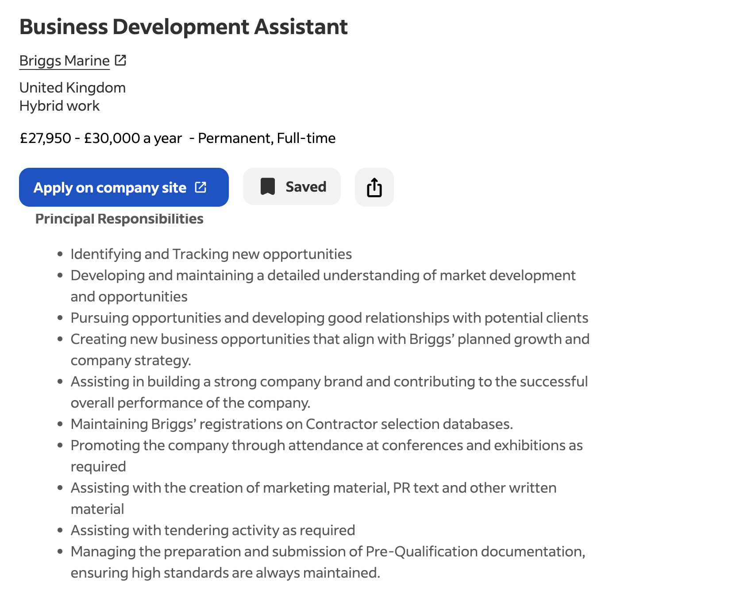
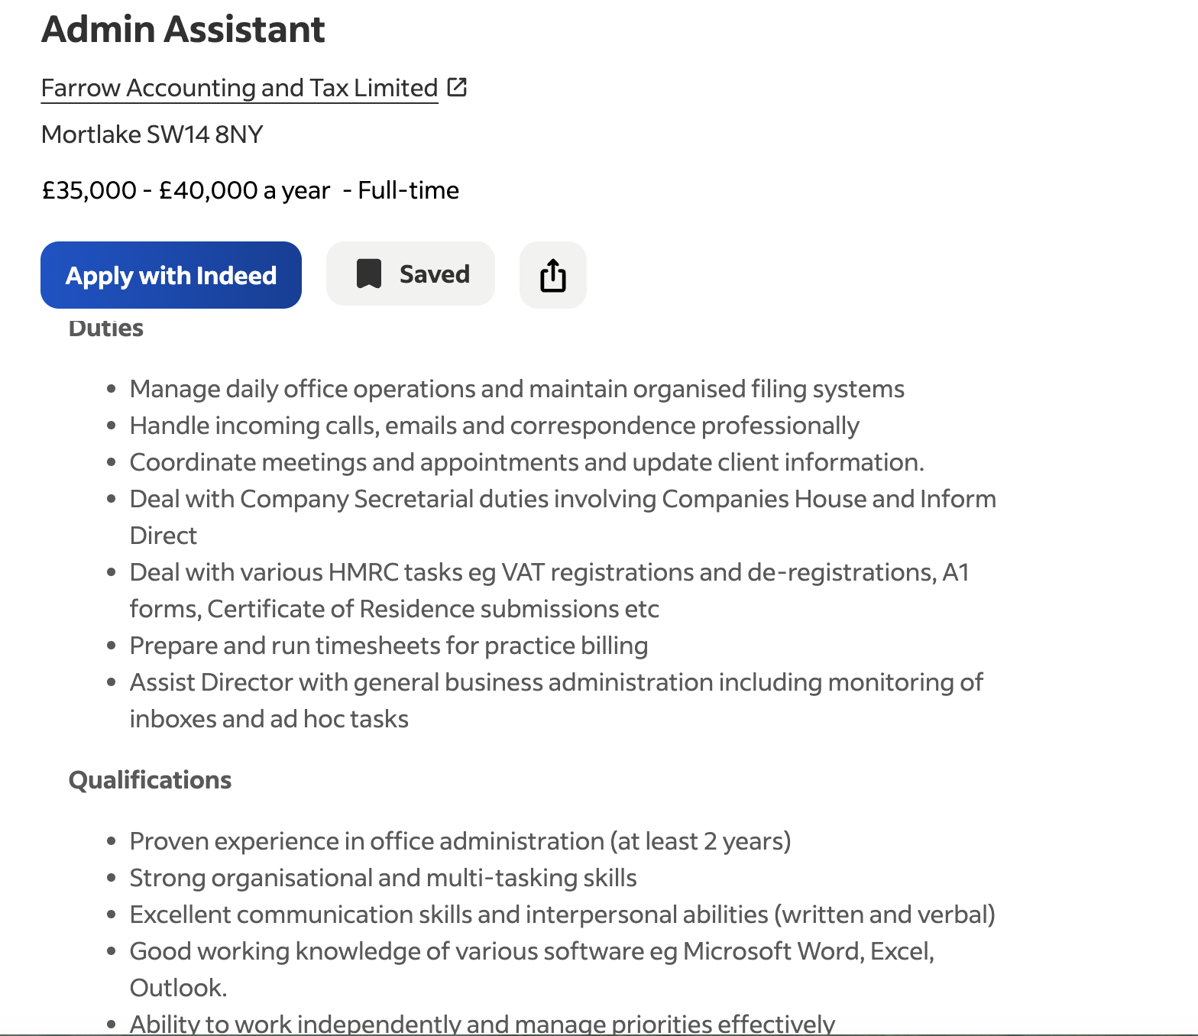
Comparison of two job Advertisements
Both positions support the successful operation of business they have different responsibilities and different levels of knowledge.
The first job Business Development assistant is focussed on supporting business development and requires flexibility. The employee must work flexible hours and willingness to travel around Uk to attend business events and learn about the business equipment and required to have a full UK driven licence and need to have experience with similar role is essential. The job offers hybrid working, can work anywhere in Uk the employee needs to manage the time and work independently needs to have good time management also needs to be maintaining good communication with colleagues.
In comparison the Business Administration, is focused on day to day running the organisation the duties and responsibilities are managing office operations, maintaining organised the filing system, organising meeting, answering phone calls and email, the job is more administrative supporting HMRC requirements like registration preparing significant task of the role involves maintaining accurate update client records and form, time sheets certificates, and invoice. This position requires knowledge of administration procedure and financial process and regulatory compliance.
Both jobs require strong organization, communication, time management attention in detail and the ability to manage multitask, in both jobs must have good communication with colleagues and clients. Both roles’ employees need to be adaptable and willing to learn. The difference as well is that the Business Development is focus on external stakeholders Business Administration, which require more internal communication supporting managers and departments within the organisation. The business Development involve more with stablished procedures.
The main difference is that the Business Development Assistant focuses on external business growth and the Business Assistant Administration focus on internal business support.
Self-=Assessment
A Self-assessment is very important in professional development because it help to understand my current abilities to know in which areas I need to improve in the future in my career growth.
This assessment is based on my experience at work personal achievements and academic development.
SWOT Analysis
Strengths
As a part of my job one of my strengths is communication through my professional experience as a receptionist. I must communicate with a wide range of people every day with my managers visitors colleagues every day I have to s=deal with emails phone call and face to face communication.
This experience has help me to increase my confidence and develop a professional communication. Good communication is important Business Assistant and Business Administration jobs because require good interaction with colleagues’ contractors and clients.
Organisation is another of my strengths and is very important in my current job, I have responsibility for meeting rooms and desk booking, visitor’s rand staff registration.
I need record important information accurately I need to prioritise task. This has developed my ability to manage responsibilities and meet deadlines.
Organisation is the requirement in the two jobs advertisements making an important skill for my future career.
Customer service I can consider one of my strengths. Working in a busy reception has taught me to remain to be professional and helpful even when unexpected situation the important to listening carefully even when the dealing is challenging, and identifying the person needs and provide an appropriate answer. These skills can be transferred to future administrative or business development jobs.
Another strength is willingness to learner that is the reason I desire to continue my education demonstrate that I am commitment to development myself studied business to allow me to develop knowledge of areas such as marketing business plan and different types of analysis like PESTLE SWOT analysis, organisation, communication combining with academic and work experience this give me a stronger foundation for my future employment.
Weakness
I have several strengths. I have recognised same areas I need to further development in confidence in a new professional environment, I’m confident in my current responsibilities moving a new role with different expatiations at the begging will be challenging, to participate in presentations meeting or professional discussion can help me to improve my confidence and experience.
Another area to improve business and financial knowledge the second job advertisement include responsibilities involving HMRC, VAT registration. I have experience in general administration, but I would be developing a stronger understanding this task. I can address this weakness study in the university, professional training or practical experience, another weakness is improving digital and technical skill, employers expect employees to be able to learn new soft ware quickly. I have experience working with Microsoft applications, but I need to improve Excel and another business software skills and this will help me to increase my employability.
Opportunities.
There are many opportunities available to support my professional development. My university studies are one of the most important this allows me to develop theorical business knowledge and apply in practical situations.
My existing work experience is another big opportunity I can use my current job to developing skills like administration, problem solving, time management and communication in my workplace there are revision every two months and my manager tells me what I need to improve and what I’m doing well.
There are opportunities for additional training to develop skill this could help me became a stronger candidate for further position.

Treats
The potential threat to my career development is competition in the employment market. Other candidate may have specialist qualification or direct experience in the business or administration. To remain competitive. I need to be developing my knowledge and demonstrate my skills, and practical experience can add value to the organisation.
Another potential threat is the changing nature of the workplace. Could be technology or digital systems the employees need to update their knowledge if I m not continuo learning some skills became relevant. I can reduce this risk with good attitude toward learning and regularly updating my digital skills.

Evidence of Readiness
I believe I’m ready to progress professionally because I already I have substantial workplace experience and I have gain transferable skills. My experience in a busy reception demonstrates that I can work with different people in professional manners and manage my responsibilities. With good communication and respond challenging situations.
My study at the university provides evidence of my readiness. I have developed my understanding of business concepts and learn how to analyse organisations using tools such as SWOT and PESTLE. Completing academic assessments and presentations has strengthened and my ability to search information and communicate clearly.
My main achievement is demonstrating commitment. Continuing my education and developing my professional career that shows I’m challenging myself and improve for more opportunities. The employability is not only having a qualification it is to involve attitude, reliability communication adaptability and willingness to learn.
Positive feedback about my professionalism customers service would provide further evidence of my readiness and constructive feedback would help me to identify the areas I need to development.
In my SWOT analysis demonstrate that I have strong foundation for future employment and personal advancement. My main strength are communication and organisation, customers service reliability and willingness to learn. The areas I need to improve business knowledge digital and confidence in an unfamiliar environment, using opportunities workplace experience academic studies protectional training. With the time I can development affectively. Also learn the importance to respond proactively to external treats like market competitors and digital change. I will continue learning and professional development to enhance my employability towards a success carer
Employment Goals
I have identified many employment goals that will support my professional development and future carer.
Short term
My short-term goals is to strengthen my business and financial knowledge in such areas as HMRC procedures, VAT. Companies house, invoicing and financial administration and improve my digital skills with Excel and business administration system, this will help me to increase my confidence and apply for administrative job. Also, I need to improve my confidence with unfamiliar professional environments, this can improve participating in presentations meetings with professional development activities. This will help me to became more confident when communicate with managers visitors and contractors
Long Term
Long term is improved my business administration and business development position where I can practice my existing communication customers service organisation skills while I’m using the additional knowledge. For the future I would like to apply into a position with responsibilities like administrative and business support management job.
This is very important for me because they allow me to build experience increase my employability and align with my career aspirations combining with my practical work experience and my academic business knowledge.
Personal Development plan
My personal plan is focus in improving three areas which I identified in my SWOT analysis.
- Specialist business knowledge: Complete courses to learn about HMRC, VAT, invoicing, administration with online resources, university or workplace training, to complete revenants’ courses and demonstrate improvements with practical exercises

- Digital skills: Develop skills with Excel with spreadsheets formulas reporting using Microsoft and business system with online courses or university resources.

- Professional confidence: Develop with presentation, meeting networking activities with group discussions.

All these specific points will help me to address my current weaknesses and preparing for future employment, after serten time I would review my progress and update my plan for my development needs with successful achievement will increase my confidence strength my employability and get ready for progression into business roles

