Economics of Sustainability

Assignment 1

Student: 1807552
Jonathan Preston
(BMSP6007)
Tutor: Anthony Burns

Introduction

Packaging externalities are prevalent in terms of pollution by littering, municipal solid waste (MSW) recovery and processing costs. Externalities focus on the cost or benefit of production that is not directly received by the producer (Messer, 2021). This essay will investigate the impacts incurred by the life cycle of packaging and how those impacts can be mitigated through economic intervention. Sir Isaac Newton has been quoted as stating that "to every action there is always an equal and opposite or contrary, reaction." This has never been so abundantly evident than in today’s world of global consumerism where little thought may be afforded to the consequences of continued demand and supply of goods and services that modern society has come to expect. However, the damage effects all environmental systems. The effects are far reaching, are not easy to control and are costly to society (Callan & Thomas, 2012). Since the 1950’s the use of plastic in the USA alone has risen by 10% year on year. Consequently, there has been a comparable increase in plastic waste .For example in 1960 the United States accumulated just under 400,000 tons of plastic waste. By 2010 that waste was closer to 30 million tons. In the UK plastic packaging is a key part of the UK packaging industry accounting for over 50 % of all goods packed in the UK (Mordor, 2020). A government report in 2018 states that more than 2 million metric tons is used in the UK every year (GOV.UK, 2020) Plastic packaging constitutes a significant part of the UK packaging industry. According to the UK Parliament Plastic Waste Report, 2020 it is estimated that five million tonnes of plastic is used every year, nearly half of which is being used for packaging in the UK per annum. (Smith, 2021). Along with paper, polyethylene is one of the most widely produced packaging materials worldwide. It is a robust thermoplastic which is produced by tens of millions of tons annually across the globe (Omnexus, 2021). It is popular due to its flexibility and superior damage resistance. It is used in a diverse range of packaging solutions from food items and auto spares to hand tools and stretch wrap. Paper is used in primary and secondary packaging by companies worldwide. Paperboard is a stronger rigid packaging material which has wide ranging applications including drink cartons, confectionary packets, and cereal boxes (Roake, 2021). According to the American journal of agricultural economics there exists a principle in the theory of economics that to change the behaviour of an element of economics it is necessary to create incentives which are of benefit to the economic element and consequently the behaviours that are sought become more attractive to the economic element in question. Published literature on the economics and environmental externalities make the case that there are three main solutions to environmental challenges. Each solution seeks to reduce the profitability of Pareto-relevant externalities for the elements involved (Randal, 1972).

- Market solutions
- Systems of charges, Subsidies, Fines and taxation
- Systems of Standards

Policymakers
Governments and policy makers and non-governmental organisations (NGO’s), businesses and civil organisations can address the negative externalities that are created by the production of packaging materials in a variety of ways:
● Implement taxation, introduce green public procurement and other economic incentives to stimulate waste reduction, reuse, recycling and use of recycled and renewable materials
● Continuous improvement of collection, sorting, and recycling systems create incentives to promote Deposit-Return Schemes.
● Provide detailed, clear, and enforceable set of critical criteria to promote reduction, re-use, and proficient recycling.
● Set targets and measures to support waste reduction and re-cycling
● Develop robust EU definitions, standards, and labelling policies such as bio-based and compostable / biodegradable plastics and domestic composting
(NGOs) and Civil Organisations
● Share knowledge and best practices to mitigate consumer confusion and prevent ‘greenwashing’ a practice where a business or organisation may display a false impression of being environmentally responsible.
● Drive a shift in consumer behaviour and support the demand for sustainable food packaging
Businesses
● Adopt a Life Cycle approach to determine the sustainability of food packaging, including packed food content.
● Improve packaging efficiency and functionality to facilitate optimum reduction and reusing of packaging. Championing recycled and renewable materials, whilst maintaining food safety at the forefront of their operation
● Create and innovate packaging for reuse and recycling that is compatible with the existent mechanisms available within the local, national, and international re-cycling infrastructures
Negative externalities from plastic production
There exist many negative externalities resulting from the consumption and disposal of plastics. Externalities which can create a detrimental effect to the aesthetics of the countryside when plastics are disposed of in landfill (Flores, 2008). The damaging effect of plastics on marine life is well documented and are arguably polluting every part of the food chain. Other disposal methods include incinerations which creates toxic emissions which pollute the air we breathe.

Economic cost of plastic pollution

Loss of ecosystem services - $3,300 and $33,000 per ton per annum
- Reduced value of marine ecosystem services $500–$2500 billion each year.
- Natural capital cost based on environmental impact $75 billion each year.
- Natural capital cost of plastic marine debris $13 billion each year.

End of life cycle
This presents an enormous challenge for the plastics industry. Single use plastics in particular are very likely to be banned for many applications by the European Commission. However, the market demand for plastics is almost certain to continue therefore it is essential that innovative solutions to the ‘plastic problem’ continue to be sought and researched (IJken, 2021).
Solutions
Taxation on plastic packaging in was introduced by the UK government in 2020. Applied to produced or imported into the UK which less than 30 % re-cyclable plastic materials. The tax will become effective in 2022 (GOV.UK, 2020).. Plastic packaging is packaging that is predominantly plastic by weight. According to Packaging Europe there 5 key points to focus on when trying to reach a packaging equilibrium.
- Damage prevention – Measures to avoid complete loss of product and or packaging.
- Cube optimization – Reducing packaging volumes to accommodate more items per sq. Inch.
- Choice of material – Consideration of full life cycle of packaging material and the environmental and economic costs of producing it.
- Collaboration – To provide overall more efficient and sustainable packaging solutions for business.

Fig 1 illustrates how hypothetically a subsidy for the plastics recycling markets which are captured from plastic waste streams, effectively creating a value for the waste plastic. The graph shows the Marginal Cost Benefit (MPB) which does not incorporate the benefit derived from re-cycling processes that are low in pollutants. The benefit gained is therefore a Marginal External Benefit (MEB). When added together this produces a Marginal Social Benefit (MSB)
MPB + MEB = MSB

Price
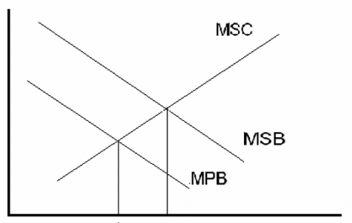Quantity
A A
Negative externalities from paper production
From 2008 to 2018, paper and cardboard were the main packaging waste material in the EU (31.8 million tonnes in 2018) According to data from the European statistics, between 2008 and 2018 paper and carboard waste packaging was the main waste material in the European Union reaching almost 32 million tonnes by the year 2018 (Eurostat, 2020). The production of paper involves the use of powerful chemicals such as chlorine and sulphur. These type of chemicals are harmful to the environment and the natural eco sytems.From 2008 to 2018, paper and cardboard were the main packaging waste material in the EU (31.8 million tonnes in 2018) According to data from the European statistics, between 2008 and 2018 paper and carboard waste packaging was the main waste material in the European Union reaching almost 32 million tonnes by the year 2018 (Eurostat, 2020). The manufacturing process at paper mills produces wastewater which contains high concentrations of total suspended solids (TSS) which contains organic compounds which are measured by their chemical oxygen demand (COD). One of the key challenges for the paper industry is to manage their effluent discharge and the by-products created during their manufacturing processes (Molina-Sánchez, Leyva-Díaz, Carlos, Cortés-García, & Valentín., 2018). This poses a significant technological challenge for the industry which is critical for it to operate and compete in the marketplace of the circular economy.

Technology based standards for paper production.
The design of technology-based standards is implemented in cases where there is proven technology to control and prevent pollution. Release standards are set after the evaluation of the technologies employed in wastewater treatment are assessed and create a basis for the best available technology economically achievable (BATEA) (Alberta Environment, 2005). The treatment of wastewater from papermills is focused on the extraction of useable resources from the effluent. This is achieved by means of a treatment facility which contains a biological reactor. The waste sludge can be treated at a rate of flow of almost 5000 m3 every 24 hours, removing colours and total suspended solids (TSS) by almost 100% producing reusable water.

The table below (fig ) illustrates the process characterisation as the influent and affluent as the wastewater is treated by the papermill plant. The percentage of colour removal and TSS within the parameters of a seven-day biochemical demand (BOD) and chemical oxygen demand (COD) (Molina-Sánchez et al, 2018).

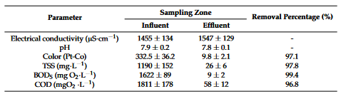

Wastewater release standards that may be enforced on any paper mill built after 1992 are shown in the next table (fig ) These standrds will also apply to mills built before 1992 that have been significantly modernised later than 2004. In this exapmle the standards set by assesing the best perfoming paper mills world wide. However
there exist some failings with technology-based standards in the United States. The US environment agency requires industries to reduce and control their pollutants by means of using a particular technology. This has proved to create some confusion in the US legal system which in some cases has believed the US environment agency carries out an evaluation of the technologies available without publishing policies to justify the costs. Terms such as ‘ feasible’ and ‘available’ technologies have been criticised for be vague and misleading (McCubbin, 2005). The cost benefits have in some cases failed to be made clear leaving the policies open to interpretation.

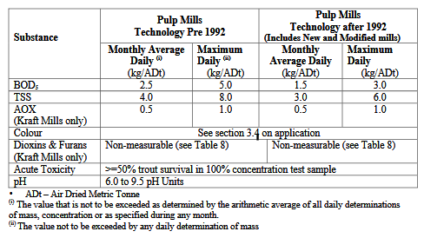
(Alberta Environment, 2005)

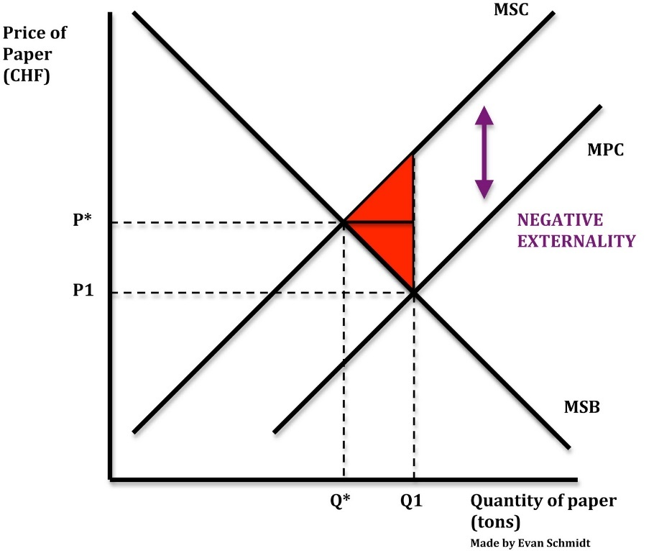 (Schmidtomics, 2010)

To illustrate the negative externalities of paper production the graph below (fig) shows the private costs of production (MPC) however without legislation the producer could show their own curve to align with the MPB curve to suit their own ambitions at quantity (Q1) and the price (P1). The producers’ private costs do not include the social cost (MSC) of any pollution shown in the graph. Therefore, if production MSC =MSB MSC = MSB (Pareto optimality / socially efficient level of output) the quantity would be produced at P. Where there is welfare loss ( MSC > MSB) is shown by the red triangles.

Obligated Package Producers
Following the introduction Packaging waste regulations in the UK in 1997 a business or organisation that produces packaging or uses packaging for its product may be recognised as an Obligated Package Producer (OPP). In 2020 the European commission published the new Circular Economy Action Plan. The action plan includes the continuous review of measures and requirements under the Packaging Waste Directive. Standards that were set by the European Directive on packaging aim to increase the retrieval and re-use of packaging materials in a sustainable way. All OPP’s must commit to reducing the production or use of packaging, reducing the quantity of packaging materials that cannot be re-cycled and must go to landfill whilst increasing the amount of packaging materials that can be retrieved and re-used.
Extended Packaging Producers
When a business has been declared as an OPP it becomes eligible as a member organisation of a compliance membership scheme which can enable the organisation to ensure that regulations on packaging are adhered to. Initial targets were set by the EU up until 2017 when the UK started to set its own targets up to the year 2030. However, an Extended Packaging Producer policy will come into effect in 2023 which is expected to contain significant changes to the current policy. It remains to be seen how these changes will affect organisations and the environmental impact of packaging waste. However different organisations will each have a responsibility to ensuring the success in reaching sustainable packaging targets.
Conclusions
The use of packaging is an essential part of global trading , however the production of the materials used, and the lifecycle of packaging will need to continue to be managed globally. Over the last 25 years environmental regulation has brought some significant improvements in maintaining air and water quality. Corporations are managing their own environmental impact, but increased expansion may bring diminishing returns. Increases in efficiency, competitiveness and profit will also require compatible strategies to reduce liabilities, pollution, resources, and costs. The ultimate end goal being the elimination of waste whilst maintaining an economical equilibrium.

References
Alberta Environment. (2005). TECHNOLOGY BASED STANDARDS FOR PULP AND PAPER MILL WASTEWATER RELEASES. Alabama: Alberta Environment.
Eurostat. (2020, December 10). Eurostat. Retrieved from Packaging waste statistics: https://ec.europa.eu/eurostat/statistics-explained/index.php?title=Packaging_waste_statistics
Flores, M. C. (2008). Plastic Materials and Environmental Externalities:. Lethbridge Undergraduate Research Journa, 5-6.
GOV.UK. (2020, November 26). Policy paper - Plastic packaging tax. Retrieved from GOV.UK: https://www.gov.uk
IJken, E. v. (2021, May 14). Increasing the circularity of plastics. Retrieved from Ecomatters: https://www.ecomatters.nl/case-studies/flagship-ecircular/
Kesicki, F. (2011). Marginal abatement cost curves for policy making –expert-based vs. model-derived curves. UCL Energy Institute.
McCubbin, P. R. (2005). THE RISK IN TECHNOLOGY-BASED. Duke Law.
Messer, S. (2021, May 13). BAD PACKAGING DESIGNS PERPETUATE NEGATIVE COSTS TO OUR COMMUNITIES. Retrieved from Greenblue: https://greenblue.org/bad-packaging-designs-perpetuate-negative-costs-to-our-communities/
Molina-Sánchez, E., Leyva-Díaz, Carlos, J., Cortés-García, F. J., & Valentín., M.-M. (2018). Proposal of Sustainability Indicators for the Waste Management from the Paper Industry within the Circular Economy Model. Scholarly Journals.
Mordor. (2020). UNITED KINGDOM PACKAGING MARKET - GROWTH, TRENDS, COVID-19 IMPACT, AND FORECASTS (2021 - 2026). Hyderabad: Mordor Intelegence.
Omnexus. (2021, May 14). Polyethylene (PE). Retrieved from Omnexus - Plastics & Elastomers: https://omnexus.specialchem.com/selection-guide/polyethylene-plastic
Polinsky, A. M., & Shavell, S. (1981). Pigouvian taxation with administrative costs. National Bureau of Economic Research, 19.
Randal, A. (1972). Market Solutions to Externality Problems: Theory and Practice. Oxford Journals, 175-183.
Roake, B. (2021, May 14). Information about packaging machines, materials, and applications. Retrieved from US Packaging and wrapping: https://packagingblog.org/2017/03/27/5-of-the-most-common-packaging-materials-in-the-world
Schmidtomics. (2010, February 16). NEGATIVE EXTERNALITIES OF PRODUCTION. Retrieved from Schmidtomics: https://schmidtomics.wordpress.com/2010/02/16/negative-externalities-of-production/
Smith, L. (2021). Research Briefing on plastic waste. London: UK Parliament.

Bibliography
Alberta Environment. (2005). TECHNOLOGY BASED STANDARDS FOR PULP AND PAPER MILL WASTEWATER RELEASES. Alabama: Alberta Environment.
Callan, S. J., & Thomas, J. M. (2012). ENVIRONMENTA LECONOMICS & MANAGEMENT Theory, Policy, and Applications.
Eurostat. (2020, December 10). Eurostat. Retrieved from Packaging waste statistics: https://ec.europa.eu/eurostat/statistics-explained/index.php?title=Packaging_waste_statistics
Flores, M. C. (2008). Plastic Materials and Environmental Externalities:. Lethbridge Undergraduate Research Journa, 5-6.
GOV.UK. (2020, November 26). Policy paper - Plastic packaging tax. Retrieved from GOV.UK: https://www.gov.uk
IJken, E. v. (2021, May 14). Increasing the circularity of plastics. Retrieved from Ecomatters: https://www.ecomatters.nl/case-studies/flagship-ecircular/
Kesicki, F. (2011). Marginal abatement cost curves for policy making –expert-based vs. model-derived curves. UCL Energy Institute.
McCubbin, P. R. (2005). THE RISK IN TECHNOLOGY-BASED. Duke Law.
Messer, S. (2021, May 13). BAD PACKAGING DESIGNS PERPETUATE NEGATIVE COSTS TO OUR COMMUNITIES. Retrieved from Greenblue: https://greenblue.org/bad-packaging-designs-perpetuate-negative-costs-to-our-communities/
Molina-Sánchez, E., Leyva-Díaz, Carlos, J., Cortés-García, F. J., & Valentín., M.-M. (2018). Proposal of Sustainability Indicators for the Waste Management from the Paper Industry within the Circular Economy Model. Scholarly Journals.
Mordor. (2020). UNITED KINGDOM PACKAGING MARKET - GROWTH, TRENDS, COVID-19 IMPACT, AND FORECASTS (2021 - 2026). Hyderabad: Mordor Intelegence.
Omnexus. (2021, May 14). Polyethylene (PE). Retrieved from Omnexus - Plastics & Elastomers: https://omnexus.specialchem.com/selection-guide/polyethylene-plastic
Polinsky, A. M., & Shavell, S. (1981). Pigouvian taxation with administrative costs. National Bureau of Economic Research, 19.
Randal, A. (1972). Market Solutions to Externality Problems: Theory and Practice. Oxford Journals, 175-183.
Roake, B. (2021, May 14). Information about packaging machines, materials, and applications. Retrieved from US Packaging and wrapping: https://packagingblog.org/2017/03/27/5-of-the-most-common-packaging-materials-in-the-world
Schmidtomics. (2010, February 16). NEGATIVE EXTERNALITIES OF PRODUCTION. Retrieved from Schmidtomics: https://schmidtomics.wordpress.com/2010/02/16/negative-externalities-of-production/
Smith, L. (2021). Research Briefing on plastic waste. London: UK Parliament.

