

Assignment

Name: Niveditha Mohan
Student ID: 2218283
Table of Contents
Introduction 3
Main Body 3
Overview 3
The gap in the market 4
Addressing the market with the proposed business plan 5
Proposed location with legal entity 6
SWOT 7
Explanation of target market 9
Strategies to Approach the target market 10
Potential external funding sources 10
Approximate Value of a construction project 11
Reference 123

Introduction

The construction industry in the United Kingdom is a dynamic and especially aggressive region, presenting several opportunities for boom and fulfillment. A well-crafted creation advertising and marketing method is critical for entrepreneurs looking to set up or enlarge their manufacturing ventures inside the UK. This blueprint outlines the agency's imaginative and prescient assignment, target market, competitive analysis, economic projections, marketing techniques, and operational pointers. It addresses key components along with assignment manipulation, hazard assessment, regulatory compliance, and sustainability practices. A sturdy marketing strategy demonstrates the entrepreneur's knowledge of the company, their capacity to navigate demanding situations, and their commitment to delivering exceptional production offerings profitably and sustainably. This study discusses the construction plan, a top-degree view of the commercial enterprise concept, the distance in the market, the proposed marketing approach and legal entity, SWOT assessment, the intention marketplace and techniques to technique it, monetary plans, and funding cited here.

Main Body

Overview

Additionally, an entire aggressive analysis will select key competitors within the marketplace, facilitating the components of powerful advertising and pricing strategies that set the employer aside from its competition. Sustainability may be a vital pillar of the employer, as green advent practices may be integrated into operations. Utilizing electricity-inexperienced substances, promoting waste reduction and recycling, and adhering to sustainable layout concepts will contribute to the business organisation's commitment to environmental protection and cater to the growing call for sustainable construction solutions. The production agency will provide a huge range of services and products, which includes architectural design, undertaking to make plans and management, internet website online practice, foundation work, structural introduction, indoors and outside completing, electrical and plumbing installations, landscaping, and general contracting services. The commercial enterprise will try to supply high-quality craftsmanship, interest in detail, and timely very last touch of responsibilities, ensuring patron pride and building prolonged-term relationships. The cause is to install a reputable construction brand recognized for excellence and reliability in the UK marketplace. The marketing method will embody meticulous economic projections, encompassing startup fees, ongoing costs, and assignment-associated prices. By wearing out a comprehensive economic analysis, the corporation can set up a pricing form that ensures profitability at the same time as ultimate competition in the enterprise. Marketing techniques are probably cautiously devised to elevate the attention of the company's offerings and entice clients. Employing a multi-channel approach, such as online structures, social media, traditional advertising and marketing, and industry networking, will allow effective emblem positioning and the establishment of a good picture based totally on niceness and reliability. Operational suggestions will define vital procedures and procedures associated with project manipulate, fantastic manipulation, safety measures, and regulatory compliance. Emphasizing smooth communique and collaboration inside the group and with clients, the agency will make certain the seamless execution of projects to the very best standards.

The gap in the market
The different phases of an asset's life cycle and interpersonal, technical, economic, and organizational components have been utilized to investigate knowledge deficiencies. Old-fashioned ideas about the sector need to be challenged to address not just the present skill crisis but also to draw in and keep the talented people of the future. The business community has to rehabilitate its reputation of being a cutting-edge field where its possible employees excel through capitalizing upon the forward motion that has resulted from broad technical advancements and continued pledges to inclusiveness, equity, and diversity (Newman et al. 2021). Following the start of the epidemic, flexible schedules became a mainstay throughout most of the UK population; however, the construction sector has encountered extra challenges that have limited its acceptance of this innovative way of functioning. The core gap in construction has been identified to be the skills set the gap between employees, which the industry is trying to eliminate with flexible work policies which can help employees to act accordingly.
One of the crucial gaps in the creative marketplace of the UK is the shortage of low-priced and sustainable housing. The call for low-cost housing extensively outweighs the supply, main to immoderate property fees and restrained options for humans and families with lower incomes. Additionally, the development business enterprise is grappling with the need to lessen its carbon footprint and undertake greater environmentally first-class practices. To cope with this hollow, the employer targets to recognition of two key elements. Firstly, it intends to invest in present-day construction techniques and technology that allow for quicker, price-effective, and green housing answers. This also can comprise using modular creation techniques, which allow the assembly of pre-fabricated additives, lowering advent time and waste. Secondly, the development enterprise goals to collaborate with community governments, housing institutions, and builders to prioritize much less costly housing tasks. By actively taking elements in tasks that promote low-cost housing schemes and securing partnerships, the enterprise can make contributions to assemble the demand for sustainable and fairly priced houses.

Addressing the market with the proposed business plan

According to research, the flexible work arrangements implemented by the NHS might create a "good precedent" in the construction sector, as neither requires a large portion of the work to be done on-site. Organizations which adopt a comprehensive approach to their personnel and enrolment approach, on the other hand, shall be most prepared to confront the difficulties that are lying forward (Awwad, Shibani and Ghostin, 2022). These organizations are going to source about and establish substitute sources of talent, make use of technology to discover potential employees, and promote a conviction of meaning and workplace atmosphere.

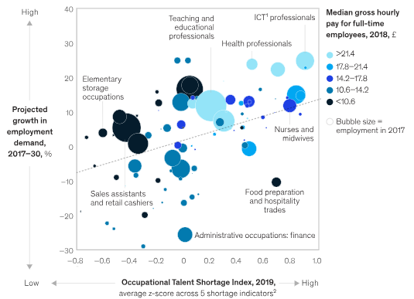

Figure: Occupational Talent Shortage by 2030 in the construction industry in the UK
Source: (mckinsey.com, 2019)

According to this occupation-by-occupation modeling, from 2017 to 2030, the requirement for overall employment at the most lucrative percentile is expected to rise by an average of around 19 percent, or 1.4 percent annually. In addition to professional positions in information and communication technology (ICT), engineering, health care, and teaching, these vocations also include managerial positions across a wide range of industries (Allas et al., 2019).

The distinguished gap in the industry ought to be eliminated by communicating openly with the current employees and asking them about the problems they are facing. Project management and proper guidance have to be provided with a critical evaluation of what is the requirement of the clients to enclose the existing gap of the employees for quality work. Training and development of employees is another form of establishment that will be followed by the respective organization to enhance the skill set and marketing management of the employees (Clarke, Littlewood and Karani, 2023). These are some of the aims that have been identified to eliminate the skills set gap in the UK construction industry.

Proposed location with legal entity
One of the key industrial sectors in the British economy, the construction sector generated roughly 6% of the country's total value added in 2019. It ranked sixth within worldwide rankings in terms of GVA for the construction industry in 2018. Within Great Britain, the construction industry utilized approximately 2.1 million people in 2020 (1.4 million in just over 342,000 VAT/PAYE-registered enterprises, along with 727,000 self-employed), alongside a significant proportion of small companies (just over one million small/medium-sized businesses, primarily independent contractors people) accounting for about 18% of every company in the country. In 2020, London and the southeast of England were home to more than a third of all construction companies. In the UK, 12.5% of construction workers were women (researchbriefings.files.parliament.uk, 2022). The South East of England is the best region to pursue an occupation within the building. It comes as unsurprising when this part of England tops the list and earns the title of Britain's trades-friendly locale with 58,204 construction-related companies in the surrounding region.
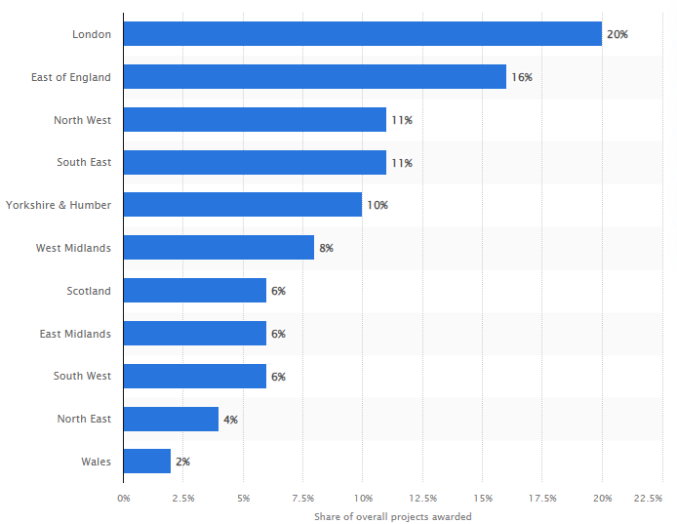

Figure: Most favored construction located in the UK
Source: (statista.com, 2022)

The government released Building 2025 in July 2013 with its building industry plan. It outlines many important objectives, which are listed as follows: A 33% decrease (from 2010/09 levels) when it comes to initial expenses of installation and the overall price of operating equipment. A decrease of 50% in the total duration required to complete new construction and remodeled infrastructure (based on criteria set by the industry in 2013) (researchbriefings.files.parliament.uk, 2022). A halving of the release of greenhouse gases from construction sites (from 1990 levels). A fifty percent reduction in the trade imbalance between overall exports and overall imports of building supplies (down from a £6 billion deficit before February 2013).

SWOT

Strength  Efficiency brings down expenses. It increases sales. It may be the difference between a three-year effort and a one-year endeavor. Any individual knows the fact that it just takes a single delayed appointment over a business to lose a client's trust (Onat and Kucukvar, 2020). Consumers become far more probable to employ a company that keeps its word and makes an effort to complete tasks on time. Undoubtedly, organizations preserve the professionalism and protection that define the workers. | Weaknesses  Establishing companies run the risk of going out of business should they concentrate entirely upon a particular sector and clients, which compounds the preceding issue. If a construction firm chooses to take care of only a single type of clientele and that particular consumption company does not work, its engineering business is left in the empty bag. Given that construction work ends anytime it's done by clients does too (Jones, Comfort, and Hillier, 2018). A business is unable to run whilst it waiting for clients. especially if there is an ongoing slump within the business sector it is pursuing.
Threats  This is true across all sectors, but especially in the engineering sector. As an example, a company can not close operations amid a recession. Additionally, consumers are powerless to stop a downturn precipitated through a financial crisis. According to Ullah, Lill, and Witt (2019), each of these events belong beneath the umbrella of unforeseen impacts. Anyone's only choice is to act sensibly in these situations. In a few years, a nascent enterprise can be obsolete. Building companies run the danger of going extinction along with their customers business suppliers. | Opportunities  Construction businesses should always be striving to increase their clients. People should refrain from allowing fortune to determine this. Rather than waiting, individuals should make the chance to succeed for themself. for instance, growing the company's companies. As another option, companies may make existing sections bigger to handle the increased burden. Keep an eye towards the latest modifications. This can be maybe one of the easiest methods to create ecologically sustainable jobs. When an organisation notices it's are a greater number of public transportation options in a given location, it may be a sign that additional individuals are moving elsewhere.

Explanation of target market
The primary target customers of the UK construction business is the homeowner, property developers, Government, businesses related to construction projects, factories, and the Government of the country. As per the opinion of Beliaeva et al. (2022) UK construction industry is based on some key segments such as industrial construction, residential construction, commercial construction, educational construction, and others. Therefore the recruitment of customers depends on the market segments from which the customers belong.
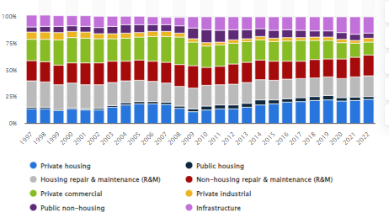

Figure: Different Customers segments of the UK construction industry
Source: (statista,2023)
The above graph reveals the numbers of customers in the different types of construction projects in the UK construction industry from 1997 to 2022. According to the graph, the number of customers in the private housing sector was 21.77% in 2021 and It was increased to 22.44% in 2022. It denotes that the number of customers in the private housing sector will increase in 2022 in comparison to 2021 (statista,2023). Considering these factors it can be said that the private housing sector is one of the most significant target market segments of the UK construction industry. However the demographic market segment is generally preferred by the construction industry in the UK. Demographic market segments consider the income, education, life cycle of the customers.
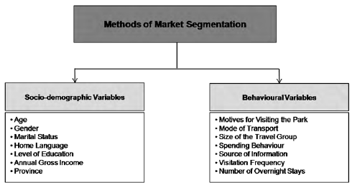
Figure: Market Segments
Sources: (researchgate,2023)
Developers of housing frequently refer to businesses or people who purchase terrain, construct it with residences or additional structures, and subsequently sell those constructions. That renders individuals both a prospective collaborators and appropriate consumers for a building firm. development firms are frequently required by enterprises to assist with the development of new workplaces, manufacturing plants, or additions for current equipment and structures. Among the biggest clients for building contractors are municipal, state, and government agencies (Awwad, Shibani and Ghostin, 2022). Although these might be challenging clients to gain, individuals are additionally an exceptionally profitable market to pursue for construction companies. Building contractors sometimes need to use additional building businesses for subcontractors or to assist handle particular areas of an endeavor.

Strategies to Approach the target market
According to Gu, (2023) UK construction industry mainly deals with two types of customers such as commercial clients and domestic clients. Both segments are very important and play an important role in increasing the value and profitability of the construction industry in the UK. Therefore, different strategies are available to attract new customers from different market segments.
Building a content creation team- Building a content creation team for developing projects is one of the most significant approaches for attracting new customers to the construction industry in the UK. Therefore, professional continent creators can make an attractive poster that includes all the benefits, cost, quality, structure, and other amenities of the construction project Beliaeva (2022). It helps to attract new customers and increase the profit.
Use of Social media platform- Social media platform helps to attract a large number of customers in the construction industry. Therefore the construction companies can use social media platforms to provide information regarding different construction projects.

Potential external funding sources
A brief financial or budget plan and decide on the required resources. Determination of potential outside funding sources to provide provide proper justification
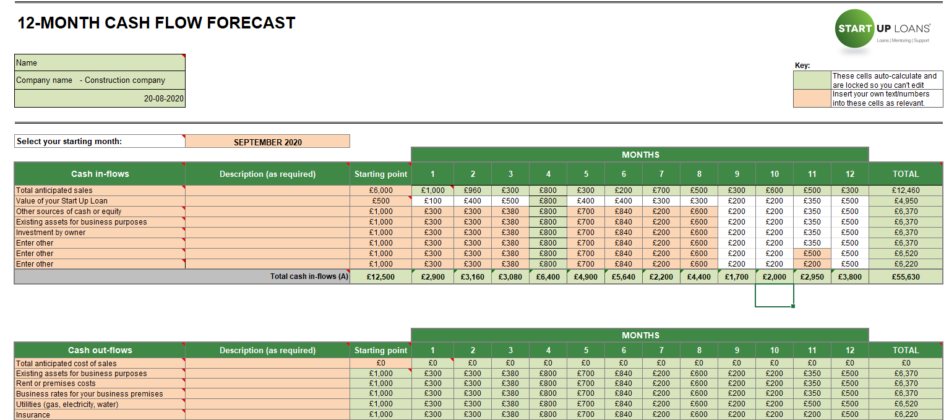
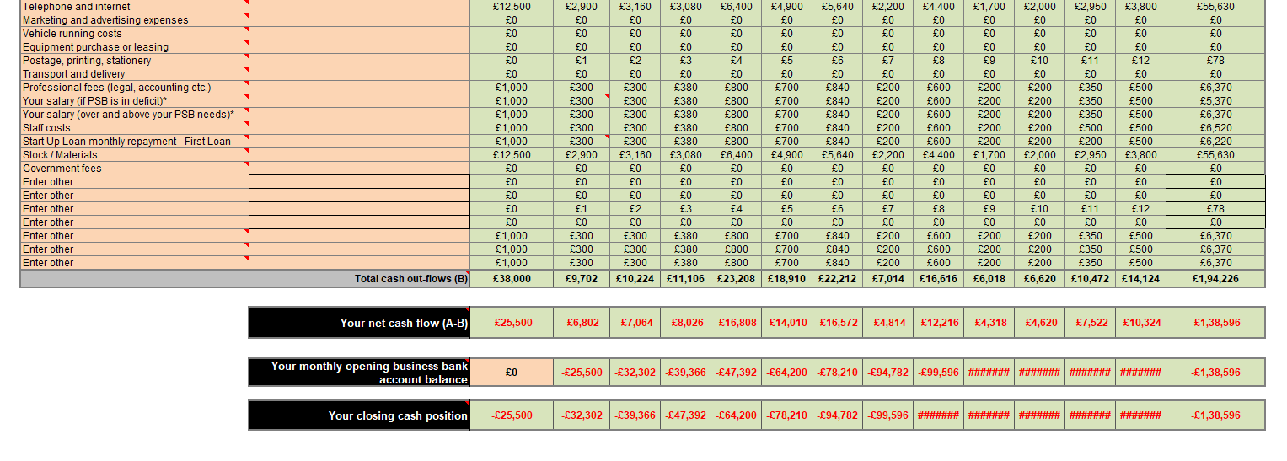
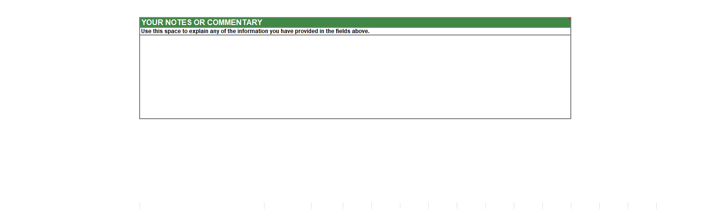
 | 2024 | 2025 | 2026
Profitability | £300 | £400 | £510
Total Revenue | £3600 | £4522 | £5100
Net income | £2346 | £4566 | £2311
Net profit margin | £750 | £360 | £907
Total equity | £5400 | £3211 | £1344
Long term loan | £3700 | £3700 | £3700
Total equity and long-term loan | £2190 | £2366 | £3296
Labour cost | £380 | £380 | £380
Return on capital employed | £690 | £550 | £680

Approximate Value of a construction project
Materials for a construction project | Cost
Labour cost | £3700
Construction material | £5000
Transportation | £2000
Electricity | £1700
Total cost | £25000
The three-year financial plan for this new construction project appears to be sound. Annual profit expansion is expected, but it's vital to remember that overall revenue growth will be far slower than the expansion of profits. This can indicate that the business receives funding from sources other than its clients. Remember that these sources of revenue are what this prediction depends on. Whole equity offers a strong base and the potential for long-term equity financing. Both the personnel cost and the return on capital employed remain constant over the course of the three years. This business model will also have an impact on the neighbourhood, providing more job opportunities, a wider range of products, and happier customers.

Considering all the above mentioned factors it can be said that there are many prospects for growth and fulfilment in the dynamic and extremely competitive construction business in the United Kingdom. For business owners wishing to start or grow their manufacturing endeavours in the UK, a well-crafted creation marketing strategy is essential. The agency's mission, assignment, target market, competitive analysis, economic projections, marketing strategies, and operating guidelines are all outlined in this comprehensive blueprint. Assignment manipulation, hazard analysis, regulatory compliance, and sustainability practices are all addressed along with crucial elements. A solid marketing plan shows the entrepreneur's understanding of the business, ability to handle difficult conditions, and dedication to provide superior production offers profitably and sustainably.

Reference
statista and 13, F. (2023) UK Construction Industry Segment Size 1997-2022, Statista. Available at: https://www.statista.com/statistics/565511/construction-industry-structure-uk/ (Accessed: 20 June 2023).
Newman, C., Edwards, D., Martek, I., Lai, J., Thwala, W.D. and Rillie, I., 2021. Industry 4.0 deployment in the construction industry: a bibliometric literature review and UK-based case study. Smart and Sustainable Built Environment, 10(4), pp.557-580. Available at: https://doi.org/10.1108/SASBE-02-2020-0016 (Accessed: 20 June 2023).
Awwad, K.A., Shibani, A. and Ghostin, M., 2022. Exploring the critical success factors influencing BIM level 2 implementation in the UK construction industry: the case of SMEs. International journal of construction management, 22(10), pp.1894-1901. Available at: https://doi.org/10.1080/15623599.2020.1744213 (Accessed: 20 June 2023).
Atkinson, R.J., Tennakoon, M. and Wedawatta, G., 2022. Use of new models of construction procurement to enhance collaboration in construction projects: The UK construction industry perspective. Journal of Financial Management of Property and Construction. Available at: https://doi.org/10.1108/JFMPC-02-2021-0016 (Accessed: 20 June 2023).
Clarke, J., Littlewood, J.R. and Karani, G., 2023. Developing Tools to Enable the UK Construction Industry to Adopt the Active Building Concept for Net Zero Carbon Buildings. Buildings, 13(2), p.304. Available at: https://doi.org/10.3390/buildings13020304 (Accessed: 20 June 2023).
Ajayi, S.O., Jones, W. and Unuigbe, M., 2019. Occupational stress management for UK construction professionals: Understanding the causes and strategies for improvement. Journal of engineering, design and technology, 17(4), pp.819-832. Available at: https://doi.org/10.1108/JEDT-09-2018-0162 (Accessed: 20 June 2023).
Onat, N.C. and Kucukvar, M., 2020. Carbon footprint of construction industry: A global review and supply chain analysis. Renewable and Sustainable Energy Reviews, 124, p.109783. Available at: https://doi.org/10.1016/j.rser.2020.109783 (Accessed: 20 June 2023).
Jones, P., Comfort, D. and Hillier, D., 2018. Materiality and external assurance in corporate sustainability reporting: An exploratory case study of the UK construction industry. World Review of Entrepreneurship, Management and Sustainable Development, 14(4), pp.454-472. Available at: https://doi.org/10.1504/WREMSD.2018.093568 (Accessed: 20 June 2023).
Ullah, K., Lill, I. and Witt, E., 2019, May. An overview of BIM adoption in the construction industry: Benefits and barriers. In 10th Nordic conference on construction economics and organization (Vol. 2, pp. 297-303). Emerald Publishing Limited. Available at: https://doi.org/10.1108/S2516-285320190000002052
Allas, T. et al. (2019) The Future of Work: Rethinking Skills to tackle the UK’s looming talent shortage, McKinsey & Company. Available at: https://www.mckinsey.com/featured-insights/future-of-work/the-future-of-work-rethinking-skills-to-tackle-the-uks-looming-talent-shortage (Accessed: 20 June 2023).
mckinsey.com (2019) The Future of Work: Rethinking Skills to tackle the UK’s looming talent shortage, McKinsey & Company. Available at: https://www.mckinsey.com/featured-insights/future-of-work/the-future-of-work-rethinking-skills-to-tackle-the-uks-looming-talent-shortage (Accessed: 20 June 2023).
researchbriefings.files.parliament.uk (2022) Researchbriefings.files.parliament.uk. Available at: https://researchbriefings.files.parliament.uk/documents/SN01432/SN01432.pdf (Accessed: 20 June 2023).
Gu, L., 2023. Executives’ financial experience and myopic marketing management: A myopic loss-aversion perspective. Journal of Business Research, 157, p.113587. Available at: https://doi.org/10.1016/j.jbusres.2022.113587 (Accessed: 20 June 2023).
Beliaeva, T., Ferasso, M., Kraus, S. and Mahto, R.V., 2022. Marketing and family firms: Theoretical roots, research trajectories, and themes. Journal of Business Research, 144, pp.66-79. Available at: https://doi.org/10.1016/j.jbusres.2022.01.094 (Accessed: 20 June 2023).
researchgate (2023) Market segmentation by means of socio- demographic & behavioural ... Available at: https://www.researchgate.net/figure/Market-segmentation-by-means-of-socio-demographic-behavioural-variables-Source_fig1_281996277 (Accessed: 21 June 2023).

