DS 1 Template
.

Screenshot/Photo 1
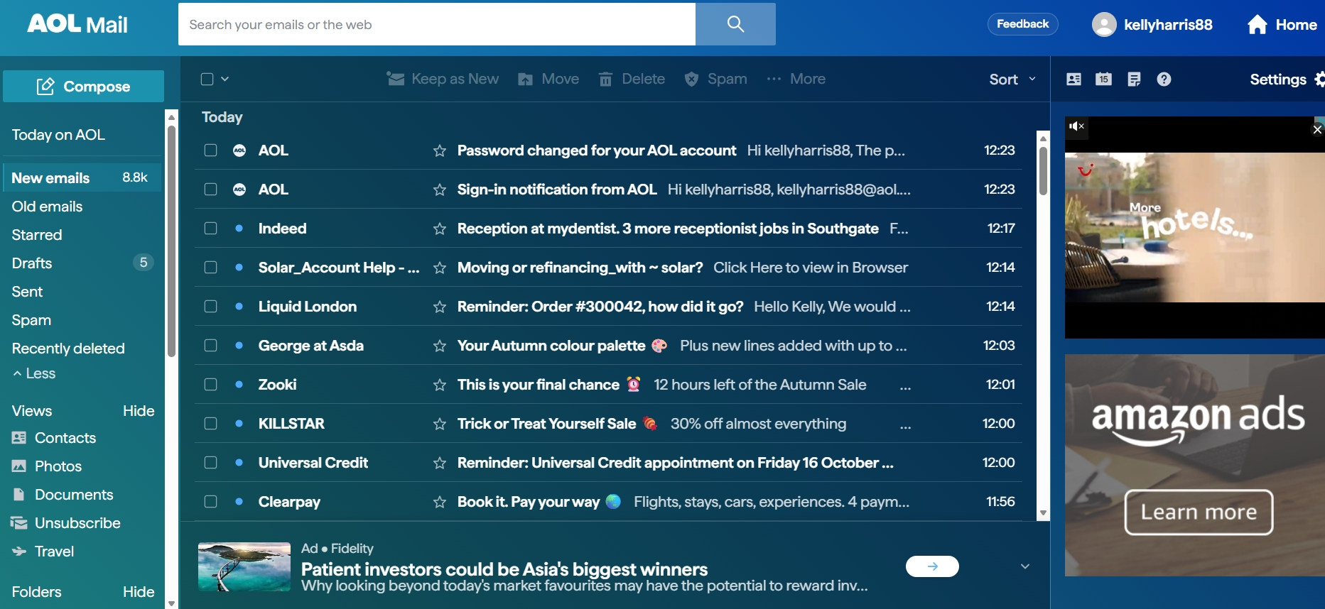
This is my main email AOL I use daily.

Screenshot/Photo 2
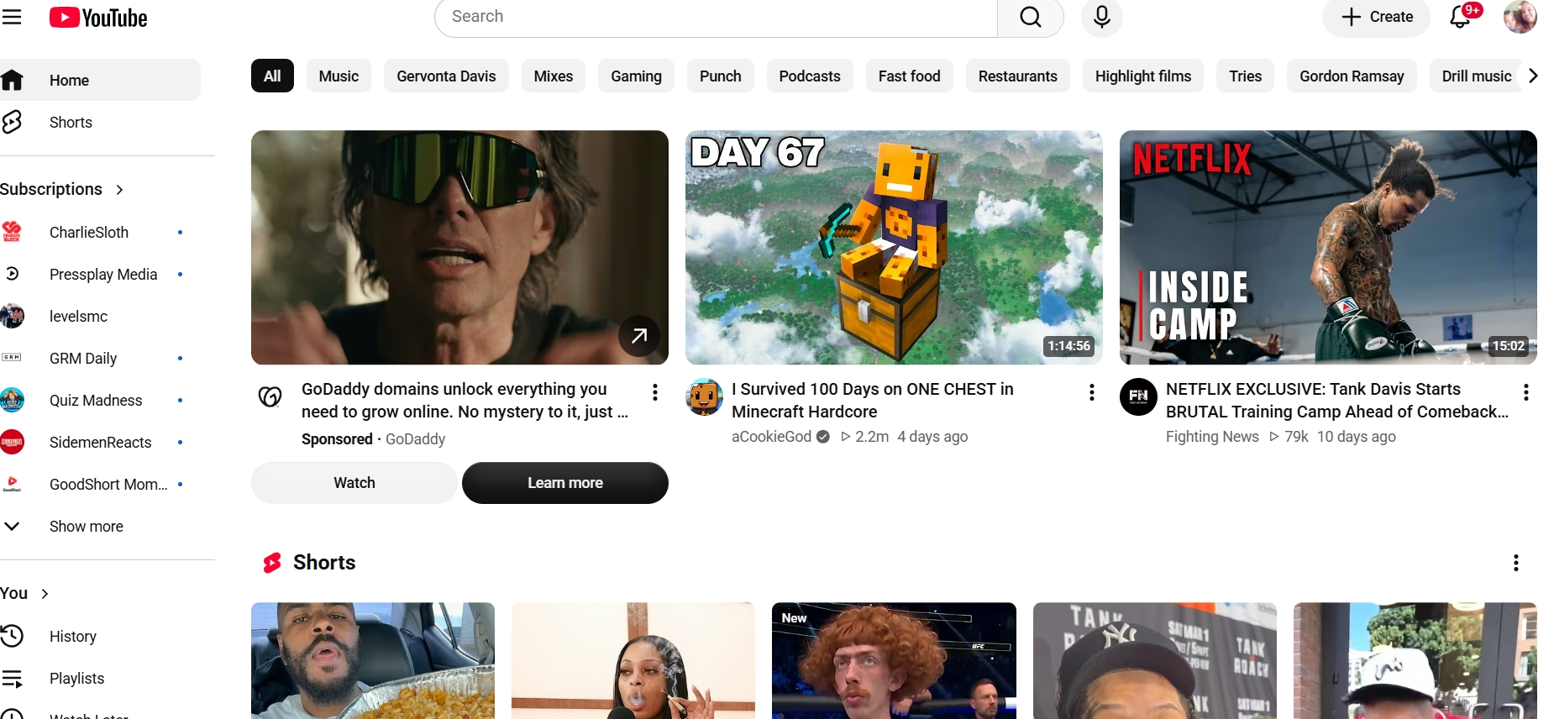
Youtube my son uses more but I do use quite a bit

Screenshot/Photo 3
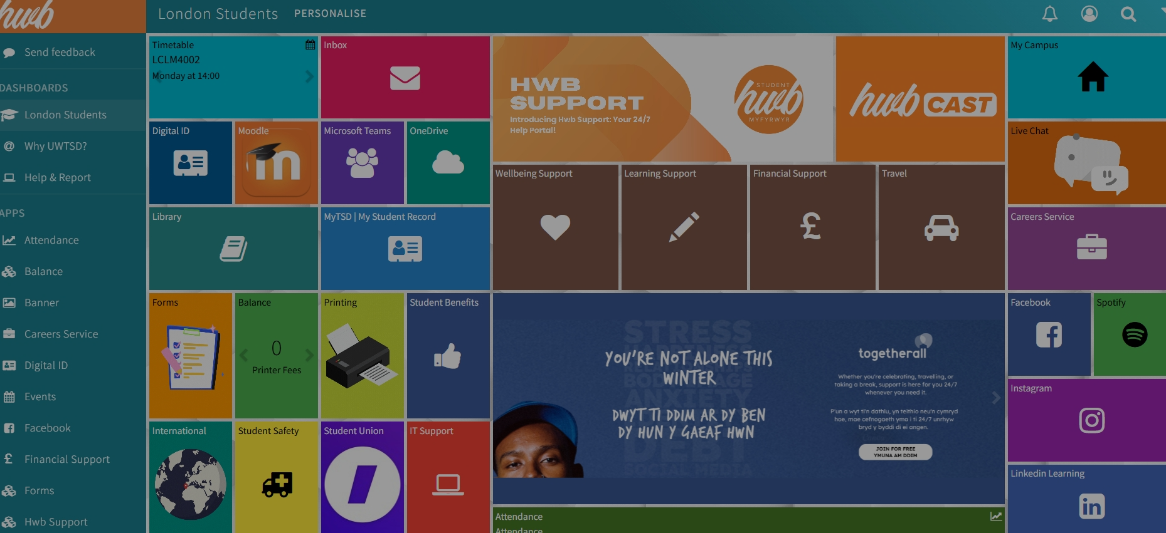
My student hub which I am starting to use daily

Screenshot/Photo 4
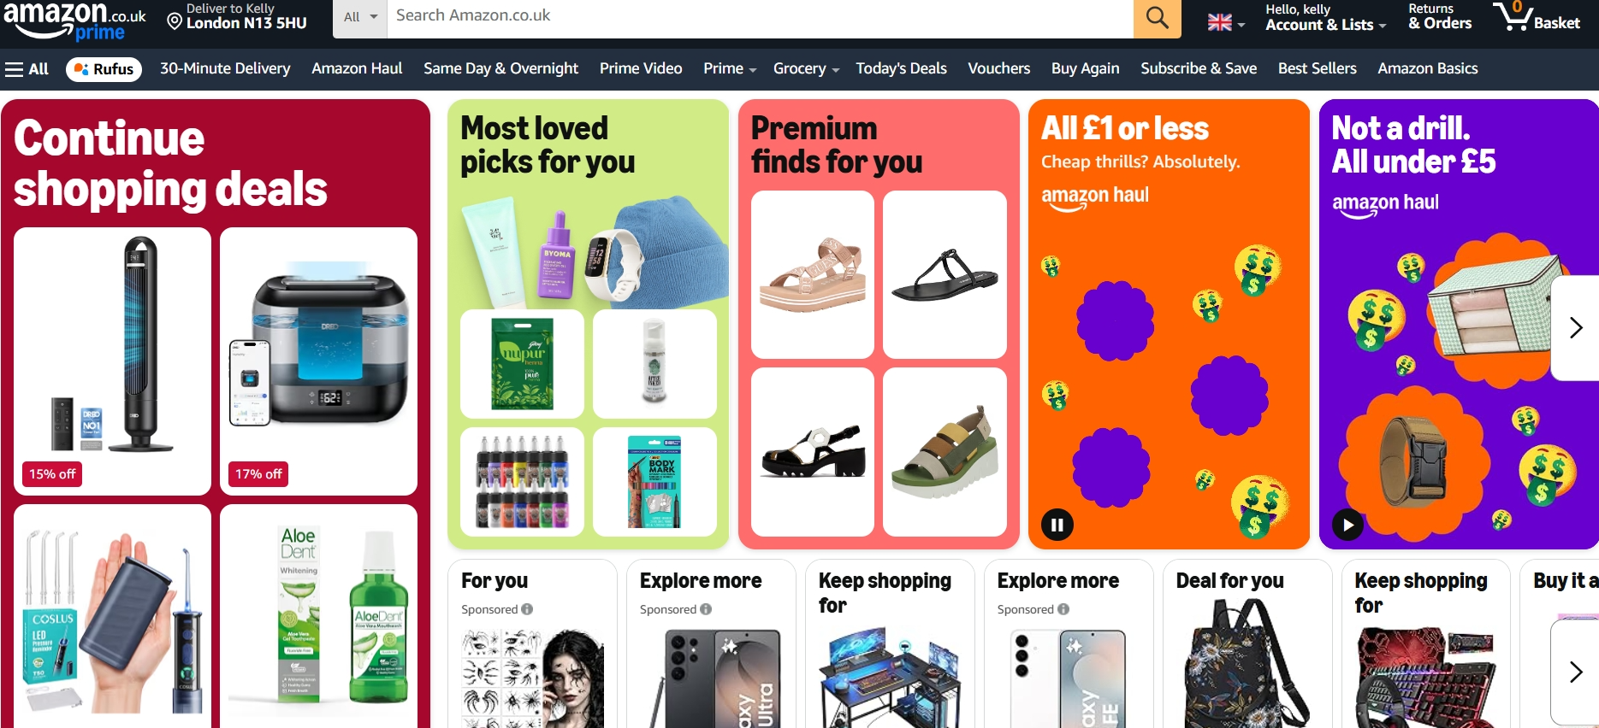
Amazon, I browse quite a bit, occasionally buying things.

Screenshot/Photo 5
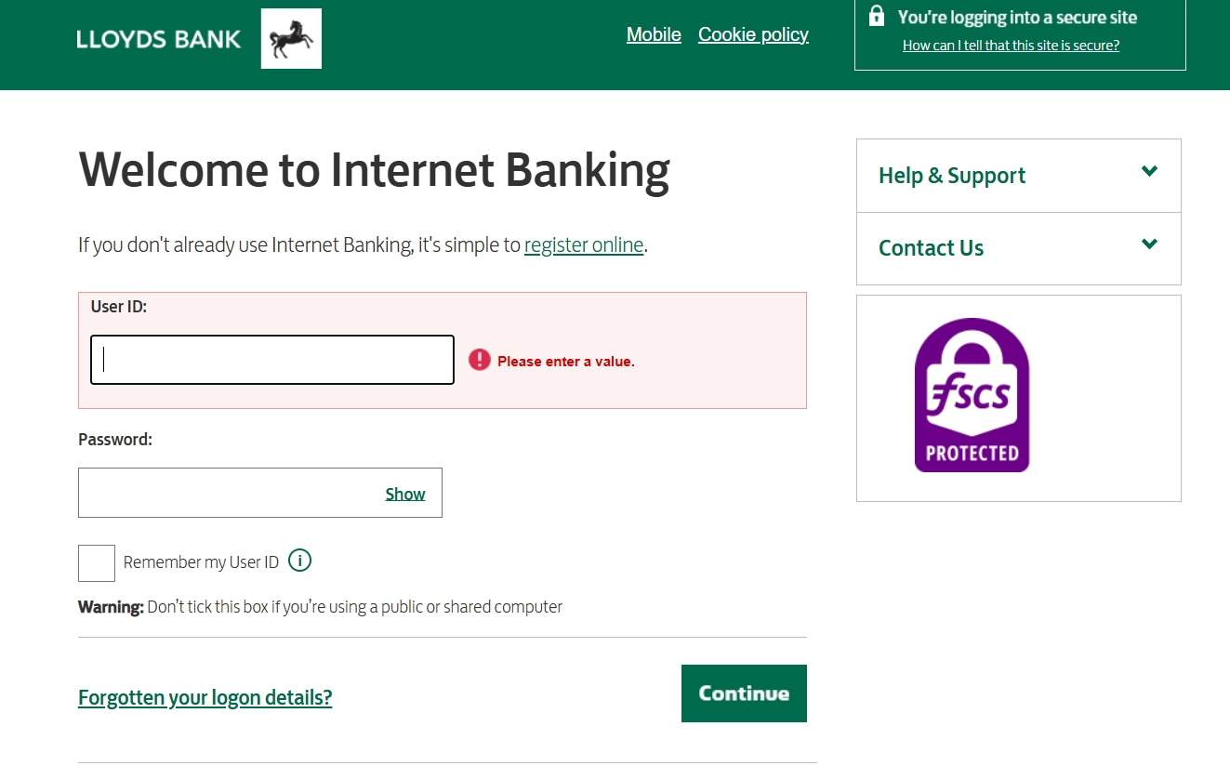
Online banking is very important in my everyday life

I want to improve my digital skills, this class will help do that. I sometimes feel nervous when having to be more “digital”, as my confidence is not where I want it to be.
I can use basic internet or you tube and social media platforms on a basic level, but would like my skills to be improved.
As it can be seen in my digital life thus far its very basic things, I am not confident to use more advance platforms/sites etc, as of yet.

