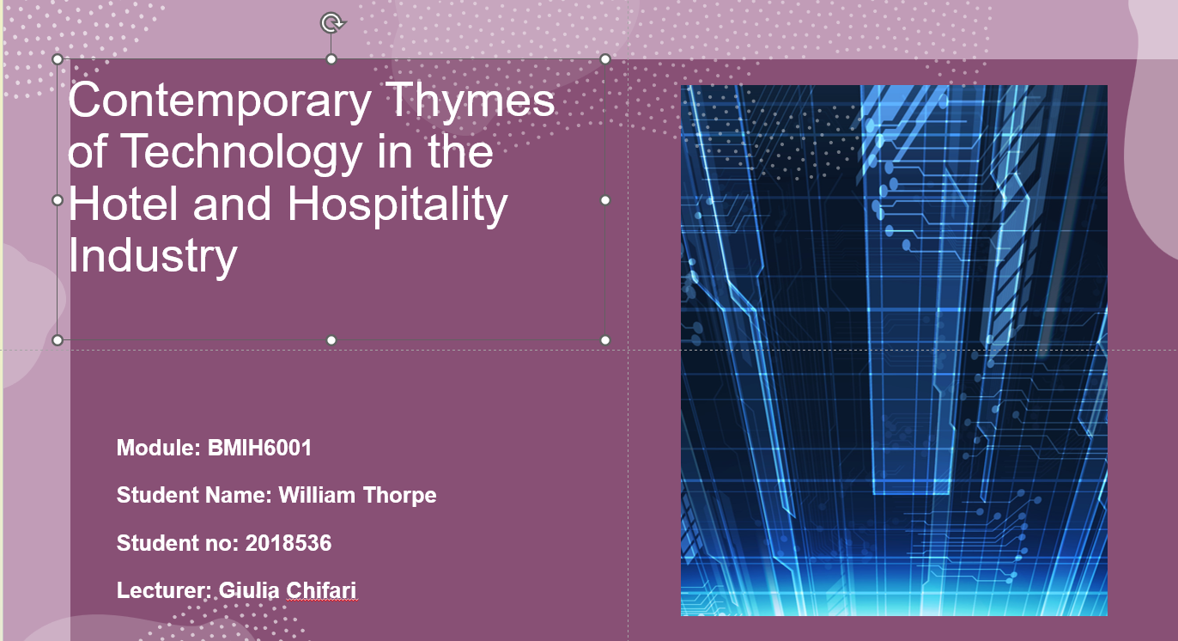

Introduction 

- Technology is important in hotels and the hospitality industry (Arici., Saydam and Koseoglu, 2023) post-pandemic era, providing digital and contactless solutions to curb the spread of the various.
- Technology relevance in the hotel industry (Niessing, 2017) allows hotels to interact with clients at every touch point and throughout the guest journey.
- The changing technological trends in the hotel and hospitality sector (Bowen and Whalen, 2017
- Hotels enhance personalise guests’ experiences through smart in-room technology, the Internet of Things IoT (Shin et al. 2022).
- Hotels allow guests to use mobile technology for a seamless experience; guest interaction is critical (Pillai, 2021).



