

Data Analysis

Student’s name: Ivelina Georgieva Draganova
Student ID: 2235428
Module Class: LCBB5000
Lecturer: Dr. Molly Jack

Contents
Part 1: E-commerce 3
Introduction 3
Order cancellation 3
Q1. Monthly Sales Performance 4
Q2. Most Frequently purchased products 6
Q3. Products per transaction 7
Q4. Profitable segment customers 7
Q5. Recommendations to gain more profits 8
Conclusion 10
Part 2: student scores report 10
Q1. Demographic distribution of students 10
Q2. Number of students who qualify and do not qualify for free lunch 11
Q3. The mean and median of students who qualify and do not qualify for reduced/free lunch 11
Q4. K-means clustering 12
Q5. Advantages of using SPSS over Excel 16
References 17

Part 1: E-commerce

Introduction
Success in modern business has often been linked to their capability to effectively utilize data analytics to boost their operations and performance. According to Alrumiah and Hadwan (2021), data analytics is critical in ensuring all information associated with business is converted into actionable insights by exploring g gaps and relationships. In the process, improvement in operation, decision-making process, and understanding of customer dynamics, especially within the e-commerce domain. This facet of the analysis, therefore, aims to utilise data analytics to provide insights into the performance of an e-commerce business based on its comprehensive sales data.

Order cancellation
Cases of order cancellation in modern e-commerce establishments tend to be common due to a wide range of factors. In the provided dataset, such observations were made as some of the purchases or orders were found to have no customers, while some had negative values. An analysis of the provided variables shows that a total of 766 orders were cancelled during the provided transaction period. An analysis of the orders shows that they had a total value of 555,001.67. Most cancellations were recorded in the United Kingdom, where a total of 624 orders were cancelled; Portugal and Finland, on the other hand, recorded the least number of order cancellations across the two months (n=1).
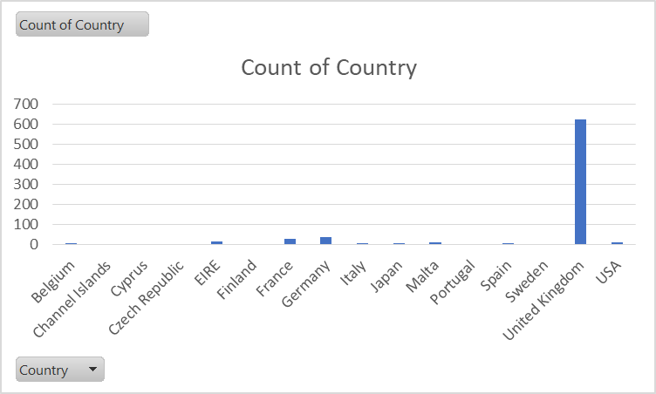
While accounting for the geographical variations of the dataset, it was essential to recognize the presence of monthly changes in the number of cancelled orders. During the month of November, the total value of cancelled orders in November amounted to 34,231.01, with December registering the highest total value of concerned orders at 520,770.66. Such a sudden increase creates the need to change the business model further and reduce the overall number of cancellations.

Q1. Monthly Sales Performance
The general analysis shows that the total sales in November were significantly higher than those recorded in December. Specifically, the total value of sales in November was found to be 2,739,679.19, and 1,994,178.62 was recorded in December.
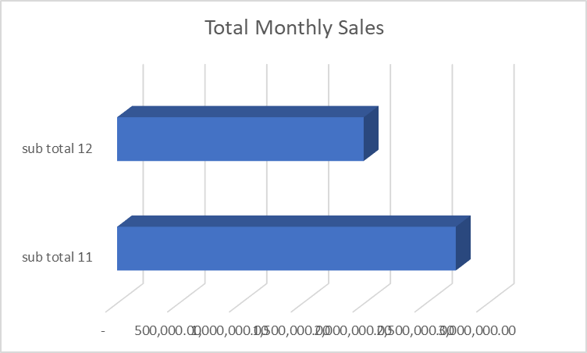
Each of the provided monthly observations was accompanied by dynamic variations with specific transactions. For instance, the highest value of sales was recorded on the 22nd of November, where a total sales of 344,094.58 were recorded. Within the same period, the business recorded relatively low sales on the 27^{th,} with a total value of 71,093.21 in sales being recorded. In December, the highest sales were recorded on the 9^{th,} when a total sales value of 604,502.11 was recorded; similarly, the lowest total sales was recorded on the 4th of the month, where a total of 79,020.71 in sales was recorded. However, the rate of fluctuation during the month of December was significantly higher compared to the month of November. This fact of business performance was predominantly observed between the 7th and 9th of the month— during these periods, the total value of sales declined from 263,611.26 to 215,952.78 before rising rapidly on the 9th to reach 604,502.11.
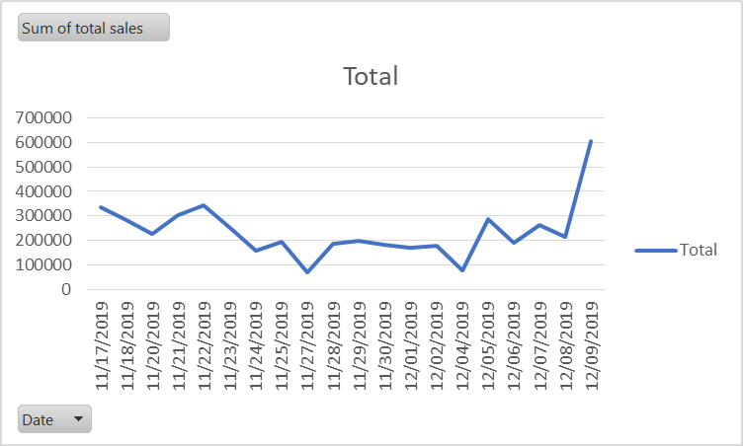

Q2. Most Frequently purchased products
Using a pivot table, it was established that a total of 553,873 products were successfully solved during the transaction period— this accounted for 2,768 items; thus, it was vital to utilise the max formula to establish the product with the highest sum of quantity purchased. Among the selected items, the most sold product was "Asstd Design 3d Paper Stickers"— a total of 12,632 in the quantity of the product was purchased during the stated transaction period.
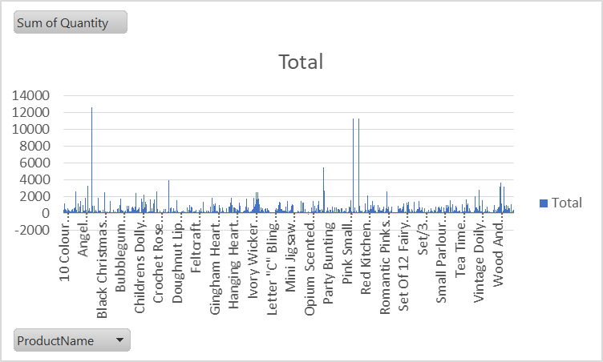

Q3. Products per transaction
During the stated period, a total of 2,419 transactions were made by the e-commerce business, accommodating 1,461 customers. This saw some customers undertake more than two transactions during the entire period. For instance, customer 12067 had one transaction on his/her record, while customer 12358 had a total of two transactions in her e-commerce purchase history. Others, like 17924 and 17949, had three or more transactions. An analysis of the provided transactions saw some transactions had multiple products, while others had a single product to transact. Despite the overall variation, it was estimated that the average product-per-transaction ratio was about 23.098.

Q4. Profitable segment customers
The business segmentation process focused on geographic boundaries instead of other characteristics. An analysis of the variation shows that customers from the United Kingdom are the most profitable as they accounted for more than 4,160,911.51 value in sales. This value accounted for about 87.9% of the total sales value in the business.
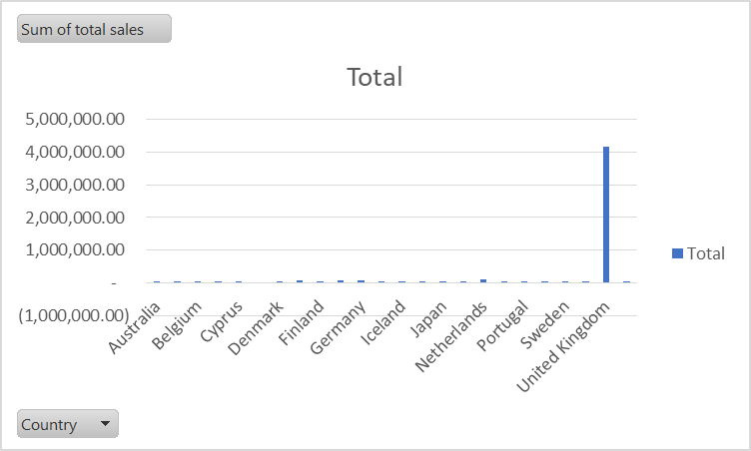

Q5. Recommendations to gain more profits
The findings show that the business has been highly efficient in increasing ls in the months of November and December. Despite the overall efficiency, challenges such as a high rate of cancelled orders and low sales in regions outside the UK are set to create more challenges for the company. In order to reduce these challenges and increase sales, the organisations need to adopt the following strategies:
Evaluate the state of cancelled orders: Cancelled orders, while they may appear random, tend to occur for specific reasons, thereby creating unique observable patterns. For instance, the analysis was characterised by a high number of cancelled orders in the United Kingdom compared to any other region; however, other dynamics associated with each cancelled order were not fully accounted for by the dataset. For this reason, it is recommended that the company analyses every record of a withdrawn purchase and the reason behind the cancellation. Upon the proposed detailed analysis, the company should refine its overall sales strategies and customer experience to reduce further cases of order cancellation.
Provide clear product descriptions: According to Abdulla et al. (2023), more than 90% of shoppers tend to avoid completing a given purchase or cancel existing orders due to incomplete or inaccurate content and/or information. This challenge can be attributed to the low sales outside the United Kingdom and high levels of order cancellation within the United Kingdom. For this reason, it is essential for the company to invest in dynamic content management so that it can provide a clear product description and information about the different products available on its e-commerce platform. In addition, the product disruption should have highlighted features that will not only compel customers to make a purchase but also help them decide on the purchase based on the qualities they want or need.
Utilise high-quality images: Poor quality and poor use of product images have been acknowledged as a key factor in the customer purchase decision-making process. This facet of the purchase experience has been noted in the works of Purnomo (2023), where more than 72% of customers have admitted to relating to product images during the purchase experiences. Data from Abdullah et al. (2023) supports this observation by stating that high-quality images in an e-commerce platform tend to capture the attention of the target audience, thereby turning simple site visitors into actual purchases. This is primarily due to their ability to reduce confusion and ensure accuracy during the shopping experience. Therefore, the organisation should increase the engagement of its target audience by utilising high-resolution images capturing the price from different angles. This approach will result in buyers having a clear idea of the link between their needs and a given product, thereby resulting in reduced cases of order cancellation.
Integration of Virtual Technology for Better Customer Experience: Adopting clear images alone does not guarantee proper engagement, better purchase decisions, or reduced cancellations. This is primarily due to the increased need to ensure the products fully match the customer's needs and reduce the gap between expectations and reality. For this reason, it is essential for the organisation to provide a virtual try-on program that will ensure that customers have a first-hand experience with a given product before making a purchase. Specifically, they will have to focus on what fits the best instead of other non-related issues, thereby reducing the potential for cancelled purchases or cancelled orders.
Fast and response communication: communication is a central factor in any business practice, especially in the e-commerce domain. Statistically, at least 80% of buyers seek immediate responses from brands or businesses they are making a purchase from (Abdullah et al., 2023). For this reason, it is critical for the business to create a response communication system for the customers. This can be achieved by assigning a customer support team that focuses on providing clarification and answering all questions that customers may have. It should be accompanied by a unique knowledge base through which both customers and members of the customer support team can refer to answers to different questions. The integration of Chabot's on websites and online stores has been acknowledged as one of the beneficial aspects of modern communications, especially in reducing the chances of order cancellation.
Lowering the shipping fees: Given the business operation outside the United Kingdom, the lower sales in other regions could be easily linked to high shipping fees. This could also be a key factor in a high number of order cancellations without and outside the boards of the UK. In order to reduce such cancellations, the business needs to consider offering free shipping at certain price points to encourage shoppers to add more time to their shopping carts. This not only curbs the challenge of shipping-related cancellations but also increases overall sales across different regions.
Substitute products instead of refunds: From a reverse logistics perspective, providing a product refund tends to present a greater challenge to the company as it may result in the complete loss of a customer. To avoid such a scenario, the company should issue automated systems with a refund credit instead of providing a full product refund. This approach focuses on ensuring a customer can choose a different time for the store and utilise their entire credit value, thereby reshaping their overall experience. This will help the company retain its revenue and preserve customer loyalty.

Conclusion
As businesses strive to be successful in the modern market environment, the importance of data analytics has also grown. In the provided dataset, it was established that the company had had numerous order cancellations. This challenge has seen the business experience high levels of cancellation and constant fluctuation in sales throughout the year. In order to eliminate such negative impacts, the study recommended the adoption of virtual testing technologies, enhanced customer communication systems, and investment in dynamic content management. At the same time, the analysis has established that regular reviews of the cancelled orders to determine the factors behind such occurrences have been identified as a critical measure in improving sales. Beyond these measures, the study has recognized the need to utilise a dynamic shipping fee model and use exchanges instead of refunds to enhance both sales and customer loyalty within the organisation.

Part 2: student scores report

Q1. Demographic distribution of students
The data shows that the schools have more male students than female students— 50.5% of the students were registered as male (n=1077), while female students accounted for 49.5% of the students (n=1056).
Gender
 |  | Frequency | Percent | Valid Percent | Cumulative Percent
Valid | Female | 1056 | 49.5 | 49.5 | 49.5
Valid | Male | 1077 | 50.5 | 50.5 | 100.0
Valid | Total | 2133 | 100.0 | 100.0

Q2. Number of students who qualify and do not qualify for free lunch
Using frequency distribution analysis, the data revealed that 57% of the students do not qualify for reduced/free lunch (n=1215) while 43% qualified for reduced/free lunch (n=918).
Lunch
 |  | Frequency | Percent | Valid Percent | Cumulative Percent
Valid | Does not qualify | 1215 | 57.0 | 57.0 | 57.0
Valid | Qualifies for reduced/free lunch | 918 | 43.0 | 43.0 | 100.0
Valid | Total | 2133 | 100.0 | 100.0

Q3. The mean and median of students who qualify and do not qualify for reduced/free lunch
The provided datasets on the students qualified for reduced/free lunch were nominal in nature— this implies that they lacked a specified hierarchy in their level of measurement. As a result, there was no output that displayed the mean or median of the students. This facet could only be achieved if the dataset had conformed to the scale/ratio mode of variable measurement.

Q4. K-means clustering
According to Kodinariya and Makwana (2013), k-means clustering is defined as an unsupervised learning model or algorithm that is used for classifying unlabeled data points into unique groups or clusters. Unlike other forms of classification, k-means clustering primarily focuses on numerical data with a key emphasis on the commonalities between the objectives during the classification process. In SPSS, K-mean classification can be achieved by using the classify option on the analyze menu and selecting numerical variables, as shown in the figure below.
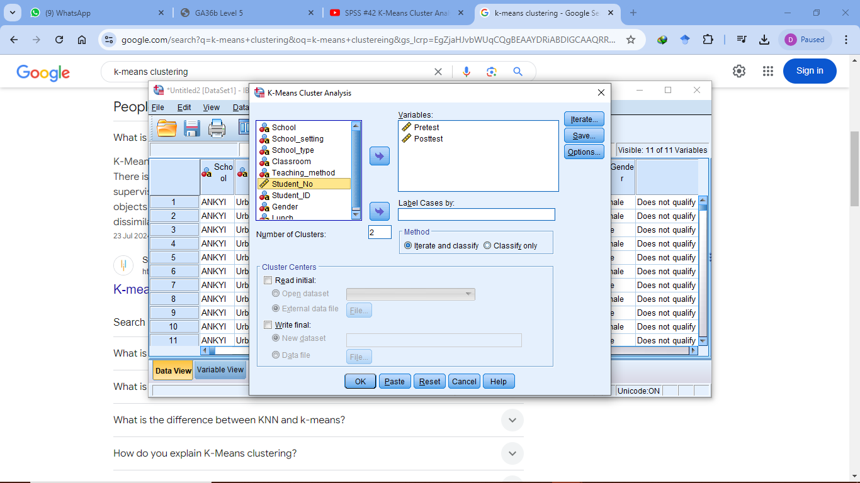
Upon selecting the dataset, one case set the number of clusters and defined the number of iterations— in this case, the number of clusters was limited to 2, with iterations set to 99.
The selected iterations and classification can be saved using the save option on the prompt. This approach will see the process further account for cluster membership and the addition of a distance from the cluster centre option where needed. Under the options button, one should select an ANOVA table for detailed information on the changes in the dataset and the definition of various relationships in the dataset. Ideally, once each option has been defined or selected in SPSS, the logical step is to press the OK to obtain the result; however, when conducting a k-means clustering, one is required to press paste to view the k-means clustering code before fully running it (the resulting code is shown in the figure below).
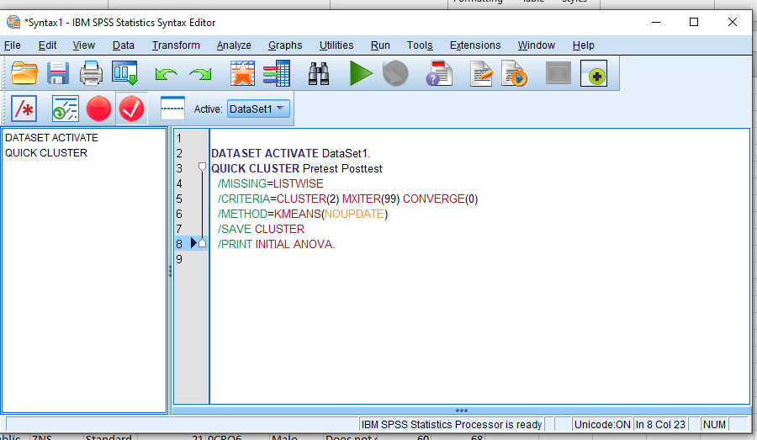
The results show that the initial clusters were relatively diverse, as shown by the presence of pretest and posttest data groups, each with unique cluster centres. Specifically, the cluster centre for the pretest was 23 and 93 in cluster 1 and cluster 2, respectively; where the posttest datasets are concerned, the cluster centres dined at 35 and 100 for clusters 1 and 2, respectively.
Initial Cluster Centers
 | Cluster
 | 1 | 2
Pretest | 23 | 93
Posttest | 35 | 100

Once the initial cluster centres had been defined, it was critical to explore the iteration history— in this case, there were a total of 7 iteration instances, each changing the cluster distance during the analysis. After the first interaction, the change in cluster centres was observed at 30.191 and 33.606 in Cluster 1 and Cluster 2, respectively. After the 7th iteration, the change in cluster centres was registered at 0.000 for both clusters 1 and 2. This implies the presence of convergence in the datasets as a result of small changes in the cluster centres.
Iteration Historyª
Iteration | Change in Cluster Centers
Iteration | 1 | 2
1 | 30.191 | 33.606
2 | .885 | .791
3 | .611 | .532
4 | .212 | .181
5 | .227 | .200
6 | .150 | .128
7 | .000 | .000
a. Convergence achieved due to no or small change in cluster centres. The maximum absolute coordinate change for any centre is .000. The current iteration is 7. The minimum distance between initial centres is 95.525.

Given the dynamic iterations provided during the classification process, the final cluster central was significantly varied from the intimal cluster centres. For the pretest variables, the clusters changed to 43 in cluster 1 and 65 in cluster 2; where the posttest variables were concerned, the clusters shifted from 55 to 78 in cluster 1 and cluster 2, respectively.
Final Cluster Centers
 | Cluster
 | 1 | 2
Pretest | 43 | 65
Posttest | 55 | 78

The ANOVA model revealed that the pretest variable yielded an F-statistic of 4351.122 with a mean squared error of 60.505 and a DF of 2131. This implies that the difference between the observed cases was statistically significant (p= 0.000). In terms of the posttest variables, an F-value of 4631.188 and a mean square error of 61.679 were obtained. With 2131 as the degrees of freedom, the difference between the used cases was found to be statistically significant (p=0.000).
ANOVA
 | Cluster |  | Error |  | F | Sig.
 | Mean Square | df | Mean Square | df | F | Sig.
Pretest | 263262.668 | 1 | 60.505 | 2131 | 4351.122 | .000
Posttest | 285646.166 | 1 | 61.679 | 2131 | 4631.188 | .000
The F tests should be used only for descriptive purposes because the clusters have been chosen to maximise the differences among cases in different clusters. The observed significance levels are not corrected for this and thus cannot be interpreted as tests of the hypothesis that the cluster means are equal.

Given the significance of the differences in the dataset, it is vital to acknowledge that the number of cases in each cluster was significantly variable. In cluster 1 a total of 933 cases were observed, while 1440 cases were observed in cluster 2.
Number of Cases in each Cluster
Cluster | 1 | 993.000
Cluster | 2 | 1140.000
Valid |  | 2133.000
Missing |  | .000

Q5. Advantages of using SPSS over Excel
The use of SPSS proved to be more advantageous than the use of Excel— the most notable advantage was its focus on utilising strict guidelines for data manipulation and the calculation process. Unlike SPSS, Microsoft Excel was focused on managing large datasets based on the specific operations guidelines provided by Microsoft. These differences saw IBM SPSS take the data analysis process to a higher level through its ability to easily visualise the datasets while focusing on the technicalities of various analysis techniques. This feature is not present in Microsoft Excel, where one needs to manage technical calculations first before visualisation (Cleff, 2019).
While accounting for the technicalities involved in the analysis process, the capacity of Excel to handle large datasets was relatively inferior to that of SPSS. This was primarily shown in the speed of operation when handling data with more than 1000 records. This is primarily because SPSS was built to handle voluminous data efficiently, especially for organisations handling large or complex projects that require extensive data processing and analysis (Cleff, 2019).
Despite the observed differences and advantages, it is vital to acknowledge that there are cases where SPSS and Microsoft Excel complement each other in the data analysis process. The complementarity is often seen in cases where the collected data is parsed through Microsoft Excel for the removal of missing values and preliminary classification and coding before it is imported to SPSS for further analysis. This level of complementarity tends to increase the efficiency of the data analysis process; however, it tends to be time-consuming, especially if there is some form of urgency within the organisation (Cleff, 2019).

References
Abdulla, H., Letizia, P., & Souza, G. 2023. Order Cancellation Behavior in Online Retailing: An Empirical Investigation. In Order Cancellation Behavior in Online Retailing: An Empirical Investigation: Abdulla, Huseyn| Letizia, Paolo| uSouza, Gilvan. [Sl]: SSRN.
Alrumiah, S. S., & Hadwan, M. 2021. Implementing big data analytics in e-commerce: Vendor and customer view. Ieee Access, 9, 37281-37286.
Cleff, T., 2019. Applied statistics and multivariate data analysis for business and economics: A modern approach using SPSS, Stata, and Excel. Springer.
Kodinariya, T. M., & Makwana, P. R. 2013. Review on determining the number of Cluster in K-Means Clustering. International Journal, 1(6), 90-95.
Purnomo, Y. J. 2023. Digital marketing strategy to increase sales conversion on e-commerce platforms. Journal of Contemporary Administration and Management (ADMAN), 1(2), 54-62.

