Taking inspiration from Einstein below, in particular that, “we cannot solve our problems with the thinking we used to create them”
What could managers of organisations do and/or not do to help to solve the world’s problems?

Whatever problems the world faced three months ago are now dwarfed by the covid-19 pandemic. The past three months has seen tragedy across the world, and the entire global population has had to face changes that were until recently unimaginable. In the midst of this momentous change managers have had to adapt quickly and effectively. They have a unique opportunity to solve our problems with innovative forward thinking and planning. We face many problems – medical, financial, political, educational and social. Many are insurmountable but the pandemic is providing a watershed moment where old goals, standards, routines and outlooks could be completely overhauled. There has been an outpouring of support of the NHS; communities have come together to support each other, formally and informally. If managers could harness these movements in their plans to rebuild their organisations and the economy, discarding the thinking used to create previous problems then we have far better prospects for the next future.

It is important to identify some of the world’s problems regarding a sustainable planet. Sustainability goes further than carbon emissions and climate change (although this is still important) it is about creating a sustainable planet for all people, regardless of gender, race, religion and so forth, all animals, seas, land and so forth. To create an equal world, which would eliminate some of the world’s problems, drastic changes need to happen. Many of these changes can stem from the world’s leading organisations.

The Paris Agreement aims to eradicate many of the world’s problems, including zero poverty, zero hunger, reduced inequality, climate action and so forth. These are some of the most pressing issues in the world. Nearly all countries in the world are on board, with dedicated targets in place. This is an important step to keep all countries accountable for their actions.

“The biggest danger is not inaction. The real danger is when politicians and CEOs are making it look like the real action is happening, when in fact almost nothing is being done.” Said Greta Thunberg of the world’s problems. Managers will need to push for change within their organisations to tackle the climate and societal issues. It is not merely enough to ‘tick box’ these issues. They must be faced assertively to instil change.

Moral managers
“Managers have responsibility for enabling an organisation to achieve its objectives. They are therefore responsible for planning, organising, and controlling organisational activities.” It has been established that the ethical culture of an organisation lies highly upon managers. Effective moral managers realise their employee’s look upon them for guidance to what is important through their actions. To help solve the world’s problems, managers should set good examples for staff to aspire to. A survey suggested that half of employees believed the top of the organisation are the moral conscious of the business. Employees look up to the highest levels to gauge what are acceptable actions (Carroll et al, 2015). During this pandemic, the public’s outcry to Dominic Cummings breaking lockdown rules demonstrates how the nation expected better of the people leading the country.

Values driven over target driven
Targets are an approach often used by managers and organisations to encourage employees to work to a certain level of capacity. Ensuring employees are hitting a basic standard that is decided by senior management. Often, employees are judged on hitting their performance targets, although there are other influences. For example, staff that engage positively with other members of the organisation and have a positive impact should be looked upon just as favourably.

Targets are in nearly all cases driven by profit. Managers of organisations should move the goal posts; profit is an important factor to sustain a business. However this is not the only important factor. Targets could be considered for how green/sustainable employees are.

Self-sufficient communities
"The time—which, looking back, seems so idyllic—is gone forever when individuals or relatively small groups could be completely self-sufficient," Einstein. Managers of organisations could contribute to communities to enable them to become more self sufficient, therefore less reliant on others and money to live. For example, Swansea University are working with a local cafe and councillors on a new campaign called ‘grow your own’ that aims to help the local community grow their own fruit and veg, providing they have any small space to do so. These can then be bought by the local café involved to provide money back into the community, whilst also providing fresh and local food. This isn’t exactly as self sufficient communities lived years ago, however in the modern world this is a step forward.

Ethical supply chain
Whilst there is a growing concern among businesses regarding the sustainability of their supply chain, often this is masked by cost (Rogers et all, 2013). Managers of organisations must follow the chain of products they purchase. Whereas spend is often looked upon as a cost saving exercise, this should be researched thoroughly, to see whom this is supporting or degrading. There is a corporate social responsibility to ensure the businesses supply chain is ethical if managers want to help solve the world’s problems. The world must become better connected at sharing and fairly paying for one another’s work. One country benefitting, at the top of the hierarchy, does not solve the world’s problems – just one countries problems.

Energy efficiency
In a time where many are working from home due to a worldwide pandemic, energy consumption has reduced within organisations, in turn leading to cost saving. Whilst many organisations have noted productivity has remained the same whilst employees work alone from home, few have implemented new ideals – where staff can choose to either work from home or come into the office. For many individuals, this can become a wellbeing incentive as well as cost and time saving. On the other hand, domestic energy has increased. Managers of organisations should aim to find the most energy efficient solution – this could be different among different companies, depending on size, location and so forth.

Become carbon neutral
According to the United Nations Foundation, we have around a decade to drastically reduce carbon emissions to ‘avoid catastrophe’. Managers of organisations need to take this into consideration when creating business plans. For managers of organisations to help solve the world’s problems, focus should be on reducing carbon emissions or becoming a carbon neutral business. This was not often the priority long ago, however, this is now important due to the global warming. In addition to this, a company’s reputation is at risk should they ignore their carbon footprint due to the public’s growing concerns about climate change. In this day of social networking, a bad image can spread around the world in the space of an hour. Becoming carbon neutral will also mitigate future risks, where carbon consumption taxes could be put into place.

For example, ‘construction declares’ is a worldwide petition connecting construction and the built environment. Since May 2019 over 900 architectural practices in the UK have made a declaration of climate emergency and committed to positive change in this area. Wilmot and Dixon, a global architectural company, have committed to become carbon neutral by offsetting their emissions. The same company also fund community projects in poorer areas by building for free as a form of support to the local area.

Poverty reduction
The issue of poverty has been mostly ignored in within the corporate world until recently, from both a theoretical view and also practically (Jain, Vachani, 2006). Managers of organisations have further responsibility than just business operations alone if they are to help solve the world’s problems. Many have built in strategies, in varying detail. Take HSBC for example: “Supporting microfinance is one of the ways in which financial institutions can support the UN Millennium Development Goal of eradicating extreme poverty.” However well intentioned, this statement is too vague to be of real value. For managers of organisations to become part of the solution to the world’s problems, guidelines must be clear, and rules must be in place and adhered too within the organisational plan. Detailed research is necessary to move the world forward in the right direction. Organisations must not only state what they want to help, but how they will do this and a timeline of actions to support this.

“Businesses can help alleviate poverty with programs and projects that aim to improve the living conditions in underdeveloped communities” Carchman, 2017. This is important on a global scale. The world will not be free of problems when there is inequality. Privilege exists mostly due to luck as to where you are born, the colour of your skin, your family’s income. The playing field is not level from the start, and an issue that managers of organisations need to consider when aiming to solve the worlds problems.

Progressive and ethical leadership
Progressive and ethical leadership is a proactive action, opposed to reactive. This type of leadership is important for creating an equal world. Managers that lead with environment and society in mind are often referred to as PPP – people, planet, profit. Stakeholders are treated as favourably as shareholders (Werft, 2015). Organisations rely on managers to make moral, progressive decisions to lead the company forward. Most strategies for improving an organisation’s ethical standard must originate by the highest management and other management levels below this (Carroll et all, 2015).

“With big data and technologies, the time for companies and governments underplaying deforestation, wildlife trade, poaching or illegal fishing is over. Artificial intelligence can now be used to help boost protection and resilience of natural systems instead.” Marco Lambertini, Director-General of WWF International. Progressive and ethical leadership is a necessity for managers who wish to help solve the world’s problems. With new technologies and the internet this is more possible than ever before, as information is quick and research is available to make informed decisions.

Support individual’s actions
Supporting individual’s actions within an organisation is important, it instils trust into staff. Swansea University allow staff 2 paid days off per year to volunteer. Employer supported volunteering only exists in 37% of UK organisations according to research collected by the organisation Perkbox. The research also showed that only 11% of UK employees failed to identify a cause they would support, with the majority stating they would opt to help healthcare charities (43%), followed closely behind by giving back to the local community (33%) and environmental causes (31%). The co founder of Perkbox, said: “It’s clear that workplaces need to be doing more to allow employees to take time and contribute to charities. With already limited personal time, without being given volunteering days, those in full-time positions must fit volunteering into their evenings and weekends, causing them to juggle commitments. This often means that volunteering can fall to the back burner, affecting both social consciousness and society itself.”

Progress, as well as profit
Where primary focus for many organisations used to be for profit, rather that societal value, many have played a part in the world issues. This thinking will only contribute to further damage of the planet.

Profit is important to sustain jobs and livelihood, but equally so is progression, these must work in unison. To help solve the world’s problems, the corporate world needs to become less concerned solely with profit. Einstein once said, "Production is carried on for profit, not for use". Keep Cup for example, which produce reusable coffee cups, believe “collective individual action is a powerful catalyst for change”. Their aim is to reduce the number of one-use cups in the world. Their goals are sustainability, specifically reducing single use cups, on a global scale. Profit is a latter – although necessary for businesses to be viable. They pursue the profit to finance their goals to reduce single use cups in turn having a positive impact on the world.

It is important for managers to lead in a way that is focused on society and environment as well maintaining profitable performance. Taking Patagonia for example, which state they “are in business to save the planet” the company have proven time and time again environmentalism is at the front of their business. The company is transparent and clear with its goals. Patagonia also connects individuals to Patagonia grantees, which act on some of the world’s most pressing issues. This is done by connecting individuals to environmental projects close to their neighbourhood – linking likeminded individuals and encouraging change within communities. Environmentalism and sustainability are embedded into the company, without these, Patagonia would not exist - profit is secondary.

Equal pay across the board
Managers of organisations should ensure pay to employees in head offices are paid correctly as well as the supply chain products may come from. Many large organisations outsource products and/or jobs to countries where the cost is lower than that of the UK (or any westernised society). It is important for companies to pay fairly across the board, regardless of where the job or product may be from.

Wage ratio, which is reflects how much the CEO of a company earns in comparison to the lowest wage at the business, is implemented in some companies, notably the BBC. This is intentional at to reduce the pay gap within organisations. In 2019 a study found by the CIPD, the average salary for chief executives was 117 times that of an average worker. It is important to work for the good of whole economy, rather than the enrichment of the few at the very top. Globally this is important, other countries must be considered to create a fair and equal world.

Encourage research and education
Following on from the Black Lives Matter movement, many organisations in the US have recently given employees time off to learn about black history, white privilege and anti-racism. Research and education can open people’s minds to steps they can make themselves as individuals. Research and education are also an important part of progressing organisations into new and different goals and standards.

Sustainability teams or guides need to be created and followed. Monitoring employee wellbeing, poverty reduction, green goals, reducing carbon emissions whilst maintaining a profitable business. Encouraging staff to become involved and follow sustainable guidelines will be necessity for organisations that wish to have a positive impact on the world. Education in this area to ensure guidelines are abided by will help the cause. Managers will need to adopt a pro-active approach to ensure this is followed through. Swansea University employee a on site sustainability team, which overseas all departments work in this area. There are also staff within this team which educate the other departments on the goals of the organisation and how each employee can contribute.

Employee forums
Managers of organisations should encourage employee forums that would allow open conversations that permit staff of the organisation to bring forward new ideas that managers might not have considered. Many organisations already adopt this approach to seek ideas to improve the business. This collective approach could benefit output for the firms and the wider community. It is more impactful to work collectively towards a goal, and learning strengths and weaknesses within the organisation.

Staff and societies wellbeing
Research has been shown that well-being programs in the workplace have positive effects on employees’ health behaviours. In turn this leads to lower health risks, and lower health risks lead to less chronic disease, equating to less care costs (Liebert, 2012). For managers of organisations who wish to contribute to the world’s problems, health and well-being programs in the workplace would become essential.

The study below took place over 2 years, evaluating wellness programs in the workplace by looking at health behaviours. Substantial improvements were documented, in particular the frequency and volume of exercise and the consumption of healthier foods, i.e. fruits and vegetables.
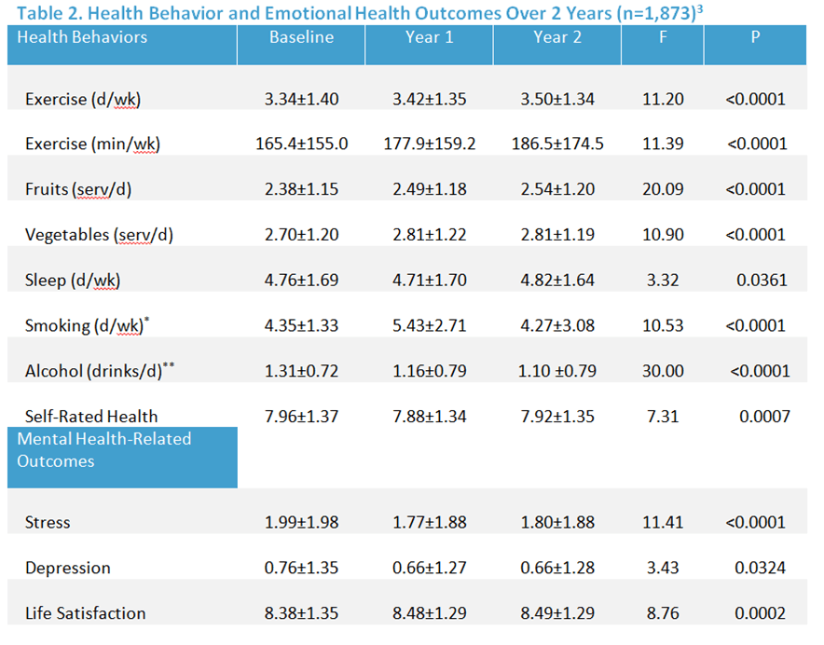
Figure 1: Source: Population Health Management Article

In 2019, New Zealand became the first country in the world to release a wellbeing budget, which tackle issues such as mental illness, child poverty, family violence and many more of the world’s issues. Wellbeing is looked upon as a priority, which is an important step in fighting the world’s issues. If a government can do this on such a wide scale, managers of organisations could adopt the same principles. This could lead to a trickledown effect – creating happier, healthier families in turn creating more positive and engaging communities.

In the 1970s, the fourth king of Bhutan coined the term “gross national happiness” - he is quoted: “Gross National Happiness is more important than Gross Domestic Product.” It puts environmental and sustainability issues at the centre of its objectives. The country sets ambitious targets regarding climate change and sustainability - a leading example for managers of organisations that wish to contribute to solving the world’s problems.

Opportunities
Managers should provide opportunities to current staff for training and furthering education, and to provide employment to a range of people – regardless of race, gender, and religion. The workplace must be accessible and non-discriminatory. During this pandemic, many employees have been required to work from home due to lockdown rules. This has created opportunities for disabled people who have taken on roles they were previously not deemed suitable for due to mobility issues. When forced to do so during this crisis, managers relatively quickly put into place the structure to work from home. There has been massive progress in the structures to enable to people to work from home, which we are unlikely to revoke.

To create equal opportunities, managers from organisations could offer scholarships/apprenticeships free of charge. For example, universities could offer free degrees to children of poorer families in the local area. This comes at no cost to the university.

Build societal value
Social Value aims to benefit to a community and the wider world, including but not limited to, ‘happiness, well-being, inclusion, equality, employment and environment.’ For example, Swansea University has a somewhat negative impact in some respects due to some (although rare) student issues within the local community. Swansea University have a committed community liaison team who aim to bridge the relationship with students and community, which is done through free events for local people and supporting local events. The community team also provide a grant to members of the local community intended to help finance local ideas or events in the area.

Incorporate sustainability into everyday operations
Sustainability as normal day operations must become to norm for managers to help solve the world’s problems. A sustainable plan would need to be implemented, either externally or by an in-house sustainability team. Clear values will need to be created for employees to understand the business objectives. Many businesses embed sustainability into their business for reputational reasons; however, to solve the world’s problems it must go further than this, and the need for integrated sustainability is imperative (Mosher and Smith 2015).

Currently the world is facing a pandemic of two sorts, one medical, and one financial. All whilst protests take place on a global scale - a fight for human rights, which has become one of the largest civil rights movements in history. Both are the main stories of 2020, and are highlighting the world’s problems, they have been heavily reported by the press, whilst also affecting people daily in varying ways on a global scale.

Organisations that contribute to solutions to economic, social, and environmental challenges will help them grow their companies' value, while also building a better world for all (Korngold, 2013). There has been a shift of recent times due to the Paris Agreement 2015 and laws being implemented following this.

If all the issues discussed were taken into account by managers planning an uncertain, even frightening, future, there would be a chance to emerge from these times with new priorities that benefit the majority of the whole world’s population.

“[Organisations] must look past their own goals to identify the needs of society as a whole, as those with employees who want to help have a real chance to make a change.” Chieu Cao, founder of Perkbox – a company designed to enrich the life of employees and their experiences within an organisation.

Reference List

Brown, K., 2020. 5 Global Issues To Watch In 2020 | Unfoundation.Org. [online] unfoundation.org. Available at: <https://unfoundation.org/blog/post/5-global-issues-to-watch-in-2020/> [Accessed 4 June 2020].

Carroll, A., Brown, J. and Buchholtz, A., 2017. Business & Society.

Korngold, A., 2014. Business Can Do What Governments Can't: Solve The World's Biggest Problems. [online] the Guardian. Available at: <https://www.theguardian.com/sustainable-business/business-government-world-problems-davos-multinational> [Accessed 5 June 2020].

Lambertini, M., 2020. Sustainable Development Is Only Possible On A Healthy And Sustainable Planet. [online] ITU News. Available at: <https://news.itu.int/sustainable-development-sustainable-planet/> [Accessed 5 June 2020].

LeCheminant, J. and Merill, R., 2012. [online] Wellsteps.com. Available at: <https://www.wellsteps.com/images/stories/manuscripts/WC_two_year_results.pdf> [Accessed 6 June 2020].

Mosher, M. and Smith, L., 2015. [online] Sustainability.com. Available at: <https://sustainability.com/wp-content/uploads/2016/07/sustainability_incorporated.pdf> [Accessed 9 June 2020].

Reynolds, R., 2015. Sustainable Leadership. [online] Files.ctctcdn.com. Available at: <http://files.ctctcdn.com/53dc5b5b001/c590532f-6b38-483e-a4f6-98e234c1f40d.pdf> [Accessed 6 June 2020].

O. C. Ferrell, Mary Margaret Rogers, Linda Ferrell & Jennifer Sawayda (2013) A Framework for Understanding Ethical Supply Chain Decision Making, Journal of Marketing Channels, 20:3-4,260-287

Scott, K., 2019. Three-Fifths Of UK Employees Do Not Receive Time Off To Volunteer. [online] Employee Benefits. Available at: <https://employeebenefits.co.uk/three-fifths-employees-volunteer/> [Accessed 7 June 2020].

Tulder, R., 2008. The Role Of Business In Poverty Reduction. [online] Unrisd.org. Available at: <http://www.unrisd.org/80256B3C005BCCF9/%28httpAuxPages%29/340A393D6E02EE97C12575E0002A6C62/$file/WEBvanTulII.pdf> [Accessed 7 June 2020].

Werft, M., 2015. 10 Reasons The World Needs More Sustainable Leadership. [online] Global Citizen. Available at: <https://www.globalcitizen.org/en/content/0-reasons-the-world-needs-sustainable-leadership/> [Accessed 8 June 2020].

