

Methods and Search Strategy Academic Poster

Programme: BSc (Hons) Health and Social Care
Module: Independent Project
Module Code: BMHP6020
My Project title: Evaluating the factors contributing to the rise in Type 2 Diabetes Prevalence in England

Student name: Mohammad Shakil Ahmad
Student ID: 2233030

Evaluating the Factors Contributing to the Rise in Type 2 Diabetes Prevalence in England
01 Introduction and Research Aim  In this study, the methodology discusses the method of obtaining secondary data, its analysis, as well as its validation to determine the magnitude of factors that led to the increasing prevalence of type 2 diabetes in England. It concentrates on some of the decisive factors like obesity, lifestyle behaviours, ethnicity, healthcare access, and social determinants of health. They are intended to evaluate critically these contributing factors and also the importance of the operations of the public health policies to provide evidence on the prevention and management strategies. | 02 Search Strategy  A search strategy for secondary research is an organised and systematic approach to finding relevant literature and facts by using reliable sources (Cooper et al., 2018). The plan will help to identify the proper, up-to-date, and reliable materials. In the present study, the query process was carried out on scholarly databases and government health repositories involving keywords and Boolean logic (e.g., AND, OR). Keywords used were Type 2 diabetes prevalence in England, diabetes and socioeconomic status UK, lifestyle risk factors of diabetes, and ethnic disparities in diabetes prevalence. The databases applied comprised Google Scholar, PubMed, NHS Digital, Public Health England (PHE), and Diabetes UK.
03 Searching for Information  To determine the scope of the problem, a wide intellectual search was performed based on the literature. The next set of procedures was used:  - Keyword selection based on initial reading and project objectives.  - Use of filters to include only studies published between 2014 and 2024, in English, and specific to England.  - Prioritisation of peer-reviewed journal articles, government reports, and official statistics.  - Critical review of abstracts and introductions to assess the relevance of each source.  - Grouping data into thematic categories: obesity and diet, physical inactivity, ethnicity, deprivation, and public policy response.  This process helped ensure that the selected literature was both current and directly applicable to the research question. | 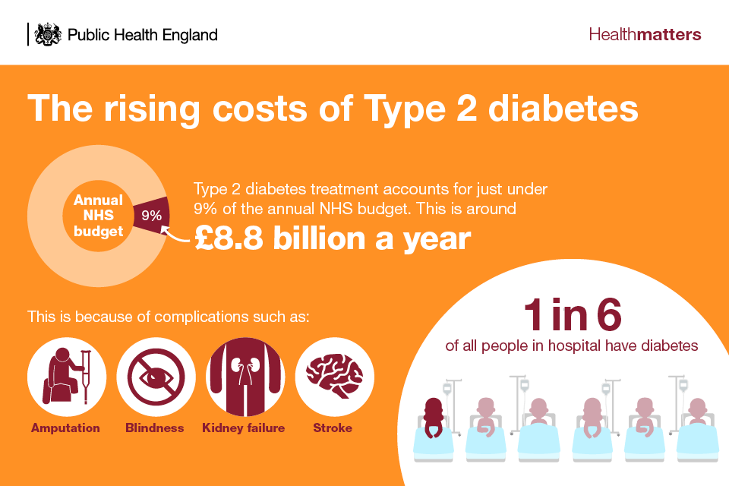  04 Picture / Graph / Visual Aid / Statistics  The prevalence of type 2 diabetes in England has increased by more than 50% over the past decade. According to Diabetes UK (2023), people living in the most deprived areas are twice as likely to develop the condition compared to those in the least deprived areas. Additionally, South Asian and Black African-Caribbean populations show disproportionately high rates.  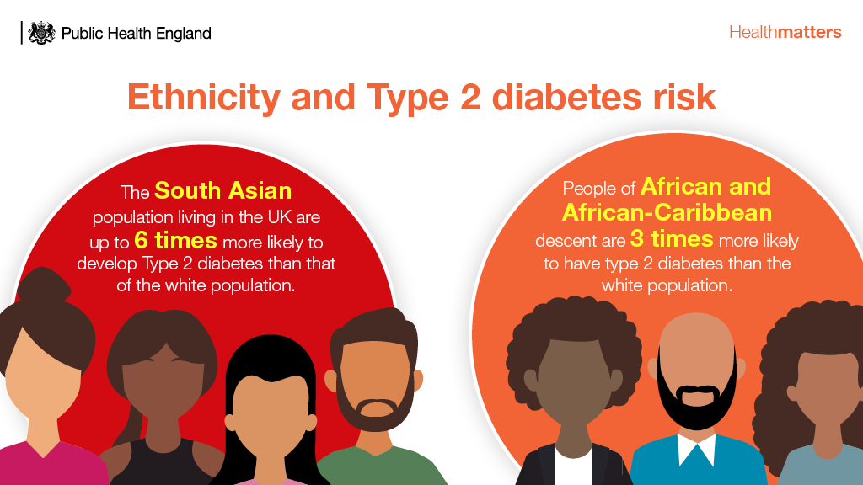
05 Research Validation and Analysis
Validation in secondary research refers to the process of ensuring the credibility and trustworthiness of sourcesInvalid source specified.. Only reliable and authoritative materials (e.g., NHS, Diabetes UK, academic journals) were used.
Thematic analysis was employed to identify recurring patterns and core themes across literature. These include:
- Lifestyle-related risk factors (e.g., diet, obesity, inactivity)
- Ethnicity and genetic predisposition
- Health inequalities and socioeconomic deprivation
- Gaps in healthcare access and health education
- Evaluation of national campaigns such as the NHS Diabetes Prevention Programme
This analysis will form the basis of Chapter 4 in the dissertation.
06 Inclusion Criteria  - Studies from 2015 to 2025  - UK/England-focused research  - Full-text availability online  - Focus on type 2 diabetes and contributing factors  - Peer-reviewed journals, government, or NGO reports | 07 Exclusion Criteria  - Non-English language studies  - Research conducted outside the UK  - Studies focused solely on type 1 diabetes  - Blogs, editorials, or non-peer-reviewed sources  - Outdated publications (pre-2015)
08 Ethical Considerations
Ethics in secondary research centres around proper data handling, citation, and academic honestyInvalid source specified.. All sources were cited using Harvard referencing. No personal or confidential data was used. All information was taken from public and academic domains, complying with GDPR and university ethical guidelines.

References
Ahmed, S., 2024. The pillars of trustworthiness in qualitative research. Journal of Medicine, Surgery, and Public Health, Volume 2, p. 100051.
Cooper, C. et al., 2018. Defining the process of literature searching in systematic reviews: a literature review of guidance and supporting studies. BMC medical research methodology, Volume 18, pp. 1-14.
Gov.UK, 2022. Health matters: preventing Type 2 Diabetes. [Online]
Available at: https://www.gov.uk/government/publications/health-matters-preventing-type-2-diabetes/health-matters-preventing-type-2-diabetes
[Accessed 25 June 2025].
Stewart Jr, C., 2023. Research ethics for scientists: A companion for students.. s.l.:John Wiley & Sons.

