
University of Wales: Trinity Saint David Prifysgol Cymru: Y Drindod Dewi Sant

School of Business: Ysgol Busnes
Module Leader: Glenn Behenna
Student Name: | Emma Green
Student Number: | 1708678
Module No: | BMMB7013D
Module Title: | Strategic Management
Statement of Confirmation of Authenticity
By the act of making this submission, the student declares that this is the work of the student named above. The work has not, in whole or in part, been knowingly presented elsewhere for assessment, or where an assessment has been built on a previous assessment, this has been identified. Where materials have been used from other sources it has been properly acknowledged. If this statement is untrue, the student acknowledges that an assessment offense has been committed.
Attention is drawn to the plagiarism and unfair practice policies of both the University and of ILM.
Permission for ILM to use this script
ILM uses learners’ submissions – on an anonymous basis – for assessment standardisation. By submitting, both the center and the learner agree that ILM may use this script on condition that identifying information is removed. However, if you are unwilling to allow ILM use this script, please refuse by ticking the box: □

Table of Contents
Executive summary 2
Introduction 2
What is Strategy? 3
Chosen organisation’s Internal and External Environment 4
PESTEL Analysis 4
SWOT Analysis 9
TOWS Analysis 13
Stakeholder Analysis 14
Strategic Management 16
Porters Five Forces 19
Kaplan and Norton Balanced Scorecard 20
Current strategic Direction 21
New Strategy Proposal 23
Conclusion 27
Bibliography 28
Appendix A – PESTEL 31
Appendix B – SWOT 32
Appendix C – TOWS 34
Appendix D - Stakeholders Questionnaire 35
Appendix E - Stakeholders 37
Appendix F – Stakeholder Analysis 38
Appendix G – Porters Five Forces 39
Appendix H – Kaplan and Norton Balanced Scorecard 40
Appendix I- Mintzberg 41
Appendix J – McKinsey Model 42
Appendix K - Ansoff’s Matrix 43
Appendix L – Risk Assessment 44
Appendix M – Communication and Marketing Plan 45

Executive summary

Backdrop from the pandemic has caused many issues in an overworked Emergency Department. This report focuses on reshaping the Emergency Departments strategic direction using theoretical frameworks and techniques to analyse the micro and macro environments. Various tools were used to scrutinise the current strategic direction. Based on these results a new proposed strategy was suggested to reduce patients waiting times on ambulances, allowing ambulances to be released back into the community in the form of an ambulance Pod.

Introduction
This report will focus on the Accident and Emergency Department (ED) within a National Health Service (NHS) setting. Emphasis will be on the patient waiting times, in particular offloading of ambulance patients. Furthermore it will analyse the department’s current strategy through an evaluation of the micro and macro environment. The stakeholders will be explored, all those associated with the ED and how they can determine any changes, in particular within a modern environment and how ED can overcome any competition. Conclusively, a new strategy will be proposed to exert and enhance the growth of the department.
Firstly, a brief summary of the ED department and where it convenes within the business.
Hywel Dda Health Board is part of NHS wales and provides healthcare services for those living across three counties, with 11,500 employees to provide a service to approximately 385,000 people. The Emergency Department consists of 3 resus Beds, 2 triage rooms, 4 treatment rooms, 1 ambulance offload room, 10 major’s rooms. There is a total space for 20 patients to either be on a bed or a trolley. There are currently two surge rooms with 8 chairs if needed.
Identifying the critical success factor of an organisation drives everything in strategy, therefore the emergency department’s success factor would be patients being seen in a timely manner, patients offloaded off ambulances as soon as they arrive, patients wanting peace of mind. A recent questionnaire was given to 54 patients who arrived by ambulance to the emergency department over a 4 week period.

What is Strategy?
Whittington et al (2020) defined strategy as “the long term direction of an organisation”. For example Amazon’s direction is from book retailing to internet services, Disney’s long term direction was from cartoons to entertainment.
Leading strategic theorists demonstrate valuable elements of strategy. Alfred Chandler draws attention to the flow from “goals and objectives” to managing assets that support strategic plans. Porter focuses on choosing various activities to provide a mix of value. Contrariwise, Drucker affirms that strategy is how organisations gain a competitive advantage. Whereas Mintzberg’s view is that it’s a pattern that does not always follow a plan.

Chosen organisation’s Internal and External Environment
Answering a series of “hows” is how Thomson et el (2007) describes creating a strategy. Therefore organisations must address how their business can enhance growth and achieve their financial goals, identify their competitors, how to adapt to rapid changes in conditions, keeping stakeholders satisfied and how to strategically manage the potentiality of the organisation. (Thompson et al, 2007)
Baumol and Blackman (1991) propose that organisations must recognise new opportunities and develop new procedures to accomplish various approaches. For Organisations to achieve this they must be aware of their internal and external environments, using both PESTEL and SWOT analysis.

PESTEL Analysis

Appendix A identifies a PESTEL analysis that was undertaken. This analysis speculates what the future holds depending on the current situation. (Stoyanova and Harizanova, 2017) PESTEL is theoretically associated with strategic planning when identifying macro environment factors encompassing an organisation. Clegg et al (2020) affirms, these factors are uncontrollable but need to be “considered both as sources of competitive advantage and as a potential source of erosion of competitive advantage.” Whittington et al (2020) concurs that the environmental factors provide opportunities and threats. An example being, Facebook, they lost 20 per cent share price in 2018 when it was disclosed that the Russians interfered with in the Presidential elections in America.
A proposed new strategy of a seasonal marquee with 6 beds outside ED for ambulance offload patients is to be considered.

Political
The Covid-19 pandemic forced the health board in particular the ED department to make changes according to the Welsh Government. The departments current strategy could not have prepared or factored in
this crucial disruption. The UK leaving the EU will have an effect of society, many uncertainties around sourcing medication and equipment that is sourced from EU Countries. One example as reported by Dayam (2021) is the shortages of blood bottles, these are used to stop the coagulation of the blood before testing, this extreme measure caused the NHS to suspend training and scarcely use them in much needed areas wisely. This not only affected the UK NHS but also the USA who also issued recommendations on how to deal with this issue. However the UK suggests a more serious severe situation. In particular the shortage of heavy goods vehicle drivers. The company who provide the blood bottles believe the problem to be “UK border challenges”. This suggests they believe a direct effect from the extra checks and requirements being imposed from the UK leaving the EU. (Dayam, 2021)
This same issue applies to the medical professions as many originate from EU countries, this major disruption will have a detrimental impact on the health service. However the British Medical Association requested that the UK government establish a more flexible migration system for health are social care staff. (Van Schallcwyk, 2020)
Economical
The financial crisis in 2008 impacted the NHS due to economic and regulatory factors, both of which bring difficulties to the care that needs to be provided. Low NHS salaries impact the lack of highly qualified staff, thus resulting in Nurses taking action through strikes. Mahase (2022) reports the campaign is for a pay increase of 17.6%, however the government states that the cost would be at least £8bn to cover this increase. Evidence sourced from BBC (2019) suggested that a strategy was implemented to target overseas nurses to relieve pressures and shortages. Figure 1.0 identifies the foreign NHS workers from the EU, this has both positive and negative impacts on the NHS, as the population increases. The economy is growing and life expectancy is increasing, this will have an impact on the health service.

Fig 1.0
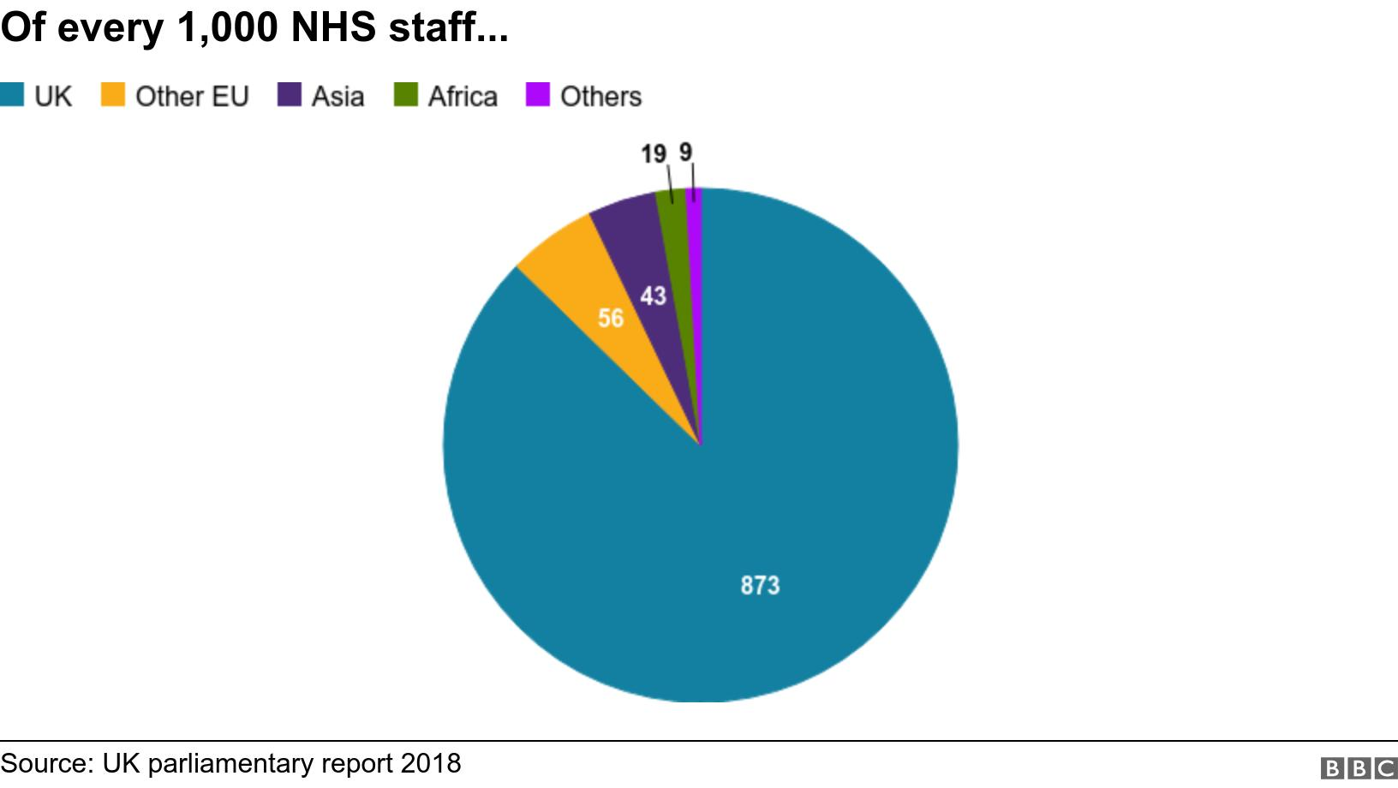
Source: www.bbc.co.uk (2019)

Social
Kotler (1997) reported that the social cultural environment is what shapes, values, beliefs and the norms. NHS wales identify a core principle in valuing all who work in the NHS. The wellbeing of the workforce is paramount to delivering effective patient care, therefore the trust strives to encourage work satisfaction. There are many wellbeing options available to employees.
A common worldwide phenomenon is he aging population, with the aid of health service improvements, although the older generation tend to have more medical needs, for example diabetes and cancer which develop mainly in later stages of life, thus increasing the costs. Social media allows information to be spread quicker, allowing patients to gain more knowledge of the treatment options.
Technological
Over the years the health board has innovated in particular within the technological environment. The pandemic assisted with the speed of implementation in many technological advances. Information technologies head of department Paul Solloway reported in 2020 that over his long serving career the health board has gone from 404 Computers and 3 servers to 8,624 computers and 649 servers throughout the healthbaord.(NHS Wales, 2020) Furthermore, the pandemic initiated the emergent of office 365, hybrid working became the norm. A, it can be proposed that those with less technological knowledge have found it difficult with the new methods of working. The pandemic was the driving force behind the new disruptive innovation and employees and patients needed to keep up. Working remotely has enhanced and given employees more flexibility and a variety of skills, knowledge, culture and experience. (Pullen, 2016)

Legal
The Emergency Department must adhere to the local government restrictions and during covid this involved working from home, taking staff away from potentially a dangerous area. The emergency department had to abide also by the health board policies, in particular employee mandatory rights and health and safety of staff. There is occupational support for employee with work related stress or childcare issues.

Environmental
With many members of staff still remotely working, there is less travelling between the counties, resulting in fuel costs saving for the trust. Added security is now in place in ED as a result of added abuse from the community.

The PESTEL framework helps understand the factors in the macro, competitor and market environment of an organisation, however the implications from this allow organisations to guide strategic plans and choices. One completed, the next stage is to identify opportunities and threats, this is crucial when making strategic choices. (Whittington et al, 2020)

SWOT Analysis
To ascertain the internal and external environment for the health board, a SWOT analysis was conducted, as shown in Appendix B. Many organisations use this tool to evaluate internal Strengths, Weaknesses, Opportunities and Threats. The purpose of a SWOT analysis according to Clegg et al (2017) is to categorise options, identify factors which can have an effect on an organisations strategy formation. It was agreed by Barr and Dowsing (2019) that this analysis identifies the weaknesses and confronting the issues can be beneficial to the organisation. Additionally, it represents the awareness of stakeholder’s refinement of processes, value, and technology to achieve a competitive advantage which is a crucial success factor for any organisation. (Hussey, 2002)
The SWOT analysis will include the new proposed strategies alongside the current internal and external environments.

Strengths
The Emergency department within Hywel Dda employs more than 100 Nurses, health cares and admin staff, along with 40-50 Doctors. The ED runs a 24 hours 365 day service for emergency care patients. In 2020 the ED saw 40,000 patients.
Hywel Dda shone in the BAME National Health and care awards. (Riley, 2022) These awards highlighted the black and minority ethnic NHS staff and health care services who make improvements in BAME career development.
The ED leads a supportive career for Doctors and Nurses through learning and teaching to allow them to pursue careers in specialist registrations.
Weaknesses
The biggest weakness facing the Emergency Department is the reduction in financial resources, resulting in equipment being old.
Despite employing over 100 nurses, 40 doctors the ED is still undermanned with the increasing population. This is with the majority of the staff doing 11.5 hour shifts.
There are numerous of complaints regarding waiting times and patients not being offloaded off ambulances, sometimes spending 24 hours in an ambulance, having a knock on affect to patients needing ambulances in the community.

Opportunities
Due to the influx in patients, the ED need to recruit new staff.
For the ED to purchase new equipment, external outsourcing may be needed.
Outsourcing is common within organisations who contract out business functions to third party providers. Benefits include cost savings and efficiency gains against competitors. On the other hand, loss of control is a business risk.
Some of the benefits of outsourcing include:
- Improving focus of core business activities
- Increase efficiency
- Enable controlling of costs
- Increased reach
- Greater competitive advantage
However, outsourcing does not come without its disadvantages:
- Service delivery
- Confidentiality and security
- Lack of flexibility
- Difficulties for management
- Instability
Working in the public sector the competitive positioning should be the role of the government. However the public service can be considered like any other independent organisation with goals and stakeholders that require effective management to connect the two. This is supported by choices made with regard to activities and demonstrating how these activities can be convened into the targeted outcomes, it is to the strategic choice and mix of public service activities. Hansen (2016) argue that porters strategic model vary depending on the public organisation, the model is less appropriate in traditional settings and more relevant in market like organisations. Private sector theories is based on growth, profit and competitive advantage, aspects not always suitable to the public sector. (Bercourt, 2006)

Threats
One of the biggest threats to the Emergency department is the effect that the covid-19 pandemic has had on the economy.
The ability to retain ED staff has become an issue, due to agencies paying more for all professions.

According to Shinno et al (2006) it was suggested regardless of the SWOT advantages, that it does not consider the significance of each of the SWOT’S dynamics. To control this constraint, a TOWS analysis was formulated to strengthen the examination.

TOWS Analysis
Weihrich (1982) formulated the TOWS analysis, emanated from the SWOT analysis of an organisation, to objectively deliberate both macro and micro factors in which manage the organisations growth and position within the market. Tows integrates the strengths internally with external opportunities and threats and the internal weaknesses with external opportunities and threats. Weihrich (1982) state “a firm uses its strengths to take advantage of opportunities, but ignore other importation relationships, the challenge of overcoming weaknesses to exploit opportunities”. A TOWS analysis was conducted in Appendix C with the new proposed strategy included.
Strengths / Opportunities – This highlights the primary strengths and opportunities, along with potential development and growth.
Weaknesses / Opportunities – The importance of the potential opportunities whilst revising the weaknesses
Strengths / Threats – The strengths of an internal environment should exceed the external threats

Weaknesses / Threats – No organisation wants to be in this position and could result in private organisations becoming liquidised and fighting for survival, this would be the same for the ED it demonstrates patients care could be compromised. The ED must overcome these and surpass in the more powerful and positive strategies within the TOWS analysis.

Stakeholder Analysis
Organisations must involve all stakeholders to ensure their strategic plan succeeds. According to Friedman (2006), stakeholders are “any group or individual who can affect or is affected by the achievement of the organisation.” Freeman (1984) affirms a stakeholder is “any group or individual who can affect or is affected by the implementation of the change project”. There is over 20 years between these comments, although still pertinent today. Expectations of stakeholders need to be looked at and co-ordinated with the organisations methodologies, terms, conditions and plans. During the pandemic employees, patients and the local community have all been emotionally challenged. Kotter (2012) stated that organisations need to have an emotional and creative element, also be easily understood by those affected by the change.

The stakeholders listed in Appendix E are associated with the NHS and its current situation. Stakeholder analysis recognises contributor characteristics and how they can control decisions that are made in both present and future strategies. (Brugha and Varvasovsky 2000) Additionally, knowledge can also be generated, this information is used when devising a strategy as it identifies how stakeholders involvement. Appendix E identifies two categories of stakeholders, primary and secondary, primary stakeholders include employees and patients as both are involved in the organisation. Contrariwise, secondary stakeholders are for example patient’s relative, primary care services are also not immediately involved but are affected. (Friedman, 2006) Those that receive something from the NHS are primary stakeholder, for example patients receive care and staff receive a pay check. Frederick Taylor’s motivational theory implied that many employees were motivated by money. Hertzberg (1959) and Mayo (1932) argue that money is not a motivating factor for all employees.
Donaldson and Preston (1995) cited by Friedman (2006), argued that it was imperative to distinguish stakeholder and influencers.
The stakeholders, internally and externally may effect a strategic plan. (Appendix F)
Johnson et al (2009) claim that mapping and identifying stakeholders is a tool which assists in the evaluation of and individual’s effect on an organisation. Appendix D demonstrates a questionnaire that was provided to stakeholders to identify specific requirements. This shaped a ‘stakeholder engagement’ to involve them in improving the effectiveness of the ED. Furthermore the results were analysed and put into a graph as shown in Appendix D, to ensure future strategies are communicated and stakeholders are satisfied. The health board focuses on the community and this was shown in the graph, however the need for better communication was identified for future reference. The use of social media allows the trust to communicate with the community, however internal communication seems to be more difficult. According to Waters and Hamal (2011) Twitter is one of the prominent messaging strategies used by most organisations. Additionally Stelner,(2009) emphasised that many online users are focused upon for network marketing through social media, for example Instagram and Twitter, consequently incorporating stakeholders for advertising strategies.

Strategic Management
Many strategies fail because new strategies are often not strategies. A strategy involves choices of what a business is going to do and what it’s not going to do. (Vermeulen, 2017) An example is the British Hornby Railways toy company who did model railways and scalextric, they were facing bankruptcy. New management changed the course to focus more on collectors. The new strategy was aimed to make more models instead of toys, to target adults instead of children. This increased Hornby’s share price from £35 to £250 over 5 years. This is because it makes clear strategic choices. However Hornby abandoned their set of choices which resulted in profit warnings and new management were encouraged to leave. All employees must know the choices and the reasoning behind them not just the strategic team, communicating the choices is not enough. From the evidence above if an organisation in particular the health service did not understand the meaning of strategy, they could not communicate the choices and reasoning to their employees which would result in the failure of the strategy. (Vermeulen, 2017) The health board’s strategic approach would align with the ‘P’ from Mintzberg which best describes the strategic approach of planning.
One of their strategic plans 2020-2024 is to deliver equality, diversion and inclusion, which was planned from national and local reporting. The health service is always strategically planning for the future to improve health and wellbeing for the public and employees.
Ambrosini and Bowman (2009) affirms strategic management to be mainly how organisations generate and sustain competitive advantage.
According to the British Medical Association the NHS has consistently opposed the outsourcing of the NHS to the independent sector, on the basis it threatens the clinical and financial viability and sustainability of the NHS. According to Quelin and Duhamel (2003) large organisations who outsource believe it contributes positively to market value for the business, more importantly is reduces costs and improves performance. When deciding to outsource the NHS, careful consideration into the risks of losing dependence and the risks associated. The trust needs to control the quality, outsourcing would be difficult to bring back in house in the long term. However further research has identified that due to the global pandemic the NHS is in need of outsourcing to help with staffing, training and waiting list figures. Adequate risk assessment will need to be done to ensure patient safety. (NHS outsourcing, 2022) A case study revealed that IBM transformed the way they distributed their products through Europe, their outsourcing policy was to reduce costs while maintaining high levels of service for finished goods and parts. They chose many outsourcing providers to cover Europe. They signed a 5 year outsourcing deal with Geodis. Some of what they outsourced was logistics (from suppliers to factories), flows better all European factories. However they chose not to outsource purchasing of transport as they believed they could get a better deal that Geodis could offer.
Kim and Mauborgne (2014) reported in their Harvard business review that five forces “industry boundaries ae defined and accepted and the competitive rules are known”. Businesses try to surpass competitors to a majority share or necessity. As the market space becomes crowded, the prospects of profit reduce. In contrast, Blue Oceans are defined as “untapped market space, demand creation and the opportunity for highly profitable growth”. Most blue oceans are created from five forces or Red Ocean as its known, by expanding existing industry boundaries. An example being when Nintendo created the Nintendo Wii.
The Emergency department’s position relates to the five forces as it’s not competitive and needing to make a profit, it is also government run.
Creating a blue ocean strategy in healthcare would be less about what patients need and more about what patients don’t need. (Kim and Mauborgne, 2014) It’s about eliminating waste and removing what is not necessary or required for healthcare.

Porters Five Forces
An organisations strategic position is derived from the internal and external environment, stakeholder’s future and the capability of the organisation to devise a successful strategy. Porter (1996) identified competitive forces have a crucial impact on an organisations ability to add additional growth and revenue. Additionally, Porter alleges that the sector are obliged to be analysed by the causes and forces of competition. Therefore, Porters ‘Five forces’ model is indispensable in presenting those issues.
Johnson and Scholes (2002) state strategic groupings as “organisations within an industry with similar strategic characteristics following similar strategies or competing on similar basis”.
The Emergency Department has had to re-evaluate its position with regards to managing increased attendances and waiting times. Porters five forces analyses the market and competitive environment. Similar to the PESTEL analysis but focuses more on the business strategy than various products. Porter’s (1980) forces suggest five areas in which organisations must identify, this used alongside the SWOT analysis will indicate areas of competitors in which the department must consider when structuring a strategy. Appendix G identifies where the Emergency Departments position is economically within the health care market. Hansen and Ferile (2016) argue that Porters strategic model vary depending on the public organisation, the model is less appropriate in traditional settings and more relevant in market like organisations.

Kaplan and Norton Balanced Scorecard
Appendix H, identifies the Kaplan and Norton Balanced Scorecard, it aligns a departments activity to the organisations strategy, improving micro and macro communications and guide business performance against their strategic goals. (Kaplan and Norton, 2001)
This approach allows leaders to inspect their department using four elements, financial, stakeholders, internal process and organisational capacity.
Many researches share different views on this, Some report report that it outlines the critical success factors and measures organisational growth, (Birchard 1996) whereas Jenson (2002) affirms it is a benchmark of how they executed, whereas Frigo (2002) claims it is more of a challenge to measure the indefinable. It was suggested by Olive et al (2001) that this method should not be used by organisations in the public sector as it centres more on finances. As the NHS is government funded it has to demonstrate the value for money.

Current strategic Direction
The health boards strategic plan in 2020 was to provide a “healthier mid and west Wales – our future generations living well”, (Hywel Dda health board.co.uk, 2020) the pandemic however generated many internal and external changes encouraging innovation. In 2022 the health board has identified priorities and actions to be delivered over a 3 years period. Figure 1.1 identifies this plan, strive to deliver excellent service and provide the best health and wellbeing for patients. However due to the increase in patient numbers this is proving to be a difficult task.
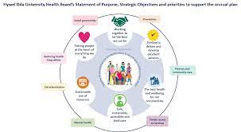
Figure 1.1 – Hywel Dda Health Boards 2022-2025 strategic plan
Strategic managements comprises of developing strategies and devising policies to reach the main objectives and goals. Moore (1995) affirms that to think “strategically in the public sector requires managers to assign equal importance to substance, politics and organisational implementation.” Strategic planning has however evolved since, it is vital that the emergency department continue to examine it’ choices and make necessary changes to current facts and forces within the micro and macro environments.
A crucial element of strategic management is to maintain stability and be able to change imminently if needed. Mckniney’s 7’s model as identified in Appendix J is suited to the Emergency Department. All the factors are independent however if one fails it could result in the other factors being brought down with it.
Strategy | The logistics of the Emergency Department is to see patients within a 3 hour period and to save the lives of those needing emergency care. The current strategy is to see patients in a timely manner and reassure them with safe discharges. Effective communication is a key component to patients care. Patients arrived by ambulances should be offloaded as they arrive, this has become a big problem resulting in ambulances being stuck within the department, sometimes more than 24 hours, thus having a knock on affect to the community. The new prosed strategy will combat this.
Structure | The NHS is highly structured. The hierarchy within the department has a Senior Nurse, 3 Senior Sisters, 8 Junior Sisters, 35 Qualified Staff Nurses, 20 Health care support works, 18 administrative employees and 40- 50 Doctors.
Systems | There is strict control within the NHS over all systems .
Shared Values | The health board strives off its values. A large department like the ED however has may mixed value which can sometimes be difficult.
Style | Lewin (1939) describes the ideal manager to compromise of authoritative and delegate styles. The ED has many leaders who all have different leadership styles.
Staff and Skills | The current acuity of patients has led to staff feeling less motivated having an effect on the strategic direction.

New Strategy Proposal
Martin (2014) reports that there are three elements to strategic planning
- Mission statements
- Actions and Drivers
- Transforming these into money gain

Plunkett and Attner (1994) however identified six stages to strategic planning
- Overview and evaluation of mission statement
- Objectives
- Goals and strategies
- Environmental analysis effecting organisation
- Re-assessing, formulating and implementing of strategy
- Monitoring and evaluating end results
However in 1990 in Mintzberg suggested a ’10 school of strategy’ (See Appendix I). According to Mintzberg strategy is “best characterised as a stream of decisions made overtime” (Clegg et al, 2020)
The Emergency Department seem to uphold the configuration school, one of Mintzberg (1990) school of strategy. They have a good system in place when change is needed, they are also methodical in their strategic approach.
Moore (2003) state that being both creative and innovative is necessary for this ideology. Furthermore Mintzberg and Ahlstrand (2008) believe that an organisation must recognise in order to succeed. Both theorists believe this ‘configuration school’ can have its restrictions as it can be analysed by both leaders and management although it is stable and can change when needed.
In the health boards strategy for 2022 – 2025 one of their objectives is to ‘strive to deliver excellent service and the best health and wellbeing for patients’, currently this is not being achieved due to the demand on the department.
Adopting the configuration school, the proposed new strategy is based on offloading patients quicker into the ED allowing ambulances to be released back into the community.
To achieve this, a Patient Offload Department (POD) is proposed at the ED. The POD will contain 6 beds in a safe comfortable environment to accommodate Ambulance patients at times when ED is full. This will help patients be transferred safely but will also allow ambulance crews to be released quicker. Although this in isolation, does not solve the problem of handover delays, it’s a step to ensure ambulances are released quicker.
For the purpose of the new proposed strategy there are many tools to assist in this proposition.

The Mckinsey Model This investigates the ‘hard elements’ of the organisation’s structure, systems and strategy. Furthermore the ‘soft elements which include the shared values, staff, styles and skills. These are determined by the trusts core values. This model however focuses primarily on the internal foundations and therefore an external model is needed to obtain a wider view. (appendix J).
See Appedix K, Ansoff’s (1965) strategy model “defined the nature of an organisations business” hence the focus was more on the strategic formulation rather than the implementation. Ansoff identified three action levels, operational, administrative and strategic. (Clegg et al, 2020)
Furthermore Ansoff stated that the role of management is to support and implement strategy, additionally, he argued that there are four strategic decisions that organisations should make.
Penetrating the market - Increasing sales of existing products within the existing market.
Diversification – Developing a new product to the market or expanding a new service
Product Development – Introducing something new to the existing market, providing a new service
Market Development – Use current products to enter into a new market.
Ansoff axes can be used for different strategic options, ensuring all four areas have been considered. (Whittington et al, 2020)
To confirm the market penetration is completed, a risk assessment was done in Appendix L, including the price strategy and promoting the new service to the community and stakeholders.
The Diversification factor would be the new ambulance POD to improve offload times and patient safety. A communication plan was done in Appendix M to ensure stakeholders were informed of the plans with time scales, social media plans to relay information.

The strategic position of ED was looked at based on the PESTEL, SWOT and TOWS which was conducted. This emphasises the strengths, weaknesses, opportunities and threats including stakeholders both internally and externally.
There is no competition for the proposed strategy. There is however a risk regarding staffing the POD. Working in the public sector the competitive positioning should be the role of the government, however public service can be considered like any other independent organisations with goals and stakeholders that require effective management to connect the tow. (Ferguson, 2019) Private sector theories is based on growth and profit and competitive advantage, aspect aren’t always suited to public sector. However managers can obtain several benefits from formulating written strategy documents, for example vision goals.

Conclusion
It is evident from the report that organisations including the ED are evolving and changing forces will have an impact on their strategic direction. The pandemic in 2020 altered the health services strategic direction, they had to adapt, innovate and work differently in a different environment. Managers must continuously monitor the micro and macro environment as strategic management is a dynamic process.
The stakeholder questionnaire and results identified the crucial need for extended communication with stakeholders as they are imperative in the impact on strategic decision making within.
Those with high power influence must ensure governing structures are set, goals are clear, and implement them aligning with the organisations core values and cultures to achieve accomplishment.

Bibliography
Ambrosini, V. and Bowman, C., 2009. What are dynamic capabilities and are they a useful construct in strategic management?. International journal of management reviews, 11(1), pp.29-49.

Barr, J. and Dowding, L., 2019. LEADERSHIP IN HEALTH CARE. 4th ed. London: SAGE PUBLICATIONS.

Belcourt, M., 2006. Outsourcing—The benefits and the risks. Human resource management review, 16(2), pp.269-279

Birchard, B., 1996, ‘Where Performance Measures Fail, CFO’. The Magazine for Chief Financial Officers. 12(10), pp. 36

Clegg, S., Schweitzer, J., White, A. and Pitelis, C., 2017. Strategy Theory and Practice. 2nd ed. London: Sage.

Dayan,.M (2021) “What happened to those Brexit Medicines shortages?”. Nuffield Trust.

Duffy, S and Rees, J. (2022) NHS Wales: Ambulance handover delays treble in two years, BBC News. BBC. Available at: NHS Wales: Ambulance handover delays treble in two years - BBC News [Accessed 20 November 2022]

Freeman, R.E. (1984), Strategic Management: A Stakeholder Approach, Pitman, Boston, MA

Friedman, A.L and Miles, S. 2006, Stakeholders: Theory and practice. Oxford University Press

Frigo, M.L., 2002, ‘Strategy and the Balanced Scorecard’, Strategic Finance Journal, 84(5), pp. 6-9.

Health Board Approves First Strategy For Health And Care (2020) - Hywel Dda University Health Board. [online] Hduhb.nhs.wales. Available at: <https://hduhb.nhs.wales/news/press-releases/health-board-approves-first-strategy-for-health-and-care/> [Accessed 20 November 2022].

Hussey, D., (2002) Company Analysis: Determining Strategic Capability. Strategic change

Jensen, M., 2002, ‘Value Maximization, stakeholder theory, and the corporate objective function’, Business Ethics Quarterly, 12 (2), pp. 235-256.

Johnson, G., Scholes, K. and Whittington, R., 2009. Exploring corporate strategy: text & cases. Pearson education.

Kaplan, R.S. and Norton, D.P., 2001. Transforming the balanced scorecard from performance measurement to strategic management: Part 1. Accounting horizons, 15(1), pp.87-104.

Kim, W.C. and Mauborgne, R., 2014. Blue ocean strategy, expanded edition: How to create uncontested market space and make the competition irrelevant. Harvard business review Press.

Kotler, P. and Scheff, J., 1997. Standing room only: Strategies for marketing the performing arts. Harvard Business School Press.

Mahase, E., 2022. Nurses vote to strike over pay, as other health workers are balloted.

Mintzberg, H., Ahlstrand, B.W. and Lampel, J. (2008) Strategy Safari:the complete guide through the wilds of Strategic Management, 2nd, Ed. Pearson Prentice Hall, NY

.Mintzberg, H. (1987) 'The Strategy Concept 1: Five Ps For Strategy,' California Management Review, Vol 30, No 1.

Moore, M.H (1995) Creating Public Value: Strategic Management in Government. Cambridge MA: Harvard University Press

Olve, N.G., Roy, J. and Wetter, M. (1999). Performance Drivers, A Practical Guide to Using the Balanced Scorecard. Chichester: John Wiley & Sons.

Plunkett, W. & Attner, R. (1994) Introduction to Management, 5th Ed, USA: International Thomson Publishing

Porter, M.E (1996) What is Strategy? Harvard Business Review

Porter, M. E. 1980. Competitive Strategy Techniques for Analyzing Industries and Competitors. New York, NY: Free Press

Pullan, P., 2016. VIRTUAL LEADERSHIP. 1st ed. Great Britain: Kogan Page Limited.

Quélin, B. and Duhamel, F. (2003) ‘Bringing Together Strategic Outsourcing and Corporate Strategy:’, European management journal., 21(5), pp. 647–661. Available at: https://doi.org/10.1016/S0263-2373(03)00113-

Riley, J. (2022) Hywel Dda Health Board Shines at national BAME award nominations, Western Telegraph. Western Telegraph. Available at: https://www.westerntelegraph.co.uk/news/20147413.hywel-dda-shines-national-bame-award-nominations/ (Accessed: November 4, 2022).

Rosenberg Hansen, J. and Ferlie, E., 2016. Applying strategic management theories in public sector organizations: Developing a typology. Public Management Review, 18(1), pp.1-19.

Stelzner, M.A. (2019) Social Media marketing industry report Available at: http://www.socialmediasummit09.com (Accessed: 20th November 2022).

Stoyanova, Z.& Harizanova, H.( 2017). ‘Analysis of the External Environment of Green Jobs in Bulgaria’ Economic alternatives, (1), 122-136

The British Medical Association is the trade union and professional body for doctors in the UK. 2022. NHS outsourcing. [online] Available at:[Accessed11October2022].
Thompson Jr. A., Strickland lll, A. J. and Gamble J.E.( 2007) CRAFTING & Executing Strategy. 15th Ed, New York: McGraw-Hill Irwin

van Schalkwyk, M.C., Hervey, T.K., McCarey, M., Dayan, M., Barlow, P. and McKee, M., 2020. How will Brexit affect the healthcare workforce?. bmj, 371.

Vermeulen, F., 2017. Many strategies fail because they’re not actually strategies. Harvard Business Review.

Waters, R.D. and Jamal, Y.Y. (2011). ‘Tweet, tweet, tweet: A content analysis of non-profit organizations’ Twitter updates, Public Relations Review, 37 (3), pp. 321-324

Weihrich, H. (1982) ‘The TOWS matric: a tool for situational analysis’ Long Range Planning 15 (2), pp. 54-66

Appendix A – PESTEL
Table 1. Emergency Department PESTLE analysis

Political | Local Authority Pressures, Government policies, Government funding, Covid-19 restrictions, Tax Policies, Trade regulations, Brexit - how will medication and equipment be transported.
Economical | Budget – Making it difficult to provide sufficient quality care to patients, Wages, More Internal job opportunities, Life expectancy increasing, Inflation, Patient confidence, Recession, lack of qualified staff.
Social | Staff resistance to change, Staff sickness, Working from home, staff burnout, Low objectives – lack of confidence, Cultural trends, Lifestyle changes, Increase in population, Nursing apprenticeships being offered, advent of social media – information is spread faster than ever and patients have a better knowledge of the treatment available to them
Technological | Old Equipment, Availability, Keeping current with online E learning and online teaching, IT skills, Cyber Security, Clinical technology modernised, Potential ROI, High need for remote internet access, Social media is used to communicate to stakeholders, increase of IT software licences, marketing online and through social media, Copyright, better technology will improve patients care, government organizations like the NHS are able to speed up and automate more clinical tasks.
Law/Legislation | Health and Safety regulations, Human rights act, Equal Opportunities, Fire safety regulations, Changes in law, Product safety, Government restrictions, GDPR rules, employment laws and contractual rights, employees sickness, adequate CRB checks and safeguarding policies, litigation – taking healthbaord to court
Environment | Risk of covid-19 outbreak internally, Disease, Dated Premises, Winter pressures, an increase in unwell patients during winter months, increase of waste.

Appendix B – SWOT
Table 2. Emergency Department– SWOT Analysis
Strengths  - Patient satisfaction  - Patient outcomes  - Quality of care  - Staff motivation, staff ethics  - Economic dynamism in the community  - Quality programmes and teaching support for students  - Good partnerships throughout Wales, England and overseas  - High knowledge employees  - Teamwork  - Willingness to improve services  Proposed Strategy  - Quicker offload times  - Extra bed capacity  - Quicker release for ambulances to get to patients  - Patients safety  - Paramedics assisting with patient care  - New equipment from welsh government | Weaknesses  - Reduction in financial resources  - Reduction in state funding  - Old Equipment  - Blended working (lack of IT literacy)  - Poor customer relations  - High re-attender rates  - High number of failed discharges  - Poor communications from management  - Patient complaint  - Long waits to see a doctor  Proposed Strategy  - Lack of knowledge and understanding of the engagement work needed to support sustainable growth  - Conflict between Ambulance Service, GP’s and Emergency Department  - Lack of staff  - Decreased motivation with added pressures
Opportunities  - Valuable ideas from employees  - Community engaged  - Re-organise  - Budget costs – look for other ways of working  - New ideas from employees and managers  Proposed Strategy  - Links between Welsh ambulance service and Emergency department  - Provision to provide support to students  - To lower ambulance waiting times  - Patients security | Threats  - Uncertain economy  - Retention of key employees  - Reductions in funding  - Cyber threats to IT infrastructure  - Staff shortages  - Staff sickness  - Staff morale and motivation  - High stress levels  - Department mergers  - Ability to retain staff  Proposed Strategy  - Lack of Staff  - Increased Stress in an already crowded department  - Lack of equipment to hand  - Increase in walk in patient delays

Appendix C – TOWS
Table 3. Emergency Department – TOWS Analysis

 |  | INTERNAL FACTORS
EXTERNAL FACTORS |  | Strengths | Weaknesses
EXTERNAL FACTORS | Opportunities | Strengths/Opportunities  Maxi-Maxi Strategy  - Reduce Waiting times  - Allow ambulances to be released back into the community  - Better patient care  - Links with the community showing extra support for patients | Weaknesses/Opportunities  Mini-Maxi Strategy  - Conflict between ED employees and paramedics  - No other Ambulance POD within the 3 sites  - Provision to employee more staff  - Extra bed capacity - No waiting on ambulances in the cold  - Lack of equipment – would need to purchase new
EXTERNAL FACTORS | Threats | Strengths/Threats  Maxi-Mini Strategy  - Antisocial behaviour and abuse to staff  - Patients seen more efficiently | Weakness/Threats  Mini-Mini Strategy  - Lack of knowledge and understanding of work needed to support increase in patients needing emergency treatment  - Prolonged Covid, resulting in further spread, resulting in closure  - Lack of staff to care – due to sickness or other reasons

Appendix D - Stakeholders Questionnaire

On a scale of 1-5 please rate the following
- Do you feel the Health Board is open about its plans and changes?
Strongly disagree 1 2 3 4 5 strongly agree

- Have you ever been engaged in plans around the Emergency Department?
Strongly disagree 1 2 3 4 5 strongly agree
- How much do you feel the Health Board is committed to the local community?
Strongly disagree 1 2 3 4 5 strongly agree

- Overall, how responsible do you think the Emergency Department is towards all its stakeholders?
Strongly disagree 1 2 3 4 5 strongly agree
- Do you think the Emergency Department has clear goals?
Strongly disagree 1 2 3 4 5 strongly agree
- Do you feel there is sufficient contact between the Emergency Department and its stakeholders?
Strongly disagree 1 2 3 4 5 strongly agree
- Do you feel the health board communicates with you?
Strongly disagree 1 2 3 4 5 strongly agree

- Is it important to have open communication?
Strongly disagree 1 2 3 4 5 strongly agree

- Are you happy with current communication channels?
Strongly disagree 1 2 3 4 5 strongly agree

- Is it easy to communicate with any issues?
Strongly disagree 1 2 3 4 5 strongly agree

- Are queries dealt with quickly and efficiently?
Strongly disagree 1 2 3 4 5 strongly agree

- How much do you know about healthbaord as an organisation?
Strongly disagree 1 2 3 4 5 strongly agree

- Are you aware of courses and training options available in the Emergency Department?
Strongly disagree 1 2 3 4 5 strongly agree

Appendix E - Stakeholders
Chief Executive
Shareholders
Management

Partners and Providers | Media | Patients and Public
Carmarthenshire County Council  Ambulance Service  Care homes  Trade Unions  GP’s | Hywel Dda Intranet  Local Newspapers  Social media, Facebook, Twitter, LinkedIn  Chief Executives video messages  National Media | Patients  Public  Relatives  Carers
Government | Internal Stakeholders | Political
Department of Health  Public Health Wales  Health and safety  Care Quality  Equality and Human Rights commission  NHS Employees  NICE | Staff – All departments  Governing Body  Clinical Executives  Management Team  Finance Director | Local Councillors  Safeguarding Boards  MP’S
Professional Bodies
Pharmacies
Medical committee

Appendix F – Stakeholder Analysis

High Power | Keep Satisfied  Chief Executive  Director of Operations  Finance Director  Human Resources  Consultant  Trade Unions  Local Authority  Local Council  Local MP’S  Public Health Wales  Lead nurses  Ambulance Service | Manage Closely  Medical Director  Clinical Governance Lead  Clinical Commissions Group  IT manager  Junior Doctors  Patients  Nursing Staff
Low Power | Monitor  Medical Records  National Assembly for Wales  Suppliers  Domestic  Kitchen Staff  Students | Keep Informed  Media  General Public  Town and Community  Police  Admin Staff  Health Care Assistants  Laboratory  Family members
 | Low Impact | High Impact

Appendix G – Porters Five Forces
Competitive Force | Analysis | Competitive Response
High patients acuity | High numbers of patients are attending ED, many coming through the door very unwell, unable to get an ambulance as they are all sitting outside ED with patients in. | New proposal, set up a POD to allow the release of ambulances to the community. Increasing patients care and afety
Threat of Entry - Low | Time and Cost  Specialist knowledge is needed  The main area If supplier’s power is the availability of knowledge trained staff .Making changes to ways of working to suit the need of the patients. | Recruit further afield. Innovating new products and services
Threat of Substitute - Low | Alternative and natural medicines | Health care services are difficult to replicate
Supplier Power - High | The industry is reliant on Medical equipment from suppliers.  This could be a new drug or different procedure. This would depend on the scale of the results as to what treatment is required. However new medical developments are most likely to cause a change in delivery. | Change in suppliers can have an adverse effect on the service. If stock isn’t delivered from suppliers the service collapses  Build supply chains with company’s
Power of Buyers - Low | Patients coming have to be given care  Consumers have limited bargaining power | Treat patients coming in
Competitive Rivalry – High | Quality of service  Patient Loyalty  Private Hospitals | Many people are seeking private health care due to the long waits, the NHS need to work to reduce this

Appendix H – Kaplan and Norton Balanced Scorecard

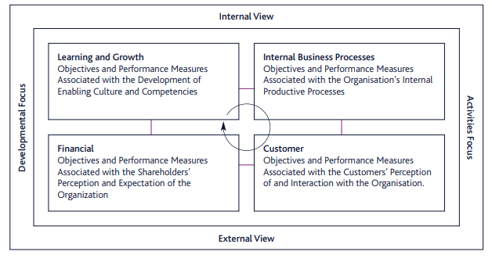

Source : Kaplan and Norton Balanced Scorecard Quadrants (1996)

Appendix I- Mintzberg

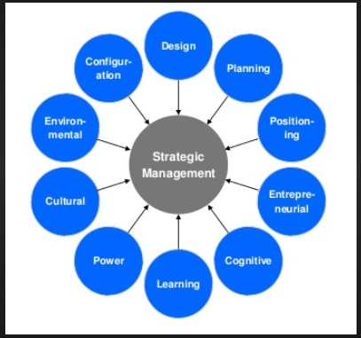

Mintzberg's 10 Schools of Strategy 1998

Appendix J – McKinsey Model

Source: mckinsey.com 2016

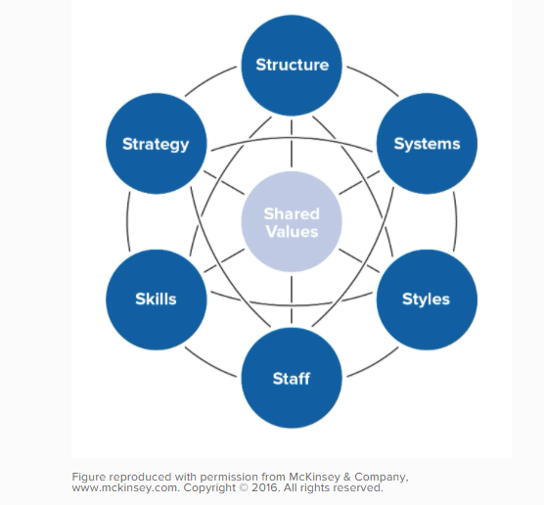

Appendix K - Ansoff’s Matrix
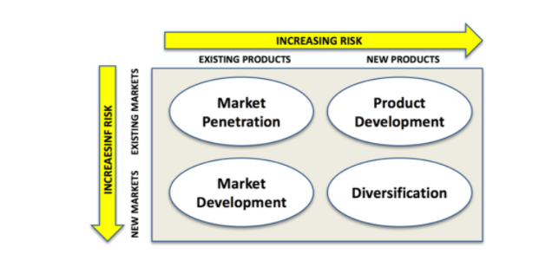

Source: Ansoff Matrix – Source: Corporate Strategy by H Igor Ansoff (1965)

Appendix L – Risk Assessment
Emergency Department Risk Assessment
Risk | Issues affected | Likelihood | Risk Level | Controls
Unsuccessful bid | strategy proposal | Possible | High | Communicate with appropriate bodies; Ensure bid is processed
Consultation response | Strategy rejected | Possible | High | Ensure all Stakeholders are aware of the strategy and reasoning behind it
Competition | Lack of usage | Possible | Low | POD is a back u to the main department – usage may or not be an issue depending on patient numbers
Pricing structure | Cost | Possible | High | Conduct thorough research of pricing strategies. Adopt flexible pricing structure.
Facility outcomes not met | Waste in finances | Unlikely | Low | Ensure that project outcomes are articulated to all stakeholders and those delivering the project
Unable to staff POD | Patients and Ambulance service | Possible | High | This will be run jointly by Ambulance service and the ED. However current staffing is an issue. This could be an issue and numbers will need to be looked at
Lack of monitoring of facility | Reporting structure is flawed | Remote | Low | Implement monitoring procedures with staff and volunteers

Appendix M – Communication and Marketing Plan
Table 7– Emergency Department
Marketing & Communication Plan
Aim | Stakeholders involved and community informed
Aim | POD to be delivered and opened as soon as possible
Objective | Achievement targets | Timescales
To offload patients from ambulances as they arrive | Reduce the ambulance waiting times to under 1 hour | Within 1-2 months
Notify the public and stakeholders of the opening of the POD | Use Social Media and emails  Proactive work with the media to share good news about the service locally. | Within 1-2 months
Monitor the flow of the POD | Figures within first 6 months of opening | 1-2 years

