ABSTRACT

In today network management becomes very important in the growth of computer-networks. A person is needed with critical skill and full knowledge of managing networks, His different thinking about network admin. Or admins that gives a best net. Environment. Also there is another branch that relates to computer network is called cyber security. The computer network is first step of cyber security. In modern world network management suffering from cyber attacks by the attackers. The main motive to safe our network form malwares, threats and cyberattack .There are many types of attacks occur on a network according to layers of OSI or TCP/IP reference Model . But We have many techniques and methods to prevent our systems from cyber attacks . Those methods and topics mentioned below . Every One needs to be aware about cyber attacks and how to prevent their data oy system form cyber attacks.

Sr.No. | Topic | Page No
1. | Introduction | 3-4
2. | Cyber Attacks | 4-8
3. | Protection Of Business Form N/ w Attacks | 8-9
4. | NPF (Network Protection Foundation) | 9-10
5. | Mitigating Effects Of Virus, Worms etc. | 10
6. | End Point Vulnerabilities and Protection | 10-11
7. | Securing Cisco Routers | 11-12
8. | IOS Based Security | 16-21
9. | AAA to local router database and external server | 21-22
10. | AAA-remote using local DB | 22
11. | Server Based AAA using TACACS+ AND RADIUS | 22-25
12. | Server Based authentication and accounting | 25-26
13. | ACL (Access Control List) | 26-29
14. | Zone Based CLI | 29-30
15. | Secure N/w Design , Management and reporting | 30-31
16. | Layer -2 Attacks | 31
17. | Cisco IOS IPS And NIPS | 32-33
18. | VPN | 33-36
19. | PKI (Public Key Infrastructure) | 37-38
20. | ASA NAT/Pat | 38
21. | References | 39
22. | N/w Design for A2Z Technologies Ltd | 39-44
COMPUTER NETWORKS AND CYBER SECURITY

Introduction to Cyber Security: - Cyber security is the branch of computer science which deals with cyber defense and cyberattacks. The cyber security is the practice of protecting systems networks and software program from digital attacks over the internet. The main aim of cyber security is to protect data systems and information from unauthorized access to data source and other computerized system over the internet .

METHODS TO PROVIDE SECURITY

- System Access Control :- This method checks that unauthorized users / persons do Not get into the system by alerting authorized users to aware about the security.
- Data Access Control :- It monitors who can access the data ,and for which purpose .A system may support important access controls with this .This system defined various access rules according to security levels of the people/users ,the files / folders or other objects in a system.
- System and Security Administration :- A system admin. Handle every term of security and protect the data sources of the organization. This is responsible for installation troubleshooting and admin. Of an org. security Sol.
- System Design :- IT describe the basic architecture of the system ,design model ,system info. Etc. This is the app. Of system theory to product Development.
Components of Cyber Security : -Cyber security or computer security is associated with many areas or terms. These Terms or areas are given below :

1). Confidentiality :- The confidentiality is term that ensure that our data is not accessed by other unauthorized access. That mean it makes only authorized access for database or system over the internet.

2).Integrity :- Integrity is term that ensure us our data is not being altered by other unauthorized user or access . In simple words this term states that data can be add remove or alter by only the verified user or authorized access.

3). Authentication :- Authentication is term that users are the peoples who claim to be authenticated .
4). Access Control :- This term states that users can access only those resources that they allowed by organization to them.
5). Non – Repudiation :- It states that if a message is send by sender to receiver then sender or originators of message cannot deny that they are not sender.
6). Availability :- This checks systems are work properly and services are not disabled to accessed/authorized users .
7). Privacy :- This term ensure that anyone has right to access info. And allow other
authorized users to use that info.
8). Steganography :- The Steganography is art or technique of hiding important data into
non-secret or normal file . This terms is used to avoid detection by attackers or
unauthorized users.
9). Cryptography :- This term is used for protect digital data . This is communication
Technique that transform data into one special type of format that can be only access by
Authorized users. There are some common terms of cryptography are given below :
a). Plain Text – This is the original message that is the input to the receiver .That receiver has authorized access only .
b). Cipher – This is the bit by bit or character by character encryption transfor. without changing the meaning of important data is called cipher .
c). Cipher Text - This is the codded message or data /info. This is done by algo.
d). Encryption - This is the process of conversion of normal text or plain text into the cipher text with use of encryption algorithm.
e) Decryption – This is the reverse or opposite to encryption through this encrypted text converted into simple/plain text.

CYBER ATTACK :- The cyber attack are attempts to gain unauthorized access into any one’s system. These are unwanted attempts to steal, expose, modify ,disable info. Through illegal access. The cyber attacks are done by cyber criminals using many system against single or multiple users over any network or remotely.
SOURCES OF CYBER ATTACKS :-
- Downloadable Programs : - The downloadable files are one of the most important part of virus. When a user using internet for downloading files then unwanted or rapped file with virus downloaded to our system . Then those files infect our system .If any users want to download then make sure about that file is secure or reliable to system.
- Cracked S/w :- These s/w are another source of cyber attack . When a user install a cracked s/w then that s/w contains many infected files with virus and bugs ,that are difficult to find and also to remove.

- E-Mail Attachments: - The e-mail attachments are most common threat of cyber -attack or viruses .Cyber -criminal sends you mail with attachments and with a link that needs to be handle carefully ,especially if the mail is from unknown sender .
- Internet :- The internet is major reason for cyber-attack every one uses internet acc. To their way. But they are mostly not aware about cyber threat or attack . There are malicious websites, malwares , insecure web links and also unnecessary ads. ,this raise to a big cyber attack . Every person is need to be aware about the secure internet websites and other security terms over the internet.
- Booting from Unknown CD : - When the computer system is not working ,it is a good practice to remove the CD, It may start to boot automatically from the disk which enhances the possibility of threats and attacks.
- Using USB Flash Drive :- When user using USB Flash drive from unknown source or without scan through antivirus. This cause to be a big malware threat or cyber attack to be.

TYPES OF CYBER ATTACKS
- DDOS ATTACK
- MITM
- PISHING
- PASSWORD ATTACK
- SQL INJECTION
- CROSS-SITE SCRIPTING (XXS) ATTACK
- BRUTE FORCE ATTACK
- RANSOMWARE ATTACK
- MALWARE
DDOS ATTACK ( Denial of Service/Distributed Denial-of- Service Attack ):- A denial – of– service attack is a attack in which control system resources so that it cannot respond to Service. A DDOS attack is also an attack on system’s resource but it launched from the huge number of hosts or users that are controlled of operated by through the malicious software. This attack doesn’t gives direct benefit to the attackers.
MITM ATTACK ( Man in The Middle ) :- This attack begins when there is communication between the client and server . The attackers hijack the session between the trusted client and server .Then attacker come in the middle of user and server . Attacker ‘s computer distributes its ip address to client when server continuous the session . Then connection between user and server is through the attacker ‘s computer in this process attacker steal information . This attack also leads to IP Spoofing . This is an attack in which attacker convince a system that is communication with known system And provide the access to attacker’s computer. The attacker sends packets to the host as trusted and well known system .The victim user /host may accept that packets and act upon it.
PHISHING :- Phishing is the attack in which attacker send emails and messages to the user and appear as trusted users or source. The goal of this attack is to gain info. And influence victim to do something. It is the combination of social engineering and also technical tricks .Attackers attach an attachment to the message or e –mail . The attachment may be link of fake page audio file Picture or may be PDF.

PASSWORD ATTACK :- Password attack are most commonly used attacks for gaining access from the victim’s system .This is a effective approach to obtain passwords. Access to a person’s can be obtained by password sniffing to the user’s desk .Social Engineering is main thing I password attack.
SQL INJECTION:- The SQL Injection has become a common issue with the websites that are driven with databases. The occurs when attacker executes a query to the database through input data from users to the server. The successful SQL injection exploit can read important data from database, modify and other admin operations. This attack is common with PHP and ASP applications .J2EE and ASP.NET are less possibility.
CROSS SITE SCRIPTING (XSS) :- This attack is based on use of third party web resources to run in the victim’s computer . In this attack attacker create a payload to the user’s /victim system. The payload is based on JavaScript with malicious content .It targets database over the internet of victim .When the victim access their website and make a request to the server. Then the website shows the new page with the attacker’s payload as the part of HTML body to the victim’s browser which runs malicious script.

BRUTE FORCE ATTACK:- This attack is similar to password attack in which attacker uses a random approach by trying many different passwords in hope of one is logically works. These passwords are Names, Job title hobbies, etc. There is one dictionary attacks comes into it many types of passwords dictionary made by attackers over the internet. The attacker uses that dictionary for gaining access to the victim’s system. In That dictionary every word has different combinations. 40 Millions -passwords approx. available in this dictionary.

RANSOMWARE ATTACK:- This attack is a one type of malware that is used by attacker for blocking victim’s data for ransom . IF this attack is executed then attacker block authentication to the user until user/victim pay ransom for that. Attacker blocks all activity and asking for money to get access to victim.
MALWARE ATTACK:- Malware attack is when malicious s/w can be described as unnecessary s/w that is installed in your system without permission .It can self-replicate itself into your system . Here are most common malwares:
- Macro Virus: - These viruses infect application installed your computer with all data carrying, like MS-word , Excel . When application is opened the virus executes control before transferring controls to the system.
- File Infectors: - File Infectors are type of executable codes. Their extension like .exe .apk etc. When file is executed then virus infect all files in your computer.
- Trojans : - A Trojan is a non-self replicating type of malware . Which appears to perform a desirable function but instead facilities unauthorized access to the user’s computer system.
TOOLS AND PROCEDURE TO MITIGATE FROM MALWARE ATTACKS :-
- Install Anti-Virus Software : - One of the most important term to prevent your system from malware attacks is installation of anti-virus software . Make sure the antivirus is trusted .Anti-Virus keeps your system away from malware and other threats.
- Regularly Update Software :- After the installation of anti-virus software it’s vital to ensure that your s/w is being regularly updated. This will help to stop to gaining access to attackers.
- Install Apps. From Trusted Sources :- Installing s/w from trusted source helps to prevent other harmful content with that s/w .If you are installing s/w from unknow source that means there is risk of malware attack .
- Install firewall : - Other way to safe your device is installation of fire wall . A firewall prevents harmful content from internet sources . Firewall blocks unauthorized access and malicious content.
- Back Up : - It’s necessary to back up your data regularly . This ensures that you can still retrieve all your valuable files and record (data) .
- Never clicks on suspicious links and other files. Those files or links leads to phishing attack .
Fundamental Principles of Securing a Network :-

Confidentiality :- The term confidentiality means objects resources and data are protected from unknown viewing and other access. This means that data is protected from suspicious use from unauthorized access. Confidential information often has a value and systems are there fore under frequent attack as criminals attack for loop holes /vulnerabilities to exploit.
Integrity : - Another term is Integrity that measures safe information from unauthorized alteration. This term checks accuracy and completeness of data in your system. The maintenance of integrity it is not necessary to control access at the level of but ensure that only those users are able to alter data or info. who have access to alter. The effective integrity also prevent against unintentional modification/alteration of the data ,like users errors etc. result of sys. Malfun.

Availability :- In terms of security the availability of the legal or authorized users is most imp. This term ensure protect timely and uninterrupted access .There are most basics threats to availability are non- suspicious /malicious in nature . They include hardware failure, N/w bandwidth issue and also some s/w issues. The availability and responsibility of a website/ Software is a most important for many organizations.
How To Protect Business from Network Attacks :-

Using Encryption :- For small to medium business ‘s security encryption is term . Which allows to security of data. Using disk encryption to protect all our computers ,Tabs, phones etc. is done. Make sure the key or encryption password is stored of safe location and also away from stored data. Never share key or password in the mail document . But give it to them through different way like phone call .

Limit Employee Access to Database : -Limiting access to your company database decreases possibility of the errors by users , which is the number-one Info. security risk. Employees should only have authorization to the systems and specific Info. according to their job role. If there is an employee resigned from his designation or transfers to a different another Branch, take secure action immediately about deleting records like password, accounts from every systems and collecting company ID badges and entry keys.

Install UPS (Uninterrupted Power Supply) :- Uninterrupted Power Supply (UPS) can give better power and battery life to save data files of your systems during power off/disruption.

Install Hardware or Software Firewalls :- Firewalls prevents your company’s system from attacks made by hackers . Also firewall allows better security blockage to users for using harmful websites or software on system.

Secure all Wireless Access Points of N/w :-
- Change the admin password regularly . Also make sure admin password is more complex.
- Set all access points on wireless and to prevent broadcasting of SSID (Service Set Identifier)
- Set router to WPA-2 , WPA (Wireless Protection Access) with the AES (Advance Encrypted Standard)
Setup Filters (Web & Email) :- Use Email and web browser filter to prevent hackers and block spam emails and web pages .Also another thing i.e.“ Blacklist ”services to prevent/block harmful websites or emails using by the user or employee.
Train Your Employees :-Cyber-vigilant Emp. are one of the best security method against
Cyber threat or security breaches. Every emp. should know about some facts of security As given below :-

- What type of business and personal use is only allowed to emails.
- How to manage data of the company either home or office .
- Steps to do when any cyber incident happens .

Update O.S /Software Regularly :- Every time checks for updates of the system if system
is old or new. Make sure s/w installed on your system are regularly up to date . If s/w or O.S are outdated then there is threat of cyber incident by attackers.

NFP ( Network Foundation Protection ) For securing a Network :- This is a frame work designed by Cisco for group of logically fun. that occur on a n/w .This framework include many security tech. required for secure devices like routers switches etc. This also describe the availability of the n/w even when it is suffering from network attack.
This framework includes Three basic sections :-

- Management Plane :- The management Plane is feature of cisco s/w (IOS XR) .This feature restrict the interface of n/w Manag. Packets have access to enter or attach a new device .This feature helps admin to use one or more interfaces as Manag. Interfaces .This feature works as traffic manager to the network by the admin. When this feature is enabled then only those interfaces manages traffic who are designated by the admin.
- Control Plane :- In Network Foundation Protection system control plane is refers to path of overall data transmission in a network. This feature refers to all fun. and processes that shows which path or route to use data in form of packet or frame. This also responsible for network topology design, all the routing table ,forwarding table and also enabling functions to the data plane. Now, in simple words this is responsible for how data packets should be moved/ forwarded.
- Data Plane :- This is the third feature of NFP which is real end user traffic carrier. The another name of this is bearer plane or forwarded plane. This feature enable multiple protocols with multiple conversations types. This allows to user to exchange information in many different ways. This travels through the router in a network.

Mitigating the effects of Viruses ,Worms and Trojan Horses To a Small To Medium Business :- There are many types of viruses and malwares that infect your computer system. Some of them infect all the files and shutdown your system while some are affect your system normally .Unfortunately there is no particularly way to find your system is infected or not . If you are running anti-virus s/w it may alert you that it has found harmful content on your computer .The antivirus s/w able to find out malicious content /code automatically. If antivirus don’t detect then you must need to take additional steps toward security.
Minimizing The Damage :- If you are at work at that time then you need to inform IT department as soon as possible. Soon they investigate that incident and find out problem or malicious code. After that they clean your system , that makes less damage to your system and also other systems attached to the same n/w. In other condition if you are on your computer at home then firstly disconnect your system from the internet. Because when system is of line then attacker will not able to send virus or malwares.
Remove Malicious Code :-If your system has anti-virus s/w then update the virus definition (If possibly) and perform a full system scan manually .Then your antivirus found malicious code during scan . Now permanently delete that code from your system.
Change Your Passwords :- When your system is under effect of attack then your passwords may be compromised . Because there are most attacks done by attackers for gaining user’s credentials like username and passwords. To avoid cyber threat you have to update your password and make them more complex. IF your password is normal then lost of chances to be cracked . So make sure use alphanumeric password and also include special character
Use Anti -Spyware S/w :- Spyware is common source of viruses but you can min. the risk
of infection to files by anti-spyware s/w.
Reinstall O.S (Operating System ) :- If above steps are be failed to find out solution. Then
the most effective step is reinstallation of operating system. This step very effective but
as result your data will be loss. But this can wipe your system’s hard drive completely . And gives the surety that your system is free from modifications made by attackers.

End Point Vulnerabilities And Protection Methods :- The each and every device is cone-
ected to internet is called end point. And also every device has an entry point for infection. This end point vuln. Is multiplied by the total no. of applications on each node and weather each app. Interact with security terms .Even an enterprise can have lots of vuln.
Due to compromised installations of applications ,operating system . Also the main reason is outdated patches of operating systems or applications s/w. This end point vuln. Leads to target users system and their services being used by the users. These end points are like entry points to any network ,this include mobile phones PCs Laptops and other devices used for specific functions. The end point attack affect files , folders and NAS (N/w Attached Storage ) also affect the hardware server of the network.

Protection Of End Point Vulnerabilities :- The End Point security works when system
Admins are allowed to take over all control in terms of security for all corporate endpoints.
System admins works under security policy settings.

Securing Cisco Routers :-
- Configure Secure Admin. Access :-
Step 1 : Attach cables to the n/w.
Step 2 :Basic settings configuration for each router.
- Router> enable
Router# configure terminal
- Configure host names .
R1(config)# hostname R1
- IP address according to given table.

R1(config)# interface g0/0
R1(config-if)# ip address 209.165.200.225 255.255.255.0
R1(config-if)# no shutdown
R1(config)# interface s0/0/1
R1(config-if)# ip address 10.1.1.1 255.255.255.252
R1(config-if)# no shutdown
R1(config)# no ip domain-lookup

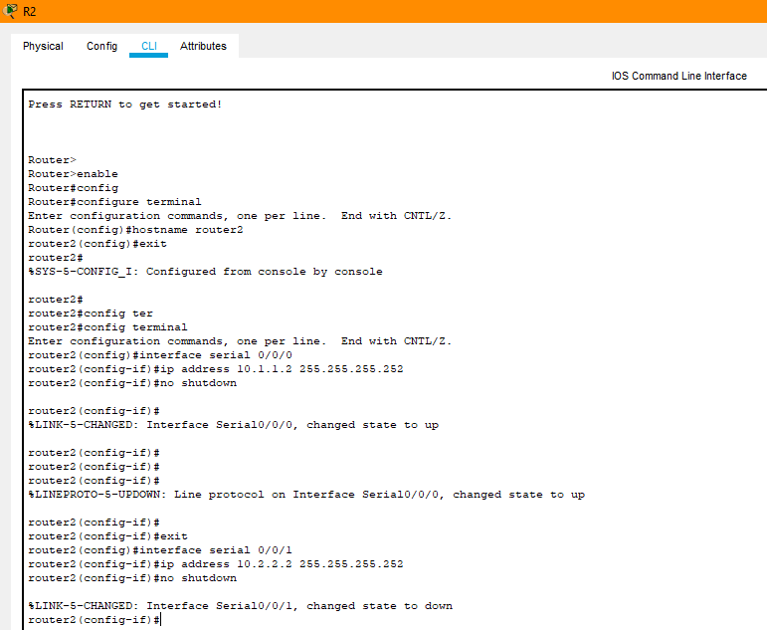

Configuring ospf to router 1
R1(config)# router ospf 1
network statements for the networks on R1
R1(config-router)# network 209.165.200.0 0.0.0.255 area 0
R1(config-router)# network 10.1.1.0 0.0.0.3 area 0

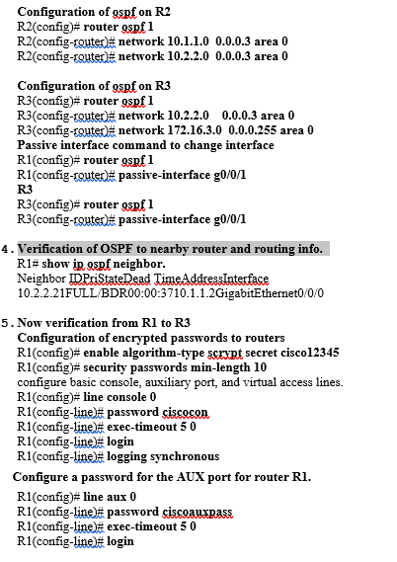
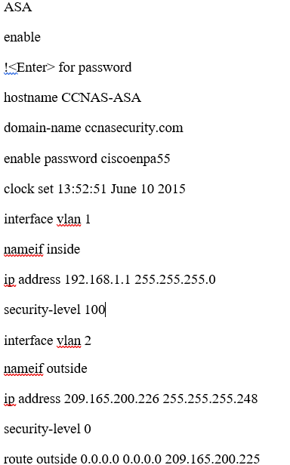
object network inside-net
subnet 192.168.1.0 255.255.255.0
nat (inside,outside) dynamic interface
class-map inspection_default
match default-inspection-traffic
exit
policy-map global_policy
class inspection_default
inspect icmp
exit
service-policy global_policy global
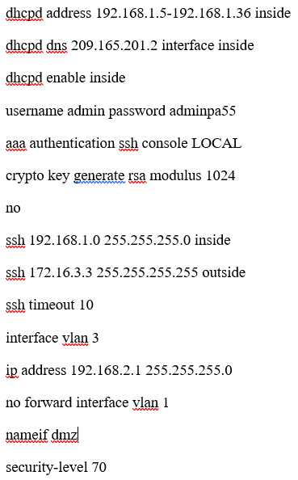
interface Ethernet0/2
switchport access vlan 3
object network dmz-server
host 192.168.2.3
nat (dmz,outside) static 209.165.200.227
access-list OUTSIDE-DMZ permit icmp any host 192.168.2.3
access-list OUTSIDE-DMZ permit tcp any host 192.168.2.3 eq 80
access-group OUTSIDE-DMZ in interface outside
b). Privilege Levels
R1(config)#username admin1 privilege 0 secret Study-R1
R2(config)#username admin2 privilege 15 secret Study-R2
R3(config)#username admin3 secret Study-R3
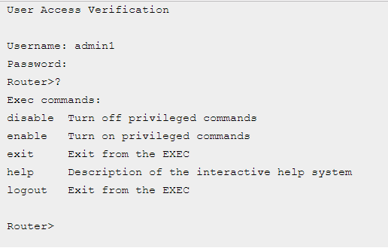

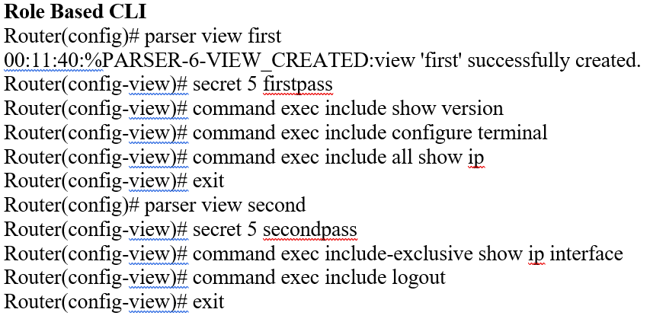

Implementation of secure management and monitoring network devices:-

Implementation of SNMP (Simple Network Management Protocol)

R1> enable
R1> config ter
R1(Config)#snmp-server community R1 ro
R1(config)#snmp-server community R1 rw rw

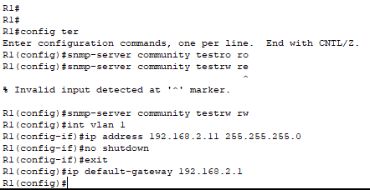

Automated features to enable security on IOS-based routers :-
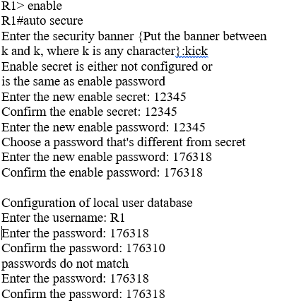

Configuring AAA local authentication
Configuring Console, Aux and VTY lines for
local authentication, exec-timeout, and transport
Securing device against Login Attacks
Configure the following parameters

Blocking Period when Login Attack detected: 2

Maximum Login failures with the device: 3

Maximum time period for crossing the failed login attempts: 4

Configure SSH server? [yes]: y

Enter the host name: CCNA
Enter the domain-name: asa
Configure CBAC Firewall feature? [yes/no]: n

Enable tcp intercept feature? [yes/no]: y
This is the configuration generated:
!
service password-encryption
no cdp run
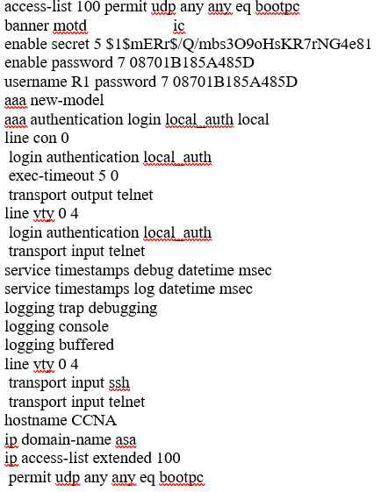
Apply this configuration to running-config? [yes]:
Applying the config generated to running-config

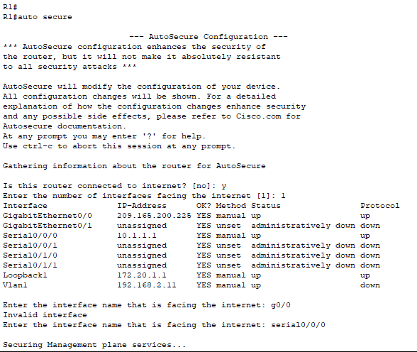

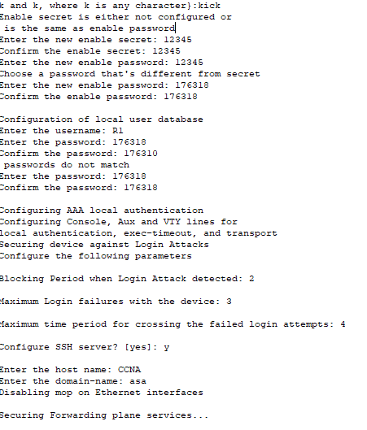

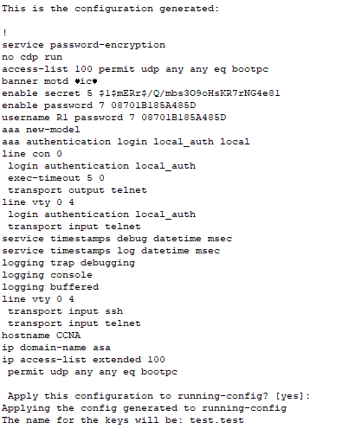

Implement control plane security :- The control panel security is according to systems operating systems Like Windows 11,10 , 8 ,7 or Linux ,unix etc.

Implementation of AAA on Cisco routers using a local router database and external
Server :-
A). how AAA is used to secure a network:-
AAA Stands for Access Authentication and Authorization .The AAA server checks user’s
credentials for Authentication with other users credential is stored on the database. The
AAA is a type of frame work controlling Access for computer resources enforcing policies
and providing important info. to bill for services. Now the term is for authentication , this
term allows a best way of identification of user . This allows every users a valid username
and valid password for gaining access . This process for each user having unique way or
credentials for gaining access. Now, The last term is authorization, this terms is comes after
authentication . When user logged into system Then user may try to issue commands . The
authorization process checks weather the user has the authority to access that commands.
In simple words authorization is process in which permissions are checked. Which Command is available for user at that time. These Processes are very imp. For effective and secure network management.

AAA authentication that validates users against a local database:-
R3(config)# username Admin01 privilege 15 algorithm-type scrypt
R3(config)# aaa new-mode
R3(config)# aaa authentication login default local-case none
R3(config)#exit
R3 con0 is now available
Press RETURN to get started.
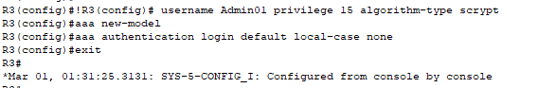

AAA authentication profile for Telnet using the local database:-
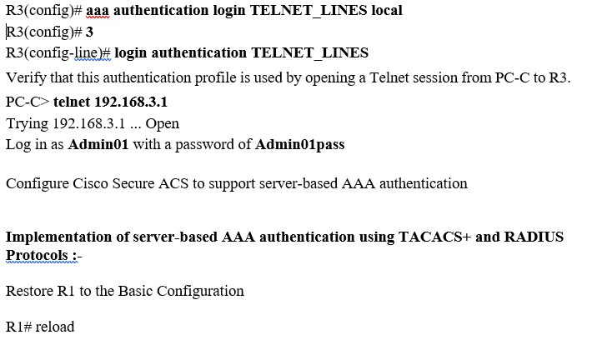
System configuration has been modified. Save? [yes/no]: no
Proceed with reload? [confirm]

Verify connectivity
Download and Install a RADIUS Server on PC-A
Download the WinRadius software

Configure the WinRadius server database

Config. onWinRadius server.
- select Operation > Add User.
- Enter the username RadUser with a password of RadUserpass.
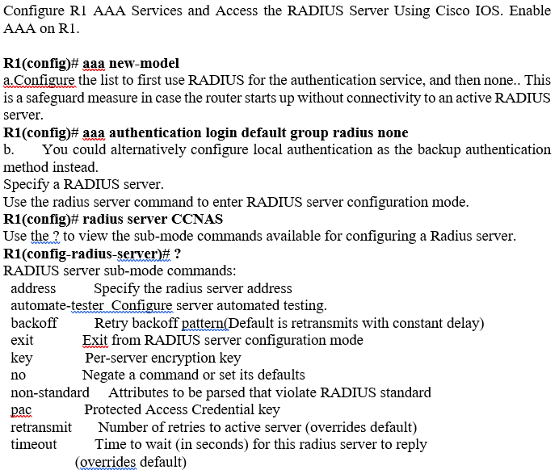

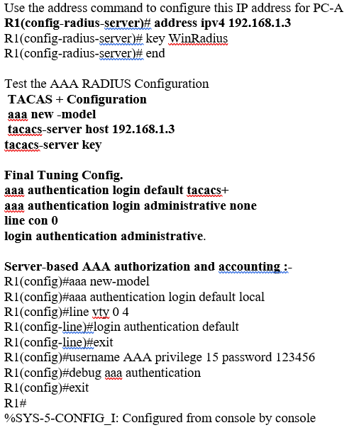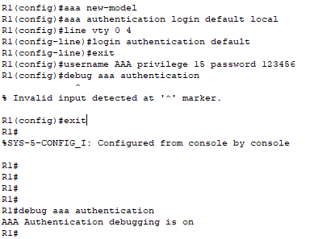

R1#
R1#
R1#
R1#
R1#debug aaa authentication
AAA Authentication debugging is on

AAA Accounting:-

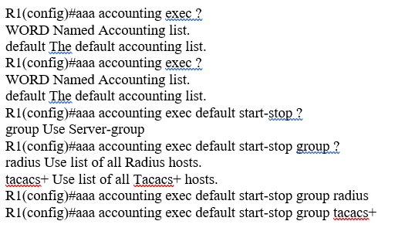

Mitigating threats to Cisco routers and networks using ACLs
- ACL
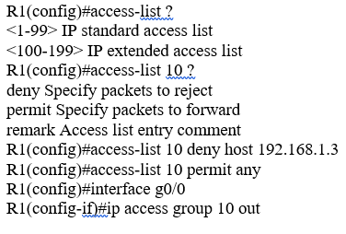
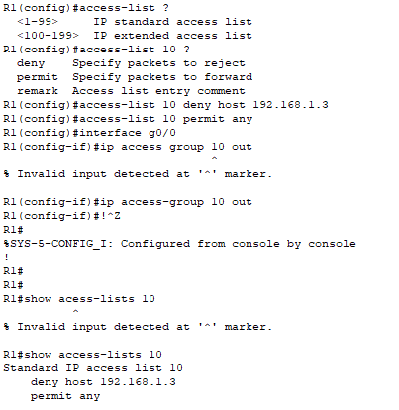
% Invalid input detected at '^' marker.
R1(config-if)#ip access-group 10 out
R1(config-if)#!^Z
R1#
%SYS-5-CONFIG_I: Configured from console by console
!

R1#
R1#
R1#show acess-lists 10
R1#show access-lists 10
Standard IP access list 10
deny host 192.168.1.3 permit any

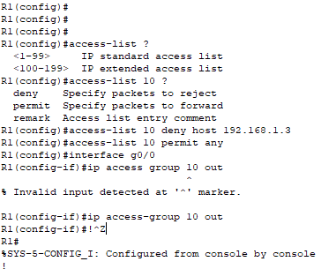

Zone Based firewall Using CLI

R3#
R3#
R3#
R3#config t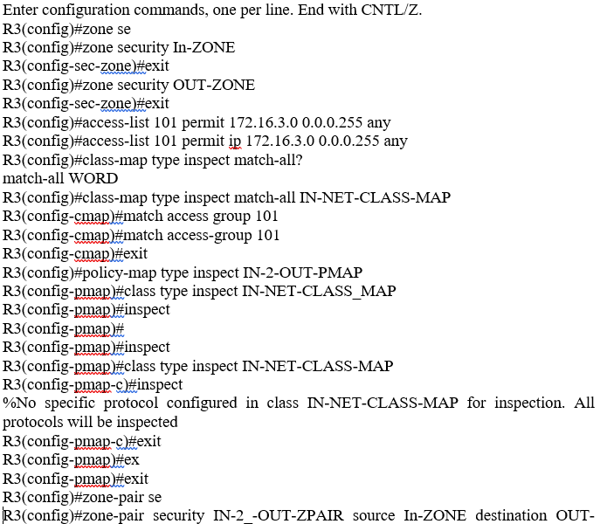
ZONE
R3(config-sec-zone-pair)#service-poilcy type instpect IN-OUT-PMAP
^
R3(config-sec-zone-pair)#service-poilcy type instpect IN-2-OUT-PMAP
R3(config-sec-zone-pair)#zone-pair security IN-2-OUT-ZPAIR source IN-ZONE destination OUT-ZONE
R3(config)#zone-pair security IN-2-OUT-ZPAIR source IN-ZONE destination OUT-ZONE
R3(config)#zone-pair security IN-2-OUT-ZPAIR source IN-ZONE destination OUT-ZONE
R3(config)#zone-pair security IN-2_-OUT-ZPAIR source In-ZONE destination OUT-ZONE
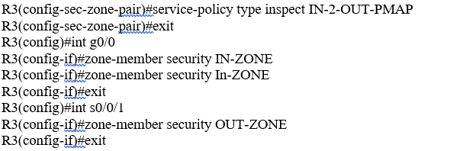

Secure network design, management and reporting:-
Comprehensive security policy :- A comprehensive network security policy is a type of plan like battle that guide your organization. This policy ensure that your network or system’s data is safe from cyber threats or breaches.It helps to enhance over all security level of any organization . Some of the few security threats are avoided by this from network or system. This helps in compiling equip. and auditing of network. This leads to increase in the operational efficiency. Accountability is is maximum of both user and stakeholders in your org.

Techniques and tools used for network security testing:-
            - Network Scanning :- This is a port scanning tech. used to checking all hosts connected to the network. The N/w services are scanned like HTTP and FTP etc. This helps to find the available ports are only allowed to secure services.
            - Vulnerability Scanning :- This is scanning tech. used for finding loop holes and also vulnerabilities in a system . In simple words this tech. tells weakness of the system or network. Those weaknesses can be improved.
            - Ethical Hacking :- This tech. find out potential threats in a system or n/w. This helps to track unauthorize users on a n/w and also find out malicious content.
            - Penetration Testing :- The Pentest attack made on a network or system to find out security breached or loop holes. This tech. works with all type of devices like routers servers mobile wireless devices etc.

Network Scanning Tools :-
- Intruder
- Wireshark
- Snort
- Skybox Security
- Angry IP Scanner
- Retina
- Splunk
- Advance IP Scanner
- Acunetix
- PRTG Network

The Most Common Layer 2 Attacks and Their Mitigation :-

Vulnerabilities of and mitigation techniques for securing the Layer 2 infrastructure

- VLAN Hopping :- This is a type of network security exploit in which attacker attacks to a Virtual Lan and their resources over the network. The main motive beyond this attack to gain access to the host on virtual LAN
- CAM Overflow Attack :- This attack occur when attacker try to connect or may be conn. to one or more switch ports . After That he execute an application file that replicate many MAC addresses to the switch ports.\
- MAC Spoofing :- This attack is also layer 2 attack in which attacker attack on system to change the assigned MAC to the system. This MAC ( Media Access Control )cant be changed easily.

Techniques For Layer 2 Attacks Security :-
- Manage switches in safe manner.
- To avoid unknown n/w restrict management access to the switches.
- Every time assign and use dedicated VLAN ID for all trunk Ports.
- Avoid use VLAN 1 for something.
- Use MD5 authen, where possible.
- Shutdown ideal ports that are not in use and also put them into useless VLAN.
- Use ACL IOS to filter traffic.
- Use Port-level Security like DHCP Spoofing ARP and IP Source guard.

Switch Security :-
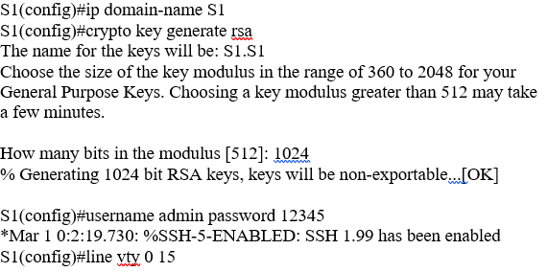

S1(config-line)#transport input ssh
S1(config-line)#login local
S1(config-line)#end
S1#
%SYS-5-CONFIG_I: Configured from console by console

S1#show ssh

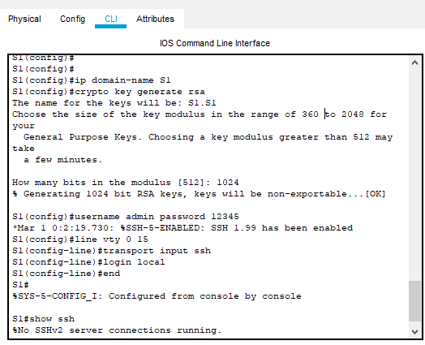

Cisco IOS IPS :-
The Cisco IOS stands for Internetwork Operating System. This s/w runs on cisco systems devices like router, switches etc . IPS Stands for Intrusion Prevention System. This working on with same tech to CISCOIDS Intrusion Detection System. This uses underlying routing that lead to extra security.This is used to prevent attacks or filtering safe data transmission in a network.

NIPS :- This stands for Network Intrusion Prevention System. This is used for monitoring n/w. Also this
Makes confidentiality ,integrity and availability on a network .This is mostly used to be safe from attacks like DDoS and unauthorized access. NIPS monitor malicious script by analyzing n/w traffic and packet filtering. NIPS is become very strong against trijan horse,worms,viruses and other threats.

Signature used to detect network traffic :- When and Antivirus, IDS , IPS and NIPS are comes into the action , they begins creating the signatures for each and every file .After that they starts monitoring of those signatures to incoming files from outside or inside . IF no signature found on the file then they shows an alert to that file as malicious file or content.

IOS IPS

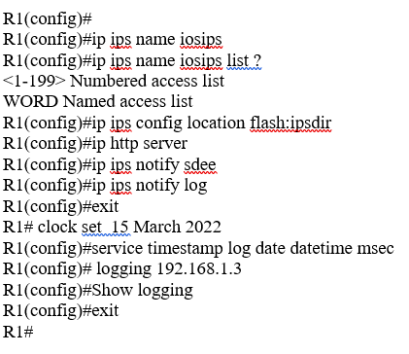

Implementation of Site to Site VPN :-
- Create a customer gateway
- Create a target gateway
- Configure routing
- Updating of security group
- Creating a site to site VPN.
- Downloading of configuration file
- Configuration customer gateway device.

The Purpose Of VPN :- Main purpose of VPN (Virtual Private Network ) is to hide online activity and used as security guard against hacker . VPN also snoop networks and able to hide information ,IP address or your online activity.

Working Of IPsec VPN :-IPsec is package of rules or protocols that are be in use to start secure and encrypted conn. between multiple devices. This hleps to exchange data through public n/w very safely. IPsec
VPN are used for security terms in which IP packets are encrypted throughout transmission . This VPN changes key exchange between 2 devices to decrypt the encoded message. IPsec adds multiple headers to the data packet having encryption and authentication info. The IP sec use UDP (User Datagram Protocol ) for transmission . Because IPsec allows packets to go through firewall . In simple words IPsec is works on those terms as mentioned ,Key exchange, Packets headers and trailers, Authentication, Encryption, Transmission ,Decryption etc.

Site-to-site IPsec VPN, with pre-shared key authentication, using CLI :-

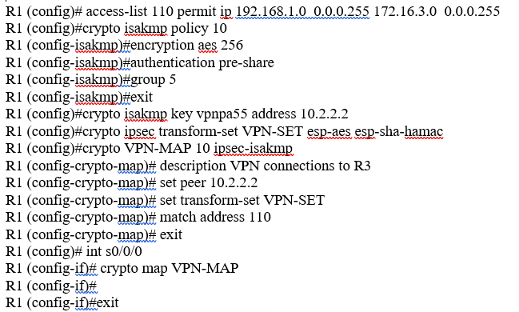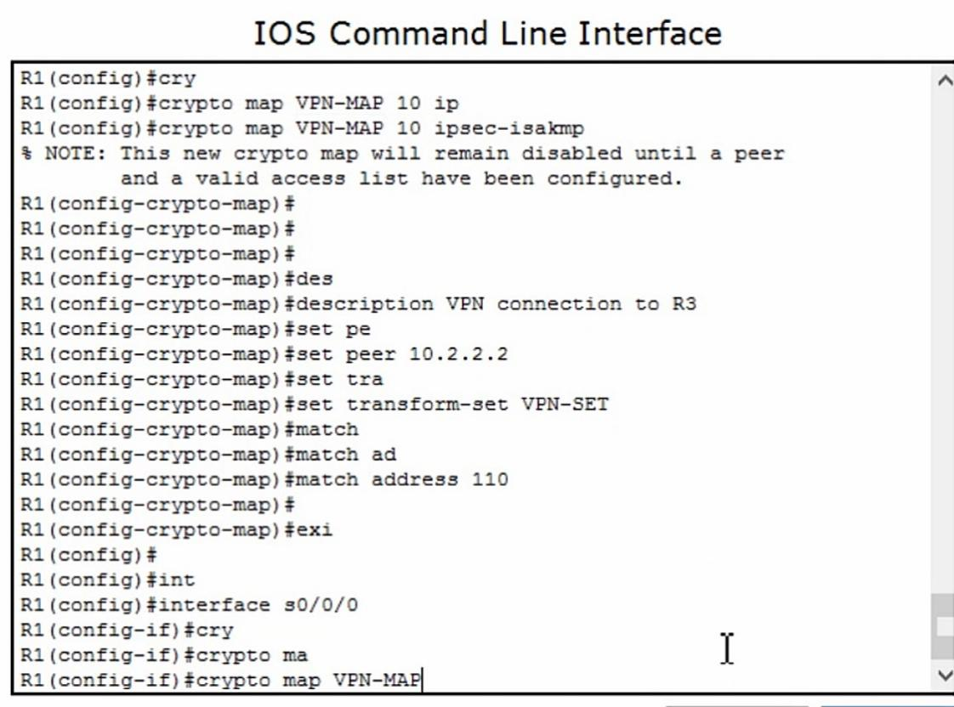
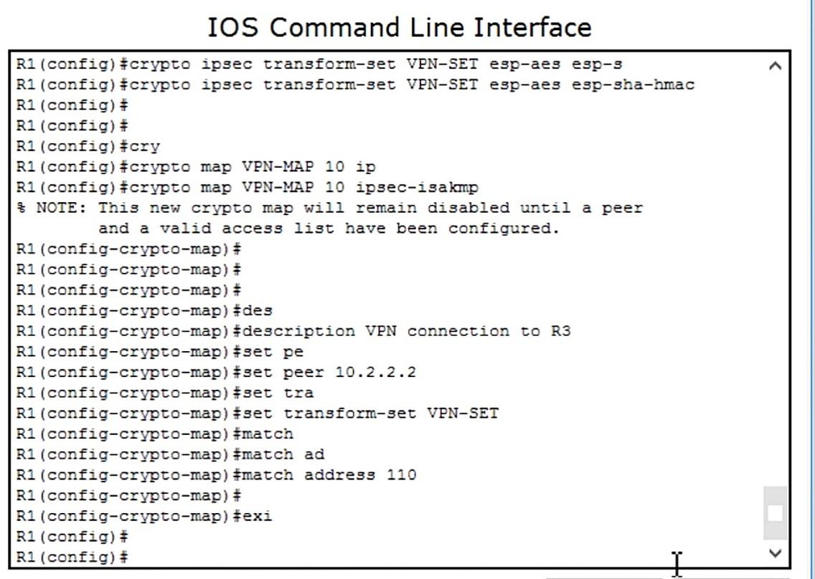

Now Repeated On R3
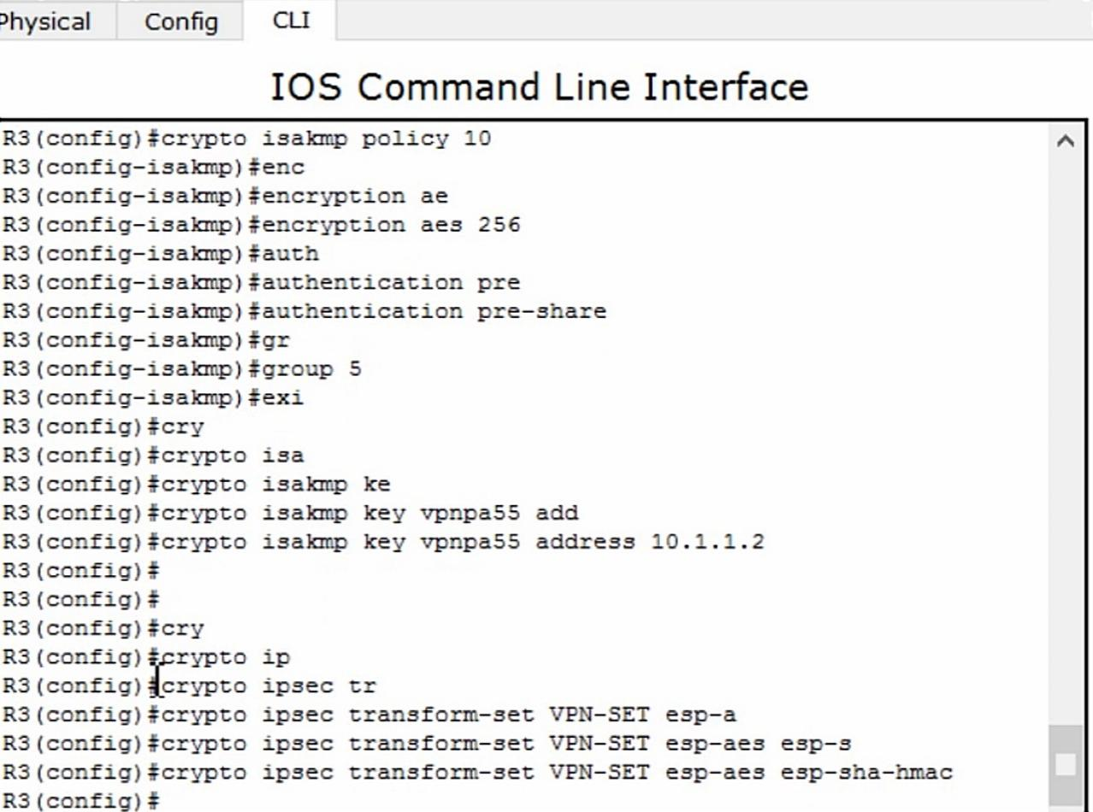

How the types of encryption, hashes, and digital signatures work together to provide
confidentiality, integrity, and authentication :-
Encryption ,Hashes ,and Digital Sign. Are best security terms that works together . In a network signatures are assigned to every device by IPS or IDS that are validated firstly for incoming and out coming requests. Signature include one sub type called hashes . Transformation of data of any size into a specific fixed out-
Put is called hashes. Signature has also a valid encryption key of server to decrypt the message securely .
This all process is interconnected to each other and provides confidentiality ,integrity and authentication.

How cryptographic hashes are used to ensure data integrity and authentication

In the TLS (Transport Security Layer) hash function is used to ensure integrity of encrypted data. A Cryptographic hash is one type of checkpost. But this function is used to detect deliberate alteration of data .When data is processed by Hash function then it produce small string of bits known as hash. This function does not require cryptographic key.

How encryption algorithms are used to ensure data confidentiality:-
Enc. Algorithms are used to make data confidentiality . Because when a data is encrypted with specific encryption algo. . Then a secret key is set up by the sender .No one can decrypt data without decrypt key, who don’t have key. So as this encryption algo. Helps to make data more and more confidential.

How a public key infrastructure is used to ensure data confidentiality and provide
Authentication :-
PKI (Public Key Infrastructure) this is the encryption method that prevent communication between server and client. With encryption and decryption PKI is fully based on Digital Cert. That check the ID of machines or users. This can use encryption directly through the key that generates it. PKI has two key (Public ,Private ) encryption system for best security.
Use OF PKI :-
- Securing Emails
- Web Communication
- Digitally Sign. S/w
- Di.Gi. Sign. Apps
- Encryption of file
- Decryption of files
- Smart Card auth.

Remote Access VPN :-
aaa authentication login VPNUSERSAUTH local
aaa authorization network VPNUSERS local
username ra-user password 0 passw0rd
crypto isakmp policy 7
encr 3des
hash md5
authentication pre-share
group 2
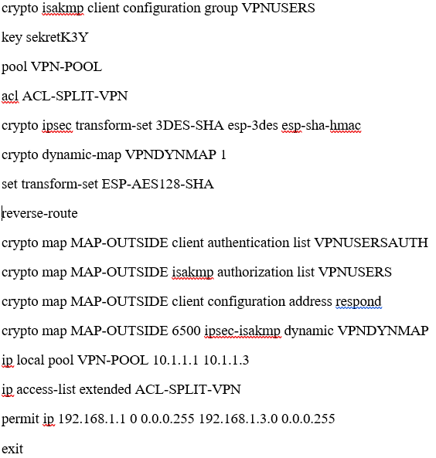
ASA firewall configuration with NAT/PAT :-

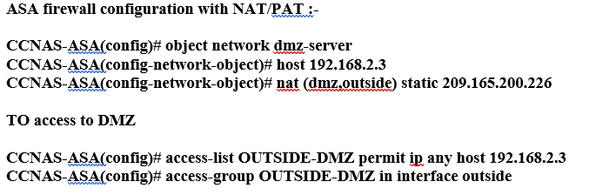

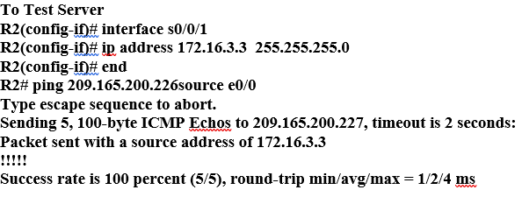

Abbreviation’s Used
Tech - Technology
S/w - Software
Addr - Address
Info - Information
Manag. - Management
Emp - Employee

REFRENCES :

- www.google.com
- www.cisco.com
- www.itexamanswers.net
- www.liunxteck.com
- www.youtube.com
- www.ccna6rs.com
- www.ciscopress.com
- www.juniper.net
- www.ipcisco.com
- Www.ciscopackettracerlab.net
- www.cisa.gov

NETWORK DESIGN AND IMPLIMENTATION

Network Blueprint Design For A2Z Technologies Ltd (UK)

Devices :-

  - Routers
    - Router 2811 (4 units)

    - Wifi Router WRT300N (Wire Less )Wireless router used in HR dept and Marketing Dept

    - Switch :-2690 24 TT

    - Firewall :- ASA5506

    - DHCP Server

    - Cisco IP Phone

    - PC’s Laptops ( Mobiles ,Tabs According To need)

- Technologies To BE Used :

  - ACL (Access Control List ) :- ACL used in filtering routing protocols, permit or deny traffic and maintain traffic .
  - VLAN :- Virtual LAN this design allows network design to be flexible.This is mainly for physically settlement of devices
  - NAT /PAT :-Network address translation or port address translation. These tech addresses network and also ports of the system .
  - IPS /IDS :- Intrusion Detection and Intrusion Prevention System works as check post is checks signature of each file and if found unknown then IDs shows alert and IPS block that request or file.
  - NIPS :- This is same as to IPS
  - Zone Based Firewall – Zone based firewall is for special are in which the user wants more security from other the this is used.
  - VPN :- This protocol hides online activity .This allows you to work on the internet secretly from attackers and other persons.
- Design And Configuration :-
- 6 Departments namely , HR, R&D, Marketing ,Finance, Sales, Customer R/ship Dept
- The company should be able to run voice over the VLAN and Wirelessly according to architecture.
- The design should support Email and Communication
- The Design Should also support Data Base Server
User Requirements :-

Number of Workstations :
- Marketing and Customer on the 1st Floor occupy 15 workstations
- HR and R&D Department on 2nd Floor with 10 workstations
- Sales And Finance Dept on 3rd floor With 15 and 10 system for each.
Availability :- Uninterruptible Network Connection and implementation should be scalable for future operations.
Security :-Network should be secured with restrict access. The n/w should have monitoring on indoor or outdoor operations.

Minimum Applications Requirements :- (Imp.)
Email Client - MS Outlook
Web Browser - MS EDGE
Data Base - MS Access

Device | Type | Specification | Numbers | Location
Gen. PC’s | Host/Admin | I5 128 SSD  RAM 8GB | 75 | Apartment of Company
Server | Application,  Email  Data Base | CPU:Intel Xexon  RAM-64gb ROM-64tb | 3 | Server room
2811 Router | Integrated Service | DRAM-512MB  Flash memory 128mb | 4 | 1st to 3rd floor
IP Phone | VoIP | Cisco IP Phone 7960  Cable :cat5E (8P8C twisted pair ) | 75 | 1st to 3rd floor
5506-X-ASA | Firewall | Unlimited Nodes Memory -4GB | 1 | Server Room
2690 24TT | Switches | DRAM -4GB 24 ports | 7 | 1 TO 3rd floor
Cables | Copper Straight Through,serial | RJ45 |  | As per need

N/w – Requirements :- NIC Card, RJ45 connector etc, NOS ,Linux For server, Windows For clients

BUDGET | PERICE/PERUNIT | UNITS | AMOUNT
Gen .PC | 15000 | 75 | 1,25,000
Cisco IP Phone 7960 | 9089 | 75 | 6,81,675
Cat 5E | 1350 | 75 | 101250
2690 switch (24) | 1700 | 7 | 11900
Cable -moderm | 2099 | 1 | 4190
2811 Router | 44210 | 4 | 176800
5506-x-asa | 42569 | 1 | 42569
35506-24ps multilayer switch | 64659 | 1 | 64659
Serial DCE | 240 | 3 | 720
Dell Power edge R340 server | 97902 | 3 | 293706
 |  | TOTAL | 2502469

ADDRESSING :-
DEPARTMENT | NO.OF DEVICES | N/W ADD. | FIRST ADD | LAST ADD | BROADCAST ADD | SUBNET  MASK
MARKETTING | 15 | 192.168.1.0 | 192.168.1.1 | 192.168.1.254 | 192.168.1.255 | 255.255.255.0
CUSTOMER | 15 | 192.168.2.0 | 192.168.2.1 | 192.168.2.254 | 192.168.2.255 | 255.255.255.0
HR | 10 | 192.168.3.0 | 192.168.3.1 | 192.168.3.254 | 192.168.3.255 | 255.255.255.0
R &D | 10 | 192.168.4.0 | 192.168.4.1 | 192.168.4.254 | 192.168.4.255 | 255.255.255.0
SALES | 15 | 192.168.5.0 | 192.168.5.1 | 192.168.5.254 | 192.168.5.255 | 255.255.255.0
FINANCE | 10 | 192.168.6.0 | 192.168.6.1 | 192.168.6.254 | 192.168.6.255 | 255.255.255.0

ROUTING PROTOCOLS USED :

- DHCP (Dynamic Host Control Protocol ) for assign dynamic ip addresses
- RIP (Routing Info. Protocol)
- OSPF (Open Shortest Path First)

IMPLEMENTATION :-
- Prepare :- 2 Weeks
- Plan :- 2 weeks
- Design :-3 weeks
- Implement :-4-5 weeks
- Operate :-3rd Month.
- Optimize

This purpose plan will follow the Cisco PPDIOO.

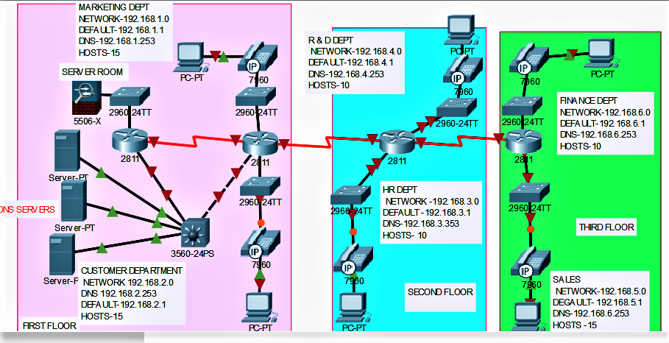

NOTE :- This above image shows blueprint design and hosts are used only one .But according to design host limit and their ip address ranges are written in above table. Security not mention because it depends upon company’s choice where they want what protocols and other security terms.

