3/23/2026
University of Wales Trinity Saint David
London campus
Module Name: Learning In the Digital Era
Module Code: ACCA 4025

Student Name: Mesfin Tezera
Student ID: 2510889
Group: 2

Professor: Koushik Modak

E-Portfolio Link:
Wix Harmony Editor | Mesfin Tezera Port
LDE Assignment 1
E-Portfolio

Table of Contents

Introduction 2
Main Body 2
Task 1: Essential Academic and Employment Skills for the future career Path 2
Task 1 (a): Report on Essential Academic and Employment Skills 2
Task 1 (b): Evaluation of Task 1 (a) based on Similarity report 2
Task 2: Collaborative Mind Map and Individual Poster 2
Mind Map (Collaborative) 2
Poster (Individual) 2
Task 3: Virtual Collaboration and RefWorks 2
Report on Virtual Collaboration 2
Step-by-step process of using RefWorks with visuals 2
Task 4: E-Portfolio Creation and Evaluation 2
Task 4 (a): E-Portfolio Creation 2
Task 4 (b): Illustrative Review of E-Portfolio tool Selection 2
Conclusion 2
References 2
Task 1 References: 2
Task 3 References: 2

Task 1 Essential Academic and Employment Skills for the future career Path

Introduction

To succeeds in both education, career and the modern workforce, individual most develop Essential Academic and employment skills. “These are core, transferable abilities- such as communication, decision -making, self-awareness, and teamwork-that can be used in almost any career. As our economy becomes more driven by technology, a higher percentage of future jobs will require these specific skills to bridge the gap between finishing school and staring a successful career. By working hard on this area, students can be proper for higher -paid positions and long-term professional growth. This essay will examine how mastering clear communication, effective decision- making, personal self-awareness, and strong teamwork create a foundation for success in a changing world.

(a): Report on Essential Academic and Employment Skills

An Essential Academic and Employment Skills identifies the core, transferable abilities such as communication skills, problem-solving, decision making, self-awareness, and team working those are success in both education and the modern workforce. In future in the employment and education sector there will be in high percentage of jobs and high education requires those elements. They aim to bridge the gap between education and employment by promoting skill development to support higher paid job and career progression, particularly in a changing, technology-driven economy.

The essential academic and employment skills are important and include Communication skills, Decision making skills, Self-awareness skills and team working skills. let us look one by one all those point in detail. First Communication skills these skills are both verbal and written form of communication skills it is very crucial skills because to transfer information clearly and effectively so that to avoid misunderstanding, through good communication anyone can articulate their thoughts ideas clearly can be understand them [1]. When we communicate effectively, the benefit helps both sides. If we look at decision making skills on other hand it is involve the ability to analyse situations and making good decision or make good choice because good decision can lead to successful outcomes at workplace or academic and employment [2]. Other decisions, such as career decisions, are more obviously important because they are likely to have a major influence on our lives Self-Awareness skills also teach us tolerance, creativity, initiative and willing to learn new things on lifelong learning or employability on professionalize our self the area we are working and maintain us to stay in our professional growth [3] .

Also, when people became aware of critical and personal thinking experience in their life they start to understand the force of self- awareness, they start to change their direction and move to the right ways. Finally, team working skills its highest and important skills for student and after graduation when they come to e ability to work effectively with others towards a common goal. These skills refer to the groups, individuals’ disciplines and create Strong teamwork abilities [4].The ability to working effectively with others is critical and important. Those skills communication, decision-making, self-awareness, and teamwork—are crucial for both academic success and professional growth.

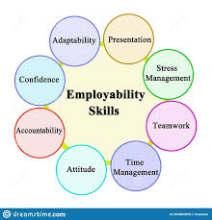
Figure 1: Employability Skills [5].

Task 1 (b): Evaluation of Task 1 (a) based on Similarity report

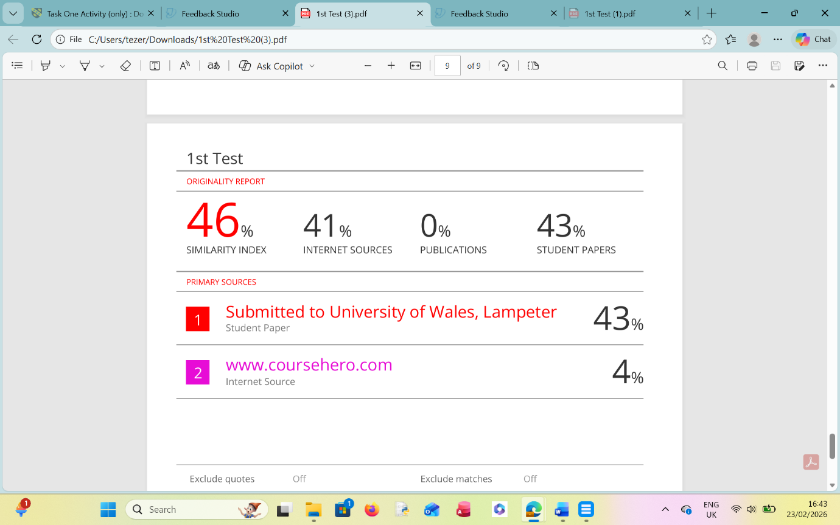
The similarity report indicates a level of overlap consistent with common patterns used by many learners. However, the reminder of the work shows strong compatibility in terms of referencing, specifically concerning the correct use of IEEE standards and citations. Some of the recognised similarity is therefor due to use of online student’s paper and digital learning Platforms rather than a lack of original thought.
I believe the work merits a mark 74% because I have extensively researched distance learning modules and online academic platform to inform my approach. Furthermore, I included a significant image display relevant to academic and employment skills to enhance the task. This work demonstrate that I am strictly following the classroom guidelines and the specific briefs provided for my assignment.

Task 3 Individual Posters
Poster Link:

https://www.canva.com/design/DAHC0QikkkU/UW-iYfwqHR3qc1hkJql1jw/edit?utm_content=DAHC0QikkkU&utm_campaign=designshare&utm_medium=link2&utm_source=sharebutton

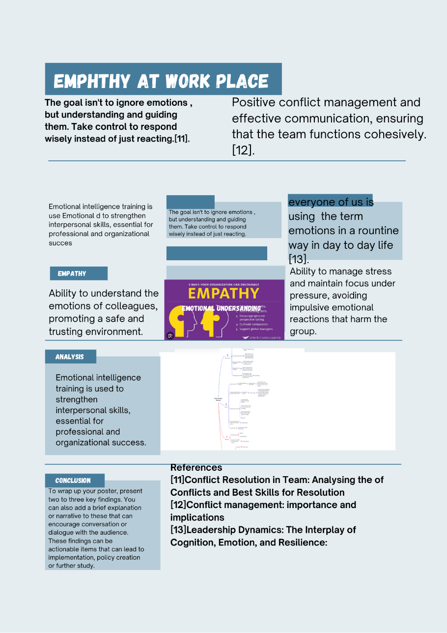

Poster Image1: Explaining Empathy at workplace because Empathy One of the most valuable skills to have in the workplace is empathy. This can help you better relate to your coworkers and clients.

Mind Map Link: https://mm.tt/map/3952802819?t=dCVxYhEwu0

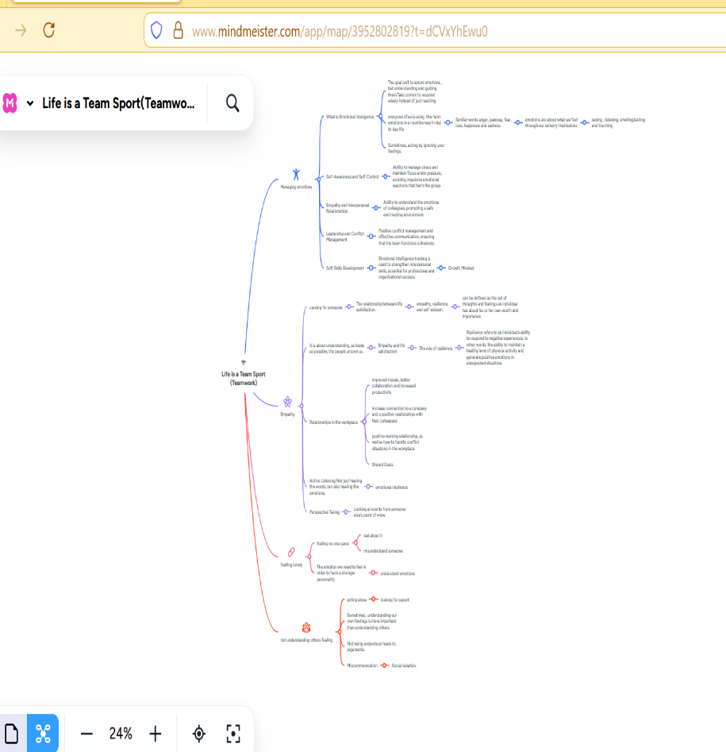

Figure 2: Mind Map (Collaborative group mind mapping take place in class

Task 3 (a) Unit 3Topic Summery (350) words
Digital collaboration has big impact son people life day to day activities such as today there are numerous people relay on the digital collaboration to do their job every day. for example, everyday there are thousands of emails sent and received every day. team meeting among employs, companies and individualise. Digital collaboration created [6]. a shared virtual space where distance and time zones become irrelevant. The more
people use digital collaboration the more they share knowledge with each other’s.21st centre many people start using this digital application to solve problems through communication virtually. the benefits of collaboration to both parties, and the enablers of mutually beneficial collaborative relationships. Such collaboration is at the centre of digital transformation projects; this digital collaboration has also created massive social media sites which brings millions of people around the world to come together to discuss their issues. Those social media have been used for many types of purposes such as discussion, marketing, meetings and much more things [7].
It has been created already those communication styles for project collaboration in many countries and organization as well to make life easier for workers in every sector of business.
[8]. This digital collaboration has changed the way people communicate traditional majority organizations, Companies all around the world tried to use those tools to see growth in their business implies that most of the global workforce needs to be either reskilled or upskilled to adapt to the changing digital landscape has brought to the workplace.
A collaboration platform is a platform that allows employees to collaborate and coordinate their work together in that way the benefits many ways., those ideas such as managing time, money travel etc., in this ways sharing, real-time information and data, virtual meeting, task administration, etc. make origination much more profitable for example During the pandemic, organizations everywhere in the world widely adopted collaboration platforms and it was useful to them to chare all their business duties. . Since the benefit of this platform and remote working trend, the organization is likely to continue using these platforms up to today. Organizational integration is a crucial factor for the success of the organization. Organizational integration which consists of human integration and task integration seems to benefit from the application of a collaboration platform [9].

Task 3: Virtual Collaboration and RefWorks

Task 3: Virtual Collaboration and RefWorks

Report on Virtual Collaboration

Task 3 (b)Use of RefWorks

RefWorks is characterized by steady logins and large amounts of references. Many student benefits for this fast-growing system to make large number of references in one time for them
academic research around universities and colleges [10]. RefWorks is a cloud-based reference management tool designed to help students organize their research and automate the often-tedious process of citing sources. For most students, it acts as a digital library and personal citation assistant. On this application student can insert their work without any difficulties they can insert in-text citations directly into Microsoft Word or Google Docs while they are writing. The bibliography updates automatically as they add citations for reference purpose.

Task 3 Automated Referencing software tool (RefWorks)

Task3 RefWorks Adding Automatic References
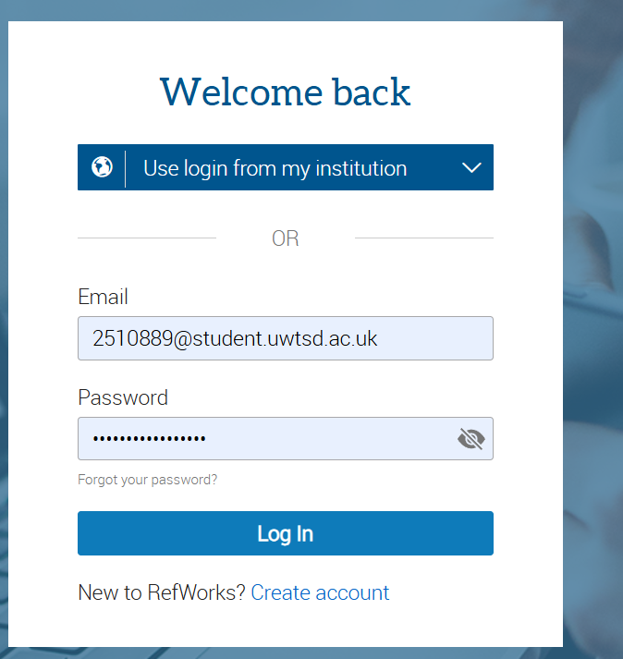
Figure 1: I Created an account to Automatic Referencing on University email address to refer for part of research in my Academic research during my Academic year at the

y.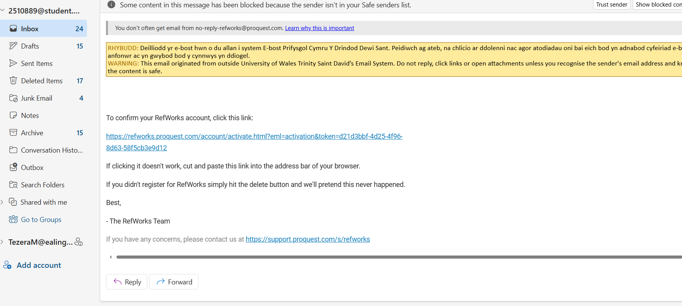
Figure 1.1
- Activation email has been sent by RefWorks
- Click on link to get to website where I can carry on the Automatic Referencing

Figure 2: RefWorks manager with word document connected

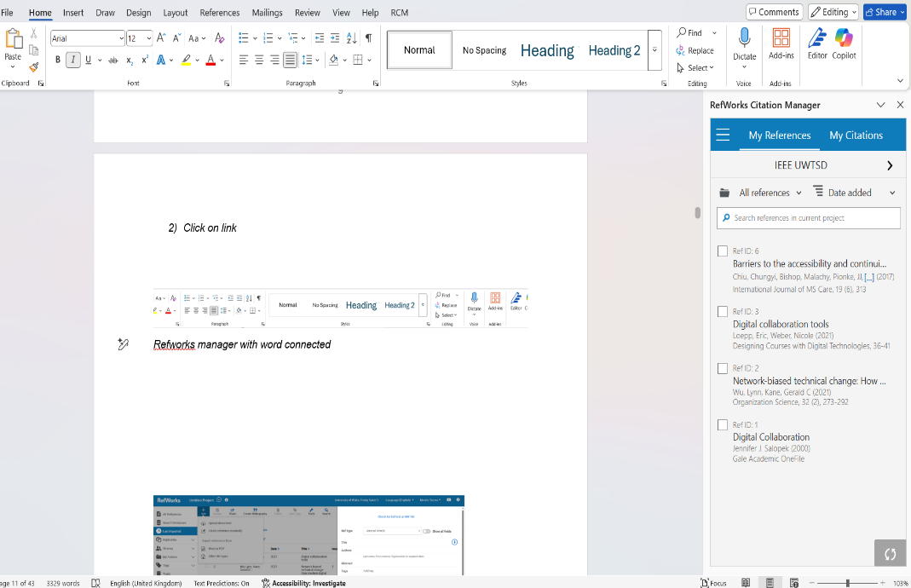
Figure 3: RefWorks Citation manger showing me that all my Reference from Automatic Referencing

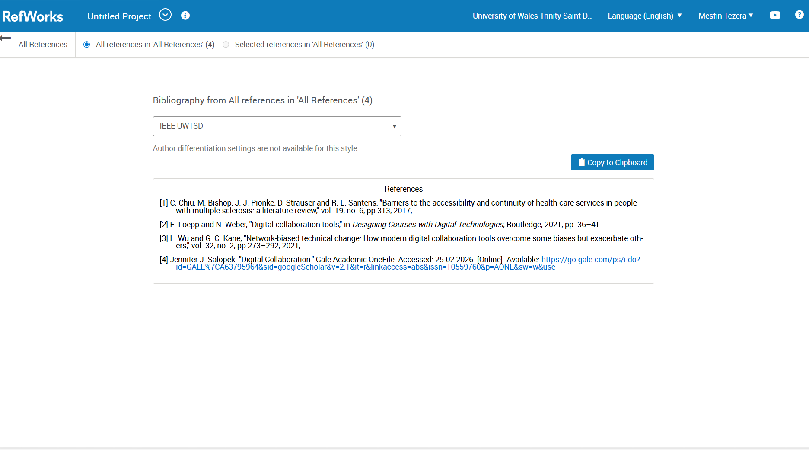
Figure 4: Here I am creating bibliography to the RefWorks so that my refence transferred to word document
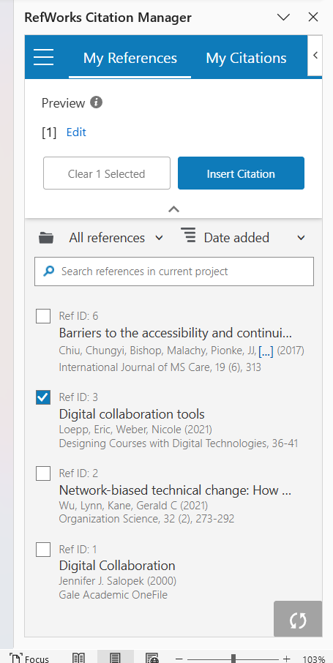
Figure 5: Automatic citations which have been saved has come forward for my conformations

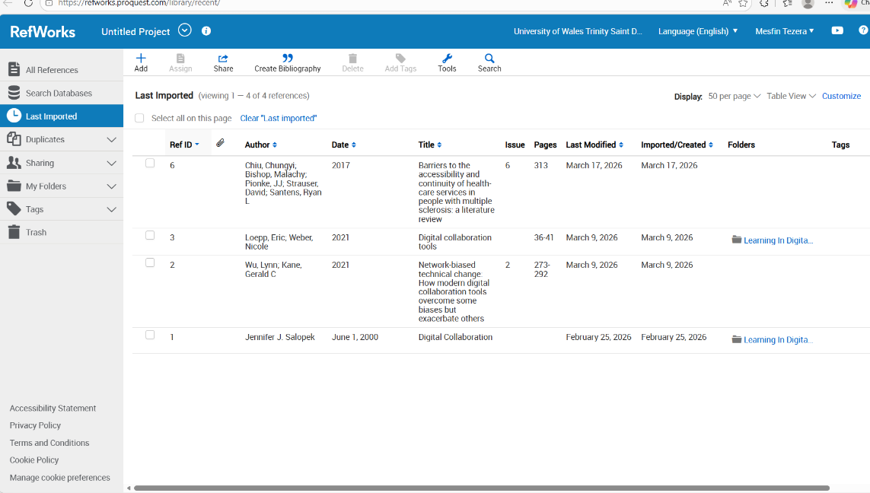
Figure 6: List of my Citations displaying on dashboard for my reference

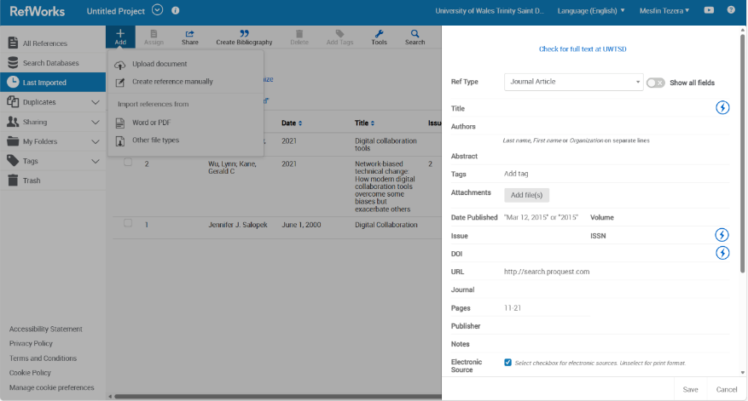

Figure 7: Creating Reference Manually in RefWorks when specific website unpublished report automatically imports from a database

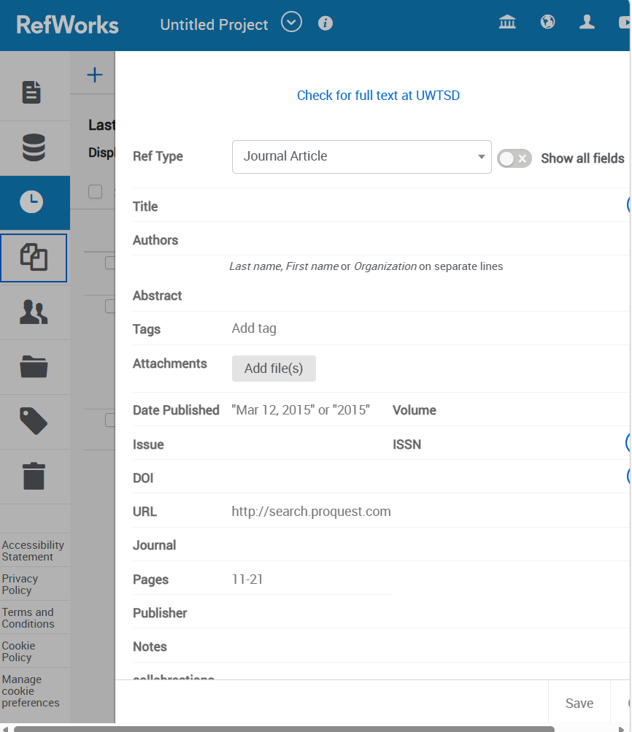
Figure 8: selected reference manually and added the name as journal here Creating Reference Manually in RefWorks when Specific website unpublished report automatically imports from a database from my reference.

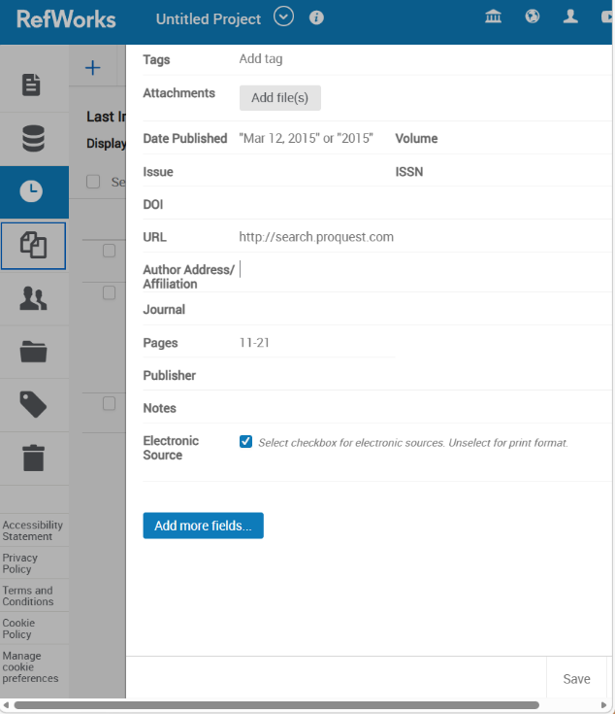
Figure 9: entering reference in sections Selecting Source Type select the appropriate source type (e.g., Book, Journal Article, Web Page, Report to indicate where the reference come from

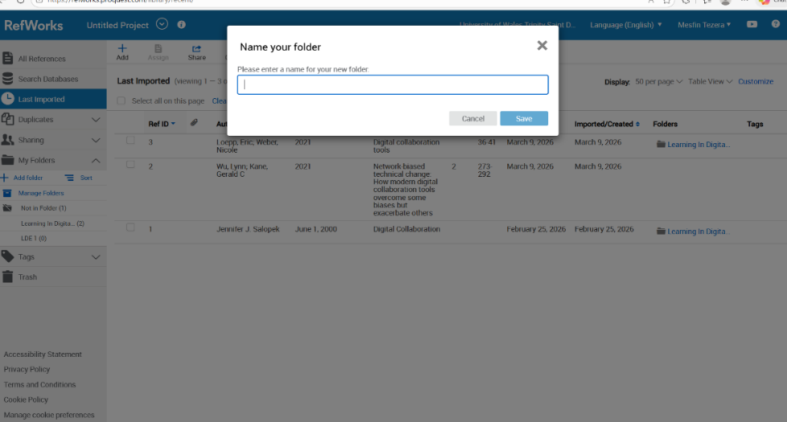
Figure 10: adding new name on folders Fill in the bibliographic details to fill in fields required by your specific referencing style.

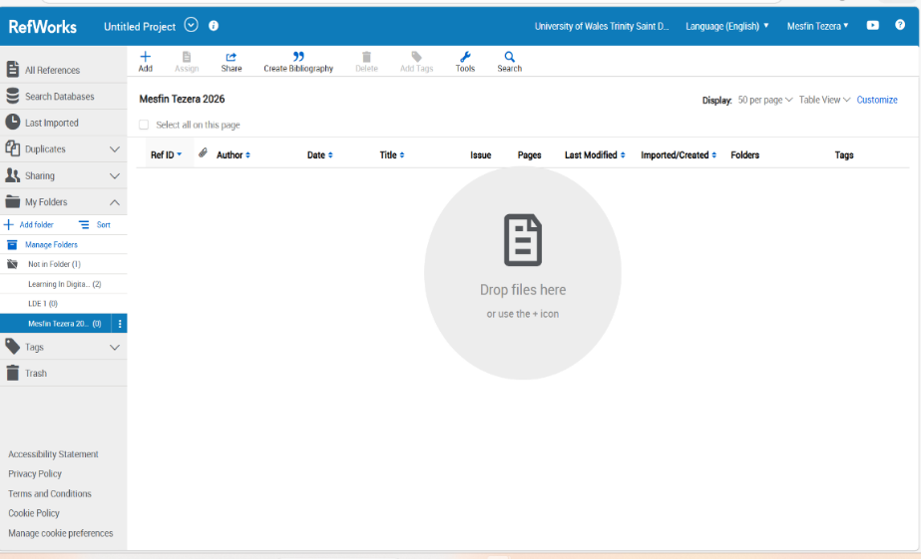
Figure 11: Demonstrate of the final organization process, wherein the reference folder was renamed for clarity, following by saving the updated file structure to ensure organized documentation.

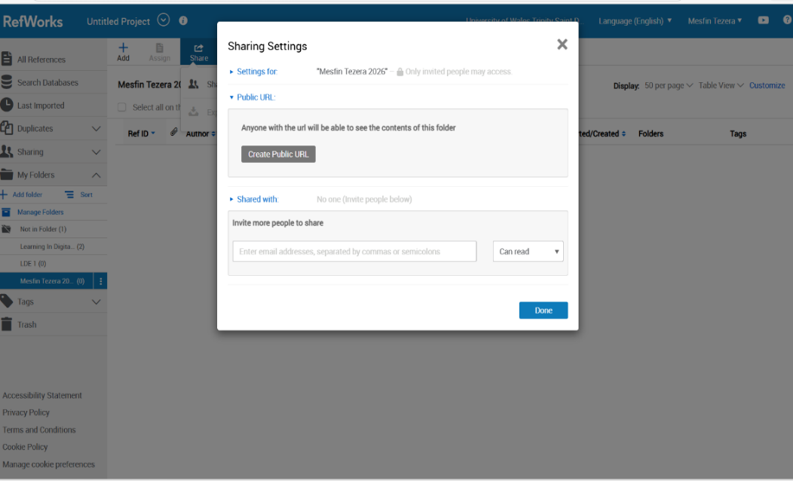
Figure 12:: illustrates the streamlined process of sharing folder and transporting digital, demonstration how users can securely transfer data and collaboration with others in real time

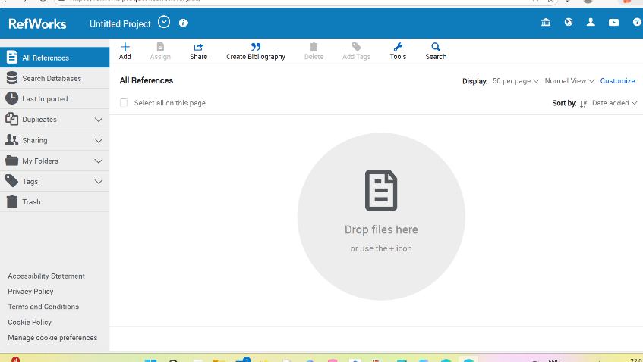
Figure 13: The RefWorks opening dashboard, serving as the central hub for user research activity, allowing for the immediate inspection and organization of all imported reference, folders and integrated citation tools to ensure system readiness.

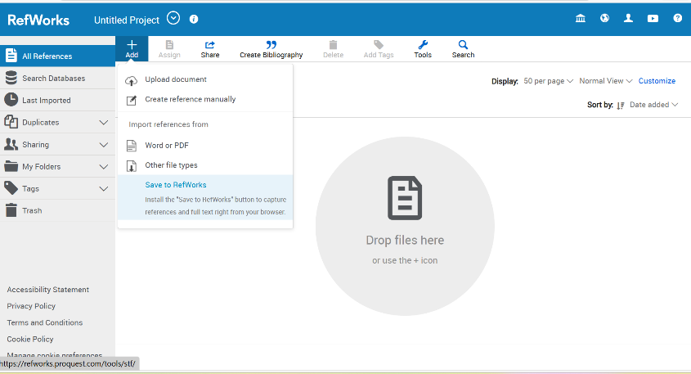
Figure 14: The RefWorks interface demonstrating the process of uploading a document (PDF)and attached it directly to an existing bibliography record to ensure accurate full-text management

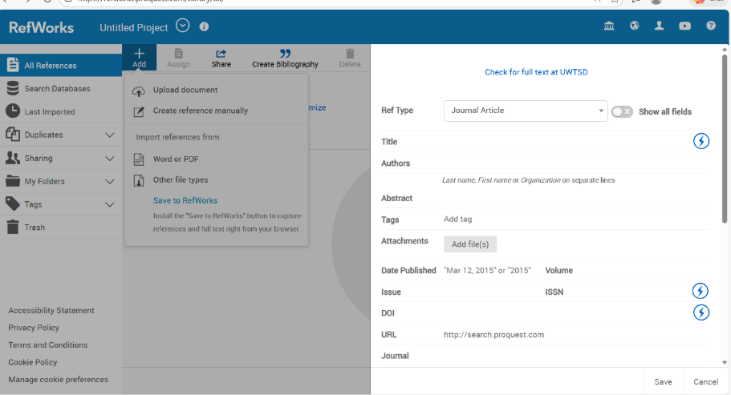
Figure 15: A screenshot shows the RefWorks user interference while a document is in process of being uploaded and processed from the user’s local repository into the RefWorks library.

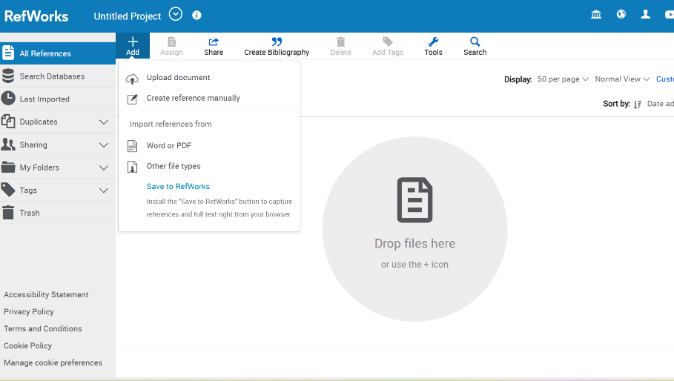
Figure 16: An illustration of the RefWorks interference, showcasing the process of re-uploading a document while simultaneously importing a specific, targeted reference to ensure citation accurate.

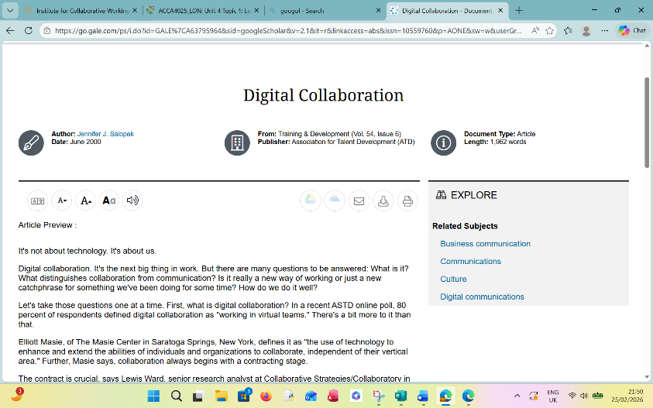
Figure 17: An overview of the RefWorks interference showcasing the bibliography creation process, highlighting the detailed bibliography information and formatting of citations for the final reference list

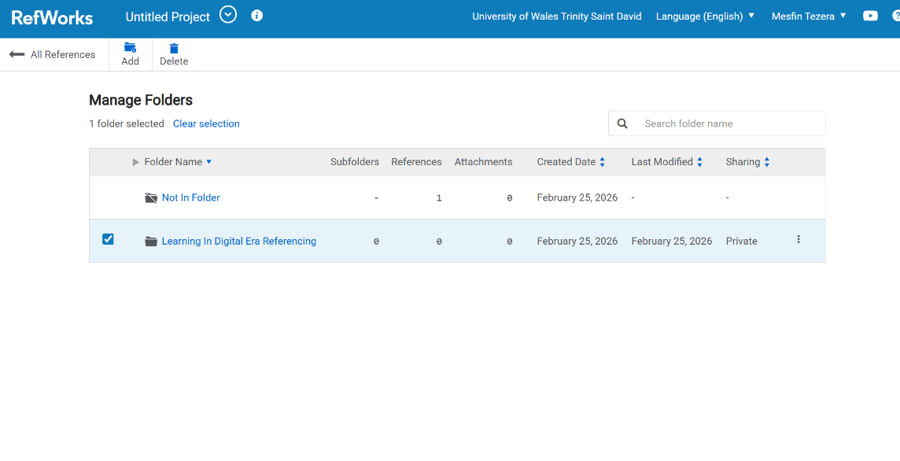
Figure 18: The RefWorks interference showing the process of checking, organizing and creating a formatted bibliograph, highlighting the selections of saved reference before generating the final list

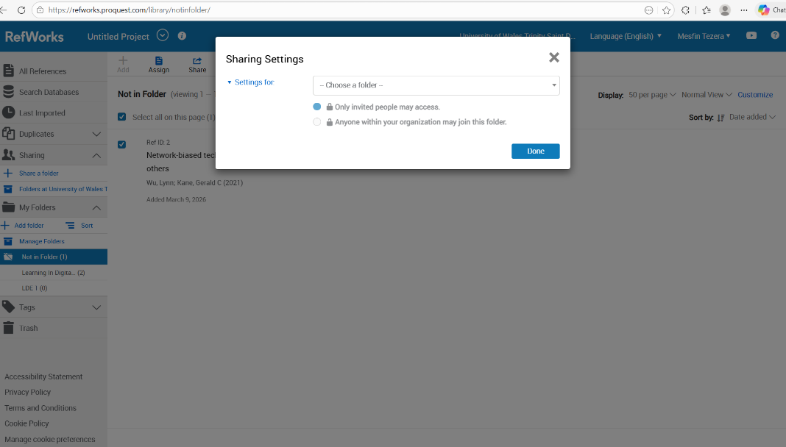
Figure 19: An illustration of the RefWorks interference demonstration the seamless process of sharing files while simultaneously utilizing the automatic referencing feature to ensure citation accordance

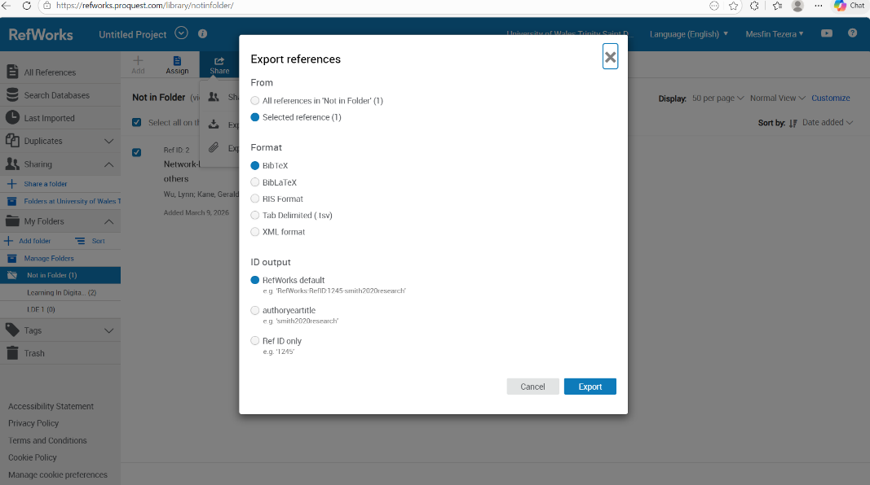
Figure 20: Demonstration the RefWorks interference during the process of sharing the files
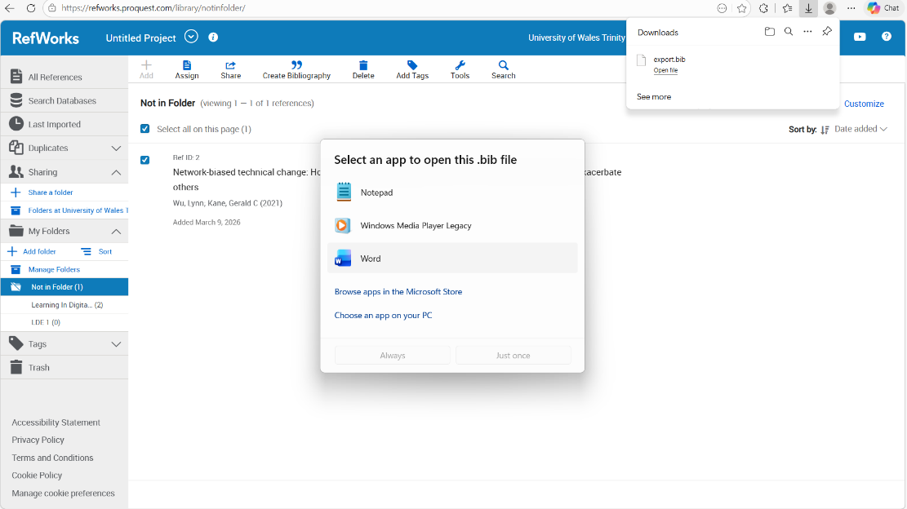

Figure21: RefWorks during viewing shared files to through the automatic
referencing

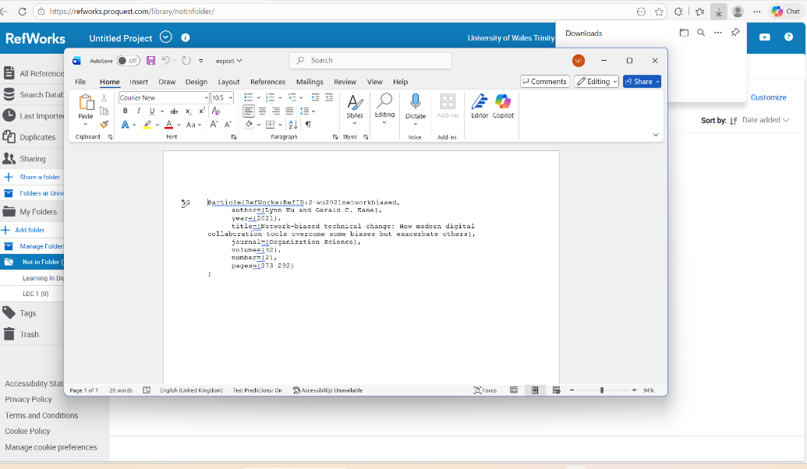
Figure 22: RefWorks during viewing shared files to check to ensure that right reference made

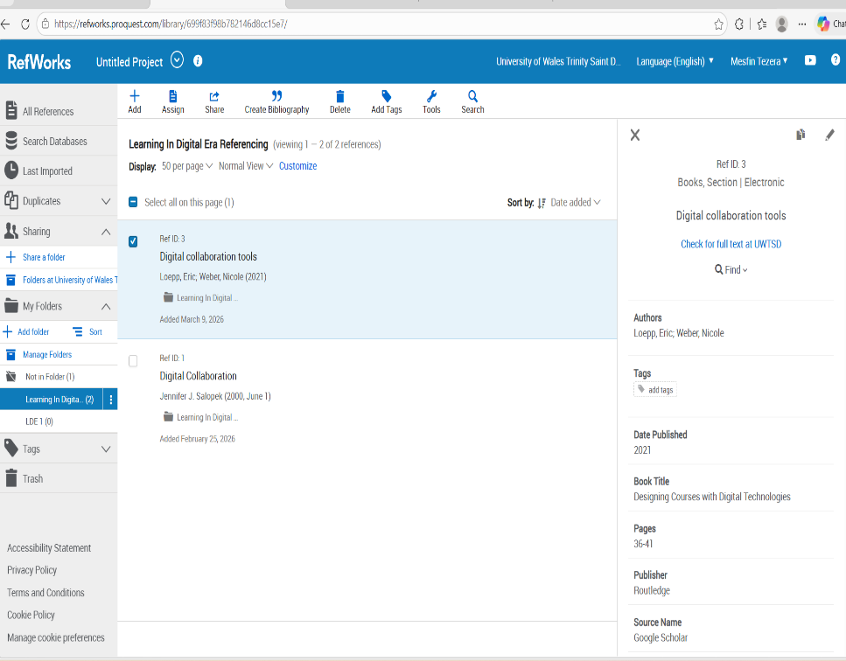

Figure 23: RefWorks during viewing saved files before to use as a citation

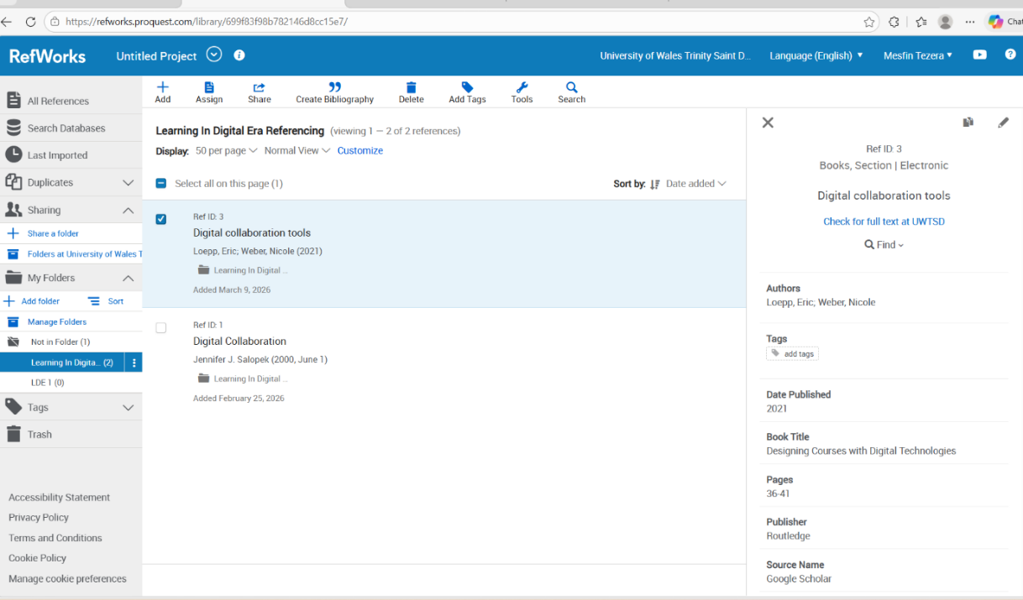
Figure 24: RefWorks during managing shared files to additional accurate citation

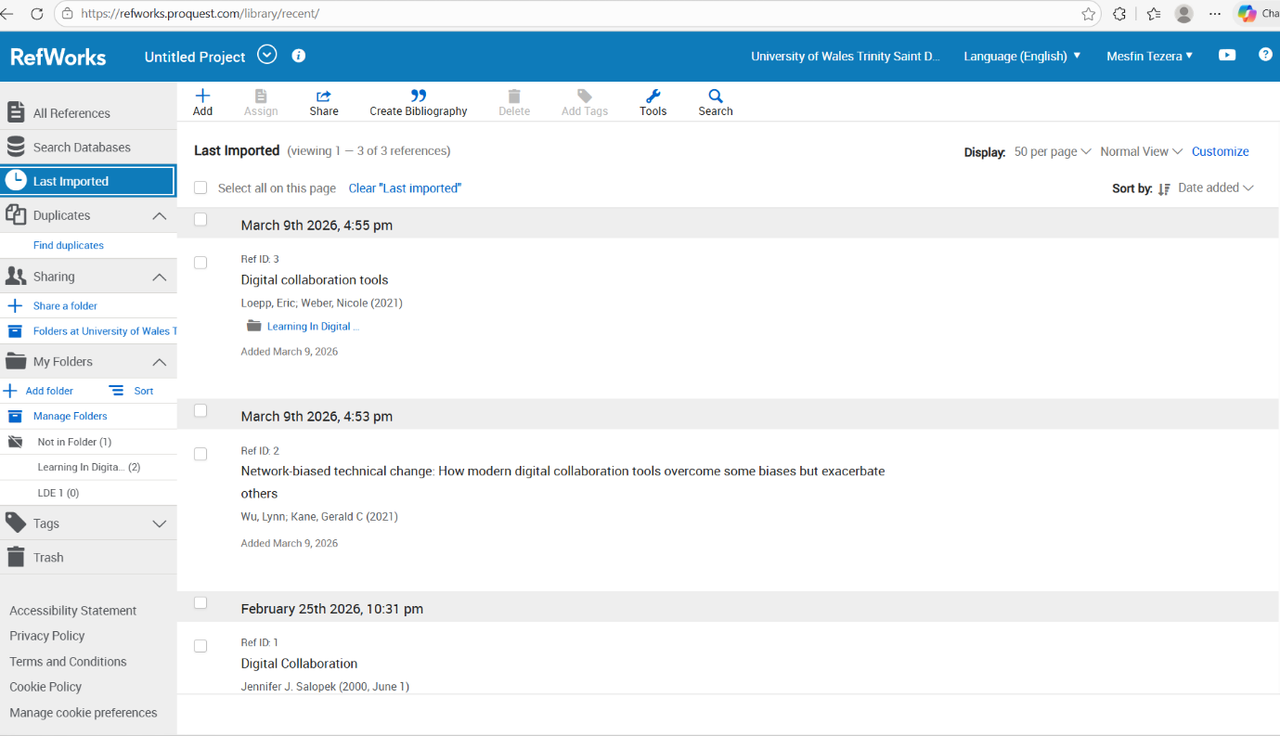
Figure 25: RefWorks during viewing shared files to check populate URL and access data field correctly

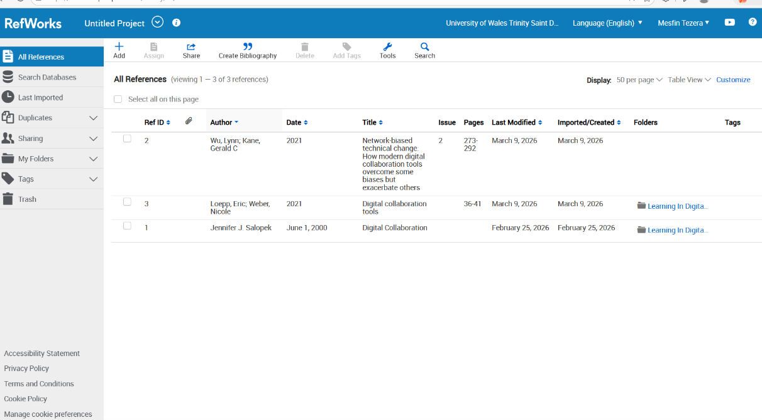
Figure 26: RefWorks during viewing all automatic references which held in the system

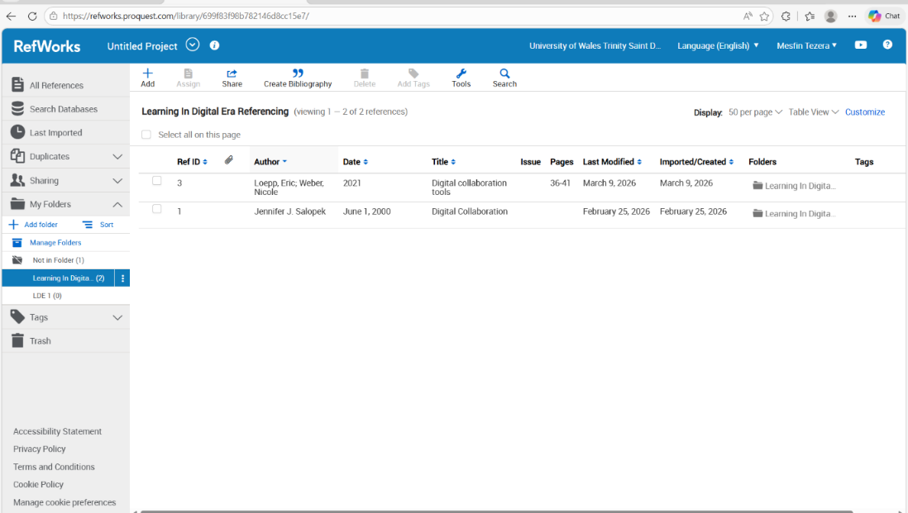
Figure 27: RefWorks viewing saved reference files to Digital era referencing

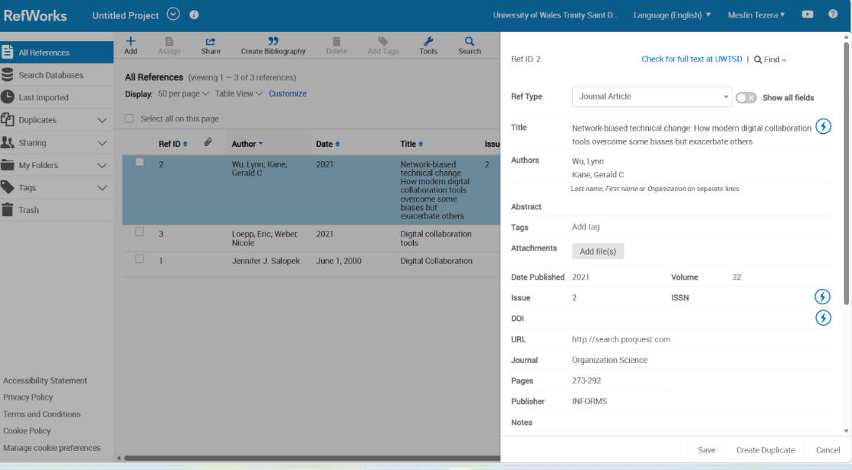
Figure 28: RefWorks during searching saved files and showing RefWorks

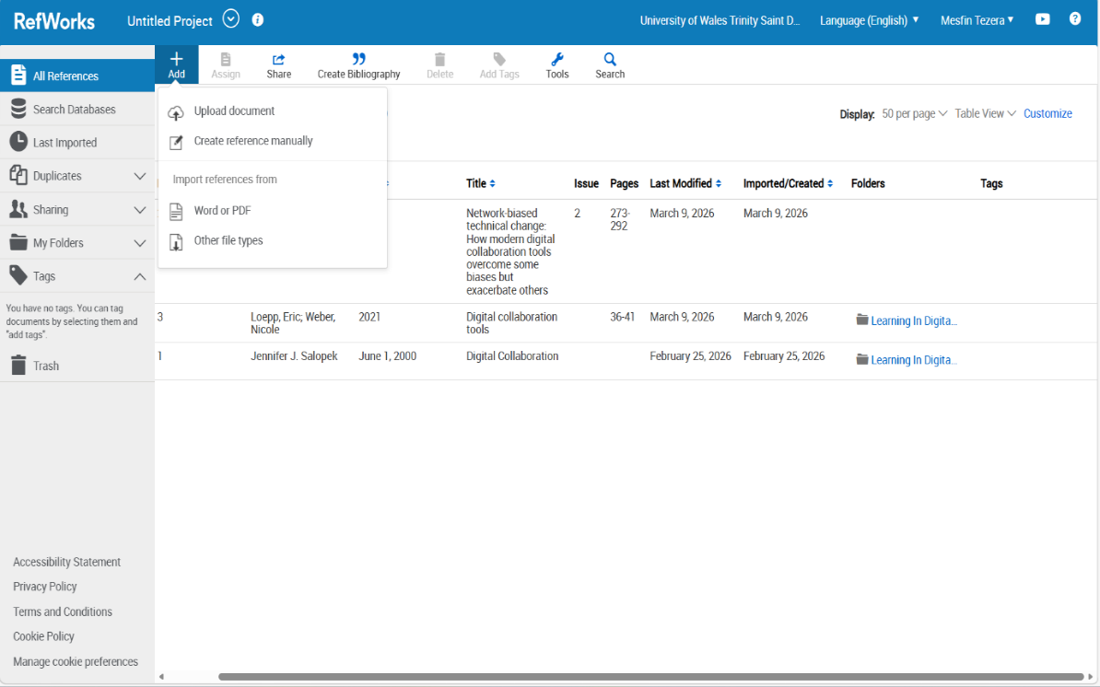
Figure 29: RefWorks uploading documents to word of PDF

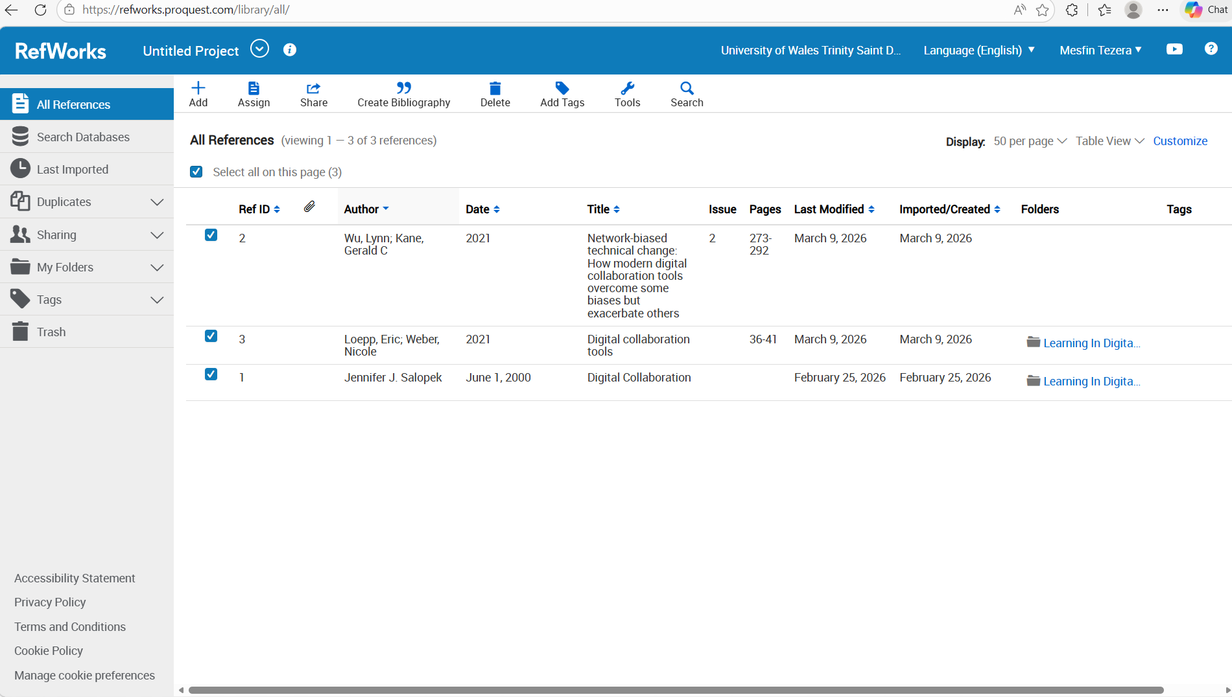
Figure 30: RefWorks during adding reference to existing files so that I can see in system

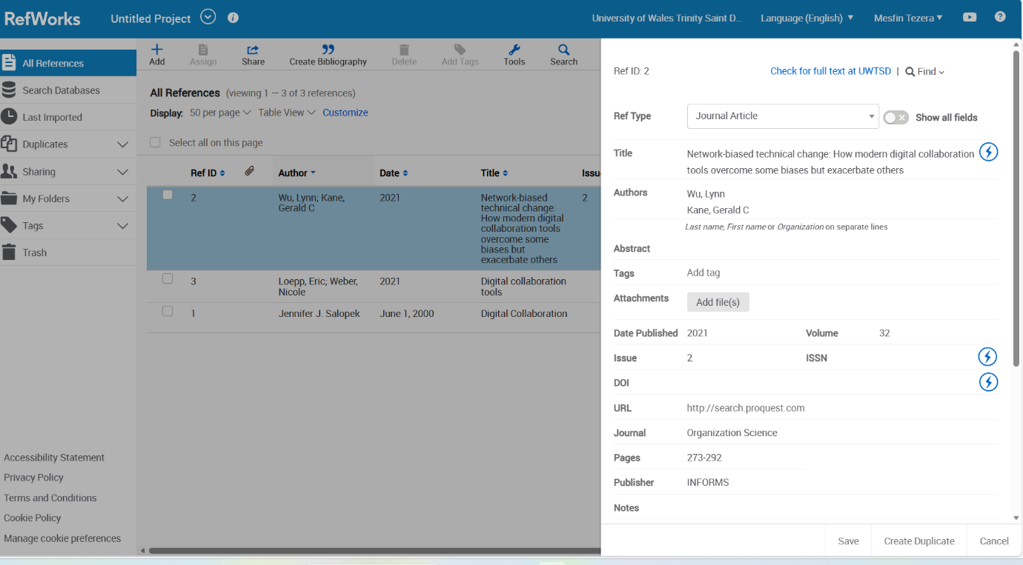
Figure 31: Manually adding existing files to RefWorks
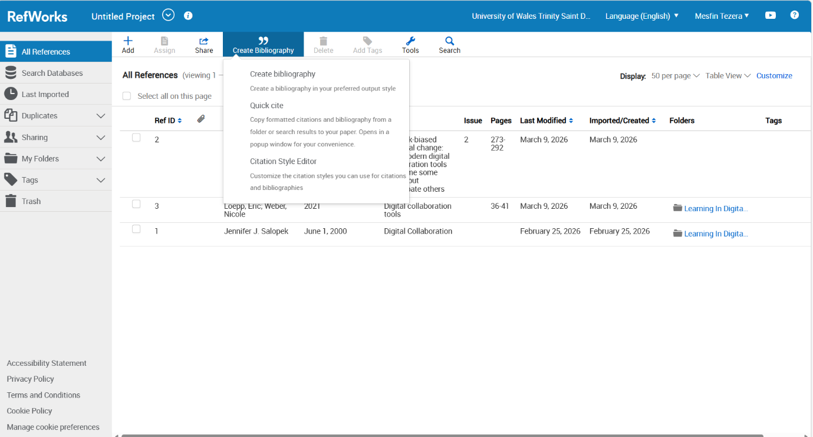
Figure 32: RefWorks during adding bibliography existing in files

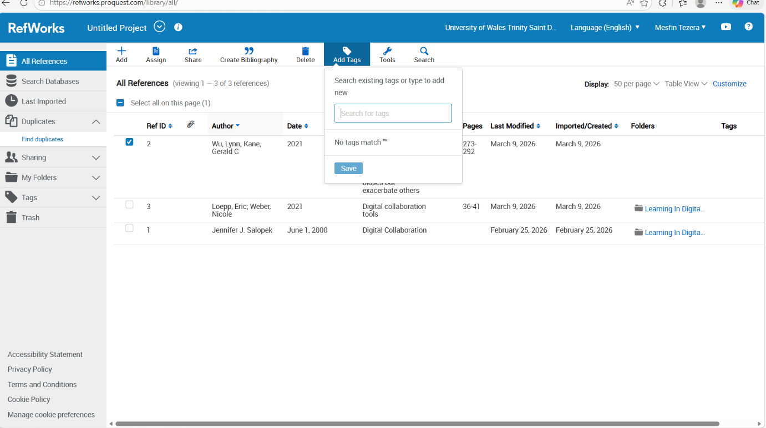
Figure 33: RefWorks during adding existing in files to adding to existing reference

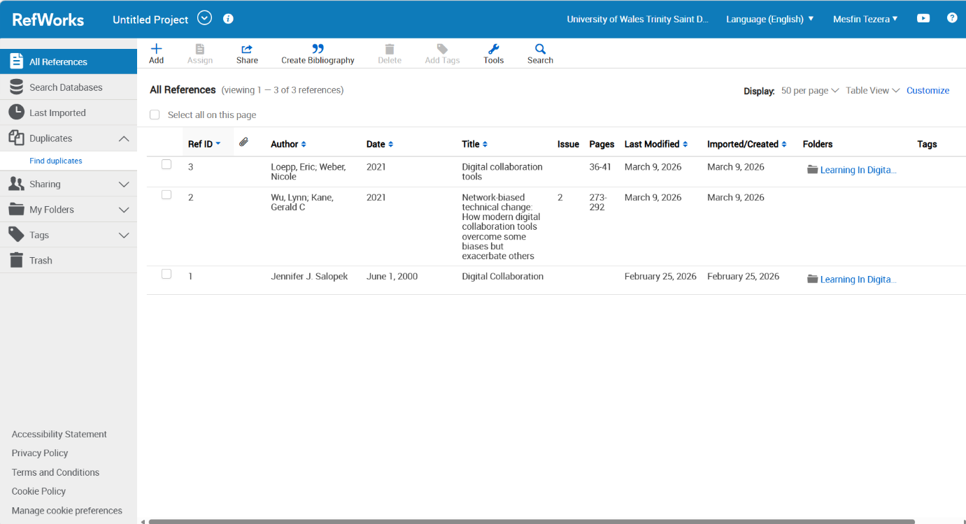
Figure 34: RefWorks during adding existing in files to the existing bibliography

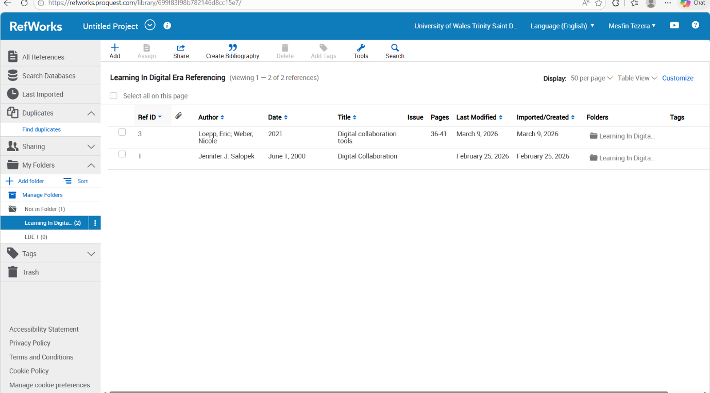
Figure 35: RefWorks during adding existing files to RefWorks

Figure 36: RefWorks searching existing in files to match with my existing reference

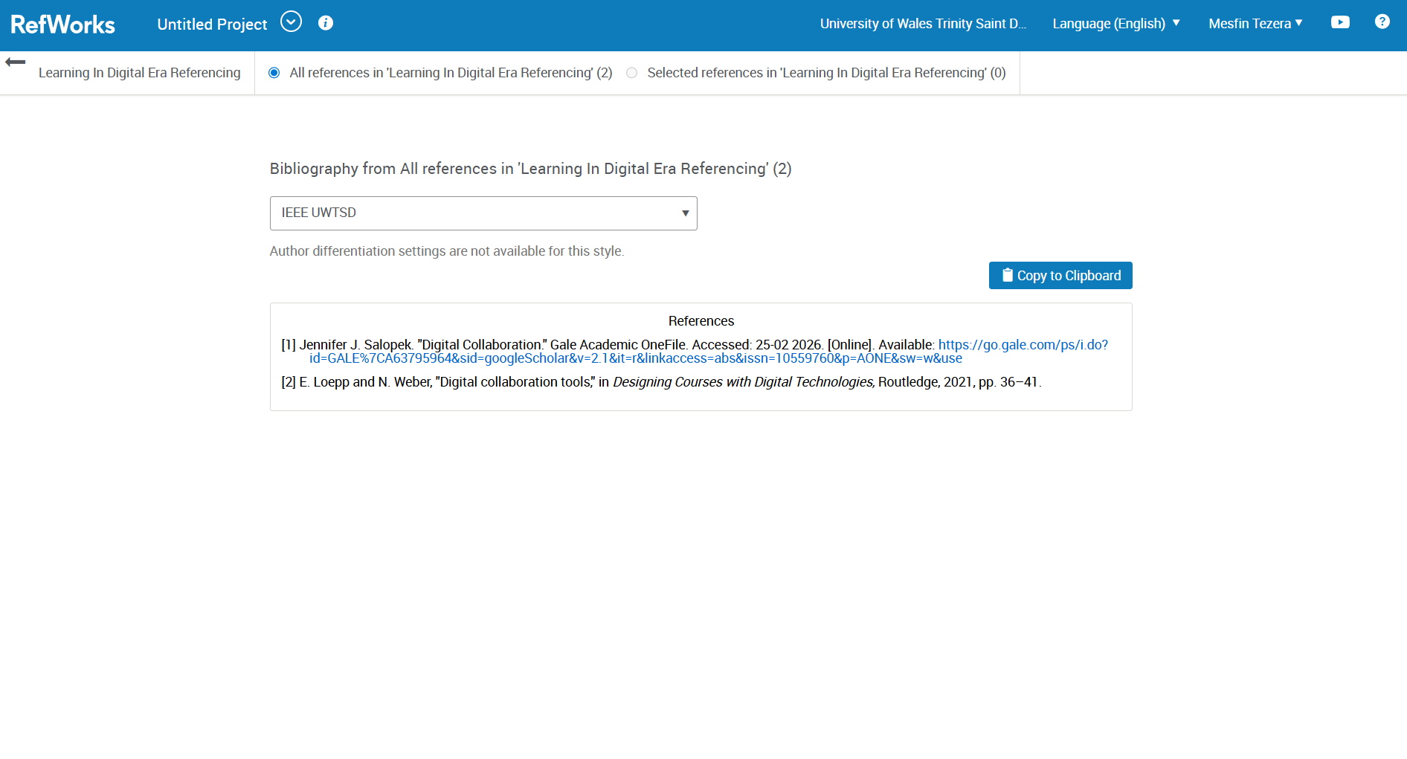

Figure 37: RefWorks during adding existing automatic reference to t folder

Task 4: E-Portfolio Creation and Evaluation

Task 4 (b): Illustrative Review of E-Portfolio tool Selection

Task 4 (b): Illustrative Review of E-Portfolio tool Selection

I created my e-portfolio website by using Wix. I chose WIX because the website was straightforward; I do not need to build anything new, but I just had to use pre-designed sites to build my own portfolio, which is for my educational purpose. This is free internet-based website, and it has a system or platform where I can easily put text, images, and video, so it’s helpful to develop and share educational material. It also saved cost because it’s free a basic level. My development of my portfolio in this website has given me good experience so that in future I can build my own website. helped me for my feature concept how to develop my own website and design it for all purpose [11].

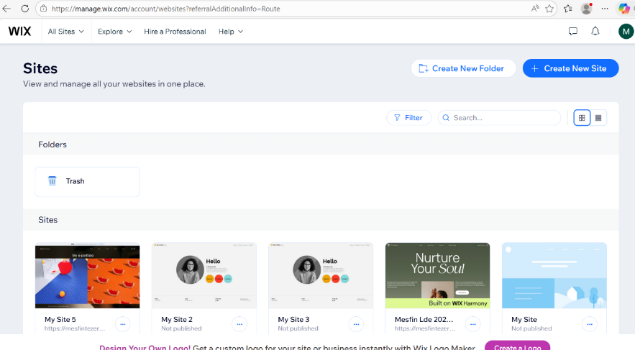
Fiegure 1: e-portfolio cration and making my portfolio illustration to complet my e-portfolio

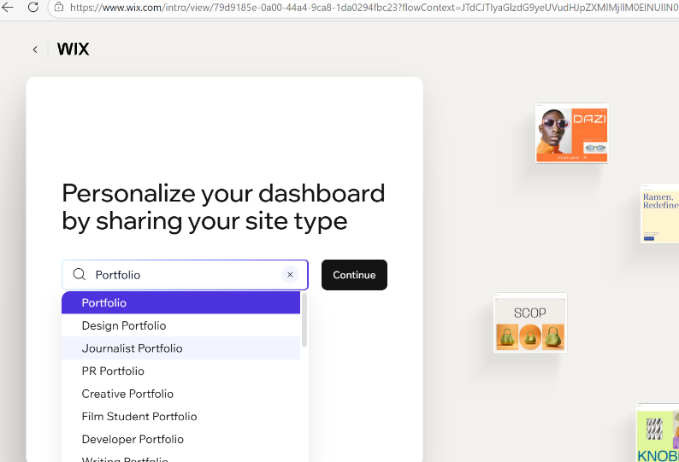

Fiegure 2: e-portfolio cration and illustration and persinilazing portfolio page

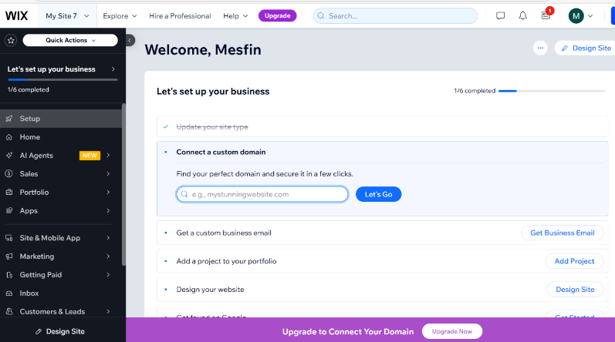

Fiegure 3:: e-portfolio cration and illustration choosing new page

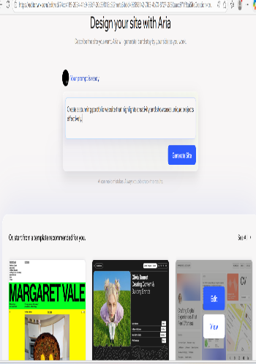
Fiegure 4: e-portfolio design cration and illustration designing new page

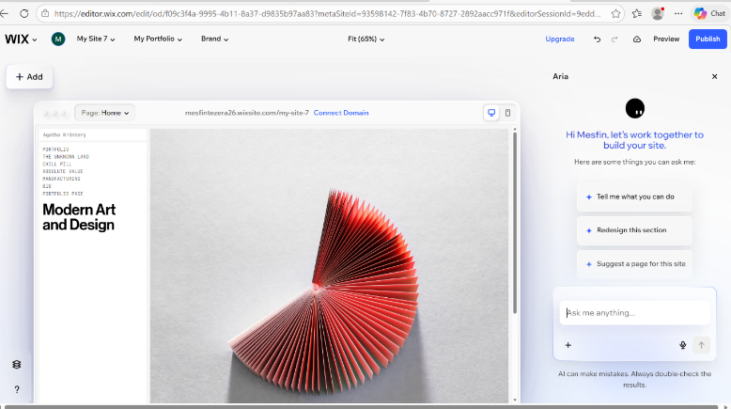

Fiegure 5: e-portfolio design cration and illustration new page

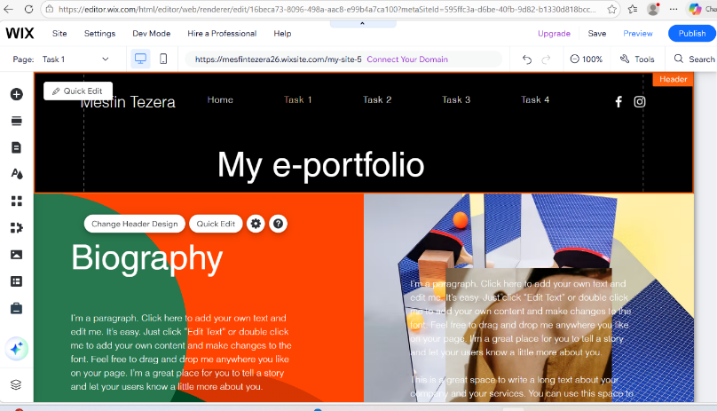
Fiegure 6: e-portfolio design cration and illustration for portfolio

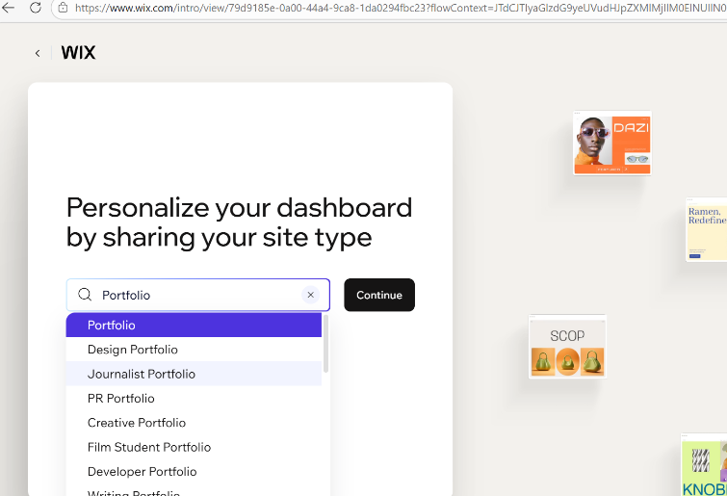

Fiegure 7 :Choosing a site for desighing an e-portfolio and illustrating it for my new website in Wix.

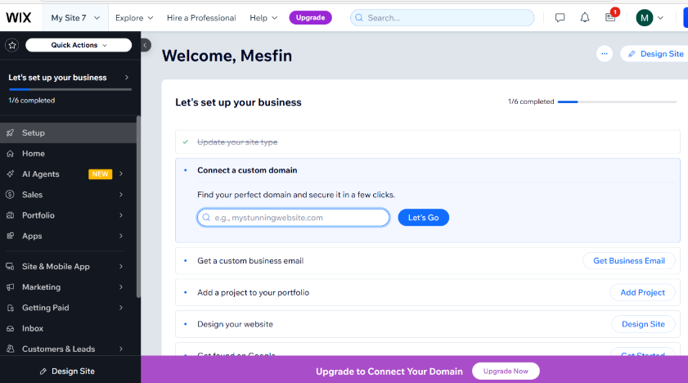
Fiegure 8: e-portfolio design cration and illustration for portfolio

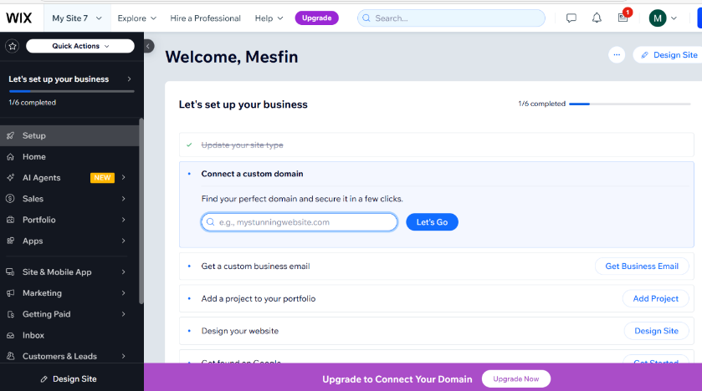
Fiegure 9 : e-portfolio design cration and illustration for portfolio

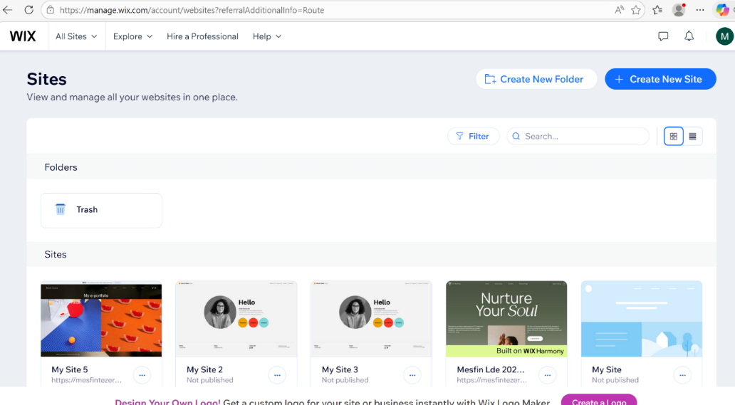
Fiegure 10: e-portfolio design cration and illustration for my site

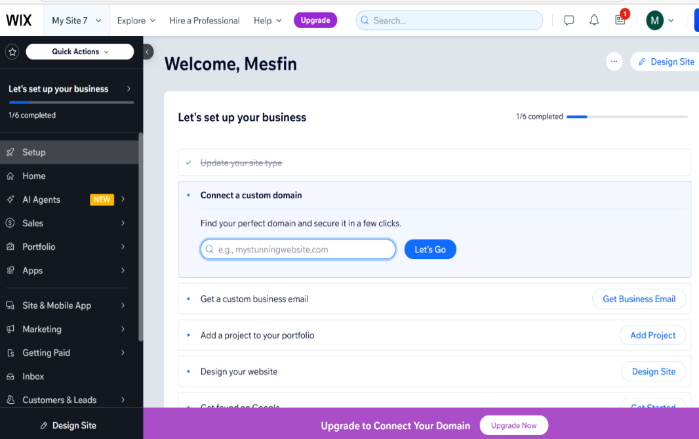
Fiegure 11: e-portfolio design cration and illustration

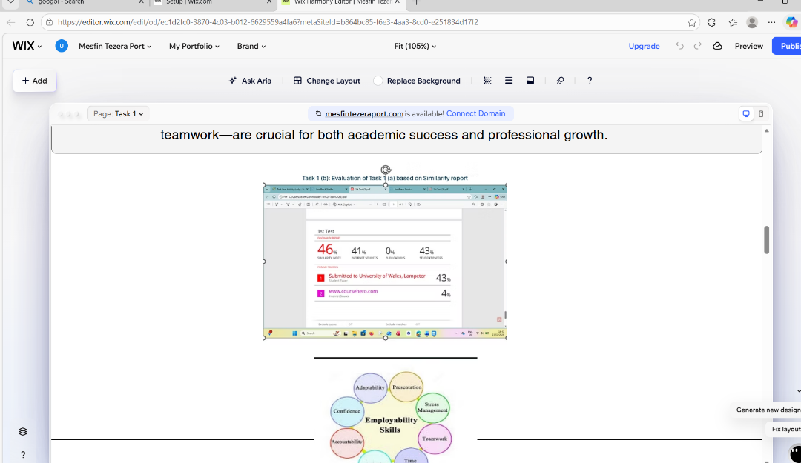
Fiegure 12: e-portfolio design cration and illustration first page

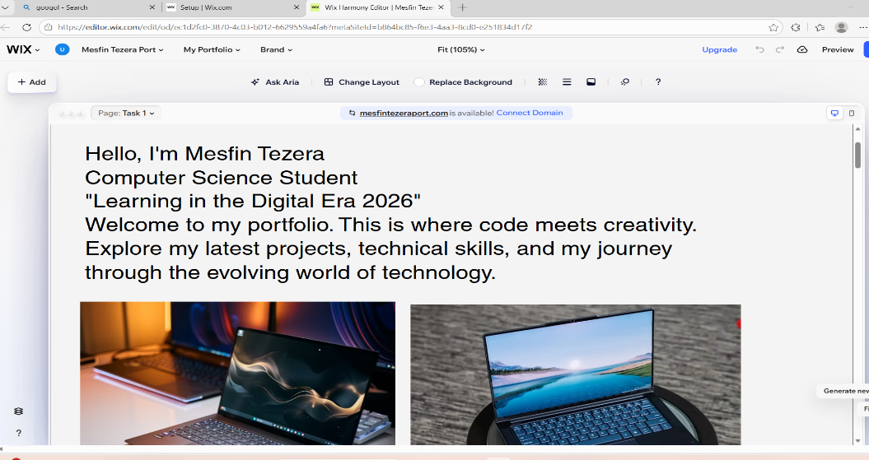
Fiegure 13: e-portfolio design cration and illustration welcoming page

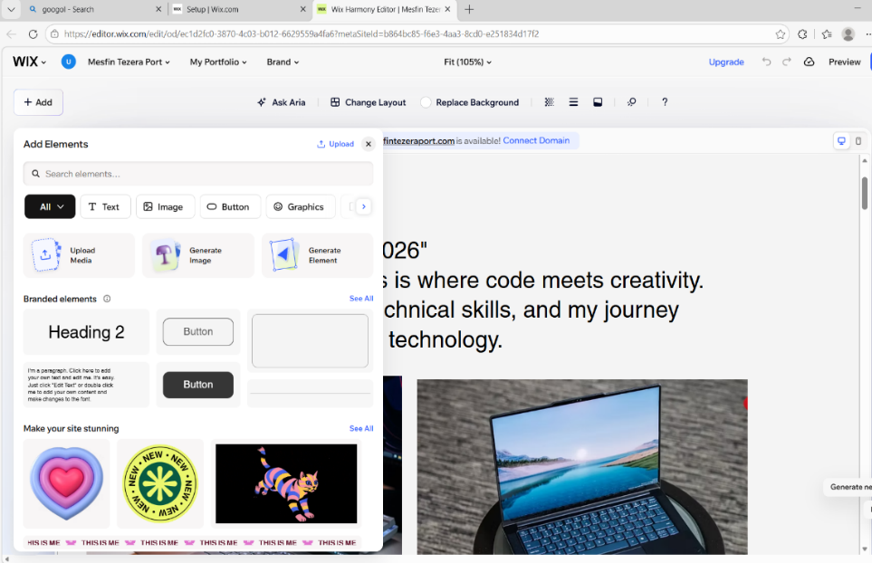
Fiegure 14: e-portfolio design cration and illustration

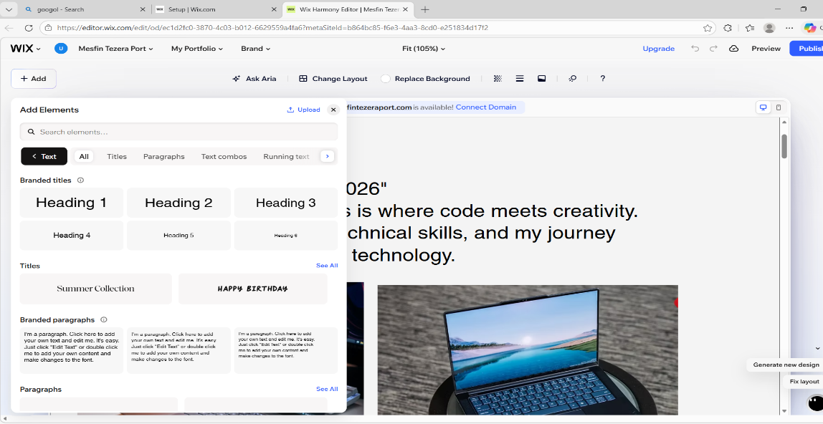
Fiegure 15 e-portfolio design cration and illustration making pargraph

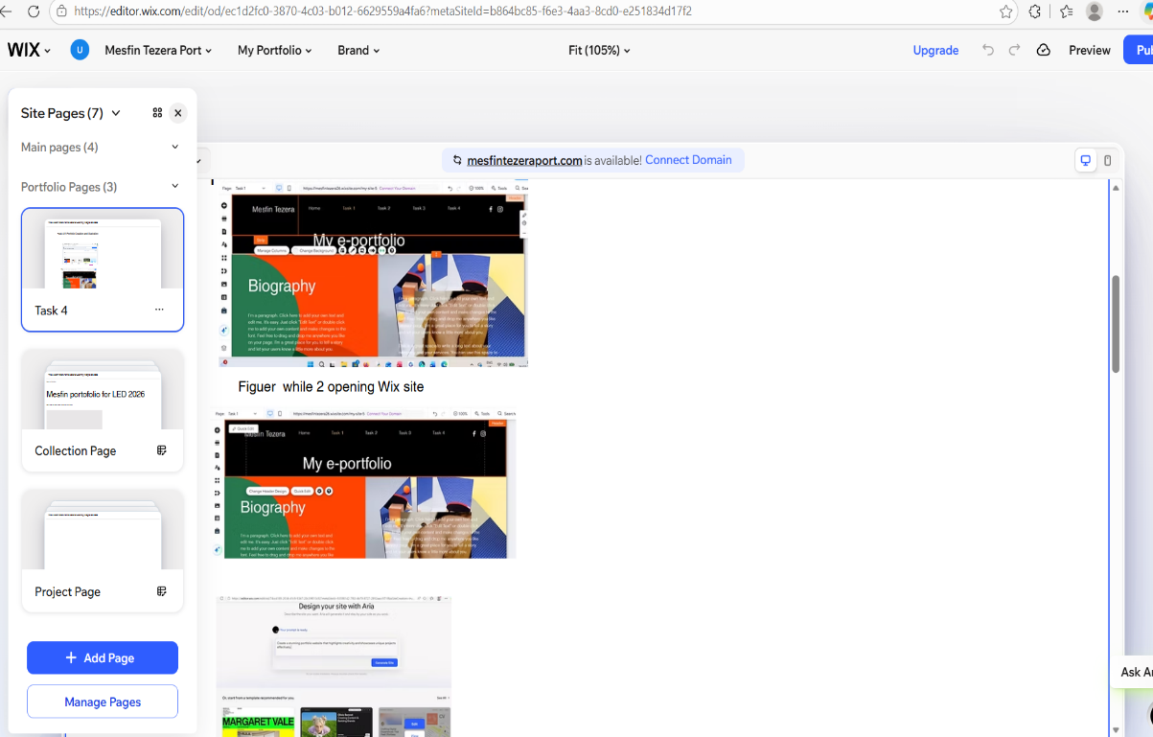

Fiegure 16: e-portfolio design cration and illustration making taskes for my files

Conclusion: -

As the modern economy evolves, digital collaboration has become a central part of our daily activities, learning digital Era allowing me to develop knowledge and work together across different tasks through virtual platforms and social media. Using digital tools, such as RefWorks for managing research citations or Wix for building a professional e-portfolio, demonstrates how technology can simplify complex tasks and help organize my tasks one's educational journey. Ultimately, combining these soft skills with digital proficiency give me a strong foundation for lifelong learning and employability. By staying committed to upskilling and following professional guidance, I can ensure they remain competitive and ready for the future demands of the global workforce. So, this Course helped me massively to work forward to me qualifications too.

References

Task 1

[1] | P.Maguire, “Clinical Review,” Clinical ReviewResearch, 28 September 2002.
[2] | P. Greenbank, “Edge Hill University,” Decission making, vol. 1, p. 1, 2010.
[3] | M. Showry, “Self Awareness Acadamic Jurnaal,” no. Aca, p. 1, 2014.
[4] | D. Jackson, “Team working Skills,” 2014.
[5] | V. V, “Essential Skills for 21st century,” 28 04 2023. [Online]. Available: https://www.linkedin.com/pulse/essential-skills-21st-century-varatharasan-visalu-velusamy. [Accessed 2026 02 23].
 | Task 3
[6] | N. Evans and A. Miklosik, “Un  iversity-industry collaboration as a driver of digital transformation: Types, benefits and enablers,” University-industry collaboration as a driver of digital transformation: Types, benefits and enablers, vol. 9, no. Issue 10e21017October 2023, p. 1, 26 10 2023.
[7] | R. D. Evans, . J. . G. Xiaoyu and . N. Martin, “Exploring the benefits of using Enterprise 2.0 tools to facilitate collaboration during product development,” Inside science online, vol. 8, no. Issue 3, p. 2016, 12 01 January 12, 2016.
[8] | R. A. Doon, “Harnessing the Potential Benefits of Remote Work and Digital Collaboration in Trinidad and Tobago,” Harnessing the Potential Benefits of Remote Work and Digital Collaboration in Trinidad and Tobago, vol. 1, no. 1, p. 24, 2025.
[10] | M. Hristova, “RefWorks Usage Patterns: Exploring the First Four Semesters of Use by Faculty, Graduate Students, and Undergraduates,” RefWorks Usage Patterns: Exploring the First Four Semesters of Use by Faculty, Graduate Students, and Undergraduates, Vols. Volume 17, 2012 -, no. Issue 2, pp. 45-64, 19 10 2012.  Task 2 Poster Individual poster
[11] | B. G. Bruster, “NATIONAL SOCIAL SCIENCE TECHNOLOGY JOURNAL,” NATIONAL SOCIAL SCIENCE TECHNOLOGY JOURNAL, vol. 8, p. 2, 2020 .
[12] | T. K. I. Adham, “Conflict Resolution in Team: Analyzing the of Conflicts and Best Skills,” Scholars Journal of Engineering and Technology, vol. 11i08.001 , no. 2321-435X, p. 1, 06 08 06.08.2023 .
[13] | L. McKibben, “Conflict management: importance and implications,” Laurie McKibben, p. 2, 28 01 2017.
[14] | D. S. Jasubhai, “Leadership Dynamics: The Interplay of Cognition, Emotion,,” Leadership Dynamics: The Interplay of Cognition, Emotion,, vol. 3, no. 1, 2025.

Step-by-step process of using RefWorks with visuals
References
[1]. L. Wu and G. C. Kane, "Network-biased technical change: How modern digital
tools overcome some biases but exacerbate others," vol. 32, no. 2, pp.273–292, 2021,

================THE END=============

