
DISSERTATION proposal LCBB6000 A1
Role of Ethical Leadership in Modern Corporations: Examining How Ethical Leadership Contributes to Employee Satisfaction, Corporate Reputation, and Long-term Success

student name: lachezar nikolov
WORD COUNT:2048

Table of Contents
Introduction 2
Aims and Objectives 2
Aims 2
Objectives 2
Research Rationale 3
Significance of Research 3
Literature Review 3
Analysis 3
Ethical Leadership – The 4-V Model and Its Key Components 4
Methodology 6
Source Summary 6
Conclusion 8
References 9

Dissertation Title: Role of Ethical Leadership in Modern Corporations: Examining How Ethical Leadership Contributes to Employee Satisfaction, Corporate Reputation, and Long-term Success

Introduction
In today's ever-changing business world, the importance of ethical leadership is getting a lot of attention. This is because ethical leadership can affect how happy employees are, how people see the company, and how successful the company is in the long run. Ethical leadership means showing good values and behaviors that follow ethical rules. It encourages people to act properly and inspires others to do the same. This dissertation wants to understand how ethical leadership connects with employee happiness, how the company is seen, and how well the company does overall.

Aims and Objectives

Aims
1. Reviewing Existing Knowledge: This dissertation aims to carefully examine all the research that has already been done about ethical leadership, corporate social responsibility (CSR), employee happiness, company reputation, and long-term success.

Objectives
1. Understanding Impact: The dissertation wants to learn how ethical leadership affects employee happiness, how people perceive the company, and how well the company performs over a long time.
2. Exploring CSR's Role: Another goal is to see if corporate social responsibility (CSR) has a role in how ethical leadership influences employee happiness, company perception, and overall company success.
3. Uncovering Influences: The study also intends to find out if certain things both inside and outside the company can change the way ethical leadership, CSR, and other factors are connected.

Research Rationale
It is important to do this research because we want to understand more about how ethical leadership works in modern businesses. We want to know if it really makes employees happy, if it changes how people see the company, and if it helps the company succeed in the long term. This knowledge can help companies become better and more successful while also doing good things for their employees and the community.

Significance of Research
Understanding how ethical leadership affects employee happiness, company reputation, and long-term success is like having a roadmap for companies to follow. It can show them how to be better leaders, how to make their employees happier, and how to make their company more successful over time. This research can also help companies realize the importance of doing good things for society and the environment, which can make the world a better place.

Literature Review

Analysis
In the world of research, many experts have already taken a close look at ethical leadership, especially in Western countries. They wanted to understand how it affects businesses. What they discovered is quite interesting. When leaders in a company act ethically, meaning they do things that are right and good, it can actually make the whole company perform better. This is like having a team captain who sets a good example for everyone else on the team.
For example, a study by Shin et al. (2015) and another one by Wang et al. (2017) found something important. They saw that when leaders in a company show ethical behavior, it helps the company adopt good values. And when a company has strong values, it tends to do well and succeed. Think of it like having a strong foundation for a building. If the base is strong, the whole building can stand tall and steady.
There's another study by Saha et al. (2019) that focused on something called Corporate Social Responsibility or CSR. This is about how companies take care of not just themselves but also the society and the environment around them. Interestingly, this study showed that leaders who really care about doing what's right also care about these bigger things. They care about making the world a better place through their company's actions.
De Roeck & Farooq (2017) looked at how both CSR and ethical leadership can shape how employees behave. When a company shows that it cares about doing good things, like helping the community or being environmentally friendly, it influences how employees act. They want to be part of this goodness and do their best to contribute positively.
Another important idea in business is customer orientation. This means paying close attention to what customers want and need. It's like really listening to your customers and trying to give them exactly what they are looking for. Some research by Feng et al. (2019) suggests that ethical leadership also connects with this idea. When leaders care about ethics, they also care about customers. They make sure the company is focused on making customers happy by providing products and services that meet their needs.

Ethical Leadership – The 4-V Model and Its Key Components
Bill Grace, a well-known figure in ethical leadership, developed the 4-V Model of Ethical Leadership. He co-founded the Center for Ethical Leadership and emphasizes that effective ethical leadership begins with understanding one's main values and how they match the organization's mission. He believes this link can turn the vision into an inspiring force for followers (Lindberg, 2021).
The 4-V Model consists of four important elements: Virtue, Values, Vision, and Voice. These parts play a crucial role in shaping ethical leadership practices and their positive impact on organizations and people.
- Virtue: At the core of the 4-V Model is virtue, with ethical leaders showing virtuous behavior that sets an example for their team members. Their actions reflect ethical principles, creating a culture of honesty and trust within the organization.
- Values: Ethical leadership starts with understanding one's core values, giving a clear sense of guiding principles for making decisions. This self-awareness forms the foundation for leaders to match their choices with their ethical beliefs.
- Vision: Ethical leaders direct their actions toward a shared vision, supported by ethical considerations. Their actions pave the path to this vision, motivating their followers to work together for an ethical and meaningful goal.
- Voice: Effectively conveying the vision is crucial for ethical leaders. Clear communication empowers followers to take ethical actions in line with the shared vision.
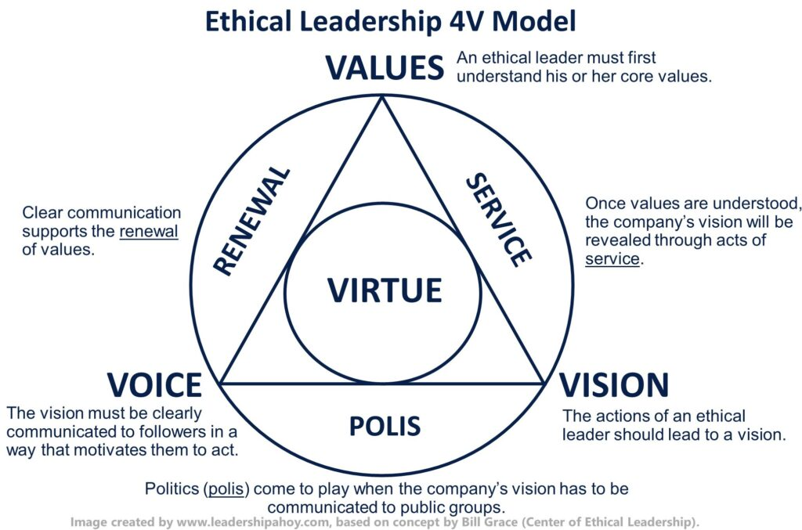
Source Link: https://www.leadershipahoy.com/ethical-leadership-explained-by-a-ceo/
Additionally, the 4-V Model connects with three extra aspects: service, polis, and renewal.
Service: Ethical leaders translate their core values into action through acts of service. This practical expression of ethical values contributes to achieving the shared vision.
Polis (Politics): Ethical leaders navigate the complexities of communicating the organization's vision to external groups, making sure the ethical vision is accurately and transparently conveyed to stakeholders.
Renewal: Regular renewal of the organization's core values and vision strengthens ethical behavior and maintains alignment with the shared vision.
In conclusion, Bill Grace's 4-V Model of Ethical Leadership highlights the importance of values, virtue, vision, and voice. These core elements guide ethical leaders in making a positive impact within their organizations and beyond, promoting a culture of integrity, service, and shared purpose (Lindberg, 2021).

Methodology
This dissertation will use different methods to understand things better. It will use secondary data only for research including people in different companies to see how they feel about ethical leadership, how happy they are, how they see the company, and how well the company does. It will use math techniques to look at the relationships between these things and also how some things can change these relationships.
The dissertation will also talk to leaders in some companies and ask them more detailed questions. This will help to get a deeper understanding of how ethical leadership connects with how the company cares about society, how people feel, and how well the company does.

Source Summary
Source 1: Ethical Leadership, Corporate Social Responsibility, Firm Reputation, and Firm Performance This study discovered that when leaders are good and ethical, it really helps companies in developing places like Vietnam to do responsible things for society (corporate social responsibility or CSR). This also makes the companies look good and succeed overall. When leaders act ethically, it encourages the whole company to do responsible things, which makes the company's reputation better and helps it do well. So, being ethical in leadership is like a driving force for companies to do better things and succeed in the long run.
Citation: Nguyen, N.T.T., Nguyen, N.P. and Thanh Hoai, T. (2021). Ethical leadership, corporate social responsibility, firm reputation, and firm performance: A serial mediation model. Heliyon, 7(4), p.e06809. doi:https://doi.org/10.1016/j.heliyon.2021.e06809.
Source 2: Effect of Ethical Leadership and Corporate Social Responsibility on Firm Performance: A Systematic Review Lots of research papers say that when leaders are ethical, it's really good for the company and how well it does in the long run. This research also found that personal values and the business world around the company can affect how this works. The study suggests that we need to look at both things inside and outside the company that impact how being an ethical leader, caring about society, and how well a company does are connected.
Citation: Saha, R., Cerchione, R., Singh, R. and Dahiya, R. (2019). Effect of ethical leadership and corporate social responsibility on firm performance: A systematic review. Corporate Social Responsibility and Environmental Management, 27(2), pp.409–429. Available at: https://onlinelibrary.wiley.com/doi/abs/10.1002/csr.1824.
Source 3: Corporate Social Responsibility and Ethical Leadership: Investigating Their Interactive Effect on Employees’ Socially Responsible Behaviors This research tells us that when leaders and the company care about doing good things for society (corporate social responsibility or CSR), and leaders also act in ethical ways, it makes employees want to do good things for society too. When employees see their leaders doing good and responsible things, they feel more connected to the company and want to do things that help society too. So, when leaders and the company care about doing the right thing, it inspires employees to do good too.
Citation: De Roeck, K. and Farooq, O. (2017). Corporate social responsibility and ethical leadership: Investigating their interactive effect on employees’ socially responsible behaviors. Journal of Business Ethics, 151(4), pp.923–939. doi:https://doi.org/10.1007/s10551-017-3656-6.
Source 4: Customer Orientation and Firm Performance: The Joint Moderating Effects of Ethical Leadership and Competitive Intensity This study shows us that when companies really care about what customers need (customer orientation), and they have leaders who are ethical, it's great for how well the company does. Ethical leaders encourage good behaviors, and this helps the company succeed. Also, when there's a lot of competition, companies need to work extra hard to be customer-oriented and ethical to do well. So, it's important for companies to care about customers, have ethical leaders, and consider the competition to do their best.
Citation: Feng, T., Wang, D., Lawton, A. and Luo, B.N. (2019). Customer orientation and firm performance: The joint moderating effects of ethical leadership and competitive intensity. Journal of Business Research, 100, pp.111–121. doi:https://doi.org/10.1016/j.jbusres.2019.03.021.
Source 5: Ethical Leadership Explained by a CEO. In the article "Ethical Leadership Explained by a CEO," Lindberg, C. (2021) talks about ethical leadership. The article is on a website called Leadership Ahoy!. The author looks at ethical leadership from a CEO's point of view and explains its important ideas. They talk about the 4-V Model of Ethical Leadership made by Bill Grace, who is known for ethical leadership. This model is about four main things: being good, having values, having a clear goal, and speaking up.
The article says ethical leadership is important for making sure people and companies do the right thing. Ethical leaders show good behavior and follow their important values. They have a clear goal and tell their followers about it. They also help shape how a company acts and make sure it does things with honesty.
This article is useful for understanding how ethical leadership works in real situations, especially from a CEO's point of view. It talks about the 4-V Model and how it helps people understand ethical leadership better. The information in the article adds to what people know about ethical leadership and how it matters in today's business world.
Citation: Lindberg, C. (2021). Ethical Leadership Explained by a CEO. [online] Leadership Ahoy! Available at: https://www.leadershipahoy.com/ethical-leadership-explained-by-a-ceo/. [Accessed: 14 Aug. 2023].

Conclusion
By studying ethical leadership in modern companies, this dissertation wants to help us understand how it connects with how happy employees are, how people see the company, and how well the company does. By looking at lots of information and talking to leaders, this study hopes to show how these things are connected. This can help companies know how to be ethical leaders and do well in the long run. The findings from this study can be really helpful for companies that want to be ethical leaders and do things that help society and the environment.

References
Nguyen, N.T.T., Nguyen, N.P. and Thanh Hoai, T. (2021). Ethical leadership, corporate social responsibility, firm reputation, and firm performance: A serial mediation model. Heliyon, 7(4), p.e06809. doi:https://doi.org/10.1016/j.heliyon.2021.e06809.
Saha, R., Cerchione, R., Singh, R. and Dahiya, R. (2019). Effect of ethical leadership and corporate social responsibility on firm performance: A systematic review. Corporate Social Responsibility and Environmental Management, 27(2), pp.409–429. Available at: https://onlinelibrary.wiley.com/doi/abs/10.1002/csr.1824.
De Roeck, K. and Farooq, O. (2017). Corporate social responsibility and ethical leadership: Investigating their interactive effect on employees’ socially responsible behaviors. Journal of Business Ethics, 151(4), pp.923–939. doi:https://doi.org/10.1007/s10551-017-3656-6.
Feng, T., Wang, D., Lawton, A. and Luo, B.N. (2019). Customer orientation and firm performance: The joint moderating effects of ethical leadership and competitive intensity. Journal of Business Research, 100, pp.111–121. doi:https://doi.org/10.1016/j.jbusres.2019.03.021.
Lindberg, C. (2021). Ethical Leadership Explained by a CEO. [online] Leadership Ahoy! Available at: https://www.leadershipahoy.com/ethical-leadership-explained-by-a-ceo/. [Accessed: 14 Aug. 2023].

