Appendices

1803328
The Enquiring Teacher: Level 7
‘What is the impact of a structured musical input on engagement in a Foundation Phase session?’

Appendix A – Blank Observation Schedule

Observation Schedule
Class Context:

Level | Engagement | Signals
1 | Extremely Low | Child seems absent. Staring into space, no eye contact or communication. Little involvement or reaction to their peers or the music.
2 | Low | Minimal engagement with their peers or music. Easily distracted and lack of interest. Often stares into space.
3 | Moderate | Fairly engaged with their peers and music. Show some signs of energy but can still be distracted or disengaged.
4 | High | Engaged with the music. Not easily distracted and seem involved with the activity
5 | Extremely High | Continuous engagement with the music. They are concentrated and creative in the observed time.
Engagement Level: Tick if observed | Use of music | Child A | Child B | Child C | Child D
Extremely Low | (Introduction)
Low | (No music just singing)
Moderate | (Singing with guitar)
High | (Singing with music)
Extremely High | (Music)
Additional information:

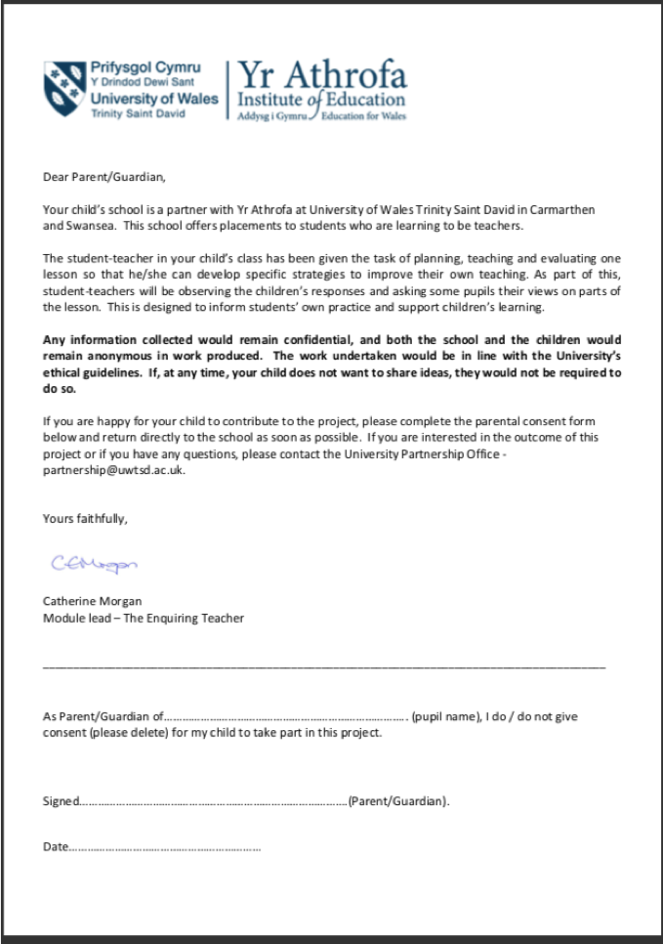
Appendix B – Consent Form

Appendix C – Lesson 1 PowerPoint

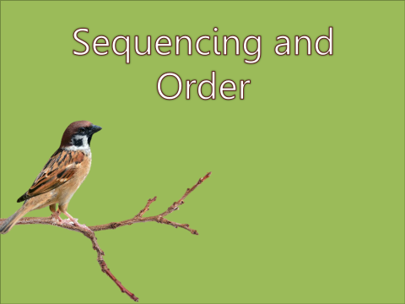
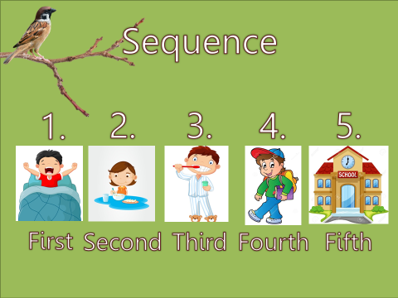

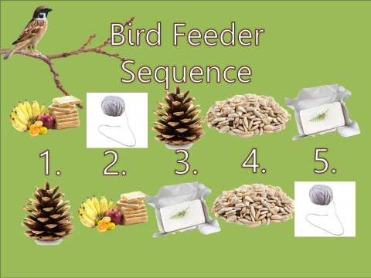
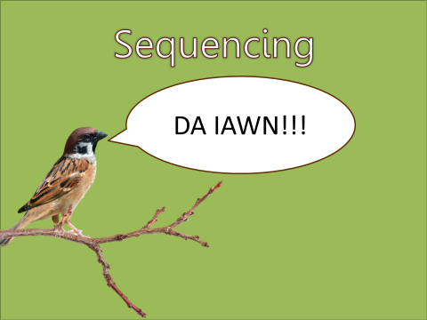

Appendix D – Lesson 1 Observation Schedule
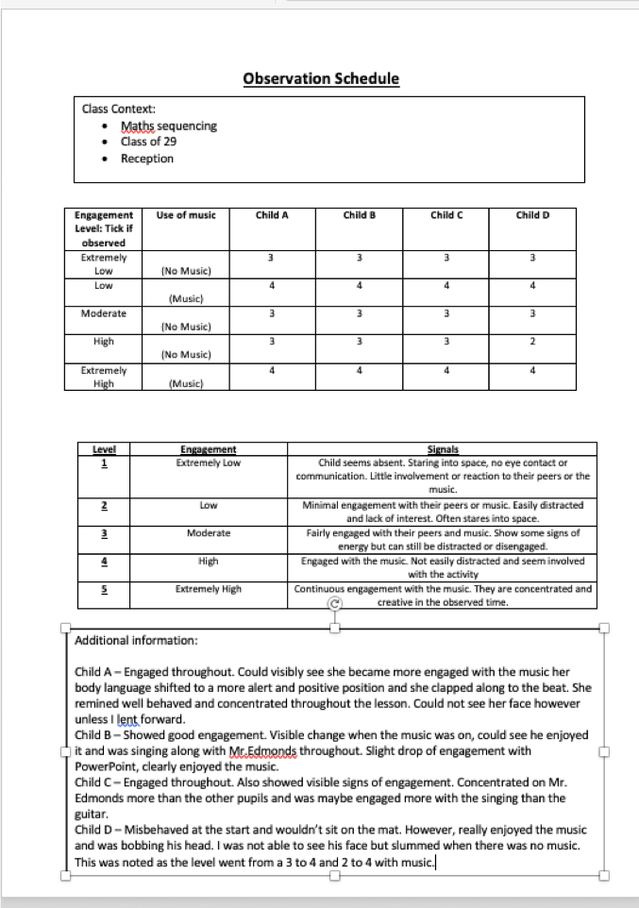


Appendix E – Interview Questions
Focused group questions

Today we are going to ask a group of children some questions about today’s lesson. It is perfectly fine for you not to take part but it would be really great if you could. Thank you.

- Did you enjoy today’s lesson?

- Was there anything you liked about today’s lesson?

- How did the music make you feel?

- What is the first thing you will tell your parents about today’s lesson?

Appendix F – Lesson 2 Observation Schedule

Observation Schedule
Class Context: Reception Class: 20 pupils (18 present).
B. I. N. G. O. Oracy task

Level | Engagement | Signals
1 | Extremely Low | Child seems absent. Staring into space, no eye contact or communication. Little involvement or reaction to their peers or the music.
2 | Low | Minimal engagement with their peers or music. Easily distracted and lack of interest. Often stares into space.
3 | Moderate | Fairly engaged with their peers and music. Show some signs of energy but can still be distracted or disengaged.
4 | High | Engaged with the music. Not easily distracted and seem involved with the activity
5 | Extremely High | Continuous engagement with the music. They are concentrated and creative in the observed time.
Engagement Level: Tick if observed | Use of music | Child A | Child B | Child C | Child D
Extremely Low | (Introduction) | 3 | 3 | 1 | 3
Low | (No music just singing) | 3 | 4 | 1 | 3
Moderate | (Singing with guitar) | 4 | 4 | 2 | 4
High | (Singing with music) | 5 | 5 | 2 | 4
Extremely High | (Music) | 4 | 4 | 2 | 4
Additional information:
Child A – Enthusiastic and Engaged throughout. Particularly with YouTube music.
Child B – Also enthusiastic through, again with YouTube music.
Child C – Lack of engagement throughout, as discussed with research partner
Child D – Fairly engaged throughout, engaged with barking and singing.

Appendix G – Lesson 2 Transcription
(RP = Research Partner)

RP: Was there anything you liked about today’s lesson?
Child A: I liked the singing.
RP: You were very good at singing as well. [Child B] was there anything you liked about today’s lesson?
Child B: The singing!
RP: And [Child C] was there anything that you liked about the lesson today?
Child C: … singing.
Child D: I liked the guitar!
RP: When I played the guitar, did that make you feel anything?
Child A: Yeah.
RP: What did it make you feel?
Child A: Happy!
RP: [Child B] Did the guitar make you feel anything?
Child B: Happy!
RP: And what about you [Child C], did the guitar make you feel anything?
Child C: … Happy.
RP: [Child D]?
Child D: It made me happy.
RP: What is the first thing that you might tell your parents about today’s lesson.
Child A: I will say… we sang the BINGO song.
RP: That’s good. [Child B]?
Child B: We sang a lot!
RP: [Child C?]
Child C: … singing.
RP: [Child D]?
Child D: The guitar was fun.
RP: Would you all like music, guitar or singing to be used more in your lessons?
Child A: Yeah I like to sing more in lessons.
RP: What about you [Child B]?
Child B: Yes.
Child C: [interrupts] Yeah.
RP: And [Child D]?
Child D: Yes please.
RP: Thank you very much Shells, very good singing!

Appendix H – Lesson 1 Reflection

Pre-Forma Reflection Street

Question: Can we improve pupil engagement through the use of music in the Foundation Phase?

Reflection based upon Brookfield (1998) ‘Four Lenses’ and Kolb

Date: 20/02/2019

Critical Incident: Lesson Study 1
Comments:

Self-View - How did you feel about the lesson? | I feel that the lesson was overall a success. The learning objective was met, and there were also a lot of positives to take from the Lesson Study. Despite not being the person writing the observations, it certainly appeared that the children were more engaged whilst I was playing the guitar and singing. I feel that the interview section could have been improved, perhaps my suggestion of interviewing the children separately was not best for the study.
Student view - How did the pupils feel about the lesson? | Our case pupils appeared to enjoy the lesson. My research partner observed a particular increase in the engagement levels of the children when the music was being played. Children’s answers to interview questions were limited, however the overall consensus was that music improved the lesson.
Peer View - How did my colleague feel about the lesson? | My research partner feels the lesson went well. He observed an improvement in engagement whilst music was being played, and also an improvement in behaviour. He liked the idea that the guitar was a “treat” for the children, suggesting that good behaviour was met with songs.  He wishes that his observation point was better for the lesson. He agrees that the interview section could have been improved.
Literature Review - What does the literature say around this? | See Lesson Study results and analysis.
Improvements for future- How can we improve the lesson for future? | If we were to do this Lesson Study again, we would definitely have piloted the lesson. This could have improved my research partner’s observation point and therefore potentially improved the results of the Leuven scale. For our next lesson study, the interview will definitely take place as a group.

Appendix I – Lesson 2 Reflection


