GIS application
M3X8639 – Geographical Information Systems
Jonathan Thomas
241978
Date: 06/02/18
Contents
Introduction 2
Identifying a Subject Area 2
Acquiring Data 2
Earthquake Data 3
World Map 4
Tectonic Plates 5
Populated Places 6
Cleaning the Data 6
Importing Data 8
Base Layer Styling 12
Identifying Areas for Analysis 13
1980-84 vs 2005-09 13
2015 14
London vs Lima 14
Creating Layers 14
1980-84 16
2005-09 18
2015 19
London vs Lima 20
General Analysis 22
1980-84 vs 2005-09 22
1980 – 1984 Earthquakes 23
2015 Earthquakes 24
Focused Analysis 24
London vs Lima 2015 26
London vs Lima 1980-84 29
London vs Lima 2005-09 30
London vs Lima 1965-2016 31
Analysis Findings 32
Conclusion 34
Reference List 35

Introduction
In this assignment I have been tasked with exercising a range of skills within QGIS to analyse a chosen data set and create a number of high quality maps. To undertake this task successfully I will first identify a subject to examine. Following the selection of a suitable subject area I will source the datasets and maps I require and ensure that they are suitable for spatial analyses within QGIS.
Once I have obtained suitable data I will demonstrate a number of skills and produce a geovisualisation of the data and perform a number of analyses. The following report will contain supporting evidence of my analyses included detailed descriptions and screenshots of the processes I have performed.
Identifying a Subject Area
Datasets are available covering a wide range of subject areas including sociodemographic data, environmental data, government spending and much more. After some consideration I chose to analyse an environmental dataset that provided historical data pertaining to earthquakes recorded between January 2nd 1965 and up to 30th December 2016.
Acquiring Data
The dataset I have acquired was initially recorded by The National Earthquake Information Center (NEIC) a department of the United States Geological Survey (USGS). The NEIC which is located 10 miles west of Denver, Colorado has three main objectives:
- To determine as quickly and accurately as possible the location and size of all significant earthquakes around the world.
- To collect and disseminate this data to scientists and the wider public to allow for research and investigation.
- To further their own active research program that aims to improve the ability to locate and record earthquakes. (1)
The NEIC records and publishes data on approximately 30,000 earthquakes a year. The dataset I will be analysing concerns itself only with those earthquakes recorded with a magnitude of 5.5 or greater. Earthquake magnitude is commonly compared against the Richter scale devised by Charles F. Richter and Beno Gutenberg (2). Since its development in the 1930s the Richter scale however has been replaced by the more accurate moment magnitude scale (MMS) developed by seismologists Hiroo Kanamori and Thomas C. Hanks. The MMS benefits from the development of modern computing power to produce far more accurate recordings of the size and impact of an earthquake (3-4). According to the MMS, an earthquake with a magnitude of 5 is considered to be ‘moderate’. The largest recorded earthquake in history occurred in 1960 in Valdivia, Chile registering a magnitude of 9.5(5).

Earthquake Data
File name | earthquake-database.zip  database.csv
File type | CSV compressed in ZIP file
File size | 2,341KB
Column count | 21
Row count | 23413 (including titles)
Overview of contents | The dataset contains detailed recording of earthquake events sorted in order of occurrence from 02/01/1965 up to and including 30/12/2016. Each occurrence is geotagged with latitude and longitude metadata allowing it to be geovisualised accurately. Each occurrence also has a unique ID and additional information to relating to the earthquake event.  All data attributes and examples have been recorded below.  The CSV file has been opened and examined using Microsoft Excel. Initial inspection of the data has identified that a number of cells are null, dates are recorded in MM/DD/YYY format and that a small number of date values have been recorded in accurately. Later inspection will rectify these and any additional concerns identified.
Data source | Although originally recorded by the NEIC and made available by the USGS this dataset was acquired by a third part source called Kaggle. Kaggle is an online platform providing reputable data to data scientists and enthusiasts.  https://www.kaggle.com/usgs/earthquake-database
Terms of use | “USGS-authored or produced data and information are considered to be in the U.S. public domain… When using information from USGS information products, publications, or Web sites, we ask that proper credit be given. Credit can be provided by including a citation such as the following:  Credit: U.S. Geological Survey  Department of the Interior/USGS” (6)
Attribute Name | Data Type | Example Data
Date | Date | 07/08/1966
Time | Time | 17:36:12
Latitude | Number | 31.0395
Longitude | Number | -113.7773333
Type | VarChar | Earthquake
Depth | Number | 6
Depth Error | Number | 31.61
Depth Seismic Stations | Number | 13
Magnitude | Number | 6.35
Magnitude Type | Number | ML
Magnitude Error | Number | 0.123
Magnitude Seismic Stations | Number | 4
Azimuthal Gap | Number | 335
Horizontal Distance | Number
Horizontal Error | Number | 99
Root Mean Square | Number | 0.6
ID | VarChar | CI3330114
Source | VarChar | CI
Location Source | VarChar | CI
Magnitude Source | VarChar | CI
Status | VarChar | Reviewed
In addition to the dataset identified the acquisition of a number of additional files will be required to produce a successful geovisualisation. I identified the following requirements as integral to this project.
World Map
The earthquake data provided by the USGS contains records of earthquakes from across the world. To give the data its true and suitable context would require a map of the world with clearly marked borders for each country in the form of a .shp file.
File name | countries_shp.zip  countries.dbf  countries.prj  countries.shp  countries.shx
File type | Files compressed in ZIP file.
File size | 31,624KB
Overview of contents | The necessary map image files were compressed into a single ZIP file. Within this ZIP file was the countries.shp required to visualise countries across the world.  When imported to QGIS the countries.shp successfully outlined the countries of the earth and their borders.
Data source | https://www.arcgis.com/home/item.html?id=b8ed97e61f374030b8b4ef30d3fb1df3
Terms of use | “No special restrictions or limitations on using the item’s content have been provided.”
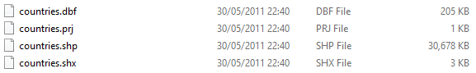
Tectonic Plates
It is a commonly known fact that the large majority of earthquakes occur on the outlines of the oceanic and continental plates, often referred to as tectonic plates (7). To provide the viewer with this context I felt it appropriate to source a .shp file that clearly marked the outlines of these tectonic plates.
File name | tectonicplates-master.zip  PB2002_plates.shp  Additional files included but not required.
File type | Files compressed in ZIP file.
File size | 25.2MB
Overview of contents | The folder contains a large number of files that were not required for this project. Within this Zip file was a file entitled PB2002_plates.shp which is required to make the tectonic plate boundaries.  When imported to QGIS the PB2002.shp successfully outlined the tectonic plates.
Data source | Originally created by Peter Bird, UCLA and sourced from github - https://github.com/fraxen/tectonicplates
Terms of use | “This collection of data is made available under the Open Data Commons Attribution License: [http://opendatacommons.org/licenses/by/1.0/]”
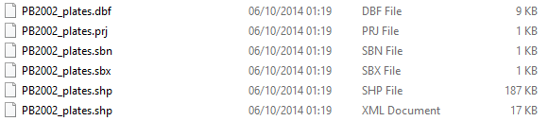

Populated Places
To add further geographical context to the project I felt it important to identify and display notable cities across the world.
File name | ne_10m_populates_places_simple.zip  ne_10m_populates_places_simple.shp
File type | Files compressed in ZIP file.
File size | 81.2KB
Overview of contents | The necessary map image files were compressed into a single ZIP file. Within this ZIP file was the ne_10m_populates_places_simple.shp.  When imported to QGIS the ne_10m_populates_places_simple.shp successfully identified populated places across the world.
Data source | http://www.naturalearthdata.com/downloads/10m-cultural-vectors/10m-populated-places/
Terms of use | “All versions of Natural Earth raster + vector map data found on this website are in the public domain. You may use the maps in any manner, including modifying the content and design, electronic dissemination, and offset printing… No permission is needed to use Natural Earth. Crediting the authors is unnecessary.” - http://www.naturalearthdata.com/about/terms-of-use/
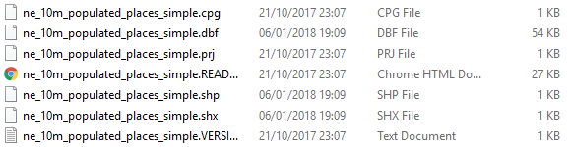

Cleaning the Data
To ensure that the data I had acquired for this project was fit for purpose I took some time to analyse the contents of the earthquake database CSV file in an attempt to identify discrepancies and errors.
To begin the analysis I sorted the database chronologically according to the date of the earthquake occurrence. I manually scrolled through the database in Microsoft Excel and quickly identified that some of the dates were left aligned in their column as opposed to the majority being right aligned.
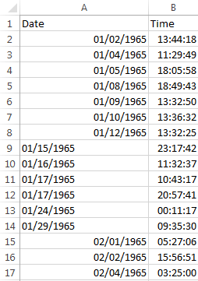
This was a reoccurring discrepancy that occurred wherever the number in the middle of the date was greater than 12. This made clear to me that the dates had been recorded in MM/DD/YYYY format often used in the US yet Microsoft Excel was setup to use UK format DD/MM/YYYY. As a result, all dates that appeared left aligned were in a standard text format rather than as a date to indicate they did not conform to the DD/MM/YYYY format.
As I continued to analyse the data I noticed errors in rows 3380 and 7514 as shown below.
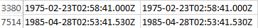
It is clear that dates had been concatenated with the time of the earthquake occurrence. To rectify this error I manually corrected both the date and time values to be uniform with other values.
I chose to alter the values to the UK standard DD/MM/YYYY format allowing me to analyse them in a more familiar format. I utilised the Text to Columns feature in Excel that quickly converted the dates to a single chosen format.
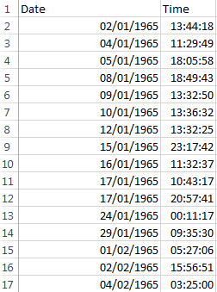
Before and after data cleaning
Importing Data
The first stage in the development of this GIS project was to import the earthquake database. I chose to import this database first to identify any errors that may exist and rectify those found. I imported the data using the Add Delimited Text Layer option in QGIS.
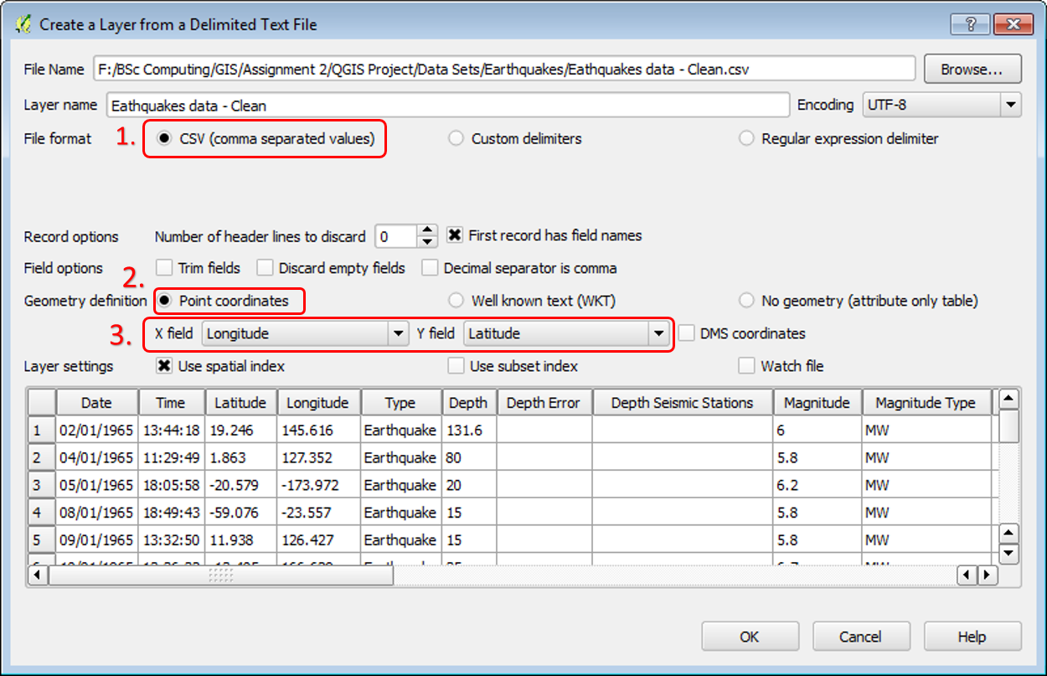
The image above is the dialogue box used to create a new delimited text layer.
- When importing the data file, I selected the CSV (comma separated values) radio button as the correct file type.
- As each record in my data was georeferenced with longitude and latitude markers I selected Point coordinates as my geometry definition.
- Finally, I ensured that the X and Y fields corresponded with the longitude and latitude attributes within my data.
The earthquake database was successfully imported and created a new layer which I entitled ‘Clean Earthquake CSV’. I then saved this layer as an ESRI shapefile (.shp) allowing it to be embedded within the project and the data to be easily manipulated to allow for analyses to be performed at a later point.
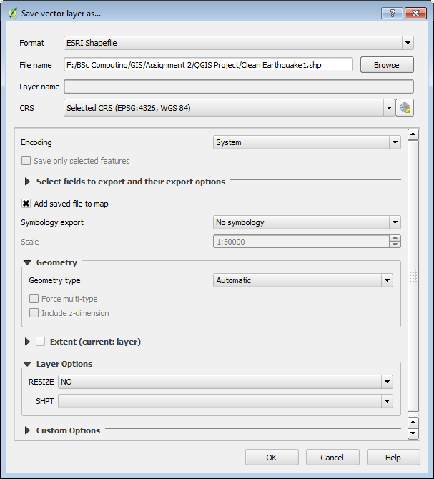
Saving the delimited text layer as a native .shp file.
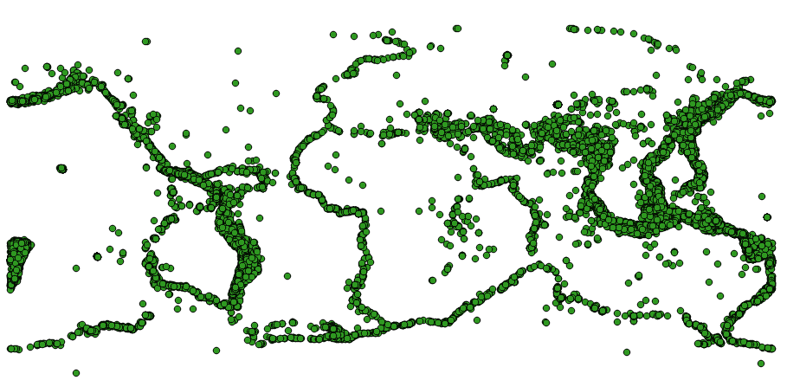
Earthquake database displayed as a .shp within QGIS.
With the earthquake data successfully imported the next task was to provide an appropriate geographical context. I imported the countries.shp file using QGIS’ Add Vector Layer tool.
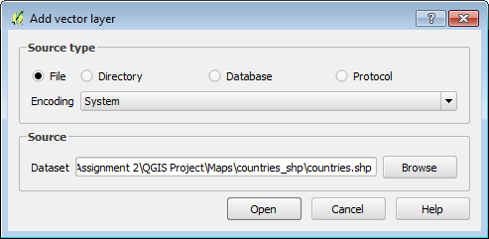
With the countries.shp file selected it was successfully opened within QGIS to display the following map.
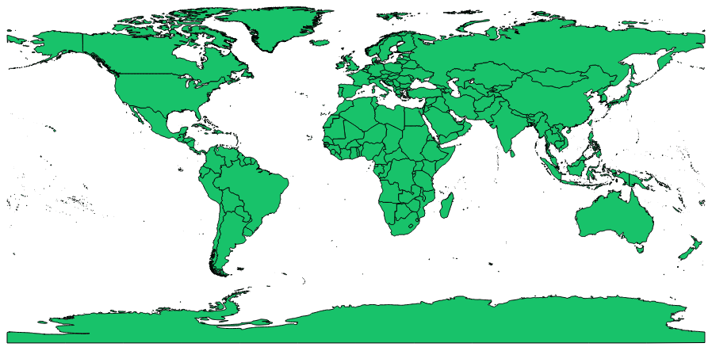
At this stage it was also appropriate to open the PB2002_plates.shp file in QGIS to outline the earth’s tectonic plates.
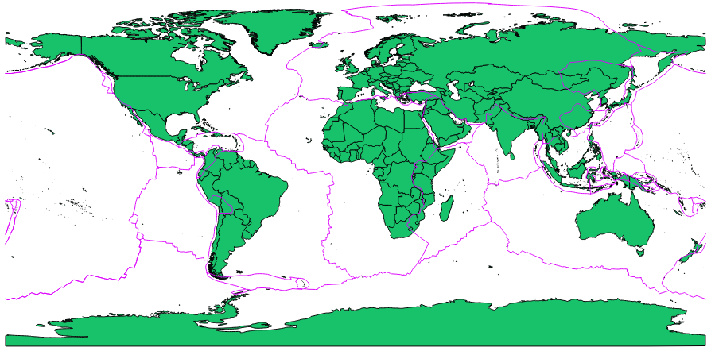
With both the Countries and Tectonic Plates layers in place the previously imported earthquake database now benefits from geographical context.
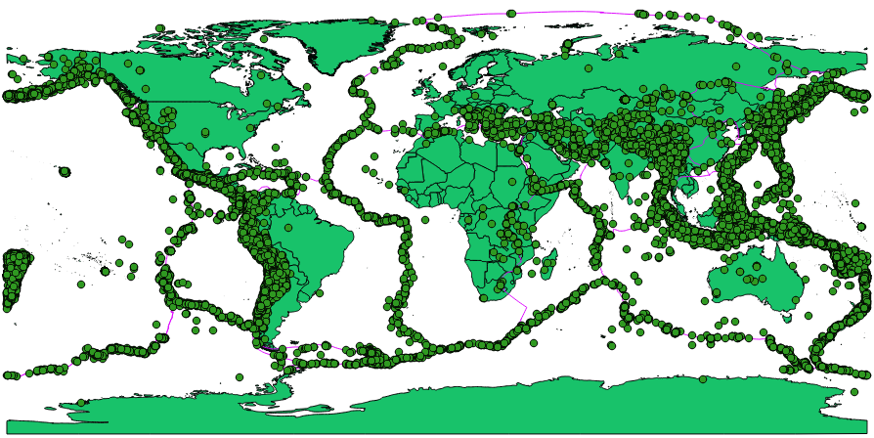
With the appropriate layers selected it becomes instantly clear that the majority of earthquakes occur on or very close to the boundaries of the earth’s tectonic plates. This is a good example of how geovisualisation is a powerful means of analysing spatial data. The pattern of earthquake occurrences is far more easily recognised in this context than it would be in a simple text file.
To add further geographical context to the map I felt it beneficial to add the locations of populated places. The following image depicts the map with the Countries, Tectonic Plates, Clean Earthquakes SHP and Populated Places layers selected.
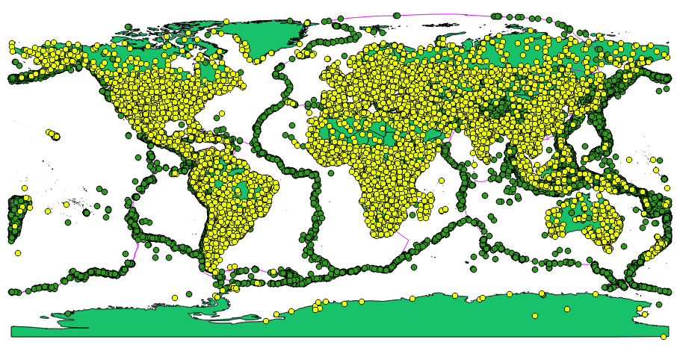
Base Layer Styling
With the key base layers now successfully imported to the project I chose to perform some basic styling on the layers to make them more identifiable. The default colour of the Countries layer was green, Tectonic Plate boundaries were pink, Populated Places were yellow and earthquakes in green. I chose to alter the styling properties of the earthquake data to make it more prominent.
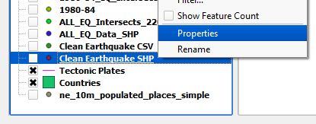
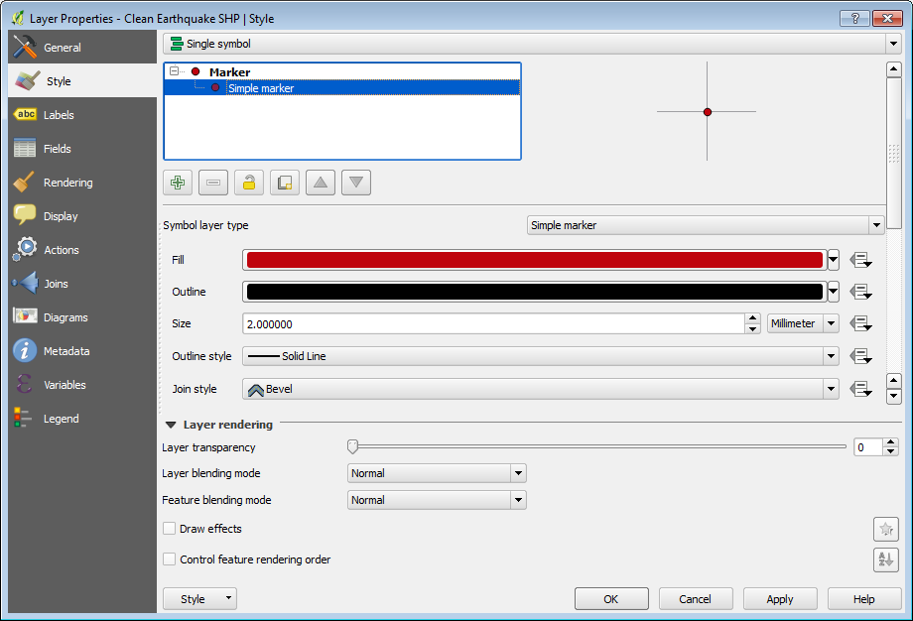
In the Style properties for the earthquake markers I chose to retain the circle marker but adopted a red colour fill which was more visible against the green map.
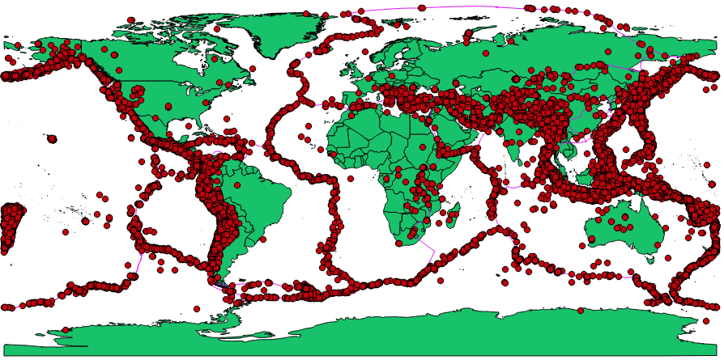
Identifying Areas for Analysis
According to the National Oceanic and Atmospheric Administration, 2017 was the most expensive year on record for North America in terms of damage caused by natural disasters. It is calculated that 16 weather and climate disasters of 2017 caused approximately $306B in damages (8). After a record-breaking year some sources suggest that the years to come will see an increase in natural disasters. The Daily Mail for example carried a story in November 2017 suggesting that scientists are warning of “at least 20 serious earthquakes” in 2018 (9). While it is too early in the year to substantiate these claims a 7.1 magnitude earthquake on the coast of Peru on 14/01/2018 leaving 2 dead has certainly got 2018 off to a rather ominous start (10).
In 2010 the British Geological Survey defied the suggestion that earthquakes were becoming more frequent and proposed that their rate of occurrence is continuing at a steady rate (11). Another area for consideration is that earthquakes appear to be more frequent as a result of more accurate recording and also the increase in human population (12). Also, earthquakes that result in injury or death are more likely to be reported by news outlets increasing the perception that their occurrence is more frequent.
With these factors in mind I have chosen the following areas for analyses:
1980-84 vs 2005-09
I have chosen the five-year period beginning 01/01/1980 and ending 31/12/1984 to compare against the five-year period beginning 01/01/2005 and ending 31/12/2009. I will compare the overall earthquake count and annual average of each to compare against each other. I will do this to determine whether the earthquake count is higher in the more recent period of time.
2015
I will analyse 2015 as a standalone year against which I will compare the average number of earthquakes from the five-year periods analysed against the earthquake count of 2015.
London vs Lima
For my final analysis I have decided to analyse the number of earthquakes within a given radius of London compared to the number within the same radius of Lima. According to the Natural Earth Populated Places data the population of London is approximately 8,500,000 and the population of Lima is approximately 8,000,000. They are cities not dissimilar in size yet their geographical location is significantly different making them interesting entities to compare.
Creating Layers
Populated Places
The Populated Places layer contained 7343 locations. To provide an appropriate level of geographical context I created a new layer displaying only the top 30 cities in the world according to population.
To do this I first duplicated the Populated Places layer to preserve the original and entitled it Top 30 Cities.
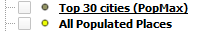
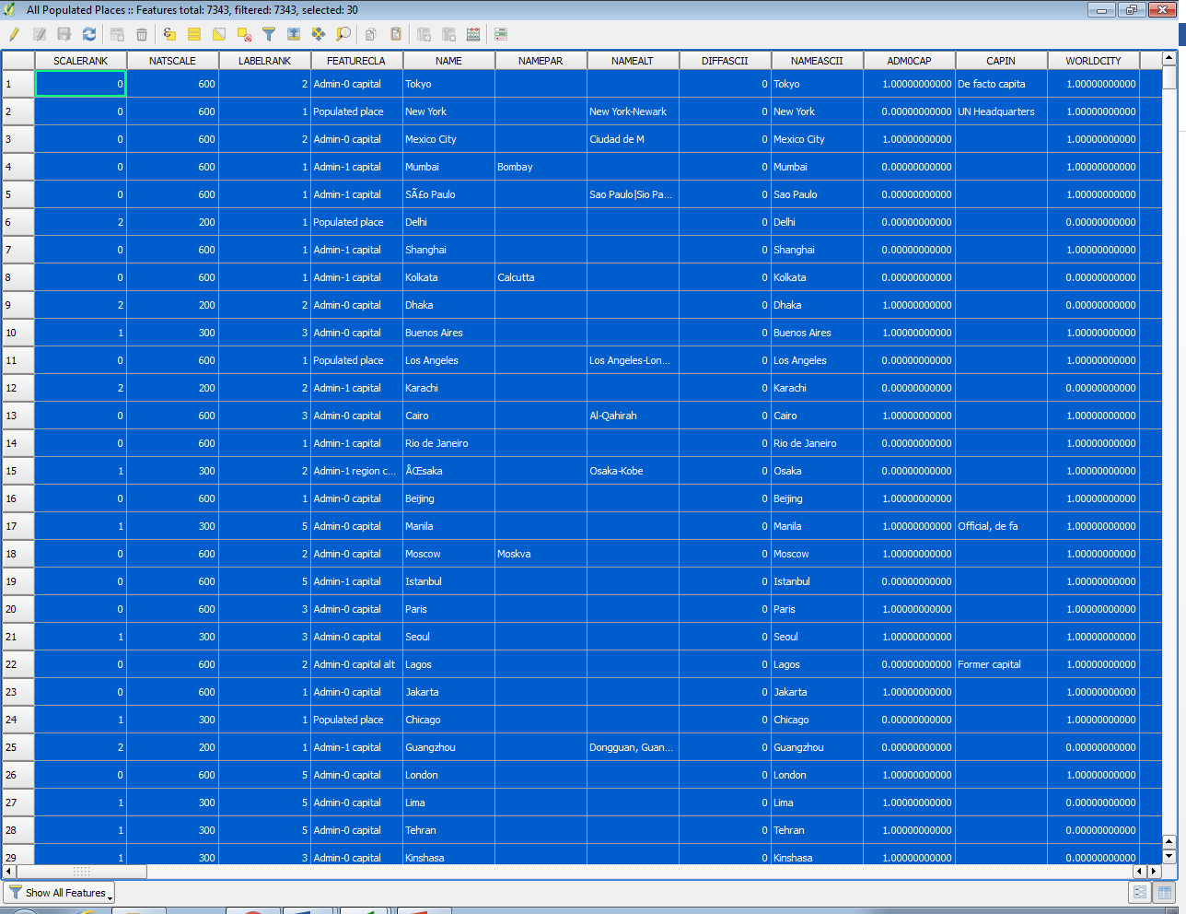
On the newly created layer I opened the attribute table and sorted the contents by the PopMax attribute. I then selected the top 30 cities in the table and inverted the selection to select all but the top 30 cities. I then removed the selected records from the attribute table leaving me with only the top 30 cities as intended.
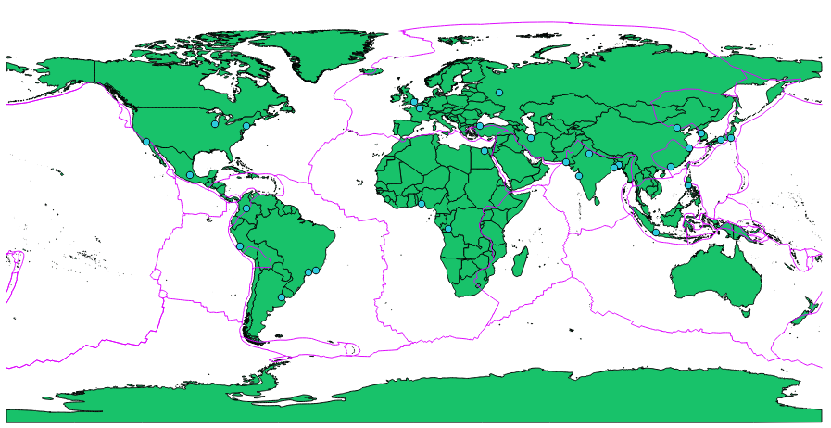
The city markers were then labelled with the value of their ‘nameascii’ attribute. The label font size was set to 8.25 with a 1mm white buffer to make labels more distinguishable on the map. Finally, I chose to offset the labels by -3.0 on the Y axis so the name did not overlap the city marker.
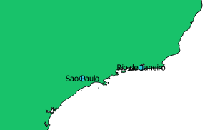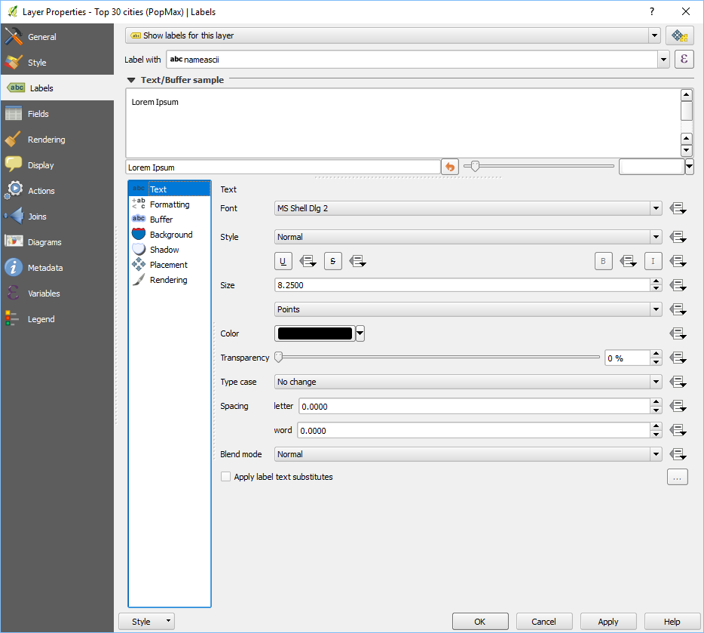
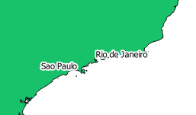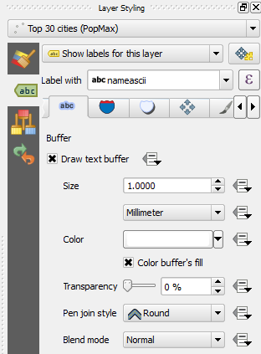
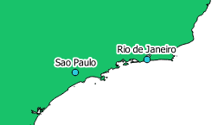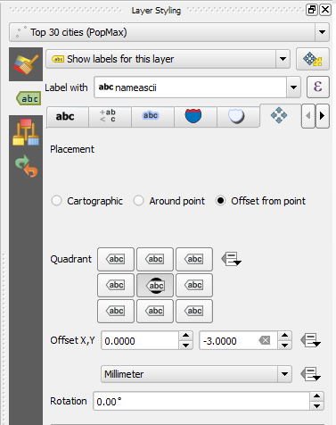
1980-84
To display only those earthquake occurrences within my given time period required me to perform a query against the data earthquake data layer. To do this I first duplicated the Clean Earthquake SHP layer. On the newly created layer I initiated the Query Builder tool from within the layer properties.
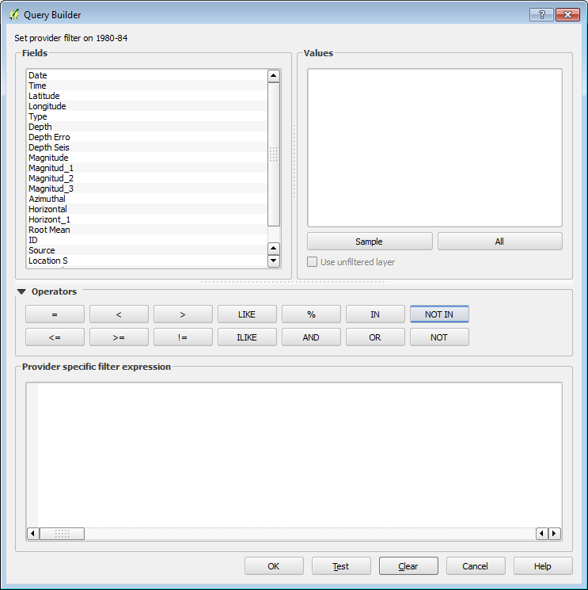
To retrieve the data required from the attribute table I developed the following query:
“("Date" LIKE '%/1980') OR ("Date" LIKE '%/1981') OR ("Date" LIKE '%/1982') OR ("Date" LIKE '%/1983') OR ("Date" LIKE '%/1984')”
This query is instructing the attribute table to return only records where the Date attribute ends with either 1980, 1981, 1982, 1983 or 1984. In QGIS the presence of the % symbol acts as a wildcard. For example, the first part of the query specifies “("Date" LIKE '%/1980')” which retrieves all Date values that end with “/1981” regardless of what precedes it. I have combined each of the statements with the OR operator allowing the retrieval of all values from the specified range.
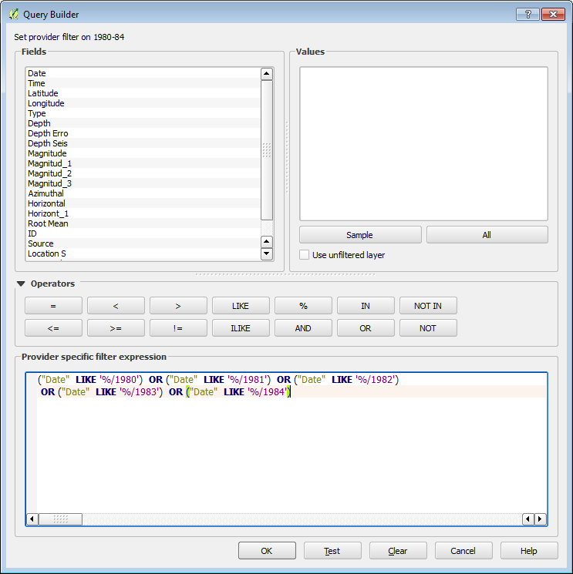
With the appropriate data now retrieved I am able to select the new layer to generate the following map.
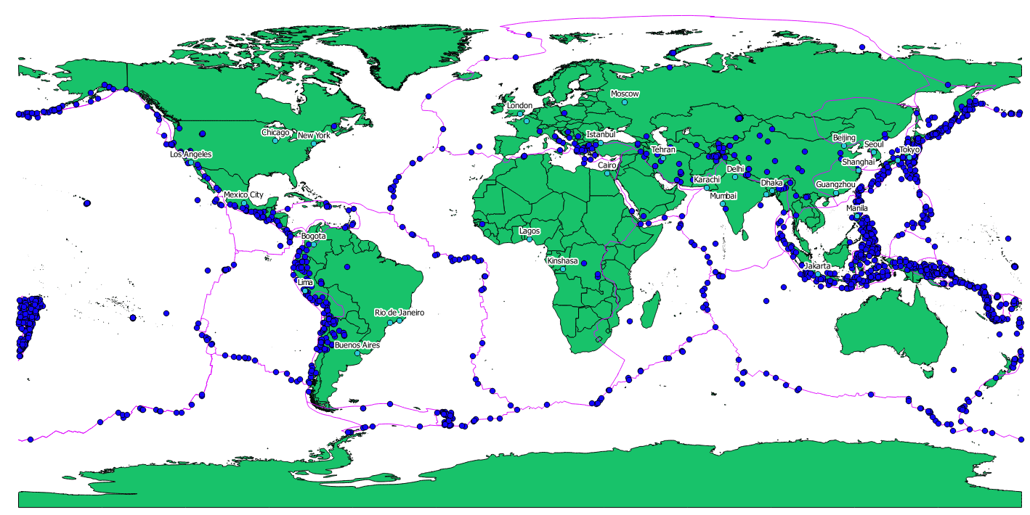
NB: The Top 30 Cities were identified with recent data and may not have been the 30 most populated cities in the period of 1980-84. Their inclusion is to add geographical context rather than an area for analysis.

2005-09
Following the same process outlined above I was able to filter the original data to show only records relating to the years 2005, 2006, 2007, 2008 and 2009.
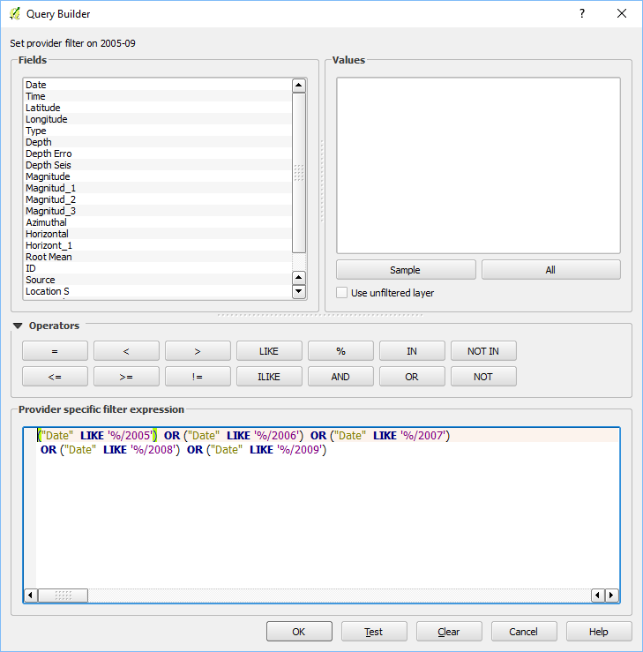
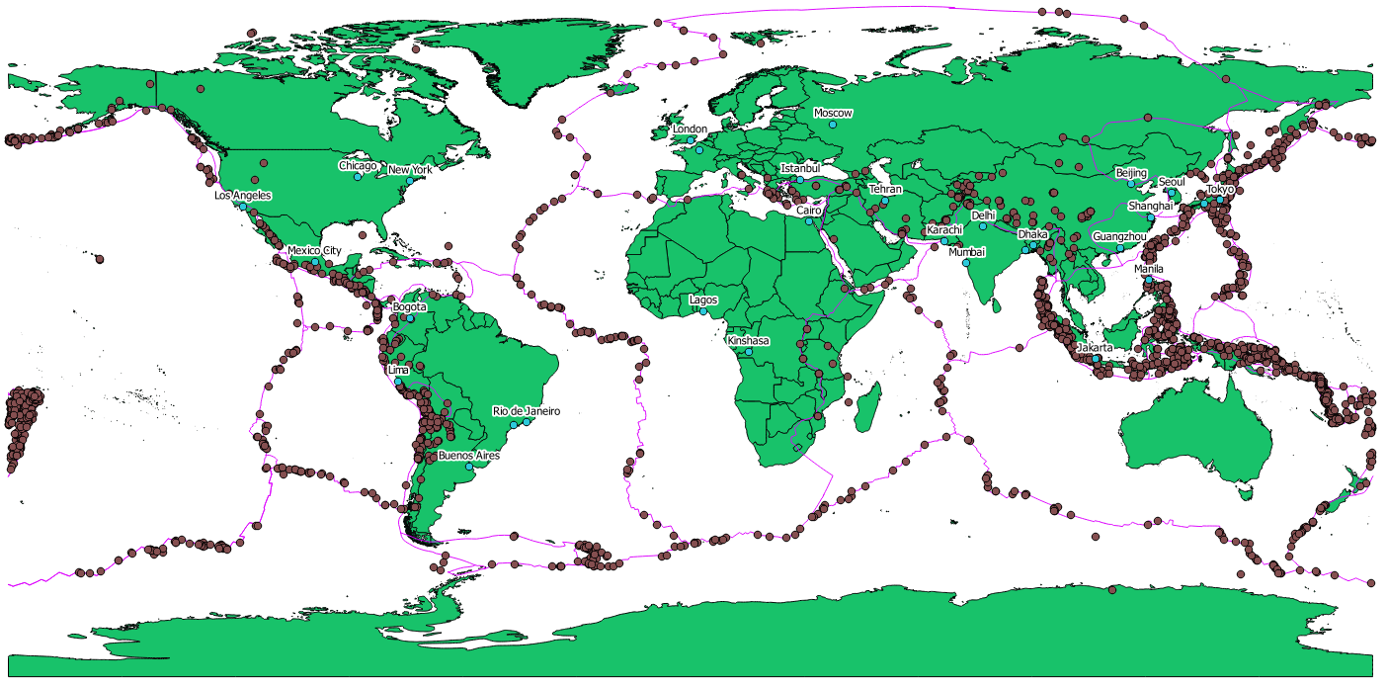

2015
The same process was followed again to retrieve earthquake incidents of 2015.
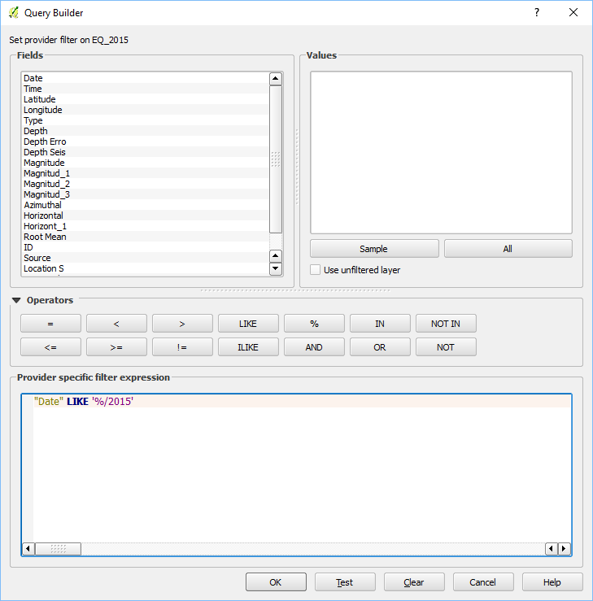
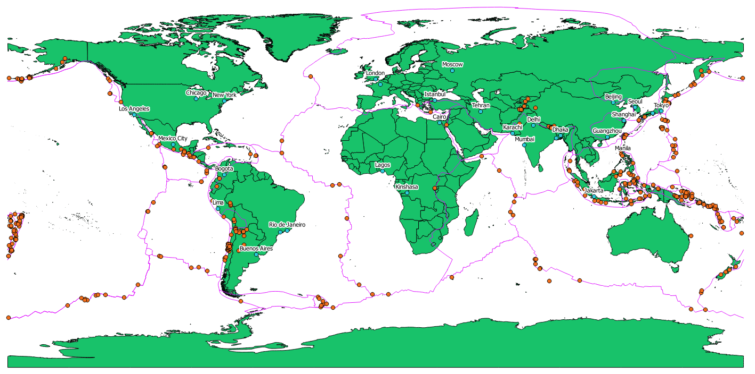

London vs Lima
As explained previously I will conduct an analysis of earthquakes within a given radius of London, England and Lima, Peru. Both of the chosen cities appear in the top 30 cities and share a similar population.
I used the Query Builder tool this time to query the Populated Place attribute table. I developed the following query:
"nameascii" = 'London' OR "nameascii" = 'Lima'
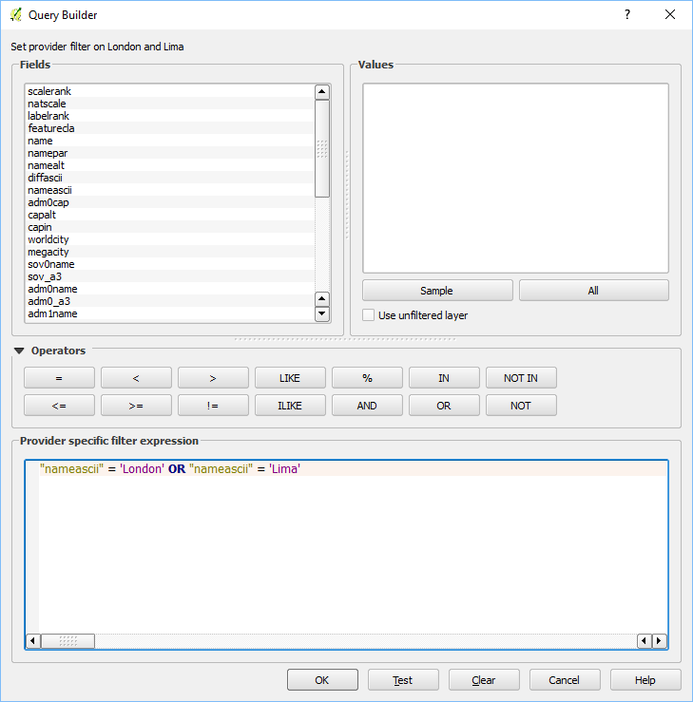
The query developed retrieves records where the ‘nameascii’ attribute is equal to either ‘London’ or ‘Lima’. Where previously I have used LIKE and the % wildcard, in this instance I have used to = operator to indicate I require the result to be an exact match.
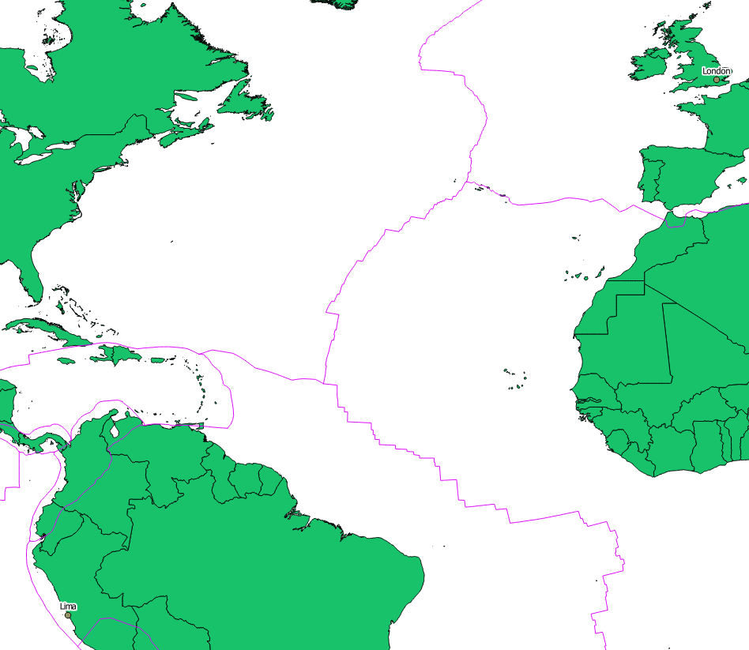
When creating this layer, it is important to note that the NAD83 / Maryland coordinate reference system (CRS) was used as opposed to the default WGS84. Due to the earth being spherical it produces some dilemmas when considering an accurate way to portray it on a flat plane such as a computer screen. A number of projections exist in an attempt to solve this conundrum. WGS84 is the most commonly used around the world while NAD83 is popular in North America (13). I have chosen to create this layer using NAD83 as it uses meters as its standard unit of measure as opposed to WGS84 which uses degrees which will allow me to create the buffer created for analyses.
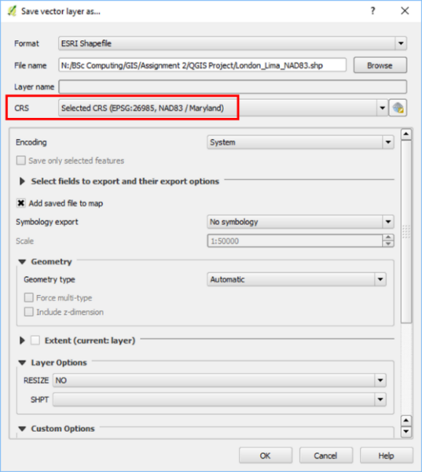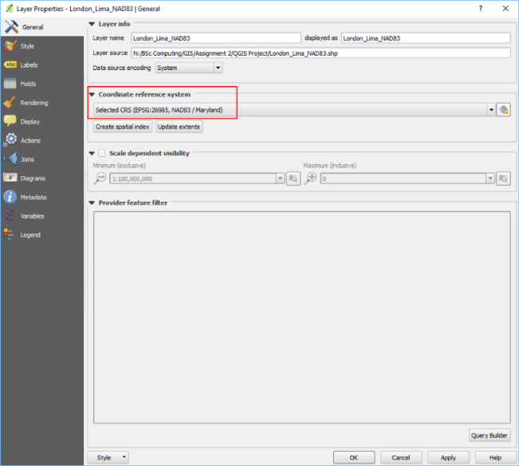
With all of the layers created I grouped them together according to their content allowing the user to more easily manage what is viewed.
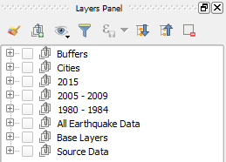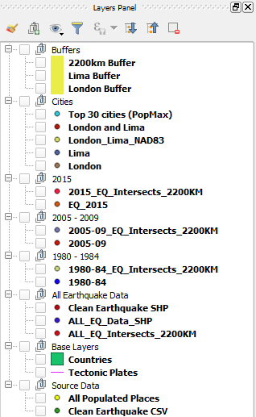

General Analysis
The following maps have been created using the Print Composer tool in QGIS. Print Composer allows the user to create high quality images of their chosen layers and add additional key features including legends, scales and text. The following four maps have been created to give an overview of the data I have utilised in this application. Following these maps, I will conduct a more focused analysis on earthquakes within a given buffer of London and Lima as outlined briefly above.
1980-84 vs 2005-09
The first map I have created displays both the 1980-84 and 2005-09 earthquake occurrence layers on the same map. The 2005-09 layer is displayed on top of the 1980-84 layer. As already discussed earthquakes are more likely to occur along the borders of tectonic plates, as a result many of the 2005-09 markers overlap and hide markers of the lower layers.
Although this map may appear rather cluttered by having all occurrences displayed on a single map it clearly supports the fact that the majority of earthquakes still occur on or near to tectonic plate boundaries.
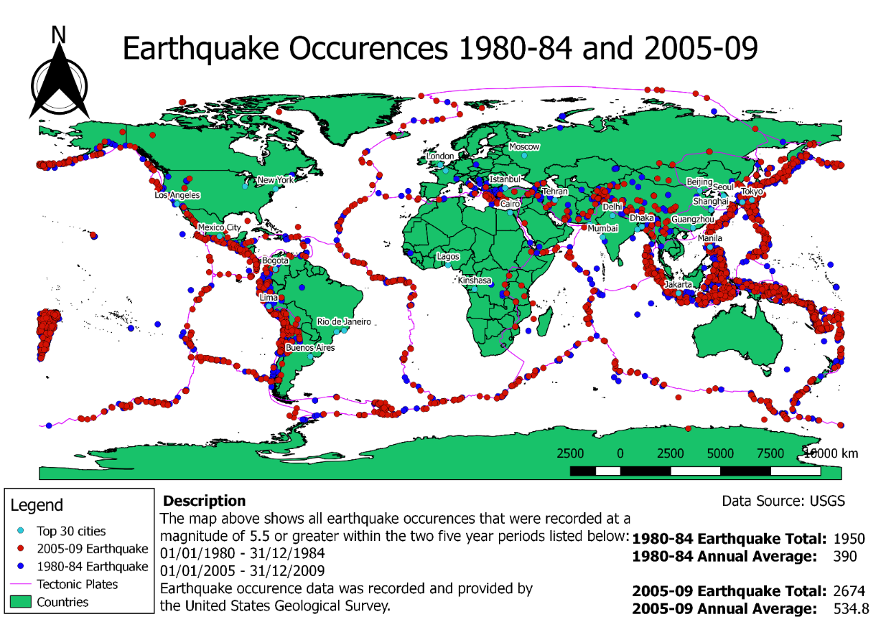

1980 – 1984 Earthquakes
The following map displays all earthquake occurrences recorded for the years between 1980 and 1984.
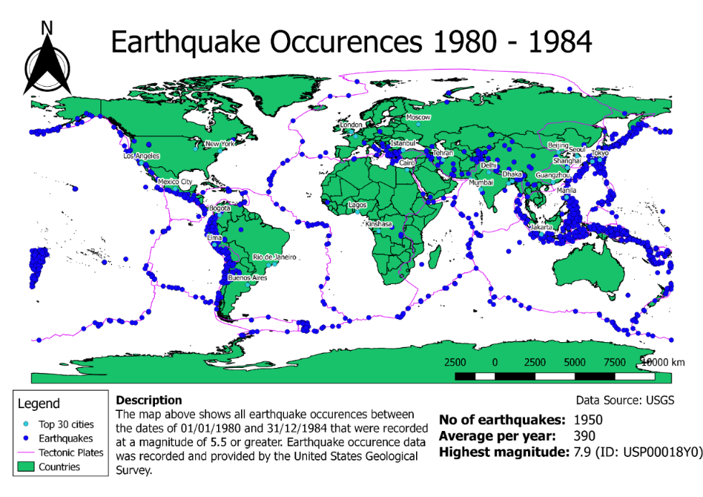

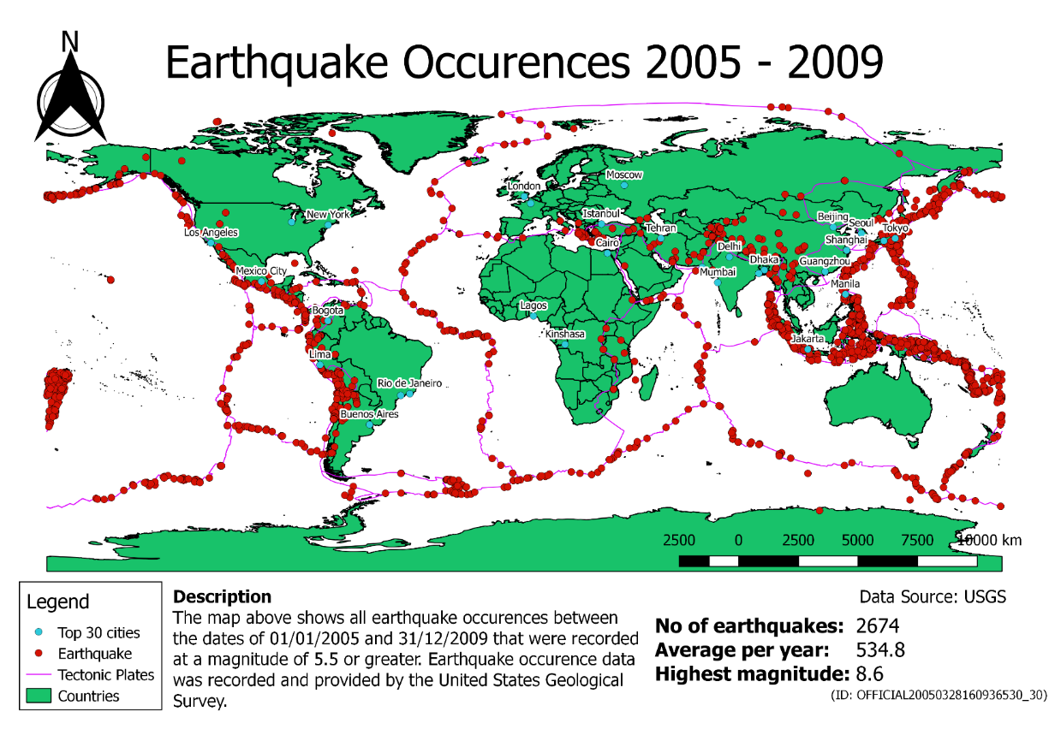
2005 – 2009 Earthquakes
The following map displays all earthquakes occurrences recorded for the years between 2005 and 2009.
2015 Earthquakes
The follow map displays all earthquakes occurrences recorded the year of 2015.
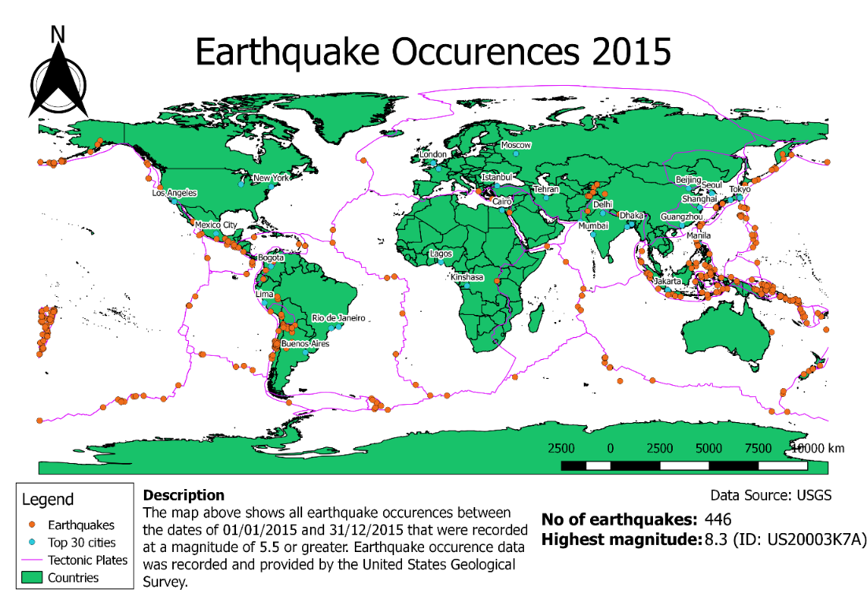
Focused Analysis
London vs Lima
Having analysed the 2015 data and map above it became immediately apparent that nearest earthquake to London was a significant distance away. Using the Measure Line tool in QGIS I determined the distance from London to the nearest earthquake as approximately 2,157KM. To compare how earthquakes impact London and Lima comparatively I felt it valuable to consider how many earthquakes had occurred within the same distance of Lima when considering the chosen date ranges.
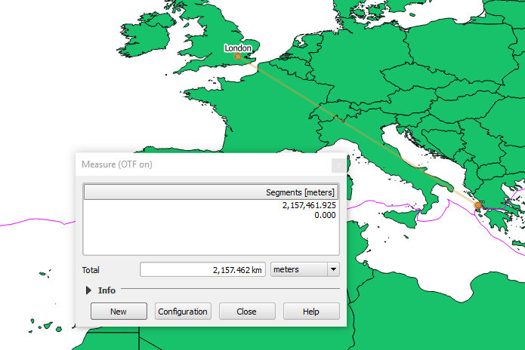
Using the Measure Line tool in QGIS.
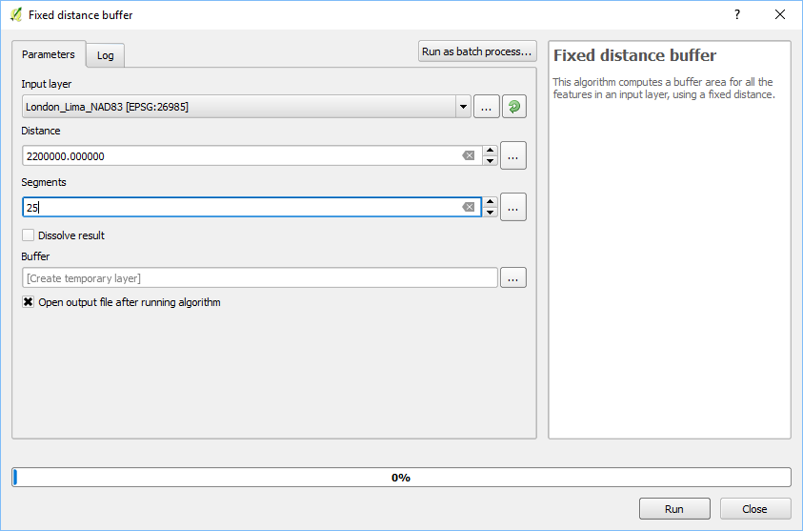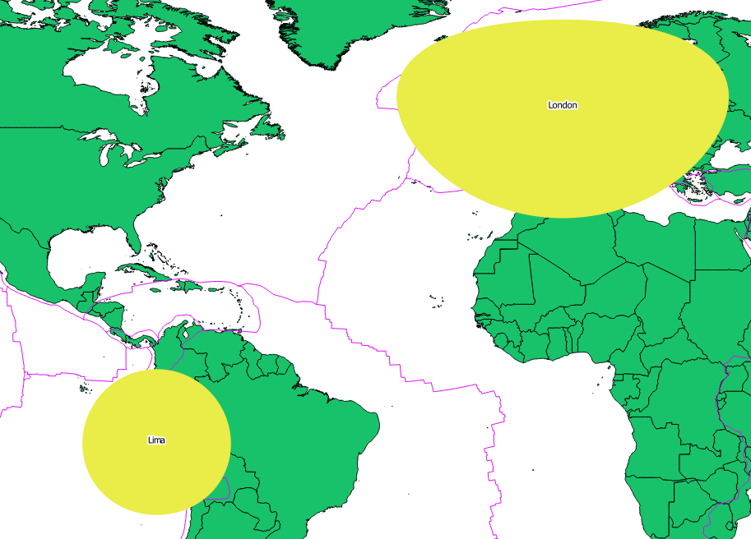
To continue the analysis, I created a fixed distance buffer around both London and Lima of 2,200KM. As explained earlier, projections of the spherical face of the earth on a flat plane can be somewhat difficult. As a result of this projection locations further from the equator are likely to appear larger than is actually accurate (14). Although the fixed buffer distances appear wildly unalike this is a result of the projection in place. Lima being significantly closer to the equator than London its buffer is less distorted.
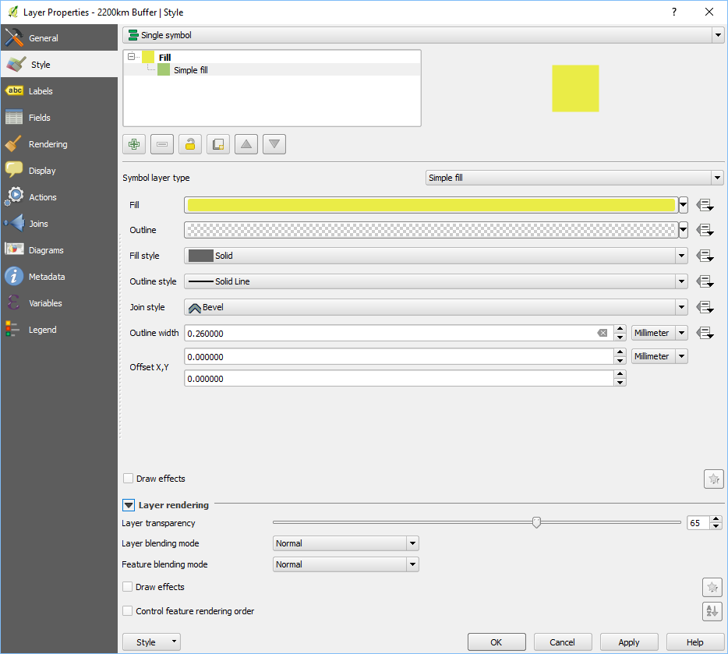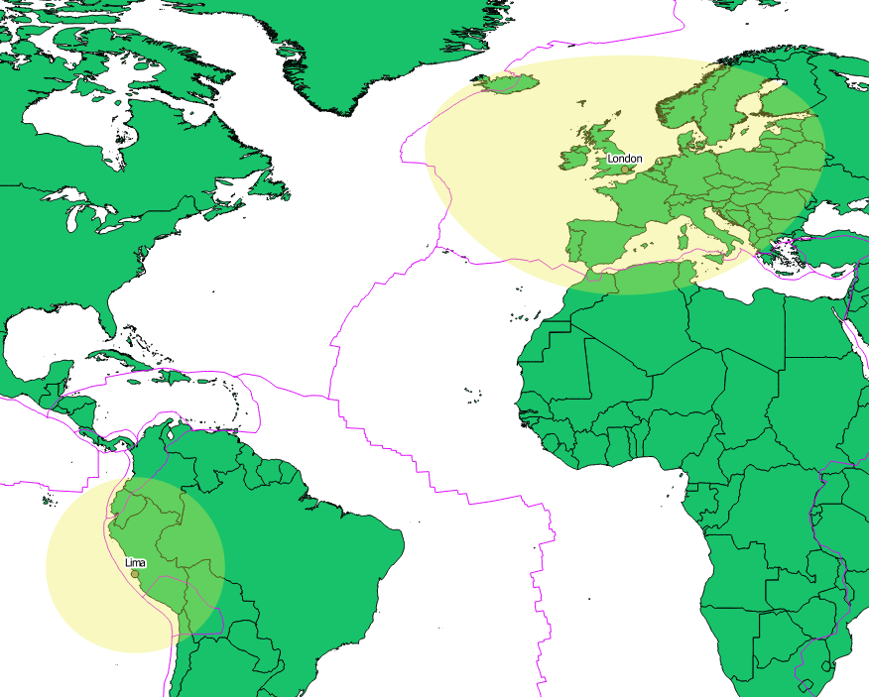
To ensure that the fixed buffer distance is visible yet not blocking other features I have altered the layer properties and given the buffer a transparency of 65%.

London vs Lima 2015
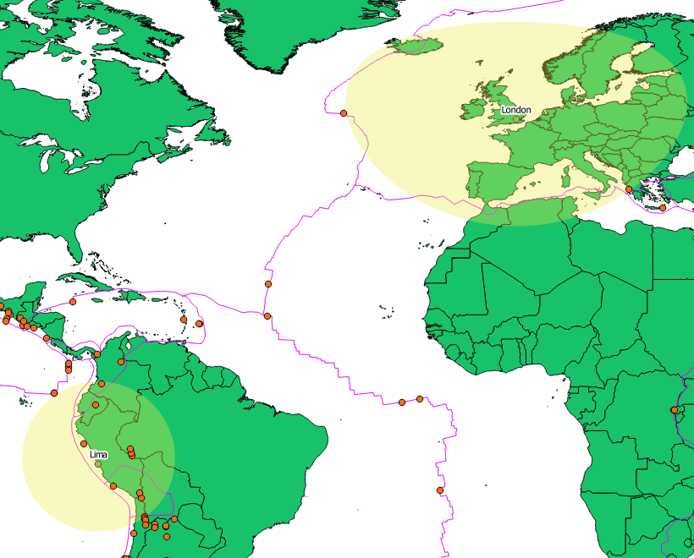
With both the 2015 earthquake data layer and buffer zones selected in QGIS I was able to utilise the Spatial Query plugin to conduct further analysis.
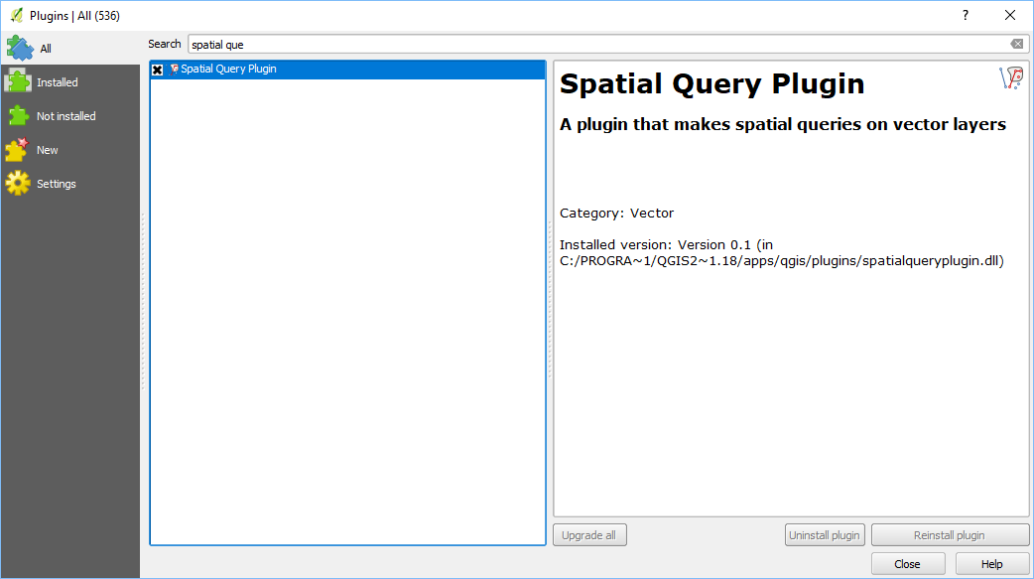
Spatial Query is an official plugin that allows the user to analyse where points or markers interact with another feature. In this case I wished to determine how many of the points on the EQ_2015 layer intersected with the 2,200KM buffers. The Spatial Query plugin was installed using the official QGIS plugin installer by selecting Plugins > Manage and Install Plugins from the command bar.
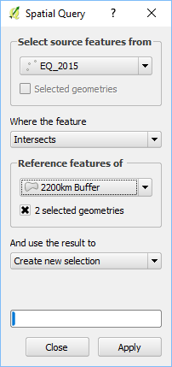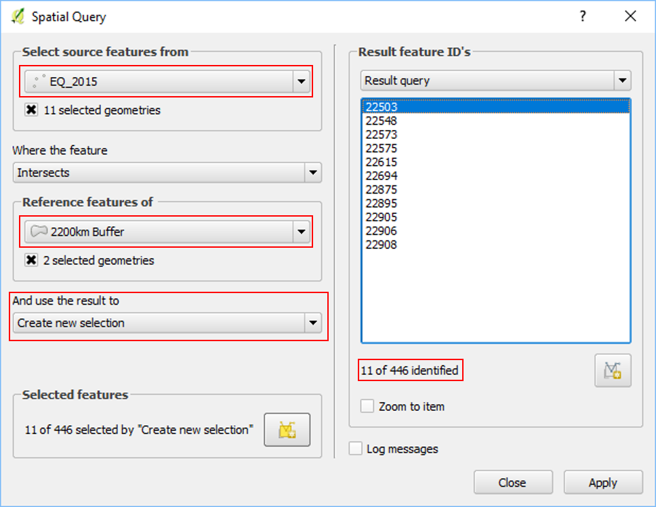
In Spatial Query I selected the data layer and the buffer layer and determined that a new selection be created of all those earthquakes that intersect with the buffer. As you can see from the diagram above (right) 11 records of 446 were identified as intersecting with either of the London and Lima buffers.
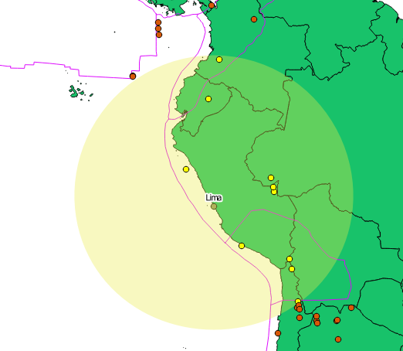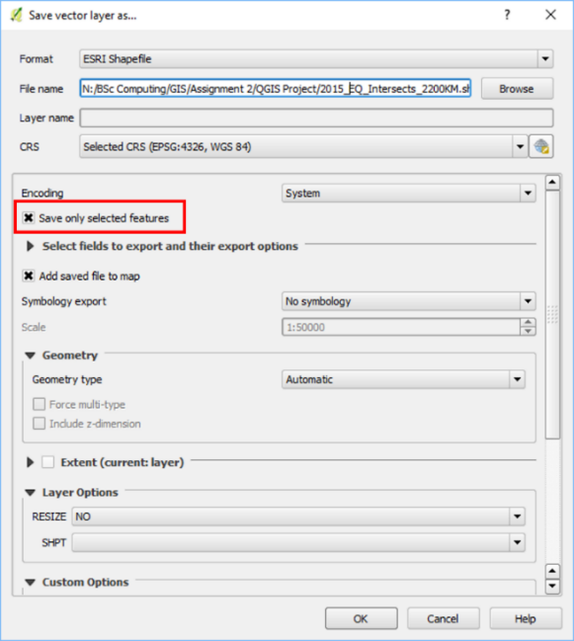
Spatial Query has automatically selected those occurrences within the buffer zone and changed the marker colour to display their selection. With the earthquake occurrences selected I was able to save a duplicate vector layer that included only the selected features by checking the ‘Save only selected features’ box. This process created a new vector layer displaying only those earthquakes that intersected the buffer as the image below exhibits.
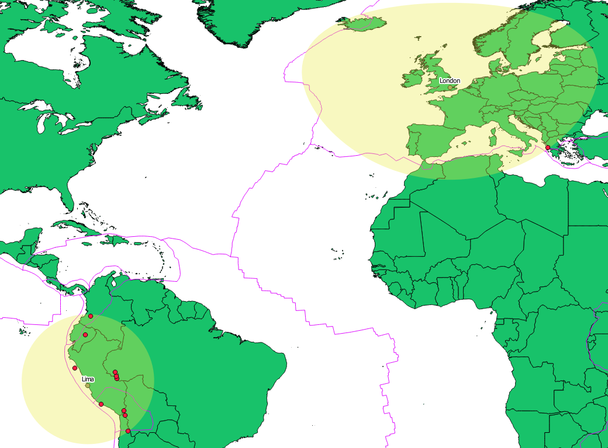
London vs Lima - 2015
City | London | Lima
Number of earthquakes | 1 | 10

London vs Lima 1980-84
By following the same processes detailed above I was able to use buffer zones to count how many earthquakes had occurred within the buffer of each city in my chosen date ranges.
Spatial Query determined there was a total of 76 earthquake occurrences within the buffers.
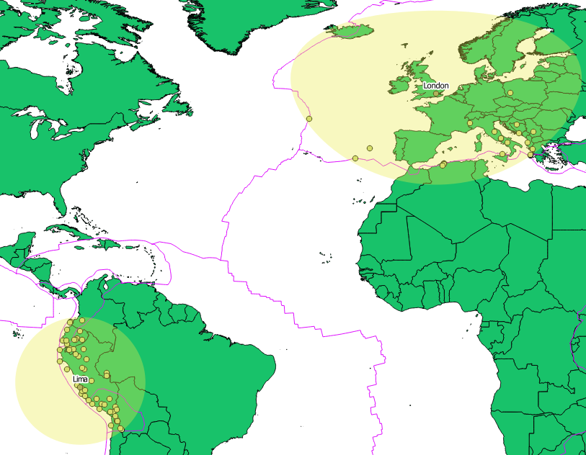
London vs Lima – 1980 - 1984
City | London | Lima
Number of earthquakes | 22 | 54
Average no per year | 4.4 | 10.8

London vs Lima 2005-09
By utilising Spatial Query again I was able to determine that 102 earthquakes occurred in the buffer zones between 2005 and 2009.
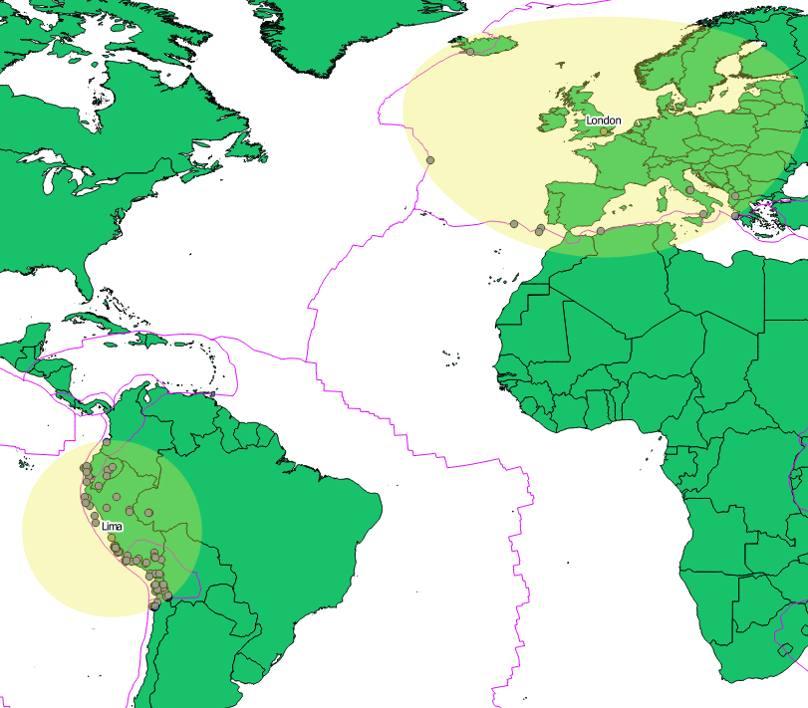
London vs Lima – 2005 - 2009
City | London | Lima
Number of earthquakes | 11 | 91
Average no per year | 2.2 | 18.2

London vs Lima 1965-2016
Although not one of the original areas for analysis I felt it would be interesting to consider the total number of earthquakes occurrences that have occurred within the buffers from the data provided by USGS.
The Spatial Query identified 885 earthquake occurrences.
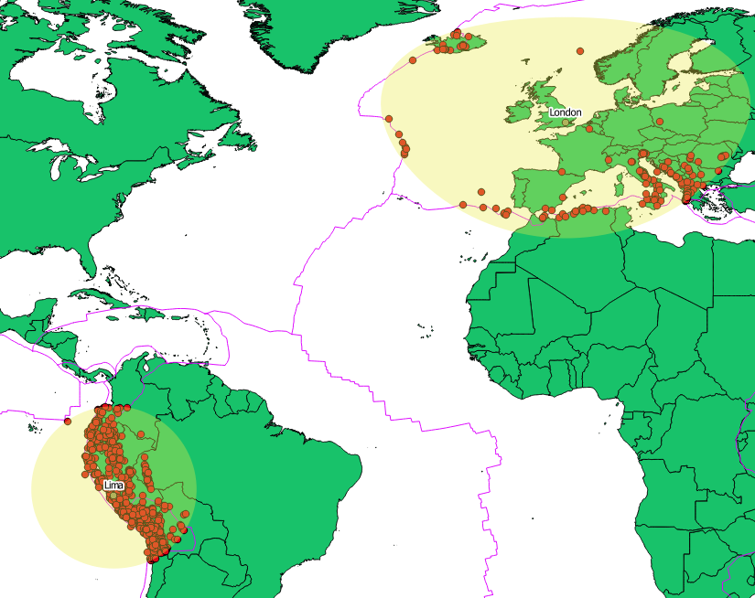
London vs Lima – 1965 - 2016
City | London | Lima
Number of earthquakes | 172 | 713
Average no per year | 3.3 | 13.7

Analysis Findings
The basis for my analysis was the notion that following a record-breaking year of damage caused by natural disasters that extreme weather phenomena including earthquakes are becoming more frequent and more damaging. As stated earlier the claim that earthquakes are becoming more frequent is one adamantly denied by the British Geological Society (11). The BGS claim that the case is simply that we are recording more earthquakes than previously and that the frequency of larger events remains stable. In an attempt to remove this element of debate I opted to analyse only earthquakes of a magnitude of 5.5 or greater.
Another major consideration is that ‘natural disasters’ such as earthquakes are actually natural occurrences and it is the damage to or loss of human life that makes these occurrences ‘disasters’. The growing world population (which jumped from 1.5 billion in 1900 to 6.1 billion by the year 2000 (15) has naturally resulted in more inhabited spaces across the world increasing the likelihood of a ‘natural disaster’ (16). In my analysis I have considered all earthquakes regardless of their impact on human life and by doing so I have nullified the social factor that human impact makes earthquakes appear more frequent. Analysing all earthquakes impartially has allowed me to develop an accurate statistical representation of earthquakes and their frequency.
According to BGS earthquake frequency remains stable – a claim which is clearly supported by the data I have analysed. Within 2,200KM of London there was a total of 172 earthquakes between 1965 and 2016, an average of 3.3 per year. Within the same distance between 1980 and 1984 there was 22 earthquakes and 11 earthquakes between 2005 and 2009. The average number of earthquakes per year based on these two periods of time is 3.3 – the same as the long term average.
Within 2,200KM of Lima there was a total of 713 earthquakes between 1965 and 2016 giving an average of 13.7 per year. Compared to the 3.3 average of London this is significantly greater but not unexpected given how closely situated to a tectonic border Lima is. Within the same distance there was a total of 54 earthquakes between 1980 and 1984 and 91 earthquakes between 2005 and 2009. While these two statistics suggest an increase in earthquake occurrences the combined annual average of 14.5 is not drastically above the long term average of 14.
When looking at earthquakes on a global scale the original date file covering 1965 to 2016 records 23,412 earthquakes giving an annual average of 459. In the 1980-84 period there was a total of 1,950 earthquakes and an annual average of 390 and a total of 2,674 in 2005-09 with an annual average of 534.8.
The following table (next page) provides an overview of the key statistics that I have analysed.

 | 1980-84 |  | 2005-09
 | No of earthquakes | Average per year | No of earthquakes | Average per year | Combined annual average | 1965-2016 annual average
London | 22 | 4.4 | 11 | 2.2 | 3.3 | 3.3
Lima | 54 | 10.8 | 91 | 18.2 | 14.5 | 14
World | 1950 | 390 | 2674 | 534.8 | 462.4 | 459

In the table above, I have shaded cells red where the total or average value is higher than its counterpart, yellow where it has remained constant and green where it is lower. For example, London experienced half the amount of earthquakes in 2005-09 that it faced in 1980-84 and is shaded green. Conversely both Lima and the world experienced an increase in earthquake occurrences when comparing the two time periods and are shaded red.
The data table above provides a seemingly mixed set of results. London experienced far less earthquakes in more recent times yet Lima experienced far more. The table at first glance seems to suggest that earthquakes are becoming more frequent but this doesn’t tell the whole story. The most telling statistics are the combined annual averages of the two time periods analysed compared against the long term averages. For London the average number of earthquakes has remained perfectly in line with the long term average. Although the annual average has increased for both Lima and the world, when more closely scrutinised the combined annual average of Lima is only 3.5% above the long-term average and more tellingly the combined annual average of world earthquakes is only 0.75% above the long-term average, an almost negligible amount.
The maps below display the two locations on which I have focused my analysis and provide a description and some of the key findings.
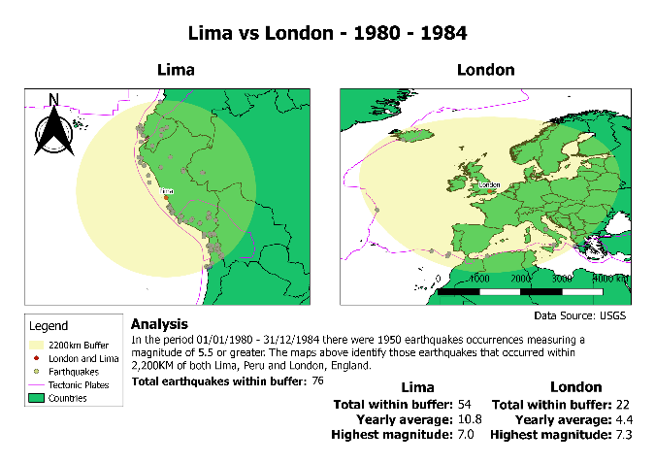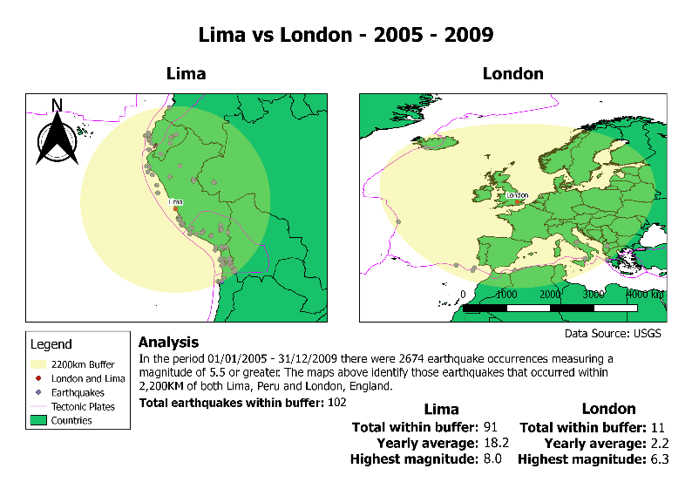

Conclusion
In conclusion, I am confident that the analysis I have performed on a large dataset has benefitted greatly from the use of a GIS application and geovisualisation. While this data could also have been analysed in other software packages the practice of geovisualisation gives the data far greater context and allows it to be considered more thoroughly. Martin Dodge of Manchester University suggests that in the modern day visual representation is more important than ever before stating “[vision] is the quickest and most direct source of information, the widest-ranging and the one that supposedly offers the truth” (17). Geovisualisation allows viewers to create an association between data and a geographical location far quicker than analysing textual data. Geovisualisation gives the viewer an immediate context to the data they are viewing by defining a location.
The GIS application I have developed affords the end user the ability to easily:
- Quickly recognise earthquake patterns for a number of different periods of time by selecting and deselecting created layers.
- View buffer zones around Lima and London and count earthquakes occurrences within those zones. An analysis that would have been incredibly difficult without the use of a GIS application.
- Layer and view data to perform direct comparisons of historical data on the same map.
In addition to these benefits the end user also profits from the ability to amend the layers I have created and conduct different analyses. For example, a number of layers display data according to the result of a query. These queries can be altered as the user sees fit to display the data they require. My solution also includes all of the base layers and source data that would be required to start afresh allowing the end user the opportunity to perform analyses on whatever aspect of the data sets available they should choose.

Reference List
1. National Earthquake Information Center (NEIC) [Internet]. Earthquake.usgs.gov. [cited 6 February 2018]. Available from: https://earthquake.usgs.gov/contactus/golden/neic.php
2. Richter scale | Definition & Facts [Internet]. Encyclopedia Britannica. [cited 6 February 2018]. Available from: https://www.britannica.com/science/Richter-scale
3. Magnitude Explained: Moment Magnitude vs. Richter Scale- Incorporated Research Institutions for Seismology [Internet]. Iris.edu. [cited 6 February 2018]. Available from: https://www.iris.edu/hq/inclass/animation/magnitudes_moment_magnitude_explained
4. Hanks T, Kanamori H. A Moment Magnitude Scale [Internet]. US Geological Survey; 1979 [cited 6 February 2018]. Available from: https://web.archive.org/web/20100821063413/http://www.gps.caltech.edu/uploads/File/People/kanamori/HKjgr79d.pdf
5. 20 Largest Earthquakes in the World [Internet]. Earthquake.usgs.gov. [cited 6 February 2018]. Available from: https://earthquake.usgs.gov/earthquakes/browse/largest-world.php
6. Publishing O. Information Policies and Instructions [Internet]. Www2.usgs.gov. 2012 [cited 6 February 2018]. Available from: https://www2.usgs.gov/laws/info_policies.html
7. Endsley K. Where Do Earthquakes Happen? [Internet]. Geo.mtu.edu. [cited 6 February 2018]. Available from: http://www.geo.mtu.edu/UPSeis/where.html
8. Billion-Dollar Weather and Climate Disasters: Overview | National Centers for Environmental Information (NCEI) [Internet]. Ncdc.noaa.gov. 2017 [cited 6 February 2018]. Available from: https://www.ncdc.noaa.gov/billions/
9. Weston P. Swarms of big earthquakes are set to devastate Earth in 2018 [Internet]. Mail Online. 2017 [cited 6 February 2018]. Available from: http://www.dailymail.co.uk/sciencetech/article-5099551/Swarms-big-earthquakes-set-devastate-Earth-2018.html
10. Eliott C. McLaughlin C. Deadly earthquake shakes Peru [Internet]. CNN. 2018 [cited 6 February 2018]. Available from: http://edition.cnn.com/2018/01/14/americas/peru-earthquake-deaths/index.html
11. British Geological Survey Seismology Monitoring Page [Internet]. Earthquakes.bgs.ac.uk. [cited 6 February 2018]. Available from: http://www.earthquakes.bgs.ac.uk/education/faqs/faq18.html
12. Is earthquake activity increasing? | British Geological Survey (BGS) [Internet]. Earthquakes.bgs.ac.uk. 2010 [cited 6 February 2018]. Available from: http://www.earthquakes.bgs.ac.uk/research/earthquakeActivity.html
13. WGS84 Vs NAD83 [Internet]. Grind GIS-GIS and Remote Sensing Blogs, Articles, Tutorials. 2017 [cited 6 February 2018]. Available from: http://grindgis.com/blog/wgs84-vs-nad83
14. Datum and Projection [Internet]. web.viu.ca. [cited 6 February 2018]. Available from: https://web.viu.ca/corrin/FRST121/recent%20stuff/Datum%20and%20Projection.htm
15. Roser M, Ortiz-Ospina E. World Population Growth - Our World in Data [Internet]. Our World in Data. 2017 [cited 6 February 2018]. Available from: https://ourworldindata.org/world-population-growth
16. Ehrlich P. Population and “Natural” Disasters | MAHB [Internet]. MAHB. 2013 [cited 6 February 2018]. Available from: https://mahb.stanford.edu/blog/population-and-natural-disasters/
17. Aitken S, Valentine G. Approaches to human geography. Los Angeles, Calif. etc.: SAGE; 2012.

