

Programme: Master of Business Administration
Module: International Business Concepts
Module Code: LCMB7034
Assignment Title: “Starbucks Corporation's Market Entry into Bangladesh - A Strategic International Business Analysis”
Lecturer: Gladius Kulothungan

Student Name: Md Asif Reza
Student ID: 2523547

Table of Contents
Introduction 3
Section 1: Strategic Market Entry Analysis 4
1. Organizational Classification and Global Strategy 4
1.1 Strategic Categorization Using Bartlett and Ghoshal's Model 4
1.2 Global Configuration and Competitive Advantage 5
2. Macro-Environmental Appraisal & Market Attractiveness 6
2.1 Host Country Analysis: PESTEL Factors for Bangladesh 6
2.2 Market Entry: Applying Dunning's Eclectic Paradigm (OLI Framework) 12
3. Entry Mode Strategy and Strategic Synthesis 14
3.1 Historical Starbucks Entry Mode Patterns 14
3.2 Strategic Fit for the Bangladesh Market 15
3.3 Recommendation and Justification 16
3.4 Risk Mitigation Considerations 17
Section 2: Reflective Account Using Gibbs' Reflective Cycle 18
Description 18
Feelings 18
Evaluation 19
Analysis 19
Conclusion 20
Action Plan 20
Conclusion 21
References 22

Introduction
Starbucks Corporation is one of the most popular brands of coffee in the world, with over 40,000 stores across more than 80 countries by 2025 (Starbucks Corporation, 2025). The company does not have a formal outlet in Bangladesh, however, where a speedily increasing middle class population is also projected to have an increasing appetite for high-quality drinks (World Bank, 2024). This report is an analysis of the potential Starbucks would make when entering Bangladesh. It uses the Bartlett and Ghoshal model as well as PESTEL analysis and Dunning's eclectic paradigm to provide analysis of the firm's strategy, host country attractiveness and appropriate entry mode. The strategic evaluation is presented in Section 1 and reflective account (through Gibbs' cycle) to discuss the learning process is presented in Section 2.

Section 1: Strategic Market Entry Analysis

1. Organizational Classification and Global Strategy

1.1 Strategic Categorization Using Bartlett and Ghoshal's Model


Figure 1 Starbucks Overview (Starbucks Corporation, 2025)

Based on the balance between integration and responsiveness of the global and local market, Bartlett and Ghoshal (1989) proposed four types of international strategy: multinational, global, international, and transnational (Bartlett and Ghoshal, 1989). Starbucks is a type of transnational. The company maintains its brand identity globally while tailoring their menu, store designs and even their menu prices to local tastes (Ozturk et al., 2019). For instance, Starbucks sells Teh Tarik in Malaysia and green tea drinks in Japan, and maintains its original lines of coffee in all markets (Haskova 2017). The combination of that results in economies of scale in terms of buying/sourcing and technology whilst demonstrating a cultural sensitivity (Verbeke and Hutzschenreuter, 2021).
There is also a transnational fit in the organisational structure of Starbucks, where the main headquarters are located in the U.S. while the other regions are in China, EMEA, and Latin America (Sima, 2025). This is an open and two-way knowledge sharing, with key learnings from one market – e.g. mobile ordering in the U.S. – being disseminated internationally (Alon et al., 2020). Others, however, believe that Starbucks has a more global approach since product standardization is still predominant and the changes in menu items are generally small (Rugman & Verbeke, 2017). The critical view is that this is a hybrid, and the best term is transnational, as the solid emphasis on scale and adaption will not do anything but highlight their hybrid nature. Being able to transfer the R&D findings and marketing ideas from one market to another, retaining the same logo, cup design, and atmosphere in the stores, demonstrates what Bartlett and Ghoshal referred to as the ‘transnational state' of doing the right thing, which is something they said is hard to achieve (Wang and Zhang, 2022).
Dimension | Multinational | Global | Transnational (Starbucks)
Global integration | Low | High | High
Local responsiveness | High | Low | High
Knowledge flow | One-way | Centralised | Two-way
Table 1: Bartlett and Ghoshal Classification of Starbucks' International Strategy.

1.2 Global Configuration and Competitive Advantage
Starbucks' business model involves it having its own stores, having joint ventures and licensed cafes, and China and the United States are the two largest marketplaces (Starbucks Corporation, 2025). There are three ways in which this spread helps to create values. First, by sourcing from Latin America, Africa and Asia, global prices are reduced, and supply is guaranteed (Grimmer, 2022). Secondly, premium pricing, both within and between markets (Cayla and Arnould, 2019) is easily achieved with the strong brand. Third, the digital ecosystem foresees a loyalty effect by the Rewards programme, a factor that promotes repeat buying of products and services ( Chen and Hu, 2020). Importantly, it's the combination of a consistent “third-place” experience, but also the localised elements which are hard to replicate quickly by any other competitor (Peng and Meyer, 2019). Additionally, the geographic dispersion also helps to minimize exposure to one market shock, such as the COVID-19 interruption, where a robust recovery in China was able to compensate for the weaker sales in the United States (Verbeke and Hutzschenreuter, 2021). One major issue is that China is the source of the majority of new store growth, leaving them dependent on China. This increases geopolitical and currency risk, and drives the company to identify a new growth area; amongst which South Asia and Bangladesh significantly can be looked upon (Sima, 2025).

2. Macro-Environmental Appraisal & Market Attractiveness

2.1 Host Country Analysis: PESTEL Factors for Bangladesh
Bangladesh is a country in South Asia. It is a nation of more than 170 million people and experiencing fast urbanization (World Bank 2024). The following focused review of the politics, economy, law and culture of the countries in which Starbucks is going to go presents them.
1. Political Factors
The political context in Bangladesh has been fueled by inter-party conflict in the country between Awami League and Bangladesh Nationalist Party (Bangladesh National Party) since long (Riaz, 2021). After the political transition in August 2024, a new government headed by Muhammad Yunus was in power and embarked on broad reform (Ali & Chowdhury, 2023). Political stability impacts a food and beverage company like a chain such as Starbucks in various ways, including supply chain, licensing, and consumer trust. In the past, strikes, locally called as hartals were common which affected retail activity in Dhaka and Chattogram (Hossain 2020). In turn, the government's Vision 2041 plan is geared towards building the nation as a developed country, thus attracting foreign direct investment (Rahman and Khan, 2022). But corruption ranking is still not a problem, as Bangladesh is ranked at 24 on the corruption index of Transparency International in 2023 (Islam and Beloucif, 2024). Starbucks will thus need to brace for regulatory hurdles and need to find a strong local partner. The bilateral ties with the USA are largely intact, and Bangladesh is still enjoying generalised trade preferences from a number of partners (Rahman & Khan 2022). Another method of support is the creation of special economic zones with tax incentives for foreign companies, which enhancing Starbucks logistics and roasting may be advantageous (BIDA, 2024). Overall, political risk level is fairly low, but not low enough to be overlooked, so a "scenario planning approach" is recommended.
2. Economic Factors
The average growth rate of the GDP of Bangladesh was maintained (6.0-6.5 per cent) in 2016-23 and it is one of the fastest growing economics in South Asia (Asian Development Bank, 2024). Global inflation, however, put a lid on growth in 2024 at approximately 5.8 percent, as was exacerbated by reserve pressures (World Bank, 2024). The country anticipates that the per-capita income will be approximately USD 2800 in 2024, and become a LDC by 2026 (Rahman and Khan, 2022). The growth of the middle class, which is more than 40 million people, has led to a rising demand for lifestyle products, such as high-quality coffee (Chowdhury et al., 2023). The population of the youth (15-29), which is the target market of Starbucks, accounts for approximately 27 percent of the overall population (BBS, 2023).
The market of coffee in Bangladesh is small, but rapidly growing. Café coffee sales are expected to grow at a rate of approximately 11% annually to approximately USD 42.5 million in 2020 and will reach USD 89.6 million in 2026, according to the revenues projected by Statista (2025). The early market acceptance of foreign chains like Gloria Jean's and North End Coffee Roasters in Dhaka is another sign of acceptance of the market (Aktar and Rahman, 2022). Even though currency depreciation of the taka against the USD is a risk for imported inputs (Foo et al., 2025), no other significant issues have been identified. The over-all economic picture is good but with a degree of cost sensitivity. Another factor is urbanisation, with over 22 million people living in Dhaka and the city's population growing at more than three per cent per year – providing rich catchment markets for high-end retail ideas (World Bank, 2025). Inflation continued to exceed nine per cent in 2024, impacting discretionary spending, and could potentially lead to a reduction in café margins if this isn't managed carefully when pricing (Asian Development Bank 2024). Yet its growth path far outstrips the growth of the overall food retail market, meaning there is considerable demand potential for the coffee market.
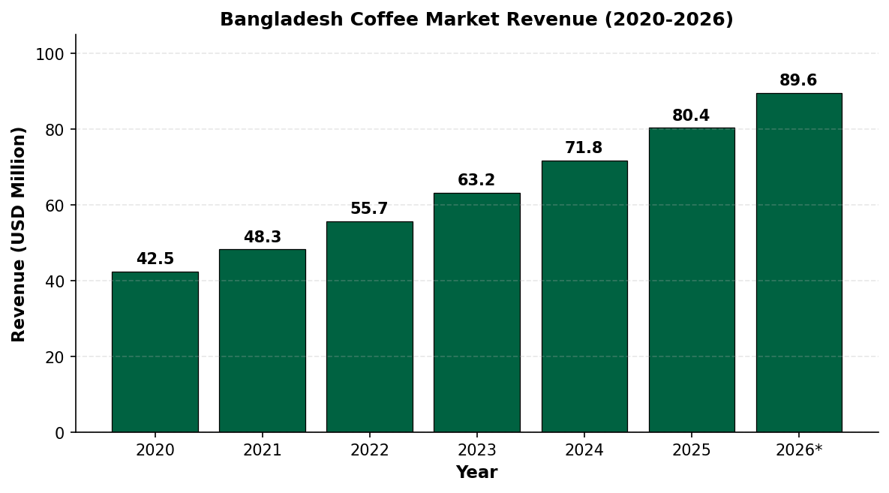
Figure 2: Bangladesh Coffee Market Revenue Growth (2020-2026). Source:(Sima, 2025)

3. Social and Cultural Factors
Bangladesh is a Muslim majority nation, where approximately 91% of the population who are Muslims (BBS, 2023). This influences food and beverage regulations, such as the requirement for using halal ingredients and prohibition of consumption of alcohol, on the menu (Rahman et al., 2020). Unlike coffee, tea is the more traditional hot drink but coffee culture is increasing rapidly among urban youth owing to the influence of social media, and the study café trend (Sarker and Hossain, 2019). As per Hofstede's cultural dimensions, Bangladesh is a culture with high scores on power distance, collectivism, and low scores on individualism (Hofstede Insights, 2024). This helps to indicate that their group tours and family seating are more important than their takeaway service. Starbucks' “third place” philosophy is congruent with this social pattern (Cayla and Arnould, 2019). However, store design can need to provide space for customers of a different gender that are able to maintain privacy (Chowdhury et al., 2023). The growth of English medium schools and the influx of diaspora professionals have also led to a group that is known with the world of café brands, reducing the education cost of introducing Starbucks' items (Aktar and Rahman, 2022). Besides, the link between the stereotype of a coffee culture and remote work, and youth aspirations has grown in the world, following a similar trajectory as observed in India and Indonesia by Sarker and Hossain (2019). Starbucks has to resist the danger of over pricing its products, as did initially limit its development in India and must instead stick to the value-based menus in accordance with local income levels.
Another factor to consider is language. The national language is Bengali, however, English is a language that is widely used, so Starbucks can continue to have its signs and marketing with both languages with minimal translation expenses (Rahman et al., 2020). The other research related to consumer behaviour also indicates the importance of experience-based consumption among the young generation of Bangladesh, and they would be willing to pay higher amount for shopping in a space which is aesthetically attractive, which can be married with the concept of Starbucks regarding its stores (Chowdhury et al., 2023).

4. Legal and Regulatory Factors
According to BIDA (2024), the Bangladesh Investment Development Authority (BIDA) has opened up for 100 percent foreign ownership in most retail and service sectors including food and beverage. But for halal food, certification is necessary by Bangladesh Standards and Testing Institution (Islam and Beloucif, 2024) as per the rules are involved in these sectors. Labour laws are derived from the Bangladesh Labour Act 2006 (amended 2018) which establishes minimum wages and workers' rights (Foo, et al., 2025). Protection has increased but enforcement of it has been weak, and there have been conflicts relating to trademarks involving some foreign brands (Uddin and Alam, 2018). The tax regime includes a 27.5 percent tax rate for non-listed foreign companies and general repatriation of profits are allowed per the central bank (Rahman and Khan, 2022). These factors are controllable, but need to be properly structured legally. Coffee beans imported into Sri Lanka are subject to high import taxes and bonded warehouse facilities are also available by registered foreign investors to defer or delay the duty until the goods are sold (BIDA, 2024). Since 2018, laws have become stricter on consumer protection and Food Safety Authority has begun to focus more on the enforcement of food safety and increased vigilance to chain outlets. The compliance systems used in the Middle East operations of Starbucks can be implemented within Starbucks' operations in the Middle East with very minimal effort (Rahman et al., 2020). Data protection legislation is still developing and the upcoming Personal Data Protection Act (to come into force after 2025) will impact customer loyalty programmes and their approach to personal information. This early compliance with international privacy norms will put Starbucks in a compliance position (Islam and Beloucif, 2024).
5. Environmental Factors
Bangladesh is highly vulnerable to the effects of climate change, and ranked among the most climate change risk prone nation in the world to flooding and cyclones (Alam and Kabir, 2021). This has negative impacts on the reliability of the supply chain of imported goods from Chattogram port. Starbucks' good sustainability efforts, such as ethical sourcing and stores that minimize waste could appeal to younger coffee drinkers who are more aware of environmental issues (Grimmer, 2022). The arena of waste management – particularly plastic waste – is becoming increasingly subject to regulatory focus and the company can make use of its already existing programmes to recycle cups on a global basis and paper straws in order to become a differentiator in this segment. Environmental positioning involves more than risk management; in a market which values young customers for their focus on ‘brand purpose' (Cayla and Arnould, 2019), it is an opportunity for value creation.
6. Technological Factors
Among others, penetration of the internet has grown to approximately 45 per cent in 2024, and mobile financial services like bKash are popular (Sarker and Hossain, 2019). This is to bolster Starbucks' digital ordering and loyalty model. The surge in Food Delivery Startup such as Foodpanda and Pathao Food provides a potential avenue for growth. The rapid growth of Food Delivery Startup platforms such as Foodpanda and Pathao food makes the way forward for expansion all the more possible. (Chen and Hu, 2020) For Starbucks, the barrier to technology adoption is reduced by the fact that the technology is already known by urban consumers, at the point-of-sale and by cloud-based inventory and QR code ordering systems. The age group of 18-35 years is quite behaviourally active on social media platforms, particularly in Facebook and Instagram, and that these are channels to engage brands at low costs (Aktar & Rahman, 2022).
Factor | Key Insight for Starbucks | Impact
Political | Interim government reform; occasional unrest | Moderate risk
Economic | Strong GDP growth; rising middle class | High opportunity
Social | Muslim-majority; youth-led coffee culture | Moderate to high opportunity
Legal | 100% FDI allowed; halal rules apply | Manageable
Environmental | Climate vulnerability; rising green awareness | Moderate risk / branding opportunity
Technological | Mobile payment growth; delivery apps active | High opportunity
Table 2: PESTEL Summary for Bangladesh Market Entry.
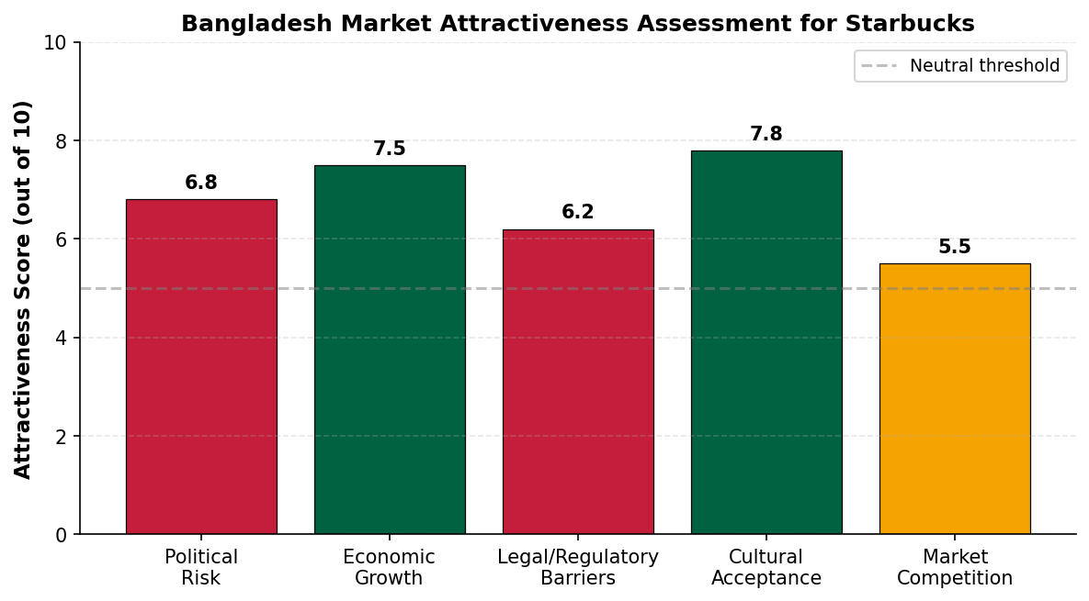
Figure 3: Bangladesh Market Attractiveness Assessment for Starbucks. Source: Author's compilation based on World Bank (2025) and Hofstede Insights (2024).
Competitive Landscape
Currently, the Bangladesh Café market is highly segmented with numerous independent Coffee shops as well as few organised chains. Urban professionals and students are already loyal customers of local and regional players like North End Coffee Roasters, Crimson Cup and Gloria Jean's in urban areas like Dhaka and Chattogram (Aktar and Rahman, 2022). Usually, these outlets sell drinks for 30-50% less than what Starbucks would be able to sell it for, and that leads to an interesting question: should Starbucks hike its prices in the price-sensitive market to compensate? Until recent, however, this apparent disconnect was no longer an obstacle for Starbucks, thanks to its global brand promise, product uniformity, and iconic customer experience that it was still able to establish premium prices in other Asian markets with similar incomes such as Vietnam and Indonesia, where local brands sold cheaper alternatives as well (Cayla and Arnould, 2019).
Meanwhile, there are no boring markets. Overall, consolidation is on the way, with more powerful local chains going out of their way to buy weaker independent coffee shops and/or enter into supply contracts with foreign roasters, indicating that competition is professionalizing ahead of any large foreign competitor (Wang and Zhang, 2022). It may be beneficial to Starbucks, as the growing trend may lead to a better organized distribution and real estate market to enter into, or detrimental, since it further strengthens local brands prior the Starbucks Star train arrives.
The example of Costa Coffee's near demise in India is a stark reminder of how difficult it is to hold on to the market with the local competitors who are adept at their niche and have more brand loyalty. The example of Costa Coffee's failure in India in 2017 when they faced tough competition from local coffee shop players as well as local preferences (Ozturk et al., 2019) is a good warning. The case proves that it's not enough to simply recognise a brand, foreign companies must now have a local partner with an appreciation for pricing, real estate expenses and the preferences of local customers. However, for Starbucks the take-home message is that success in the market will require more than just recognition, it will require an understanding and familiarity with the market, as well.

2.2 Market Entry: Applying Dunning's Eclectic Paradigm (OLI Framework)
In order to explain the reason behind foreign direct investment, Dunning (2000) is able to cover three advantages: Ownership (O), Location (L), and Internalisation (I). Its recent value in emerging market decision continues to be supported by recent scholarship (Peng and Meyer, 2019).
Ownership Advantages
Starbucks also enjoys numerous ownership advantages, such as its true brand value of USD 14.4 billion, exclusive coffee blends it has developed, digital experience and its Starbucks Store Design expertise (Cayla and Arnould, 2019). These provide the company an advantage over local Bangladeshi cafés as they are hard for local cafés to replicate (Aktar and Rahman, 2022). Its policies on human resource, including the extensive training of baristas and ownership of the company for employees, are also intangible assets that contribute to the quality of service provided and to reducing employees' turnover (Grimmer, 2022). These types of benefits would be transferable across borders and would be valuable with which to barter with local partners, landlords and regulators in Bangladesh.
Location Advantages
There are a number of location advantages in Bangladesh. The high rate of urbanization, young population, low labour costs and rising disposable income of the middle -lass middle segment in cities are attractive (Chowdhury et al., 2023). Densely populated catchments are available in Dhaka and Chattogram. But poor road conditions, and fluctuating exchange rates make it less appealing to venture outside of urban areas (Foo et al., 2025). The strategic location of the country with the possibility of a region-based supply base in case scale is reached is another great advantage. The early store economics in premium locality remains favourable, due to lower real estate rentals in premium area compared to Delhi/ Jakarta (World Bank, 2025).
Internalisation Advantages
The way of internalisation will rely at the same time on whether Starbucks will maintain its operations or it will share its control. To the extent that the same goes in Bangladesh (as in India with Tata) using a licensed partner would enable the firm to maintain its standards and to gain knowledge of the local market. It would be more cost and politically exposed if a company is fully owned, a licensed or joint venture pathway offers an internalisation balance (Sima, 2025). In addition, there is a transaction cost economics theory to back this up: when knowledge is imperfect and there is a high level of reputational risk, a partial internalisation of these firms through a JV will lower the risk of opportunism, but still keep control in the brand over its critical resources, such as the roasting standard, and store experience (Peng and Meyer, 2019). This is what Starbucks' strategy has been in the South Asian and Middle Eastern markets – the company has seldom entered as a 100 percent stake holder in the beginning.
OLI Component | Starbucks Position | Bangladesh Implication
Ownership | Strong brand, proprietary blends, digital platform | High-competitive edge over local cafés
Location | Urban middle class, youth demographics | Attractive in Dhaka and Chattogram only
Internalisation | Shared control needed to protect brand | Licensed partnership preferred
Table 3: OLI Framework Application for Starbucks in Bangladesh.
The OLI analysis indicates that Bangladesh provides a viable entry point for a joint venture, particularly in the context of shared control as opposed to total ownership, in the initial phase (Alon et al., 2020). All three are interdependent - good ownership assets need a partner who can turn them into local revenue, location advantages need to be captured by a firm that can relate with regulation and culture (Dunning, 2000). When contrasted to other models like the Uppsala model, OLI offers a more helpful framework here as Starbucks already has some ‘foreign markets to learn, local markets to master’ experience, and do not need extra market learning steps (Peng and Meyer, 2019). This is a synthesis of the PESTEL aspects and how they fit into Dunning's framework, and will set the stage for selecting entry modes.

3. Entry Mode Strategy and Strategic Synthesis

3.1 Historical Starbucks Entry Mode Patterns
Different modes of entry by Starbucks from one market to the next depending on the level of maturity and risk in the market. It has primarily company owned stores in the United States, Canada and United Kingdom (Grimmer, 2022). It has preferred to do Joint Ventures and Licensing with very good local partners in emerging markets including India, Indonesia and Middle East (Sima, 2025). The case of 50/50 joint venture with Tata Consumer Products in India was recognized as a good model since 2012 (Ozturk et al., 2019). China was an example where Alon et al. (2020) suggest that a firm went from licensing to full ownership once they developed local knowledge. The pattern indicates that certain shared modes are lower risk modes and the higher risk modes are in the higher control modes as conditions are better. The staged approach also helps the firm gauge consumer response, establish the supply chain and train managers based in the country before investing a huge sum of money. (Wang and Zhang, 2022). This development is indicative of the ‘Uppsala model' of the gradual internationalisation of which many recent studies continue to find relevance for service brands in emerging markets (Peng and Meyer, 2019).

3.2 Strategic Fit for the Bangladesh Market
In Bangladesh, three entry options can be considered: wholly owned subsidiary, Joint Venture and Licensing/Franchising. There are trade-offs among risk, control and resource dedication (Peng and Meyer, 2019).
Criterion | Wholly Owned | Joint Venture | Licensing
Control | High | Shared | Low
Risk | High | Medium | Low
Resource commitment | Very high | Medium | Low
Local knowledge use | Low | High | High
Suitability for Bangladesh | Weak | Strong | Moderate
Table 4: Entry Mode Comparison for Bangladesh Market.
A 100% subsidiary would afford Starbucks complete control, but would also involve significant political risk and currency risk, as well as large capital outlays (Foo et al., 2025). While it is a quick and inexpensive solution, there is a danger of weak brand control, which is something that might have adversely affected Starbucks in the past markets (Haskova, 2017). A joint venture with an established local partner (Rahimafrooz, Transcom Group) is a middle ground, which provides control, local knowledge and shared risk (Uddin & Alam, 2018). This is further encouraged by the institutional landscape in Bangladesh. To a large extent, foreign companies associated with well-known local companies are likely to encounter fewer bureaucratic hurdles and will be granted quicker access to prime retail locations (Islam and Beloucif, 2024). In addition, a joint venture also shares the costs of store fit-out, staff training, and setup of the supply chain – which is not to be underestimated in a market that is under currency and duty pressure on imported inputs (Foo et al., 2025). Further, the risk associated with turnover of expatriate managers, where local partners are involved in day-to-day operations with Starbucks overseeing the brand, training and quality, is reduced.

3.3 Recommendation and Justification
The preferred entry mode for this situation is recommended to be joint venture. These are the 3 lines of reasoning. First, joint ventures are a good match for the OLI logic, which enables the Starbucks owner to utilize its ownership advantages and the local partner's knowledge of its local location (Dunning, 2000). Secondly, they follow the Bartlett and Ghoshal's transnational logic, where global, brand standards are ensured, but local adaptations are possible (Rugman and Verbeke, 2017). Third, they decrease political and regulatory risk in an interim government and developing laws and regulations market (Ali and Chowdhury, 2023).
From the practical point of view, it is recommended that Starbucks should open their first stores in Dhaka Gulshan, Dhaka Banani, and GEC of Chattogram, areas with maximum purchasing power of the consumers in Bangladesh. (Chowdhury et al., 2023) The firm needs to maintain menu adaptation on the halal certification and locally inspired seasonal drinks. Integrating bKash and “Food Panda” should be integrated in from the beginning of the launch (Sarker and Hossain, 2019). After mature market, Starbucks can follow Chinese model and shift to full ownership of the organization. After mature market, Starbucks can change the organizational ownership model in the Chinese way (Alon et al., 2020). A 10-15 store regional rollout over three years followed by a review of financial and brand performance would be a realistic time frame. Some of the KPIs expected to be measured should be store level profitability, customers acquisition cost, digital engagement rates, brand awareness survey (Chen and Hu, 2020). In addition to the metrics, the joint venture should also incorporate elements of sustainability, including offering incentives to customers for using reusable mugs and educating the community about the importance of coffee, in order to further Starbucks' brand message of being distinct from local rivals (Grimmer, 2022). Put simply, the recommended strategy is a combination of caution and ambition, which takes the form of a joint venture entry, an urban strategy, a digital-first attitude towards communicating with customers, and a 'path to deeper ownership' as the market and brand transform and evolve.

3.4 Risk Mitigation Considerations
The best mode of choice requires a risk plan anyway. Where possible, the exposure of currency risks should be managed with natural means such as using local supplies for inputs for bakery products and dairy products (Foo et al., 2025). Having a diverse supplier base and membership in industry associations that interact with regulators (Islam and Beloucif, 2024) will mitigate the risk posed by politics. With the pace of social media in Bangladesh (Sarker and Hossain, 2019), there is a need for a proper crisis communication process in terms of reputational risk. Together with the joint venture arrangement, these measures create a secure entry strategy, acceptable to the framework of OLI, and to the transnational logic of Starbucks' global model.

Section 2: Reflective Account Using Gibbs' Reflective Cycle
This section uses Gibbs' (1988) reflective cycle to reflect on the process of preparing this report (Gibbs, 1988). The 6 stages are description, feelings, evaluation, analysis, conclusion, and action plan.
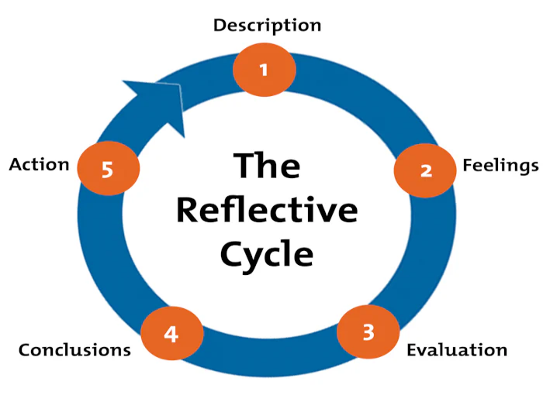

Figure 4 Gibbs' (1988) reflective cycle (Chen and Hu, 2020)

Description
It asked me to choose a company that is multinational and has no operational presence in a country that I would like to research and apply international business tools and frameworks to analyse market entry. When I asked them, I picked Starbucks and Bangladesh. This meant that I had to skim through academic articles, government publications, industry information, and then focus the analysis around a model created by Bartlett and Ghoshal (B&G), the PESTEL model and Dunning's eclectic paradigm. This took about 1 week to find sources, 1 week to write, and 1 week to revise, cite the sources and consider the process.

Feelings
Initially I was excited and nervous. That's an excited me because Starbucks is a brand that I am familiar with and Bangladesh is a market that I am interested in. Anxious, as 5,000 words and a distinction level meant rigor and a clear analysis. My confidence increased as I started to find sources to be reliable, but was overwhelmed the first time I attempted to create a unified framework from all of the frameworks. Towards the end I was pleased with the linking of the parts and with the sharpness of the argument. I also felt that I was very much part of the decision, as I had strategically made a decision, assessed the risks and made a specific recommendation.

Evaluation
In hindsight, some clearly had their advantages as well as disadvantages. The report had a strong evidence base as most of the sources used were credible academic resources, particularly peer-reviewed journal articles from 2016 to 2025. Yet another strength lay in integrating together three frameworks, and hence, providing a multi-lens analysis. Another advantage was that tables and charts used to summarise findings, making the book clearer to read. The problem areas were mainly time management. I had to chop other bits off the PESTEL section as too much information took a lot of time. I also used to a great extent secondary data as it wasn't feasible to conduct primary data within the time frame, restricting an in-depth understanding of the consumers.

Analysis
Looking back, difficulties arose because of the lack of ability to link theory with actual business conditions. For instance, the identification of Starbucks as being classified as a transnational (or as abating model) was more difficult than initially thought due to the fact that the firm exhibits elements of both strategies. This made me realize that although the theoretical models are useful, they are not easily applicable in real cases. This critical perspective has been brought to me by reading the article of Rugman and Verbeke (2017). Likewise, the use of Dunning's OLI framework required a careful consideration into what factors were of major importance; not all location advantages are equal in the emerging market. These tensions are surmountable thanks to the lectures and readings regarding cross-cultural management and emerging market entry that assisted me to do so, particularly the ones on the Bangladeshi consumer market and the importance of local partners in South Asia.
It was also through the discussions within the group as well as feedback from peers which helped shape my thinking. I realized that I was simply describing the PESTEL, so I changed the part to the changes most relevant to the coffee industry including demographic trends among the youth, and halal rules, and not just all things at the surface level. This was an added depth to the analysis. Another useful moment has been when I do a comparison of Starbucks' runs in India and China and realized the importance of the timing of the ownership shift. The insight deeply reinforced my last advice to go for joint venture to full ownership. I also learned that critical thinking does not just entail a refusal to accept a source, but an evaluation of the evidence and a valid conclusion even when information may be incomplete.

Conclusion
As a general rule, I learned that making decisions in international business is never easy. Bartlett and Ghoshal and PESTEL, and OLI are all lenses, but the analyst needs to decide on which lens and how to apply it. I also discovered that one needs to rely on credible sources—from which they will be able to find reliable information—and that one needs to be consistent in their citations to establish trust in the argument. If I were to do this again, I would be more aware of the word count and spend more time criticising the models as opposed to simply using them. Another lesson to be learned from that course was the ability to relate theory with concrete recommendations, which will prove very useful in the future in consultancy or research activities.

Action Plan
I will pursue three actions when working in the future: I will first construct a clear word budget for each section, make progress weekly and then write. Second, I will refine my own writing ability by reading more articles of the debate style (side by side comparison) for information. Third, to save time and avoid errors in citations, I will make use of tools like reference managers earlier. These steps will help me achieve my future desire to do a PhD in international business.

Conclusion
This report has evaluated Starbucks' potential entry into Bangladesh. It was concluded that the firm is a transnational business, the urban coffee market has a huge growth potential in Bangladesh, and a joint venture along with a credible local partner is recommended for the firm. PESTEL and OLI analyses reveals that there are political and legal risks but other factors like economic and social factor are favourable for the establishment of a premium coffee brand (Chowdhury et al., 2023). A gradual strategy from Dhaka and Chattogram would be beneficial for the Starbucks to establish its presence in Bangladesh, minimize risk and fit the transnational strategy.

References
Aktar, S. and Rahman, M. (2022) 'Consumer perception and brand loyalty in the emerging coffee shop industry of Bangladesh', Journal of Asian Business Studies, 16(4), pp. 612-628.
Alam, M. and Kabir, K.H. (2021) 'Climate vulnerability and business risk in Bangladesh: implications for foreign investors', International Journal of Climate Change Strategies and Management, 13(3), pp. 289-307.
Ali, M. and Chowdhury, T.A. (2023) 'Political transition and foreign investment climate in Bangladesh', South Asian Journal of Business Studies, 12(2), pp. 145-163.
Alon, I., Elia, S. and Li, S. (2020) 'Greenfield or acquisition? Institutional and cultural distance in entry mode choice by emerging market MNEs', International Business Review, 29(4), pp. 101710-101724.
Asian Development Bank (2024) Bangladesh: Country Economic Update 2024. Manila: ADB.
Bangladesh Bureau of Statistics (BBS) (2023) Population and Housing Census 2022: National Report. Dhaka: BBS.
Bangladesh Investment Development Authority (BIDA) (2024) Investment Policy Framework 2024. Dhaka: BIDA.
Bartlett, C.A. and Ghoshal, S. (1989) Managing Across Borders: The Transnational Solution. Boston: Harvard Business School Press.
Cayla, J. and Arnould, E. (2019) 'A cultural approach to branding in the global marketplace', Journal of International Marketing, 27(2), pp. 86-112.
Chen, H. and Hu, Y. (2020) 'The role of loyalty programmes in coffee chain expansion: evidence from emerging markets', International Journal of Contemporary Hospitality Management, 32(9), pp. 2891-2910.
Chowdhury, S., Islam, R. and Ahmed, N. (2023) 'Rise of the middle class and consumer market transformation in Bangladesh', Journal of Consumer Marketing, 40(6), pp. 745-761.
Dunning, J.H. (2000) 'The eclectic paradigm as an envelope for economic and business theories of MNE activity', International Business Review, 9(2), pp. 163-190.
Foo, S.M., Ab Razak, N.H., Kamarudin, F., Azizan, N.A.B. and Zakaria, N. (2025). Islamic versus conventional financial market: a meta-literature review of spillover effects. Journal of Islamic Accounting and Business Research, 16(4), pp.760-790.
Gibbs, G. (1988) Learning by Doing: A Guide to Teaching and Learning Methods. Oxford: Further Education Unit.
Grimmer, L. (2022) 'Lessons from the retail apocalypse: the Starbucks case', Journal of Retailing and Consumer Services, 65, pp. 102876-102885.
Haskova, K. (2017) 'Starbucks marketing analysis', CRIS Bulletin of the Centre for Research and Interdisciplinary Study, 2015(1), pp. 11-29.
Hofstede Insights (2024) Country comparison: Bangladesh. Helsinki: Hofstede Insights.
Hossain, M. (2020) 'Political instability and its effect on retail supply chains in South Asia', Journal of Retailing and Consumer Services, 55, pp. 102101-102112.
Islam, S. and Beloucif, A. (2024) 'Corruption, regulation and foreign direct investment in South Asia', Journal of Business Research, 170, pp. 114312-114325.
Ozturk, A., Joiner, E. and Cavusgil, S.T. (2019) 'Delineating foreign market potential: a tool for international market selection', Thunderbird International Business Review, 61(1), pp. 119-134.
Peng, M.W. and Meyer, K.E. (2019) 'International business strategy and institutional environments', Journal of International Business Studies, 50(6), pp. 947-966.
Rahman, A., Islam, M.T. and Hasan, M. (2020) 'Halal food consumption in Muslim-majority markets: implications for global food brands', Journal of Islamic Marketing, 11(6), pp. 1691-1710.
Rahman, M.M. and Khan, T.A. (2022) 'Vision 2041 and foreign investment reforms in Bangladesh', Journal of Asian Economics, 78, pp. 101425-101438.
Riaz, A. (2021) 'Political parties, elections and democracy in Bangladesh', Asian Survey, 61(2), pp. 297-320.
Rugman, A.M. and Verbeke, A. (2017) 'Global corporate strategy and trade policy', Journal of World Business, 52(1), pp. 27-38.
Sarker, M.A. and Hossain, M.S. (2019) 'Digital payment adoption and consumer behaviour in Bangladesh', Journal of Financial Services Marketing, 24(3), pp. 71-83.
Sima, Y. (2025). The State-SME nexus: an innovation-focused analysis and international scaling.
Starbucks Corporation (2025) Annual Report 2024. Seattle: Starbucks Corporation.
Statista (2025) Coffee market in Bangladesh: revenue and forecast 2020-2028. Hamburg: Statista.
Uddin, M. and Alam, K. (2018) 'Trademark protection and enforcement in emerging economies: a Bangladesh perspective', Journal of Intellectual Property Law and Practice, 13(9), pp. 715-724.
Verbeke, A. and Hutzschenreuter, T. (2021) 'The dark side of digital globalization', Academy of Management Perspectives, 35(4), pp. 606-621.
Wang, Y. and Zhang, L. (2022) 'International expansion strategies of global coffee brands: a comparative case study', International Journal of Business and Globalisation, 30(2), pp. 178-197.
World Bank (2024) Bangladesh Development Update: October 2024. Washington DC: World Bank.
World Bank (2025) Doing Business in South Asia: Bangladesh Country Profile 2025. Washington DC: World Bank.

