

Data Security, Governance and Compliance

Computer Networks and Cyber Security
ACCA7028
Dr Carlene Campbell
Peng Xu

contents

1 Common security framework 3
1.1COSO 3
1.1.1 Framework introduction 3
1.1.2 Composition 3
1.1.3 Limitations 4
1.2 COBIT 4
1.2.1 Framework introduction 4
1.2.2 Control target 5
1.2.3 Advantages 5
1.3 SOX 6
1.3.1 Framework introduction 6
1.3.2 Features of the bill 6
1.3.3 Chinese-style Sarbanes-Oxley Act 6
1.4 ISO/IEC27001 7
1.4.1 Framework introduction 7
1.4.2 New edition revision 7
1.5 Compare 8
2. Approach design 9
2.1 Demand analysis 9
2.2 Design goals 9
2.3 Access Control 9
2.4 Cybersecurity 12
2.4.1 WEP 12
2.4.2 WPA 13
2.4.3 WAPI 13
2.5 Intellectual Property Protection 13
2.6 Risk Management 13
2.6.1 Changes in the definition of risk 13
2.6.2 Changes in presentation form 14
2.6.3 New Components-Principals-Attributes structure 14

1 Common security framework

1.1COSO

1.1.1 Framework introduction
Before 1985, companies in various countries were successively found to have fraudulently appeared in their financial reports, which is commonly known as fraudulent accounts. So a security framework was designed in the 1980s, and it is the COSO framework that is still used today. It is designed by accounting associations and financial management departments of different countries after discussing and summing up experience. The full name is The Committee of Sponsoring Organizations of the Treadway Commission. It has a huge impact in preventing and solving financial fraud.

1.1.2 Composition
(1)Control environment
The first important component of COSO is environmental control. Environmental control includes four aspects, the most important of which is a series of requirements provided by the board of directors and the direction of the company's development, which has an important impact on the company's environment. The second is an assessment of the personal integrity, professional ethics and personal abilities of the members of the organization. Third, it belongs to the quality requirements of the management, which includes management methods and management skills in different fields. Finally, environmental control also includes the distribution of management personnel, which can determine the efficiency of the company's daily operations.
(2)Risk assessment
Another important component of COSO is risk assessment. In order to reduce the hazards of unpredictable risks, the COSO framework requires risk assessment of targets in advance. Such a process can be used to judge which kinds of risks need to be managed. Moreover, the evaluation method and structure need to be continuously optimized according to the trend of the company's industry and the fluctuation of product value.
(3) Control activities
Control activities still occupy an important position in COSO. Control activities refer to specific activities that execute management commands during the execution of management. Such activities are very clear and clear. It runs through the entire control system. It includes but is not limited to authorization, adjustment, employee evaluation, etc.
(4) Communication and exchange of information
The communication of information within the COSO framework is particularly important. It contains different aspects such as finance, operation, administration, and personnel resources. It is a clear and clear information exchange system that makes the management's control of the entire company so stable. The data that needs to be exchanged in each part includes financial and administrative data generated internally when the company is operating, as well as external reports generated by the activities of a large number of customers and partners. In order to keep the information exchange in a high-efficiency state for a long time, the personnel of each department need to perform their duties, maintain communication with other departments, and perform regular audit and maintenance of information.
(5) Monitoring of the environment
The last part of COSO is the monitoring of the environment. This part is closely related to the fourth part "communication and exchange of information". In the process of operation, the COSO framework requires monitoring of management activities and the work activities of employees. The management evaluation uses these data to judge, which can effectively improve the quality of company operations. When encountering an emergency, it is necessary to respond to the leadership's board of directors as soon as possible for the current operation. In order to make correct judgments and solve emergency situations.

1.1.3 Limitations
(1) Not fully aware of the importance of the board of directors to the internal control system.
(2) The information content and credibility of the "management report" advocated by COSO to reflect the operating status of internal control is questionable.
(3) The terms "reasonable guarantee" and "cost-effectiveness" in the COSO report are basically directly transplanted from accounting, which is good for evading the legal liability of certified public accountants.
(4) Exclude some important functions in business operation and management from the tentacles of internal control.
(5) There is a difference between the basic target and the classification sub-target.
(6) The criteria for evaluating the effectiveness of internal control are too subjective.
(7) The color of accounting and auditing in the internal control system is too heavy. It considers many existing and microscopic or risk avoidance matters of the enterprise, and has little relationship with the business platform and business expansion. Risk prevention is also passive and lacks initiative.

1.2 COBIT

1.2.1 Framework introduction
Similar to COSO, COBIT is also an internationally accepted audit standard, but it was published later than COSO, and it pays more attention to the effectiveness and confidentiality of the system. Its full name is Control Objectives for Information and related Technology. As an authoritative information management standard recognized globally, COBIT is linked to corporate control and risk management, so it is still in use today. In 2019, it was revised to the latest version. Until now, COBIT and its derivatives have been used in more than 100 countries around the world to participate in corporate management, improve corporate operational efficiency, and reduce risk losses.

1.2.2 Control target
(1) Effectiveness
It means that the part of regulation is related to the business process, rather than meaningless, to avoid wasting corporate resources.
(2) High efficiency
The standard requires that the processed information be transmitted to management in a timely, accurate and consistent manner.
(3) Confidentiality
This standard pays special attention to the protection of information, and it should pay attention to the access of unauthorized personnel
(4) Completeness
The information required to be managed is accurate and complete, and the requirements are consistent with the expectations of the board of directors.
(5) Availability
Refers to the information is available in business processing needs. It also refers to the maintenance of necessary resources and related performance.
(6) Compliance
To put it simply, it is legality, which requires companies to abide by corresponding laws and regulations in the course of business operations. Law-abiding is the basic principle, and unauthorized commercial standards cannot be used.
(7) Information reliability
The information provided to daily managers (CEO, CIO) must be true and reliable.

1.2.3 Advantages
After long-term use by different companies in various countries, COBIT has proven to be a very useful and stable corporate framework. At the same time, it is very easy to implement. By building the COBIT framework, the gap between the management and IT audit management of an enterprise becomes no longer so difficult to bridge, and its interconnection becomes possible. Over the years, a large number of companies have benefited from COBIT to implement information technology-based regulatory audits of their business activities. In order to classify business practices, you need to know what the function of the business activity is and how much it can affect the company. Therefore, most IT information managers, system control engineers or security management specialists can consider adopting the COBIT framework.
After adopting the COBIT structure, the management's control over the company structure has increased. And management will quickly find it easier to understand the impact of control and plan the business. The business templates and some excellent cases provided by COBIT can enable homeowners managers to grasp the meaning of IT management at the fastest speed, so managers are easier to make correct decisions in business practice.

1.3 SOX

1.3.1 Framework introduction
The third framework to be introduced is the SOX Act. Its emergence is related to several scandals in the 21st century. At the end of 2001, at the beginning of 2002, several surprising scandals broke out in American energy companies and Enron. The scale also keeps rising with the increase in frequency. Enron's ups and downs have greatly affected the confidence of American investors, which has led to a gradual decline in investors' investment in the US market. The U.S. economy is therefore showing signs of weakness. In order to resolve this crisis, the US Congress passed the Sarbanes-Oxley Act. The bill was created to rectify the structure of listed companies and protect investors. The core essence of this bill is to ensure that listed companies comply with securities laws and increase the exposure of company financial information, especially to protect the interests of investors. Since the release of the SOX Act, companies listed in the United States have established compliance standards, and all managers must consider the IT risks of their own companies.

1.3.2 Features of the bill
It can be seen from the original intention of the bill that the biggest feature of the SOX bill is that it greatly increases the legal responsibilities of corporate managers and accounting staff. Specifically, the legal framework of the United States is based on case law, and trials in similar cases in the past have a huge impact on subsequent court trials. Regardless of the "Securities Law" or the "Securities Exchange Law", they all regulate the market through statutory cases. However, the SOX Act directly stipulates the legal responsibilities of corporate managers and accounting personnel. For example, it clarifies the maximum years of imprisonment for illegal corporate managers and the maximum fines.

From historical experience, legal constraints can improve the professional ethics and work quality of accounting to a considerable extent. However, too high legal risks can also bring serious consequences. Excessively stringent laws will bring public grievances to the overall risk of the accounting profession, and ultimately may reduce the quality of the accounting profession.

1.3.3 Chinese-style Sarbanes-Oxley Act
In China, the continuous financial fraud of listed companies has not only impacted the confidence of the capital market, but also put the reputation of listed companies at risk. While people are hoping for the "Chinese-style Sarbanes-Oxley Act", they find that external supervision is simply unable to restrain the financial chaos within the enterprise. China's capital market needs the resolute implementation of the Sarbanes-Oxley Act and the long-term self-discipline and checks and balances of corporate financial internal control mechanisms.

1.4 ISO/IEC27001

1.4.1 Framework introduction
Finally, this article will introduce the international safety management requirements ISO/IEC27001. This international standard is closely related to the British national standard. The predecessor of ISO/IEC27001 was British BS7799. At the end of the 19th century, the British Standards Institute proposed and then revised the BS7799 standard. The standard consists of two major components. One is the implementation rules for information security management. It provides detailed implementation standards for the security information management part of the enterprise framework, and is responsible for giving suggestions for the security management process for reference by security managers. . The second part is the specification of information security management system. It proposes a documented information security management system and stipulates the security measures implemented by the enterprise.
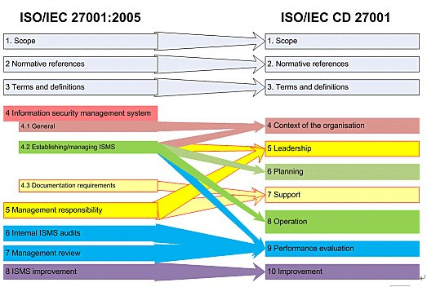
Figure 1: Revised changes

1.4.2 New edition revision
Since the International Organization for Standardization transformed BS 7799 into ISO 27001:2005 and was released in 2005, this standard has been recognized internationally. A considerable number of organizations have adopted and carried out information security management system certification. By the end of 2011, internationally The total number of ISO 27001 certification certificates issued is about 15,625 (among which, BSI has a market share of about 45.65%). In China, since the ISO 27001:2005 was transformed into the national standard GB/T 22080:2008 in 2008, the information security management system certification has been further promoted in China. By the end of 2011, the number of certification certificates issued by China was 1,107. More and more industries and organizations recognize the importance of information security and develop it as one of the basic management tasks.

1.5 Compare
The simple definition of IT governance is the institutional measures to maximize the benefits of all parties involved in the informationization process. IT governance models include COBIT, ITIL, ISO/IEC27001, etc. There are some differences between them.
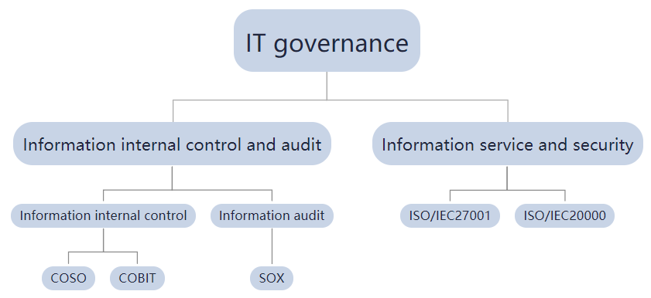
Figure 2: IT governance

(1)COBIT and ITIL
It can be understood from the previous analysis that COBIT is based on a mature architecture that has existed before. For example, the capability maturity model proposed by the Software Engineering Research Institute, CMM's five-level division of software enterprise maturity, and ISO9000 standards. On the basis of these different standards, COBIT also focuses on the needs of enterprises, but weakens the practices of enterprises. In other words, COBIT does not care about how to conduct management audit activities, but instead focuses on the idea of how to construct a control structure. This can effectively speed up the work efficiency of senior management.

Fundamentally, ITIL is based on the best practices of the company. In the process of ITIL implementation, the government must first use mobile phones and analyze the problems that exist in various enterprises, and then more importantly, through past prior knowledge, find the most suitable solutions, and finally form ITIL. In this In this case, ITIL can determine the best goals of different management levels and the relationship between different stages and different objects. It should be noted that the scope of the control architecture defined by him is in fact not very broad. In other words, ITIL pays more attention to the methods used in the implementation process. From this it seems that compared to COBIT, ITIL has a smaller control range and a smaller field of view. All in all, it pays more attention to IT methods and operating procedures in order to reduce the burden on managers.

From the above comparison, it is not difficult to find that even though the two standards have a lot of differences, in terms of guiding principles, the two standards are very consistent. Therefore, for an experienced security auditor, it is very important to comprehensively grasp the advantages of the two standards by taking their own strengths, and combining them to comprehensively evaluate the IT management environment. In the specific implementation process, the key target instructions and key performance indicators provided by COBIT are integrated with ITIL, and a more complete COBIT audit process for ITIL process management can be established.

(2) COBIT and ISO/IEC27001
After comparison, it can be found that ISO/IEC27001 hopes to provide enterprises applying the standard with a standard that pays more attention to quality and efficiency. That is to say, ISO/IEC27001 pays special attention to the comprehensiveness, openness and effectiveness of information security management. . Its biggest feature is that it is extensive but not in-depth, and it is only for reference.
CoBIT is completely based on IT. It is different from ISO/IEC27001. CoBIT pays more attention to the strategic objectives required by the enterprise. It includes a series of enterprise planning and manpower allocation and enterprise intellectual property rights. On the other hand, IT management is guided by IT standards. Plan and process IT resources under.

2. Approach design

2.1 Demand analysis
(1) Ensure the safe and stable operation of the company's wireless network.
(2) Allow company employees and customers to access the company's network resources stably and safely.
(3) Pay attention to protecting employee data and customer data.
(3) Pay attention to protecting the company's intellectual property rights.

2.2 Design goals
(1) Design and deploy antivirus software on the terminal, and conduct network access compliance checks;
(2) Establish access control for personnel and equipment at the network boundary, and confirm that the terminals connected to the intranet to access the company's resources comply with the management items, that is, allow employees and customers to access company resources and reduce risks;
(3) Centralized storage and centralized backup of application business data, using professional data backup
(4) Establish a sound risk management mechanism to respond to internal and external threats, establish a systematic rapid recovery mechanism, and reduce losses caused by risks.

2.3 Access Control
Caribbean Coffee Company has a large number of employees and customers. In order to enable its employees and customers to access the company's resources through device terminals, an access control framework is needed to allow employees to access company resources while reducing the risk of information theft. After repeated comparison and research, IAM (Identity and Access Management) framework can meet the demand.
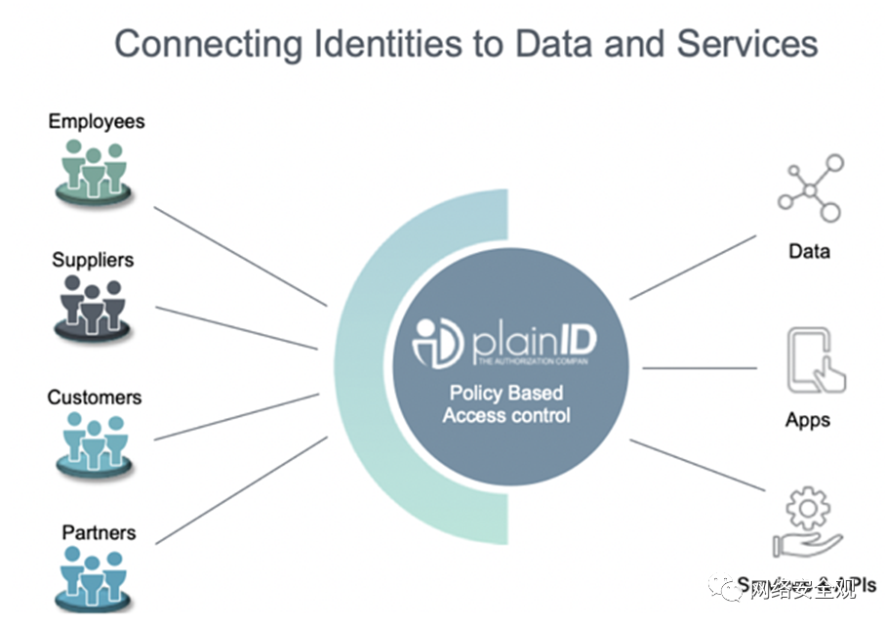
Figure 3: Connecting ldentities to Data and Services

(1) Framework introduction
IAM is a web service that allows administrators to securely access AWS resources and supports administrators to use IAM control to authenticate and authorize any user to use resources.
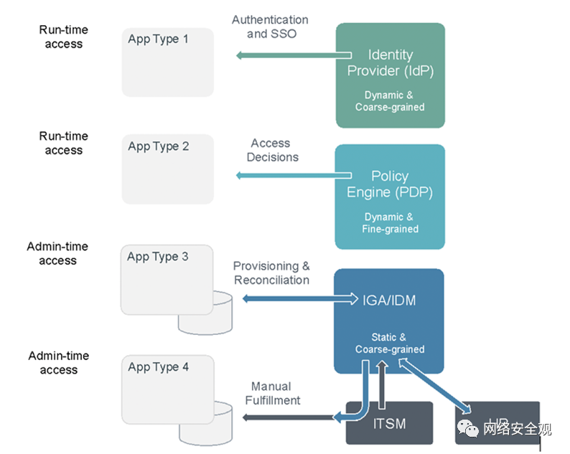
Figure 4: IAM structure

IAM's identity and management technology includes identity storage, security policy implementation, applications, report password management tools, configuration software, and identity storage. The identity management system can be deployed within the enterprise, and the system can also be set up in the cloud.
(2) Different application types supported by IAM
① Disconnected application
②Apps supporting IGA
③Apps supporting the strategy engine
④Applications that support IDP

(3) The authorization model of the IAM architecture
①Temporary authorization during operation
This authorization mode relies on the state of the user to make the access request to make conditional access decisions. This authorization method makes authorization more flexible. In this case, the user's state becomes part of the access decision, which is very effective. Make the access decision more accurate.
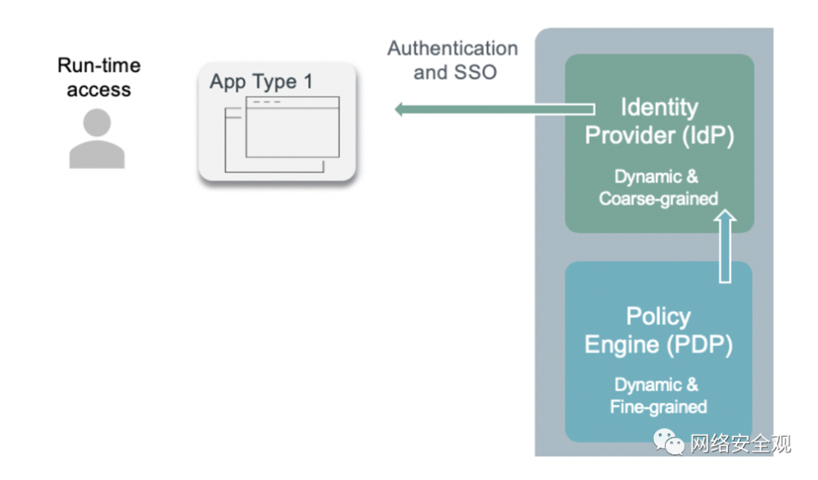
Figure 5: Authorization Mode

②Management authorization
In this authorization mode, the user's access decision and authorization decision will be pre-stored in the system's database. When the access decision is made, part of the authorization information is directly called, which makes the access control faster
Czech.
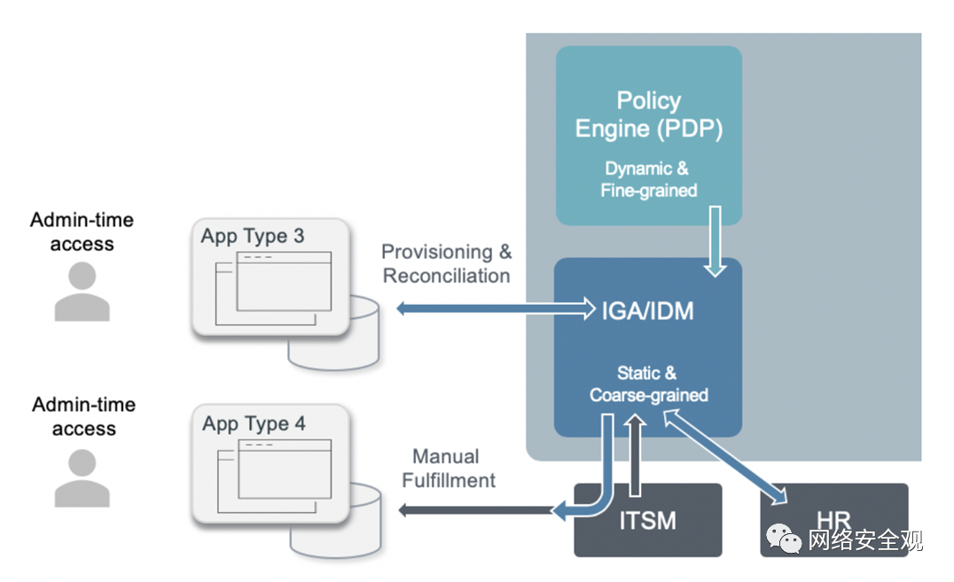
Figure 6: Another authorization model

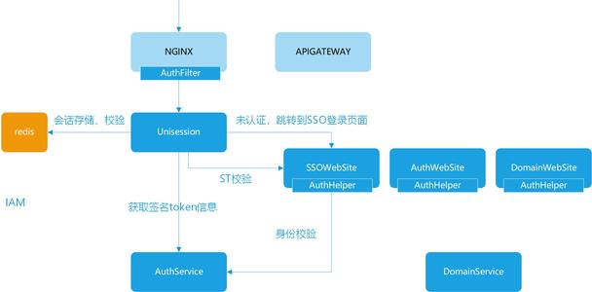
Figure 7: IAM conversational mode

2.4 Cybersecurity
According to design requirements, most of Caribbean Coffee's network is composed of wireless networks, and a stable and secure wireless network needs to be constructed to support the company's operations. There are three main security standards for wireless network WLAN: WPA, WEP and WAPI.

2.4.1 WEP
WEP refers to Wired Equivalent Privacy, which is an obsolete agreement. It encrypts the wireless transmission of information between two different equipment stations.
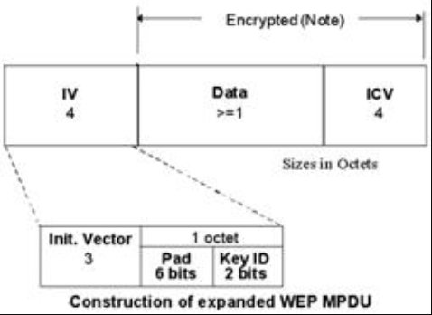
Figure 8: WEP mode

(1) Decision of protocol connection
There are two different connection decision methods for WEP. The first is open system authentication. Under this authentication, different terminals can connect without key authentication. The other is shared key authentication. First, the host sends an authentication request, and then the access route sends a plaintext, and then the host packages the plaintext according to the designed key, and sends it back to the access route after the encryption is successful. After the decryption is successful, the access request is accepted.

(2) Disadvantages of the protocol
Under this protocol, the key cannot be reused, the initial vector is 24 bits, and the key address will be reused after all used within a few hours, which makes the key very easy to obtain.

2.4.2 WPA
WPA (Wi-Fi Protected Access) is a protocol created to solve WEP's flaws. WPA uses a new algorithm to solve the security loopholes in WEP. Under this protocol, all wireless access points will be authenticated by a unified key. The length of the key is 256 bits. Such a long key length can better ensure the security of the wireless network.

2.4.3 WAPI
WAPI is a new generation of security protocol and a mandatory requirement for China's wireless network security. It was first proposed by Xidian University. WAPI is composed of wireless LAN authentication infrastructure and wireless LAN security infrastructure. It uses a grouped symmetric password to protect security.

2.5 Intellectual Property Protection
The company owns billions of dollars in intellectual property rights, so it is important to pay attention to the protection of intellectual property rights when designing the corporate management framework. In China, companies follow the GB/T 29490-2013 national standard, which is the "Enterprise Intellectual Property Management Regulations."
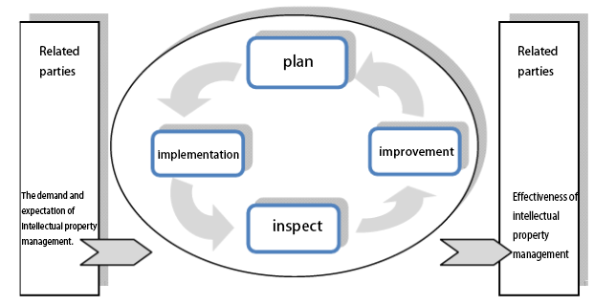
Figure 9: Enterprise Intellectual Property Management Model

This standard provides an enterprise intellectual property management model, as shown in the figure.

2.6 Risk Management
Risk management and emergency planning should be considered when designing a company's management framework to avoid potential threats and reduce disaster losses. After investigation and analysis and many comparisons, the COSO-ERM framework is very suitable for use in this scenario. In 2017, the COSO-ERM framework has undergone some changes.

2.6.1 Changes in the definition of risk
In the old version of ERM, risk refers to the possibility that an event may occur, and it will bring a negative impact to the enterprise. The opportunity is that an event may happen and bring a positive impact on the realization of the goal. In the latest revision, risk refers to the possibility of events occurring and affecting the realization of strategic and business goals.

2.6.2 Changes in presentation form
The old version of the ERM model uses a cube model similar to the IC frame in order to facilitate the presentation. This makes people think that ERM is a variant of the IC frame, thus ignoring the unique advantages of ERM. In the latest version, a similar DNA spiral structure is used. This framework structure is more in line with the integrated ideas and concepts, which shows the relationship between different elements such as strategy, operation and performance management in risk management.

2.6.3 New Components-Principals-Attributes structure
As early as 2006, COSO proposed in an internal control of financial reports that in order to target smaller public companies, it adopted this Components-Principals-Attributes structure. This framework separates each part of the structure. This decentralized The processing makes the whole framework more layered and more systematic and specific.

Reference

[1] Wang Tao. Research on Iam application of ERP system [D]. Shantou University, 2009
[2] Zhan Baorong, Yu Xichang, Liu Chaozheng. Design and implementation of resource open platform based on Iam [J]. Wireless communication technology, 2020,29 (03): 45-49
[3] Zhang Lei. Practical exploration based on coso-erm -- Taking G company as an example [J]. Administrative assets and finance, 2020 (22): 53-54
[4] Wang Yan, Kong Wen. Research on optimal budget performance management in Colleges and universities from the perspective of risk management -- Based on coso-erm framework [J]. Accountant, 2020 (19): 65-67
[5] Yang Xi. Analysis on internal control objectives and risk management of colleges and Universities Based on COSO report [J]. Guangxi Education, 2020 (39): 95-97
[6] Wu nade. Application of COSO framework in internal control audit [J]. Accounting learning, 2020 (26): 117-118 + 145
[7] Wang Mingjie. Discussion on the application of ITIL in tobacco enterprise information operation and maintenance management mode. 2020, 4 (1)
[8] Ma Jinbo. Research and application of it operation and maintenance management system based on ITIL [J]. Information technology and informatization, 2020 (04): 53-54
[9] Shen Weiwei, Mao ting. ISO 20022 message and WAPI Standard Development [J]. Electronic finance, 2018 (10): 27-29
[10] Huang Guoqun. Characteristics and Enlightenment of management experience of foreign enterprises with intellectual property advantages -- Also on the applicability of GB / t29490-2013 [J]. Journal of information, 2016,35 (01): 87-93

