Student Name:  Ciolan Silviu Alexandru  Student Number:  2027368 | Module: Hotel Placement – Food & Beverage Operations (BMIH4002)  Lecturer: Laurence Blake

Topic of choice: | Ratings, Inspections and Reporting Procedures
This module brought me in an area that I want to explore in depth, as I like to expand my knowledge, because food is an important part of our lives. I have chosen the second topic for this journal, and more specific, Ratings, Inspections and Reporting Procedures. Here I have found out that there are specific standards and regulations that are strict within Food Industry that the manufacturers have to be aligned with. For example, I have learned that there is a management system that addresses food safety through the analysis and control of biological, chemical and physical hazards from raw material production, procurement and handling to final product manufacturing, distribution and consumption, called HACCP (HACCP - definition and meaning, 2022).
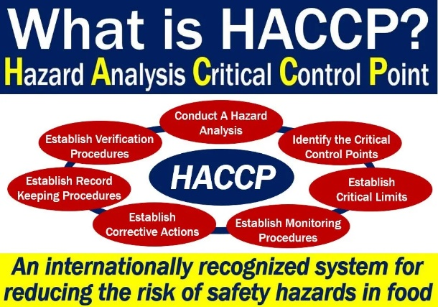

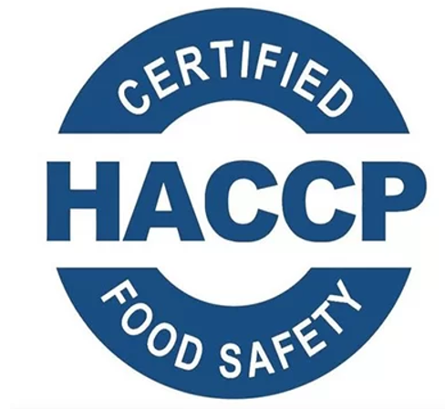
Because many illnesses are caused by food-derived pathogens and there are always food safety concerns for both customers and producers in the food industry, a comprehensive management system to identify, assess and manage hazards is essential. In addition, HACCP certificates give food manufacturers a high chance of competing in the international market and give customers a good sense of security to purchase food conveniently. From my point of view, a business that respects its customers, will apply for this HACCP certification, to make sure they let their customers know that they are delivering quality products and services (Foodslord | What is HACCP standard in food industry? 2022). The Regulations that specify that all the food businesses should put in place, implement and maintain documented food safety management procedures based on HACCP principles, is Regulation (EC) No. 852/2004 (Class notes).

With the help of this topic, I have learnt that SFFB stands for Safer Food, Better Business, which makes sense, because all the customers will come back the second time as well if the first time was a blast for them. There is no doubt that SFBB can be a huge support for all the food businesses to comply with food hygiene regulations, to show what they have to do to make food safely, to train their staff, to protect their business’s reputation, to improve their business such as by wasting less food and many more other good reasons why all the food businesses should go for this certification. At the same time, SFBB can help all the food businesses to receive a higher score from EHO’s.
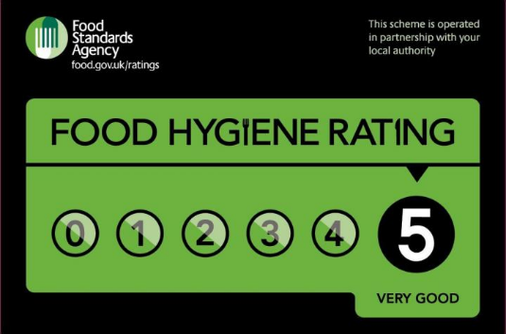
The rating scores given are between 0 and 5 with the following meaning:
5 – hygiene standards are very good
4 – hygiene standards are good
3 – hygiene standards are generally satisfactory
2 – some improvement is necessary
1 – major improvement is necessary
0 – urgent improvement is required
The scheme display of the rating sticker is voluntary in England (Food Hygiene Rating Scheme, 2022).
Employees of the business community will visit the facilities to ensure that all the businesses comply with food laws and produces edible food. In this case, an inspection takes place. To be able to conduct one of these inspections, an officer has to analyse all the business premises, to check the workflow, to check the food management system and to check the types of food that are being prepared within that area.
The officers have the right to enter within the premises of any business, and inspect, at any reasonable time. They are usually arriving without appointment, to make sure they have the business in a normal state, not prepared for their visit. The recurrency of their visit is dependable on the type of business and the previous inspection, and also it can take place after a request or complain from a customer. The officers can help the businesses by offering their help and advice on food safety. At the same time, the officers can take action if they conclude that the standards of food hygiene are not good enough. In some serious cases, action might include closing the premises of a business or prosecution.
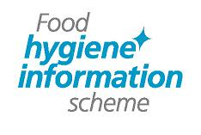
Following this inspection, the food outlet will be given a Food Hygiene Information Scheme (FHIS) rating based on their inspection results.
There are three different ratings:
- Pass – the business meets the legal requirements for food hygiene.
- Improvement Required - the business did not meet the legal requirements for food hygiene, and needs to make some improvements.
- Exempt Premises – in this case, after the inspection of a local authority food safety officer the business met the pass criteria, but did not meet the criteria to be part of the scheme. These companies are not aware of food safety and are not normally considered food companies. For example, newspaper stores, drug stores, and visitor centers selling cookie jars (About the Food Hygiene Information Scheme | Food Standards Scotland, 2022).

REFERENCE LIST (not included in word count)
Food Standards Agency. 2022. Food Hygiene Rating Scheme. [online] Available at: https://www.food.gov.uk/safety-hygiene/food-hygiene-rating-scheme [Accessed 26 January 2022]
Foodslord. 2022. Foodslord | What is HACCP standard in food industry? [online] Available at: https://foodslord.com/haccp-standard-food-industry/ [Accessed 25 January 2022]
Foodstandards.gov.scot. 2022. About the Food Hygiene Information Scheme | Food Standards Scotland. [online] Available at: https://www.foodstandards.gov.scot/consumers/food-safety/buying-food-eating-out/food-hygiene-information-scheme/about-the-food-hygiene-information-scheme [Accessed 29 January 2022]
Market Business News. 2022. HACCP - definition and meaning. [online] Available at: https://marketbusinessnews.com/financial-glossary/haccp/ [Accessed 22 January 2022]
Rbkc.gov.uk. 2022. Safer food, better business | Royal Borough of Kensington and Chelsea. [online] Available at: https://www.rbkc.gov.uk/business-and-enterprise/food-safety/safer-food-better-business [Accessed 29 January 2022]

