

Postgraduate/Distance Learning
Assignment coversheet & feedback form

THIS SHEET MUST BE THE FIRST PAGE OF THE ASSIGNMENT YOU ARE SUBMITTING (DO NOT SEND AS A SEPARATE FILE)

For completion by the student:
Student Name: Maria Morais

Student University Email: 1909318@student.uwtsd.ac.uk
Module code: HPCA7002  Module title: Researching Contemporary Cosmologies | Student ID number:1909318 |  |  | Educational support needs:  No
Assignment title: Developing Intuition During the New Moon Time - Essay 2

Assignment due date:10th August 2020
This assignment is for the 1st x 2nd 3rd 4th 5th 6th module of the degree
I confirm that this is my original work and that I have adhered to the University policy on plagiarism.
Signed ……..Maria Morais ……………………………………………………………
Email submission: if you are submitting this form via email, please tick this box x
(as a substitute for your signature) to confirm that you agree to the above declaration.
Marker’s signature: |  |  | Date:
For completion by Marker 2/Moderator:

Comments:

Marker’s Signature: |  | Date:
External Examiner’s comments (if relevant)

External Examiner’s Signature: |  | Date:

‘Developing Intuition During the New Moon Time’ Essay 2
Word count – 3347

Maria Morais - 1909318

Introduction

The aim of this research was to gather data on how the Wild Woman Project (WWP) circle leaders developed intuition during new moon rituals. The research question was- How do Wild Woman Project Leaders Develop Intuitive Powers during the New Moon Time in Order to Better Connect with the Wild Woman Archetype? The wild woman archetype was the life work of the Jungian analyst Clarissa Pinkola Estes. The author described the archetype in her book ‘Women who run with the wolves’ essentially as a woman that was not domesticated and was deeply intuitive.’
WWP leaders followed the moon calendar and it was during the new moon time that they performed rituals with their community to set up intentions for the month ahead. According to Bernd Brunner the phase of the new moon was seen since ancient times as ‘a time of prayer for the moon to return. And when the silvery disk finally appeared in the sky, it was greeted joyfully, with exclamations of salvation.’ This research explored the activities and rituals that these women practiced with the objective to develop their own intuition and the intuition of other circle participants. I have also inquired the WWP circle leaders with regards to their connection with the moon, in particular with the new moon, and with the wild woman archetype.
A mixed method including questionnaire and interviews was utilised to encourage participants to give their own descriptions on how they developed intuitive powers to connect with the wild woman archetype during their new moon circles.
With this essay I intended to research intuition solely from a woman’s perspective. The main findings of the field research confirmed that for these women, connection was the essential component of intuition, and that intuition was not necessarily exclusive to spiritual psychic abilities as assumed by authors such as David. G. Myers.

Literature review

Estes suggested that stories should be seen as bridges to connect with one’s intuition and that is through intuition that women connected with the wild woman archetype. The author added that ‘A woman’s issues of soul cannot be treated by carving her into a more acceptable form as defined by an unconscious culture, nor can she be bent into a more intellectually acceptable shape by those who claim to be the sole bearers of consciousness.’ The sole bearers of consciousness were according to Estes the primary cause for ‘women who began as strong and natural powers to become outsiders in their own cultures.’ The author suggested that women could not be accepted if they were authentic.
With a view to deepen my knowledge on intuition as a concept, I have researched the work of Myers, and author that widely discussed the concept of extrasensory perception and made a clear distinction between intuition and sixth sense. The author made reference to a medium to the masses named James Van Praagh that declared that ‘every single person, if they chose to and discipline themselves, can become aware of spirit’, in order to reply to a question placed by a woman on his website. The woman asked if it was possible, ‘for someone like myself to develop my intuition further, and how would I go about it?’ In this essay I have questioned the assumption made by Myers that intuition was related to spirituality, because it was not implicit that she was concerned with her awareness to spirit, she was asking about how to develop her intuition.
The WWP circle leaders perform new moon rituals with the objective to develop their intuition and so I have also researched the moon according to Brunner. Gazing at the moon was described by Brunner as an activity that happened long before the invention of the telescope, but the various moon phases were described by the author as a phenomena disconnected from the relationship between the moon and the observer. A different perspective on moon gazing was given by Estes. Estes, established a relationship between women’s menstrual cycles and moon phases stating that women’s understanding of moon cycles occurred not just physically, but also emotionally and spiritually. With the ability to connect within a cycle in this case by the moon cycle, Estes considered that women were able to connect with their own cycles and by connecting with their own cycles, women were also able to develop their intuition.

Methodology

WWP circle leaders share a Facebook group to discuss new moon themes in order to prepare for the monthly circles. After receiving written authorisation from the group admin I have sent a message to all WWP circle leaders inviting them to respond to a questionnaire of less than twenty questions. An introductory section identified the researcher, the nature of the research, assured anonymity, confidentiality and data protection. According to Judith Bell data protection means that under no circumstances the interviewees can be identified.
It was explained that they have been chosen for their interest in leading WWP initiatives and permission was obtained to use the data they’ve submitted. The respondents were informed that they had the right to request their submissions to be deleted at any time.
The methodological approach during the design phase followed what Oppenheim suggested with regards to the exclusion of certain sample elements if they do not fit with the criteria established for the research.
The criteria to fit the research sample were:
- Gender – Woman
- Active WWP Leader
- The respondent was aware and/or have read the book ‘Women who run with the wolves’
The total number of WWP leaders was 390 members at the time the questionnaire was sent. Participants were offered a ten-minute phone interview if they would like to elaborate on their relationship with the wild woman archetype. Permission to publish interview responses was obtained by email prior to the interviews taking place. I received back 10 questionnaires and was able to make 3 interviews which means that I was able to reach 3.3% of the WWP circle leaders.
Reflecting on my position in the field a pertinent question from Zayin Cabot came to mind, ‘Can we let go of our strongly ethnocentric modernities for a moment in order to allow others to speak for themselves?’ I have personally engaged in several moon ritual practices as a WWP leader since 2017, and according to Cabot making reference to Bado-Fralick, ‘ the insider/outsider distinction all too often undergirds the assertion that there is only one objective voice.’ In this research the assumption was that there were many voices and that each woman was unique, and this assumption was defended by Cabot when he said that ‘we need multiple ontologies and multiple ecologies if we are going to garner the kind of participation that we need to face our shared planetary predicament.’ My academic interest with this pilot study was to explore intuition in the context of the WWP new moon circles. I was deeply inspired in this process by the works of Bado-Fralick and Zayin Cabot.

Findings and Discussion

Moon cycles and women

Developing intuition was a theme I have explored in the questionnaire and during the interviews to the WWP circle leaders. Main findings suggested that the majority of the circle leaders facilitated new moon circles to better connect with their intuition and/or to help others develop their own intuition (80% of the respondents). When the circle leaders were asked about how exactly they were developing intuition ‘being still/ stay quiet’ was the indicator mentioned more often. Other similar indicators were given such as, ‘silence’, ‘make a pause’, ‘meditation’, ‘build a solid inner landscape’, ‘turn into authentic self’, ‘looking inside’, ‘turning into deeper thoughts’, ‘stillness’, and ‘self-reflection’.
Circle leader B1 mentioned in her interview that circles bring her connection, calm conversation, authenticity, particularly when ‘speaking from the heart and from the bone’. Circle leader B1 confirmed the connection that Estes established between moon cycles and women cycles with regards to the fact that ‘each moon cycle is reflected within themselves.’
Circle leader A1 stated that something very special happens every time she connected with nature, ‘time slows down and I can feel my whole body and my cells responding to that.’ Just like circle leader B1, circle leader A1 also mentioned that women are cyclical like the moon and that the ‘new moon is an opportunity to go within to the dark places of ourselves.’
Brunner mentioned that ‘the absence of the moon from the sky was frequently accompanied by the fear- contrary to empirical evidence – that it would die, never to return.’ But when asked about why the new moon time was the right time to set up intentions and create a circle, not a single woman mentioned fear, so I have no evidence that the feeling of fear that Brunner refers to is actually felt by women when they observed the moon. On the contrary, these women described the new moon as a dark time to remind us to ‘be reflective and go inward.’ Estes also suggested that life cycles follow the moon cycles, ‘what is left is reborn, in unexpected ways and by inspired means, only to fall back to nothing, and yet to be reconceived again in full glory.’
It was suggested in the primary data collected (interviews and questionnaire) that the women from the WWP were connecting with their own cycles in order to develop intuition and that they gazed at the new moon to remind themselves that they have no fear of the unknown.

Physic Intuition as connection not as spiritual phenomenon

Physic intuition was according to Myers a spiritual phenomenon related to foresight. The author, described intuition as ‘unrepresentative experiences and anecdotes’ that leads us to ‘misperceive the probabilities of random coincidence.’ By placing intuition in the mind the author separated intuition from the human perceptual system and confused intuition with precognition or foresight.
A completely different perspective was given by the circle leaders I have interviewed because they all related intuition with connection not with a spiritual phenomenon. Connection was described in two ways, as a connection with nature and a connection with self.Connection with nature was mentioned by circle leader C1 as ‘connection with rhythms and cycles’, and by B1 as ‘the very elemental things that make us human, which I think are generally connected to nature.’ Circle leader A1 mentioned that there was a global ‘eager to connect, because we have all disconnected from nature and from our biological rhythms.’ New moon cycles were described by circle leader A1 as a way to ‘connect with the nature outside us and with that to receive an invitation to look inside.’
In the questionnaire I have asked about foresight in order to understand how circle leaders perceived the ability to foresee the future and if that was in any way related with their perception of intuition. The question inquired about their new moon intentions and how they would know if their intentions were manifested. The answers did not indicate that these women were certain about the outcome or even if they were creating intentions with the belief that they were creating a future for themselves, ‘I prefer to think of the intentions as ongoing reminders for creation and action in the world’. The majority mentioned that they used a journal to capture the intentions and that later they revisited their notes to establish connections between what they wrote and their actual life events.
The idea of journaling intentions on a regular basis in order to develop intuition, reminded me of the importance of storytelling in the way that it was described by Estes, and not of the intention to foresee the future as described by Myers. According to Estes, stories help us connect with instinct. Storytelling can help us know ‘about where we truly come from, what we are made of, and how we must all, on a regular basis, use our instincts and find our way back home.’

The path to embrace the wild woman archetype (connection with self)

Estes defended that when women re-established a connection with the wild woman archetype, they brought vibrant life force to inner and outer worlds. The wild woman archetype was defined by the author as ‘the basic nature of women’ and Estes also stated that ‘the comprehension of this wild woman nature is not a religion but a practice. The questionnaire had a question about religious beliefs. The answers were as varied as the number of respondents, suggesting that the circle leaders of this pilot study were from a variety of backgrounds and that they did not share a common belief system.
According to the WWP circle leaders, practicing the connection with the archetype helps women develop their intuition and the new moon circles are an opportunity to practice the connection with the archetype, which is aligned with Estes when she mentioned that ‘ritual is one of the ways in which humans put their lives in perspective.’
Circle leader C1 defined the path to embrace the wild woman archetype in four distinct steps; Following the intuition ‘ at first it was just following my intuition’, Trust intuition, ‘ feeling confident to make much bigger decisions’, Questioning the world outside, ‘questioning authority and thinking, is this right for me?’, and Putting herself first, ‘I think that a lot of times women or society are not used to women doing that.’ I could not find evidence of specific steps to embrace the wild woman archetype in the literature review, I have only found evidence in Estes that by connecting with the wild woman archetype a woman connects with herself and gains the ‘ability to infuse energy and strengthen life’, which according to the author also means to ‘stand out of the way of what dies.’
Connection to self was not an idea present in Myers, the author defended that ‘in the dark of the night, the theists and atheists will each have moments when they wonder if the other side might be right’ and he added that ‘If we are honest with ourselves, we cannot know which is right.’ For the non-rational beliefs (or beliefs outside of the rational mind), the author placed intuition as faith in God not as a connection with self.

New moon circles leadership

The majority of the circle leaders that responded the questionnaire have been circle leaders between 1 and 5 years (50% of the respondents). The majority of the women that lead new moon circles were not astrologers (80%) which suggested that in order to lead a new moon circle there was no need for a deep knowledge on the moon as an astrological symbol.The age group of the respondents ranged from 30 to more than 50 years old and they were from the UK (30%), US (50%), Portugal (10%) and Canada (10%). 40% of the women that responded the questionnaire have more than 30 women actively attending their circles every year. The interviews were done to a circle leader with less than 6 months experience (A1), a circle leader between 1 and 5 years’ experience (B1) and a circle leader with more than 5 years’ experience (C1).
When asked about leadership circle leader A1 said that being a circle leader was all about taking responsibility and ‘to be aligned with my values, otherwise is fake.’ She also mentioned the importance of being in her heart, ‘I want to be with my heart and not in my head.’ Circle leader C1 defined leadership in this project as ‘an additional level of exercise, to connect with intuition in a really deep way.’ She added that intuition supports her during circle when things don’t go exactly as planned ‘intuition is kind of like the part of you that you consult to move forward and continue navigating the circle’, ‘sometimes you may have planned for something and it’s not going the way it should go so you may need to adjust and change what was previously planned.’ Circle leader B1 mentioned that the reason that made her take the role of circle leader was the connection she could establish with other women during circle.
Taking responsibility, connect with their intuition and connect with other women during circle were the strongest leadership indicators found in the interviews. The literature review particularly with Myers, suggested that intuitive leaders were opened to transcendent connection with their communities and that they ‘provided a foundation for morality and selfless compassion’, offering ‘hope in the face of adversity and death.’ Although there were some similarities between Myers definition of intuitive leadership and the women I have interviewed, there was a perception in Myers that intuitive leadership was only accessible to spiritual gurus such as Martin Luther King and Mother Theresa just to name a few.This perception of leadership placed intuitive leadership as inaccessible to humanity reserving that possibility only to a few. I did not find any evidence in Myers paper that intuition was in fact related to spirituality, it seemed that Myers simply emitted an opinion without any empirical evidence for his claims. In the interviews to the WWP circle leaders I could find evidence that intuition was related to connection (connection with self and connection with nature) which confirmed what Estes found when she established a connection between moon cycles and women’s cycles in life.

Conclusion

This essay gathered data on how the Wild Woman Project (WWP) circle leaders developed intuition during new moon rituals in order to respond to the research question- How do Wild Woman Project Leaders Develop Intuitive Powers during the New Moon Time in Order to Better Connect with the Wild Woman Archetype? The data was collected using mixed method methodology that included questionnaire and interviews.
The main findings of the field research confirmed that for these women, connection was the essential component of intuition.
The paper further explored the research question on a findings and discussion section via the themes; moon cycles and women, physic intuition as connection not as spiritual phenomenon; the path to embrace the wild woman archetype and new moon circles leadership.
Circle leaders from the WWP developed intuition when connected with their own cycles as they observed the moon, when journaling intentions on a regular basis, when connecting to the part of themselves that is representative of the wild woman archetype and by taking responsibility of their unique leadership qualities.

Bibliography

Bell, Judith, Doing your Research Project (McGrawHill Education, Kindle Edition, 2014), Part 1- Chapter 3.

Brunner, Bernd, ‘Gazing at the Moon’, In Moon – A brief history, (Yale University Press), pp.1-23.

Cabot, Zayin, Ecologies of Participation – Agents, Shamans, Mystics, and Diviners (Lexington Books, 2018), pp.1-51.

Estes, Clarissa Pinkola, Women who run with the wolves (London, Rider, 2008), pp.1-296.

Myers, David G., ‘Psychic intuition’, In Intuition, (Yale University Press), pp.226-246.

Oppenheim, A.N., Questionnaire Design, Interviewing and Attitude Measurement (London, Continuum, 2005), pp.5-37.

Questionnaire

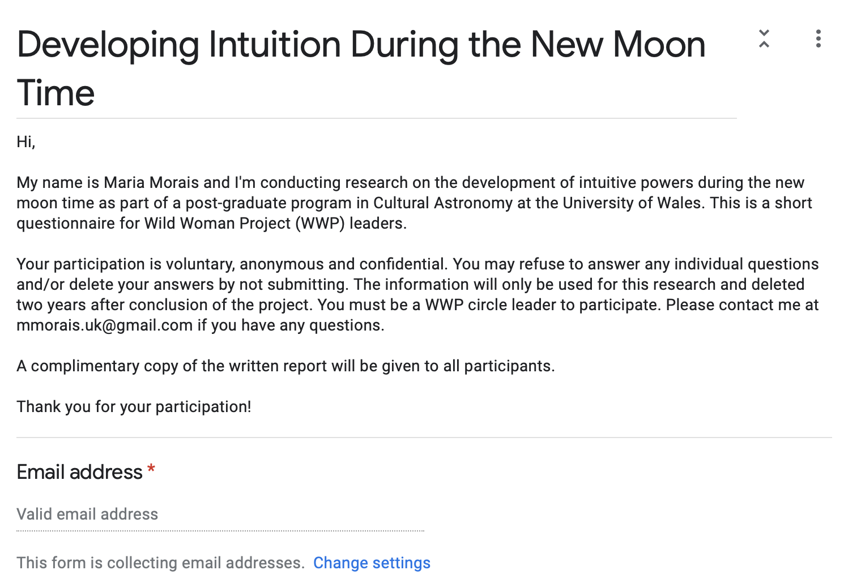

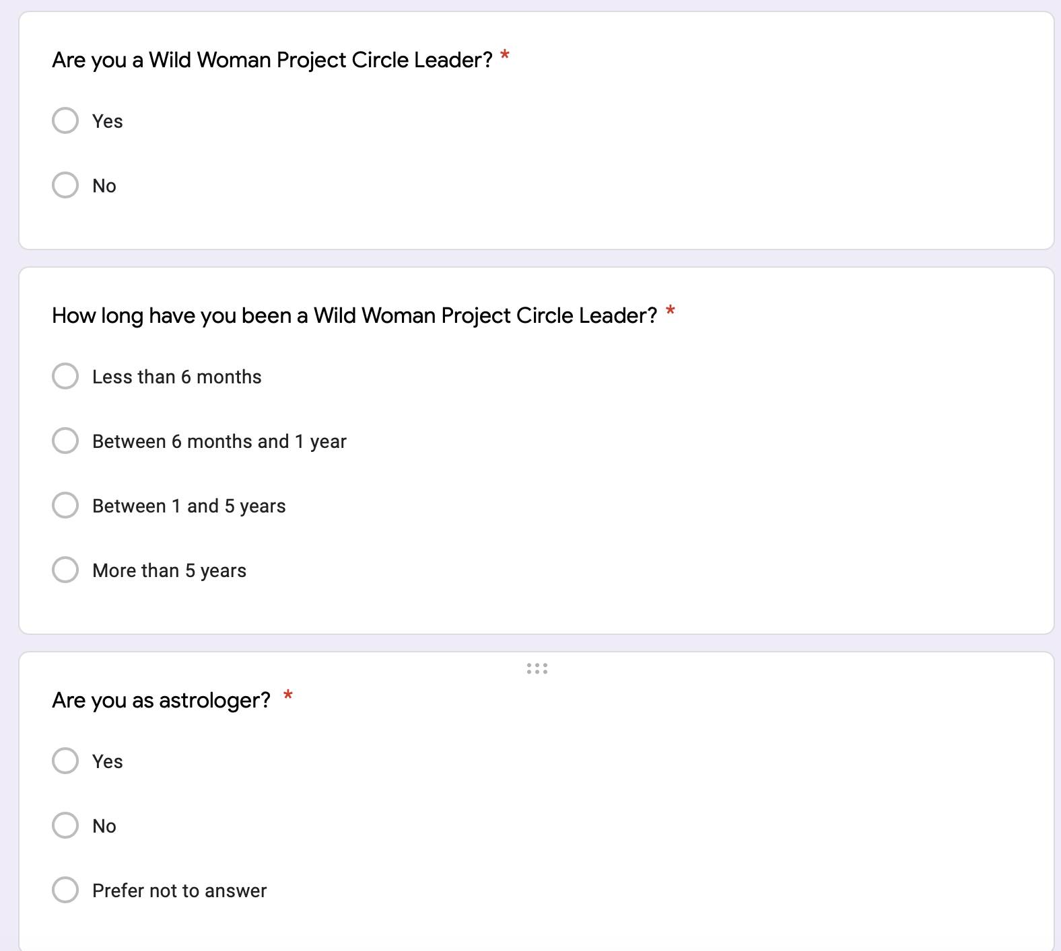
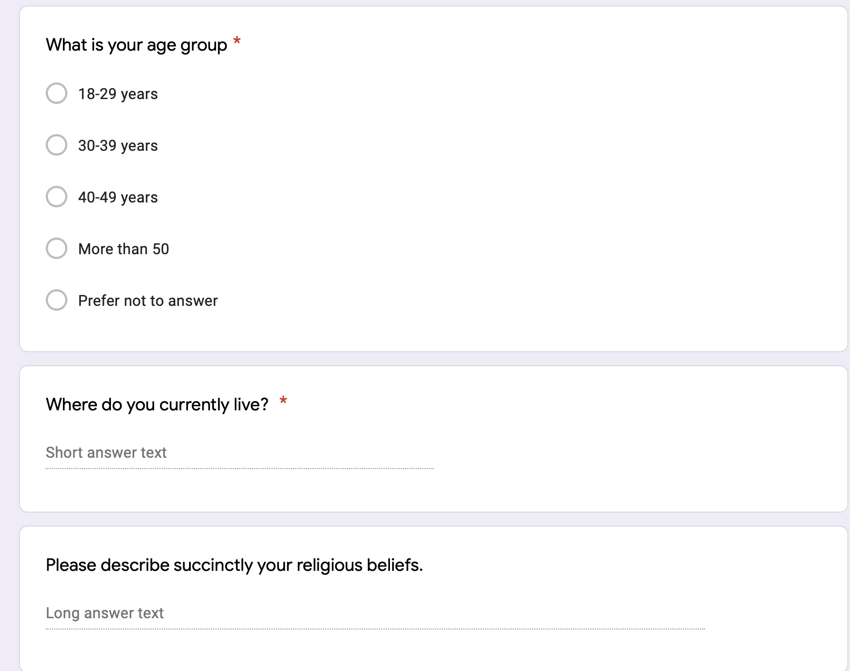



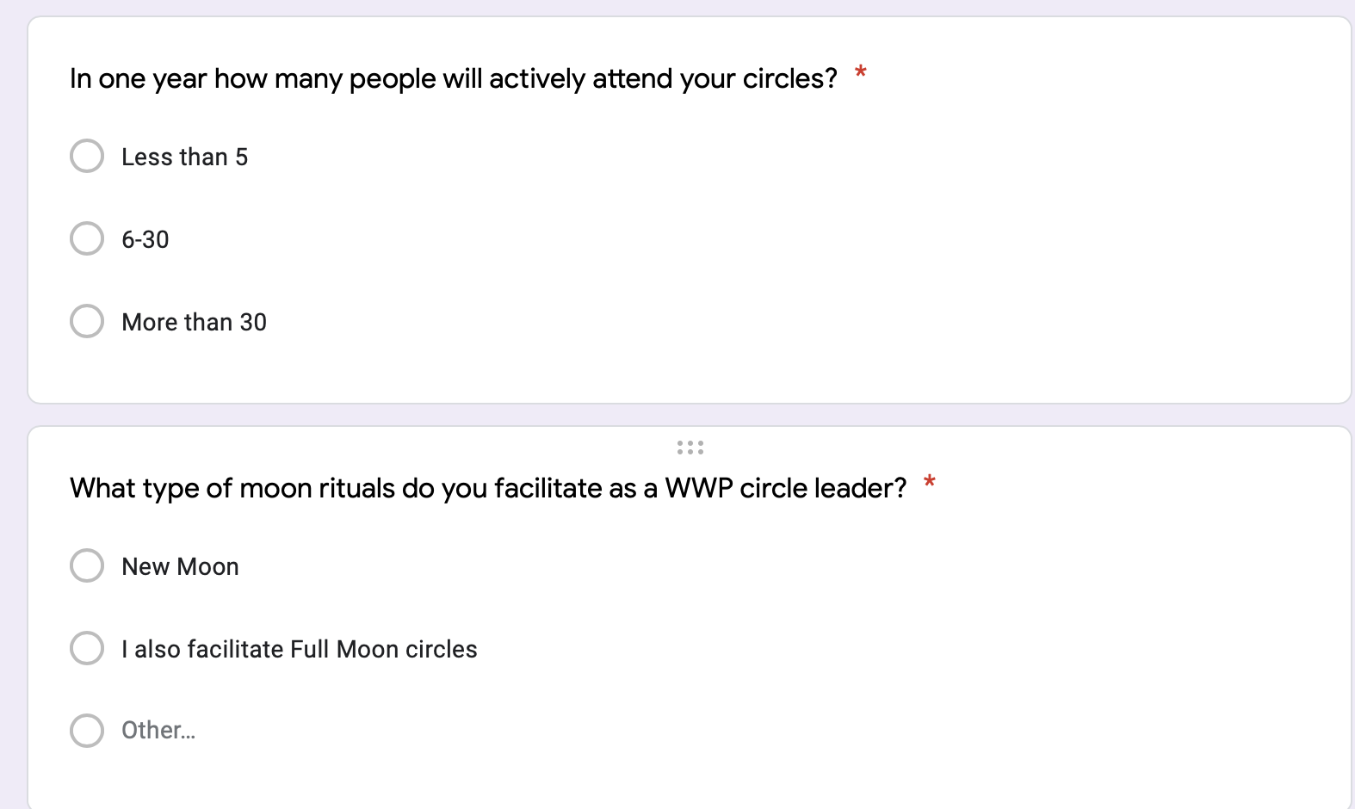

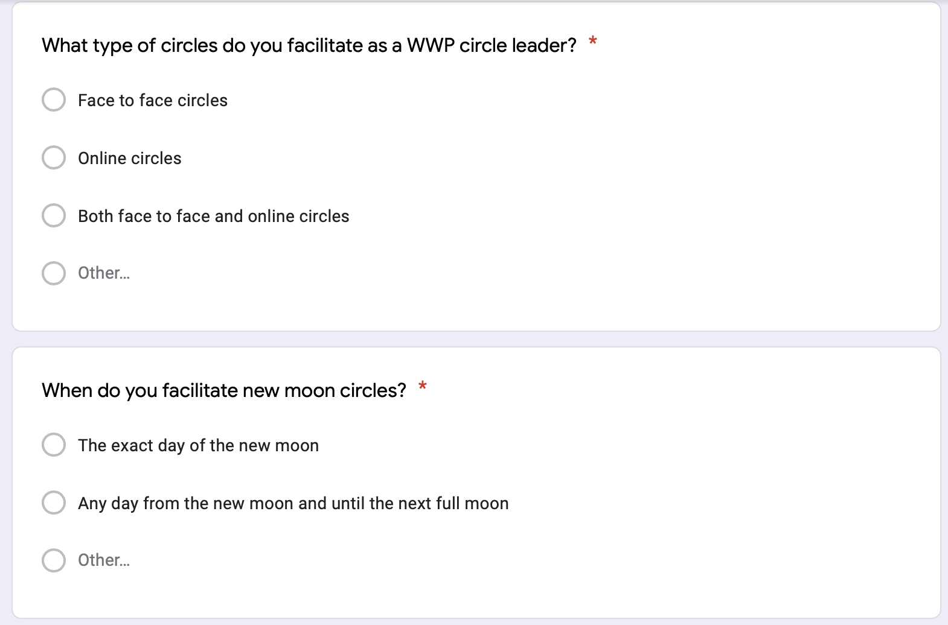

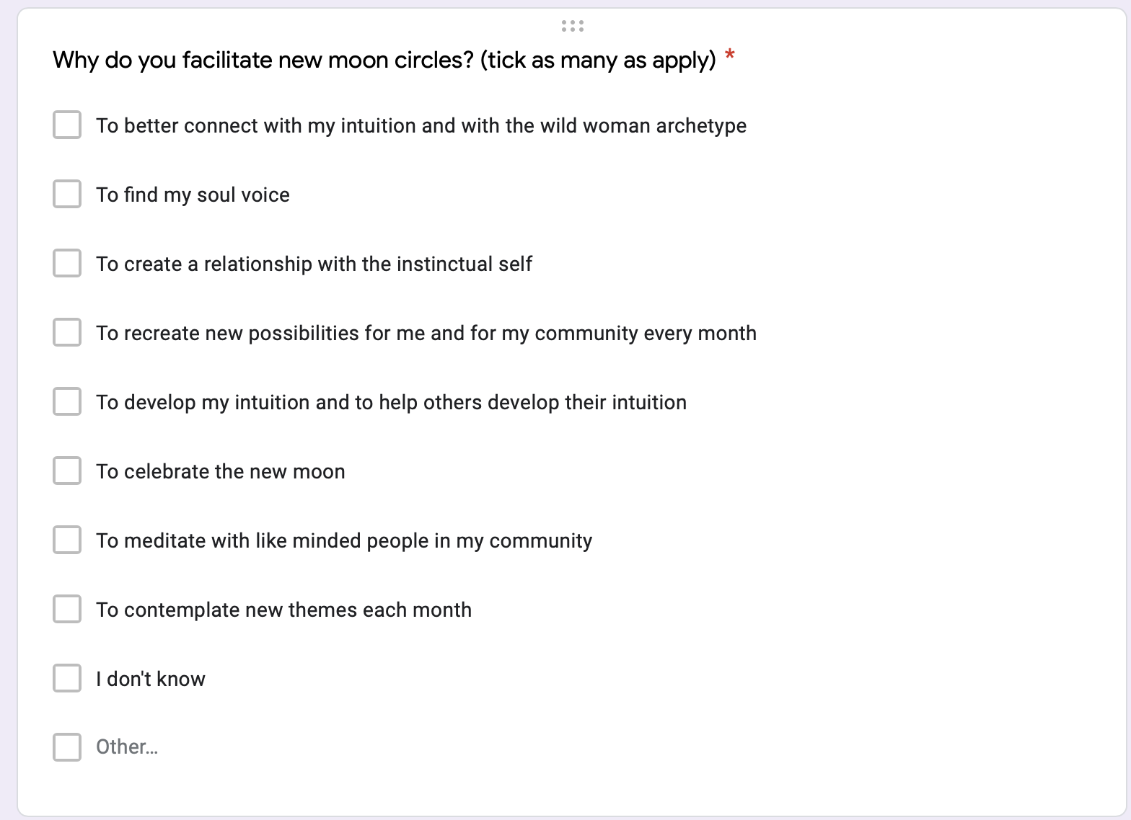

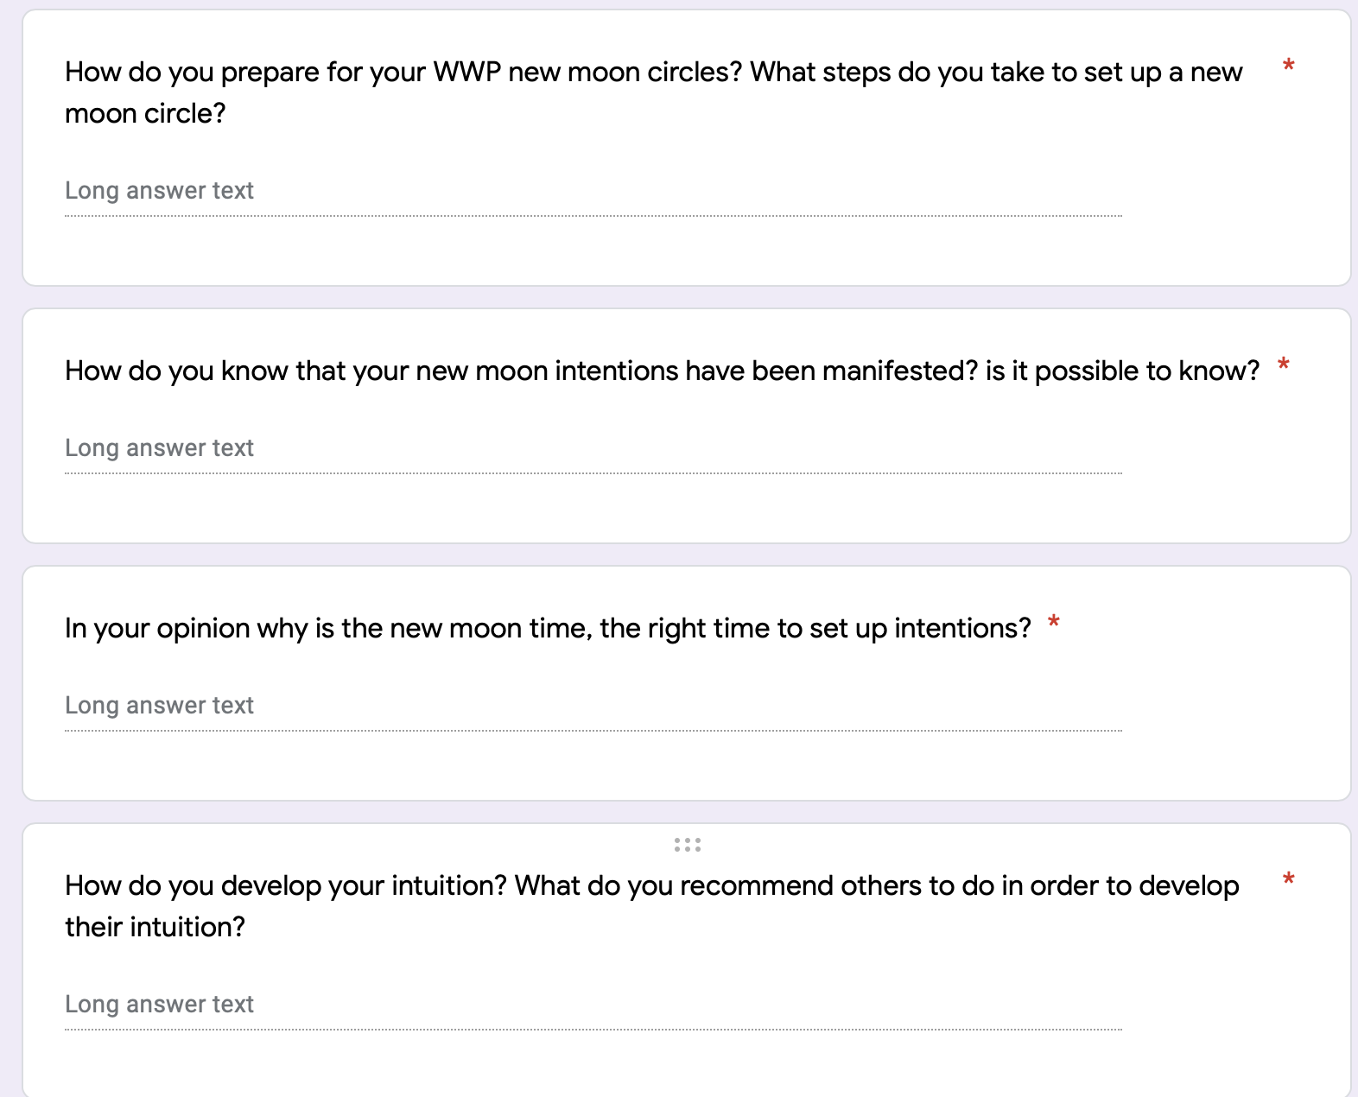

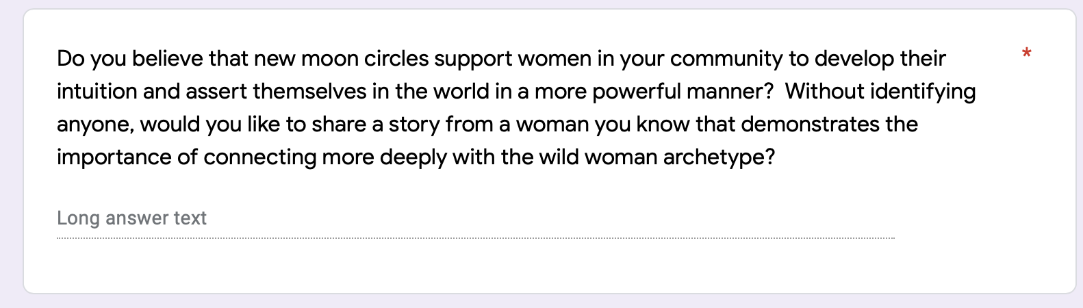

Clarissa Pinkola Estes, Women who run with the wolves (London, Rider, 2008), pp.2.
Bernd Brunner, ‘Gazing at the Moon’, In Moon – A brief history, (Yale University Press), pp.7.
David G. Myers, ‘Psychic intuition’, In Intuition, (Yale University Press).
Clarissa Pinkola Estes, Women who run with the wolves (London, Rider, 2008), [hereafter Estes, Wolves], pp.4.
Estes, Wolves, pp.4.
David G. Myers, ‘Psychic intuition’, In Intuition, (Yale University Press), [hereafter Myers, Intuition], pp. 226.
Myers, Intuition, pp. 227.
Myers, Intuition, pp. 226.
Myers, Intuition, pp. 227. ; Estes, Wolves, pp.4.
Bernd Brunner, ‘Gazing at the Moon’, In Moon – A brief history, (Yale University Press).
Bernd Brunner, ‘Gazing at the Moon’, In Moon – A brief history, (Yale University Press), pp.3.
Estes, Wolves.
Estes, Wolves, pp.159.
Estes, Wolves, pp.255.
Judith Bell, Doing your Research Project (McGrawHill Education, Kindle Edition, 2014), Part 1- Chapter 3.
A.N. Oppenheim, Questionnaire Design, Interviewing and Attitude Measurement (London, Continuum, 2005), pp 33.
Zayin Cabot, Ecologies of Participation – Agents, Shamans, Mystics, and Diviners (Lexington Books, 2018), pp.15.
Zayin Cabot, Ecologies of Participation – Agents, Shamans, Mystics, and Diviners (Lexington Books, 2018), pp.9.
WWP Questionnaire.
WWP Interviews.
WWP Interviews – Circle leader B1.
Estes, Wolves, pp.255.
WWP Interviews – Circle leader A1.
WWP Interviews – Circle leader A1.
Bernd Brunner, ‘Gazing at the Moon’, In Moon – A brief history, (Yale University Press), pp.7.
WWP Questionnaire.
Estes, Wolves, pp.159.
Myers, Intuition, pp. 227.
Myers, Intuition, pp. 237.
Myers, Intuition, pp. 240.
WWP Interviews.
WWP Interviews – Circle leader B1 and C1.
WWP Interviews – Circle leader A1.
WWP Interviews – Circle leader A1.
WWP Questionnaire.
WWP Questionnaire.
Estes, Wolves, pp.257. ; Myers, Intuition, pp. 240.
Estes, Wolves, pp.4.
Estes, Wolves, pp.257.
Estes, Wolves, pp.21.
Estes, Wolves, pp.22.
WWP Questionnaire.
Estes, Wolves, pp.195.
WWP Interviews – Circle leader C1.
Estes, Wolves, pp.97.
Myers, Intuition, pp. 245.
Myers, Intuition, pp. 245.
WWP Questionnaire.
WWP Questionnaire.
WWP Questionnaire.
WWP Questionnaire.
WWP Interviews.
WWP Interviews – Circle leader A1.
WWP Interviews – Circle leader A1.
WWP Interviews – Circle leader C1.
WWP Interviews – Circle leader C1.
WWP Interviews – Circle leader B1.
WWP Interviews.
Myers, Intuition, pp. 246.
Myers, Intuition, pp. 246.
Estes, Wolves, pp.255.

