Developing Workplace Critical thinking

Module No: BMSK5001
Module lecturer: Husam Helmi
Student Name: Saifur Rahman
Student ID: 1605226

Contents
Introduction 1
Task 1: Management theories relevant to individual’s role in the organization and workplace environment along with its impacts on own values, beliefs and attitudes. 2
Conclusion: 17
References 18

Introduction
A critical thinker is an open-minded person. This type of people takes rational and logical decision based on a series of analysis and investigations. Every successful organization pursues the process of critical reasoning before making their important business decisions (DeCastell, 2016). Critical thinking helps to recognize every possible outcome against possible solutions of the company. Under this approach, the board members of the company collect all the data and information regarding the particular topic and weighing them according to the significance. The best possible solutions are selected for further progression. The practice of critical thinking within the workplace environment is important as it allows the company to evaluate all the corners of the situation appropriately and precisely. The focused company is this report is Tesco. Tesco is a multinational grocery business. The brand recognition of Tesco is very and the company worth millions (Rayner and Cools, 2012). A huge amount of employee works under this organization. The management of these large amount people is a challenge. I used to be a part in this company during the voluntary work experience period. I was appointed as an assistant sales manager in the London branch of Tesco. The report is going to analyze different methods and approaches of building workplace critical thinking.

Task 1: Management theories relevant to individual’s role in the organization and workplace environment along with its impacts on own values, beliefs and attitudes.
Human all around the world is different from one another in perspective of perception, values and beliefs. Large organizations especially multinational companies like Tesco deals with hundreds of people every day and make business deals (LeBlanc, 2013). To be successful in the industry, it is important to understand people’s values to be acquainted with the business contractors. In general sense, attitudes, values and beliefs are considered in the same manner. However, the meaning of attitudes, beliefs and values are not same.
Differences among attitudes, values and beliefs:
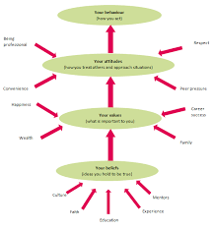
Figure 1: differences of attitudes, values and beliefs (Thomson, 2015).
Attitudes refer to the thinking of a person. What a person thinks about an object, situation or issue and how he is going to behave towards the issue is called attitudes. Attitude may changes over time with the changing nature of culture, social positions and status. The attitude of an employee may change with its higher positions in the office or organizational culture (Glaser, 2011). Values on the hand cannot be changed very easily. Value indicates the sense of right or wrong. The ethics and morality influences the values of a person and plays role in deciding what is right and what is wrong. Honesty, fairness practice is result of good values.
Beliefs depict one’s learning from family, culture and school. The spiritual faith is one kind of belief. People possess their beliefs through past experiences. With reasonable logics, the beliefs of a person can be influenced over times. In an organization like Tesco the believes, attitudes and values of employees plays important in critical reasoning process as each employee contribute in collecting data and processing them (Boyd, 2014). For example: the monthly retention rate of Tesco has been recorded by a group of employees. Whether the group is negligible or careful to their duties shows the attitude of the group. The moral values will influence the process how the group honestly calculates the amount and the belief of the group can create misperception in the data processing approach. Understanding the importance, Tesco started to provide regular training and motivational sessions to their employees in order to be efficient in critical thinking process.
Relevant models regarding individual’s role and workplace environment:
Maslow’s Hierarchy need model:
Maslow invented the theory in 1943 as a method of motivating employees of the organization. The Maslow’s hierarchy of need is a pyramid showing the desires a person have in his life in the form of need. The diagram of the model is below.
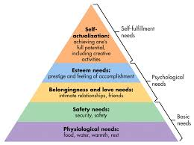
Figure 2: Maslow’s Hierarchy of need (Bandura, 2012)
According to the model an individual have certain stage of needs in his life in a chronological way. The basic need of an individual is the physical and psychological need. At the fulfilling stage of physical need, employees look for psychological needs. Food, cloths, security are the basic need of the employee according to the Maslow’s theory. The second level of the need hierarchy is the psychological need where an individual opts for self-esteem through recognition, prestige accomplishments (Schoenfeld, 2017). The third and upmost level of need pyramid is the self-actualization need where an individual desire for fame. According to the Maslow, an organization can consider the need theory to motivate their employees toward their performances. The model is a summary presentation. Employer often uses the model to identify ways of satisfying their staff group as a satisfied workgroup is considered to be an asset to the organization. Tesco management board also considers this theory important.
Impacts on individual’s role within the organization:
The understanding of the Maslow’s need hierarchy theory will help an employer to make decisions regarding employee motivation strategies. When an employee’s needs are recognizable, it becomes easy to satisfy and motivate them. Being a assistant sales manager in Tesco, Maslow’s pyramid help me to identify the sources which will eventually satisfy them. For example, a sales manager manages to provide regular wages on particular date of the month. The regular flow of salary can keep their many difficulties aside. Security in the workplace is also necessary (Rayner and Cools, 2012). The manager always tries to maintain a clean and hygiene environment within the company. The limitations of Maslow’s need pyramid are that it does not consider the differences among values, attitudes and beliefs. I was aware of the limitation during the application of the model. Sales manager has the responsibility not only to the staff group but also to the customers. A sales manager is entitled to monitor the employee attitudes towards customers, proper supply of products and coordinating the group work by assigning every one particular job. Need hierarchy model helps us understand the ways of encouraging staff.
Impacts on workplace environment:
Tesco is an international company. Its work largely depends on the employee performance. That is why Tesco is always concerned about the employee satisfaction level as it knows that without a satisfying work group, Tesco cannot achieve success. Tesco follows Maslow’s need theory as a method of motivating and encouraging employee performance. For example, Tesco always make sure of the regular wage service practice. At the lower level, employees are very much sensitive to their salary income (LeBlanc, 2013). After fulfilling the basic need, Tesco looks into the process of satisfying self-actualization. Tesco arranges annual prizing ceremony for the best performer of the year within the organizations. These policies taken under the Maslow’s need theory contributes in managing employees
Tesco do not attract personal values and beliefs but tries to maintain their own organizational values during the job hour. The employee attitudes towards customer need to be pleasant and welcoming which will the influence the employee satisfaction level. Tesco offers self-esteem to their employees. Different remuneration policies and reward systems helps the company to motivate employees and staff. The motivated workers tend to perform more gently and effectively (Probert et al., 2012). On the other hand, employees who have negative attitudes and wrong values cannot be improved through remuneration process. Appropriate punishment should be imposed and practice in this scenario to make other intimidated through this action.
Paul and Elders critical thinking theory
Critical thinking is a form of thinking which allows a person to skillfully improve their way of thinking on a subject matter by carefully going through steps of the matter and imposing intellectual standards onto them (Holowchak, 2015). A very famous model for critical thinking was introduced by Paul and Elder. This critical thinking model has been proven useful countless times whether in a workplace or educational purposes or even in day to day life problem solving.
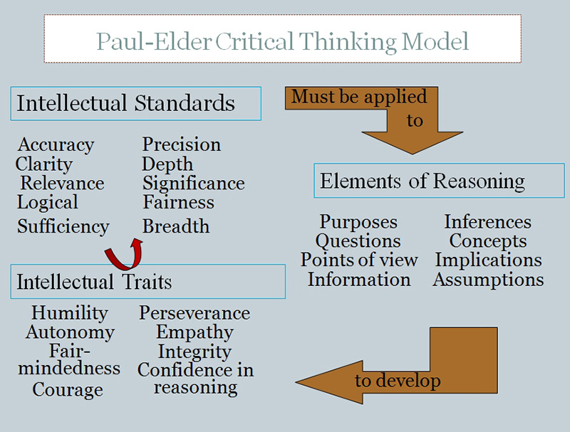
Figure 3: Paul- Elder critical thinking Model (Flora, 2014).
The Paul-Elder critical thinking model has been divided into three basic components. The Intellectual Standards is first of those components, which improves the form of reasoning by invoking a series of questions related to quality, relevance, depth etc. of the subject matter. Elements of thought are the component where a person would breakdown the subject matter to figure out its purpose, point of view, its ultimate goal etc. Finally, when a person practices these components and applies it in real life, he/she is expected to develop a few qualities known as Intellectual Traits (Glaser, 2011). Examples of Intellectual Traits can be Humility; Confidence in reasoning, Empathy, Integrity and much more. By understanding and practicing each of these components, a person can improve their way of thoughts over time.

Impact on individual’s role- assistant sales manager:
Critical thinking is the ability to analyze and gather evidence of a particular subject or a course of events rather than accepting the results or one’s own way of reasoning. Critical thinking is a way in which a person can assess the right or wrong in their own decision-making process which is why critical thinking is such a sought-after characteristic for an assistant sales manager (DeCastell, 2016). As an assistant sales manager developing and using critical thinking has enabled me to carry out my duties much more efficiently. For example, by applying the rules or components of Paul-Elders critical thinking theory I can carefully analyze and bring out a pattern to how my team is functioning and whether or not my customers are happy with our services. It allows me to carefully study my customers and my team and it lets me know how a certain individual or a group behaves and why they do it. As an assistant sales manager at TESCO, anything that happens in this department, is my responsibility and it is my responsibility to study and learn the reason of success and failure of the department in which critical thinking undoubtedly plays a massive role
Impact on workplace environment
Employees always provide the best results when they are fully familiar with the nature of the tasks they have been assigned to. For example, as an assistant sales manager at TESCO it is my duty to ensure that my team’s performance is always good. When an employee understands their jobs correctly it is easier for them to assess various problems and devise an effective solution which in turn becomes beneficial for the company. As an assistant sales manager at TESCO, critical thinking is a must have trait for me because it is my job to assess the difficulties and come up with a solution (Cofer and Appley, 2013). For example, if the sales record for a year is not up-to mark then it is my duty to find out the reason and evidence behind it and come up with a solution. Critical thinking allows me to take the subject matter and very carefully examine why the sales has gone down, identifying the issues and coming up with solutions as well as contingency plans to avoid this kind of difficulties in the future. For instance, If all employees of Tesco are equipped with critical thinking abilities then everyone within Tesco can do their work much more efficiently which ultimately gives the company an excellent and superior workforce. This is why it is undeniable that critical thinking has a major impact over a company.
Gibbs theory:
Gibbs theory is process of six steps. It is the result of Kolb’s learning strategy. The six step of Gibbs theory is below in diagram.
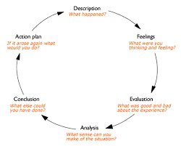
Figure 4: Gibbs theory model (Bolles, 2015).
The model first starts with the description stage where an individual explains what has happened. The second stage recognizes the feelings after evidencing the data and information. The evaluation of the collected information and feeling comes in the third stage of the cycle and analysis in fourth stage. Conclusions have been reached after the analyzing and evaluation of process. Action plan is the last stage in the cycle and the most important one.
Impact on Individual and workplace environment:
Gibbs cycle provides a systematic way in Tesco. In the course of job performances, an assistant sales manager in Tesco often needs a scientific and systematic approach in order to manager its work within the organization. Gibbs cycle ease the work of a manger and show guidelines to solve a problem. For instance, people in normal work life tend to juggle of different roles and duties. The bear of playing different roles at one time often creates difficulties. People with different values had different sets of rules in life (Bandura, 2012). The application of Gibbs theory in Tesco work management offers employees a open brainstorming place above the differences among attitudes and values. Tesco brings parity in their workplace management process to build a platform for critical thinking.
Kolb’s learning cycle:
Kolb stated that Learning is the process whereby knowledge is created through the transformation of experience. Kolb’s learning theory was invented in 1984 where Kolb depicts two dimensions of learning. Below is the diagram of the learning cycle:
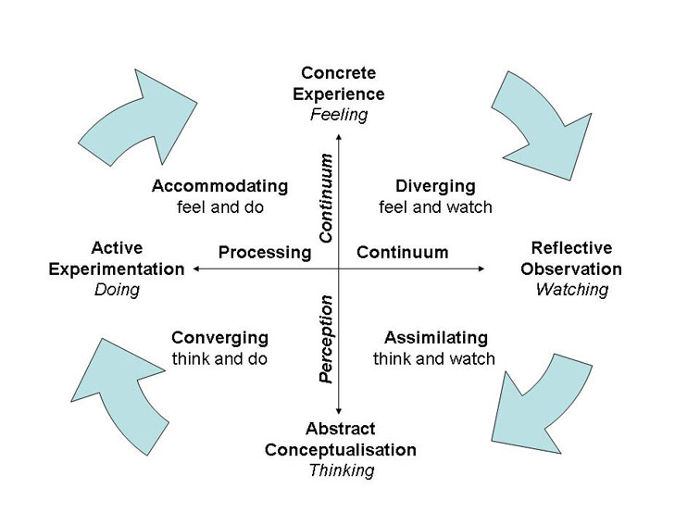
Figure 5: Kolb’s learning style (Thomson, 2015).
The experiential learning cycle of Kolb is a set of four stages. Each step directs towards others. In the primary stage of concrete experience, a person gathers new experiences. After the new feeling the person reflects observation in the second stage of learning. At the third level, the learner reaches to abstract conceptualization and thinks about the experience. At the last stage, the learner becomes confident about his action and takes decision regarding active experimentation (Schoenfeld, 2017). In the Learning cycle model the second dimension mentions four different strategies that person can follow in making their choices. Diverging, assimilating, converging and accommodating are the four different approaches in this cycle.
Impact on Individual’s role within Tesco:
Kolb’s learning model considers the differences among people’s behavior regarding choice making processes. As stated before an assistant sales manager needs to deals with different kinds of human behavior. The customers in the shop and the subordinated employees hold different sets of attitudes and values that raise difficulties in managing people. Determining the right amount of product stock requirement, maintaining the raw material supply is a challenge. The learning cycle shows me the path to be expert at work through the periods of experiences. The production of learning dimension decides my own category of learning style. The determination of correct learning style of an assistant sales manager helps to detect the flaws, limitations and opportunities of the category (Rayner and Cools, 2012). A sales manager can develop their skills through this model application. The ability of critical reasoning may also be improved through the observation stages. For example: the managerial jobs such providing guidance to the salespeople, monitoring method of the system, controlling the activities of mass staff group requires large experiences. Being an assistant sales manager I can learn this knowledge from my senior sales manager through observing his works. The experience of my training session in Tesco will also help in my learning process to reach the last stage of the cycle know as active experimentation. I believe, anyone at any level can start practice this theory in real life job performances.
Impacts on Tesco Workplace environment:
The application of Kolb’s cycle in Tesco employee training session can help to improve the learning process. The modern world is changing and Tesco being a customer oriented company is aware of the fact. With the changing nature in business and technology industry, Tesco feels the need to develop better learning strategies for their employees. The Kolb’s learning strategy help Tesco to design better learning sessions and workplace environment (Probert et al., 2012). For example, Tesco recently recruit a reasonable amount of new sales people in their shop. Tesco provides these employees learning opportunity through training sessions. Tesco arranges the training process in such a way where employees gather knowledge simultaneously working for the company. The application of Kolb theory influence Tesco managers to offer employees open spaces to critically think about the situation. The discussions of past incidents in the industry context also enlighten new employees with the probable ways of solutions. The divergence term is most commonly used among the employees of Tesco. Tesco has been very much beneficial through the practice of this model in their daily business arena.
Reinforcement Theory:
The reinforcement theory is often used to encourage a desired behavior or to increase the probability of getting a desired response. The reinforcement theory was introduced by a 12th century psychologist B.F Skinner and it is known as one of the oldest behavioral theories.
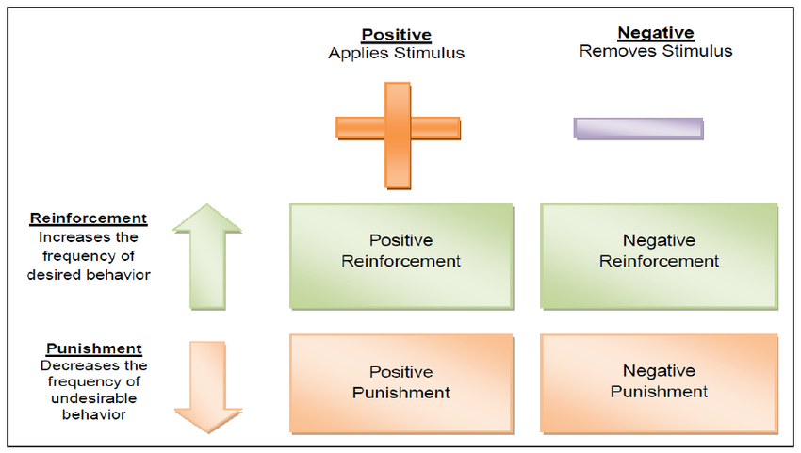
Figure 6: Reinforcement theory (LeBlanc, 2013).
Reinforcement theory proposes that we can change an individual’s behavior by reinforcement, punishment and extinction. Rewards are used to promote behavior we want, extinction is used to stop someone from performing a learned behavior and lastly punishment is to prevent the behavior we don’t want. Reinforcement again can be divided into two parts such as Positive reinforcement and Negative reinforcement (Holowchak, 2015). Positive reinforcement is when an employee gets rewarded for his/her work thus encouraging his/her motivation to perform their individual tasks more efficiently. And quite obviously, negative reinforcement the process of eliminating something unpleasant such removing extra workload from an employee. Similar to reinforcement, punishment has been divided into two parts as well, Positive punishment and Negative punishment. Positive punishment can be described as adding something unpleasant. For example, if an employee is being late he might be punished by adding extra workload. Negative reinforcement can be removing something that the employee may desire, for example if an employee comes to work late the assistant manager can punish him by taking away their break. It is best to enforce this the moment when a behavioral change is required for it to start acting immediately.
Impact on individual’s role:
As an assistant sales manager for TESCO, the reinforcement theory has helped me improve the performance of the entirety of my division. During my role as the assistant sales manager at TESCO, I started to use the Reinforcement theory and it gave me unbelievable results. I discovered that instead of punishing those who perform unwanted behavior, If we reward those who do well in their work it places a positive impact on the employee himself as well as the others around him (Glaser, 2011). As the assistant sales manager at TESCO, it is my responsibility that everything goes smoothly in my department; hence the need to have some sort of punishment or reward system for employees and undoubtedly the reinforcement theory has helped me a lot in shaping the positive and negative behavior of my subordinates. An assistant manager’s duty is incredibly tough and when it is a huge company like TESCO, dealing with the environment does not get any easier. Once I started applying this theory for the team the impact was immensely satisfactory. For example, when my team or an individual employee would complete their goals I would reward them from time to time. The reward does not have to be something substantial. It might be a little bonus or even a day off or decreasing their workload. Also when an employee does not fulfill their duty by a certain time limit, he/she may be punished by having taken away their breaks or giving them extra works to do, in other words increasing their workload.
Impact on workplace environment
Companies around the world such as Tesco have been using the Reinforcement theory for years to control their workforce behavior and workforce environment. In Tesco motivating employees can be very difficult since each person is different and they each have different tasks hence sought-after different goals in a workplace. For this reason, finding a motivational system for Tesco can be difficult. Since Reinforcement theory focuses solely on the individual’s personality, this system can work wonders for motivating individual employees in a Tesco workplace (DeCastell, 2016). Companies like Tesco can use this system as a means to promote good behavior in the workplace. As stated before if an employee gets rewarded for positive behavior, it can have a massive impact on the collective workforce and during my employment at TESCO as an assistant sales manager, when I started rewarding positive behavior for example when I started rewarding employees that come to work on time and punishing those who don’t the number of late comers had dropped a significant amount. This ultimately led to a huge difference at the sales department for the company.
Contingency theory:
The contingency theory is basically an organizational theory. Fiedler is the inventor of this model. This theory believes that there is no particular best policy of managing people in the organization. Below is the diagram of the contingency theory.
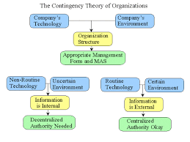
Figure 7: Contingency theory model (Bandura, 2012)
.
The contingency model depicts that the best solutions of a problem depends on the situations and perception. The managers of the organization like Tesco need to have the leadership skills in his character and understand the thoughts of his subordinates. The diagram above shows three different management approaches for the organization in terms of three different organizational structures (Bolles, 2015). The management form and methods will be determined according to the organizational structure. The structure of a company is the combined influences of company environments and technology. In situations where uncertain company environment exits along with the non-routine technology, the company usually follows decentralized management process. In this scenario, the information of the company is internal. The whole management decision making process will change over time if the company environment and technology possess different characteristics and phenomena. In the diagram, it can be seen that companies with routine technology and certain environment used to practice external information environment within the organization. This kind of organizations practice centralized management process.
Impact on Individual’s role:
An assistant sales manager is associated with different kinds of human interactions. Sales manager is liable to manage the entire workforce under his supervision. Each individual possess their own set of values, beliefs and attitudes. It is the job of the sales manager of Tesco to manage their employees according to their values and attitudes. The application of contingency theory in real life job performance will help a sales manager to decide the best actions as per the situation needed. The intrinsic and strict rules of the organization like Tesco often create more difficulties and sufferings for the employers in managing their employees. Tesco allow their sales managers to apply and follow contingency theory in real life complications to some extents. Under the supervision of the sales manager centralized management policy seems appropriate as per the contingent theory (Boyd, 2014). Following the theory, managers of Tesco hold different approaches such as centralized or decentralized methods in their own role playing policy. Contingency theory enlightens managers with the existence of situational differences and guides them to manage them appropriately. The application of the model in managerial work improves the level of performances.
Impacts on workplace behavior:
Tesco is a multinational company and deals with different cultures, origins, ethnics and customs. Contingency theory application has always been an asset to the company. Tesco uses the model in deciding their optimum business solutions. Cultural barriers can often be solved through this approach (Flora, 2014). The jury member of the Tesco Company chooses to select their business policy and management style according to the country norms and rules. For example, countries in Europe or Middle East usually practice a 24 hours market opening norms. On the other hand, in the eastern part of Asian countries like India, Bangladesh keeps their shop closed at night. Tesco consider these market practices and adjust their service opening hours as per the scenario. Countries like china are extremely possessive about their culture and customs. Tesco in such cases always tries to avoid any offensive behavior to the customers and employees of china (Cofer and Appley, 2013). The use of technology in the Tesco management process is routine and traditional in some cases and opposite scenario is seen in other branches. With the need of the situation Tesco adjust their business policy. This practice eventually contributes to build a workplace critical environment. Contingency theory allow flexibility in Tesco and relaxes the rules as per the situation requires. The noticeable fact is that Tesco only applies this theory to some limit. The main values and objectives of the organization cannot be influenced though this policy.

Conclusion:
The above discussions represent different benefits of developing critical reasoning within a workplace. The experience of working in Tesco improves my skills and abilities to work in future corporate sectors. Different theories such as Maslow’s need hierarchy, Kolb’s theory, reinforcement theory have been analyzed in the report to enlighten the learners about the importance of these models in the real life applications. The summary result of critical reasoning may consume a bulk amount of time though the significance of the method balances the cost. An organization like Tesco is well aware of the necessity of Critical reasoning process and always admires the strategies of building workplace critical reasoning. The report helps to understand the essentiality of this process in terms of making important decisions and policies. The discussed model above shows the implication of the theory on business arena focusing on the activities of Tesco. Each model explanations and their contributions in shaping individual’s role in the organization and the environment of the company make learners understand about the application process. In a nutshell the report brings a great help to the learner who want to have a descriptive overview on the role of critical reasoning in business world.

References
Bandura, A. (2012). Social learning theory. Englewood Cliffs, N.J.: Prentice-Hall.
Bolles, R. (2015). Theory of motivation. New York: Harper & Row.
Boyd, R. (2014). Critical reasoning and logic. Upper Saddle River, N.J.: Prentice Hall.
Cofer, C. and Appley, M. (2013). Motivation: theory and research. New York [etc.]: Wiley.
DeCastell, S. (2016). Literacy, society, and schooling. Cambridge: Cambridge Univ. Press.
Flora, S. (2014). The power of reinforcement. Albany: State University of New York Press.
Glaser, R. (2011). The nature of reinforcement. New York: Academic Press.
Holowchak, M. and Holowchak, M. (2015). Critical reasoning & philosophy. Lanham, Md.: Rowman & Littlefield.
LeBlanc, J. (2013). Thinking clearly. New York: W.W. Norton.
Pichère, P., Cadiat, A. and Probert, C. (2012). Maslow's hierarchy of needs.
Rayner, S. and Cools, E. (2012). Style Differences in Cognition, Learning, and Management. Hoboken: Taylor and Francis.
Schoenfeld, W. (2017). The Theory of reinforcement schedules. New York: Appleton-Century-Crofts.
Thomson, A. (2015). Critical reasoning in ethics. London: Routledge.

