HNC / HND / BSc Quantity Surveying

Bibek Khatri Student Id - 2530477
Assignment Title - Digital Surveying and Highway Design (ACBA4017)
Lecturer - Hannah Williams
Contents
1.0. Introduction 1
2.0. Survey Planning 1
2.1. Purpose of the Survey 1
2.2. Definition of survey area 2
2.3. Site Evaluation 3
2.4. Risk Evaluation 3
3.0. Practical (Conduct the Survey) 4
3.1. Summary of Survey Execution 4
3.2. Problem faced and their solution 5
4.0. Analysis and measurement 5
5.0. Survey Pictures and data plotting 7
6.0. Summary 11
7.0. References 11

1.0. Introduction
Digital surveying is the process of capturing and recording the accurate geometry and spatial features of buildings, land, and infrastructure using advanced technologies such as 3D laser scanners, drones, and digital imaging systems. Unlike traditional surveying techniques, it provides highly accurate and detailed data, often to the level of millimetres, producing reliable digital representations of real-world environments. The main output is a point cloud. It is a collection of millions of three-dimensional coordinates that accurately describe the surveyed object (Dealstudio.digital, 2025).
This assignment is based on practical use of digital surveying technologies, 3D laser scanning in particular, to a real-world building survey project. The work is divided into three phases: planning a professional survey, carrying out the survey in the field and interpreting the processed point cloud data in an effort to extract accurate building measurements. This process illustrates how digital surveying may improve the accuracy, efficiency and quality of data for construction, refurbishment and building management projects, and assist in informing decision making through the project lifecycle.

2.0. Survey Planning
3D laser scanning is a modern surveying technique for capturing buildings and construction sites quickly and accurately. It measures millions of points to produce a detailed digital depiction, known as a point cloud, of the area that has been scanned. This technique reaches much higher accuracy than the traditional manual measurements, making it especially useful for complex buildings, heritage structures and industrial facilities (Greenhatch Group, 2026).
The data collected can be used to create accurate drawings, 3D models and Building Information Modelling (BIM) models. These digital models allow architects, engineers and contractors to identify potential design clashes, improve project planning and reduce costly errors during construction.
3D laser scanning provides a reliable digital copy of the building and ensures decisions are made on the basis of accurate information. This makes it an important tool in refurbishment, renovation and construction projects where accuracy of measurements and fast collaboration are required (Greenhatch Group, 2026)

2.1. Purpose of the Survey
- This survey is undertaken to obtain accurate information about the existing internal layout and condition of the building prior to the commencement of the refurbishment works. A detailed digital record of the building will be created using laser scanning technology, which will capture important features such as walls, floors, ceilings, doors, windows, structural elements and visible building services (Jandrell, 2025).

A detailed survey is required as existing drawings may be out of date, incomplete or inaccurate due to previous alterations. If unknown services, structural changes or unanticipated site conditions are encountered during construction, they can cause delays and additional costs. By spotting these issues early, the project team can take steps to reduce risks and make better choices.
The survey data will be used to generate accurate 2D drawings and a BIM (Building Information Modelling) model. The information will help architects, engineers and contractors to plan the refurbishment more effectively, coordinate building services and avoid design clashes.
- Capture a precise picture of the building as it is.
- Recognise structural characteristics and building services.
- Support refurbishment design and planning.
- Minimize construction errors and delays.
- Improved cost estimation and project coordination.
- Provide accurate data for BIM modelling and future building management (Jandrell, 2025).

2.2. Definition of survey area
The area to be surveyed will include all internal areas affected by the refurbishment project. These spaces may include offices, classrooms, meeting rooms, corridors, reception areas, staircases, plant rooms, storage spaces and service risers. The survey scope should include any area to be changed, refurbished, or evaluated as part of the project (Jandrell, 2025).
The laser scan will provide the location, size and condition of key elements of the building. walls, floors, ceilings, doors, windows, columns, beams and other structural elements Visible mechanical and electrical (M&E) services, including ventilation ducts, pipework, lighting systems and cable trays will also be recorded. Ceiling voids and service spaces will be scanned where accessible to provide additional information for design and construction teams.
Areas to be taken:
- Offices and conference rooms
- Teaching spaces and classrooms
- Corridors and circulation spaces
- Reception areas and stairways
- Service risers and plant rooms
- Accessible service areas and ceiling voids
Level of Detail Needed:
- Architectural features inside
- Structural components (columns and beams)
- Visible M&E services
- LOD 2 or LOD 3 standard BIM model developed
This scope of survey will provide the information required for accurate planning, design and refurbishment works (Jandrell, 2025).

2.3. Site Evaluation
Prior to the commencement of laser scanning survey, the site assessment will be completed to ensure that sufficient access, safety measures and scanning positions are available. A walkthrough of the building will be performed to identify all areas within the scope of the survey including offices, classrooms, corridors, plant rooms and service areas.
Key Considerations When Assessing a Site:
- Access Point: Verify access to all rooms, corridors, staircases and restricted areas. Prior to the survey, organise keys, access cards and permissions.
- Scanning Positions: Determine scanner positions for full coverage and minimise blind spots. Larger rooms or complex spaces may require additional scan positions.
- Lighting Conditions: Laser scanners do not require lighting to measure but need sufficient lighting for colour imagery, navigation and safe movement around the site.
- Obstructions: Look at furniture, equipment, storage items and temporary barriers that might block important features of the building.
- Health and Safety: Check fire exits, trip hazards, construction works, ceiling access requirements and personal protective equipment (PPE) requirements.
This assessment will ensure efficient data collection, reduce delays, and improve the accuracy of the final survey deliverables (THE FUTURE 3D Team, 2026).

2.4. Risk Evaluation
A risk assessment will be conducted to identify possible risks that may affect the safety of survey personnel or the quality of the survey data. Appropriate control measures will be introduced to reduce these risks.
Identified Risks and Mitigants:
1. Restricted or Locked Zones
- Risk: Incomplete survey coverage.
- Mitigation: Arrange access permissions and keys before the date of the survey.
2. Trip Hazards and Blockages
- Risk: Injury to survey personnel or damage to equipment.
- Mitigation: Make sure walkways are clear and record hazards during the site inspection.
3. Construction Activities Underway
- Risk: Insecure work environment and poorer quality of scan.
- Mitigation: Work with site management to arrange scanning during less busy times.
4. Bad lighting
- Risk: difficulty of navigation and degradation of image quality.
- Mitigation: Ensure that working lights are available in all survey areas.
5. Security or Unauthorised Access Issues
- Risk: Delay and disruption to the survey.
- Mitigation: Notify security personnel and building occupants of the survey schedule.
This will allow the survey to be completed safely, efficiently and with minimal disruption to building operations by identifying risks and implementing suitable control measures (THE FUTURE 3D Team, 2026).

3.0. Practical (Conduct the Survey)
The survey was conducted as a group exercise in the first-floor corridor of the building at UWTSD, which included a small bridge walkway connecting two portions of the floor. The exercise consisted of two different and compared survey methods:
- Manual survey with tape measure
- 3D laser scanning survey
Prior to commencement, the team surveyed the site to determine access points, survey extents and appropriate sites for measurements and laser scanner deployment. The corridor was always available during the survey so that normal building activities could be continued.
The manual survey consisted of measuring corridor lengths, widths and key features by hand and recording the dimensions on site. The same location was afterwards surveyed with a 3D laser scanner providing a digital model of the environment from several scan positions.

3.1. Summary of Survey Execution
Most of the survey went according to plan. The survey area was accessible and the corridor provided good visibility for both manual measurement and laser scanning. The team was able to gather all information needed from the corridor and bridge walkway.
The manual survey produced accurate measurements however it was a slow process as each dimension had to be measured and recorded individually. This took a lot of time and effort from the team.
The 3D laser scanner, by contrast, was able to capture large parts of the corridor quickly and accurately. Multiple positions were used to scan the corridor to ensure complete coverage of the area. The scanner drastically cut down the time taken to collect data and gave a far more detailed record of the building.

3.2. Problem faced and their solution
- People Walking in Corridor
The corridor was still in use, so people sometimes walked through the survey area while measurements and scans were being performed.
Response - To avoid disruption and get accurate results, the team waited for the area to be clear before starting scans and measurements.
- Obstructions and Furniture
The line of sight of the scanner was partially blocked by some furniture and fixed objects.
Response - Other scanning locations were utilised to photograph areas that could not be seen from the original viewpoints.
- Manual Surveying Time
The manual survey took more time than expected because all the measurements had to be collected manually.
Response - The team divided the work among its members to improve efficiency and complete it more quickly.
The survey demonstrated the benefits of employing 3D laser scanning over traditional methods of measuring. Both surveys were successful, but the laser scanner was much faster and provided more detail. The obstacles faced were successfully overcome through teamwork, careful planning.

4.0. Analysis and measurement
Following the survey, measurements were taken from the processed laser scanning data and compared to observations from the manual survey. The drawing from the laser scan was a more accurate representation of the area surveyed and allowed measurements to be taken efficiently. The survey included the first-floor corridor and bridge connection area.
Measurements Taken
Element | Manual Measurement (mm) | Laser Measurement (mm) | Remark
Corridor width | 2500 | 2400 | 100mm difference
Corridor width of link bridge | 2150 | 2000 | 150mm difference
Corridor door width | 1750 | 1700 | 50mm difference
Length from link bridge to open space | 7900 | 7650 | 250mm difference
Total length of corridor | 31500 | 30800 | 700mm difference

Results analysis
The laser scan data was clear and easy to extract from the processed survey data. Compared with traditional manual surveying, laser scanning provided faster and more detailed information. In the manual survey, measurements had to be taken individually using a tape measure and recorded on site, which increased both the time required and the likelihood of recording errors.
As shown in the data extracted from both the manual survey and the 3D laser scan, there is very little difference between the measurements. The small differences observed are likely due to manual handling and measurement errors associated with the traditional surveying method.
The laser scanner recorded the entire corridor and bridge area in digital form so that measurements could be checked later without returning to site. This is a big advantage on bigger projects where access might be restricted, or where further measurements are required after the survey has been done (Surveyx.co.uk, 2026)
Comparison of Survey Methods Manual Survey
- Low-cost gear.
- Good for simple measurements.
- More time consuming.
- Higher risk of human error.
- Limited Data Collected.
3D Laser Scanning
- Quick data collection.
- High accuracy.
- Quick coverage of large areas.
- Digital record can be used for future measurements
- BIM & CAD modelling supported (Surveyx.co.uk, 2026)
The analysis showed that 3D laser scanning was the more efficient survey method. However, the manual survey was able to capture the key dimensions but required much more time and effort. The laser scan provided accurate measurements, more detail and a permanent digital record of the first-floor corridor and bridge connection area. For refurbishment and building documentation projects, laser scanning is a more reliable and professional solution than traditional manual measurement methods.

5.0. Survey Pictures and data plotting
The following figures show the completed work during the survey. Manual measurements were taken on site with a tape measure and recorded as sketches. After the survey, the 3D laser scanning drawing was given by the lecturers. We used both sets of information to compare the two survey methods and to assess their accuracy, speed and level of detail in collecting building measurements.
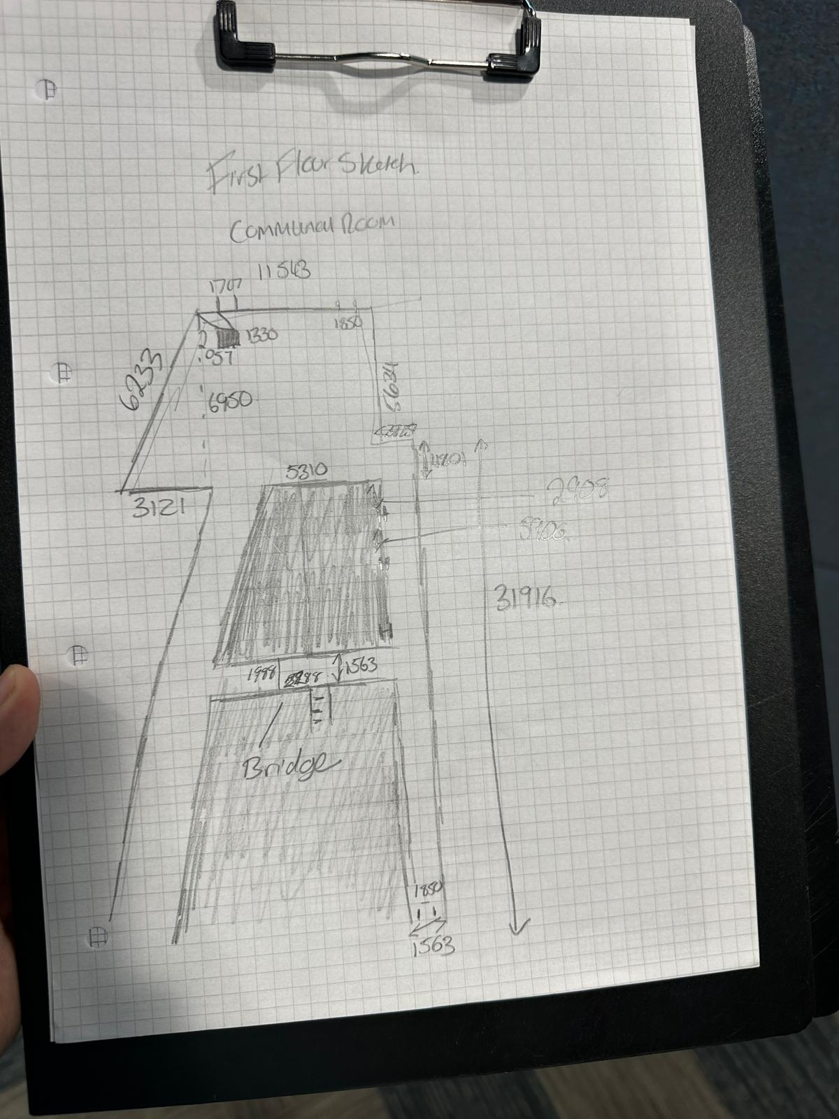
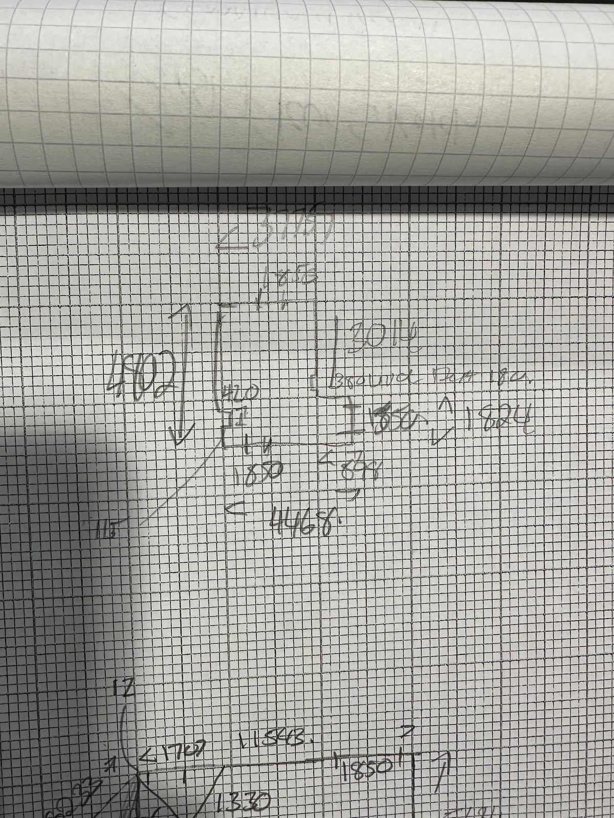
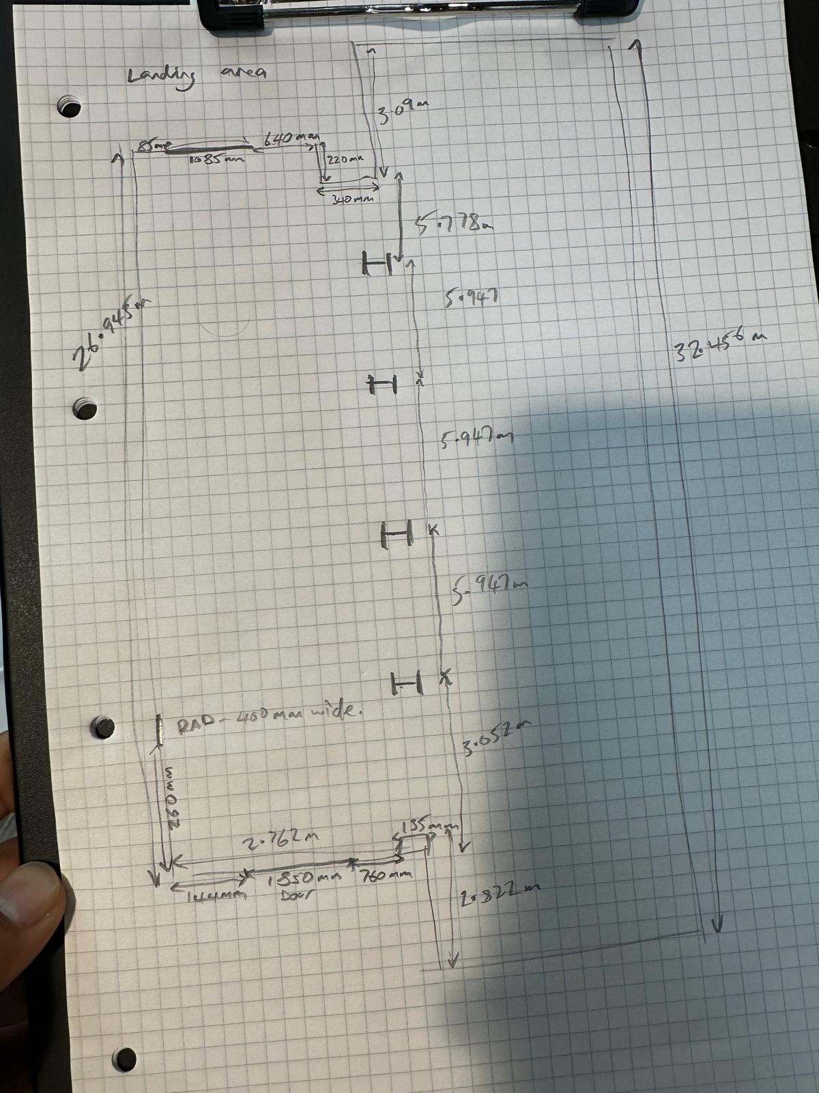
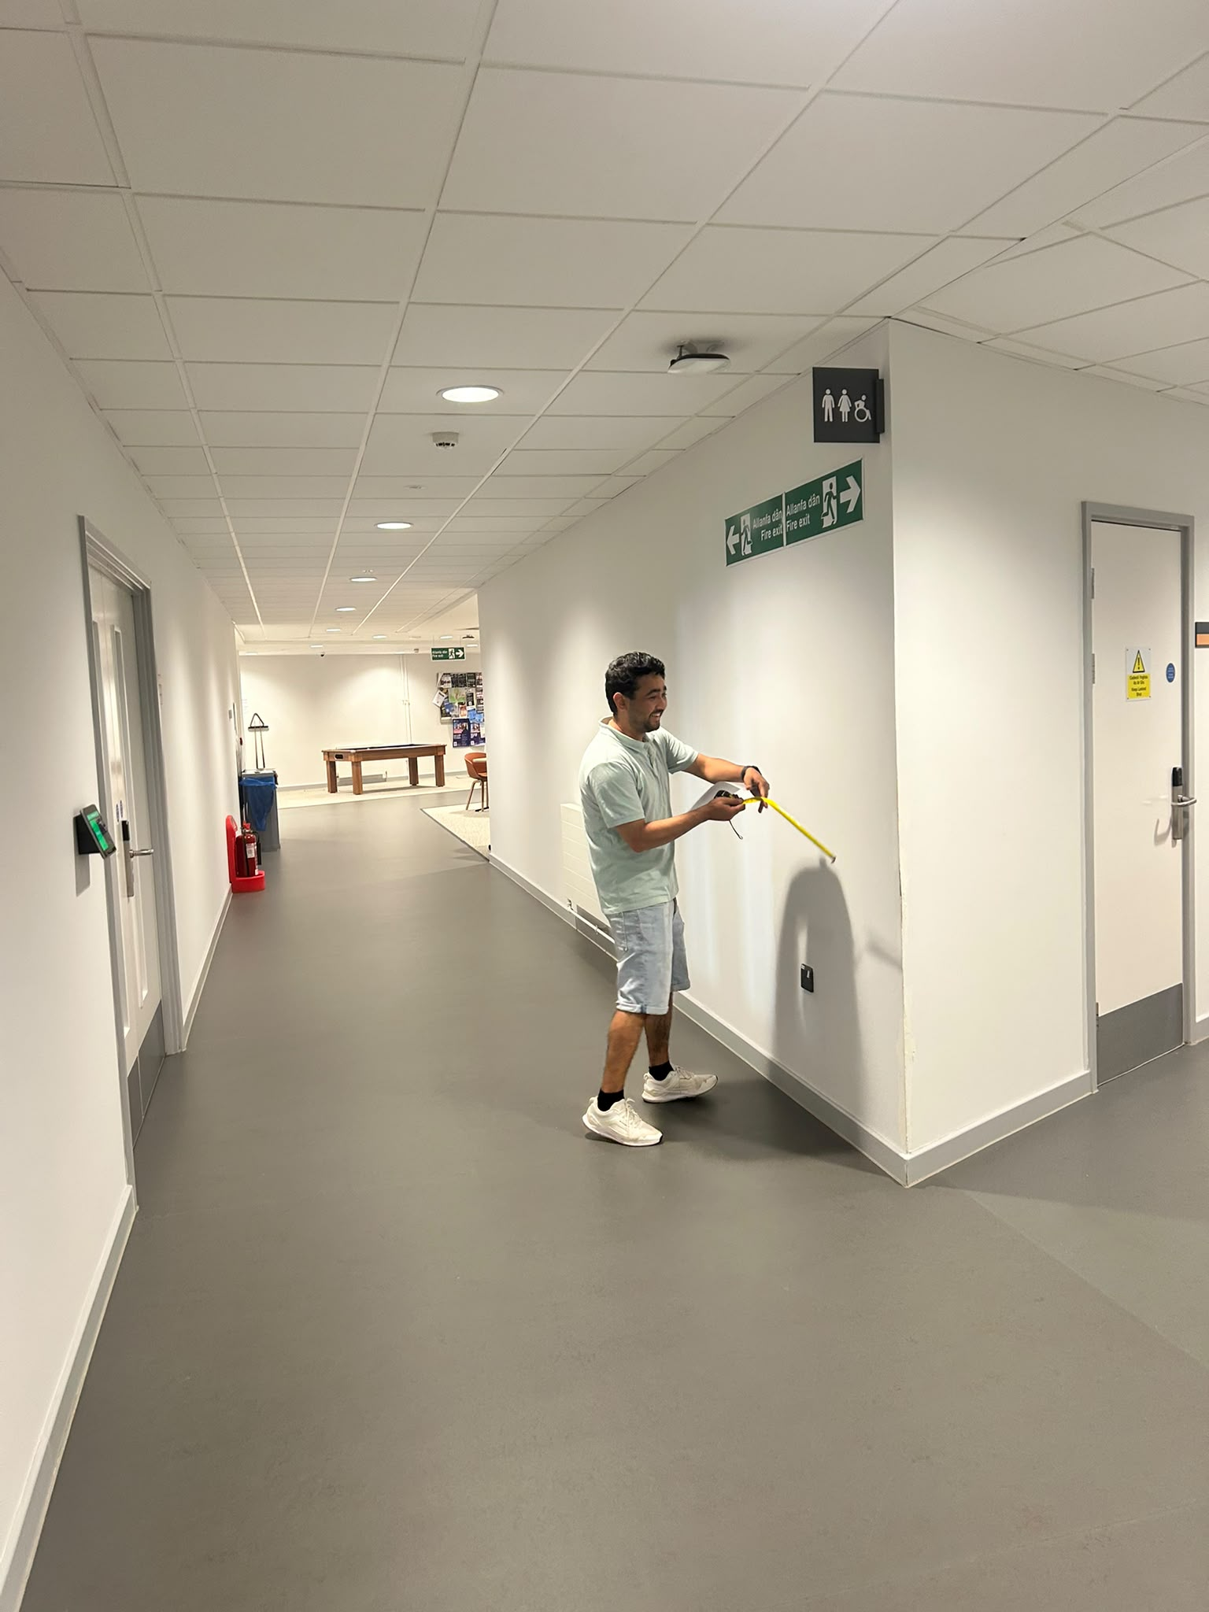
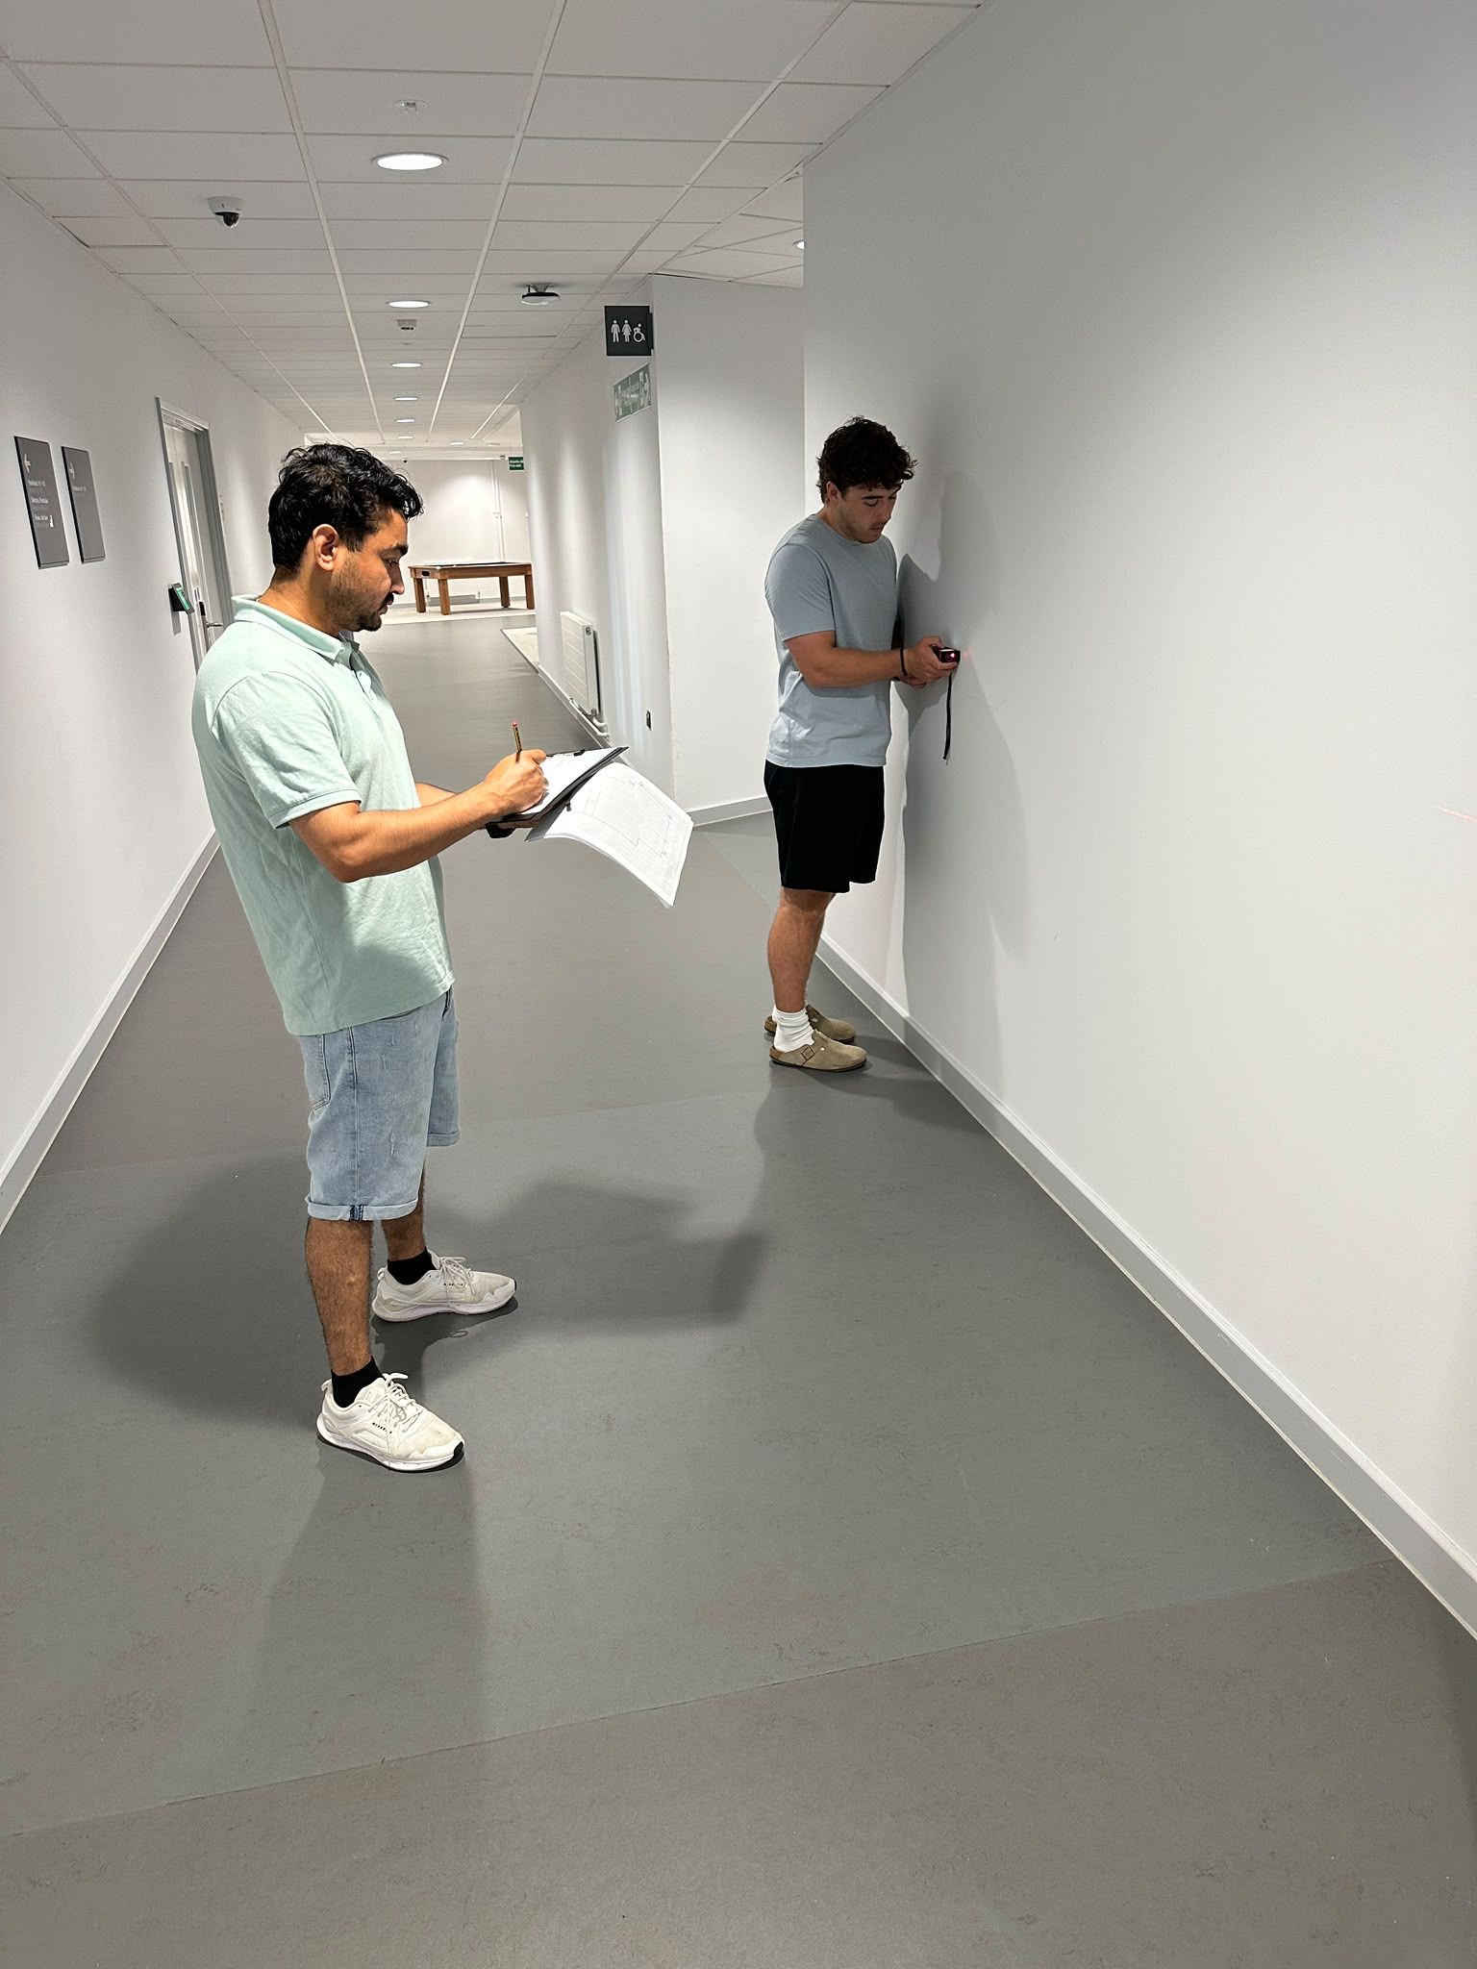
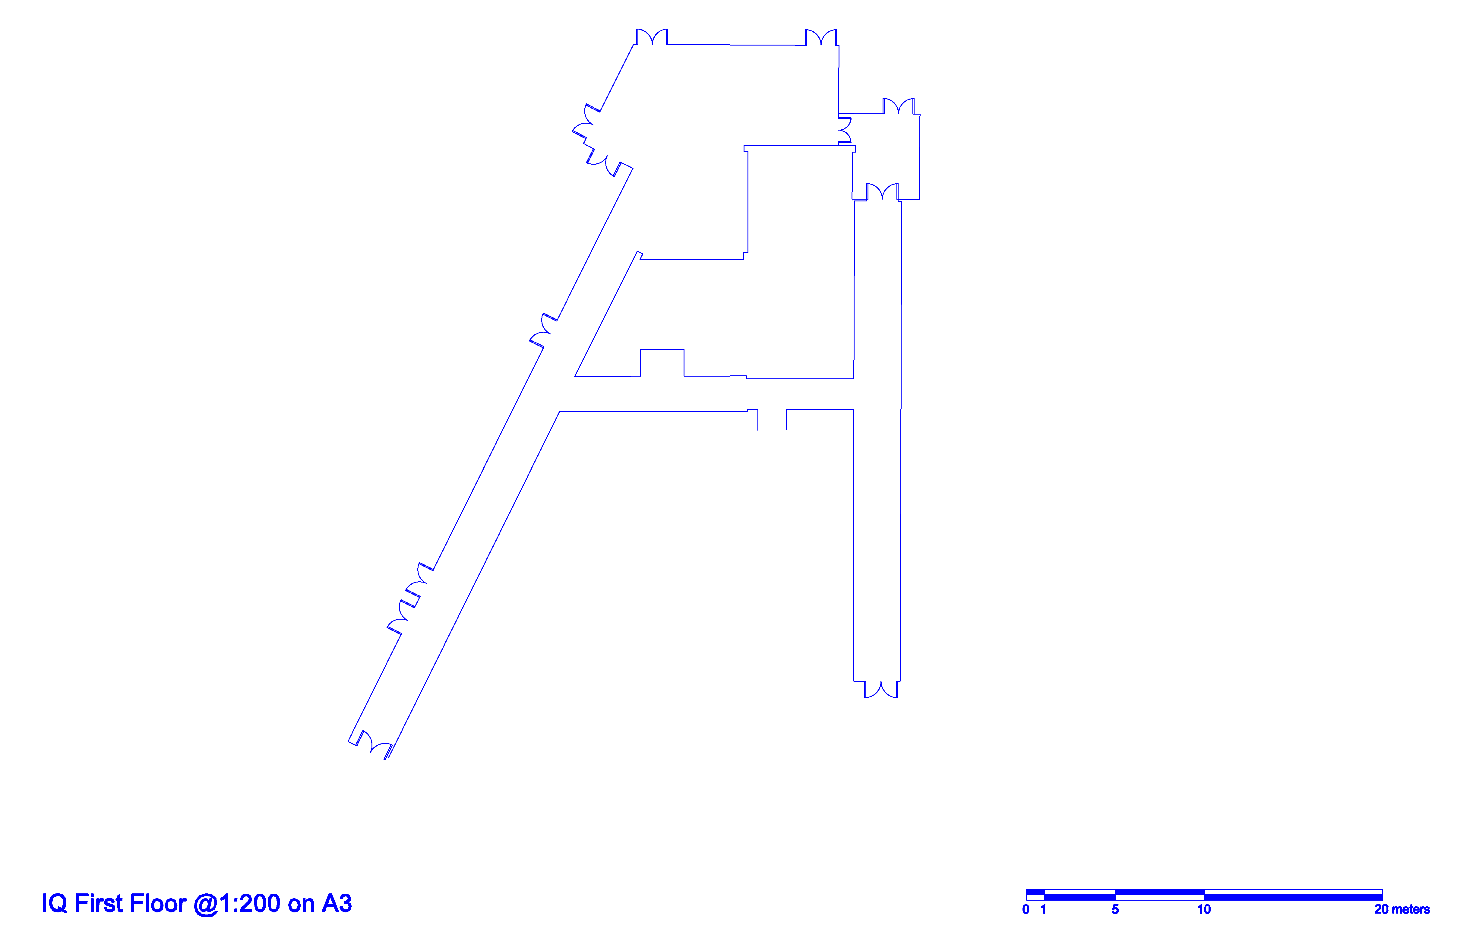

Produced from 3D Laser equipment

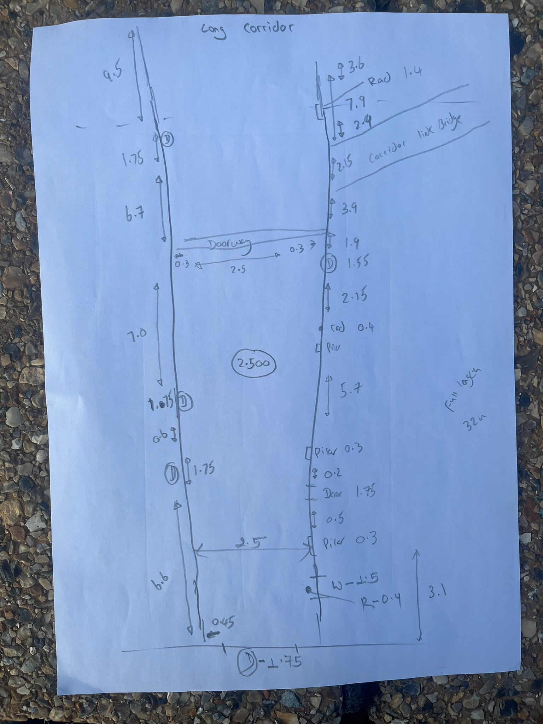

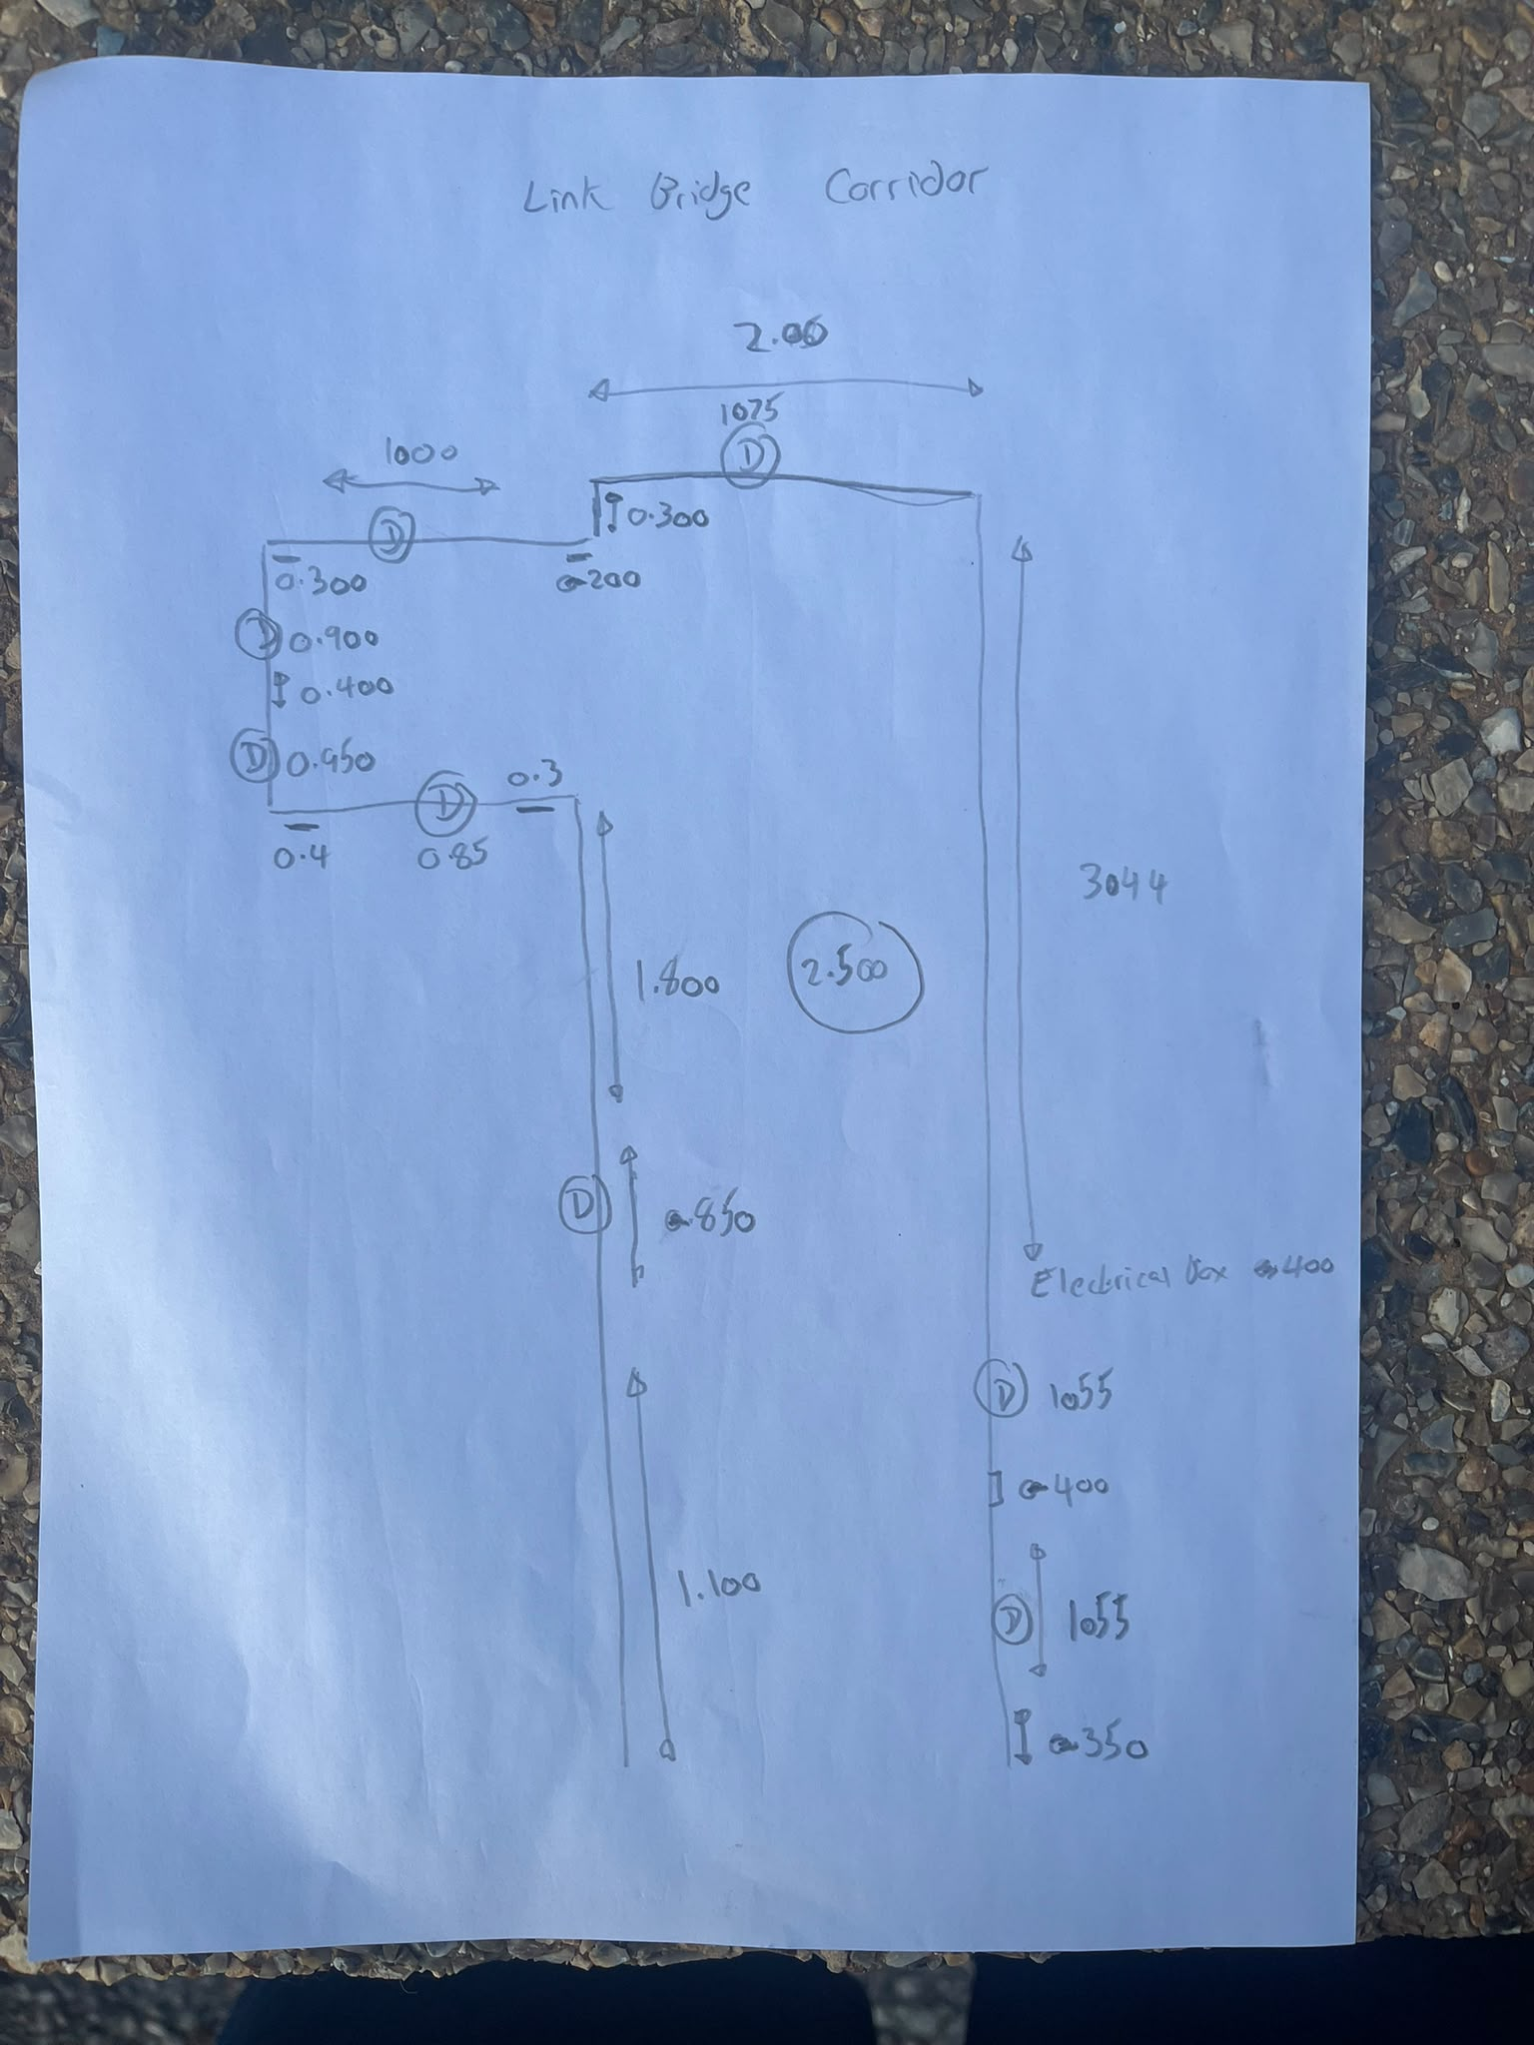
Manual Measurement plotting sheet

6.0. Summary
This survey demonstrated the advantages of 3D laser scanning over traditional manual surveying methods. Both methods delivered measurements for the first-floor corridor and bridge connection area at UWTSD, but the laser scanner worked faster and with a higher level of detail. The digital survey also created a permanent record which can be used for future measurements and BIM modelling. In general, 3D laser scanning proved to be a more efficient, accurate and reliable method for building surveying and refurbishment projects.

7.0. References
- Dealstudio.digital. (2025). Digital surveying in construction - applications, uses and potential for buildings and territories. [online] Available at: https://dealstudio.digital/journal/digital-surveying-in-costruction [Accessed 13 July 2026].
- Greenhatch Group (2026). Step-By-Step 3D Laser Scanning Survey Guide. [online] Greenhatch-group.co.uk. Available at: https://www.greenhatch-group.co.uk/blog/3d-laser-scanning-survey-process [Accessed 13 July 2026].
- Jandrell, O. (2025). How Internal Refurb Projects Benefit from Full-Scope 3D Survey Support. [online] Platinum 3D Consultants. Available at: https://www.platinum-3d.com/uncategorised/how-internal-refurb-projects-benefit-from-full-scope-3d-survey-support/ [Accessed 13 July 2026].
- THE FUTURE 3D Team (2026). How to Prepare Your Building for 3D Scanning. [online] THE FUTURE 3D. Available at: https://www.thefuture3d.com/blog/prepare-building-for-3d-scanning/ [Accessed 13 July 2026].
- Surveyx.co.uk. (2026). Laser Scanning vs Traditional Survey — Why Modern Methods Produce Better Results | SurveyX. [online] Available at: https://surveyx.co.uk/blog-laser-scanning-vs-traditional-survey [Accessed 13 July 2026].

