"Innovative Business Proposition: Arabian Essence Henna - Crafting Traditions A Design Thinking Approach to Revolutionize the Henna Industry"

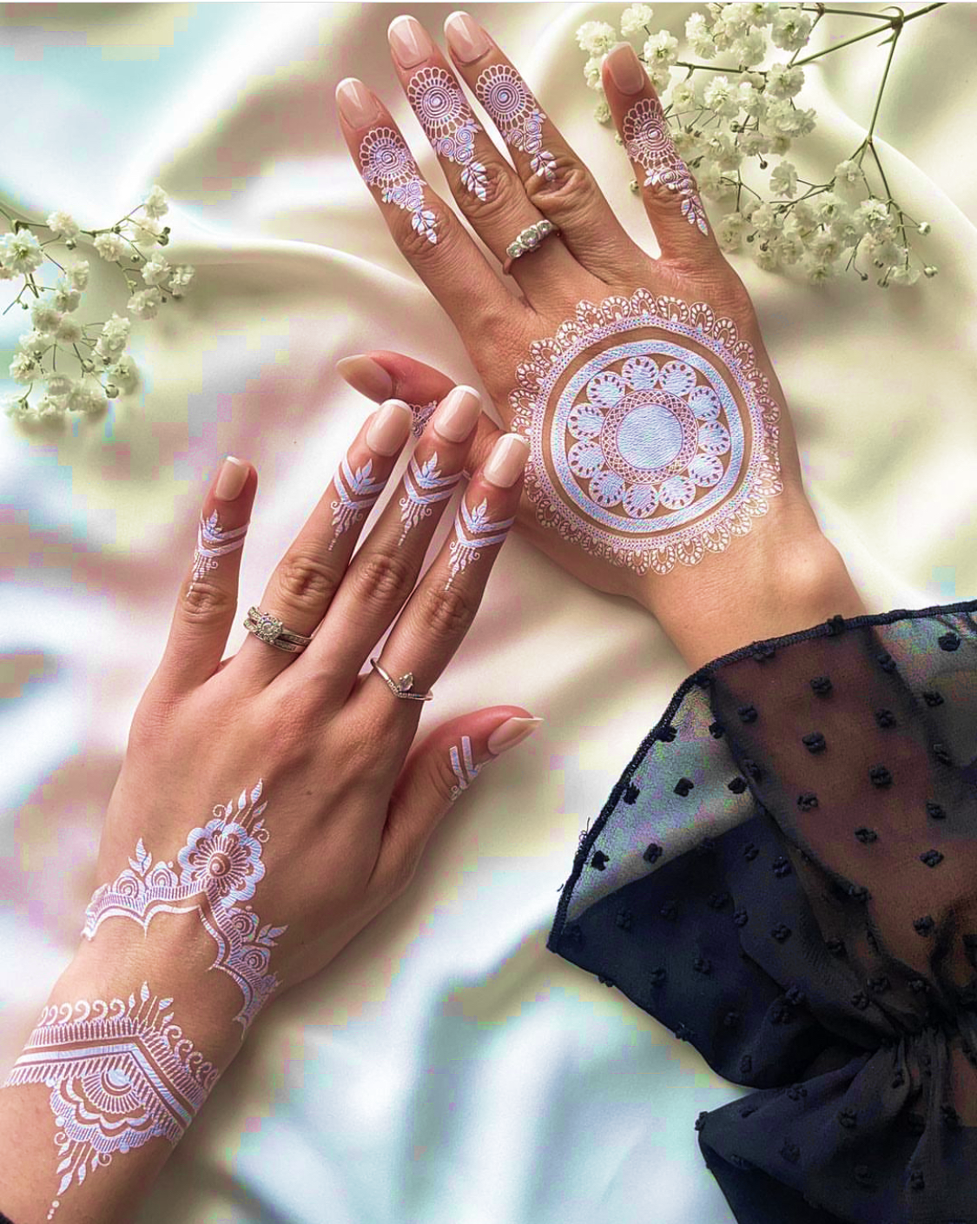Student Name: Leila Kanfoudi
Student ID: 1914911
Lecturer: Rexon Nting BMSW6102


Contents
Introduction: 3
1. Innovative Product/Service Proposition 3
2. eCommerce Website Proposal 5
3. Marketing Strategy 6
4. Privacy and Data Protection 8
Conclusion: 10
References 11
Appendix A ………………………………………………………………………………………………………………………………………..13

Introduction:
In a dynamically evolving business landscape, the integration of innovative ideas, coupled with robust strategies, is imperative for a successful venture. "Arabian Essence Henna: Crafted Traditions" envisions offering customizable and authentic Arabian Henna designs through an online platform, catering to individuals seeking personalized body art for significant occasions. This project plan delves into crucial aspects such as the product/service proposition, eCommerce website proposal, marketing strategy, and privacy/data protection measures, meticulously designed to establish a unique and culturally immersive experience for customers. By exploring the intricate details of each section, this business proposition aims to align with regulatory compliance, customer engagement, and sustainable business practices, setting the stage for a successful and ethical entrepreneurial endeavor.

1. Innovative Product/Service Proposition
Arabian Henna Service Details:
"Arabian Essence Henna: Crafted Traditions" aims to introduce a unique and culturally immersive experience through offering customizable and authentic Arabian Henna designs. This service caters to individuals seeking personalized body art for various occasions such as weddings, festivals, and personal celebrations. The venture's primary sales strategy revolves around establishing an accessible and user-friendly online platform that enables customers to explore, customize, and order distinctive henna designs tailored to their preferences.
Target Customers:
The identified target customers for "Arabian Essence Henna: Crafted Traditions" embody individuals who possess a fervor for cultural experiences and value personalized body artistry to enhance and commemorate special events. This demographic exhibits a keen appreciation for traditional practices and cultural nuances, expressing a deep-seated interest in embracing diverse cultural experiences.
These individuals actively seek henna as an art form, recognizing it as a symbolic expression of artistry, heritage, and individuality. For them, henna transcends mere body adornment; it represents a form of self-expression during significant occasions such as weddings, festivals, and personal celebrations.
Characterized by their cultural awareness and inclination towards embracing age-old traditions, this customer segment views henna as an embodiment of cultural richness and symbolism. They aspire to adorn themselves with authentic and meaningful henna designs that reflect their uniqueness and align with the essence of the occasion they're commemorating.
The target customers prioritize authenticity and craftsmanship, seeking designs that speak to their individuality and resonate with the cultural significance of the art form (Fortier, 2018). "Arabian Essence Henna: Crafted Traditions" aims to cater to this astute audience by offering a diverse array of authentic Arabian Henna designs, providing a platform where customers can hold and personalize their cultural experiences through artful henna designs that accompaniment and elevate their special moments.
Sales Strategy:
The primary emphasis of the sales strategy for "Arabian Essence Henna: Crafted Traditions" centers on establishing a user-centric and immersive online podium. This podium will serve as a gateway for customers to explore an extensive assortment of authentic Arabian Henna designs. Empowering customers with the ability to initial their selections based on individual preferences such as intricacy, size, and color, is pivotal. This customization feature confirms a tailored and unique experience, resonating with the customer's visualization for their body art. The platform's intuitive design streamlines the ordering process, facilitating an effortless journey for customers to browse, customize, and seamlessly purchase their chosen designs. By prioritizing user engagement and personalization, the sales strategy aims to deliver an enjoyable and personalized shopping experience, reinforcing "Arabian Essence Henna: Crafted Traditions" as the go-to destination for authentic and customized henna designs.
Sustainability Plan:
"Arabian Essence Henna: Crafted Traditions" is dedicated to sustainability by emphasizing the utilization of organic and ethically sourced henna products. This conscientious approach resonates with the increasing consumer preference for environmentally friendly and socially responsible goods. Furthermore, the venture places great emphasis on maintaining an ongoing dialogue with customers. This continuous feedback loop will serve as the cornerstone for refining and enhancing designs, aligning them more closely with customer preferences and dynamic market trends. By nurturing this iterative process, the business aims not only to innovate but also to remain pertinent in an ever-evolving market landscape. Through these efforts, "Arabian Essence Henna: Crafted Traditions" is committed to not only meeting but also exceeding the expectations of customers while maintaining its dedication to sustainable and socially responsible practices.
Competitor Analysis:
Competitors in this space primarily focus on offering henna services, yet differentiation lies in our personalized services, commitment to authenticity, and emphasis on online accessibility. By conducting a thorough analysis of competitors, we aim to understand their strengths and weaknesses (Radev, 2022). This allows us to capitalize on their shortcomings, offering a superior experience through personalized design options, cultural authenticity, and an intuitive online platform that simplifies the customer journey.
In summary, "Arabian Essence Henna: Crafted Traditions" seeks to provide a distinctive and culturally rich henna experience for customers who value authenticity and seek personalized body art for their special occasions. Through our maintainable practices, continuous improvement based on customer feedback, and differentiation from contestants, we aim to establish ourselves as a premier destination for reliable Arabian Henna designs in the online marketplace (Naumov, 2019).

2. eCommerce Website Proposal
The selection of an appropriate eCommerce platform is essential for the success of "Arabian Essence Henna: Crafted Traditions." Shopify arises as the ideal choice due to its user-friendly interface, customizable templates, and robust features custom-made for online retail businesses (Patwa, Dhoot and Sundaram, 2013).
Platform Choice: Shopify
Shopify stands out as an exceptional platform, recognized for its intuitive design and user-friendly interface. Its vast array of customizable templates permits us to create a visually appealing and immersive online experience. The platform's scalability bring into line with our business growth plans, ensuring seamless expansion as our customer base upsurges.
Features:
- Personalized Design Options: The addition of personalized design options within the platform will empower customers to modify henna designs according to their preferences (Tawfiq, 2019). This feature will include various customization parameters, such as pattern intricacy, size, and color, providing a truly unique and personalized experience.
- User-Friendly Interface: A paramount focus will be on creating an intuitive interface for customers, facilitating easy navigation through the website. This ensures that customers can effortlessly browse, select, and customize their desired henna designs.
Payment Services:
The platform will incorporate secure payment gateways such as PayPal or Stripe, ensuring the security of online transactions. This instills trust and confidence among customers, assuring them of a safe and reliable payment process.
Content Creation:
Engaging and culturally immersive content will play a crucial role in captivating the audience and creating a memorable user experience. High-quality imagery showcasing intricate henna designs, detailed product descriptions explaining the cultural significance of each design, and culturally engaging content will be curated to enrich the customer journey. This content will not only showcase the products but also convey the cultural heritage associated with Arabian Henna, resonating with the target audience's interests.
In essence, the selection of Shopify as our eCommerce platform aligns with our goal of providing a seamless and engaging online shopping experience for customers interested in authentic Arabian Henna designs. The integration of personalized design options, secure payment gateways, and culturally immersive content ensures that our platform stands out in delivering a unique and enriching experience to our valued customers.

3. Marketing Strategy
Crafting an effective marketing strategy is imperative to drive awareness, engagement, and sales for "Arabian Essence Henna: Crafted Traditions." Leveraging various channels and methodologies, the marketing approach aims to resonate with the target audience seeking personalized cultural experiences through authentic Arabian Henna designs.
Targeted Marketing:
Social Media Engagement:
Utilizing platforms such as Instagram, Pinterest, and Facebook will be fundamental in fostering visual engagement and targeted advertising (Elnaili, 2014). These platforms allow us to showcase high-quality imagery of intricate henna designs, engaging users through visual storytelling. Regular posts featuring diverse henna designs, behind-the-scenes glimpses of the creation process, and user-generated content will help build a vibrant community around Arabian Essence Henna. Engaging with followers through comments, likes, and direct messaging will cultivate relationships and encourage user-generated content sharing, amplifying our reach organically (Contardo et al, 2012).
Paid Search Engine Campaigns:
Implementing Google Ads will enable targeted keyword campaigns, enhancing visibility and driving traffic to our website. Strategically placing ads optimized for relevant keywords related to Arabian Henna designs, cultural body art, and event-specific henna will ensure our offerings reach potential customers actively seeking such products. Utilizing data analytics to refine and optimize these campaigns regularly will maximize their effectiveness and return on investment.
Customer Journey Enhancement:
Designing personalized experiences throughout the customer journey is crucial. From the initial website visit to post-purchase interactions, each touchpoint should resonate with the customer. Implementing tools for personalization, such as recommending similar designs based on their selections, providing a seamless browsing experience, and personalized product suggestions, will enhance user engagement and foster brand loyalty (Amir and Abdukic, 2021).
Email Marketing Campaigns:
Implementing email marketing campaigns tailored to customer preferences will be pivotal in nurturing customer relationships. Newsletters featuring new designs, cultural insights, and exclusive offers will keep customers engaged and informed. Personalized offers based on previous purchases or browsing history will enhance relevance and encourage repeat purchases. However, it is essential to obtain proper consent and offer easy opt-out options to comply with data protection regulations.
The integrated marketing strategy, encompassing social media engagement, paid search engine campaigns, customer journey enhancement, and targeted email marketing, aims to create a cohesive and immersive experience for our target audience. By strategically utilizing these channels, Arabian Essence Henna will not only drive visibility and engagement but also establish itself as a premier destination for authentic and personalized Arabian Henna designs, thereby fulfilling the aspirations of individuals seeking cultural experiences and personalized body art for their special occasions.

4. Privacy and Data Protection
Ensuring privacy and data protection is paramount for "Arabian Essence Henna: Crafted Traditions" to build trust with customers and comply with stringent regulations. The focus will be on adhering to the General Data Protection Regulation (GDPR)/Data Protection Act 2018 and Privacy and Electronic Communication Regulations (PECR) guidelines, coupled with robust security measures to safeguard customer data.
1. Regulatory Adherence:
Adhering to stringent data protection regulations is fundamental for "Arabian Essence Henna: Crafted Traditions" to ensure the confidentiality and integrity of customer information. Compliance with the General Data Protection Regulation (GDPR) and the Data Protection Act 2018 (DPA 2018) is a pivotal aspect of the venture's commitment to data privacy and security (Eve and Nomi, 2014).
GDPR/Data Protection Act 2018:
Compliance with GDPR and DPA 2018 necessitates careful handling of personal data. The venture will ensure that data processing is conducted lawfully, clearly, and only for legitimate drives. This includes limiting the collection of data to necessary information, obtaining explicit consent from individuals for data usage, and respecting individuals' rights to control their data. Arabian Essence Henna will prioritize transparency by providing comprehensive details on data usage, storage, processing, and the purpose behind data collection through a prominently displayed and easily accessible privacy policy on the website. By empowering individuals with control over their personal information, the venture aims to foster trust and demonstrate a commitment to ethical data handling practices (Arhab et al, 2022).
Privacy and Electronic Communication Regulations (PECR):
Compliance with PECR guidelines is essential, especially concerning electronic communications and direct marketing activities. Arabian Essence Henna acknowledges the importance of respecting individuals' privacy in electronic communications. To align with PECR regulations, the venture will meticulously ensure that email marketing campaigns strictly adhere to these guidelines. This includes obtaining explicit consent from recipients before sending marketing communications, ensuring clarity regarding the nature of communications, and providing an easily accessible option for recipients to opt out of receiving marketing messages. Upholding these regulations not only demonstrates respect for individuals' privacy preferences but also ensures lawful and ethical engagement in marketing practices (Granström et al, 2023).
In summary, Arabian Essence Henna is committed to upholding the principles outlined in GDPR/Data Protection Act 2018 and Privacy and Electronic Communication Regulations (PECR) to safeguard customer data, promote transparency, and conduct ethical and lawful marketing communications. These measures underscore the venture's dedication to respecting individual privacy rights while maintaining the highest standards of data protection.
2. Security Measures:
Ensuring robust security measures is imperative for "Arabian Essence Henna: Crafted Traditions" to protect customer data and maintain a secure online platform. The implementation of various security protocols aligns with the venture's commitment to safeguarding sensitive information and adhering to data privacy regulations.
Encryption for Data Protection:
Implementing encryption mechanisms stands as a fundamental pillar in safeguarding customer data. Encryption methods, both for data in transit and at rest, ensure that sensitive information remains encrypted and indecipherable to unauthorized entities. Utilizing Secure Sockets Layer (SSL) encryption for website transactions encrypts data during online interactions, assuring secure communication between users and the website. Moreover, employing encryption protocols for storing customer data fortifies data security, reducing the risk of data breaches or unauthorized access to stored information (Amin et al, 2020).
Secure Access Protocols:
Arabian Essence Henna is committed to implementing stringent access control measures to prevent unauthorized access to customer data. Multi-factor authentication will be enforced, requiring multiple verification steps for access, ensuring an additional layer of security beyond passwords. Access rights will be strictly restricted, granting access only to authorized personnel based on job roles and responsibilities. Continuous monitoring of access logs will be conducted to track user activities and ensure that only authorized individuals have access to sensitive customer information (Riad, 2018).
Regular Updates and Security Audits:
Continuous monitoring, frequent updates, and security audits play a pivotal role in identifying and mitigating emerging threats. Regular updates of security protocols, software patches, and system enhancements are crucial to address vulnerabilities and stay ahead of potential risks. Conducting frequent security audits and assessments helps identify loopholes or weaknesses in the security framework, allowing proactive measures to strengthen data protection.
In conclusion, compliance with GDPR/Data Protection Act 2018 and PECR guidelines is central to Arabian Essence Henna's commitment to data privacy. The implementation of robust security measures, including encryption for data protection, secure access protocols, and regular security updates, underscores the venture's dedication to preserving customer data confidentiality and integrity. Prioritizing data privacy and security builds trust among customers, ensuring their information remains confidential and secure during their interactions with the online platform, thereby establishing Arabian Essence Henna as a reliable and secure destination for authentic Arabian Henna designs.

Conclusion:
In essence, "Arabian Essence Henna: Crafted Traditions" is poised to carve a niche in the market by offering a unique blend of cultural authenticity and personalized experiences. The innovative product proposition of customizable Arabian Henna designs, coupled with a user-friendly eCommerce platform powered by Shopify, reflects a commitment to delivering quality and convenience to customers. The comprehensive marketing strategy, integrating social media engagement, paid search campaigns, personalized customer journeys, and email marketing, is geared towards fostering brand loyalty and engagement within the target audience. Moreover, the stringent adherence to data privacy regulations, such as GDPR/Data Protection Act 2018 and PECR guidelines, coupled with robust security measures, underlines the commitment to safeguarding customer data. "Arabian Essence Henna: Crafted Traditions" aspires to not only meet but exceed customer expectations, providing a seamless, secure, and culturally enriched experience, establishing itself as a premier destination for authentic Arabian Henna designs.

References
Ali, T., Marc, B., Omar, B., Soulaimane, K. and Larbi, S., (2021). Exploring destination's negative e-reputation using aspect-based sentiment analysis approach: Case of Marrakech destination on TripAdvisor. Tourism Management Perspectives, 40, p.100892.
Amin, A., Liu, X.H., Saleem, M.A., Henna, S., Islam, T.U., Khan, I., Uthansakul, P., Qurashi, M.Z., Mirjavadi, S.S. and Forsat, M., (2020). Collaborative wireless power transfer in wireless rechargeable sensor networks. Wireless Communications and Mobile Computing, 2020.
Amir, H. and Abdukic, A., (2021). The Spiritual Nature Based on Ethics in The Halal Entrepreneurial Industry. Turkish Online Journal of Qualitative Inquiry, 12(10).
Anderson, A.R., Younis, S., Hashim, H. and Air, C., (2019). Social enterprising informing our concept; exploring informal micro social enterprise. Social Enterprise Journal, 15(1), pp.94-110.
Arhab, N., Oussalah, M., Kokkonen, H. and Ollakka, A., (2022). Analysis of car parking industry from social community perspective. Social Network Analysis and Mining, 12(1), p.162.
Contardo, I.F., Patwa, N., Dhoot, A. and Sundaram, A., (2012), October. The Effect of Emirati Culture on Western Cosmetics Buying Decision: A Strategic Marketing Analysis. In 5th Annual EuroMed Conference of the EuroMed Academy of Business.
Elnaili, S.M., (2014). Domestication and foreignization strategies in translating Sinbad of the Arabian nights. Louisiana State University and Agricultural & Mechanical College.
Eve, Nomi. Henna house: A novel. Simon and Schuster, (2014).
Fortier, C., (2018). The expenses of love: Seduction, poetry, and jealousy in Mauritania.
Granström, D.E.A.S., Pronk, A.M. and Criscione-Naylor, N., (2023). Robotic Services in the Hotel Industry: An Examination of Henn Na Hotels. International Journal of Gaming, Hospitality and Tourism, 3(1).
Korže, S.Z., (2019). From Industry 4.0 to Tourism 4.0. Innovative issues and approaches in social sciences, 12(3), pp.29-52.
Lantto, R., Järnefelt, V., Tähtinen, M., Jääskeläinen, A.S., Laine-Ylijoki, J., Oasmaa, A., Sundqvist-Andberg, H. and Sözer, N., (2019). Going beyond a circular economy: a vision of a sustainable economy in which material, value and information are integrated and circulate together. Industrial Biotechnology, 15(1), pp.12-19.
Naumov, N., (2019). The impact of robots, artificial intelligence, and service automation on service quality and service experience in hospitality. In Robots, artificial intelligence, and service automation in travel, tourism, and hospitality (pp. 123-133). emerald publishing limited.
Patwa, N., Dhoot, A. and Sundaram, A., (2013). The Effect of Emirati Culture on Western Cosmetics Buying Decision: A Strategic Marketing Analysis. i-Manager's Journal on Management, 8(2), p.14.
Radev, R., (2022). Application of natural dyes in the textile industry. Известия на Съюза на учените-Варна. Серия Икономически науки, 11(3), pp.69-78.
Riad, A., (2019). Finding Room for the Creative Class (Doctoral dissertation, Technische Universität Berlin).
Rubio, L., Guerra, E., Garcia-Jares, C. and Lores, M., (2019). Body-decorating products: Ingredients of permanent and temporary tattoos from analytical and european regulatory perspectives. Analytica Chimica Acta, 1079, pp.59-72.
Tawfiq, W., (2019). The Saudi Arabian bride shopping experience (Doctoral dissertation, Iowa State University).

Appendix A

