

Navigating the Cybersecurity Landscape: Designing a Robust Framework for Information System Security and Compliance – Insights from NatureGarden

Table of Contents

1. Introduction 3
2. Literature Review 5
2.1 Overview of information security framework 5
2.1.1 ITIL (Information Technology Infrastructure Library) 5
2.1.2 ISO 27000 (International Organization for Standardization) 7
2.2 Security Challenges of Personal Devices Connecting to Enterprise Networks 8
2.2.1 Security Challenges and Data Leakage 8
2.2.2 Unauthorized access 9
2.2.3 Malware propagation 9
2.2.4 Security strategies and preventive measures 9
2.2.5 Future trends and development directions 10
3. Security framework design 11
3.1 Introduction to NG Information System 11
3.2 Analysis of existing security frameworks 11
3.3 Design a customized security framework for NG 12
3.3.1 Information security governance 12
3.3.2 Risk management 13
3.3.3 Security policies and procedures 14
3.3.4 Protection mechanism 15
3.3.5 Contingency Plan 16
3.3.6 Service levels 17
3.4 Assumption Scenarios 18
3.5 Conclusion 18
4. Critical analysis 19
4.1 The importance of continuously updating regulations and standards 19
4.2 Addressing compliance challenges 19
4.3 Governance and strategic planning in dynamic environments 20
5. Conclusion 21
5.1 Summary of findings 21
5.2 Contribution to the discipline 21
5.3 Suggestions for future research 22
6. References 22

- Introduction

In today's digital era, enterprises' needs for information system security, governance, and compliance have become increasingly urgent. This article will take NatureGarden (NG) as an example to delve into the great success of this globally renowned brand in the field of products that maintain healthy life, as well as the challenges it faces against the backdrop of growing demand for network usage.

As a global brand that sells products to maintain healthy living, NG's success lies not only in the high quality of the products themselves, but also in its widespread presence around the world. The company provides IT services to employees and customers through cloud services, and about 95% of the company's network is based on wireless technology. This digital operating model makes the company not only effective in product sales, but also has a huge influence online and on social media, promoting sustainable business growth.

However, as the company has grown in size and its international customer base has grown, NG has recently come under intense pressure to allow employees and customers to access the company's network and resources using personal devices. This increase in demand not only brings convenience, but also raises critical security issues. The company is very concerned about the security of employee and customer personal data and customer data, especially considering that the company's core products in the health field involve a large amount of sensitive information. In addition, companies own intellectual property worth billions that need protection from potential threats.

Although information security occupies an important position among the company's priorities, the company's information security system is currently in disarray due to a lack of clear policies. The company recognizes that it is imperative to establish a comprehensive information security framework that balances the convenience of network access with the non-negotiable nature of data security. Therefore, this paper aims to propose an innovative information system security framework through a comprehensive analysis of existing literature and security models to meet the unique challenges faced by NG companies in the digital era. By in-depth studying various challenges and proposing corresponding solutions, we will help NG Company achieve a leading position in the field of information security and ensure that it maintains excellent performance in global competition.

- Literature Review

2.1 Overview of information security framework

In the current era of rapid development of information technology, in order to maintain the security of an organization's information system, different information security frameworks and models have emerged. Among them, the Information Technology Infrastructure Library (ITIL) and the International Organization for Standardization (ISO)'s information security management system (ISO 27000 series) are two examples that have attracted much attention.

2.1.1 ITIL (Information Technology Infrastructure Library)

ITIL is a framework that provides best practices for service management and is committed to assisting organizations in providing high-quality IT services. Figure 1 shows the main components of the ITIL framework and their interrelationships.

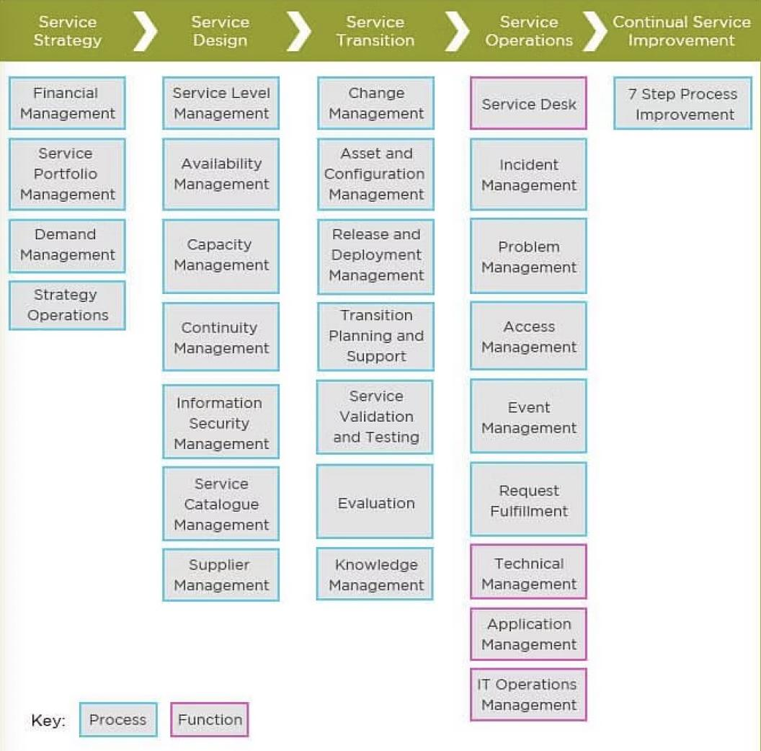

ITIL emphasizes the full life cycle of services, including service strategy, service design, service transition, service operation and continuous service improvement. In terms of information security, ITIL provides guidance on service strategy and service design, helping organizations establish information security governance structures, effectively manage risks, ensure service availability, and respond to threats to the integrity of information systems in a timely manner. ITIL describes processes, procedures, tasks, and checklists which are neither organization-specific nor technology-specific. It was designed to allow organizations to establish a baseline.
It is used to demonstrate compliance and to measure improvements. There is no formal independent third-party compliance assessment available to demonstrate ITIL compliance in an organization.

2.1.2 ISO 27000 (International Organization for Standardization)

The series provides best practice recommendations on information security management—the management of information risks through information security controls—within the context of an overall Information security management system(ISMS), similar in design to management systems for quality assurance (the ISO 9000 series), environmental protection (the ISO 14000 series) and other management systems. Figure 2 illustrates the main elements and associated processes of the ISO 27001 standard.
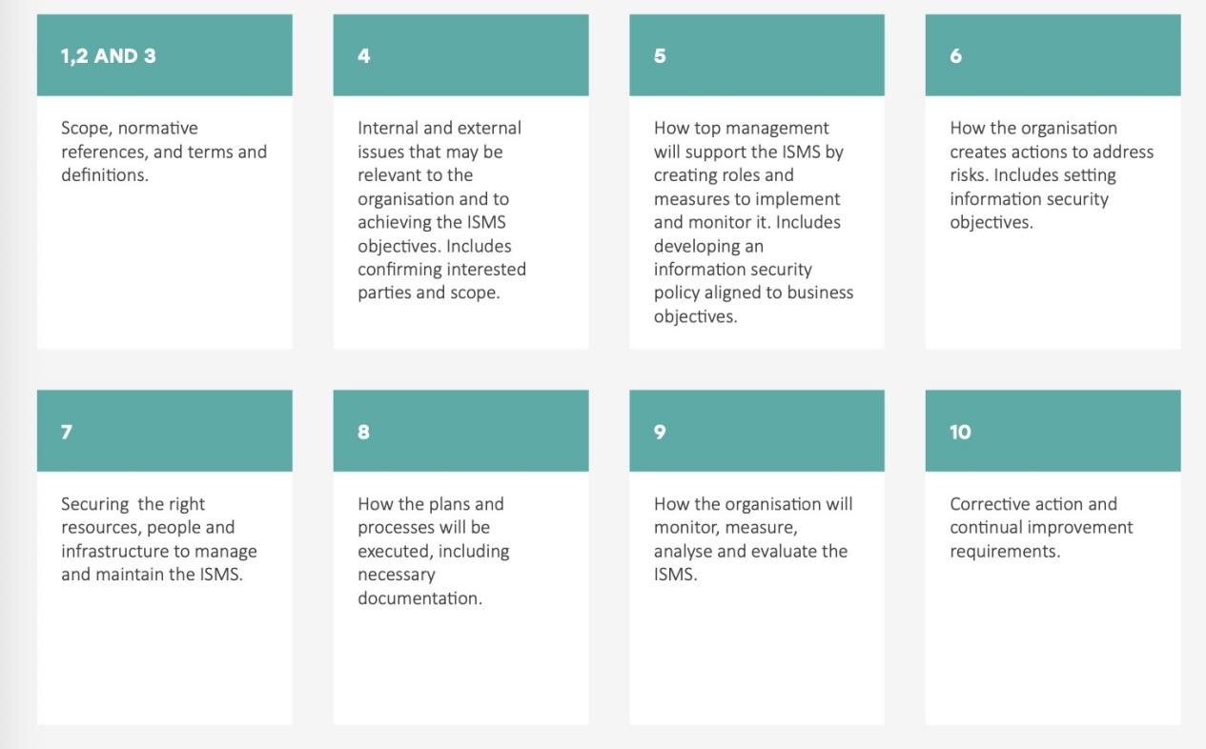

The series is deliberately broad in scope, covering more than just privacy, confidentiality and IT/technical/cybersecurity issues. It is applicable to organizations of all shapes and sizes. All organizations are encouraged to assess their information risks, then treat them (typically using information security controls) according to their needs, using the guidance and suggestions where relevant. Given the dynamic nature of information risk and security, the ISMS concept incorporates continuous feedback and improvement activities to respond to changes in the threats, vulnerabilities or impacts of incidents.

2.2 Security Challenges of Personal Devices Connecting to Enterprise Networks

As the business scope of enterprises expands, the needs of employees and customers on enterprise networks become more diverse. Against this backdrop, allowing personal devices to connect to corporate networks is becoming an increasingly common requirement to improve work flexibility and customer service experience. However, this trend also comes with a series of security challenges involving information leakage, unauthorized access and the spread of malware.

2.2.1 Security Challenges and Data Leakage

One of the most significant challenges in allowing personal devices to connect to corporate networks is the risk of information leakage. Research by Tabrizchi and some other scholars point out that data security issues in cloud computing environments remain a key challenge[1]. Relevant research also includes Song’s Practical techniques for searches on encrypted data[3]. Sensitive information within corporate networks can be compromised by access to personal devices, especially in the absence of hardened security policies and controls.

2.2.2 Unauthorized access

Personal devices connected to corporate networks bring the risk of unauthorized access. Without proper authentication and access control mechanisms in place, malicious users can exploit weaknesses to gain entry into enterprise systems. This situation is critical to maintaining the confidentiality of customer data and corporate confidential information. In this regard, Subashini discussed security issues in cloud computing environments in detail in their research [6].

2.2.3 Malware propagation

Another significant concern is that allowing personal devices to access corporate networks can lead to the spread of malware. The study by Song emphasizes practical techniques in encrypted data search, but also mentions new security threats introduced due to device access[5]. This threat can spread to corporate networks via unsecured personal devices, compromising the security of the entire system.

2.2.4 Security strategies and preventive measures

In order to solve these security challenges, enterprises need to formulate strict security policies and take corresponding preventive measures. Research by Zhang shows that in the e-Health system, the risk of data leakage can be effectively reduced through secure and privacy-protecting data sharing methods [7]. In addition, Jain emphasized the technical perspective and review of big data privacy protection [4], which is instructive for enterprises to ensure data privacy when allowing personal devices to access the network.

2.2.5 Future trends and development directions

In the future, as technology develops and threats evolve, enterprises will need to continuously innovate and adjust their security strategies. The review by Kreso studies the latest methods and future development directions of privacy-preserving data mining[2]. This continuously updated research is critical for enterprises to adapt to the changing security environment to ensure that their network systems can cope with evolving threats.

In this rapidly changing digital era, enterprises must adopt comprehensive security measures, including establishing strong authentication mechanisms, strengthening access control, implementing terminal security control measures, etc., to maintain the integrity and confidentiality of their information systems. These measures not only help address current security challenges but also lay the foundation for future security developments.

3. Security framework design

3.1 Introduction to NG Information System

Before designing a customized security framework, a brief introduction to NatureGarden (NG)'s information system is first needed. NG is a world-renowned healthy lifestyle product brand, and its products are widely used around the world. The company has a large employee and international customer base, and cloud services are used in the network system to provide IT services to employees and customers. Nearly 95% of corporate networks are based on wireless technology. Additionally, the company has a huge presence online and on social media platforms for promoting its events. Given their size and international nature, companies are under tremendous pressure to allow employees and customers to access corporate networks/resources using personal devices. In this context, information security issues become a major concern for companies, particularly the security of personal employee data and customer data, as well as the protection of intellectual property worth billions.

3.2 Analysis of existing security frameworks

Before designing a customized security framework, we first conducted an analysis of existing security frameworks. This includes comprehensive consideration of international standards such as the Information Technology Infrastructure Library (ITIL) and the ISO 27000 series. The ITIL framework covers the full life cycle of services, including service strategy, service design, service transition, service operation and continuous service improvement. However, for a large-scale company like NG that involves the access of a large number of personal devices, the ITIL framework may need to be further customized to meet its special needs.

We also analyzed the ISO 27000 series. ISO 27001 emphasizes the establishment of an information security management system and ensures that information assets are properly protected through detailed requirements and frameworks. However, for enterprises like NG that involve the access of a large number of personal devices, further attention needs to be paid to the special risks of personal devices.

3.3 Design a customized security framework for NG

3.3.1 Information security governance
To meet NG's special needs, we designed a customized security framework that focused first on information security governance. Information security governance spans the entire organization and ensures that information security policies are aligned with business objectives. Figure 5 shows NG’s information security governance framework.

Information security governance framework:

1. Leadership responsibility: Emphasize that information security is the responsibility of the leadership and ensure that information security is included in the company's strategic planning.
2. Align business and information security: Ensure that information security policies are consistent with business goals, and fully consider the new challenges brought about by personal device access.

3.3.2 Risk management
In NG's security framework, risk management is viewed as a continuous process. We have introduced a risk assessment and risk treatment phase to address the potential risks associated with allowing access to personal devices. Table 1 shows the key steps and related measures of risk management.

Table 1: Key steps and measures for NG risk management

Step | Description
Risk Assessment | Identify potential risks associated with personal device access
Risk Identification | Analyze, quantify and prioritize identified risks
Risk handling | Take appropriate measures to mitigate or eliminate risks and ensure information security
Continuous monitoring and improvement | Regularly monitor risk status and continuously improve risk management measures

3.3.3 Security policies and procedures
To ensure consistency and enforceability, we have designed detailed security policies and procedures for NG.

NG Security Policy and Procedure Elements:

1. Access control policy: Clearly define access rights for employees and customers, paying special attention to personal device access.
2. Data confidentiality policy: Ensure that sensitive data is properly protected and standardize data processing procedures.
3. Device access policy: Regulate the use of personal devices by employees and customers to ensure security.

3.3.4 Protection mechanism
The protection mechanism is the core of the NG security framework. We have introduced advanced authentication technology, encrypted communication, network firewall and other protection mechanisms to ensure the security of information when personal devices are accessed.

NG protection mechanism framework:

1. Authentication technology: Multi-level authentication ensures that only authorized personnel can access the system.
2. Encrypted communication: Protect the confidentiality of data transmission and prevent sensitive information from being stolen.
3. Network firewall: Monitor and block potential threats to ensure network security.

In this framework, personal devices are required to pass multiple layers of authentication and protect transmitted data through encrypted communications, while leveraging network firewalls to monitor and block potential threats.

3.3.5 Contingency Plan
In order to deal with potential security incidents, we have designed a comprehensive emergency plan for NG. Table 2 lists the key components of an emergency plan.

Table 2: Key components of NG emergency plan
Component | Description
Incident identification and notification | Quickly identify potential security incidents and promptly notify relevant personnel
Incident Assessment and Response | Analyze the severity of the incident and quickly take appropriate response measures
Recovery | Restore affected systems and services as quickly as possible to ensure business continuity
Post-mortem analysis and improvement | Conduct a thorough analysis of the incident and improve emergency plans and security strategies

3.3.6 Service levels
In order to ensure service quality, we have developed a clear service level agreement (SLA) for NG.

NG Service Level Framework:

1. Network availability: Specify network availability standards to ensure that employees and customers can access the system at any time.
2. Data transmission speed: Set the standard for data transmission speed to provide an efficient service experience.
3. Security: Ensure data security during the service process and prevent potential security threats.

3.4 Assumption Scenarios
In implementing the security framework, we designed it based on some what-if scenarios. These assumptions are:
Employee training: We assume that NG employees can accept and understand the new security policies and procedures, and have a supportive attitude towards the implementation of the security framework.
Resource Availability: We assume that the required human, technical and financial resources will be sufficient and available during implementation.
Technical compatibility: We assume that the existing technical foundation of NG is compatible with the new security framework and does not require too many technical changes.
Regulatory compliance: We assume that NG’s security framework can meet relevant regulations and compliance requirements, such as GDPR, HIPAA, etc.

3.5 Conclusion

By introducing NG's information system and analyzing it based on the existing security framework, we designed a customized security framework to meet the company's special needs of allowing access to personal devices. The framework covers key areas such as information security governance, risk management, security policies and procedures, protection mechanisms, contingency plans and service levels. This customized security framework is designed to ensure that NG's information systems maintain a high degree of security and reliability when accessed by personal devices.

4. Critical analysis

4.1 The importance of continuously updating regulations and standards

In today's information age, businesses face increasingly complex and evolving cyber threats. In order to ensure the security of information systems, it is crucial to continuously update regulations and standards. As technology evolves, new threats and vulnerabilities emerge, so regulations and standards must keep up. For example, as personal devices increasingly connect to corporate networks, new regulations and standards are emerging to address this trend. Not only do data privacy regulations need to be considered, there are also regulations around device security that need to be looked at. Therefore, regularly reviewing and updating the company's security policy to comply with the latest regulations and standards is a key part of ensuring the security of information systems.

4.2 Addressing compliance challenges

Businesses operate globally and need to comply with regulations and standards in different countries and regions. Compliance challenges arise primarily from differences and constant changes in regulations. For example, Europe's GDPR (General Data Protection Regulation) and the US's HIPAA (Health Insurance Portability and Accountability Act) both have strict requirements on data privacy, while the Asia-Pacific region may have different regulations. Therefore, companies need to develop a comprehensive compliance strategy to ensure compliance with regulatory requirements in various regions. In addition, it is also crucial to keep abreast of new regulatory trends and adjust corresponding compliance measures.

4.3 Governance and strategic planning in dynamic environments

Information security governance and strategic planning should be dynamic and adaptable to the changing threat and regulatory environment. Governance structures should be flexible and able to adjust to emerging threats. Strategic planning needs to consider the future development direction of the company's business to formulate corresponding information security strategies. In the process of governance and planning, attention should be paid to close integration with business strategies to ensure that information security measures are not just an independent technical task, but a part that helps achieve the company's overall goals.

- Conclusion

5.1 Summary of findings

Through the study of the NatureGarden (NG) case and the design of the security framework, we have drawn a series of important conclusions. First, continually updating regulations and standards is critical to maintaining information system security. Enterprises need to pay close attention to emerging threats and regulatory changes, and promptly adjust security strategies to adapt to the new environment. Secondly, compliance challenges require a global perspective, and companies need to develop comprehensive compliance strategies to meet regulatory requirements in different regions. Finally, information security governance and strategic planning should be flexible and dynamic, able to adapt to changing business and threat environments.

5.2 Contribution to the discipline

This study makes multiple contributions to the information security discipline. First, through in-depth research on the NG case, we provide practical guidance for enterprises to design a security framework in the context of allowing access to personal devices. Secondly, the importance of continuously updating regulations and standards is analyzed in depth, emphasizing that the information security discipline needs to pay attention to the dynamic changes in the regulatory environment. Finally, the discussion of governance and strategic planning provides a more comprehensive and dynamic perspective for the information security discipline, helping to promote the development of the discipline.

5.3 Suggestions for future research

In order to further promote the development of the information security discipline, future research can be carried out from the following aspects. First, the compliance requirements in different regions can be studied in depth to provide enterprises with more specific compliance strategies. Secondly, you can pay attention to emerging threats and technology trends and explore new security framework designs. Finally, case studies and empirical research can be used to verify the effectiveness of existing theories in practice and provide more reliable theoretical support for the discipline.

- References
1.Tabrizchi, Hamed, and Marjan Kuchaki Rafsanjani. "A survey on security challenges in cloud computing: issues, threats, and solutions." The journal of supercomputing 76.12 (2020): 9493-9532.

2.Kreso, I., Kapo, A. and Turulja, L., 2021. Data mining privacy preserving: Research agenda. Wiley Interdisciplinary Reviews: Data Mining and Knowledge Discovery, 11(1), p.e1392.

3. Song, D.X., Wagner, D. and Perrig, A., 2000, May. Practical techniques for searches on encrypted data. In Proceeding 2000 IEEE symposium on security and privacy. S&P 2000 (pp. 44-55). IEEE.

4 Jain, P., Gyanchandani, M. and Khare, N., 2016. Big data privacy: a technological perspective and review. Journal of Big Data, 3, pp.1-25.

5. Zhang, A. and Lin, X., 2018. Towards secure and privacy-preserving data sharing in e-health systems via consortium blockchain. Journal of medical systems, 42(8), p.140.

6. AlZain, Mohammed A., Ben Soh, and Eric Pardede. "A Survey on Data Security Issues in Cloud Computing: From Single to Multi-Clouds." J. Softw. 8.5 (2013): 1068-1078.

7. Zhang, Y., Xiang, Y., Zhang, L.Y., Rong, Y. and Guo, S., 2018. Secure wireless communications based on compressive sensing: A survey. IEEE Communications Surveys & Tutorials, 21(2), pp.1093-1111.

