Pizza for U
In this topic I will cover and upload the information about all 3 types of diagrams and a slightly improved on “The Pizza For U Catering Services Harrow” .
This is the first of my diagrams – Data Flow Diagram, explaining the way of processing and improvement on to the store the records from all transactions.
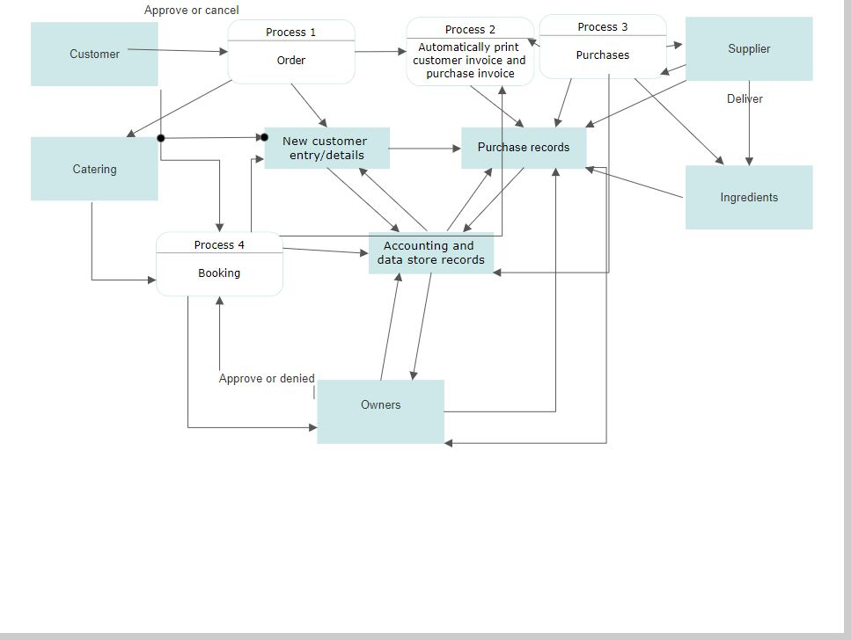
I have tried to do it simple as it can be explained. The diagram above allows better obtain and maintain the listing information on the task.
Next diagram I chose to use Chen notation. This is an ERD or Entity Relationship Diagram. Trying to make a better benefit of the information as It follows, this diagram will be more detailed.
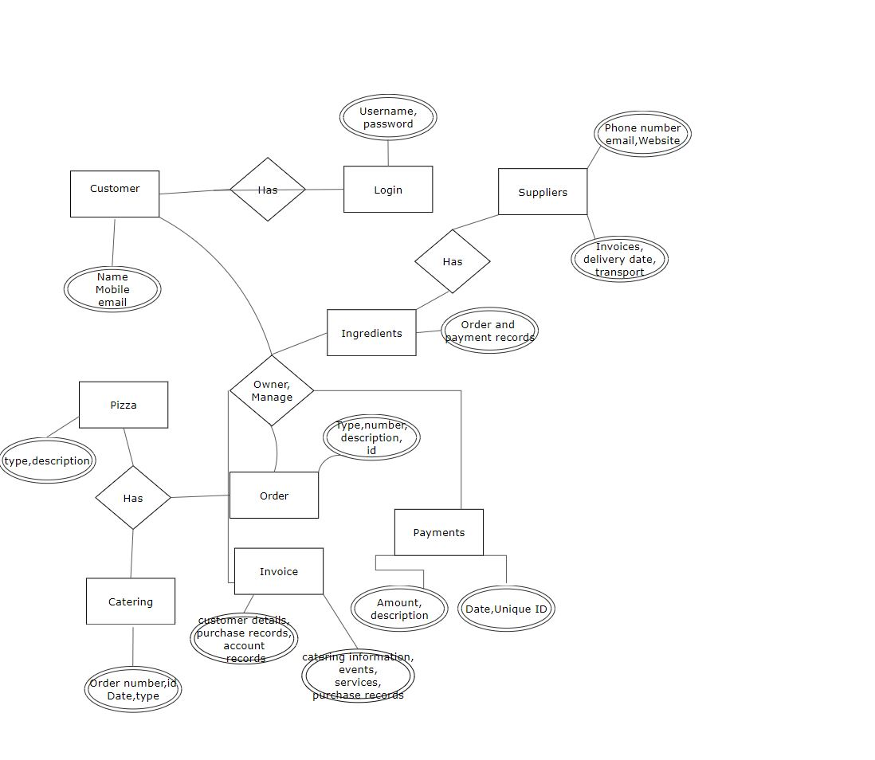
For my third Use Case Diagram I modified the Use cases and Character as a main Boundary.
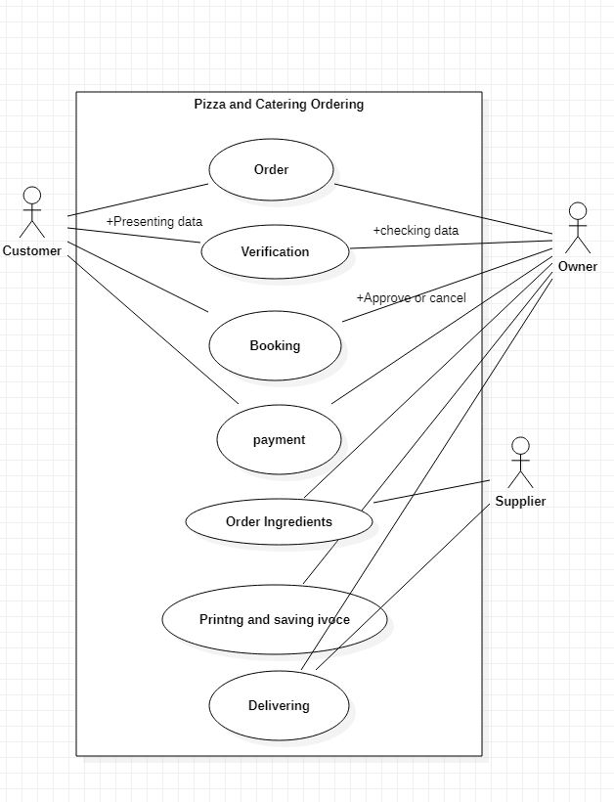
For the last part of the task will be represent a better invoicing system.
The Pizza For U Catering Services Harrow
Tel:
Order Number: …………. Invoice No:
Order Details: ………………………… Request on / / at :
Order Information:……………………………………………………………………………………………
…………………………………………………………………………………………….
……………………………………………………………………………………………
Payment- received/declined: ……………….
Customer Details:
Name tell:
Address
Additional information
New or existing customer/customer orders (made before)

