Qualification: CIPD Diploma in Applied Human Resources

Module Name: Understanding the Business Context of Human Resources

Activity One and Two

Word Count: 1906 + 548
Student Name: Jacqueline Towell
Student Number: 1808171
CIPD Membership Number: 23203590

By signing below, I confirm that the work/evidence presented is my own, unaided work. I understand the regulations pertaining to candidate malpractice and the action that may be taken as a result.

Signed: 
Date: 20/03/2019

Activity One (1906)
Understanding the Business Context of Human Resources
The application of Human Resources from a legal perspective can very little between private, public and third sector organisations, however, from a regulatory and operational perspective there may be many differences, those differences can affect the HR Function, the role it plays and how the HR Strategy supports the business purpose and strategy.
By comparing a private SME company and Public Sector Organisations we see distinct differences in the business purpose and strategies.
Small and medium-sized privately owned companies operate to make a profit for their shareholders, Taylor & Wilkinson, (2016), usually, a person or persons in a business consortium, partnership or family, a board of directors (often owners) would set and agree on the business strategy and performance targets. Trading to provide a service or product (or both) to its customers, making a profit to pay shareholder dividends, develop the business and further invest in the product and services they offer with a view to increasing turnover and profit of the business. Investment funds are provided by the owners and shareholders and sometimes via business finance/loans with the responsibility for sourcing that sitting with the board, owners and shareholders, however, by having limited company status, those individuals and the company have a separate legal status should either become bankrupt or insolvent, (Taylor & Wilkinson, 2016).
In contrast, Public Sector Services exist to serve the public, for example, the health service and local government services such as healthcare, housing, schools and colleges. These services are funded by public money and are managed by elected officials, within central and local government, (Taylor & Wilkinson, 2016). As a result, these organisations are subject to an increased level of bureaucracy, public and government scrutiny with strategy and targets set by the government. Reward is a prime example, pay structure is set by the Treasury and cannot be adjusted at a local level, in turn, this may affect employee engagement, creating challenges for HR, (Roper, 2017).
Public sector organisations are defined as (Taylor & Wilkinson, 2016);
- Central Government Departments
- Local and Regional Government Organisations
- Public Service Providers
- Quango’s (quasi-autonomous non-governmental organisations)
- Publicly Owned Organisations
Business type, purpose and strategy affect how the HR service is delivered both in terms of how and what is offered. In the private SME you may find a single generalist HR Manager or Officer working in collaboration with the management team and developing the people strategy, succession planning, training, development and overall responsibility for the HR Function delivering;
Recruitment Onboarding Wellbeing Policies & Processes Employee Relations
Absence Management Performance Management
But may also seek external support for legal advice, recruitment and payroll. In some organisations, HR may partner line managers with recruitment, disciplinaries, grievances, and performance management.
In smaller privately owned organisations HR responsibilities may be combined with another role resulting in a preference for the informality of HR practices, Edwards & Ram, (2010), there are positives to this; retaining a family atmosphere and flexible working, Taylor & Wilkinson, (2016), but it could lead to poor or lack of performance management and disciplinary processes which in turn may mean inconsistency in some approaches and a feeling of unfairness.
In the Public Sector, we find that Trade Unions and Collective Agreements still have a significant role, resulting in HR Professionals having an additional level of consultation, negotiations and agreements not found in non-unionised organisations. Those HR professionals experienced in working alongside Trade Unions often welcome the framework that it provides, (CIPD, 2016).
HRM in the Public Sector has been affected by austerity for a number of years, central government budget cuts, such as pay freezes and headcount reduction targets result in HR Professionals being constantly required to implement change, (Taylor & Wilkinson, 2016). The challenges of increased sickness absence being higher in the public sector than any other sector, Office for National Statistics, (2018) (demonstrated below*) and staff turnover requires innovative solutions to a decreasing workforce, (Pirie, 2015).
HR Professionals in the public sector are more likely to specialise in a particular area, such as Recruitment, Employee Engagement and Equality and Diversity.
*An example comparing the UK average to public sector organisations of 500+ employees.
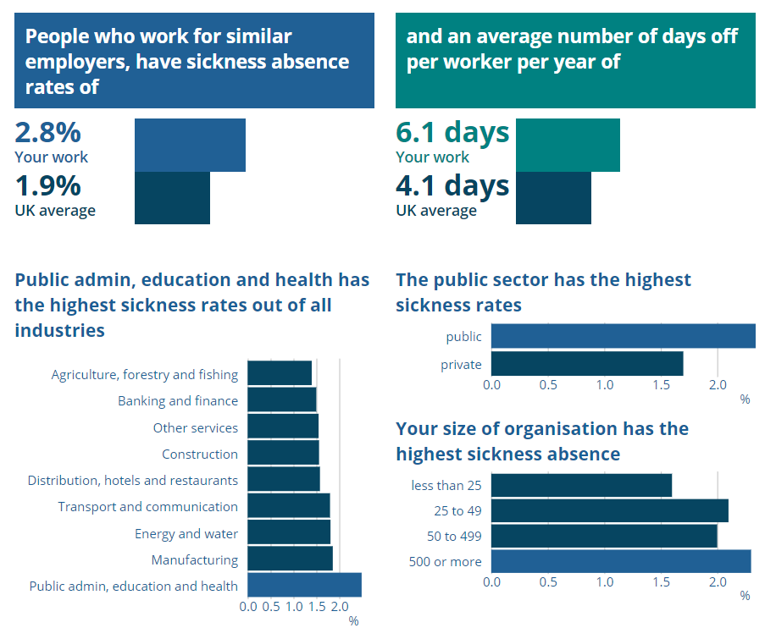
(Kew & Stredwick, 2016), identifies six types of organisational structure;
Bureaucracy Divisionalisation Matrix Networks Virtual Strategic Alliances
Around one-sixth of UK employees work in the public sector, Office for National Statistics, (2018), with most decisions and strategies set by local government, HR Professionals sit outside most decision making processes in a Bureaucratic structure, defined by, Weber, in Kew & Stredwick, (2016) as hierarchy, specialism and an impersonal logical approach to HRM.
HR Professionals are recruited with specialist skills into large HR Departments separated by functions, HR Strategy will likely focus on government initiatives, for example, Cultural Diversity. Policies and procedures are usually quite rigid, they often seem inflexible and requests for change in a hierarchical structure take time to move through the various levels of approval, however, there is some comfort in having sound documented policies and procedures, this offers consistency of approach, fair treatment and transparency as the rules are applied across the board, (Kew & Stredwick, 2016).
Within the SME and using Premier Group Construction as an example of a divisionalised organisation, the HR Manager role covers all aspects of HR and is part of the Senior Management Team and senior managers have control over their function decision making. Policies and procedures are in place and apply to all, however, there is flexibility in how they are applied which leads to inconsistencies. Suggestions for change are promptly dealt with at a local level and Human Resources has input into organisational strategies, which are usually based over a shorter term that the Public Sector, for example, driving the pay & reward strategy, organisational development, working with the SMT on the formation of a commercial team and working with line managers to drive performance management.
The purpose of organisational design and development is to improve business performance, ensure the business is sustainable and create a structure for aligning people and organisations with the business strategy, (Roberts, 2016). They are also two of the ten required professional areas in the CIPD Profession Map, (CIPD, 2013).
Organisational Design; shaping the organisation in line with the business purpose.
Organisational Development; planned approach to continuous improvement through the involvement of people.
Both are found in the public and private sector and focus on both internal and external factors that can affect organisational performance such as business growth targets, the economy, and Brexit, which require businesses to be swift and flexible, (Roberts, 2016).
HR can enable people management systems and practices to resolve and improve an organisations ability to respond to change, through the development of Human Capital (HC) such as, (CIPD, 2014):
- Job design
- Talent and succession planning
- Training and development
- Improved employee engagement
- Performance Management
- Reward Management
- Updating terms and conditions
- Aligning Human Resources with operational demand
(Phillips & Phillips, 2014), also raises the importance of HC in shaping the HR Strategy and identifies the same need to develop HC to achieve organisational strategy and goals, but also identifies how that might be achieved through;
- Social Media and the use of Technology, for example, e-learning and use of social media for job-based networking.
- Demographics – such as Generation Y’s, an ageing workforce, working life changes, and the shift in expectations.
- Accountability - managing costs and ROI
- Understanding societal changes – improving trust and engagement
- Environment – understand what is important to employees and getting involved
- Economy – appreciating and addressing the impact that globalisation and Brexit may have on an organisation and its employees, looking for solutions which may involve strategic alliances
- Empowerment, leading to engagement, employees who feel empowered to contribute to change, are more productive.
- Worklife Balance – recognising the shift in expectations and tackling the changing needs of the workforce.
Crucial to HR being able to contribute to the organisational strategy is sound employment law expertise, having a good understanding of the organisations business sector, business strategy and factors affecting business and employee performance, such as; business demographic and competition. Privately owned organisations base their strategy around competing in the market with their competitors, whilst public sector focus on securing future funding and what strategies that will allow them to, pursue, (Farnham, 2015).
Irrespective of the level in which the HR Professional sits, we are able to contribute to formulating the business strategy, at board member level we are able to contribute to business objectives and decision making, providing key data to support those decisions, (Taylor & Wilkinson, 2016). Responding to external influences such as the local job market, salary benchmarking and internally providing the communication link between the management team and employees. At the manager and officer level, we support the business and the employees by providing sound employee relations, guided by the policies and procedures that we have formulated to support the business strategy, using best practice to guide our decision making and ensuring that the organisation works within those guidelines, such as those provided by ACAS, (ACAS, n.d.).
HR Strategy is nothing new, but historically not always aligned with business strategy, however, Thomason, (1991), concluded that at key points in history HR Strategy has responded to business strategy and a competitive market and made links to the development of the two from the onset of the industrial revolution to the 1960s, from pre-personnel management, and the recruitment of labour which was viewed as a “problem for HR to deal with”. At this “job fit stage” HR role was to ensure that candidate skills and knowledge matched the job. The Systematic Fit Stage came later, driven by increased global trade, the internal and external fit was key, linking recruitment and selection to pay and reward, this was beginning of HR being viewed as a valuable commodity, (Farnham, 2015).
Today contemporary HR strategy is more diverse, developing into several delivery models, such as Shared Service Centres, Centres of Excellence with a purpose of serving the business models in the best way, partnerships and strategic alliances may share services and technology allows us to provide remote HR administration services by outsourcing those basic functions. HR Strategy is a gradual process of influencing HR Practices and Policies to achieve organisational goals by aiming to improve employee performance and competitive edge, through recruitment, training and development and performance management whilst acknowledging company politics and restrictions that may place upon us, (Farnham, 2015).
The concept of Vertical and Horizontal Integration is significant in the implementation of the HR Strategy, Vertical Integration identifies the link between HR and the wider business strategy and external influences, i.e. the ‘external fit’, whilst Horizontal reflects the ‘internal fit’ for example HR Policies and the level to which they impact across the business, putting the two together HR Strategies require an external fit with the business strategy and be vertically integrated with them (Farnham, 2015).
Business strategy will influence workforce planning, HR needs to understand what the business is trying to achieve and be able to determine what that means in terms of required workforce numbers and required skill sets for the mid and long term, by analysing the gap with existing workforce HR will be able to determine training and development needs and potential recruitment requirements.
Analysing the results of this strategy is also key to HR demonstrating the value of the HR proposition, return on investment and being able to demonstrate that value is as important as the strategy itself, (Griffiths, 2018).
Activity 2 (548)
CNC Supplies Ltd
A small privately owned company with 70 employees and a Senior Management Team consisting of 6 Members; Managing Director, Operations Director, HR Manager, Financial Controller, Commercial Manager and Health and Safety Manager, in a business structure displayed on the Organigram provided. CNC has been established for 30 years and currently have a turnover of approximately 12 – 14 Million, they provide construction and maintenance services within the fuel industry.
The company’s clients are major blue chip organisations, such as Shell, Esso, and BP and Large supermarket chains, such as Tesco and Asda. In terms of direct competitors there are a handful, but given the specialist nature of the work there is currently enough projects for everyone, however, with the decline of the use of fossil fuels in vehicles and the demand for vehicles to be powered by renewable resources, the business has to look towards the future and adapt, (Johnston, 2017).
To identify and then analyse the risk of the external factors impacting CNC a SWOT and PESTLE analysis was carried out, these methods were chosen because SWOT prompts the identification of threats and opportunities and PESTLE prompts the identification of the external marketing environment affecting the business, using these methods the following were recognised, (CIPD, 2018);
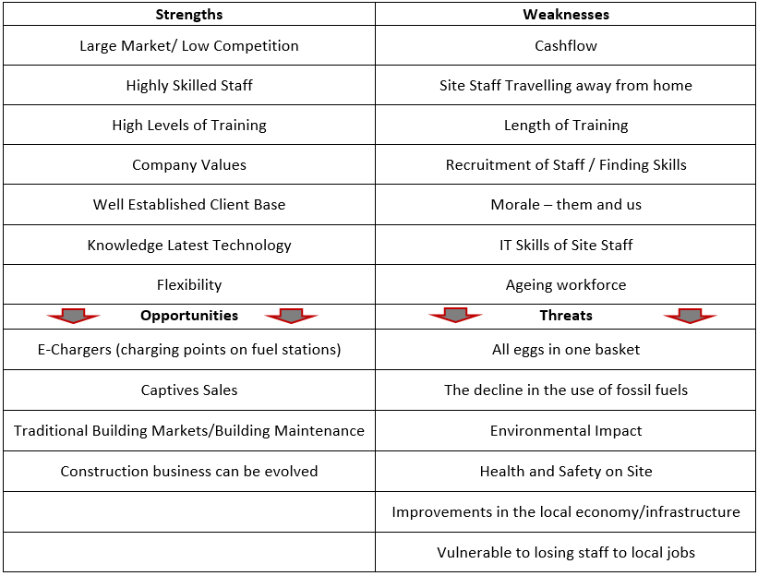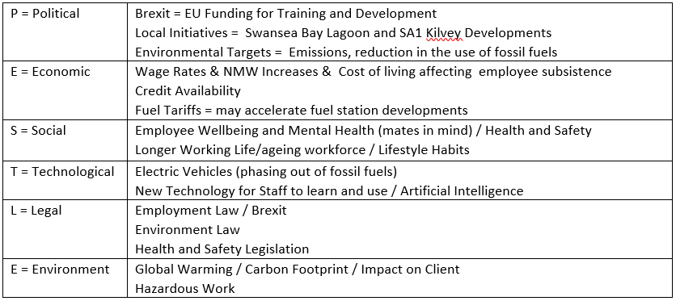

Looking at the external influences and specifically at the two most influential aspects and how they affect the organisation and ultimately the HR Function.
Employment Law
Changes to national minimum wage, pension contributions and increased legislation around some training, such as H&S, affecting job costings and ultimately increasing prices. Equality and Diversity legislation resulting in an ageing workforce, Government, (n.d.) creating additional challenges particularly in the Construction Industry brought by a workforce with potentially limited abilities.
The effect on HR is the requirement to ensure that those providing job costings are fully aware of increased costs. Financial Controller is aware in the preparation of budgets and sales forecasting. Equality and Diversity policies are up to date, Managers are trained in working with an ageing workforce and liaise with HR with regard to job modifications and the potential requirement for Occupational Health Reviews, and in worst case scenario’s, manage the performance management process where employees are no longer able to carry out their role ensuring the correct process and procedures are followed (CIPD, 2019).
Environmental
Monitoring and reporting of waste management and carbon footprint are often stipulations of client contracts, furthermore, in the case of waste management companies are required to securely dispose of waste and obtain the appropriate certificate as evidence, the HR role in the process is to ensure the appropriate training is provided.
The introduction of fuel tariffs could escalate into the oil industry bringing forward the move to E-Chargers, (electronic charging points) on fuel stations and fewer fuel outlets. This will challenge HR with the need to retrain or redeploy staff and potentially lead to a restructuring of the business, HR will be the driver of any restructure ensuring that employment law and best practice are adhered to, (ACAS, n.d.).
Both approaches identified an overlap in the legal, environmental, economic and technological aspects of the analysis and emphasise the need to remain compliant and the importance of being able to act promptly to the market and diversify the business.

Team SWOTand PESTLE notes



