58167

Abstract
End of year coursework
materials
PSDM4003

HNC MECHANICAL ENGINEERING

MATERIALS

LEVEL 4

NAME: GERAINT WILLIAMS

MODULE CODE: PSDM4003

LECTURER: PETER TAYLOR

ASSIGNMENT TITLE:

END OF YEAR COURSEWORK

WORD COUNT: 2232 WORDS

SUBMISSION DATE: 2nd MAY 2021

Task 1

a.
Tensile testing gives a wide range of information about a material
Yield stress level testing
Yield strength testing include taking a little example with a fixed cross-segment region and afterwards pulling it under control, bit by bit expanding power until the example changes or breaks.
Young’s modulus testing
The estimations from young’s modulus rely upon the applied power, the sort of material, and the space of the material. The pressure of the medium identifies with the proportion of the applied power concerning the cross-sectional region. The strain thinks about the adjustment of the length of material as for its unique length. Measure the underlying length of the substance. Utilizing a micrometre, you recognize the cross-sectional space of the material. At that point, with a similar micrometre, measure the various breadths of the substance. Then, utilize different opened masses to decide the applied power.
Ultimate tensile stress testing
Tensile test is used to provide insights on how materials behave under tension load. In basic tensile test, the involved material is pulled to its limit for determination of definitive tensile strength of the material. The power (F) applied and prolongation ($∆L$) of the involved material, are some of the measures that are estimated throughout the test. Material properties are regularly communicated regarding pressure (power per unit region, $σ$) and strain (percentage change long, $ε$). The power estimations are separated by the involved material’s cross-sectional territory ($σ=\frac{F}{A}$), which enable us to derive the pressure. Strain estimations are acquired by partitioning the adjustment of length by the underlying length of the example ($σ=\frac{∆L}{L}$). Finally, these measures are then introduced on an XY plot called pressure strain bend (Ku et al.2011).

b.
- Engineering stress
The engineering stress is defined as the ratio of the force applied to the actual area of the cross-section. Engineering stress is not equal to the actual stress acting on the body due to application of force, the cross-sectional area changes and stress on the body changes. Measurement for stress is N/m².

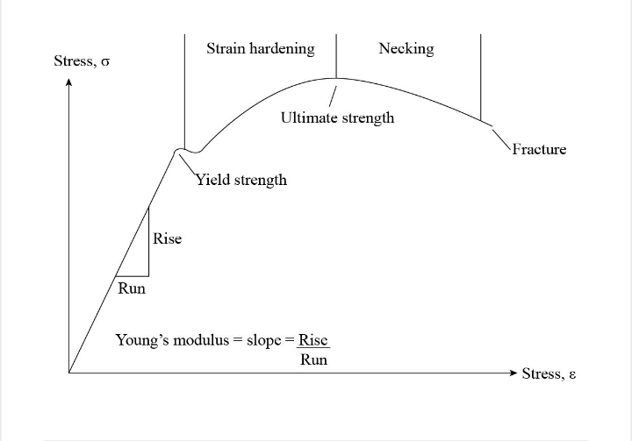
Wikipedia

- Yield stress level
If a body is acted upon by a force, then it follows the elastic behaviour up to the certain value of stress and after that body follows the plastic behaviour. The maximum value of stress at which the body follows the elastic behaviour is equivalent to the yield stress level for that body. Measurement for yield stress level is N/m².

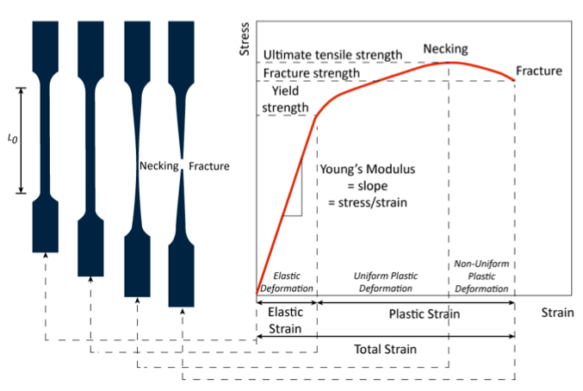
Matmach.com

- Young’s modulus
The young’s modulus also known as modulus of elasticity determines the relationship between axial stress and strain on the body. It is equivalent to the ratio of axial stress to the corresponding strain lying in the elastic region. Measurement of young’s modulus is N/m².
Ultimate tensile stress
The maximum value of stress that any material can withstand without breaking and necking phenomenon is observed in the body. It is the point on stress-strain curve that separates the plastic region and necking region. Measurement of ultimate tensile stress is N/m².
- Ductility
Ductility is the property of a material, by which the material can be transformed into wires. It determines the ability of the material to stretch into wires under the axial load without any fracture or failure of the body. If the material involved is more ductile then it can be easily transformed into wire.

- Toughness
Toughness is also another mechanical property of material that determines the ability of the material to withstand the shock and is equivalent to the area bounded below the stress-strain curve up to the fracture point. Toughness is equal to the amount of energy stored by the body per unit volume up to the fracture point.
c.
Aluminium tensile load, F = 250 kN
Young’s modulus of the material, $∈$ =70 GPa
Length of the rod, L = 4.2 m
Yield stress of the material, $δ_{y}$= 260 MPa
Rod elongation, $δ$ = 7 mm

Engineering strain in the aluminium rod:
$ε$ = $\frac{δ}{L}$ =$\frac{7}{4.2 x 1000}$
= 1.6667 x 10⁻³
Engineering stress on the rod:
$$δ= ∈x ε$$
= 70 x 10³ x 1.6667 x 10⁻³
= 116.667 MPa

Yield stress = $\frac{allowable }{FOS}$
$δ_{y}$ = $\frac{ δ_{a}}{FOS}$ = $\frac{\frac{P}{A}}{FOS}$
= $\frac{4P}{πd^{2 (FOS)}}$

$d^{2}$ = $\frac{4P}{πδ_{y (FOS)}}$ = $\frac{4 x 250 x 1000}{π x 260 x 2}$

=24.74 mm

Diameter of the rod is approximately 24.5 mm.
Factor of safety (FOS) is an important aspect in the analysis as it indicates the capability of a structural system viability beyond the expected load. e.g., the FOS of 2 does not mean that the rod will withstand twice much load as was initially designed, FOS is dependent on the material used and use.

Task 2

a.
When the cold rolling process is done on any material, then its shape is changed permanently due to the defects or dislocation in the actual grain structure. Because of these dislocations impacts, the strength of the involved object is decreased, will increase its strength as opposed to base material. This is because the grains of cold worked, will have its grains fully re-crystallised.
Comparing small and high angle grain boundaries, the small angle grain is more effective in disturbing motion dislocation boundaries because the grain boundary crystallographic misalignment is absent for the small angle grain boundaries, which result in no change in the direction of slips. (Serquis, A., Liao, X. Z., Zhu, Y. T., Coulter, J. Y., Huang, J. Y., Willis, J. O., ... & Indrakanti, S. S. 2002).

b.
Minimum tensile strength, $S_{y}$ = 370 MPa
Minimum ductility = 27%
Table to check the required metal from the graph:

Metal | % cold work allows for tensile strength = 370MPa | % cold work for ductility$>27\%$
Steel | all % C | 0 %
Copper | $$>45 \% C$$ | $$<10 \% cold work$$
Brass | $$>14 \% C$$ | $$<18 \%$$

The material is only suitable if both the capabilities lie in the same region. This is the case with only Brass where > 14 % cold work required and tensile strength, < 18 % cold work required for ductility.
The required material is Brass.
c.
For yield strength, we must have at least 27 % CW. For ductility, it should not exceed 29 % CW. Split the difference and go with 28 % CW. Anneal, and then cold work to the final 28 %. Requirements, the diameter at the period of cast step.

CW = $\frac{d_{1}^{2}- d_{2}^{2}}{d_{1}^{2}}$ x 100
28 = $\frac{d_{1}^{2}- {12.7}^{2}}{d_{1}^{2}}$ x 100
$d_{1}^{2}$ = 3.67$d_{1}^{2}$ – 575.80
$d_{1}$= 14.96 mm
diameter of 15 mm, just before that last bit of CW
CW = $\frac{d_{0}^{2}- d_{2}^{2}}{d_{1}^{2}}$ x 100
35 = $\frac{d_{0}^{2}- {19}^{2}}{d_{1}^{2}}$ x 100
$d_{0}^{2}$ = 2.85$d_{1}^{2}$- 1031.42
$d_{0}$ = 23.6 mm
zero cold work at 23.6 mm, try to get 15 mm.
CW = $\frac{d_{0}^{2}- d_{1}^{2}}{d_{0}^{2}}$
= $\frac{{23.6}^{2}- {14.96}^{2}}{{23.6}^{2}}$ x 100
= 59 %

about 60 % CW would result.
- Draw the 19 mm stock down to 15 mm. 60 % CW result should be okay, close to cracking.
- Anneal
- Cold work 28% down to 12.7 mm, the final desired diameter. If there is much risk of failure by cracking, carry out annealing first.
Task 3

a.
- Aluminium
Al – 1S² 2S² 2P⁶ 3S² 3P¹ =13 electrons

- Manganese
Mn – 1S² 2S² 2P⁶ 3S² 3P⁶ 4S² 3d⁵ =25 electrons

- Lead
Pb – 1S² 2S² 2P⁶ 3S² 3P⁶ 4S² 3d¹⁰ 4P⁶ 5S² 4d¹⁰ 5P⁶ 6S² 4f¹⁴ 5d¹⁰ 6P² =82 electrons

b.
- Atomic structure of an atom gives protons and neutrons arrangement in the nucleus while crystal structure explain the electron structure of the individual atom.
- Atomic structure reveals the nucleus of an atom composition in terms of the number protons and neuron and as well the number and probability distribution of the basic electron while Crystal structure provide a clear arrangement of atoms in the crystalline solid material.
- Atomic structure gives us the number of electrons while crystal structure gives the atomic bonding type in a crystalline solid.

Metals are good conductors of heat and electricity, in general, whilst ceramics are poor. This is because metals have at least one free electron per atom, which is not tied to any particular atom but move freely throughout the metal. This gives the metals the ability to conduct heat and electricity as opposed to ceramic, which are poor conductors of heat and electricity.
c.
Crystalline defects are introduced into the crystal as a result of the changes in the systematic arrangement of the atoms in the lattice structure. A solid surface can change its shape due to deformity in the crystal, which causes crystal defects.
The three main areas of crystal defect in engineering materials and their mechanical properties are:
- Point defects
When an atom is dislocated from the crystal surface, either an atom will be missing, or an extra atom will enter the crystal surface. Some point’s defects may alter the density of the crystal due to the change in overall mass of the crystal, as density increases in the interstitial point.

- Line defects
Line defects arises due to dislocation of atoms around the atom in a linear fashion. On this defect, a misalignment of atoms takes in the crystal. The types of line defects are edge dislocation and screw dislocation – the change in the position of the atom from the crystal site induced by stress.
- Bulk defects
Bulk defects is a crystal defect whose 3D deformity is observed due to crack and pore in the crystal.
- Planar defects
Planar defects occur when either the crystal grows from the lattice points. On this way, the shape of the crystal changes and deformity is introduced.

Task 4

a.
For brass specimen, the stress-strain behaviour for which is shown in Figure 4b (i), the tensile strength is 450 MPa. Tensile strength is the ultimate tensile stress which the material can withstand in the given stress-stain curve for brass, ultimate tensile stress is the topmost stress point, which is clearly 450 MPa.
From Figure 4b (ii), the hardness for brass corresponding to this tensile strength (450 MPa) is approximately 125 HB or 75 HRB.

b.
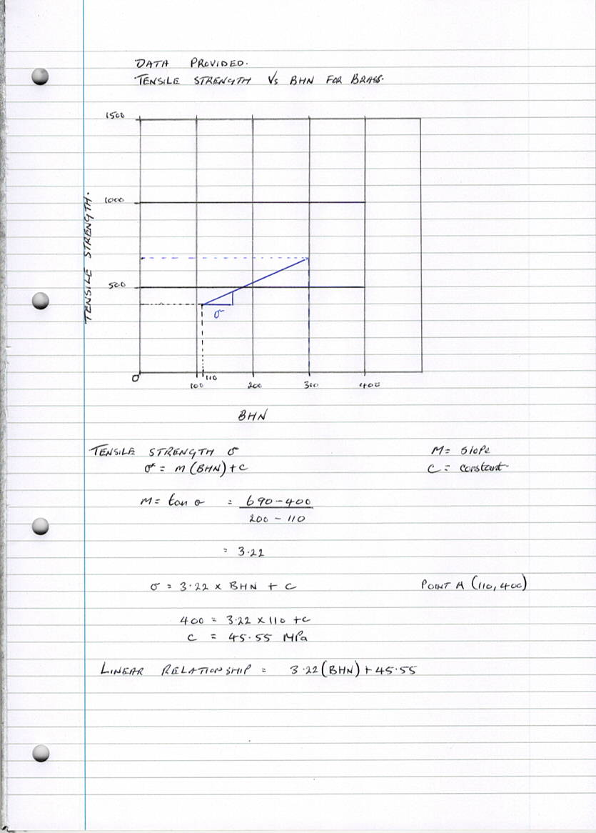

c.
Low carbon steel has chemical composition carbon of 0.23 % and mechanical properties such as yield strength 26.0 kg/mm² minimum. Carbon steel with between 0.15 to 0.30 % carbon are extensively used for structural steel and fluid application as building bars, grills, beams, and channels.
Case hardening process
- The primary role of case hardening process is to provide an end product of low carbon steel with having superficial high carbon content without affecting the inner or the core of the metal in its composition.
- This process involves addition of high carbon percentage to the outer layer of a low carbon steel which is to be case hardened through heating while in contact with a certain material which may be very rich in carbon content.
- The operational involvement with low carbon case hardening steel is:
Carbonizing which help in introducing the additional carbon.
- Gradual cooling of the cementing temperatures, Annealing.
- Refining – aims at compensating effects of sustained heating
- Hardening tempering as required

Case hardened steel application
Case hardening steel is used in automobile engineering, mechanical and plant engineering for parts such as cardan shafts, coupling parts, gears, and bolts. Example are C10 – 0.07 to 0.013 % carbon and C15 – 0.12 to 0.18 % carbon (Fasano, A., Hömberg, D., & Panizzi, L. (2009).

Task 5

a.
(i)The major limitations of iron-iron carbide phase diagram include:
- The non-equilibrium martensite does not appear in the diagram
- The diagram does not include the arrangement at the phase in microstructures.
- Time-temperature relationship to the formation of pearlite, bainite, and spheroidite is absent
(ii)
Pearlite, bainite, and spheroidite in their microstructures, they all contain the $α$- ferrite and cementite phases. The two mentioned phases exist as distinct layers that alternate with one another in pearlite. Bainite consist of smooth and parallel needle-shape particles of cementite that are surrounded by an $α$- ferrite matrix. For spheroidite as the name suggests, the matrix is ferrite, and the cementite phase has a shape similar to that of a sphere particle. Bainite is harder and stronger than pearlite, which in turn is also harder and stronger than spheroidite. In essences, Bainite is the harder and stronger among the three.
b.
Martensite is the hardest phase of carbon steel. It is formed when quenching the $γ$-phase of the carbon steel, known as Austenite, at a very high cooling rate. Here, it converts its phase from FCC (Face Cantered Cubic structure) to BCT (Body Cantered Tetragonal). When we heat the carbon steel up to about 800 to 900 degrees Celsius, it will reach at Austenite phase. If we perform rapid cooling or quenching such as cooling curve not touching the nose in T-T-T diagram. Therefore, martensite formation starts around 220 to 100 degrees Celsius. The T-T-T diagram is below (Huang et al., 2019).

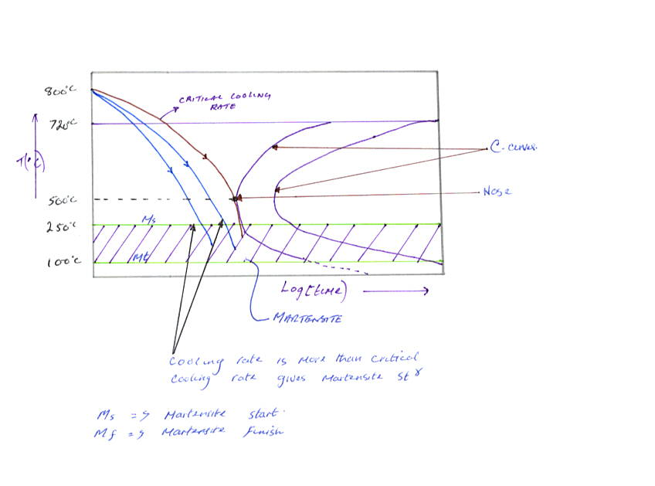
Effects of martensite in carbon steel mechanical properties
- It is the hardest phase of carbon steel, therefore hardness will increase
- It has BTC structures; toughness and fatigue properties are good.
- It increases ultimate tensile strength and yield strength of the component.
- Fatigue life of the component also increase.
Entwisle, A. R. (2011).

Reference

Entwisle, A. R. (2011). The kinetics of martensite formation in steel. Metallurgical transactions, 2(9), 2395-2407.
Fasano, A., Hömberg, D., & Panizzi, L. (2009). A mathematical model for case hardening of steel. Mathematical Models and Methods in Applied Sciences, 19(11), 2101-2126.
Huang, G.L., Matlock, D.K. and Krauss, G., 2019. Martensite formation, strain rate sensitivity, and deformation behavior of type 304 stainless steel sheet. Metallurgical transactions A, 20(7), pp.1239-1246.
Ku, H., Wang, H., Pattarachaiyakoop, N. and Trada, M., 2011. A review on the tensile properties of natural fibre reinforced polymer composites. Composites Part B: Engineering, 42(4), pp.856-873.
Serquis, A., Liao, X. Z., Zhu, Y. T., Coulter, J. Y., Huang, J. Y., Willis, J. O., ... & Indrakanti, S. S. (2002). Influence of microstructures and crystalline defects on the superconductivity of MgB 2. Journal of applied physics, 92(1), 351-356.
Voigt, M., Bojsen-Møller, F., Simonsen, E.B. and Dyhre-Poulsen, P., 2015. The influence of tendon Youngs modulus, dimensions and instantaneous moment arms on the efficiency of human movement. Journal of biomechanics, 28(3), pp.281-291.
Wang, Z., Guan, K., Gao, M., Li, X., Chen, X., & Zeng, X. (2012). The microstructure and mechanical properties of deposited-IN718 by selective laser melting. Journal of alloys and compounds, 513, 518-523.

https://www.admet.com/wp-content/uploads/2017/07/ductile-specimen-shape-during-testing.png

Bibliography

Benedek, J., Shachrai, A. and Levin, L., 2010. Case hardening of steel by a CO2 laser beam. Optics & Laser Technology, 12(5), pp.247-254.
Cardoso, P. E., Braga, R. R., & Carrilho, M. R. (2008). Evaluation of micro-tensile, shear and tensile tests determining the bond strength of three adhesive systems. Dental Materials, 14(6), 394-398.
Hopcroft, M. A., Nix, W. D., & Kenny, T. W. (2010). What is the Young's Modulus of Silicon? Journal of microelectromechanical systems, 19(2), 229-238.
Lebedeva, N. P., Koper, M. T. M., Feliu, J. V., & Van Santen, R. A. (2002). Role of crystalline defects in electrocatalysis: Mechanism and kinetics of CO adlayer oxidation on stepped platinum electrodes. The Journal of Physical Chemistry B, 106(50), 12938-12947.
Lütjering, G. E. R. D. (2018). Influence of processing on microstructure and mechanical properties of (α+ β) titanium alloys. Materials Science and Engineering: A, 243(1-2), 32-45.
Nimbhorkar, S. R., & Deshmukh, B. D. (2013). Effect of case hardening treatment on the structure and properties of automobile gears. International Journal of Pure and Applied Research in Engineering and Technology, 1(8), 317-325.
Pelleg, J. (2012). Mechanical properties of materials (Vol. 190). Springer Science & Business Media.
Voigt, M., Bojsen-Møller, F., Simonsen, E.B. and Dyhre-Poulsen, P., 2015. The influence of tendon Youngs modulus, dimensions and instantaneous moment arms on the efficiency of human movement. Journal of biomechanics, 28(3), pp.281-291.

