University of Wales Trinity Saint David

Safety and Hazard



Risk Assessment
Systems Engineering (ACDB5021)

Katie Byrne

2114211

4th October 2024

Lecturer: Austin Clark

Contents
- Introduction
- Brimstone Missile
- Task/System Description
- Hazard Descriptions
- Pre-Control Risk Estimate
- List of Controls & Mitigations
- Post-Control Risk Estimate

Part 1

Introduction

Using the Haz ID, Risk Estimation, and Control ID that were developed in class by the group, this project will provide a risk assessment from the assigned activity. A thorough job description, hazard descriptions, a pre-control risk estimate, a list of controls and mitigations to lessen the likelihood and severity of the hazard, and finally the application of a post-control risk estimate are all included in the risk assessment. The tasks will include a list of dangers that apply to industry standards and best practices, from the manufacturing stage to disposal.
Any source that might cause injury, damage, or detrimental consequences on someone's or something's health is considered a danger. Hazard identification is essential in safety circumstances to avert mishaps and guarantee a secure atmosphere.
Depending on the risks involved, different actions can be performed to prevent hazards in different situations. The following are some examples:
- Hazard Identification: Evaluate the surroundings on a regular basis to spot any risks including broken machinery, slick flooring, or dangerous materials.
- Putting Safety Procedures into Practice: To reduce risks, create and implement safety protocols and procedures. This might entail carrying out routine safety exercises, adhering to certain operating procedures, or donning protective gear.
- Education and Training: Make sure anyone working in the environment receive in-depth instruction so they can recognise possible risks and know how to properly address them.
- Maintaining Equipment: Regularly inspect and maintain equipment to prevent malfunctions that could lead to hazards.
- Prepare for emergencies: having plans in place for evacuation, first aid supplies, and having qualified personnel on hand to handle situations skilfully.
- Culture of Safety: Promote a culture in which it is everyone's duty to recognize and report hazards as soon as they are discovered.
Risks can be avoided by putting these environment-specific strategies into practice, making the situation safer for everyone.

Brimstone Missile
The Brimstone missile is an advanced air-to-surface missile developed by MBDA, primarily used by the UK Armed Forces. It is designed for precision strikes against a variety of targets, including armoured vehicles, and is notable for its accuracy and effectiveness in urban environments. Here are some key features:

- Guidance System: Brimstone uses a combination of laser guidance and millimetre-wave radar, allowing it to lock onto moving targets and operate in adverse weather conditions.
- Launch Platforms: It can be deployed from various platforms, including fast jets like the Tornado, Typhoon, and even some unmanned aerial vehicles (UAVs).
- Range and Payload: The missile has a range of approximately 60 kilometres and carries a shaped charge warhead, designed to penetrate armour effectively.
- Operational Use: Brimstone has seen combat in various operations, including those in Iraq and Afghanistan, where its precision has been critical in minimizing collateral damage.
- Variants: There are several variants of the Brimstone missile, with improvements in guidance, range, and target engagement capabilities over time.

Overall, the Brimstone missile represents a significant advancement in precision-guided munitions, aimed at enhancing the effectiveness of modern air operations.
The Brimstone missile, developed by MBDA and introduced into service with the UK Armed Forces in 2005, originated from the late 1980s as part of a program to create a precision-guided munition capable of engaging moving targets. It combines laser and millimetre-wave radar guidance, allowing for high accuracy and minimal collateral damage, which was demonstrated in combat during operations in Afghanistan and Libya. The missile has undergone several upgrades, including the Brimstone 2 variant, enhancing its targeting capabilities and range. As of the 2020s, it remains a critical asset for the UK's air-to-ground strike capabilities, reflecting advancements in modern military precision technology. [1]

Task and Hazard Description
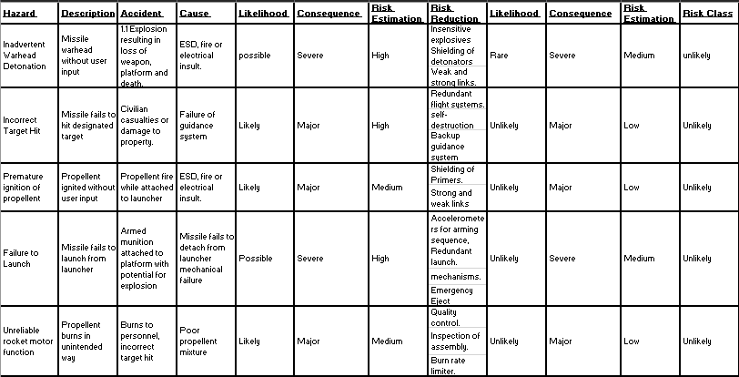
The Task that the risk assessment will be written for is the usage of the Brimstone Missile.
There are many hazards associated with the Brimstone Missile. These include an inadvertent warhead detonation, incorrect target hit, premature ignition of propellant, failure to launch and unreliable rocket motor function.
The inadvertent warhead detonation would result in a 1.1 explosion resulting in loss of weapon platform and death. This has been determined to have a rare likelihood, a severe consequence, and an unlikely risk class. The incorrect target hit would result in civilian casualties or damage to property. This has been determined to have an unlikely likelihood, a major consequence, and an unlikely risk class. Premature ignition of propellant would result in a propellant fire while attached to launcher. This has been determined to have an unlikely likelihood, a major consequence, and an unlikely risk class. A failure to launch would result in armed munition attached to platform with potential for an explosion. This has been determined to have an unlikely likelihood, a severe consequence, and an unlikely risk class. Lastly, an unreliable rocket motor function would result in burns to personnel and an incorrect target hit. This has been determined to have an unlikely likelihood, a major consequence, and an unlikely risk class.

Risk Matrix

Before identifying any hazards from The Task, a Risk Matrix was created in order to categorise the severity and likelihood of each risk. There were five levels of severity made. They were:
5. Severe – multiple fatalities
4. Major – single fatality and / or severe injuries with lasting irreversible damage.
3. Moderate – single severe injury or multiple minor injuries > a week off work
2. Minor – minor injuries time off work
1. Not significant – no time off work no significant injury
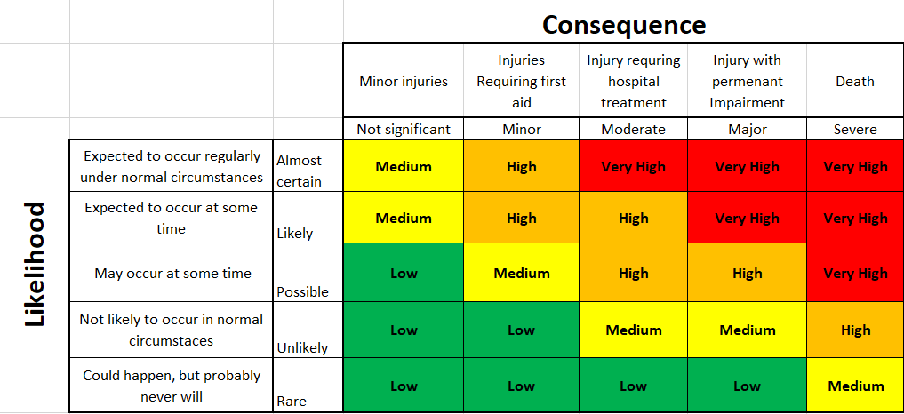

There were five levels of likelihood of a hazard occurring. They were:
5. Almost Certain - > 10-3
4. Likely - > 10-4
3. Possible - > 10-5
2. Unlikely - > 10-6
1. Rare - < 10-6

Risk Classes

Risk Classes are ranked from Rare to uncertain. This determines the likelihood and consequence as one. Overall, all hazards identified were determined to be unlikely to happen after risk reduction measures were implemented.

Part 2

ALARP Justification

"As-Low-As-Reasonably-Practicable" is what ALARP stands for. This risk management concept makes sure that risks are minimized to the lowest level that is practically attainable in each circumstance. Finding a balance between the amount of risk and the resources needed to further reduce that risk is the aim of ALARP. By applying the ALARP principle, organizations can make informed decisions about risk control measures and prioritize actions to manage risks effectively.

In practice, an ALARP justification involves:
1. Identifying the hazards.
2. Assessing the risks associated with those hazards.
3. Implementing measures to reduce the risks.
4. Demonstrating that further risk reduction would be impractical or disproportionately costly compared to the benefit.

The ALARP principle ensures a balance between risk reduction and resource expenditure, aiming for a practical and reasonable approach to safety. [1]

The Chosen ALARP Justification

Inadvertent warhead detonation is the chosen ALARP Justification for this assignment. Inadvertent warhead detonation can occur due to various factors such as mechanical failures, electrical malfunctions, or human errors. The consequences of such detonations can be catastrophic, leading to significant damage and loss of life. It's crucial to have stringent safety measures and protocols in place to prevent such incidents.
In the event of an inadvertent warhead detonation caused by a missile warhead without proper user input, it could result from a malfunction in the missile's guidance system, a failure in the arming mechanism, or a defect in the warhead itself. These types of incidents underscore the critical importance of robust safety measures and fail-safe mechanisms in missile systems to prevent accidental detonations.
In the scenario of an inadvertent warhead detonation triggered by an ESD (Electrostatic Discharge) fire or electrical insult, it could be caused by a sudden discharge of static electricity or an electrical surge that interferes with the warhead's electronics or detonation mechanism. These events can lead to unintended activation or malfunction of the warhead, resulting in a detonation without the intended user input. It highlights the importance of proper grounding, shielding, and protection against electrical disturbances in sensitive military equipment to prevent such dangerous occurrences.
Using insensitive explosives can help reduce the risk of inadvertent warhead detonation by increasing the stability and resistance of the explosive material to accidental stimuli. Insensitive explosives are designed to be less reactive to impact, friction, or heat compared to traditional explosives, making them less likely to detonate unintentionally. By incorporating insensitive explosives into warheads, the likelihood of accidental detonation due to external factors such as ESD fires or electrical insults is significantly reduced, enhancing overall safety and reliability of the munitions.
Shielding detonators can also contribute to risk reduction by providing physical protection to the detonation mechanism, preventing unintended activation from external factors like ESD fires or electrical insults. This additional layer of protection helps safeguard the detonators from accidental stimuli, reducing the likelihood of inadvertent warhead detonation. It's an essential safety measure to enhance the overall security and reliability of the munitions.
Weak links and strong links refer to components within a system that have varying levels of reliability or robustness. In the context of safety cases and risk management, identifying weak links involves pinpointing elements in the system that are more prone to failure or vulnerabilities, potentially leading to hazardous situations. On the other hand, strong links represent components that are more resilient and less likely to fail, serving as critical safeguards in preventing accidents or mitigating risks. Understanding and addressing both weak and strong links are essential in developing effective safety strategies to ensure the overall integrity and security of the system.
To write an ALARP (As-Low-As-Reasonably-Practicable) safety justification on this hazard, we would need to assess the risks associated with the weak and strong links in the system. By identifying and addressing the weak links to improve their reliability and resilience, we can reduce the likelihood of failures that could lead to hazardous situations. Simultaneously, reinforcing the strong links further enhances the system's robustness and ability to prevent accidents. This approach ensures that risks are minimized to a level that is both achievable and reasonable, aligning with the ALARP principle of striking a balance between risk reduction measures and their feasibility.
Risks
The risks of an inadvertent warhead detonation of a Brimstone missile, while generally low due to stringent safety and reliability measures, can include:
- Collateral Damage: An unintended detonation could cause damage to nearby civilian structures, vehicles, or personnel, leading to unintended casualties and escalation of conflict.
- Loss of Assets: If a missile detonates prematurely or accidentally during transport or launch, it could result in the loss of valuable military equipment and personnel.
- Environmental Impact: A detonation could release harmful materials or create hazardous conditions, affecting the surrounding environment and potentially leading to long-term ecological damage.
- Escalation of Hostilities: An accidental explosion could be misinterpreted as an act of aggression by opposing forces, potentially escalating tensions or leading to retaliatory actions.
- Operational Security Risks: An inadvertent detonation could compromise operational security, revealing capabilities or locations to adversaries.
Mitigation measures, including rigorous safety protocols and advanced design features, are in place to minimize these risks.

Risk Reduction Measures
Mitigating the risk of an inadvertent detonation of a Brimstone missile—or any guided missile system—requires a multi-faceted approach that encompasses design, handling, storage, operational protocols, and training.
The use of insensitive explosives in the context of a brimstone missile can significantly help reduce the risk of inadvertent detonation. Insensitive explosives are designed to be less sensitive to various stimuli such as heat, shock, and friction. This means that they require a greater amount of energy to initiate a detonation compared to more sensitive explosives. By incorporating insensitive explosives into the design of the brimstone missile, the likelihood of accidental detonation due to environmental factors, handling, or unintentional impacts is minimized. This is particularly important in military applications where safety is crucial, as it helps to ensure that the missile remains stable and secure under a wide range of conditions. In summary, using insensitive explosives enhances safety by reducing the chances of inadvertent detonation, providing an additional layer of protection for both personnel and equipment.

Shielding of detonators can significantly reduce the risk of accidental detonation by providing a physical barrier that protects the detonators from external stimuli. This shielding can be designed to absorb or deflect energy from impacts, heat, or blasts that might otherwise trigger the detonator. By incorporating effective shielding, the chances of a detonator being activated unintentionally due to environmental factors, such as shock waves from nearby explosions or mechanical impacts during handling, are minimized. This is crucial in preventing unintended detonations, especially in scenarios where safety is paramount, such as during transport or storage of munitions. Overall, proper shielding enhances the safety of explosive systems by ensuring that detonators remain secure and unaffected by potential hazards, thereby reducing the overall risk of inadvertent detonation.

Weak and strong links in safety systems can help reduce risk by creating a layered approach to safety and failure management. Strong links are designed to withstand significant stress and are meant to carry the primary load or function of a system. In contrast, weak links are intentionally designed to fail under specific conditions, thereby preventing larger failures in the system. By strategically incorporating weak links, you can ensure that if a failure occurs, it will happen in a controlled manner that minimizes risk and prevents catastrophic outcomes. For example, if a strong link fails, the weak link will break first, allowing for a controlled failure that can be managed or mitigated. This concept aligns with safety principles like the ALARP principle, which emphasizes minimizing risk to as low as reasonably practicable. By using both weak and strong links, you create a robust safety framework that enhances overall system reliability and safety.

Cost
In an ALARP argument, the implementation of weak and strong links, shielding of detonators, and the use of insensitive explosives can have varying effects on cost.

1. Weak and Strong Links: While incorporating weak links can initially seem cost-effective since they may prevent larger failures and reduce overall risk, designing systems with both types of links can increase upfront engineering and material costs. However, the long-term savings from preventing catastrophic failures can justify these costs.

2. Shielding of Detonators: The cost of shielding can vary based on the materials and design complexity. While it might add to the initial expense, it can significantly reduce the risk of unintended detonations, which could lead to much higher costs associated with accidents, damage, or loss of life.

3. Insensitive Explosives: These may come at a premium compared to standard explosives, but their use can greatly enhance safety and reduce the likelihood of accidents, thus potentially lowering insurance costs and liability over time.

In summary, while there may be higher initial costs associated with these measures, the ALARP principle emphasizes that if the costs of preventing risks are deemed reasonable compared to the potential consequences of a failure, then these investments can be justified. The goal is to balance safety improvements with economic feasibility.

Conclusion
In conclusion, implementing risk reduction measures such as weak and strong links, shielding of detonators, and using insensitive explosives plays a crucial role in enhancing safety and minimizing the likelihood of incidents. While these measures may involve higher initial costs, they are justified within an ALARP framework, as they significantly reduce the potential consequences of failures. By investing in these safety strategies, organizations can achieve a balanced approach that prioritizes safety while remaining economically viable, ultimately leading to a safer operational environment.

