Module Name: Understanding and Engaging in the Customer Experience.
Module Title: Customer Relationship Management Emerging Theme.

Name: Shirina Begum
Student ID: 1912208
Module code: BMSW5103
Lecturer: Olubukola Adegbite

Table of Contents
Introduction: 3
Company Overview: 4
Task A: Investigation of customer experience 5
Importance of emerging themes on Customer Relationship Management (CRM) 5
Tech Touch versus Human Touch 5
Customer Experience and Brand Experience 6
Influence of emerging themes on customer relationship management (CRM) 6
Recommendations on Customer Relationship Management (CRM) 7
Task B: Quality models for improving customer relationship management (CRM) 9
Total Quality Management (TQM) 9
Six Sigma 11
Conclusion 14
References 15

Introduction:
Quality management is a particularly important aspect of any retail organization. Apart from quality processes, customer experience and service also play a vital role in the expansion and fame of any organization. This report discusses the customer experience in Aldi based on emerging themes and its overall impact on customer relationship management and provides recommendations based on the findings. Moreover, quality models that can be implemented in Aldi for improving their customer relationship management are also discussed here through a comprehensive study.

Company Overview:
Aldi is a discount supermarket chain owned by two German families. Founded in 1946 by Karl Albrecht and Theo Albrecht, today Aldi has more than 10,000 stores in 20 countries of the world including the USA, Australia, China, and many countries of Europe. Its headquarters is in Essen, Germany. Aldi has a turnover rate of over € 50 billion. In 2018, their annual revenue was around $ 92 billion. Aldi has always been focusing on improving its customer experience and maintaining its quality of service. These trends helped Aldi to reach their current level through a combined approach of their employees and management.

Task A: Investigation of customer experience
Customer Relationship Management or CRM combines technology with the policies and strategies used by companies for managing and analyzing interactions with customers and data of customers from all sources (retail store, online, social media engagements, etc.) for excelling in customer service relationships and customer retention which in turn helps in better sales and increased profit (Meyer et al., 2017) In recent times, several trends are emerging in CRM which influences the policies of a company and the quality process they follow. In this report, we will analyze the CRM of Aldi in terms of the customer experience on emerging themes and recommend some guidelines to be followed by Aldi. We will also discuss the impact of these emerging themes on quality management which will help in the development of customer relationship management.

Importance of emerging themes on Customer Relationship Management (CRM)
Customer Relationship Management is always evolving and changing according to customer demands. Its main target is to acquire customers, the development of customers and retaining customers can be achieved only by constant adaptability with the emerging trends (Andajani, 2015). The emerging themes of customer relation in Aldi that will be discussed here are
- Tech Touch versus Human Touch
- Customer Experience and Brand Experience

Tech Touch versus Human Touch
Recently, the digitalization and use of technology in supermarkets have been on the rise. It is often found that supermarkets rely on preprogrammed chatbots integrated with artificial intelligence (AI) and machine learning (ML) for marketing, data collection and targeting customers including answering queries of the customers. These specified marketing and data processing helps in customer retention (Andajani, 2015) (Richardson, 2010). Aldi uses an AI-based chatbot for their online store which can answer the queries of the customers along with the price of the commodity, the delivery period, etc. Moreover, Aldi stores have a self-checkout system that is automated, and the customers can buy the commodities without taking the hassle of standing in a line (Salomann et al., 2016). Aldi has also integrated contactless payments via different payments gateways. Aldi collaborated with other tech companies (Instacart) to launch an online grocery delivery service. Shelf stacking and floor-cleaning robots are also about to be brought in by Aldi. These overall investments in tech have made the customers do shopping more efficiently by saving time and from the comfort of their home (McKean, 2013).

Customer Experience and Brand Experience
A brand is a feature that distinguishes a company from other companies with its products and services. It is a greater concept and holistic vision that the world has about the products and services of a company (Lemon et al., 2016). Aldi is a global grocery supermarket having its stores in 20 countries around the world. Brand experience is a long-term strategy that Aldi has developed over the years. The Brand value of Aldi has helped them acquire new customers and is dependent on its effective marketing. Customer experience, on the other hand, is a part of the brand experience. It is the individual experience of a customer by using the products or services of a brand. Customer experience is an instant reaction of a customer to the service they receive (Mascarenhas et al., 2016). Aldi has skilled employees that help to provide a soothing customer experience. The emotions and empathy involved in the services provided by Aldi along with the quality of the product have made them obtain a good customer experience. Customers mostly look for friendly service while shopping in Aldi. Though customer experience and brand experience are different, they are equally important for Aldi to fulfill the promise towards its customers and increase its market acceptance around the world.

Influence of emerging themes on customer relationship management (CRM)
Customer Relationship Management is a business philosophy that helps to study the customer requirements and behaviours for improving the customer relationship which will allow customer retention. The influence of technology on CRM is evident as the world is being digitalized every day. Businesses are prone to have a sustainable and effective CRM considering both human touches, tech touch, brand experience as well as customer experience (Zeng et al., 2020). Aldi is a global brand has already gained customers with their sole marketing policy. Along with that, they have well-trained and friendly employees at their outlets that promote an excellent customer experience. Customer experience and brand experience together help Aldi to gain new customers and retain the older ones and hence increase their profit (McKean, 2013).
Aldi has always been operated by human employees until recently they started investing in tech. The involvement of robots, chatbots, websites and apps along with self-checkout and contactless payment integrated by Aldi has had both positive and negative reactions by the customers. The application of technology has certainly improved efficiency, but it lacks human emotion and empathy. Moreover, AI and ML need time to train and improve themselves. All technologies are being programmed in a certain way, because of which, if a certain malfunction or situation arises, these machines or technologies are unable to tackle the problem which may lead to poor customer experience and loss (Wortmann, 2014)
Aldi focuses on customer relationship management despite the differences in the emerging trends. They formulate their strategies and policies of CRM considering the best way to maintain a relationship with the customers. For this, Aldi has employed both human roles and tech roles in their outlets so that a customer can have the best experience while shopping (Zeng et al., 2020). Aldi engages with the customers through their websites, apps and social media pages which requires human intervention and emotions to attract the customers. Customers are always looking for the best experience while shopping from Aldi because of its brand value. Keeping this their priority, Aldi trains and keeps their staff updated on the company policies and their branding promises so that customers' expectations can be fulfilled (Wortmann, 2014). As a result, customers are more likely to shop from Aldi and stay loyal to them because of the services they receive. Overall, an effective CRM by Aldi helps them in raising their sales every year and earning more revenue.

Recommendations on Customer Relationship Management (CRM)
Customer relationship is vital for Aldi to compete in the market. To adapt to the trends of the customer relationship, some of the recommendations are mentioned below.
- Aldi should engage with customers more through human touch in their stores including greeting the customer and tending to the needs of the customer.
- Engagement through social media, websites and app should be made easy and effective by reducing the complexity to browse and order products
- Since Aldi has a self-checkout and cashless payment procedure, it is the responsibility of the employees of Aldi to help the older customers with these processes as they might face several difficulties.
- The marketing and sales strategies to the target customers are mostly based on buying patterns of the customer from the historical data. It is essential that Aldi uses modern and intelligent machine learning algorithms to make their AI learn fast and cope with the customer needs efficiently and suggests products according to the customer mindset.
- Employees should be professionally trained on how to deal with customers prioritizing the company policies regarding the customer relationship
- Chatbots or AI used for customer service online should also have a human intervention to assist customers with complex issues that cannot be solved by the chatbot
- Since customers have positive expectations from Aldi, it should be the top priority of Aldi to fulfill those expectations no matter if it is a new customer or an old one.
- After-sales service and return policies of Aldi should be customer-friendly
A decent combination of human involvement along with technology will allow Aldi to offer the best customer experience coinciding with their brand value and hence help achieve retentive customers.

Task B: Quality models for improving customer relationship management (CRM)
Quality management refers to the procedure followed for maintaining the standard of products or services of a specific company. The quality management process varies with the operations of the company. A company can follow more than one quality management model to provide the best services to its customers. In this section, we will discuss the quality models that can be used by Aldi for improving its customer relationship management. We will be focusing on Total Quality Management (TQM) and Six Sigma models in our discussion

Total Quality Management (TQM)- Edward Deming.
Total Quality Management (TQM) is a business philosophy that refers to the continuous improvement of the overall business processes leading to customer satisfaction by a systematic use of tools and techniques to achieve products and services of the highest quality (Kruger, 2010). According to Douglas Chiguvi, “TQM is concerned with continuous improvement in all work, from high-level strategic planning and decision-making to detailed execution of work elements on the shop floor. It stems from the belief that mistakes can be avoided, and defects can be prevented. It leads to continuously improving results, in all aspects of work, because of continuously improving capabilities, people, processes, and technology and machine capabilities.” (Douglas, 2016) TQM refers to a management philosophy that integrates all levels of the company focusing on customer satisfaction by improving quality.
TQM starts with the customer expectations (Coskun, 2010). Identifying the customer needs, the company works to fulfill the needs by engaging all employees. These help in an overall improvement of the process as well as the products. The Deming PDCA cycle provides opportunities for constant appraisal and development (Dudin et al. 2015). The PDSA (PLAN, DO, STUDY, ACT) cycle is used for continuous improvement where the manager analyses the current process, identifies a problem, and PLAN for removing the problem. The plan is executed in the DO phase and the outcome of the plan is evaluated in the STUDY phase. If results are satisfactory, the plan is then implemented for success in improving quality in the ACT phase. This is a continuous cycle (Mehra et al., 2008), (Witell et al., 2011).

Figure 1TQM (Self-made)

Aldi can use TQM for improving its customer relationship as it focuses on customer satisfaction. Aldi being a supermarket needs to engage with customers more than other companies. It needs to focus on satisfying the demands and requirements of the customers. Aldi can analyze the daily or weekly buying pattern of products by different customers and the demands or feedbacks of the products through a market survey. This would help them find defects in their overall process. Aldi can then develop plans for fixing the defect or changing the process or product by an alternative. The new plan will be executed, and a trial should be done on the new strategy. Afterward, the results from the trial will be analyzed through customer feedback and according to the results the strategy can be implemented for a positive outcome or discarded in case of a negative outcome. In this way, Aldi can work for the continuous improvement of its processes and services. Along with Aldi, its supply chains and after-sales will also be affected by TQM. As such, keeping the regular or seasonal products in stock and prompt delivery of products are crucial factors in this regard. Implementation of TQM engages customers as well as employees that help in attracting customers by fulfilling their requirements (Kuo et al., 2012). Moreover, Aldi follows ISO standards for their business process that influences a customer positively and builds trust and hence, improves the customer relation. Aldi will also implement TQM in their customer service and customer care so that the trained employees can win over the hearts of the customers with their friendly behaviour and services.
Implementation of TQM by Aldi will offer a competitive advantage and will help them get loyal customers. It will improve reliability and quality assurance in the minds of the customers. Moreover, the customer service and care will also progress rapidly resulting in higher customer satisfaction.

Six Sigma - Bill Smith.
Six Sigma was introduced by Bill smith while working at Motorola in 1986. Six Sigma is an organizational procedure for improving the quality of a product or service by minimizing waste and defects in process and procedure (Klefsjö et al., 2011). In a retail business, there is a scope of implementation of six sigma in several organizational procedures. For instance – marketing, inventory, transportation, customer care is some of the sectors where six sigma can be applied. Customer expectations are prime concerns of six sigma as defects are eliminated and waste is removed by the fulfillment of customer expectations (Zu et al., 2018). The goals of six sigma include customer satisfaction, improving quality of service and product, reducing waste, decreasing error, eliminating defects, reducing working time and increasing efficiency.
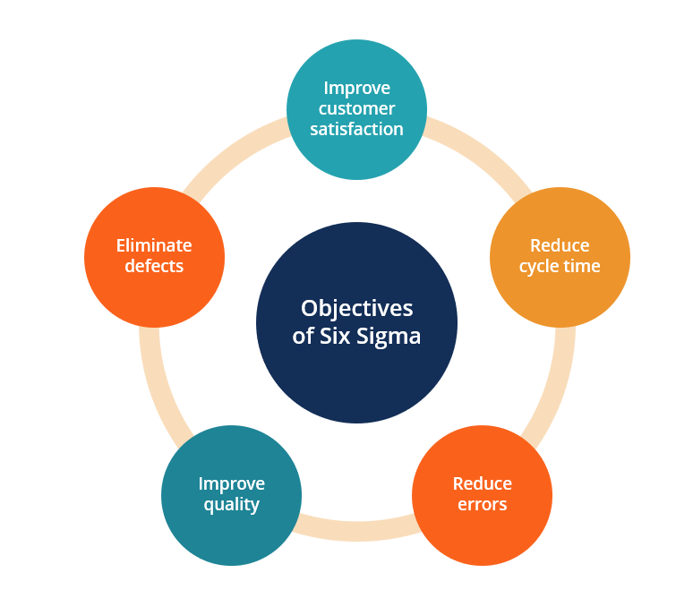
Figure 2Six Sigma (Self-made)
Six sigma implementation starts with a proper strategy of the business to enhance sales with the vision of zero defects and errors in service or products. For this, a benchmark needs to be fixed considering which the business strategy can be measured. With proper methodologies, the goal of the company can be achieved. After a statistical evaluation, the root cause of the problem can be identified, and robust procedures can be applied to correct the error. This sums up the steps of six sigma (Zaid et al., 2020).
Six Sigma uses the DMAIC principle for the elimination of error. The DMAIC principle includes DEFINING the problem of a system or process, MEASURING the error and improvement procedures, ANALYSING of the process and the factors influencing the process, implementing new strategies or policies for IMPROVEMENT of the inaccuracy, and finally assuring the sustainability of the accuracy of process or service by CONTROLLING the newly implemented procedure (Witell et al., 2011).
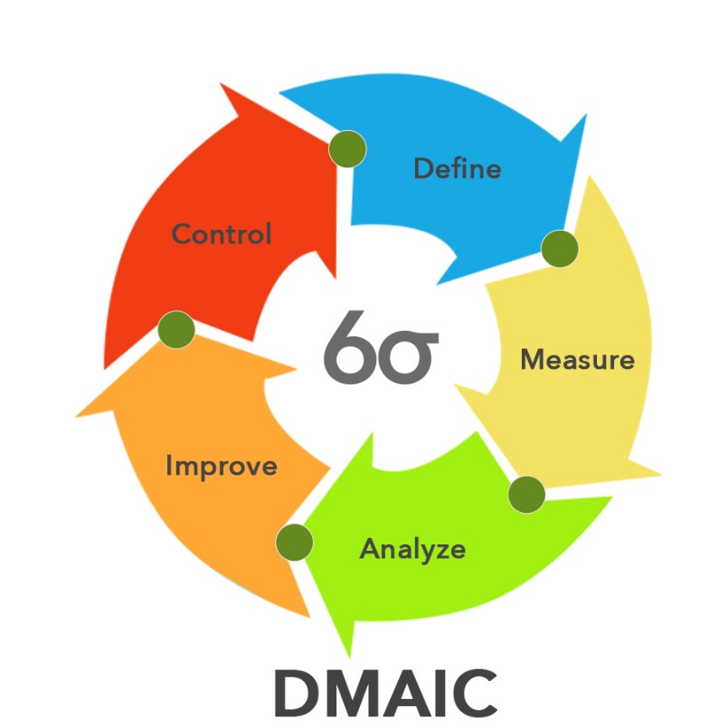
Figure 3DMAIC Principle (Witell et al., 2011)

Aldi can use and implement the six-sigma model in several ways. First, they need to understand the customer demands and expectations by engaging with the customers. For instance, a product may be more demanding during the daytime than at night. Aldi can bring that product in the front and allow customers to get the product in a much efficient way. Another major implementation of six sigma can be on the checkout of products. By installing more counters and self-checkout stations as well as cashless payment, Aldi can reduce the checkout time and hence improve customer relations. Aldi should always try to maintain their inventory of highly demandable products so that customers do not have to return because of products being out of stock. This would minimize time loss of the customers. Apart from that, an efficient and simpler arrangement of products and their alternatives in shelves and proper tags and guideways to find the specific product needs to be done by Aldi so that people can find their desired products easily and in just a few seconds. These processes will improve the relation with customers and improve the overall efficiency of the business. Aldi will be improving their service using DMAIC principles of Six Sigma as a part of their continuous development and attaining customer satisfaction resulting in loyal customers and increased profit.

Conclusion
For running a business, organizations must understand what their customer wants. By knowing the customers, the companies would be able to serve the customers with a quality experience and this would generate customer value and satisfaction for the company. This report has investigated the customer experience of Aldi, a Germany-based supermarket company that has expanded its operations in more than 20 countries. The company uses both tech touch and human touch-based services in its stores so that it can give a satisfactory customer experience to all its customers. The latter part of the report focused on how Aldi manages its service with the help of Total Quality Management and Six Sigma. This has enabled Aldi to serve its customers with better products and add more value to their experience. For this reason, Aldi has been able to survive even after the dominance of Tesco or Asda in the supermarket industry.

References
Aized, T. ed., 2012. Total quality management and six sigma. BoD–Books on Demand. (Accessed: 6th November 2021).
Andajani, E., 2015. Understanding customer experience management in retailing. Procedia-Social and Behavioral Sciences, 211, pp.629-633.marketing, 80(6), pp.69-96. (Accessed: 4th November 2021).
Chiguvi, D., 2016. Impact of Total Quality Management on Customer Satisfaction in the Retail Sector: Case of indigenous Supermarkets in Botswana. European Journal of Business and Management, Volume 8(28). (Accessed: 6th November 2021).
Coskun, A. ed., 2010. Quality Management and Six Sigma. BoD–Books on Demand. (Accessed: 6th November 2021).
Dudin, M., Frolova, E., Gryzunova, N. and Shuvalova, E., 2015. The Deming Cycle (PDCA) concept as an efficient tool for continuous quality improvement in the agribusiness. Asian Social Science, 11(1), pp.239-246. (Accessed: 25th October 2020).
Klefsjö, B., Wiklund, H. and Edgeman, R.L., 2011. Six Sigma seen as a methodology for total quality management. Measuring business excellence. (Accessed: 9th November 2021).
Kruger, V. 2010. Main Schools of TQM: The Big five, TQM Journal, Volume 13(3), pp. 146-155 (Accessed: 9th November 2021).
Kuo, Y. F. 2012. Integrating Kano’s Model into Web-Community Service Quality, Total Quality Management Journal, Volume 15(7), pp. 925-939 (Accessed: 16th November 2021).
Lemon, K.N. and Verhoef, P.C., 2016. Understanding customer experience throughout the customer journey. Journal of consumer marketing. (Accessed: 16th November 2021).
Mascarenhas, O.A., Kesavan, R. and Bernacchi, M., 2016. Lasting customer loyalty: a total customer experience approach. Journal of consumer marketing. (Accessed: 16th November 2021).
McKean, J., 2013. Customers are people... the human touch. John Wiley & Sons. (Accessed: 28th October 2020).
Mehra, S. and Ranganathan, S. 2008. Implementing total quality management with a focus on enhancing customer satisfaction, International Journal of Quality and Reliability Management, Volume 25(9) (Accessed: 25th October 2020).
Meyer, C. and Schwager, A., 2017. Understanding customer experience. Harvard business review, 85(2), p.116. (Accessed: 25th October 2020).
Richardson, A., 2010. Using customer journey maps to improve customer experience. Harvard business review, 15(1), pp.2-5. (Accessed: 16th November 2021).
Salomann, H., Kolbe, L. and Brenner, W., 2016. Self-services in customer relationships: balancing high-tech and high-touch today and tomorrow. E-Service, 4(2), pp.65-84. (Accessed: 6th November 2021).
Witell. L., Lofgren, M. and Gustafsson, A. 2011. Identifying ideas of attractive quality in the innovation process, The TQM Journal, Volume, Volume 23(1) (Accessed: 14th November 2021).
Wortmann, M., 2014. Aldi and the German model: Structural change in German grocery retailing and the success of grocery discounters. Competition &amp; Change, 8(4), pp.425-441. (Accessed: 28th October 2021).
Zaid, A.A., Arqawi, S.M., Mwais, R.M.A., Al Shobaki, M.J. and Abu-Naser, S.S., 2020. The Impact of Total Quality Management and Perceived Service Quality on Patient Satisfaction and Behavior Intention in Palestinian Healthcare Organizations. Technology Reports of Kansai University, 62(03), pp.221-232. (Accessed: 10th November 2021).
Zeng, Z., Chen, P.J. and Lew, A.A., 2020. From high-touch to high-tech: COVID-19 drives robotics adoption. Tourism Geographies, 22(3), pp.724-734. (Accessed: 1st November 2021).
Zu, X., Fredendall, L.D. and Douglas, T.J., 2018. The evolving theory of quality management: the role of Six Sigma. Journal of operations Management, 26(5), pp.630-650. (Accessed: 25th October 2020).

