

Postgraduate/Distance Learning
Assignment coversheet & feedback form
TO BE USED FOR ALL ESSAY SUBMISSIONS FROM APRIL 2026
THIS COVER SHEET REPLACES ALL PREVIOUS VERSIONS.
YOU MUST SIGN THE AI DECLARATION BEFORE YOU SUBMIT THE ESSAY.

THIS SHEET MUST BE THE FIRST PAGE OF THE ASSIGNMENT YOU ARE SUBMITTING (DO NOT SEND AS A SEPARATE FILE)

For completion by the student:
Student Name: HATSUKO NAGASAKI

Student University Email: 2511100@student.uwtsd.ac.uk
Module code:  HPCA7028  Module title:  Sacred Skies | Student ID number:  2511100 |  |  | Educational support needs:  N/A
Assignment title: Measurement based on a physical site
Assignment due date: 30 April 2026
This assignment is for the 1st 2nd 3rd 4th 5th 6th module of the degree
Plagiarism declaration
I confirm that this is my original work and that I have adhered to the University policy on plagiarism.

Artificial Intelligence (AI) declaration

I confirm that I have not used any AI tools in the research and creation of this assignment. I confirm that I have not presented any AI generated materials as my own work. I confirm I have copies of my drafts, notes, and other resources I used, which I may be asked to provide in evidence.

Signed: Hatsuko Nagasaki
Date: 23 April 2026

Assignment Mark
1st Marker’s Provisional mark
2nd Marker’s/Moderator’s provisional mark
External Examiner’s mark (if relevant)
Final Mark

NB. All marks are provisional until confirmed by the Final Examination Board.

For completion by Marker 1 :
Comments:

Marker’s signature: |  |  | Date:
For completion by Marker 2/Moderator:

Comments:

Marker’s Signature: |  | Date:
External Examiner’s comments (if relevant)

External Examiner’s Signature: |  | Date:

Measurement based on a physical site

According to the Agency for Cultural Affairs of Japan, there were over 80,000 Shinto shrines registered as religious corporations as of 31 December 2024. The number is assumed to be higher if it includes shrines that such organisations do not systematically manage. Shinto shrines are part of the country's daily landscape, while their historical backgrounds, the deities they worship, sizes, and positions of importance vary. Shinto shrines worship a variety of deities, including but not limited to figures depicted in Japanese mythology. Shinto is believed to have been established and evolved under the influence of other philosophies and religions, such as Daoism and Buddhism, which were brought to Japan from China. There has also been a social phenomenon in which the Kamis, worshipped mainly under Shinto, merged with Buddhism until the Meiji government ordered their separation in the late 19th century. Such Chinese influence is also believed to have shaped the location and layout of key Shinto shrines. There have been academic discussions about the existence of a ‘sacred axis’ based on the sun’s movement, along which important buildings and imperial tombs were built in ancient Japan, before a new axis, based on Chinese cosmology, became a solid part of Japanese culture from 300 B.C. to the 7th century. This essay explores the existence of such sacred axes through a literature review and an analysis of existing shrines. A sample of five shrines that worship the Sun Goddess Amaterasu was examined to determine whether they are aligned with a specific axis and whether the buildings’ orientations were designed to coincide with key dates in the Sun’s movement, such as the equinoxes and the solstices. The analysis of existing shrines involved on-site measurements at two shrines and virtual measurements at the remaining three shrines. Possible historical and social factors that may have influenced the observed orientation among these five shrines were also investigated. The study of five shrines highlighted mixed results regarding alignment with possible sacred axes, and a lack of evidence that offers clear explanations for these buildings, mainly due to the shrines' antiquity and their links to Japanese myths. It also highlighted that the alignment is not necessarily centred on the key buildings at the shrines and can take the form of alignments with objects of worship in nature, such as mountains, and with areas of political importance in ancient Japan.

Literature review
The tradition of Shinto is centred around the concept of Kami as the subject of worship. Helen Hardacre explained that Kami could arise from different beings. It could be the spirits of a particular place, natural forces like rivers and mountains, figures from myth, or holy beings not appearing in myth but believed to have grown out of communal customs and to have no textual basis. The spirits of human beings who earned the respect of locals for various reasons could also be worshipped as Kami. There have been academic debates over whether to call Shinto a religion or a philosophy, and whether it is appropriate to call it ‘indigenous.’ Sakyo Ono, a Japanese scholar of Shinto writing in 1962, explained that:
Shinto is more than a religious faith. It is an amalgam of attitudes, ideas, and ways of doing things that through two millenniums and more have become an integral part of the way of the Japanese people.
Helen Hardacre criticised this view by pointing out the influence from ‘so many other places and traditions, including Buddhism, Daoism, and Confucianism.’ Hardacre also pointed out the different attitudes Japanese scholars have shown in their writings on Shinto, targeted at audiences outside Japan and at academic circles within Japan: ‘romanticising and idealising’ in the former and ‘sober, balanced and authoritative’ in the latter. She explained that the historical influences on the study of Shinto history, including its association with the rise of nationalism in the pre-World War II period and its link to imperial ancestry, created taboos, especially for academics who were also Shinto theologians.
The study of Japanese mythology, which is linked to numerous Shinto shrines as well as discussions of imperial ancestry, is centred on several literary works, including Kojiki and Nihonshoki. Mark C. Funke explained that the compilation of these two national chronicles was designed by the court to ‘verify that its rule was sanctioned by the deities themselves’ amid the increasing introduction of Chinese ways into Japan. Both documents the myths and history of Japan from the creation to the time of writing. There are other historical documents, such as Fudoki, reports of events and traditions from certain regions presented to the monarchy of Japan, as well as compilations of poems, such as Manyoshu compiled in the 8th century, from which observations of celestial bodies and movements made by the poets could be found.
Regarding what is considered a ‘sacred axis’ in Japan, Edwina Palmer pointed out that the east-west axis was predominant in the spatial organisation of ancient Japan, as evidenced by archaeological sites and mythological literature, before the north-south axis gradually replaced it under Chinese influence. Palmer cites various findings from related literature as indirect evidence of east-west axis orientation. For example:
- In the two key works of Japanese mythology, namely Kojiki and Nihon Shoki, she contrasts the high frequency of east and west in the writing, while south is mentioned only once, and there is no mention of north at all.
- Implicit references to east-west by the expression of sunrise rays and sunsets indicate auspiciousness attached to the axis.
- Indication of marching towards the Sun being considered disrespectful to the Sun Goddess, Amaterasu.
Another subject of study that influences the discussion on such a sacred axis is the existence of the sun cult in Japan. Palmer explains a possible political background that can be read in the myths, giving superiority to the east-west axis that includes the Ise Grand Shrine worshipping Amaterasu and inferiority to the north-south axis, placing the land of the dead (Underworld) not under the ground but beyond the sea in the north from then the capital of Yamato Dynasty (currently Nara prefecture), the direction of sunset on the summer solstice. Palmer concluded that ‘The most important direction was that of sunrise on the winter solstice, so important that it was probably even considered sacred’ and that ‘This predominant axis of orientation was almost certainly associated with the cult of sun-worship’. There has also been an argument about when and why Amaterasu was installed as the sun goddess in the myths. Takeshi Matsumae explained the existence of numerous sun deities in Japanese folklore and myths, not limited to Amaterasu, and argued that Amaterasu was not the deity of imperial ancestry; Takamusubi (one of the three gods who created the universe at the beginning of Japanese mythology) was. Mark Teewen also studies theories presented by Hiroko Yoshino and Seishi Okada on the influence of Chinese cosmology on the Ise Jingu, a grand shrine considered one of Japan's most important and closely linked to imperial ancestry. He highlights various evidence of possible sun worship by the local Watarai clan and the original Geku (outer palace) of the Ise Jingu being on the east-west axis, before the Emperor Temmu (r. 672-686) established the Ise Jingu on the north-south axis.
On the ‘continuity’ of the Ise Jingu, Fabio Rambelli argued that the shrine has changed its significance and the meanings attached to it through history and served as a useful device that bridges different beliefs in Shinto, political vision, and ritual systems:
…in many cases Ise has been taken as an empty signifier that could be filled with any kind of meaning (Buddhist, Confucian, Daoist, internationalist and nativist, local and universal). At times, Ise could even work as a code or semiotic shifter, joining and mediating between different sets of representations - as, for instance, by connecting a different snrine (Omiwa or Hie, say) to the emperor through the use of relations with the goddess Amaterasu, or by transforming the Ise region into the center of the universe by associating the Outer shrines central pillar (shin no mihashira) with Mount Sumeru.
Allan Grapard studied what the official registration of over 2,800 shrines by the government in the 8th century could tell about the unique positioning of Shinto shrines at that time, discussing around three working hypotheses: 1) location of shrines carrying strategic importance in the political and military campaigns; 2) social and economic competition among the leading sacerdotal houses at the time; 3) Buddhism being a part of the equiation. He also pointed out the fact that ‘the central government took control of these shrines and their cults in a strategy of territorial and social control’, and their ‘appropriation of these shrines and cults’ must have led to significant changes in their practices and ideas.
Such a wide variety of discussion around Shinto, Japanese mythology, sacred axes in ancient Japan, as well as the Ise Jingu and other historic shrines, leads to a question of whether the Shinto shrines that worship Amaterasu show consistency in terms of their orientation to the Sun’s movements and if there are factors such as historical, political and social reasons that could explain the current orientation.

Methodology for measurement
Criteria for the selection of the shrines
Different types of Shinto shrines worship different deities from Japanese mythology or other influential figures, as Hardacre explains. In this measurement, five Shinto shrines that worship the Sun Goddess Amaterasu were examined to determine which axis their key buildings align with and whether they are designed to align with certain celestial events, such as the vernal equinox and solstices. The details of the five shrines are summarised in Table 1, and their locations on the map of Japan are shown in Figure 1. An ID number was allocated to each shrine to simplify reference in the later discussion.

Table 1: Shrines selected for measurement
ID No. | Name | Location (prefecture) | Date established
1 | Oji Jinja | Tokyo | Believed to have been built in the 14th century.
2 | Shiba Daijingu | Tokyo | 11th century
3 | Ise Jingu (Naiku) | Mie | Unknown. Believed to have been built in 4 BC.
4 | Moto Ise Naiku Kodai Jingu | Kyoto | Unknown. Believed to have been built in 59BC.
5 | Oomi Jinja | Miyazaki | Unknown. The shrine’s own record states that the shrine dates back to Ninigi's descent in the myth.

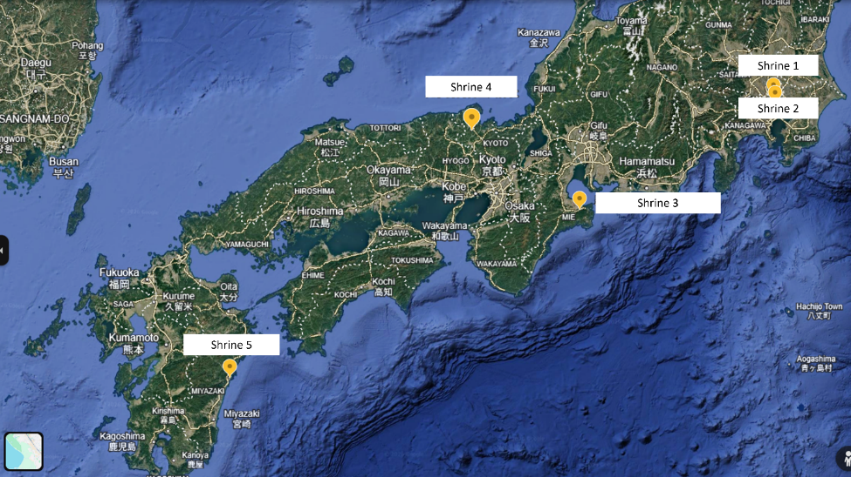Figure 1: Locations of the shrines (adapted from Google Earth)

Two shrines in Tokyo were chosen for onsite measurement. Shrine 1 is relatively small and was selected as a representative of a small neighbourhood shrine. Shrine 2 is also relatively small, located in the middle of an office district surrounded by high-rise buildings, but differs from Shrine 1 as it worships the same two goddesses worshipped at the Ise Jingu (Shrine 3), and has been called ‘Kanto-no-Oise-sama (Shrine of Ise in the Kanto region). Kanto includes Tokyo and the six prefectures surrounding Tokyo. The other three shrines (Shrine 3, 4 & 5) were selected with consideration for their varying importance to the Shinto community and their historical ties to Japanese mythology. For Shrine 3, there are two separate locations: Naiku (Inner Palace) and Geku (Outer Palace). For this measurement, the Naiku, which worships Amaterasu, was selected.
Differences in the surrounding environment were also taken into account in the selection. For example, Shrine 2 is in a busy city area of Tokyo, Shrine 4 is in a relatively mountainous area, and Shrine 5 is located close to the sea. Locations such as Mie and Miyazaki have a strong link to Japanese mythology, which raises expectations of alignment with the east-west axis, which Palmer argued was the sacred axis in ancient Japan.

Method and subject of measurement
On-site measurements were taken using a compass (SUUNTO A-10NH) and the iPhone compass app. For virtual measurement, Google Maps and Google Earth were used to measure azimuth. A website, ‘heywhatsthat.com’ was used to measure the altitude of the Sun when it becomes visible from the site. Declination was calculated using a tool provided by the University of Wales Trinity Saint David, based on the data for azimuth, altitude, and latitude obtained through the tools mentioned above.
The orientation of the shrines’ main buildings, namely Haiden (the prayer hall) and/or Honden (the main hall), was measured. In cases where the shrine’s object of worship is believed to have been a natural entity, such as a mountain, alignments between the shrine and that object were also measured.

Findings and Discussion
Mixed results for the orientation of the main buildings
The results of the measurements are summarised in Table 2. The measurements highlighted mixed results on the orientation of the main buildings. No consistency was observed by location or by the era in which the shrines are believed to have been established. One out of five shrines is on the east-west axis, two on the north-south axis, and the other two on neither axis.

Table 2: Summary of measurement results
ID No. | Name | Location | Axis | Measurement data | The timing of the sunrise is expected to beam into the main building
1 | Oji Jinja | Tokyo | Northeast - Southwest  (Building facing southwest) | Azimuth: 246.01  Latitude: 35.753278  Longitude: 139.735917  Altitude: 0.35  Declination: -19.05 | 25-26 January,  18 November
2 | Shiba Daijingu | Tokyo | East-west  (Building facing east) | Azimuth: 88.75  Latitude: 35.657639  Longitude: 139.753056  Altitude: 0.59  Declination: 0.34 | 22-23 March,  22 September
3 | Ise Jingu  - Naiku | Mie | North-south  (Building facing south) | Azimuth: 179.71  Latitude: 34.45561079393287  Longitude: 136.72635785435497  Altitude: 9.28  Declination: -46.26 | N/A
4 | Moto Ise Naiku Kodai Jingu | Kyoto | North-south  (Building facing south) | Azimuth: 169.68  Latitude: 35.430139  Longitude: 135.1545  Altitude: 4.12  Declination: -49.28 | N/A
5 | Oomi Jinja | Miyazaki | Northwest – Southeast  (Building facing northwest) | Azimuth: 132.86 (towards the direction of sunrise)  Latitude: 32.411  Longitude: 131.649417  Altitude: 0.07  Declination: -33.59 | N/A

At Shrine 1, the main building and the gate face southwest. The calculation shows that the timing of the sun's beam entering the main building does not coincide with the equinoxes or solstices. The current building was burnt down during World War II air raid and was rebuilt in 1964. There is no publicly available literary document stating that the building's orientation was originally different. At this shrine, Amaterasu is worshipped as one of the five deities, which makes the Shrine’s relationship with her different from the other four shrines. Shrine 1 has its roots in the Kumano Shrines in Wakayama. The establishment of the oldest shrine, Kumano Motomiya Jinja, is unknown, but several documents record it as 33 BC. Virtual measurement showed that Kumano Motomiya Jinja is located at an azimuth of 241.24 degrees, in the southwest direction from Shrine 1, suggesting a possible conscious choice in determining the shrine's direction.

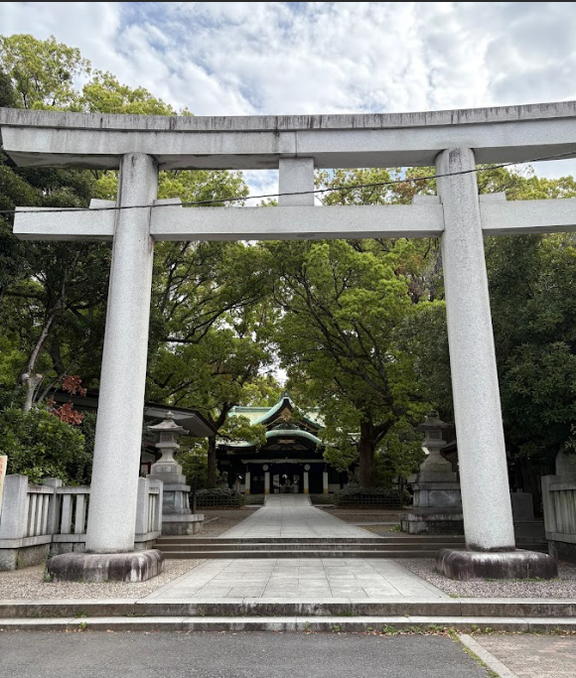
Figure 2: View of Oji Jinja (Shrine 1) from the Torii gate to the Prayer Hall/Hall of Worship.
(Photo: Hatsuko Nagasaki)

Shrine 2, Shiba Dai-Jingu (Figure 3), is the only shrine in the sample group that stands on the east-west axis, with the main building facing the east. The Sun is expected to beam into the main building around the dates of equinoxes. This shrine has its roots in the Ise Jingu, and therefore, Amaterasu is the primary subject of worship. The place has been known as the ‘O-Ise of Kanto’ (Kanto is a region that includes Tokyo and its six surrounding prefectures). The shrine has been rebuilt several times due to fire, earthquakes, and war, and the current building was completed in 1964. From the shrine, the Ise Jingu is located at an azimuth of 244.99 degrees, i.e. no special alignment seems to exist between the two shrines. No official explanation of its orientation was found at the shrine or in the literature.

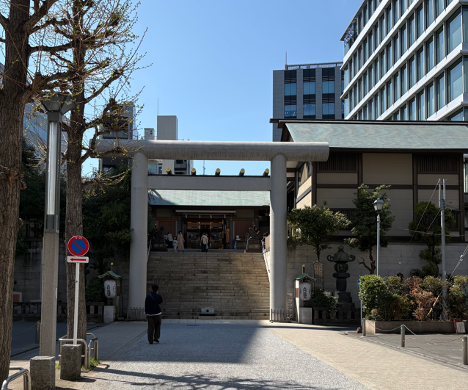
Figure 3: View of Shiba Dai Jingu (Shrine 2) from the Torii gate to the Prayer Hall.
(Photo: Hatsuko Nagasaki)
At the Ise Jingu (Shrine 3), the hall of worship of Amaterasu faces south, which confirms Teewen’s study around Yoshino’s theories on the influence of Chinese cosmology at the Ise Jingu. Within the grounds of the Naiku, neither the official website nor Google Earth showed buildings facing east. The official website of the Ise Jingu explains that the Sun rises in alignment with the Torii gate at the Ujibashi Bridge around the winter solstice (Figure 5). The virtual measurement, however, showed the Torii is located at the azimuth of 125 degrees. The calculated declination (-24.21) did not confirm its exact alignment with the sunrise at the winter solstice.
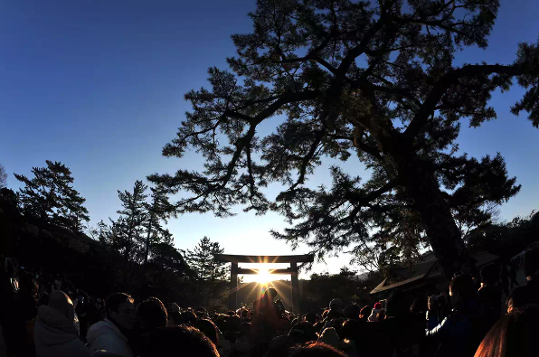
Figure 5: Ise Naiku Ujibashi Torii gate at the winter solstice
(copyright: Jingushicho; https://www.isejingu.or.jp/nature/)
Teewen also discusses Seishi Okada’s research into Geku, the Outer Palace of the Ise Jingu, which currently serves as a site of worship for Toyouke-no-oomikami, the Goddess responsible for divine foods. Okada noted that both the grave mound found at the summit of a hill called Takakurayama, located within Geku, and the hill itself faced east, indicating sun worship practised by the Watarai clan, who ruled the area before the Emperor Tenmu established the Ise Jingu and lowered their status. The current buildings in Geku, however, all face south, and the Tsuchinomiya is the only building facing the east, confirmed by the Ise Jingu itself. The building is built for Ootsuchi-no-mioya-no-kami, a guardian deity of the local area. Ise Jingu's official website states that, although the reason for the eastward orientation of this particular building is unknown, there have been various theories, such as that the change to a south-facing orientation would have the building’s back towards the Goddess in the main building, and one associated with geographical features.
Regarding the connection between the Ise Jingu and the Sun’s movement, Hardacre pointed out a different alignment, not by a particular building of worship in the Ise Jingu, but by the location of the shrine itself:
Mt. Miwa had been the original Yamato ritual site, but for reasons that remain unclear, they disengaged from the Miwa deity in favor of a cult of a solar deity at Ise. The shift created a sacred site in the direction of the sun’s rising.
If this is true, the general location of the Ise Jingu site was east of the centre of Japanese politics at that time. The Makimuku ruins are believed to be the site of the Yamato dynasty's capital. Google Earth measurements show that the Ise Jingu (Inner Shrine) is at an azimuth of 96.72 degrees from the ruins, confirming the east-west axis alignment explained by Hardacre (Figure 6). The calculated declination, however, indicates that the Sun does not rise from the direction of Ise Jingu on a date coinciding with equinoxes or solstices. The measurements around Shrine 3 highlight various historical factors that could have influenced the shrine's orientation, including the possible presence of a sun cult before the shrine's establishment and the east-west alignment between two locations on a larger scale.
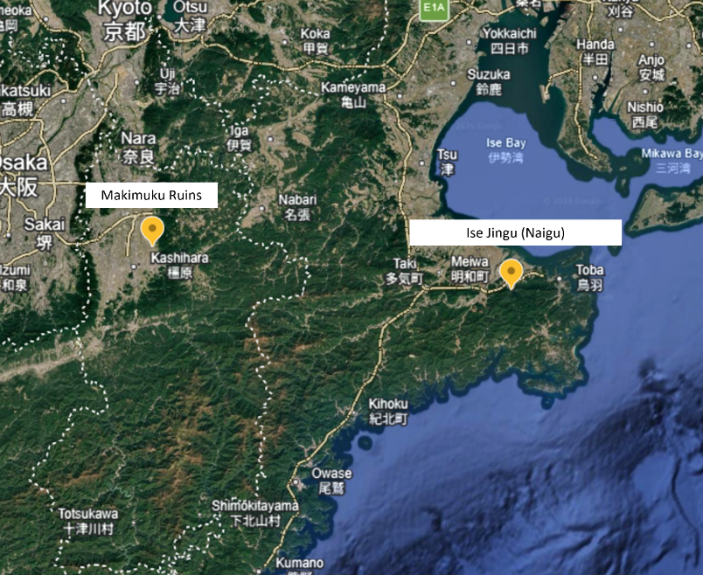
Figure 6: Location of Makimuku ruins and Ise Jingu (adapted from Google Earth)
Shrine 4, Moto Ise Naiku Kodai Jingu, has a history of serving as a temporary residence for Amaterasu during her relocation from Miwa in Nara Prefecture to the current site in Ise, at the order of Emperor Sujin (r. 97 - 30BC). The measurement showed that its hall of worship for Amaterasu is facing southward. However, the shrine's official website explains that it has historically worshipped a mountain, Himuro-ga-dake (also known as Iwato-yama), which is surrounded by untouched forest. At the summit of the mountain is what is believed to be a Hanza, a sacred rock on which a God/Goddess is said to descend in Shinto, and the shrine’s official website shares a legend that the shrine might originally have been located there. The eastern side of the mountain has been preserved as the ‘Forbidden Area’ where humans are not allowed to enter. The current shrine is located east of the mountain, at an azimuth of 101.31 degrees, suggesting that there might originally have been respect for the east-west axis (Figure 7). Calculated declination from the mountain did not indicate an alignment with sunrise at the equinoxes/solstices. The shrine also explains that the sun sets in line with the mountain's summit on the summer solstice, as viewed from the place of worship within the shrine's precincts. The virtual measurement shows that the sun sets at an azimuth of 282 degrees from the place of worship, and the declination is calculated to be 22.72 degrees, which indicates that the sunset will align with the summit around 11 June, close to the summer solstice. Measurements around Shrine 4 indicated a possible east-west orientation and sun worship before the shrine was formally established as a place of worship for Amaterasu, similar to Shrine 3.
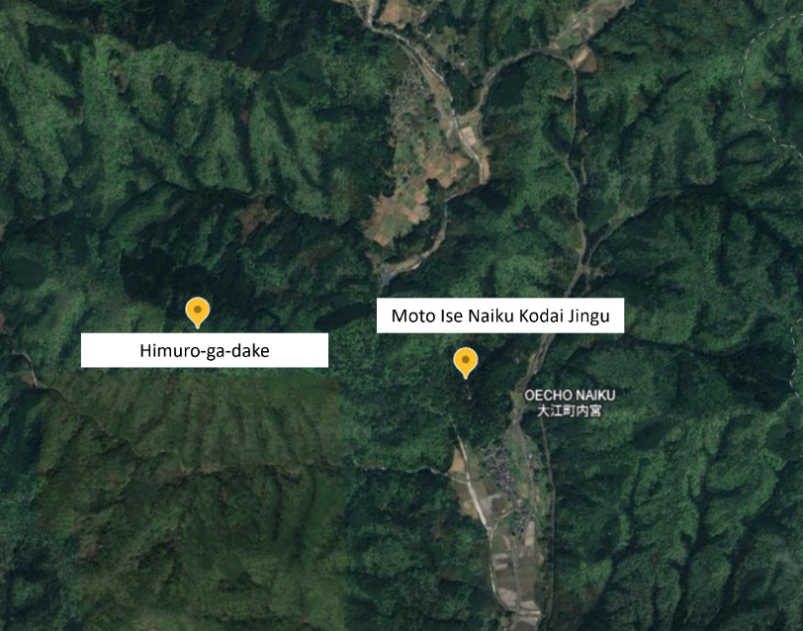
Figure 7: Location of the Himuro-ga-dake and Moto Ise Naiku Kodai Jingu (adapted from Google Earth)
Shrine 5, Oomi Jinja, is located in an area known as 日向 (Hinata or Himuka; lit. "facing the sun"), where important events in Japanese mythology are believed to have occurred, including the birth of Amaterasu from the left eye of Izanagi and the descent of her grandson Ninigi-no-Mikoto to rule the land. Palmer referred to the Hinata-Ise line as the east-west axis: ‘From the point of view of the court centered in the Yamato capital, the Izumo-Kii route forms an 'inferior' north-south axis, while the Himuka-Ise route suggests a 'superior' east-west one.’ The shrine is called ‘Hinata-no-Oise-sama’ (Ise shrine of Hinata), just as Shrine 2 was called the Ise of Kanto. According to the shrine’s official website, its record states that its origin dates back to the day of Ninigi’s descent in Japanese mythology. The shrine has been built close to the sea, and the current main building was rebuilt in the 1930s. The virtual measurement showed that the hall of worship faces north-west, with its back to the sea, and the data do not indicate any alignment between the building and the Sun on the equinoxes or solstices. In 2011, the shrine found what it claims are the remains of a dragon worshipped in ancient Japan (which could date back 5,000 years), including an artificial cave with a crack that resembles a rising dragon facing the sea. Given the old history, such a place could have an east-west orientation or an alignment with the Sun at the equinoxes/solstices, but the cave's orientation could not be determined by virtual measurement.
In summary, findings from measurements of five Shinto shrines that worship Amaterasu, the Sun Goddess, and additional online research indicate that there was no clear rule or consistency among shrines regarding what could be considered a sacred axis. The shrine can be on the east-west axis suggested by Palmer as the predominant axis in ancient Japan, the north-south axis based on Chinese cosmology, or on other axes. Even the north-south axis might not be solely due to Chinese influence and could instead reflect geopolitical considerations. The study of the five shrines also shows the possibility of a wider range of factors influencing the location and direction in which shrines are built. The alignment with what could have been considered a sacred axis can be observed not necessarily around the shrine's main building, but, on a larger scale, for example, in a mountain that has historically been the subject of local worship. The measurements also highlighted the advantages and disadvantages of using virtual methods. While it provides a bird's-eye view and enables measurement of alignment between a building and another site, such as a mountain and a building in another city, it cannot measure an architecture surrounded by forest or located in a cave, which could apply to some shrines dating back to ancient times.

Conclusion
This essay explored the presence of sacred axes in Japan by studying the orientation of existing Shinto shrines. A sample of five shrines that worship the Sun Goddess Amaterasu was examined to determine whether they are aligned with a particular axis and whether the buildings’ orientations were designed to coincide with certain solar movements, namely equinoxes and the solstices. This work involved on-site measurements at two shrines and virtual measurements at the remaining three shrines. The study of five shrines highlighted mixed results regarding the axes on which they are built, even though they all worship Amaterasu. The findings highlighted the influence of geopolitical factors on the location of certain shrines, and in some cases, alignment with the east-west axis discussed by Palmer can be observed outside a shrine, for example, between the location of the shrine and its historical object of worship, such as a mountain. Although the scope and methods of measurement for this essay were limited, they highlighted various factors that could influence the orientation of a shrine’s building and its location, reflecting political and religious influences that have transformed the style of worship and practices over centuries, and confirmed the orientations of certain locations discussed in the past academic research, as well as those claimed by the shrines themselves.

Bibliography
Agency of Culture Affairs, ‘Shukyo Nenkan Reiwa 7 Nen Ban’ (Religious Yearbook for FY2025), https://www.bunka.go.jp/tokei_hakusho_shuppan/hakusho_nenjihokokusho/shukyo_nenkan/pdf/r07nenkan.pdf [accessed on 30 April 2026]

Funke, Mark C., ‘Hitachi no Kuni Fudoki’, Monumenta Nipponica, 49.1 (Spring, 1994), pp. 1-29

Grapard, Allan G., 'Shrines Registered in Ancient Japanese Law: Shinto or Not?', Japanese Journal of Religious Studies, 29.3-4 (2002), pp.209-232

Hardacre, Helen, 'Introduction', Shinto (New York, 2017; online edn, Oxford Academic, 22 Dec. 2016)
https://academic.oup.com/book/6981/chapter/151269530?login=true [accessed on 26 April 2026]

Japanese Architecture and Art Net Users System (JAANUS)
https://www.aisf.or.jp/%7Ejaanus/ [accessed on 29 April 2026]

Matsumae, Takeshi, ‘Origin and Growth of the Worship of Amaterasu’, Asian Folklore Studies, 37.1 (1978), pp. 1–11

Palmer, Edwina, ‘Land of the Rising Sun. The Predominant East-West Axis Among the Early Japanese’, Monumenta Nipponica, 46.1 (1991), pp. 69–90

Rambelli, Fabio, ‘Floating Signifiers: The Plural Significance of the Grand Shrine of Ise and the Incessant Re-signification of Shinto’, Japan Review, No. 27 (2014), pp. 221-242

Teeuwen, Mark, ‘The Imperial Shrines of Ise: An Ancient Star Cult?’, Culture and Cosmos, 10.1 and 2, Spring/Summer and Autumn/Winter (2006), pp.79-98

Official websites of the shrines
Ise Jingu official website
https://www.isejingu.or.jp/ [accessed on 28 April 2026]

Kumano Hongu Taisha official website
https://www.hongutaisha.jp/about/ [accessed on 28 April 2026]

Motoise Naiku Kodai Jingu official website
https://www.motoisenaiku.com/shrine-information [accessed on 25 April 2026]

Oji jinja official website
http://ojijinja.tokyo.jp/index.html [accessed on 26 April 2026]

Oomi jinja official website
https://oomijinja.com/ [accessed on 26 April 2026]

Shiba Daijingu official website
https://www.shibadaijingu.com/ [accessed on 26 April 2026]

Agency of Culture Affairs, ‘Shukyo Nenkan Reiwa 7 Nen Ban’ (Religious Yearbook for FY2025), p.33 https://www.bunka.go.jp/tokei_hakusho_shuppan/hakusho_nenjihokokusho/shukyo_nenkan/pdf/r07nenkan.pdf [accessed on 30 April 2026]
Helen Hardacre, Shinto, online edn, (New York, 2017; Oxford Academic, 22 Dec. 2016) https://academic.oup.com/book/6981/chapter/151269530?login=true [accessed on 26 April 2026] (Introduction)
Ibid., Chapter 12: Shinto and the Meiji State.
Ibid., Introduction.
Sokyō Ono, Shinto, The Kami Way: An Introduction to Shrine Shinto, in collaboration with William P. Woodward (Rutland, Vermont and Tokyo: Charles E. Tuttle Company, 1962), cited in Hardacre, Shinto, 2016.
Hardacre, Shinto, Introduction
Ibid.
Mark C. Funke, ‘Hitachi no Kuni Fudoki’, Monumenta Nipponica, Vol. 49, No. 1 (Spring, 1994), pp. 1-29. (p.1)
Edwina Palmer, ‘Land of the Rising Sun. The Predominant East-West Axis Among the Early Japanese’, Monumenta Nipponica, 46.1 (1991), pp. 69–90. (p.81)
Palmer, ‘Land of the Rising Sun. The Predominant East-West Axis Among the Early Japanese’
Ibid.
Ibid., p.89.
Takeshi Matsumae, ‘Origin and Growth of the Worship of Amaterasu’, Asian Folklore Studies, 37.1 (1978), pp. 1–11.
Mark Teeuwen, ‘The Imperial Shrines of Ise: An Ancient Star Cult?’, Culture and Cosmos, 10.1 and 2, Spring/Summer and Autumn/Winter (2006), pp.79-98.
Fabio Rambelli, ‘Floating Signifiers: The Plural Significance of the Grand Shrine of Ise and the Incessant Re-signification of Shinto’, Japan Review, No. 27 (2014), pp. 221-242. (p.235)
Allan G. Grapard, 'Shrines Registered in Ancient Japanese Law Shinto or Not?' Japanese Journal of Religious Studies 2002 29/3-4, pp.209-232.
Ibid., p.209
Ibid., p.209
Kumano Hongu Taisha official website, ‘About Kumano Hongu Taisha’, https://www.hongutaisha.jp/about/ [accessed on 28 April 2026]
Teewen, ‘The Imperial Shrines of Ise?’, p.88.
Ise Jingu official website, ‘Tsuchinomiya’, https://www.isejingu.or.jp/about/geku/betsugu.html#tsuchinomiya [accessed on 28 April 2026]
Ibid.
Hardacre, Shinto, Chapter 1: Shinto in the Ancient Period.
Motoise Naiku Kodai Jingu official website, ‘Himurogatake Worship Place’, https://www.motoisenaiku.com/shrine-information [accessed on 25 April 2026]
Palmer, ‘Land of the Rising Sun’, p.78.
Oomi jinja official website, ‘History’, https://oomijinja.com/history.html [accessed on 26 April 2026]
Oomi Jinja official website, ‘Dragon God, https://oomijinja.com/dragon-god.html [accessed on 26 April 2026]

