Sponsorship within the UEFA champions league football

A definition of sponsorship is the act of supporting a person, organization, or activity by giving money, encouragement or other help.
The sponsors for the UEFA Football are;
- Mastercard
- Sony – PlayStation
- Adidas
- Ford
- Pepsi co - Walkers, Pepsi max, Gatorade, Lipton, 7up, Doritos
- Heineken - £62m a year, also won the rights to exclusive UEFA championship league content.
- Uni credit
- Gazprom - also sponsors individual teams
- Nissan - Sponsor of wales also, costs £53m
- Sky
- SAT.1
The history has shown that UEFA prefers loyal sponsors and if, for some reason, they lose one, the other will appear instantly. Each sponsor included in this story recognized gigantic potential and opportunities which lay in this competition.
With millions of fans and viewers from all around the world and the final match as the most viewed sporting event, UEFA Champions league is offering a greater number of media appearances that can significantly strengthen your brand identity. With, all you need is a smart and right strategy to get the best out of its global potential.
Although most of the financial terms are kept as a secret, UEFA might easily be the biggest sponsorship earner on the planet and, obviously, there is a valid reason why this might be true. (Nikola Popovic)
“The UEFA Champions League sponsorship is the largest activation platform for the Heineken brand. In our eight-year partnership, research has shown that Heineken awareness has grown to 60% among UEFA Champions League fans.” – Hans Erik Tuijt, Global Activation Director at Heineken
Despite improving qualitative key success factors like image, awareness and purchase intention sport sponsorship also has the goal to show bottom line impact by increasing future sales and profits. However, all the direct costs in form of sponsorship fees and indirect costs that take the shape of activation and of agency costs inferred by the company are expected to be offset by future benefits in terms of increased media exposure and brand awareness, positive image building, and ultimately higher profits (Farrell & Frame, 1997).

AIM
for UEFA is determined be a strong leader in its role as the umbrella body for European football. However, as one of the 11 values on which UEFA bases its work and activities, the body pledges to operate in a spirit of consensus.

STAKEHOLDERS
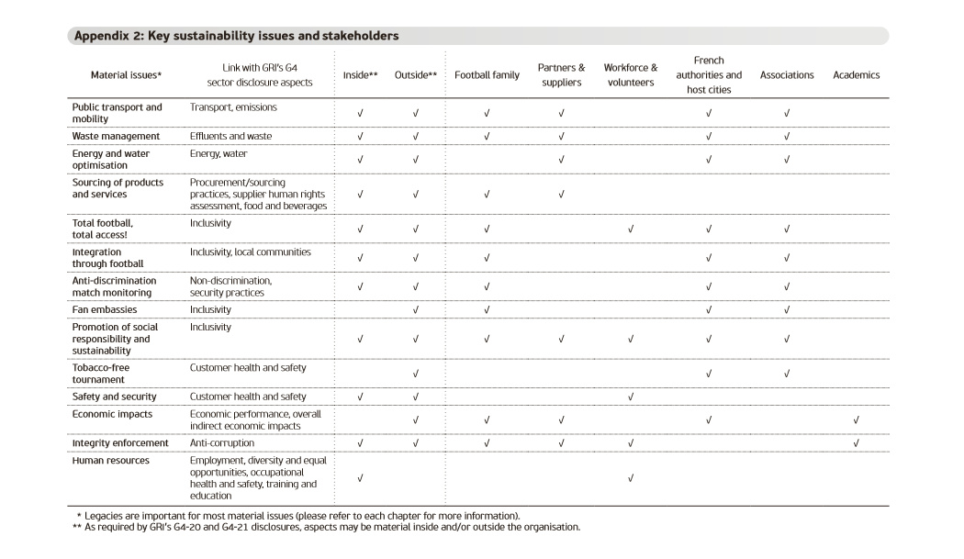
In addition to cooperation with its 55 national associations, UEFA involves all stakeholders – including leagues, clubs, and players, in the decision-making process within European football, to enable the UEFA Executive Committee to take the correct decisions for the overall well-being of the European game. Moreover, UEFA is pursuing closer relations with football fans – the lifeblood of the game – and has nurtured positive dialogue with the European political authorities over the years.
The sponsors’ data will be divided into two categories: main sponsor and partners. The companies categorized as main sponsors of a football club are the ones that have the company’s logo on the team’s official kit whilst the sponsors considered as partners are companies that supply the football club with different services: from original sports kit (Nike, Adidas, Puma) to logistic services (DHL) and travel advices and arrangements services.
PERFORMACE
Football has continued to attract passionate audiences around the globe producing some of the most popular events such as the UEFA.
The UEFA champions league has designed sponsoring opportunities for brands that are wanting to be connected in the most televised football competition that there is. The exposure of this includes television adverts, field of play, sports gear, venue positions and much more and this is shared between 9 to 12 sponsors that the UEFA decide on having as their sponsors from the bids that come in. Within the performance for sponsors is that they get great coverage within the marketing program through the televised attention and they also start to increase competition for other brands to compete against them as fans will go for the brand of the team they are supporting and follow on from there so the main sponsors have a huge impact on other brands that are not within the UEFA.

STRENGTHS & WEAKNESSES
Football has rapidly become one of the largest entertainment industries in the world with its main economic platform placed in Europe, due to the multimillion euro sponsorship deals the European football clubs close with multinationals. The latest edition of the Deloitte Football Money League (2013) states that Real Madrid is the first club (in any sport) that exceeds revenues of 500 million euro in a single year maintaining this position for nine consecutive years due to the players and sponsorships.
Strengths;
- Financial support
- Helps broaden the opportunity to reach goals
- Builds and image
- Helps target a fan base
- Helps consumers by generating product and service awareness
- Builds goodwill
- Ability to promote to its target market
- Generate positive publicity.
Weaknesses;
- Negative attitudes as they do not think positive from the outcome they all are mainly negative minded
- Absence of standardization
- More time consuming to build up and promote relationships
- Costs so much to be a part of the UEFA and normally the sponsors do not stick to their budgets.

ISSUES
Poor record - Since 1993 League of Wales teams have had a poor record in the UEFA Champions League, UEFA Cup and UEFA cup competitions - a factor which Shanklin believes has affected potential sponsorships.
'Good for everyone'
He said: "I don't think the record in European competition helped. But our Welsh international team under Mark Hughes is certainly on the upturn. We have Italy at the Millennium Stadium on 16 October. A win or a draw there will raise the profile of Welsh football even more - that can only be good for everyone in the principality." (Sponsorship boost for League of Wales, 30 September 2002).
WHY CARDIFF?
Reason for the bed with Cardiff hosting the championship final
First Minister Carwyn Jones wrote to UEFA president Michele Platini in 2011 and said: “Staging the UEFA Champions League final in Cardiff would provide a legacy throughout the country of Wales due to the passion for football across the nation.”
“This, coupled with the fact that the ‘Team Wales’ approach has provided such fantastic achievements organising successful FA Cup finals, Rugby World Cups and the Ryder Cup, fills me with confidence that UEFA should consider Cardiff and Wales a most suitable venue.” (V. Jones, 3 JUN 2017)
Agreement to be reviewed
The agreement is worth €41,351 this season and will be reviewed next summer with a view to an increase. Mitsubishi's move ends seven barren years for the Football Association of Wales' top-flight section, which had failed to attract a sponsor since office equipment specialists Konica pulled out their financial support in 1995.

Deal welcomed
There were hopes Honda would step in some months back, but the deal collapsed when the company's name was leaked before a formal agreement was ratified. FAW president Des Shanklin welcomed the news. He said: "This has been long overdue in arriving. It's a mystery to me why other companies hadn't stepped forward sooner. The deal is adequate. Maybe we could have hoped for one more lucrative, but it's a start, something we can build on."
COSTS
While sponsorships only buy the right to use the name of the respective team or organization, they represent sizeable investments averaging to about one percent of total revenue of major sponsors (Pickett 2004) and one of the most important non-television revenue sources for major league sports associations, recent figures showing that it might cost up to €150 million to sponsor the UEFА Champions League.
sponsorship deals might end up multiplying the sponsor's budget significantly, to even two or three times over the initial investment, thus the importance and influence of official sponsorships on football clubs’ financial status cannot be overlooked.
While many previous studies tried to measure the impact of sponsorships on elements like brand awareness or corporate image.
STRATEGIC PLANNING
For the UEFA to make their decisions on what sponsors have bided to be supporting the event they follow a three stage of questions, the first being under significant unaided awareness level questions and the next two stages come under producing high levels of awareness amongst brands, they ask 200 questionnaires and analyse them very thorough to get the most suitable brands for the UEFA.

STATS OF THE UEFA Champions League
• The global forecasted pot available per season for distribution to clubs in the UEFA Champions League amounts to €1.257bn.
• Clubs involved in the play-offs will receive €50m: €2m to each play-offs winner and €3m to the eliminated clubs.
• The amount of €1.207bn available to the clubs from the group stage onwards will be split as usual between fixed amounts and market pool. However, the market pool will be reduced from 45% to 40% of the total and fixed amounts increased accordingly to 60%.
Fixed amounts (€724.4m)
• Group stage fee €12m
• Group stage performance €1.5m win / €500k draw
• Round of 16 €5.5m
• Quarter-finals €6m
• Semi-finals €7m
• Final €15m winners / €10.5m runners-up
• In addition, the winners of the 2015 UEFA Super Cup can expect to receive €4m and the runners-up €3m.
Market pool (€482.9m)
• The amount of €482.9m will be distributed according to the proportional value of each TV market represented by the clubs taking part in the UEFA Champions League and be split among the clubs participating from a given association.
• In accordance with the existing system, half of the amount representing the value of each market will be split among the clubs based on their performance in the previous domestic league championship and the other half will be paid in proportion to the number of matches played by each team in the 2015/16 UEFA Champions League.
• Each time that a club of an association represented by one or more clubs in the UEFA Champions’ League group stage is eliminated in the play-offs, 10% of the respective association’s market pool share will be allocated to the eliminated club. This is a new arrangement, which was not contemplated in the distribution system beforehand.

Payments to clubs not qualified to the group stages
An enhanced distribution system for solidarity payments for clubs not competing in the UEFA Champions League or UEFA Europa League group stage has also been adopted by UEFA for the 2015-18 cycle.
• The distribution to clubs participating in the qualification phases of either competition (except those qualifying to the group stage of the UEFA Champions League, which will not be entitled to these solidarity payments) will represent 3.5% of the overall revenues. An amount of at least €78.6m will be distributed, compared to €47.5m in the 2012-15 cycle, thus representing an increase of around 60%.
• Clubs eliminated prior to the group stage will receive the following amounts per round: €200k in the first qualifying round, €300k in the second qualifying round and €400k in the third qualifying round (this latter, if not involved in the UEFA Champions League play-offs). In addition, any domestic champion not qualified for the group stage of the UEFA Champions League will receive €250k.
Solidarity payments to clubs not qualified for UEFA club competitions
• A total of €112m will be distributed to national associations and/or leagues for their clubs, compared to €82.4m in the 2012-15 cycle, thus representing an increase of more than 35%. 80% of this amount will be distributed to national associations and/or leagues with at least one club participating in the UEFA Champions’ League group stage and 20% to national associations and/or leagues without participating clubs. Only clubs not participating in the group stage of either competition will be entitled to a share of these solidarity payments.
• Furthermore, the distribution to national associations and/or leagues will no longer be exclusively based on their market value, but 60% of the available amounts will be distributed in equal shares amongst all national associations and/or leagues and only 40% will follow the market value. This will ensure a fairer distribution of solidarity amounts to European clubs. (UEFA Champions League revenue distribution, 1 March 2015)
The League of Wales has landed a sponsorship deal with Japanese car giants Mitsubishi.

FUTURE
The UEFA have made a 3-year deal for KIA motors to be s sponsorship for 2018-21
They have offered a new partnership for 4 years with Volkswagen for 2018-22
UEFA have now opened a bidding for 3 parts of the games to be sponsored. The first bidding for sponsorship is the UEFA 2020 final draw and final tournament the second bidding is for UEFA nations league finals 2019 and 2021 and the last bidding is for UEFA champions league 2018-2021. All offers for the three were all last placed by the 19th September 2017.
RECOMMENDATIONS
One of the recommendations that would be great for the sponsorships is to use sponsorships that are well known to people within Europe as when having sponsorships on the football itself especially the tops it affects the image if you get the wrong sponsors so sponsors such as the Gazprom and SAT.1 no one really knows about them and what they do you would have to research into them to know what they are. Another recommendation would be not to promote things that are not good for people such as sponsoring by Doritos its not showing a healthy living lifestyle to help people within promoting sports to people especially to the youth generation. They should have more big brands such as Nike sponsoring them instead of average cars that sponsor them as you do not see much for the car sponsors shown like you do with adidas. For the sponsorship they should put out a questionnaire or a poll where fans that follow the UEFA can pick their top three or top five sponsors that they would like to see within the UEFA as by this way they have a rough idea of what to go for and what to definitely not to go for but post the ones that have or want to put a bid in and this will help know what products and services are going to sell really well within the duration of the UEFA games.

CONCLUSION
Overall it shows that sponsorship plays a very big part within the UEFA and that brands will bid a lot of money just to be known as a sponsor as they know that whatever money they spend they will be making back and much more within the products and services they have because that is what happens when a fan base catches on with teams that they love and follow so some will buy anything just to show what they have within the UEFA.
Link for Prezi presentation - http://prezi.com/1tt3frn-kdmd/?utm_campaign=share&utm_medium=copy
REFERENCES
- Farrell & Frame, (1997), http://arno.uvt.nl/show.cgi?fid=135797
- Hans Erik Tuijt, Global Activation Director at Heineken
- http://www.goal.com/en-gb/news/uefa-rules-threaten-to-disqualify-rb-leipzig-or-red-bull/v0j6kr78ol271fvtzim2p67qm
- http://www.telegraph.co.uk/football/2016/02/12/uefa-concerned-by-bt-sports-dismal-champions-league-viewing-figu/
- http://www.uefa.com/insideuefa/about-uefa/administration/marketing/news/newsid=2496575.html#/
- http://www.uefa.com/insideuefa/stakeholders/index.html
- http://www.uefa.com/MultimediaFiles/Download/uefaorg/General/02/26/41/78/2264178_DOWNLOAD.pdf
- http://www.uefa.com/uefachampionsleague/news/newsid=2398575.html#/
- http://www.walesonline.co.uk/business/hosting-uefa-champions-league-final-13111373
- https://de.uefa.com/MultimediaFiles/Download/EuroExperience/competitions/UCL/01/63/06/61/1630661_DOWNLOAD.pdf
- https://prezi.com/1tt3frn-kdmd/sponsorship-within-the-uefa/
- https://www.researchgate.net/publication/316568763_UEFA_Champions_League_Sponsorship_Awareness_and_Financial_Performance
- https://www.theguardian.com/football/blog/2017/may/12/red-bull-uefa-multiple-ownership-rules
- https://www.uefa.com/insideuefa/about-uefa/administration/marketing/news/newsid=2518534.html#/
- https://www.youtube.com/watch?v=sFRW1xa9ivQ
- Nikola Popovic, Overtime http://promoovertime.com/big-eight-sponsors-behind-popular-football-competition/
- Sponsorship boost for League of Wales, (30 September 2002, The League of Wales has landed its first sponsorship deal since 1995, http://www.uefa.com/memberassociations/news/newsid=35969.html
- UEFA Champions League revenue distribution, (1 March 2015), http://www.uefa.com/uefachampionsleague/news/newsid=1858497.html#/
- Victoria Jones, (3 JUN 2017), http://www.walesonline.co.uk/news/wales-news/champions-league-final-being-held-13130263
- https://dictionary.cambridge.org/dictionary/english/sponsorship

