This assignment will critically consider the steps necessary in undertaking a successful small scale participatory research project with young people. The subject will be relevant to them and consider the role of the youth worker in the process. Ethical considerations and how the results will be shared will be taken into account. For the last eighteen months I have worked as a youth support worker at the local youth centre. It is because of this that I have been able to gain good knowledge of the young people that attend the centre and have built up a good, positive relationship with them. Over the months I have been able to observe what the young people like to do within their time at the centre and use my own strengths as a sports woman, within my practise. As I grew up in Manchester and went to a sports school, sport was a huge part of my life, from a very young age to adulthood, but when I moved to the Pembrokeshire area I noticed there were not many sporting opportunities for young people, whether it was within a club, centre or team. Due to my own background and knowing the positive impact sport had on myself as a young person this caused me concern as the young people I was engaging with daily expressed their own interests in sporting activities and joining sports clubs. They also informed me of the lack of opportunities for themselves within the local area. I thought about what the young people were saying and decided to work with the young people to design a project that would suit their needs. The aim of this project is to use participatory action research to fill a gap in society with gives young people the opportunity to engage with others, reach their potential, develop social skills and become a positive part of the community in which they live, through sporting activities. Before this project could begin all the necessary paperwork would have to be completed. This would include any ethical approval forms, membership forms, parental consent, observation forms and risk assessments. Before the young people can become member’s, they must complete a membership form which must include their parents signature giving them permission to attend the centre (Appendix 1 – membership form). Parents of the young people must sign this membership form and a phone call is made to the parent to confirm that they give their consent for their child to join the centre before their child can become an official member. This form also gains consent for each young person to take part in all the activities that the centre has to offer. Any additional activities or planned trips that are held off the premises would require a letter to go home gaining consent for that particular activity or trip. The information on the membership form would include names, addresses contact details of parents or persons with parental responsibility of the young person and any medical issues or allergies the young person may suffer from. There would be a section for the parents to sign agreeing that their child could be part of any observations made, be in any photographs taken and displayed within the centre and allowing their child access to the internet. Parents and young people would be informed that consent could be withdrawn at any time. When the young people become members of the centre they must complete a behaviour and learning contract which informs them of acceptable and unacceptable behaviours. The young people must sign this contract agreeing to behave appropriately while in the centre or representing the centre at any event or activity. All young people that are members of the centre are between the age of eleven and seventeen therefore while planning a project for the young people, the physical differences in size and strength would have to be taken into consideration. Would it be physically possible for an eleven-year-old to play and compete in a sporting activity with or against a seventeen-year-old? Youth work is universal and inclusive of everybody therefore measures would have to be taken to allow for these age, size and strength difference’s. To avoid the physical size and strength being a problem, included in the behaviour contract would be a statement agreeing to treat all other participants with respect and equality regardless of age and size. Young people would have to sign the contract agreeing to this and to the use of appropriate language. As I already work at the centre before this project was started, my placement within the centre was already arranged therefore I would speak to the manager of the centre about my ideas and discuss why I think they would work. I also already have a DBS (disclosure barring service) as I was already employed by the centre but for anybody new, this would be the next step. A DBS shows any criminal activity on an individual’s record. A DBS “is not a legal requirement but employers are legally obliged to ensure, by way of DBS check, that any employee working in a regulated activity with children or vulnerable adults has not been barred from doing so” (ucheck, 2016). Once the DBS has come back clear then placement could begin and the process of engaging and building positive relationships with the young people could start. At the start of engagement with young people I would put an information pack together to inform the young people and their parents of what the project would involve. It would have a detailed account of week to week sessions and it would inform them what the aim of the project would be. I would then inform the young people and their parents that I planned to observe the young people within the centre to discover what activities could be improved or changed to make them more appealing (appendix 2 - observation record sheet). A video log could also be produced and used to show other young people and parents the progression made and the impact sports can have on young people. These observations would be written down and always kept in a locked cupboard within the office at the centre but young people and their parents could request to read them at any time. The video learning log would also be kept locked away within the centre and once training is complete and the young people feel confident enough they could invite their parents in to watch a presentation showing their progression. Throughout this process the methods I would use to gather the information that I needed would be through discussion, video logs and observations. The reason these methods would be used is because they enable me to find out what the young people’s interests are and what they felt was lacking within the area, directly from the young people. These methods would also allow the young people to express their own ideas and thoughts. The strengths of these methods include empowering young people, giving them the opportunity to decide what activities would be beneficial to them. By using these method’s, the young people are also given a voice to express what they think will have a positive impact on them. The video log would show clips of each training session. The young people would then have the opportunity to develop and produce a presentation that they could share with parents and fellow members on an open evening within the centre. This would show the progression that the young people had made throughout this project and could be used to show how sport has impacted on their lives and how easily it is to learn a new skill once given the opportunity. The young people could also use this video log to share ideas with the members of other centres. After observing and chatting to the young people for a few weeks I would have an idea of what interests them and would be in a position to make suggestions to them and work with them to put session plans in place based on what they are interested in. The young people stated that there were no sports teams around the local area that they could join and suggested to me that we start to build a sports team within the centre that would allow them to play competitively against other youth centres or clubs. The young people wanted to learn a sport that they had not played before so everybody taking part had to learn from the basics, therefore I suggested basketball. The young people were very happy with this suggestion as we had all the equipment already within the centre and practise could begin immediately. I informed the young people that basketball was a sport I played for England as a teenager so was in a position to be able to teach them properly. The young people and I would then sit down and discuss plans for the next few weeks sessions (appendix 3 - session plan), how often they would practise, appropriate clothing and footwear and most importantly we would design a learning and behaviour contract which the young people and I would sign. This contract would clearly explain to the young people about what behaviours are acceptable and the consequences of not following these rules. Every young person taking part within this project would have one clearly stating that if they break the rules on which they have designed and agreed they would lose the privilege of playing in the team. Each basketball session would take place within the centre during drop in times and would be planned beforehand. As this coaching would be taking place within normal drop in times parental consent has already been given as each young person must have handed a consent form back to the centre before they can become members. During every planned basketball session, the young people would be taught the rules of the game and the basics on how to play. This would be the foundation on which we would build each session. At the end of each session the young people would get the opportunity to practise what they have learnt during the session by taking part in mini matches against other members. Once the young people had developed knowledge and understanding of the game and felt confident enough, letters would be sent home to parents asking for permission for the young people to take part in matches on and off the premises. This would mean travelling to and from other youth centres and sports clubs but parents would be informed of what staff were travelling with the young people, their contact details, estimated time of returning to the centre, method of travel and of the risk assessment that would be carried out before each journey and match (Appendix 4 – risk assessment). A medical history form would be attached to the letter and would need to be completed beforehand. I would then produce a list of clubs and centres that could be contacted to arrange matches. The young people would be given the opportunity to make contact with these clubs and centres themselves while at our centre or I could make contact if the young people preferred. We would have to ensure that all opponents would be of similar age. Before every match a risk assessment would be carried out. This would start by counting how many young people were attending, how many staff were accompanying, assessing the method of transport and all equipment that was being used. The conditions of each hall would be checked and all dietary requirements would be checked if refreshments were provided due to allergies. Once each game was over we would travel back to the centre where the young people could either be picked up or make their own way home depending on what their parents had decided although throughout this project all matches would take place within the drop-in times and all participants would be returned to the centre before the end of drop in so they would have their usual methods of getting home. Youth workers and young people could further develop this project by contacting local businesses in the hope of gaining sponsorship and designing a team kit. Young people would also be given the opportunity to do some fund raising in order to purchase any other equipment that could help them progress further. By giving the young people the opportunity to decide what activity, club, group or team they wanted to produce, we as youth workers can support them in doing so. We have allowed the young people to voluntary participate in activities of their choice, we have empowered them by allowing them to make their own decisions and choices, educated them in learning something new and taught them new skills, encouraged them to be inclusive of everybody regardless of age, sex, race or religion and we have given the young people the opportunity to be expressive, whether through opinions, emotions, ideas and/or skills. All these areas form the Five Pillars of Youth Work (Youth Work in Wales, 2013) and are the foundation for all our engagement with young people. It is these five pillars that underpin youth work. While carrying out this participatory action research project, I have learnt that using sport is an excellent way to engage with young people and sporting activities can very easily be young person led, promoting self-esteem, self-confidence, self-reliance, resilience and team spirit. I used one of my own strengths to give young people opportunities that they themselves expressed was lacking within their community. I found that the behaviour of the young people improved, their consideration for others and for rules and boundaries also improved. The young people involved became team players, more confident and more expressive. This project developed week on week and has had a very positive impact on all the young people involved. I had a feeling of satisfaction from giving the young people I was working with and had been coaching for weeks the opportunity to take part in an activity that had positively impacted on my own adolescence and I identified the need for sporting activities within the centre from my own practise. At the end of the project the young people were able to invite some local police officers to the centre and arrange to play a match against them. The match took place at the centre where other young people, who were not involved in the match had provided refreshments. There was a total of thirty-six young people, four members of staff and four police officers involved in this activity. The young people surprised themselves by winning a very difficult match while being supported by all the other young members along with the staff. There was an amazing atmosphere within the centre and as a result more young people signed up to take part in these sporting activities. As this was such a huge success matches between the police and the young people happen on a regular basis and include different sports. This project helped to build positive a relationship between the local police, parents and the young people and it had been recognised by the police that there had been a drop in antisocial behaviour by young people since this project began. Due to the success of this project, funding applications could be made to develop and support future projects of the same nature. The evidence from this project including the observations, video log and the presentation done by the young people at the end of the project could be used to support the applications. If I was to develop a project like this in the future I would run it similar to this one as all the same procedures would have to be followed meaning DBS checks of all adults involved in working with young people, ethical considerations, parental consent, behaviour or learning contracts and information packs would have to be completed. I would like to run the project on a larger scale visiting other youth centres or clubs and speaking to a larger number of young people to explore what they think would benefit the wider community rather than just that of the centre of which I am based.
References

Griffiths, G. (2016) Truth and Lies: The DBS check myths revealed. Available at: https://www.ucheck.co.uk [Accessed on 15th November 2019].

Welsh Review Group. (2018) Youth Work in Wales: Principles and Purposes. Available at: https://cwvys.org.uk [Accessed on 19th November 2019].


Appendix 1

TANYARD YOUTH PROJECT LTD
Commons Road, Pembroke, Pembrokeshire, SA71 4EA
Telephone: 01646 680068 email: tanyardyp@hotmail.com Website: www.tanyardyouthproject.co.uk
Registered Charity Number 1108844 Company No. 5336853

MEMBERSHIP Form Years 9 to 11
Member Name: Date joined:

Member's Date of Birth:

Parent / Guardian Name (1): Telephone number:
Relationship:
Parent / Guardian Name (2): Telephone number:
Relationship:
Member's Home Address:

Post Code:
Member's Medical conditions / Allergies:

Behaviour Expectations:
I will be respectful towards Tanyard staff, volunteers and other members.
I take responsibility for looking after any of the Tanyard's equipment that I use.
Bullying or discrimination in any form is not acceptable.
I understand the Tanyard fire evacuation procedure.
I understand that the Tanyard does not allow drugs, alcohol or energy drinks.
I will accept staff decisions without argument.
If I disagree, I will make an appointment to discuss this with the Project Manager.
I take full responsibility for my own belongings.
The Tanyard is not responsible for the loss or damage of my personal items.
I understand that I must meet the above behaviour expectations. If I do not, I may be banned.
Signed (young person): Date:

I give permission for my child to become a member and to watch films rated 12A
Signed (parent/guardian):

I give you permission to take photographs or film of my child participating in activities.
YES Signed (parent/guardian person):
By circling YES you are providing your consent for us to process and share photographs or film of your child's activities. If you change your mind, please let us know by email to tanyardyp@hotmail.com or by phone on 01646 680068.
Please note that we hold personal information about your child confidentially and only use it for legitimate reasons, such as making contact in an emergency or recording attendance. By completing and signing this form you are providing explicit consent for us to hold this information. We will store it securely and delete it as soon as we no longer need it. Please update us if any details change. Please refer to our Privacy Notice on our website if you would like to find out more about how we store, process and delete your information.


Appendix 2

Observation sheet

Young person’s name: D.O.B:

Date: Age:

Time of observation:

Where was the young person/people?

What were they doing/ what observations were made?

Appendix 3

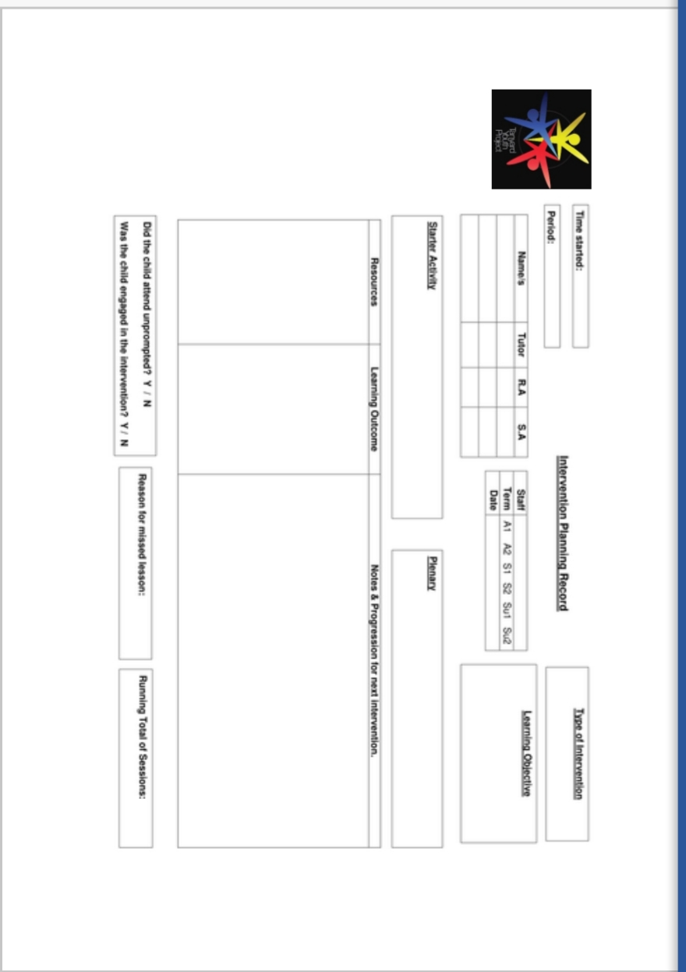

Appendix 4



