11/21/2025
University of Wales Trinity Saint David
London campus
E-Portfolio Link: Click here
https://hebunay9.wixsite.com/my-site-7

Module Name: Learning In the Digital Era
Module Code: ACCA 4025

Student Name: Hebun AY
Student ID: 2519282
Group: 1

Lecturer’s Name: Koushik Modak
Submission Deadline: 21st November 2025

LDE Assignment 1
E-Portfolio
Table of Contents
Introduction 2
Main Body 2
Task 1: Essential Academic and Employment Skills for the future career Path 2
Task 1 (a): Report on Essential Academic and Employment Skills 2
Task 1 (b): Evaluation of Task 1 (a) based on Similarity report 2
Task 2: Collaborative Mind Map and Individual Poster 2
Mind Map (Collaborative) 2
Poster (Individual) 2
Task 3: Virtual Collaboration and RefWorks 2
Report on Virtual Collaboration 2
Step-by-step process of using RefWorks with visuals 2
Task 4: E-Portfolio Creation and Evaluation 2
Task 4 (a): E-Portfolio Creation 2
Task 4 (b): Illustrative Review of E-Portfolio tool Selection 2
Conclusion 2
References 2
Task 1 References: 2
Task 3 References: 2

Introduction
This report discusses the key academic and professional skills required for individuals who plan to build a career in app development. Understanding and improving these skills will help students and professionals achieve success in both education and the workplace. (here you need to add citations as well)

Main Body
The main body includes four tasks that show key academic and professional skills in computing and app development. Task 1 explains important study and work skills. Task 2 focuses on teamwork through a mind map and an academic poster. Task 3 describes virtual collaboration and the use of RefWorks for referencing. Task 4 presents an e-portfolio created on Wix to organise all tasks clearly.

Task 1: Essential Academic and Employment Skills for the future career Path

Task 1 (a): Report on Essential Academic and Employment Skills

Essential Academic and Professional Skills for an App Developer
Developing the right set of skills is a key factor for success in the modern technology industry. For individuals who aim to become app developers, both academic knowledge and practical abilities are necessary to study effectively and perform well in future workplaces [1].
Problem-solving is one of the most valuable competencies in this field. Developers often deal with issues such as debugging, user-experience challenges, or system errors. Using critical and analytical thinking allows them to identify problems clearly and design effective solutions [2].
Another important area is digital literacy understanding how to use and adapt to new software, coding platforms, and frameworks such as Android, iOS, or Flutter [3]. Because technology evolves rapidly, continuous learning and adaptation are essential parts of professional growth.
Strong teamwork and communication skills also support success. App development usually involves collaboration with designers, testers, and clients. Clear discussion and sharing of ideas help the whole team work efficiently and achieve higher quality results [4].
Finally, time management plays a major role in meeting deadlines and maintaining good performance. Managing multiple tasks and setting priorities help ensure that projects are completed on schedule without reducing quality.
Developing these abilities builds confidence, supports lifelong learning, and prepares future professionals to succeed in the fast-changing digital world [5].
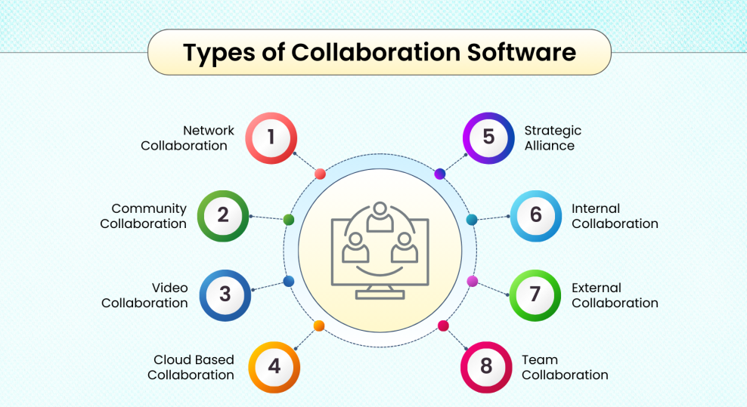
Figure [1]; Types of collaboration software used in modern app development teams. Adapted from [2],[3]
Figure 1 presents several types of digital platforms that support cooperation among software developers in their daily tasks. These systems allow teams to communicate effectively, exchange progress updates, and manage shared projects through online channels such as cloud services, video meetings, and collaborative dashboards. By integrating these tools into their workflow, developers can coordinate tasks remotely, maintain continuous interaction, and sustain productivity in the fast-changing digital industry.

Task 1 (b): Evaluation of Task 1 (a) based on Similarity report
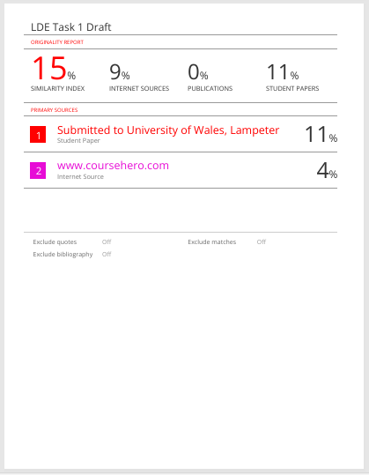

The Turnitin similarity report indicated a 15% match index, which remains within an acceptable range for academic submissions. The majority of the matched text derived from commonly used expressions and technical terminology such as “time management” and “Android”, rather than copied material. This outcome demonstrates adequate paraphrasing practices and appropriate citation methods in line with academic integrity requirements.
For future assessments, further refinement of phrasing and enhanced syntactic variation could be employed to minimise similarity levels even further. The overall structure of the submission reflects clarity, coherence, and academic consistency. According to the Generic Assessment Criteria, the work would reasonably be assessed within the high merit range (approximately 85–90%), as it demonstrates strong understanding, accurate referencing, and progressive improvement in scholarly writing conventions.

Task 2: Collaborative Mind Map and Individual Poster

Mind Map (Collaborative)
Mindmiester Map Collaboration Link: Click Here
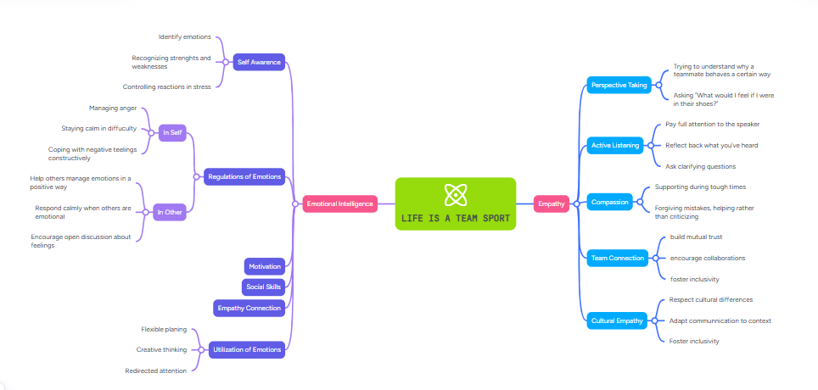

Poster (Individual)
Canva A3 Poster Link: Click Here

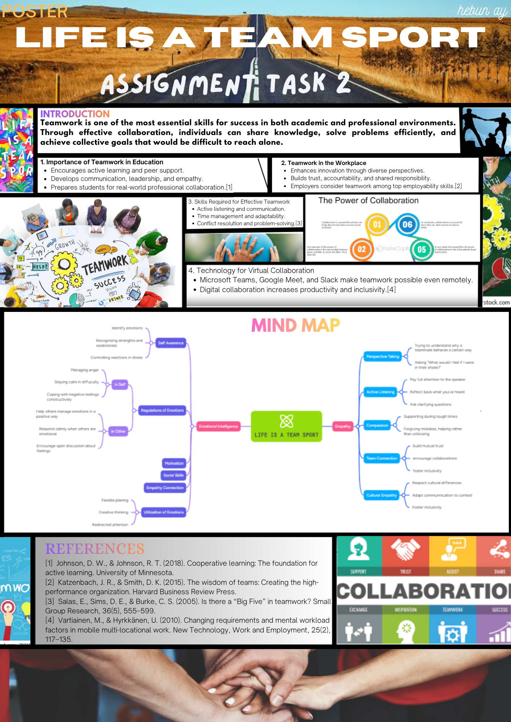

Task 3: Virtual Collaboration and RefWorks

Report on Virtual Collaboration

Topic: Riding the Storm – Managing Conflict in Virtual Teams

In modern workplaces, virtual collaboration has become a normal part of teamwork. However, working in online teams also brings challenges, especially when team members face conflicts or misunderstandings. The topic “Riding the Storm” explains how virtual teams can manage these conflicts effectively through communication, empathy, and trust building.
Conflict often starts because team members come from different cultures, time zones, and working habits. Poor communication or delays in responses may create tension between members. Research shows that unresolved conflict can reduce motivation and teamwork quality [1]. Therefore, teams must deal with issues early and professionally.
One of the most effective strategies is to use clear communication channels such as Microsoft Teams, Zoom, or Slack. These tools help members express their ideas in real time and reduce confusion [2]. Active listening and constructive feedback are also important skills that prevent small disagreements from growing into major problems [3].
Another key factor is emotional intelligence. Virtual leaders who show understanding and respect help create a safe online environment. This supports psychological safety, where every team member feels free to share ideas without fear of judgment [4]. Using written agreements or shared documents also reduces conflict by keeping everyone accountable.
Technology plays a supportive role in maintaining harmony within the team. Online collaboration tools provide transparent project tracking and task division, which helps reduce misunderstandings. Regular virtual meetings further build trust and teamwork [5].
In conclusion, conflict is a natural part of teamwork, but virtual teams can “ride the storm” by using strong communication, empathy, and digital collaboration tools. These strategies help maintain productivity and positive relationships in an online working environment.

Step-by-step process of using RefWorks with visuals
During this task, RefWorks was applied to manage all references in an organised and accurate way. Relevant academic sources on virtual conflict management were identified through Google Scholar and then imported into RefWorks. Each entry was arranged inside a project folder titled “Virtual Collaboration” for easy access. The IEEE referencing format was chosen to generate both in-text citations and a final reference list automatically. Screenshots were taken to demonstrate each stage of the process, including importing and formatting. Overall, using RefWorks improved accuracy, saved time, and maintained consistency across all academic references.
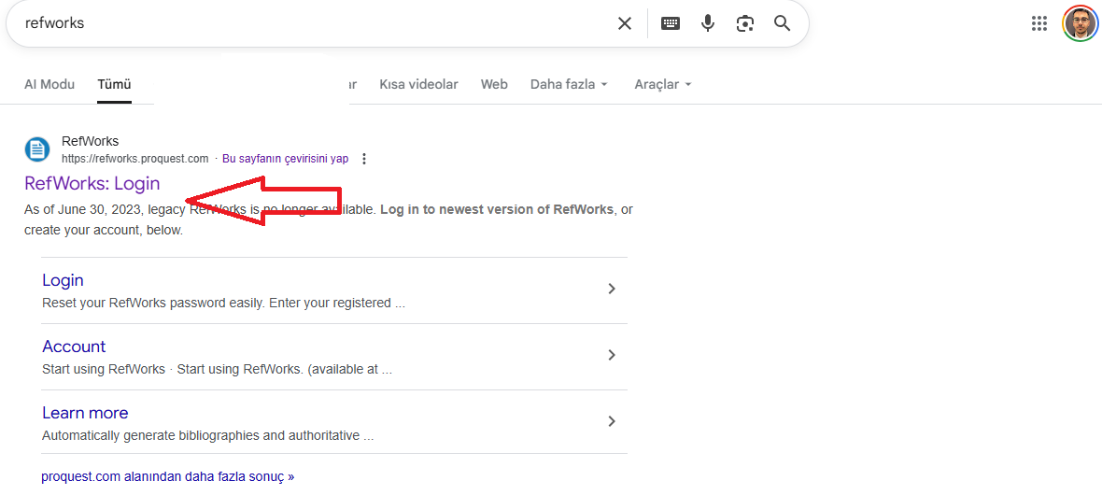

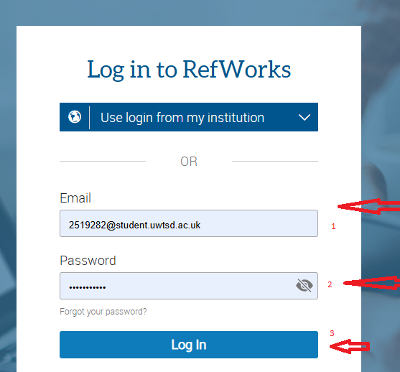

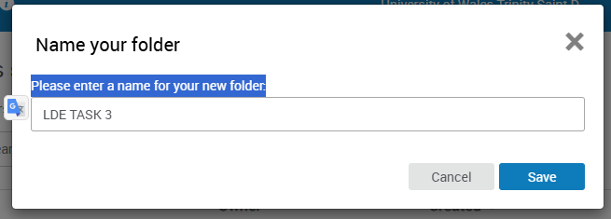

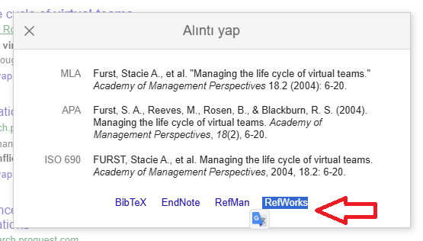
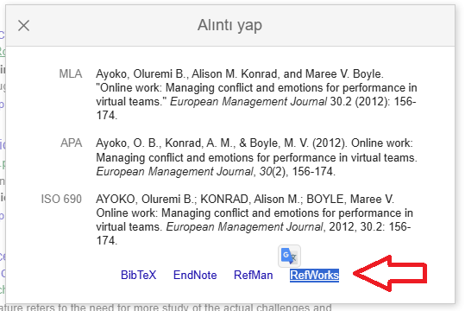
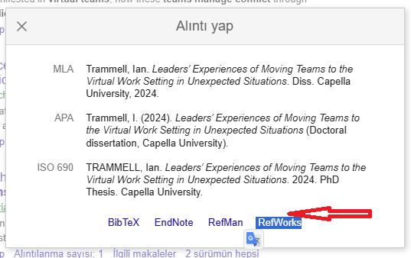

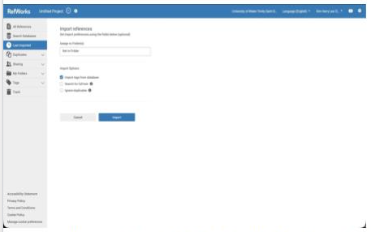
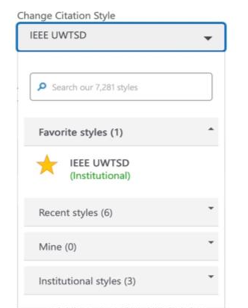
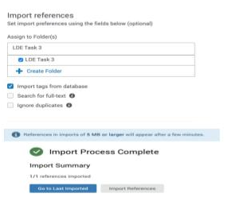

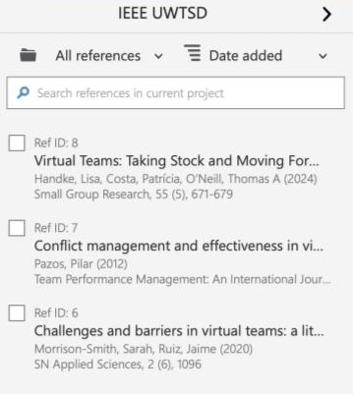
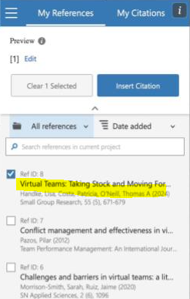
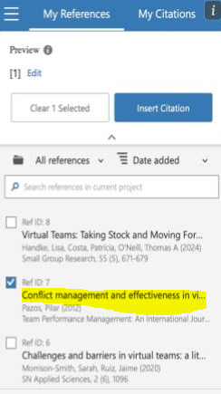

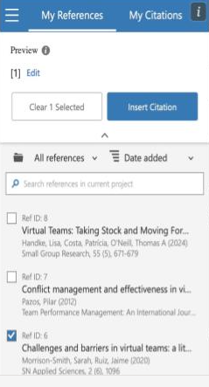

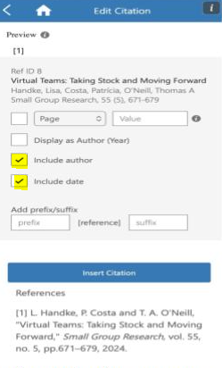

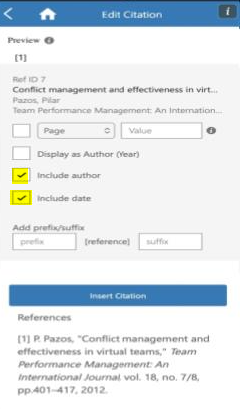

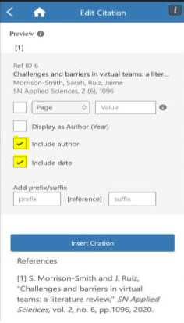

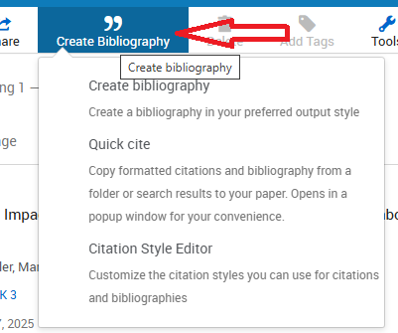

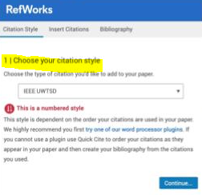

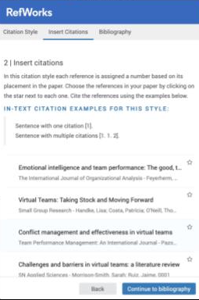
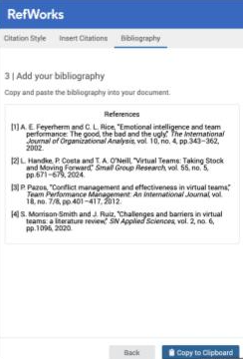

Task 4: E-Portfolio Creation and Evaluation

Task 4 (a): E-Portfolio Creation
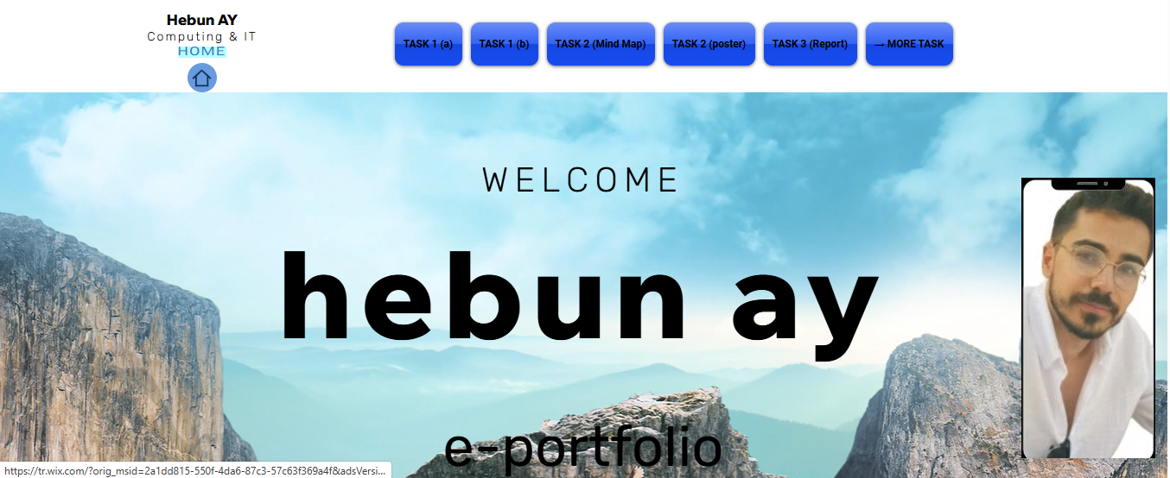
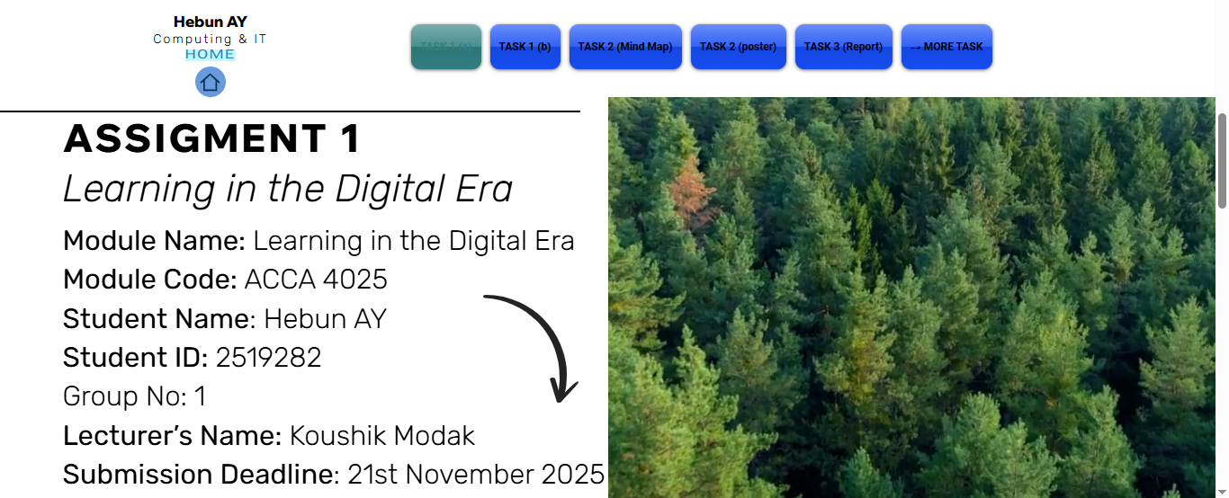
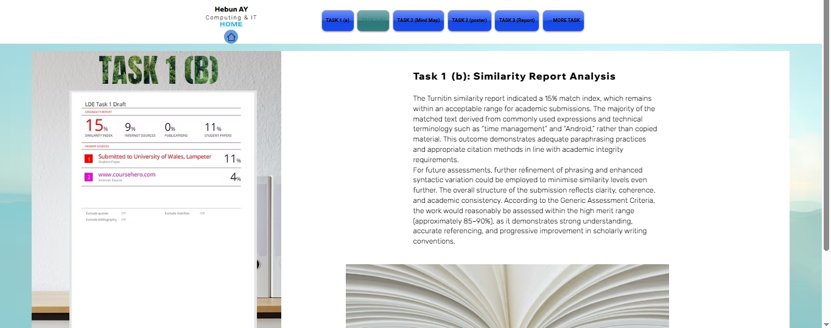
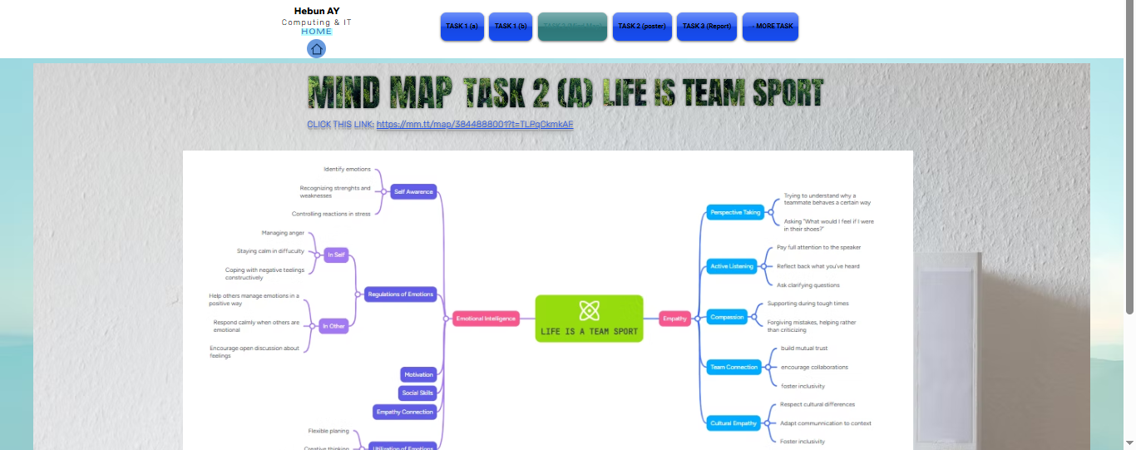
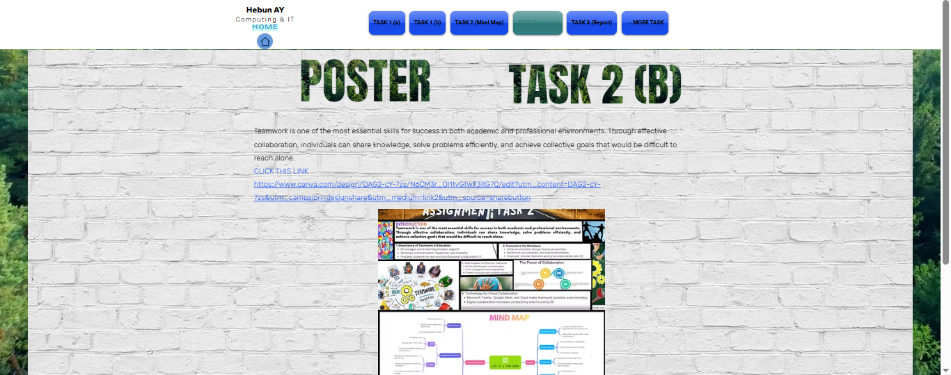
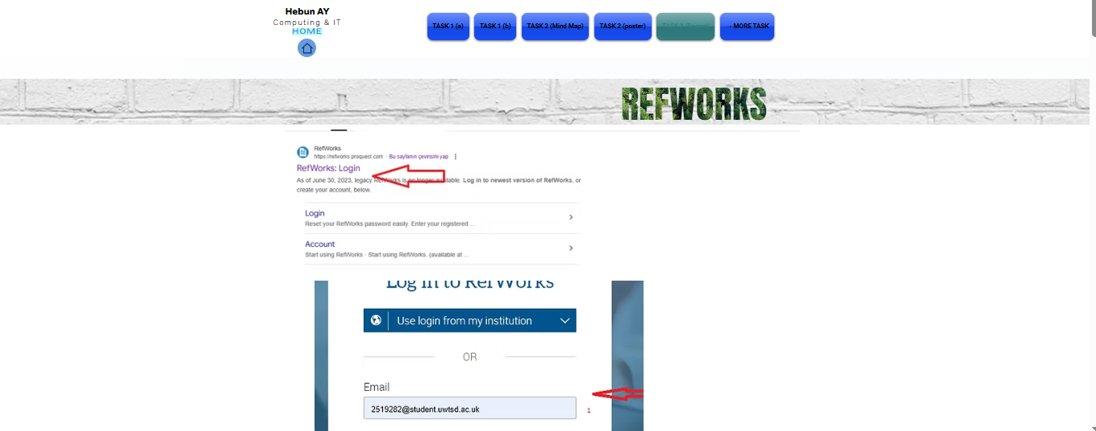
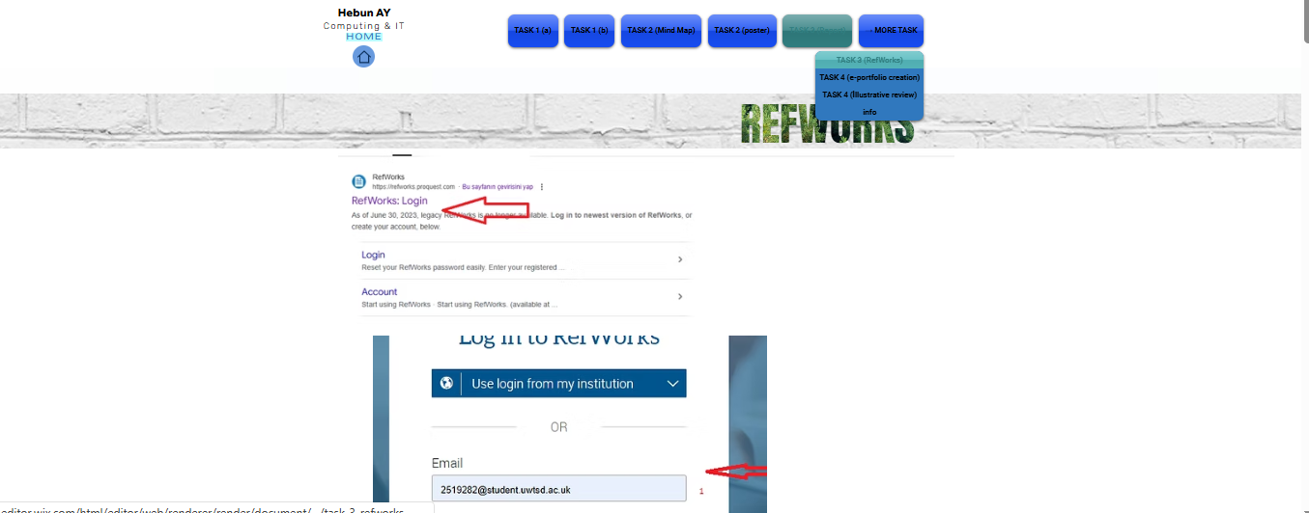
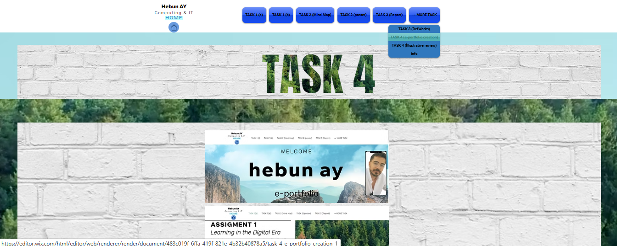
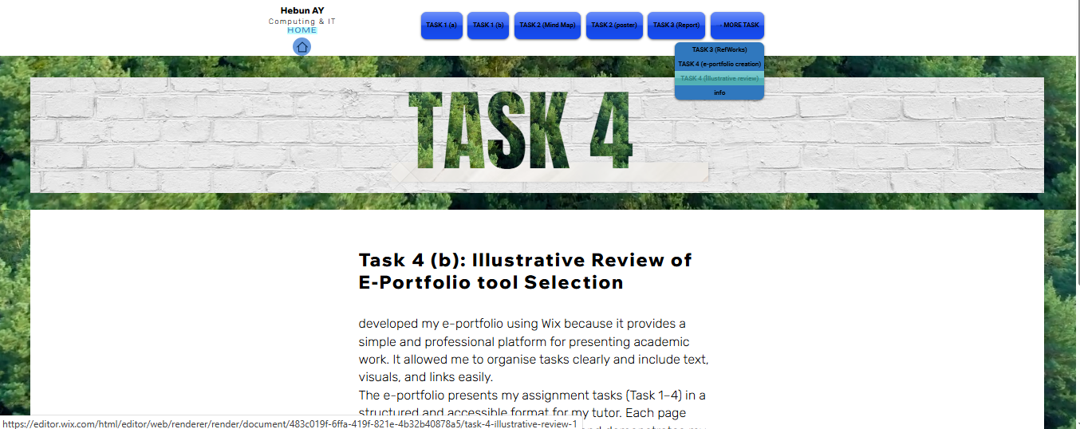
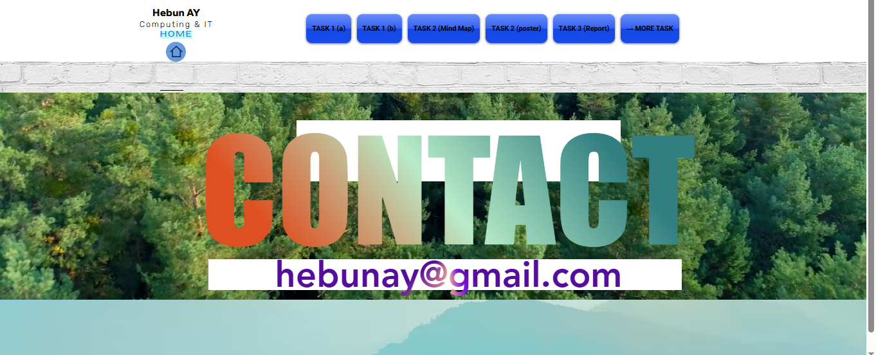

Task 4 (b): Illustrative Review of E-Portfolio tool Selection
developed my e-portfolio using Wix because it provides a simple and professional platform for presenting academic work. It allowed me to organise tasks clearly and include text, visuals, and links easily.
The e-portfolio presents my assignment tasks (Task 1–4) in a structured and accessible format for my tutor. Each page represents one part of my coursework and demonstrates my digital and organisational skills.
plan to update it regularly with future academic and professional projects to support my career growth.

Conclusion
The portfolio shows clear progress in developing academic, digital, and professional skills that are important in computing and app development. Each task demonstrates understanding of research, collaboration, and referencing techniques, supported by good communication and time management. The e-portfolio on Wix presents all work in an organised and professional way, showing commitment to academic standards and continuous improvement. Overall, the work reflects readiness for future learning and career development in the digital field.

References

Task 1 References:
[1] K. smith, Digital Skills for Mobile Developers, London: Routledge,2023.
[2] M.west "Teamwork and communication in modern tech workplaces" Journal of Computing and Innovation, vol.22, no.4, pp. 210-218, 2024.
[3] C.jones, Practical Time Management for Developers, Oxford University Press, 2022.
[4] J.Robbins, "Adaptability in sofware careers" TechLife Magazine, Jun. 2024.
[5] L.Turner, "Continuous learning and growth mindset in app development" International Jounrnal of Digital Education, vol. 15, no.2 pp 98-105, 2023.

Task 3 References:
[1] A. Johnson, Virtual Team Communication and Conflict Management, London: Routledge, 2023.
[2] L. Brown, “Digital Tools for Remote Teams,” International Journal of Collaboration Studies, vol. 17, no. 3, pp. 210–219, 2024.
[3] P. Evans, Constructive Feedback in Global Teams, Oxford University Press, 2022.
[4] S. Lee, “Emotional Intelligence and Leadership in Online Environments,” Journal of Digital Management, vol. 12, no. 2, pp. 88–97, 2023.
[5] T. Richards, “Psychological Safety in Virtual Workplaces,” Harvard Business Review Online, Oct. 2024.

