HPEN6008/5008: MODERNISM & MODERNISMS

GENDER AND MODERNISM

Issues
- Gender and Modernism: mothers as well as fathers
- Woolf on women and writing: ‘Women and Fiction’
- The ‘androgynous mind’ and women’s writing
- Gender, Art and identities of ambivalence
- Gender and eduation

Key Quotations

1. Gender relations at the turn of the century
‘Shifts in gender relations at the turn of the century were a key factor in the emergence of Modernism. The period from 1880-1920, within which Modernism emerged and rose to pre-eminence as the dominant art form in the West […], was also the heyday of the first wave of feminism, consolidated in the woman suffrage movement. The protagonist of this movement was known as the “New Woman”: independent, educated, (relatively) sexually liberated, oriented more toward productive life in the public sphere than toward reproductive life in the home.’
Marianne Dekoven, ‘Modernism and gender,’ Michael Levenson, ed., The Cambridge Companion to Modernism (Cambridge: Cambridge University Press, 1999), p. 174.

2. the Woman’s sentence
‘To begin with, there is the technical difficulty – so simple, apparently; in reality, so baffling – that the very form of the sentence does not fit her. It is a sentence made by men; it is too loose, too heavy, too pompous for a woman’s use. Yet in a novel, which covers so wide a stretch of ground, an ordinary and usual type of sentence has to be found to carry the reader on easily and naturally from one end of the book to the other. And this a woman must make for herself, altering and adapting the current shape of her thought without crushing or distorting it.’
Virginia Woolf, ‘Women and Fiction,’ Michele Barrett, ed., Virginia Woolf: Women & Writing (London: Women’s Press, 1979), p. 48.

3. ‘It is fatal to be a man or woman pure and simple; one must be woman-manly or man-womanly. It is fatal for a woman to lay the least stress on any grievance; to plead even with justice any cause; in any way to speak as a woman. […] Some collaboration has to take place in the mind of the woman and the man before the art of creation can be accomplished. Some marriage of opposites has to be consummated. The whole of the mind must lie wide open if we are to get the sense that the writer is communicating his [sic] experience with perfect fullness.’
Virginia Woolf, A Room of One’s Own and Three Guineas ed., Morag Shirach (Oxford: Oxford University Press, 2000), p. 136.

4. women and the world of feeling
‘Indeed, she had the whole of the other sex under her protection; for reasons she could not explain, for their chivalry and valour, for the fact that they negotiated treaties, ruled India, controlled finance; finally for an attitude towards herself which no woman could fail to feel or to find agreeable, something trustful, childlike, reverential; which an old woman could take from a young man without loss of dignity, and woe betide the girl—pray Heaven it was none of her daughters!--who did not feel the worth of it, and all that it implied, to the marrow of her bones! ‘

5. men and exteriors/exploration
‘Qualities that would have saved a ship’s company exposed on a broiling sea with six biscuits and a flask of water—endurance and justice, foresight, devotion, skill, came to his help. R is then—what is R?
A shutter, like the leathern eyelid of a lizard, flickered over the intensity of his gaze and obscured the letter R. In that flash of darkness he heard people saying—he was a failure—that R was beyond him. He would never reach R. On to R, once more. R—
Qualities that in a desolate expedition across the icy solitudes of the Polar region would have made him the leader, the guide, the counsellor, whose temper, neither sanguine nor despondent, surveys with equanimity what is to be and faces it, came to his help again. R—
The lizard’s eye flickered once more. The veins on his forehead bulged. The geranium in the urn became startlingly visible and, displayed among its leaves, he could see, without wishing it, that old, that obvious distinction between the two classes of men; on the one hand the steady goers of superhuman strength who, plodding and persevering, repeat the whole alphabet in order, twenty-six letters in all, from start to finish; on the other the gifted, the inspired who, miraculously, lump all the letters together in one flash—the way of genius. He had not genius; he laid no claim to that: but he had, or might have had, the power to repeat every letter of the alphabet from A to Z accurately in order. Meanwhile, he stuck at Q. On, then, on to R.
Feelings that would not have disgraced a leader who, now that the snow has begun to fall and the mountain top is covered in mist, knows that he must lay himself down and die before morning comes, stole upon him, paling the colour of his eyes, giving him, even in the two minutes of his turn on the terrace, the bleached look of withered old age. Yet he would not die lying down; he would find some crag of rock, and there, his eyes fixed on the storm, trying to the end to pierce the darkness, he would die standing. He would never reach R.

6. Gender and education

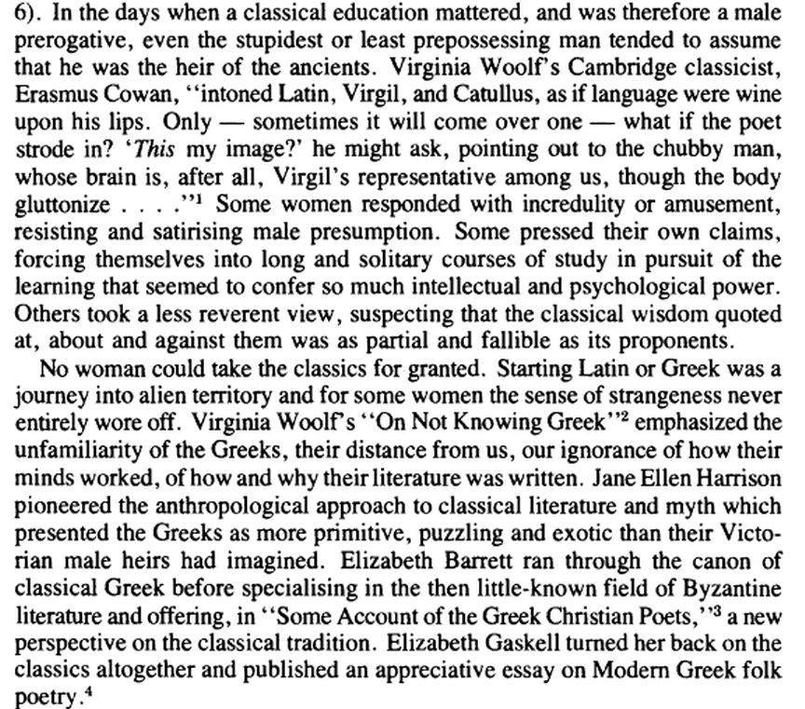

R. Fowler, "On Not Knowing Greek:" The Classics and the Woman of Letters
The Classical Journal
Vol. 78, No. 4, Apr.- May, 1983
337-349 Page 337,
http://www.jstor.org/stable/pdfplus/3296774.pdf?acceptTC=true

Further Reading

Peter Childs, Modernism (London; New York: Routledge, 2000), p. 161-75.
Makiko Minow-Pinkney, ‘Mrs Dalloway,’ Sue Reid, ed., Mrs Dalloway and To The Lighthouse (Houndmills: Macmillan, 1993), p. 98-111.
Toril Moi, Sexual/Textual Politics: Feminist Literary Theory (London; New York: Routledge, 1986), p. 1-18.
Virginia Woolf, ‘Professions for Women,’ Michele Barrett, ed., Virginia Woolf: Women & Writing (London: Women’s Press, 1979), p.57-63.

