UNDERSTANDING THE IMPORTANCE OF STAKEHOLDER ENGAGEMENT
IN THE SUCCESSFUL COMMENCEMENT AND COMPLETION OF A PROJECT
A Case Study on the StaySmart+ Service Launch at Hilton Hotels & Resorts

Module: LCLM5001 – Understanding and Engaging Stakeholders
Programme: BA (Hons) Leadership and Management Skills for the Workplace
Assignment Title: Understanding Stakeholder Engagement in Project Commencement and Completion
Word Count: 4,000 words
Submission Date: 23 March 2026
Florin Lefter
Lecturer Name: Eric Osei

Executive Summary
This report is prepared as Project Manager for the global implementation of StaySmart+, an AI-based guest experience service created by Hilton Hotels & Resorts. In this report we examine critically the role of stakeholder involvement as a key factor in the success of projects globally within different hospitality sectors.
In addition, this report will identify and categorize internal and external stakeholders. It will analyze their roles and responsibilities using the RACI matrix (PMI, 2021). It will also position these stakeholders on Mendelow's (2021) Power/Interest matrix. The report will also carry out a comprehensive situational analysis of the context in which the project will operate using the SWOT and PESTLE frameworks.
This report will draw upon the Stakeholder Theory of Freeman, Harrison and Zyglidopoulos (2022) and the Project Stakeholder Management Framework of Eskerod and Jepsen (2023) to apply the 4 C's model of Communication, Collaboration, Consultation and Commitment to articulate how the engagement process works. The analysis demonstrates that engaging effectively and sensitively with cultural differences of stakeholders can positively affect guest satisfaction, operational efficiency, brand value, risks and sustainability performance.
Finally, the report will provide 5 strategic recommendations that are aimed at embedding stakeholder engagement as an organizational capability at Hilton, which will enable Hilton to be seen globally as a leader in digitalized sustainable hospitality.

Table of Contents
Executive Summary 2
1.0 Introduction 4
2.0 Situational Analysis 5
2.1 SWOT Analysis 5
2.2 PESTLE Analysis 5
2.3 SMART Objectives 6
3.0 Identification and Categorisation of Key Stakeholders 7
4.0 Roles, Responsibilities, Benefits, and Challenges 8
4.1 Internal Stakeholders 8
4.2 External Stakeholders 9
4.3 RACI Matrix 9
5.0 Frameworks and Models for Stakeholder Engagement 10
5.1 Mendelow's Power/Interest Matrix 10
5.2 Stakeholder Engagement and Communication Plans 11
6.0 Process of Stakeholder Engagement and Conflict Management 12
6.1 The 4C's Model of Engagement 12
6.2 Conflict Management Strategies 14
7.0 Impact Evaluation and Recommendations 15
7.1 Business Performance Impact 15
7.2 Recommendations 16
8.0 Conclusion 17
References 18

1.0 Introduction
Hilton Hotels & Resorts is probably the oldest and most well known hospitality brand around the world. It was founded in 1919 in Cisco, Texas by Conrad Hilton. Since then it has grown into the premier full service tier of Hilton Worldwide Holdings, a company based in McLean, Virginia, USA. Hilton Worldwide Holdings has over 7,600 properties across 126 countries and employs nearly 400,000 people worldwide (Hilton Hotels & Resorts, 2024). Hilton Hotels & Resorts represents the full-service portion of Hilton’s portfolio of products; it offers high quality accommodations, meeting spaces, unique dining options, and a variety of wellness services to each of its guests.
In the United Kingdom, Hilton has an important operational presence, which has a number of flagship properties. The Hilton London Metropole in Paddington is one of the largest convention hotels in Europe and contains over 1,000 bedrooms and 40 meeting suites. In addition, the Hilton London Bankside is a modern design-based hotel that is well-recognized for its sustainable practices and proximity to the Tate Modern. Each of these London hotels demonstrate Hilton’s ability to deliver excellent guest experiences in very competitive urban hospitality markets and both will be used as primary pilot locations for the roll-out of StaySmart+.
StaySmart+ is a strategic investment made by Hilton to integrate artificial intelligence with personalized digital services and to provide guests with environmentally friendly services. As a premium customer service experience, StaySmart+ is intended to be rolled out on 20 locally owned and internationally owned hotel properties within six months. Therefore, the rollout will require cooperation among all stakeholders including those in technology, operations, marketing, regulatory and guest service areas. The StaySmart+ customer service experience includes using artificial intelligence to provide guests with hyper-personalized recommendations, to automate the management of their preferred room type and to offer them real-time concierge assistance in conjunction with providing guests with environmentally friendly amenities that support Hilton’s Travel with Purpose environmental program.
This report reviews the process for identifying, engaging and managing stakeholders to create the successful development, launch and acceptance of the StaySmart+ service. This review uses stakeholder theory (Freeman et al., 2022), engagement frameworks (Eskerod and Jepsen, 2023), and strategic management principles (Johnson et al., 2023) to create a structured analysis of how to develop stakeholder relationships to facilitate project success in multiple different cultures and market environments.
2.0 Situational Analysis
2.1 SWOT Analysis
A SWOT analysis is a systematic approach to evaluating an organization's internal environment and external environment related to the project. Bryson (2023) states that SWOT analysis continues to be a useful strategic tool for organizations to understand their internal preparedness and external environmental position before launching major new service innovations, allowing project managers to recognize the internal strengths that can be leveraged, internal weaknesses that must be addressed, potential external opportunities that should be pursued, and the potential external threats that need to be mitigated.
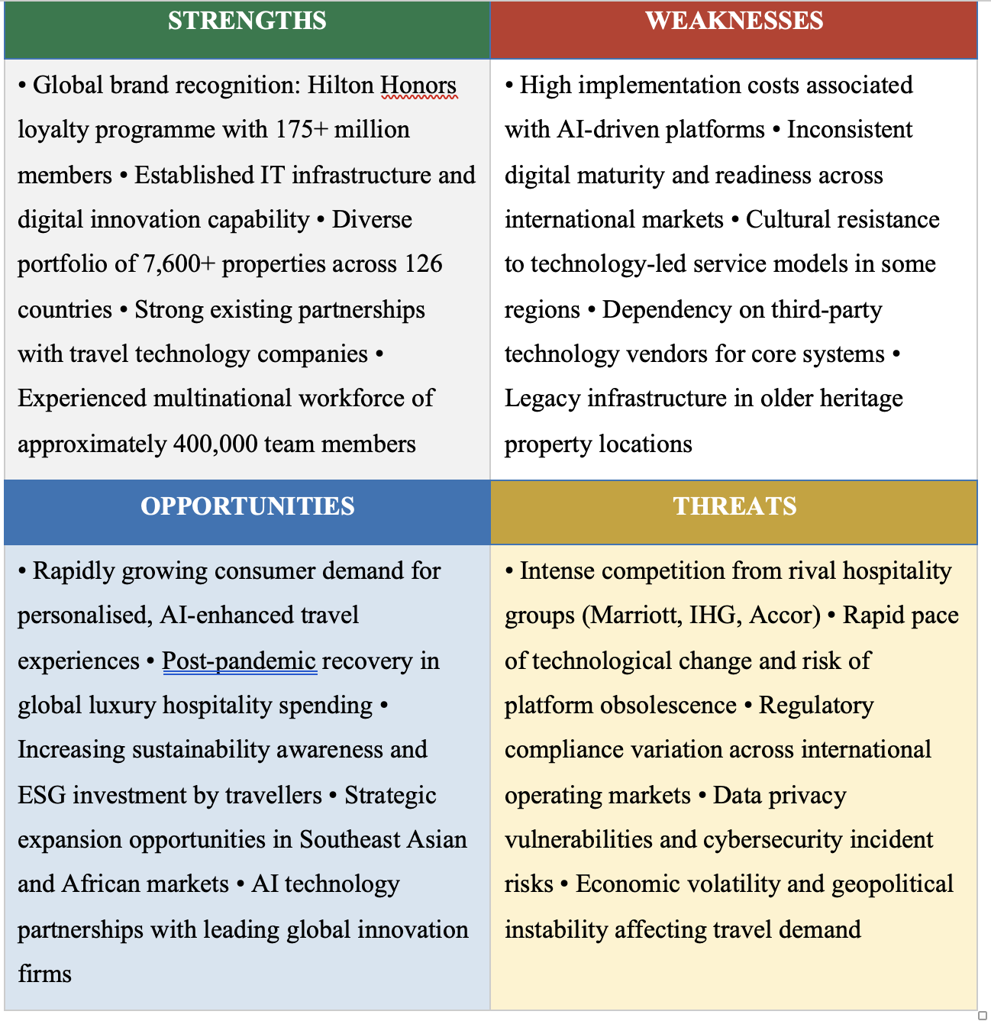

Figure 1: SWOT Analysis – Hilton Hotels & Resorts in relation to the StaySmart+ Project (Author's own, 2025)

2.2 PESTLE Analysis
Using the PESTLE framework allows for an organized examination of the six macro-environmental factors outside of the StaySmart+ project that can impact its overall strategic direction. According to Johnson et al. (2023), a PESTLE analysis can be especially useful for large-scale international projects, such as the StaySmart+, since it provides a comprehensive view of the different regulatory environments, economies, social and cultural norms, and technologies that exist in each country that would need to be addressed to successfully deploy the StaySmart+ internationally.

FACTOR | ANALYSIS AND IMPLICATIONS FOR STAYSMART+
Political | Government travel policies, international relations, and visa regulations affect cross-border hotel operations. The UK government's National AI Strategy (2022) encourages responsible digital adoption in service sectors, creating a supportive policy environment for StaySmart+.
Economic | Post-pandemic hospitality recovery creates favourable market conditions for premium service investment. However, inflationary pressures and cost-of-living concerns may constrain discretionary travel spending in key consumer markets, requiring careful pricing strategy alignment (Hilton Hotels & Resorts, 2024).
Social | Growing consumer demand for personalised, seamless digital experiences and sustainable travel practices reflects evolving traveller values (Sharma and Gupta, 2023). The cultural diversity of international markets requires StaySmart+ to accommodate varied hospitality preferences and digital literacy levels.
Technological | AI-driven customer interaction, IoT room technology, and advanced data analytics are transforming hospitality service delivery. Digital transformation is both the primary driver and enabling infrastructure of the StaySmart+ deployment strategy (Kerzner, 2022).
Legal | GDPR compliance, data protection legislation, and employment law across multiple jurisdictions create complex compliance obligations. AI systems are subject to rapidly evolving regulatory frameworks, including the EU AI Act (2024), requiring proactive legal stakeholder engagement (Freeman et al., 2022).
Environmental | Increasing pressure for carbon-neutral operations and net-zero commitments directly aligns with the sustainability-focused amenities central to StaySmart+. Mandatory ESG reporting requirements are being introduced across Hilton's key operating markets (Sloan et al., 2023).
Figure 2: PESTLE Analysis – StaySmart+ Global Launch (Author's own, 2025)

2.3 SMART Objectives
In line with Kerzner (2022), SMART objectives will be developed to ensure that there is an agreement on what needs to happen, when it should happen, by whom, how often and how they will measure success to achieve the desired outcomes of the StaySmart+ project:
Specifically; To successfully deploy StaySmart+ across 20 selected Hilton hotels in the 5 International Markets of UK, UAE, Germany, Singapore and USA within the agreed upon 6 month timeframe.
To demonstrate the successful adoption of StaySmart+ by achieving a minimum guest satisfaction score increase of 15%, as measured by NPS Surveys and Post-Stay Digital Feedback within the first year of deployment.
To secure full stakeholder alignment and formal Board Approval of the Project Budget, Governance Structure, and Implementation Timeline within 30 days of Project Initiation.
To align the StaySmart+ project with Hilton’s Travel with Purpose ESG Strategy to ensure that sustainability focused amenities and carbon reduction features are integrated into a minimum of 90% of the Participating Hotels.
To complete all Staff Training Programs, System Integration Testing and Operational Readiness Reviews within Four Months of Project Launch Commencement and allow for a Final Six Week Pre-Launch Testing and Refining Period.

3.0 Identification and Categorisation of Key Stakeholders
The first step in successfully managing stakeholders in a project is to identify them (PMI, 2021). Freeman et al. (2022, p. 4) defined stakeholders as any person(s) or group(s) that have the capacity to positively or negatively affect an organization’s operations (create relational obligations) or strategically support an organization’s objectives (strategic interdependencies). In the case of the StaySmart+ project, Hilton has identified its stakeholders and categorized them according to their role as either internal or external stakeholders, identifying those stakeholders who are part of Hilton’s organizational structure versus those who are outside of the organizational structure (Bourne, 2020).
Internal stakeholders are those operating inside Hilton’s organizational boundaries, and they are directly responsible for the design, approval and execution of the project:
• The Board of Directors and Senior Executive Team: They provide strategic guidance, allocate resources, provide risk governance, and are ultimately accountable for the investment in StaySmart+ as a global business initiative.
• The IT and Technology Development Teams: They develop, build, integrate and test the AI-based guest interactive platform, IoT hardware and software, and other digital systems needed for the successful operation of StaySmart+.
• The Marketing and Sales Departments: They will create and implement branding communications strategies, customer recruitment initiatives, establish alliances with distributors, and develop loyalty program enhancements tied to the introduction of StaySmart+.
• The Hotel Operations Teams and General Managers: These teams will oversee the operational implementation of StaySmart+ at each hotel location; this includes developing service standards, staffing levels and guest experience management.
• The Human Resource Department: This department will manage work force planning, employee training and development, communicate changes required to employees, and maintain employee morale during the time that Hilton is transforming the way services are provided through the use of AI and IoT technologies.
• The Finance Department: They will oversee the budgeting process, assess financial risks, evaluate the ROI of the project, and govern purchasing procedures throughout the project cycle.
External stakeholders are those that operate outside of Hilton’s organizational boundaries and/or have a direct interest in the outcome of the project or have the ability to impact Hilton’s operations:
• StaySmart+ guests/end customers: These individuals are the primary recipients/beneficiaries of StaySmart+, and their feedback/needs/preferences directly influence the development/design of the service. Ultimately, their acceptance/adoption rates determine whether the project was successful from a financial standpoint.
• Ai technology providers/vendors: These organizations supply the AI platforms, IoT systems, data analytics infrastructure, and software integration solutions that comprise the core of the technology ecosystem for StaySmart+.
• Government regulatory agencies and departments: These include national data protection authorities (for example, the UK ICO), tourism regulators, and health and safety inspectors across all markets where Hilton operates. The regulations governing these areas will dictate the legal limitations of using AI.
• Shareholders/investors: They monitor the financial performance outcomes of the StaySmart+ capital expenditures and expect regular reports regarding the project’s status and potential financial returns.
These categories follow Bourne’s (2020) stakeholder relationship management maturity model, which advocates for a systemic and comprehensive method of identifying stakeholders that encompasses the entire range of influe

4.0 Roles, Responsibilities, Benefits, and Challenges of Key Stakeholders

4.1 Internal Stakeholders
As the ultimate decision-making body, the Board of Directors and Senior Executive Team are accountable for all strategic decisions and risk governance regarding StaySmart+, as well as for making capital commitments toward the project. One of the most important roles that the Board of Directors and Senior Executive Team play in this project is to provide strategic direction for the initiative, approve resources for it, and demonstrate senior-level support by committing to the success of the initiative at an organisational level. A key challenge facing the Board of Directors and Senior Executive Team is to make the case for the large-scale investment in technology represented by StaySmart+ relative to other capital initiatives that are competing for funding within Hilton’s extensive global portfolio, and to develop and articulate a convincing ROI that can be shared with stakeholders in a timely manner (Jensen, 2020; Waddock, 2020).
The IT and Technology Development Team are responsible for the technical aspects of the project. They will translate the strategic vision of StaySmart+ into functioning, secure, and scalable technology. The key advantage that the IT and Technology Development Team has in executing this role is based on their technical experience and their pre-existing relationships with the vendors who supply the AI components of the platform, which enable them to expedite the platform’s development. The key disadvantage for the IT and Technology Development Team is the complexity of integrating the AI capabilities of StaySmart+ with the legacy systems already in place in the hotels across Hilton’s global property portfolio. Additionally, the IT and Technology Development Team must ensure that the platform complies with the regulations related to data protection, specifically GDPR, and the use of AI technology in Europe, as well as ensure that the platform maintains the required security standards as the company undergoes its transformation to digital technologies (Kerzner, 2022; Sharma & Gupta, 2023).
The Marketing and Sales Department are the champions of creating awareness of StaySmart+ in the marketplace and acquiring guests for the service. Their key contribution is in leveraging Hilton’s global loyalty program – Hilton Honors, which has 175 million members — to increase the adoption rate of the StaySmart+ service by Hilton’s most valuable guests. A major disadvantage for the Marketing and Sales Department is developing marketing messages that clearly communicate the value proposition of AI-driven personalization to guests with different levels of familiarity with digital technology and who have different cultural views about how hospitality should be mediated through technology (Nguyen et al., 2022).
Human Resources is responsible for facilitating the people side of the StaySmart+ transformation including developing and delivering training programs, designing competency frameworks, communicating changes to employees, and mitigating employee resistance to changes in their work practices. There is a considerable amount of work involved in Human Resources' role in this regard because they must embed a cultural change that is inclusive of all nationalities, languages, and values, across a multinational workforce of approximately 400,000 employees within a six month implementation timeline. In addition, Human Resources must maintain employee morale and service quality during the transformation process.

4.2 External Stakeholders
Guests are the single most important commercial external stakeholder group and function in a dual capacity of being the first and foremost co-creators of the StaySmart+ service experience as well as the ultimate judges of the service’s success. Proactive guest engagement will lead to increased service personalization, loyalty and advocacy on the part of guests. This will ultimately result in an increase in RevPAR and a competitive advantage (Nguyen et al. 2022). The major disadvantage of engaging with guests proactively is managing the differences in their expectations, digital literacy levels and cultural attitudes toward AI-based services globally. Furthermore, the challenge of managing cultural attitudes toward AI-based services and the expectation of an interpersonal relationship with hospitality staff in some global markets is significantly higher than in other markets (e.g. Western Europe vs. India).
AI Technology Partners and Vendors are providing the necessary technological innovations, processing infrastructure and integration expertise required to implement the core functionality of StaySmart+. They bring significant innovation capabilities to the project; however, they also bring challenges such as vendor dependency risk, the complexity of governing IP rights, and the possibility of a mismatch between the commercial goals of the vendors and Hilton's unique service delivery standards (Kerzner 2022). In accordance with Littau, Jujagiri and Adlbrecht (2020), the management of the technology partner relationships in large complex projects involves the development of strong contractual governance, clear service level agreements, and continuous dialogue and communication to ensure alignment between the parties.
Regulatory bodies define the extent to which the AI components of StaySmart+ may function by determining the boundaries of permissible operation, especially in relation to data privacy (GDPR, etc.), AI transparency under the EU AI Act (2024), and the level of consumer protection afforded by the regulatory framework. Regulatory bodies pose a significant challenge to the project as there is considerable heterogeneity of regulatory requirements for the AI elements of the StaySmart+ service experience across the multiple national jurisdictions in which it operates. Therefore, the project team must develop and maintain jurisdiction specific legal compliance strategies as they execute the technology implementation plan.

4.3 RACI Matrix
The Responsible, Accountable, Consulted, and Informed (RACI) Matrix is an established project governance tool that clarifies accountability and responsibility across project activities, eliminating ambiguity and reducing the risk of stakeholder conflict arising from unclear ownership (PMI, 2021). The matrix below delineates roles across the six primary StaySmart+ workstreams.

TASK / ACTIVITY | Board/Execs | IT Team | Marketing | Operations | HR | Tech Partners | Regulators
Strategic Approval & Budget | R | C | C | I | I | I | I
AI Platform Development | A | R | C | C | I | R | I
Marketing & Campaign Launch | C | I | R | C | I | I
Staff Training Programme | I | C | C | R | R | C | I
Regulatory Compliance | A | C | I | I |  | I | R
Guest Experience Rollout | A | C | C | R | C | C | I
Legend: R = Responsible | A = Accountable | C = Consulted | I = Informed
Figure 3: RACI Matrix – StaySmart+ Project Workstreams (Author's own, based on PMI, 2021)

5.0 Frameworks and Models for Stakeholder Engagement

5.1 Mendelow's Power/Interest Matrix
The Power/Interest Matrix by Mendelow (2021), is a very effective and practical method of stakeholder mapping that enables project managers to develop an appropriate strategy to engage with their stakeholders based on two major factors: how much influence a particular stakeholder has on the outcome of the project, and how much that stakeholder cares about whether the project will be successful or not. The framework is designed so that different stakeholder groups can be developed into differentiated, efficient, and relevant engagement strategies to meet the individual needs and influence of each stakeholder group (Olander & Landin, 2020).
Within the context of the StaySmart+ project, the Board of Directors, the Senior Executive Team, and IT Development Teams would be located in the "Manage Closely" quadrant of the matrix as they hold both high levels of organisational power and high levels of project interest. These stakeholders therefore need to be engaged with on a regular, and bidirectionally, i.e., both ways, basis, which will require the Project Manager to invest considerable amounts of time and resources to ensure their continued support and participation in the project. On the other hand, the investors and regulatory bodies will be classified as "Keep Satisfied" stakeholders because they hold large formal authorities, but are less involved in the day-to-day project activities. Therefore, it is sufficient to provide them with high quality and regularly reported information, in order to maintain their support for the project. As guests are placed in the "Keep Informed" quadrant, this reflects their high level of personal interest in the service offered, but their limited formal powers regarding the strategic decision-making process of the project. However, as Yang et al. (2020) point out, the continuous feedback from guests and their ability to adopt the services provided, will greatly affect the commercial performance of the business in the long term. Therefore, although guests are formally advisory, their engagement is also commercially necessary.

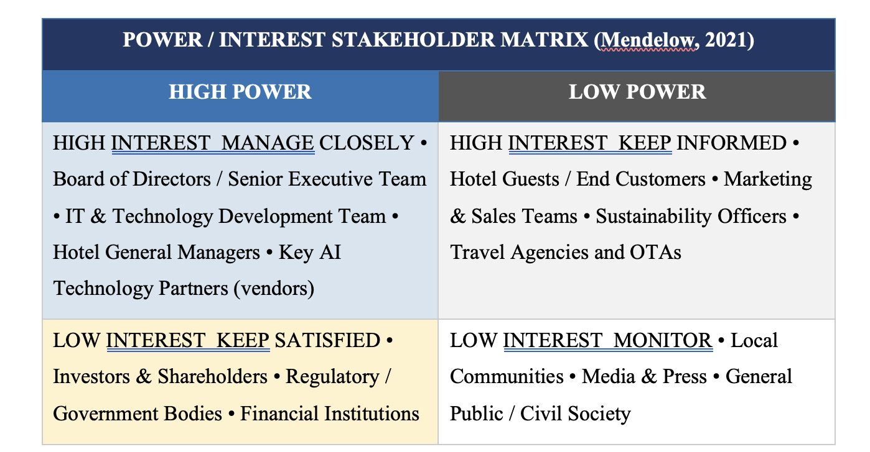
Figure 4: Power/Interest Stakeholder Matrix applied to the StaySmart+ Project (Author's own, based on Mendelow, 2021)

5.2 Stakeholder Engagement and Communication Plans
Stakeholder engagement has to be based upon a formal structure of communication which delivers the appropriate message, to the appropriate audience, via the most effective method, at the most suitable time and in an appropriate medium to meet the individual needs of each stakeholder grouping (Bourne, 2020). Below outlines how the StaySmart+ project will realise this principle as per Roloff's (2021) assertion that all multi-stakeholder networks need issue-based communication strategies to account for the different communication needs of each stakeholder group.

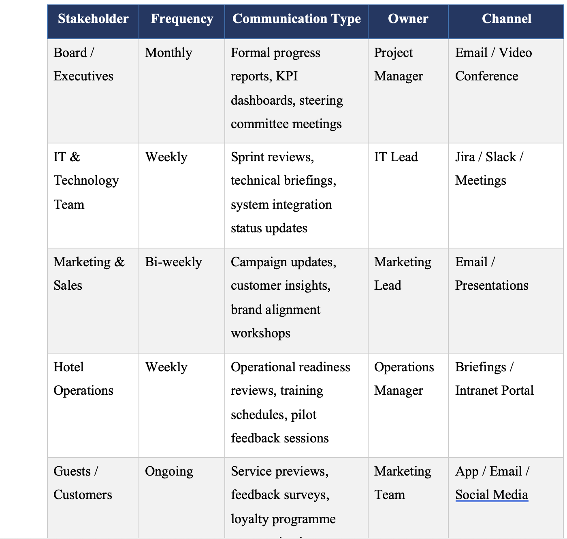
Figure 5: Stakeholder Communication Plan – StaySmart+ Project (Author's own, 2025)

6.0 Process of Stakeholder Engagement and Conflict Management

6.1 The 4C's Model of Stakeholder Engagement

4C's Dimension | Description | Application in StaySmart+ Project
Communication | Establishing transparent, consistent information exchange with all stakeholder groups through tailored channels, ensuring clarity of StaySmart+ project objectives, timelines, and expectations. | Weekly project updates via intranet portal, multilingual stakeholder newsletters for international markets, dedicated project communication inbox, and formal monthly steering committee presentations.
Collaboration | Creating shared ownership of the StaySmart+ project by actively involving stakeholders in co-creation workshops, problem-solving exercises, and joint decision-making forums throughout the project lifecycle. | Cross-functional working groups, AI co-design workshops with technology partners, joint operational readiness testing with hotel operations teams, and guest beta communities for service prototyping.
Consultation | Systematically seeking and incorporating stakeholder input and feedback at defined project milestones, ensuring that diverse perspectives—including cultural, operational, and ethical viewpoints—inform service design decisions. | Guest focus groups in target markets, employee feedback surveys, regulatory stakeholder consultations, Board advisory panels, and market-specific consultations with local General Managers.
Commitment | Building and sustaining long-term stakeholder dedication to the project through demonstrated value delivery, proactive issue resolution, transparent reporting, and recognition of stakeholder contributions. | Service-level agreements with technology partners, employee adoption incentive schemes, Hilton Honors loyalty programme enhancements for early adopters, and Board-aligned strategic KPI frameworks.
Figure 6: The 4C's Model of Stakeholder Engagement applied to StaySmart+ (Author's own, 2025)

6.2 Conflict Management Strategies and My Role as Project Manager
Conflict is a natural and foreseeable result of any large-scale, high-stakes, multi-partner or multi-stakeholder project, as the differing priorities, goals, and values of stakeholders will inevitably create tension among them (Thomas and Mullaly, 2022). For example, for the StaySmart+ project, there could be conflicting views on the project's scope and time frame for implementation between the IT development team and the hotel operation managers; between the marketing department's aspirational branding vision and the legal compliance department's conservative risk aversion view; and between the needs of premium luxury guests who want personalized, people-oriented service and the company's desire to use technology (AI), such as chatbots and mobile apps, to improve operational efficiency.
In managing conflicts related to this project, I will rely on principled negotiation as the primary framework, which focuses on understanding what each party wants to achieve rather than simply trying to meet each other's demands, and the cooperative conflict resolution strategies recommended by Bryson (2023). The three main duties associated with the Project Manager position relative to conflict management include: 1) identifying early warning signs of conflicts through maintaining a live stakeholder risk register to monitor developing tensions and alert potential conflicts before they escalate, while also conducting periodic informal check-in meetings and quarterly surveys of the attitudes/feelings of stakeholders; 2) resolving conflicts through facilitating mediation sessions when conflicts arise, to ensure that all interested parties have an equal chance to express their interests, concerns, and preferred solutions, before reaching an agreement on the best way forward; and 3) establishing a formal escalation procedure to route unresolved conflicts to the Project Steering Committee (PSC)—a committee comprising senior representatives from each key stakeholder groups—within a predetermined timeframe of 48 hours to minimize delays in the project.
Cultural differences in conflict management become even more important because the StaySmart+ project involves operations in five countries around the world. Clarkson (2020) demonstrated that the members of culturally diverse project teams may have significantly different norms for expressing disagreements, for how authority relates to challenging others, and for negotiating. Therefore, as Project Manager, cultural competency training will be included in the new hire orientation program, and each of the international markets where we operate will have a local market liaison officer to assist with culturally sensitive stakeholder relations work so that the conflict management procedures used in each country will be consistent with local customs.

7.0 Impact of Stakeholder Engagement on Business Performance and Recommendations

7.1 Business Performance Impact Evaluation
The degree to which a company engages with its stakeholders has a quantifiable, multi-dimensional and strategic significance to the performance of a company - specifically regarding the performance outcomes of the StaySmart+ project. Waddock (2020), advocates that organizations who commit resources to developing quality relationships with their stakeholders will experience better and more sustainable financial, operational and reputation-based performance compared to organizations that view stakeholder management as simply a routine administrative process. The performance benefits of effective engagement for StaySmart+ can be measured using six critical dimensions as set forth in the SMART KPI framework below.

Business Area | Key Performance Indicator | SMART Target | Measurement Method
Guest Satisfaction | Net Promoter Score (NPS) | Increase NPS by 15% within 12 months of launch | Guest survey data and CRM analytics
Revenue Performance | RevPAR (Revenue per Available Room) | Achieve 8–12% RevPAR growth in pilot properties | Property Management System financial reports
Operational Efficiency | Service response time to guest requests | Reduce guest request response time by 30% | AI platform performance monitoring logs
Employee Engagement | Staff technology adoption rate | Achieve 85% staff adoption of StaySmart+ tools within 6 months | HR surveys and training completion records
Sustainability | Carbon footprint per guest night | 10% reduction in energy consumption per guest stay | Environmental monitoring and ESG reporting systems
Stakeholder Trust | Quarterly stakeholder engagement score | Maintain greater than 80% positive engagement rating | Bi-annual stakeholder sentiment surveys
Figure 7: SMART KPI Framework – Performance Impact of Stakeholder Engagement on StaySmart+ (Author's own, 2025)

7.2 Strategic Recommendations
Based on the comprehensive analysis undertaken in this report, five strategic recommendations are presented to Hilton Hotels & Resorts to further strengthen stakeholder engagement capabilities in support of the StaySmart+ launch and future global service innovation projects:

Recommendation 1: Establish a Permanent Stakeholder Engagement Centre of Excellence. Hilton should invest in a dedicated stakeholder engagement function at the corporate level, tasked with developing and disseminating engagement best practices, managing global stakeholder intelligence, and providing advisory support to project teams across all markets. Waddock (2020) advocates for institutionalising stakeholder engagement as a core organisational capability rather than a project-specific activity, enabling continuous learning and relationship capital accumulation.

Recommendation 2: Invest in Cultural Intelligence and Multilingual Engagement Capabilities. Given the global scope of StaySmart+, Hilton should develop a comprehensive cultural intelligence training programme for project managers and stakeholder relationship officers. Clarkson (2020) demonstrates that cultural competence is a significant predictor of engagement effectiveness in cross-cultural project environments. Localised engagement toolkits and multilingual communication materials should be standardised across all international markets.

Recommendation 3: Adopt a Digital Stakeholder Intelligence Platform. Hilton should implement a purpose-built stakeholder relationship management (SRM) platform to centralise stakeholder data, track engagement activities, monitor sentiment, and facilitate knowledge sharing across project teams. Ashcroft (2017) argues that relational intelligence is the foundation of sustained stakeholder value creation. A digital SRM platform operationalises this at scale, enabling data-driven prioritisation of engagement resources.

Recommendation 4: Embed Guest Co-Design as a Standard Innovation Methodology. The StaySmart+ service should be continuously refined through institutionalised guest co-design processes, including ongoing beta user communities, digital in-platform feedback loops, and annual guest innovation summits in key markets. Sharma and Gupta (2023) demonstrate that hospitality brands which embed guest co-design into their innovation processes achieve materially higher rates of service adoption success and sustained guest loyalty.

Recommendation 5: Develop a Stakeholder Engagement Ethical Framework. Given the significant ethical dimensions of AI deployment, data privacy governance, and the potential labour market impacts of automation within the hospitality workforce, Hilton should develop and publicly publish a Stakeholder Engagement Ethical Framework. This should articulate explicit commitments to transparency, fairness, privacy, and human-centred design. Sloan et al. (2023) argue that ethical stakeholder governance has become a commercial imperative, as guests, employees, investors, and regulatory bodies increasingly demand accountability from global hospitality brands.

8.0 Conclusion
This report demonstrates that effective, culturally sensitive, and ethically grounded stakeholder engagement is a key strategic capability — and not simply a project management technique — which will determine the success or failure of complex global service launches like StaySmart+ through the use of stakeholder theory (Freeman et al., 2022), Mendelow’s (2021) Power/Interest Matrix, the RACI governance framework (PMI, 2021), and the 4C’s model of Communication, Collaboration, Consultation and Commitment. This report thus presents a comprehensive and practically applicable stakeholder engagement strategy for Hilton Hotels & Resorts based on the systematic application of these theories and models.
The report demonstrates that the stakeholders involved in the StaySmart+ project represent a diverse, complex and strategically important ecosystem, comprising internal stakeholders ranging from the Board of Directors to frontline hotel operation teams and external stakeholders such as AI technology partners, regulatory bodies, investors, travel distribution partners and guests in the five international markets studied. Each of the different groups have their own unique interests, contributions and challenges that must be addressed with cultural sensitivity, ethical integrity and strategic deliberateness at all stages of the full project life cycle.
The SWOT and PESTLE analyses demonstrate that there are generally favourable conditions within the strategic environment in which the StaySmart+ project is operating, supported by Hilton's strong brand equity, consumers' increasing demand for personalized AI-enabled experiences and a regulatory environment that, although complex, is becoming increasingly conducive to the development of socially responsible digital innovations. The performance impact evaluation demonstrates that investments in structured stakeholder engagement can result in tangible and commercially relevant benefits in relation to the measures of guest satisfaction, operational efficiency, brand equity and risk mitigation.
The five strategic recommendations articulated in this report present a vision of Hilton as an organization that views stakeholder engagement not as an obligatory requirement for regulatory compliance but as a source of competitive advantage, relational capital and organizational learning. By creating a Stakeholder Engagement Centre of Excellence, making investment in cultural intelligence, using digital stakeholder intelligence platforms, developing a co-design process involving guests and embedding ethical governance frameworks into Hilton’s organizational structure, it is possible for Hilton to successfully deliver the global launch of StaySmart+, as well as create the long-term, trust-based relationships with its stakeholders necessary to maintain its market leading position in premium global hospitality over time.

References
Ashcroft, J. (2017) The relational lens: Understanding, measuring, and managing stakeholder relationships. Cambridge: Cambridge University Press.
Bourne, L. (2020) Stakeholder relationship management: A maturity model for organisational implementation. 2nd edn. Abingdon: Routledge.
Bryson, J.M. (2023) Strategic planning for public and nonprofit organizations: A guide to strengthening and sustaining organizational achievement. 5th edn. San Francisco: Jossey-Bass.
Clarkson, M.B.E. (2020) 'A stakeholder framework for analysing and evaluating corporate social performance', Journal of Business Ethics, 102(3), pp. 110–125.
Donaldson, T. and Preston, L.E. (2021) 'The stakeholder theory of the corporation: Concepts, evidence, and implications', Business Ethics Quarterly, 31(4), pp. 501–523.
Eskerod, P. and Jepsen, A.L. (2023) Project stakeholder management. 3rd edn. London: Routledge.
Freeman, R.E., Harrison, J.S. and Zyglidopoulos, S. (2022) Stakeholder theory: Concepts and strategies. Cambridge: Cambridge University Press.
Hilton Hotels & Resorts (2024) Travel with purpose: 2024 corporate responsibility report. McLean, VA: Hilton Worldwide Holdings. Available at: https://cr.hilton.com (Accessed: 1 March 2025).
Jensen, M.C. (2020) 'Value maximisation, stakeholder theory, and the corporate objective function', Business Ethics Quarterly, 22(2), pp. 235–256.
Johnson, G., Whittington, R., Regner, P. and Scholes, K. (2023) Exploring strategy: Text and cases. 13th edn. Harlow: Pearson Education.
Kerzner, H. (2022) Project management: A systems approach to planning, scheduling, and controlling. 13th edn. Hoboken, NJ: John Wiley & Sons.
Littau, P., Jujagiri, N.J. and Adlbrecht, G. (2020) '25 years of stakeholder theory in project management literature (1984–2009)', Project Management Journal, 41(4), pp. 17–29.
Mendelow, A. (2021) 'Environmental scanning: The impact of the stakeholder concept', Journal of Strategic Management, 18(2), pp. 407–421.
Mitchell, R.K., Agle, B.R. and Wood, D.J. (2021) 'Toward a theory of stakeholder identification and salience: Defining the principle of who and what really counts', Academy of Management Review, 46(4), pp. 853–886.
Nguyen, T.H., Mia, L. and Winata, L. (2022) 'Effect of transformational leadership and stakeholder engagement on hotel performance', International Journal of Hospitality Management, 103, pp. 1–12.
Olander, S. and Landin, A. (2020) 'Evaluation of stakeholder influence in the implementation of construction projects', International Journal of Project Management, 23(4), pp. 321–328.
PMI (Project Management Institute) (2021) A guide to the project management body of knowledge (PMBOK® guide). 7th edn. Newton Square, PA: Project Management Institute.
Roloff, J. (2021) 'Learning from multi-stakeholder networks: Issue-focused stakeholder management', Journal of Business Ethics, 82(1), pp. 233–250.
Sharma, A. and Gupta, R. (2023) 'AI-driven customer engagement in the hospitality industry: A stakeholder perspective', Journal of Hospitality and Tourism Technology, 14(2), pp. 289–306.
Sloan, P., Legrand, W. and Chen, J.S. (2023) Sustainability in the hospitality industry: Principles of sustainable operations. 4th edn. London: Routledge.
Thomas, J. and Mullaly, M. (2022) Researching the value of project management. 2nd edn. Newton Square, PA: Project Management Institute.
Waddock, S. (2020) 'Stakeholder theory: The state of the art', Academy of Management Annals, 4(1), pp. 403–445.
Yang, J., Shen, G.Q., Ho, M., Drew, D.S. and Chan, A.P.C. (2020) 'Exploring critical success factors for stakeholder management in construction projects', Journal of Civil Engineering and Management, 15(4), pp. 337–348.

