



A study to provide understanding of why there are low numbers of Black and Asian police officers in senior rank positions. To determine if race is an influencing factor in selection processes, and how racial underrepresentation impacts society.

A Dissertation submitted for the Master of Science (MSc)

Supervised by: Jane Davies
Author: Julian Hart
Date: 03/06/2026
Student: 2217422
Module: BMPO7007D
Word count:16,254

Contents
Acknowledgements 3
Abbreviations 4
Chapter 1 Introduction 5
1.1 Background 5
1.2 Research focus 7
1.3 Overall research aims and individual research objectives. 9
1.4 Outline research methods and timescales 10
1.5 Value of this research 11
Chapter 2 Literature Review 13
2.1 The Theory 15
2.2 Representative Bureaucracy Leadership case studies from the US 18
2.3 Current situation in the UK 22
2.4 Summary and emerging issues 27
Chapter 3 Research Methods 28
3.1 Introduction 28
3.2 Research Strategy 30
3.3 Data Collection 33
3.3.1 Where will the data come from 33
3.3.2 How will the data be collected 36
3.4 Data Analysis 36
3.5 Limitations and potential hurdles 37
Chapter 4 Survey Findings: Description, Analysis and Synthesis 39
4.1 Introduction 39
4.2 Findings 41
4.2.1 Theme Inconsistent progression, support & structured pathway opportunities. 42
4.2.2 Theme Process fairness, transparency, consistency and feedback 46
4.2.3 Theme Social sponsorship, attainment and informal power 48
4.2.4 Theme Cultural acceptance, role modelling and barriers 52
4.3 Synthesis of findings with Literature review 55
4.4 Summary 56
Chapter 5 Conclusion(s) and recommendation(s) 58
5.1 Introduction 58
5.2 Research objectives; summary of findings and conclusion 59
Conclusion 1 60
Conclusion 2 61
Conclusion 3 62
Conclusion 4 63
5.3 Recommendations 63
Recommendation 1 63
Recommendation 2 64
Recommendation 3 64
Recommendation 4 65
Closing statement 66
List of Figures 67
Figure 1: Confidence in the local police crime survey for England and Wales 2024 67
Figure 2: Perception and experience of police and criminal justice system, England and Wales; year ending March 2025 68
Figure 3: Home Office Police workforce 2025. 69
Figure 4: Promotions trends of Inspectors to Chief Inspectors and Superintendent 2020-2025 70
Figure 5: List of associations and support groups for survey participant identification. 70
Figure 6: Braun and Clarkes six phases of thematic analysis. 72
Figure 7: Empirical respondent demographic data. 73
Appendices 74
Appendix A: Survey question sets – Group 1 & Group 2. 74
References 75
Declaration about the use of AI 82
Abstract 82

Acknowledgements
Firstly, I would like to thank my supervisor Jane Davies for her guidance and support over the past year, which has been very supportive and understanding given the commitments to her other student cohorts. I also want to acknowledge the support provided by former lecturer Alison Cooke for her unwavering belief and confidence in my ability to succeed on this Masters journey.
I would also like to extend my thanks to my fellow students, to whom we have provided a source of support whilst being on this journey of part-time study and also holding full time jobs as police officers, the mutual support has been both necessary and greatly appreciated.
I also want to thank Dr Victor Olisa QPM for his guidance, time and experiential support.
Also to thank my colleagues whom have had the patience and enthusiasm to see me succeed on this academic journey.
Finally, I would like to thank my wife Jo and family for their understanding, especially for providing me with the time and space to study as well as being patient around events that I have forsaken to study.

Abbreviations

ACC Assistant Chief Constable
BPA Black Police Officers Association
CI Chief Inspector
COP College of Policing
ESL East St Louis Police Department
HMICFRS His Majesty’s Inspectorate Constabulary and Fire & Rescue Services
MPS Metropolitan Police service
NARPO National Association of Retired Police Officers
NHS National Health Service
ONS Office for National Statistics
PFEW Police Federation of England and Wales
PRAP Police Race Action Plan
UWTSD University of Wales Trinity St David

Chapter 1 Introduction

1.1 Background
Understanding the importance of racial representation in any organisation is key to how that organisation is viewed by its workforce, society and service users (Steinberg & McDowell, 2024). In policing that is also attributable as to how that links to increased confidence and legitimacy in society, and supports decreasing racial conflict in communities has long been debated (Cashmore & McLaughlin, 2013) (Schafer, et al., 2003), however there is increasing evidence to support links between police service representativeness and community acceptance of services that are more reflective culturally and demographically (Trochmann & Gover, 2016) (Risi & Graif, 2024) (Theobald & Haider-Markel, 2009).
Although attempts have been made to increase recruitment to build diverse workforces in policing on the back of such reports as the McPherson report (1999) and more recently the Police Race Action Plan (National Police Chiefs' Council; The College of Policing;, 2022) arguably because the mix is still not right despite the passage of time. The statistics show that the workforce is still not reflective of the community in terms of diversity, whilst there have been significant improvements in police workforce ethnicity levels (The Home Office, 2025) there are occasionally scandals that have heavily criticised police culture and lack of diversity (Casey, 2023) (Angiolini, 2024). Evidence suggests that Black and Asian officers are twice as likely to resign from policing than white officers and also be subjected to misconduct proceedings (Walcott, 2021). This coupled with racial abuse inside the workplace and in the community it is hardly surprising why attrition rates higher than for white officers. Additionally a recent Freedom of Information request by Police Oracle (2026) highlighted that 11,000 hate crimes against police officers had occurred in the prevailing 3 years, although this was only captured responses from 23 forces with the remainder citing that to collate would be too expensive, this hinting at the data was either not captured, or in the too difficult to do box, other forces and Police Federation branches are now beginning to understand the impact on their officers and unravel the scale of the problems more locally and taking action to lobby for a change in legislation (Humberside Police Federation, 2026) .
Clearly these are factors when considering where the police service representation should be now, given that the McPherson report is now last century, to where it currently finds itself with projections offered by Dr Kryztian Posch, stating that at current recruitment levels it will be 2052 (or 2077 with expected increase in community diversity) before policing is representative of the community it serves (Dodds, 2018). Even as recently as 2020 there were lofty or ambitious targets for the Metropolitan Police Service (MPS) which has by far the largest proportion of Black and Asian officers as the UKs largest police force set out to achieve 16% of its officer workforce by 2022, 21% by 2024 and a huge 28% by 2030 by the Mayor Sadiq Khan (London Assembly, 2020) currently the figure for the MPS is around 15.5% (Home Office, 2025), effectively this is four years behind target.
Accepting that there are both internal and external drivers, evidence and legitimate cause for increases in racial representation in policing at all ranks, this paper seeks to understand why so few lower ranks translate into senior ranks in policing, despite all of the aforementioned, focus, intent and scrutiny to do so. In her research to understand if values and bias of police officers are blockers to achieving racial parity particularly at senior levels in policing Afful (2018) offers a critical finding as part of her conclusion; -
‘Policies and strategies are important and have their place, but it is people who translate them into action; people whose values, attitudes and behaviour either support or hinder these policies and strategies. Behaviour can be managed because it is observable, yet underlying values and attitudes are hidden’ (Afful, 2018, pp. 32-59).
Whilst a lack of representation in leadership roles is not confined to policing representation also has limitations in industry with the suggestion that Black and Asian people in leadership roles, mirrors the image of Guiness, in that Black and minority ethnic people only go so high (Cordelia, 2024) which the author found to be somewhat of an epiphany. Although in comparison other public sectors enjoy much higher rates of representation at senior levels including the National Health Service (NHS) where 28.6% of the workforce are from a Black and Minority Ethnic (BME) background and staff in very senior management levels is at 54% (NHS England, 2024) Whilst the Civil service data shows app 19% of their workforce are from a BME background with around 11% making up senior civil service roles (Institute for Government, 2024). In comparison those figures are 7.5% and 4% respectively (The Home Office, 2025).

1.2 Research focus
The concern around a lack of chief officers with from Black and Asian backgrounds has also been highlighted by the HMICFRCS in its leading lights report (HMICFRS, 2023) where it outlines that initiatives such as Police Now and Direct Entry (Inspector and Superintendent ranks) into the police service are not making an impact in the desired outcomes of transition of black and Asian candidates making it to Chief Officer levels despite being well intentioned, concluding that significant progress needs to be made and that there is a culture of underlying resentment among officers from a non-ethnically diverse background. The Strategic Review of policing report (The Police Foundation, 2022) also recommending that performance indicators should prioritise the recruitment retention and critically progression of ethnically minority group officers in wider society to eliminate racial bias and demonstrate fairness in all aspects of policing. When considering that there has only ever been one Black Chief Constable in policing history, Michael Fuller (The Guardian, 2019), whom has committed his memoirs to a book “Kill the Black one first” (Fuller, 2019) in which he outlines his first-hand experience of direct racism throughout his career and progression. Fuller is not alone in deciding to put pen to paper to highlight his struggles, there is recently a growing number of autobiographies by Black and Asian ex senior police officers that chart their painful career journeys (Grieve, 2021) These include several that have all been released in close proximity and very recent in context to this study (Logan, 2020) (Sandhu & Prebble, 2021) as well as others that have had their careers cut short or affected by detrimental treatment (Maxwell, 2020) (Virdi, 2018). There is one distinct commonality with all of the above they all served in the MPS.
In conjunction with concerns around a lack of senior Black and Asian police leadership, culturally there is arguably the biggest race divide society has witness for decades with community tensions, described as a tinderbox (Puddle, et al., 2025). There is a sharp and polarized focus on topics such as Immigration, war across mainly the middle-east, which has origins in race and religion, arguably the public media exposure garnered appetite accounts for a 25% year on year (2022-23 / 2023-24) increase in religious motivated hate crime (Home Office, 2024), and more locally politics, all of which have generated a real interest among UK’s communities.
Politically the country feels more divisive, and polarization has increased in recent years in terms of left and right wing aligned (Perrett, 2021). It is therefore perhaps crucial that the police service, particularly at the highest ranks reflects society now more than it ever has done in history, as it is now being drawn into arguments over two tier policing and policing bias (The London School of Economics, 2024). Although opportunities in senior ranks of police leadership may well be reducing due to a policing reform paper which is outlining a radical reduction to police force numbers and thereby senior positions from 43 to much fewer larger forces (Home Office, 2026). Now is the time to critically understand from an objective basis why policing finds itself in this diametrically opposed quandary position of wanting to increase representation in leadership roles, having the basis of a workforce that supports it, but not seeing fruitful outcomes, which forms the basis of this research.
To gain a deeper understanding of this phenomenal situation two areas of research will be concluded in more depth, a literature review to gain further insight and understanding and empirical data collection on both serving and retired police officer experiences to build both an evidence based and richer understanding.

1.3 Overall research aims and individual research objectives.
The overall aim of this research is to understand why there is a comparatively low proportion of Black and Asian officers in senior rank positions, Assistant Chief Constable (ACC) and above in policing. To determine if race is an influencing factor in selection processes, and how racial underrepresentation impacts on society.
To determine causation to and significance of under representation (race) in senior policing ranks (ACC and above) the research objectives of this study will do the following:
- Critically evaluate the wider impact of under representation in Police leadership on society and policing from a cultural and legitimacy perspective.
- Analyse the current representation of Black and Asian officers in senior police ranks (ACC and above)
- Examine current selection and promotion processes for senior police leadership including perceptions of fairness, transparency, and bias.
- Investigate perceptual barriers for progression to senior levels within policing for Black and Asian officers.
- Propose recommendations for improving racial equity in senior police leadership position
There is a perception that representation is required in policing to better serve communities and solidify legitimacy in a democratic society, but does that deliver better outcomes for service users, which will be explored in more detail (objective 1). Whilst there have been targets to increase representation in police leadership since the turn of the century where are we now in terms of those visionary ambitions (objective 2). There is potentially a wide ranging variance of selection process for promotion in policing, some deemed to more objective and fairer than others, some may be open to manipulation and driven by police culture (Loftus, 2008) and other factors including biases both conscious and unconscious (Oberai & Anand, 2018), this study aims to discover the if those perceptions resonate across UK (objective 3) and to understand whether these and other causes are the reason fewer Black and Asian officers succeed in progression (objective 4). Finally, the study will support from findings some recommendations to improve the proportional representative mix based on the content of the study (objective 5).

1.4 Outline research methods and timescales
This research will broadly align with table 1 in terms of commencement from proposal to conclusion and expected timescale for each increment of the dissertation research. The literature review (objectives 1 and 2) will be sourced from a wide range of available information, but also police specific publications including journals, particularly those linked with policing, reports published by those in governance roles such as The College of Policing (CoP) and His Majesty’s Inspectorate Constabulary and Fire & Rescue Services (HMICFRS). Also due to the unique and complex space that policing occupies (Reiner, 2013), it often finds itself culturally and publicly more accountable (Rowe, 2020) and often in the headlines, and as such there will also be media sources explored. Those sources will be gathered from the University of Wales Trinity St David (UWTSD) library, other online sources such as Home Office documentation and open-source research. The empirical data (objective 3 and 4) will be obtained using a survey-based approach and will be gathered from both serving and ex/retired officers, full details of the research methods specifically for the collection of primary data can be found in the research methods chapter.
Table 1 breakdown of dissertation timescales
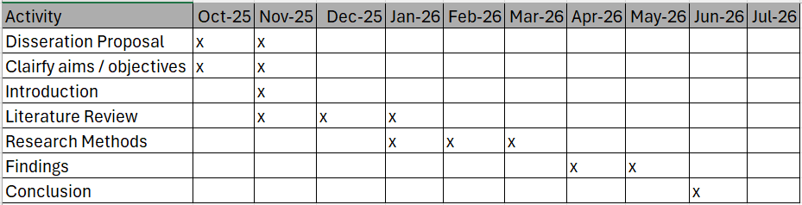

1.5 Value of this research
This research adds value to current research in a number of ways.
Firstly there is a lack of studies available in the UK about race and workforce diversity in policing leadership roles, with Silvestri (2019) suggesting that Scholars have not focussed in depth in this area of policing, this is likely for such a small reference pool available. This is highlighted by Afful (2018) in her study which focused on a small sample size. Largely this is reflective of what is present in current literature, studies confined to hyper local areas such as singular department of police forces or single forces. This study will be open to all UK police forces for officers that meet the participant criteria, Chief Inspector (CI) or above, and this includes serving and retired / ex officers, it is therefore the only known study of its kind to date.
Owing to a lack or known research material, the literature review will not only focus on literature from the UK it will also draw on literature from other similar countries in terms of democratic policing jurisdictions with a higher ratio of representative policing leadership such as the US. This will allow theory gained from the literature review to be compared and contrasted with lived experience from the primary research and therefore provide meaningful and constructive recommendations, but more than this it will also allow understanding of how if at all policing has progressed against its own ambitions set at the turn of the century with recommendations outlined by the McPherson report.
This research will benefit the existing limited academic material to help provide context to and understanding of theoretical and experiential beliefs to shape future direction of how representation may be increased, finally it shines a light on policing culture, expectation and ambition from within, directly from the sources that it is intending to champion and support.

Chapter 2 Literature Review

Chapter 1 outlines the research aims and objectives for this dissertation. This review of literature will focus on objectives 1 and 2 below. It will also touch on objective 3, albeit that will be covered in more detail in chapter 3, where the second element of that objective (a) will be covered via an empirical study. Objective 3 therefore spans chapters 2 and 3. Objective 4 will be based on the combined findings of the literature review and the findings from the empirical study covered in chapter 4. Objective 5 will be covered in chapter 5 and will outline measures for proposals based on the entire research.
- Critically evaluate the wider impact of under representation in Police leadership on society and policing from a cultural and legitimacy perspective.
- Analyse the current representation of Black and Asian officers in senior police ranks (ACC and above)
- Examine current selection and promotion processes for senior police leadership.
- including perceptions of fairness, transparency, and bias (also covered in chapter 3).
- 4). Investigate perceptual barriers for progression to senior levels within policing for Black and Asian officers.
- Propose recommendations for improving racial equity in senior police leadership position
Understanding through research the issues that are identified in literature, through empirical study and analysing several strands of opinion and view will allow this research project to suggest relevant and meaningful proposals to this timely and critical area of policing at a time when it has perhaps been needed the most.
To begin this chapter, we must look at some facts around UK policing where representation is concerned. Firstly, in almost 200 years policing history there has only been one Black Chief Constable Michael Fuller (The Guardian, 2019), and there is currently less than 5% of senior police leaders ACC and above that identify to be black or Asian (Home Office, 2025). Where ethnicity is known for police officers at all ranks in the UK (143k) 91.6% are white.
The context of and understanding the impact of police leadership representation on society in the UK from both a culturally and legitimacy perspective is arguably largely untested due to the small percentages of black and Asian police leaders. It cannot be evidenced convincingly as to whether that disparity is borne out when linking to outcomes and confidence.
To understand this phenomenon in greater detail research in this chapter is not confined to the UK, instead it turns to societies where this can be measured and evidenced by way of case study and therefore discussed in greater detail. The most similar aligned country to the UK is perhaps the United States when considering the disproportionality that make up the population of the criminal justice system versus the general population and thus is relevant to this research (Lammy, 2017). This chapter will seek to tease out the required evaluation and comparison from the US that is relevant to this research.
In comparison the proportion of US black police chiefs is believed to be around 38% in cities that have a population of 250,000 residents (Morrison, 2023). This data is from 2020; however, the exact number cannot be confirmed particularly in smaller police departments.

2.1 The Theory
There are theories offered around representation, it is believed that representation bureaucracy theory was first defined by Kingsley as “a governmental system under which the ministers and civil servants hold similar social and economic views” (Ewing, 1945, pp. 241-242). The definition suggests that public service bureaucracy should mirror the demographics it serves. Clearly due to when it was proposed that was not considering race as part of representation, more around class systems of those heading organisations and public departments. A more up to date concept is that representative bureaucracy also known as community accountability theory suggests increased diversity among a workforce improves the legitimacy of policing in the communities they serve, this includes officer / public engagement (Davies, et al., 2020)
Representation bureaucracy theory is an umbrella theory and contains several concepts within it including those defined by Mosher.
Passive representation, the degree to which the demographics of public servants (like race, gender, or ethnicity) match the demographics of the public. Active representation, the extent to which bureaucrats act in the interests of the groups they represent, often based on their shared values and experiences (Jacob, 1969, pp. 200-201)
Over time these theories have been subject to several reviews and critique as to whether they are effective and inclusive or not, including within which agencies they are most effective. Some argue that representation around race alone is not enough and that confining representation to class and race is too narrow, asserting that not enough weighting is given to gender (Bishu & Kennedy, 2020)
It is worth noting that representative bureaucracy suggests that organisations such as those engaged in policing and procedural justice will reap several benefits if they are representative of the communities they serve in addition to a shared understanding of local issues and problems, legitimacy also is increased as officers with shared values and experiences provide a link to both representative bureaucracy and social identity theory with the benefits of perceived social justice, trustworthiness and fair treatment from a procedural justice basis (Bradford, et al., 2014).
The opposed views to the benefits of representative bureaucracy centre around the culture and socio-economic values of an area as opposed to officer ethnicity.
In their study of the East St Louis police department (ESL), whereby the research focus was on police confidence and encounters from a satisfaction perspective Brunson and Gau (2015) concluded that whilst many respondents were dissatisfied with and had little confidence in the ESL this was mainly due to scarcity of resources, low satisfaction, corruption and a lack of crimes being positively solved. Race was therefore not a factor in either participant or officer perception, although a stand out factor of this study must be that the ESL is made up of 93% black officers in a population average of 97% Black and therefore this study must be viewed with caution, this does highlight that a shared racial background does not guarantee increased levels of confidence but arguably this survey and the current demographic representation in the UK are comparatively worlds apart.
To test the representative bureaucracy theory more locally, and against a less diverse demographic Davies et al (2020) conducted an emotionally based experiment of how ethnic appearance of officers (Black , Asian, White) made participants feel in relation to only viewing images of those officers. The experiment was designed to measure responses to several factors, these were whether on viewing the images, participants (60% white, 20% Asian, 20% Black) felt the officers were approachable, aggressive, friendly, respectful and trustworthy based on a scale of 1-5. Whilst this study could be argued to be one dimensional, it did yield some interesting results. These were mainly that black officers were rated more positively than white and Asian among all respondents, and that black respondents rated the images of all officers as less respectful, lest trustworthy and more aggressive. This demonstrates that respondents did not place officers within their own groups more favourably, highlighting that assumptions should not be made about for example black citizens favouring black officers as an overarching basis to suggest representation is a flat equation.
In their study of health services and environmental justice Kennedy et al (2025) argue that boundaries of representative bureaucracy theory to this point has been too narrow in its application and relevance being focused generally on race and gender when considering organizational outcomes, suggesting that there is more need to focus representative bureaucracy theory on both individual decision making from a procedural justice outcome perspective, but also considering intersectionality theory framework offered by Crenshaw (1989) as a basis to extend the scope beyond simply race and gender where outcomes and impact are measured, considered and presided over. This highlights a more multi-dimensional approach than representative bureaucracy alone, drawing on the increased complexity of social identity based on more than characteristics and individual is born with.
It is clear that representative bureaucracy theory alone has complexities that should be approached with caution when considering if a greater representation of a diverse workforce will benefit the community it serves in either passive or active capacities with better outcomes. There is also the consideration of meritocracy, the question of who is right for the job based on merit versus wanting to select candidates that mirror society (Bradford, et al., 2014). There is often perceptual tension in this area, a policy based on meritocracy does not promote diversity and vice versa as articulated by Imamura (2025). Though these tensions or conflicts are often under-currents in organizational culture for fear on either side of the argument of calling one out over the other when it comes to selection processes.
Pertaining to policing there are further studies that support the concept of police culture over riding representation from early in officers service and adopting a ‘code of silence’, suggesting that allegiance to one another is more important than the way they are perceived by citizens of outgroups (Schuck & Rabe-Hemp, 2022). Hong (2016) suggests that a 10% percent increase in police diversity in the UK correlates to a 1.4-3.8% reduction in recorded crime. Similarly, Brunson and Gau (2015) conclude that whilst a more representative workforce will not guarantee better outcomes for citizens there will be perceptions of the possibility of fairer treatment by the Police.

2.2 Representative Bureaucracy Leadership case studies from the US
Research into representative police leadership in the USA by Shoub & Christiani (2023) does highlight a distinction in racial representation of black police leaders and changes to outcomes. It uses Traffic stops data from 9 Police Departments and draws upon improving policing equating to decreasing negative and harsh involuntary contact with police officers. It also introduces the term 'descriptive representation' (Mosher, 1968) (Pitkin, 1967) which refers to the extent of which identity of those in leadership represent their communities socially as well as racially. It outlines that descriptive representation can be translated into substantive representation which produces outcomes that are broadly beneficial to the communities they represent. It does distinguish three areas as part of its study. Firstly, that the reason for appointment or transition type of police chiefs (retire, misconduct of previous chief / mandate for change) does affect the outcome rates, for both white and black officers, however outcomes are even better if the incumbent is black. Additionally, the research shows that having a mandate for reform and a black police chief reduce negative policing outcomes. It also suggests that black drivers are less likely to be searched by agencies led by a police chief appointed with a mandate for change. White drivers are more likely to experience a search under a black chief or when a mandate for change occurs. On the whole research finds evidence that the identity of the police chief and their reason for appointment matters for policing outcomes. The research also indicates the context under which a black chief comes to power is vital to whether policing outcomes change, hinting at the limitations of descriptive representation alone can do.

Whilst the research yields positive insights, it is worth noting that: (1) no Black chiefs were appointed following a predecessor being fired for personal misconduct; (2) a substantial proportion of Black chiefs were appointed following a mandate for change, indicating that Black leaders do seem to be brought in after scandals; and (3) the most common reason for a transition is due to retirement. This research has its limitations conducted on traffic stops only in 9 forces, all within the same state and it could not determine the accuracy of when a police chief came and left. All chiefs in this study are men. Clearly a similar study in the UK would focus on stop and search as there is correlation in satisfaction / confidence to this area of policing. Although due to a lack of police leaders from Black and Asian backgrounds the same conditions cannot be replicated.

The study of traffic related stops in the USA whilst indicative of perhaps bias, or even unconscious bias is eclipsed by one of the biggest concerns among Black communities in the US, specifically young Black communities which is the propensity for both physical and psychological violence, excessive force and fatal shootings, It has been defined as structural violence (Farmer, et al., 2004). Studies have shown that Black youth feel targeted and profiled by law enforcement (Wendel, et al., 2022).

Research conducted by Yong-Chan & Menfield (2024) into understanding where police departments had effective community policing policies (CPP) translated in seeing reductions in police killings in the USA. Their work hypothesized that an effective CPP in reducing the killings of Black citizens was dependent on having a Black chief and that training for officers was more effective where there was a Black chief in post. The research also highlights that while not directly involved in outcomes, black police chiefs achieve more equitable outcomes in police related shootings. In other words, they help bring policy to life and off the page.

When considering representation and how that links to better outcomes and legitimacy Saltzstein (1989) argued that having a Black mayor increases representation among both officers and staff it is not proven that alone increases positive outcomes for citizens. If we apply that principle to the UK, then we must consider the role of the Police and Crime Commissioner (PCC) as being the equivalent to Mayors in the US as holding responsibility for totality of policing. Although a recent announcement by the Labour government sees the demise of PCCs in 2028 to be replaced by the mayoral system where there is one in place and where there is not the role will be fulfilled by council leaders (Institute For Government, 2025), however of the current 37 PCC’s in England and Wales only 2 are Black or Asian, both are Black women (Association of Police and Crime Commissioners, 2024). This equates to 5.4%, while the majority are White men, this is similarly replicated across Policing, which the next area of this chapter will discuss in more detail.

To conclude whilst there are substantial theoretical benefits to support representative bureaucracy, it alone cannot be evidenced to improve outcomes for citizens, but what can be drawn from the research is that perceptions are improved which does then increase confidence around a fair and just police service, and the author supports the theory for increased representation among police leaders in the UK. There is of course wider systemic representation required in areas linked to policing, PCCs, Mayors and judiciary to support true legitimacy through the criminal justice sector from a community perspective.

2.3 Current situation in the UK
The Police Race Action Plan (PRAP) (National Police Chiefs' Council; The College of Policing;, 2022) published in the wake of increased community tensions following the death of George Floyd in the US in 2020 highlights significant deficits in representation in police leadership, and cites the need to be an anti-racist service as opposed to simply not being racist. It maps out its vision for change highlighting that having only had one Black Police Chief in history as a failure. It also links lack of confidence around representation to policing legitimacy and relationships with its communities outlining that Black officers and staff face barriers to retention and more relevant to this study, progression.
Whilst the notional link to a lack of trust and confidence is intertwined with representation throughout the rank structure, the report uses data from the crime survey of England and Wales (2024) confidence in the local police (segregated by ethnicity) to understand low confidence levels in policing among the community demographic measured by ethnicity.
The report distinctly focuses on and highlights a 20% deficit around confidence in comparison of the national average when ethnicity among the Black Caribbean community is recorded (see fig 1), however these statistics are based upon victims experiences rather than perception, additionally Black Caribbean is a subset within the broader Black Category, which shows Black African being at 65% confidence, which is broadly in line with the mean in terms of confidence (68%) in addition the data capture is 2022-23, and whilst the number of respondents are not listed, it is more of a focused snap shot and it is very probable that that respondents may have been contaminated by media and social exposure around the death of George Floyd at the time of collection. Confidence perceptions are therefore subjective and so to some extent this is not representative of confidence overall when considering how the community feels around perception especially those that have may not have had interactions with police.
A broader and more balanced survey published by the Office for National Statistics (ONS) (2025) appears much more relevant to the PRAP. It draws upon both experience and perception and the data is collected and tracked over a longer time range and with more respondents (2011-2023), this survey suggests that respondents from a Black, Asian and other ethnic group were more likely to rate their local police positively than those within the white ethnic group. In general, however, confidence in policing has had a gradual downward trend since 2011 (fig 2).
Recent research by the University of Law (2023) highlighted that almost a quarter of people from mixed or multiple ethnicity backgrounds do not see themselves represented in their local police force, they also discovered that 1 in 3 believe that this negatively affects their relationships with police. Their report also highlights that as little 0.6% of police leadership (Sergeant and above) are from a Black and Asian background in some areas in the UK. The links to reflecting society among police representation (Bradford, et al., 2014) and more specifically police leadership are also raised in the report The State of Us: Community strength and cohesion in the UK, which draws on the events of Summer 2024 to understand the impact on cohesion and provides recommendations about how to build stronger societies, it highlights; ‘In a more diverse society, sources of inclusive identity and pride across our differences become more important, to break down ‘them and us’ boundaries and strengthen a shared sense of ‘we’ (Puddle, et al., 2025, p. 96). The report also brings into focus that despite efforts to increase confidence among diverse communities, policing faces trust issues among society especially following polarising events where discriminatory treatment is perceived to be evidence of two-tier policing.
The current representation of Black and Asian officers in senior police ranks (ACC and above)
This paper specifically aims to understand why representation among senior officers is proportionally lower at the most senior ranks in comparison to the proportion of other ranks, senior ranks for the purposes of this paper are determined to be Assistant Chief Constable and above. The most recent workforce survey by the Home Office (2025) demonstrates that officers by ethnicity over time has broadly moved in line with graduated increases for all ranks from 2.5%-7% over the 2007-2024 timeframe, except for senior ranks, especially at Chief Superintendent and above, however the picture is more concerning at Chief Officer ranks (ACC and above) where it drops from its peak in 2022 of 6.8% to its current position of 4.4% in 2025 (fig 3). This could be due to the low numbers that are present in those ranks, however it does stand out especially when the ranks below are moving at a consistent rate and trajectory, for example there are suitable feeding ranks to support the sustained numbers at Chief Officer levels.
Numerically this equates (where identity is known) to 3 Asian officers (0.8%) 7 Black officers (1.9%) 6 from a mixed background (1.7%). So, a total of 16 officers from a cohort of 229 (95.3% white).
Historically several studies have attempted to understand why officers from diverse backgrounds have not converted into the most senior positions. Studies have identified that there is a lack of visible role models (Walcott, 2021) and opportunities available to white male officers such as coaching, mentoring may be in policy to support Black and Asian officers (Verma, 2015), however the reality is that culturally and socially officers from Black and Asian backgrounds regardless of academic achievement (Vuma, 2025) are often excluded from these the ‘social network’ inclusion of chief officer sponsorship ‘clubs’ (Clarke & Smith, 2024), and instead internal closed network groups operated covertly to favour white male officers suggesting that covert institutional racism is at play. Unfortunately, this is believed to be happening where there are arguably the biggest concentration of Black and Asian officers and perhaps the most opportunities to increase representation, The Metropolitan Police Service (MPS) and National Police Chiefs Council (Clarke, 2020). The MPS is of course no stranger to controversy and is the shop window of British Policing, with Commissioner Sir Mark Rowley refusing to accept ‘Institutional’ racism over systemic failures (Youtube, 2023) in response to the Casey review (2023) which specifically raises underrepresentation at higher ranks among women and men. The report also cites higher attrition rates among Black and Asian officers with significant racism in the workplace, and a systemically biased misconduct system. Whilst some of these findings are relatively new, unfortunately some also echo similar concerns raised by the Macpherson report (1999) more than quarter of a century ago. Although representation has increased generally it is still not reflective of communities, especially at senior ranks. Again these concerns were raised more recently by HMICFRS (2023) and The Police foundation (2022) and whilst there are initiatives that encourage and promote candidates from diverse backgrounds such as the college of policing current Fast Track Inspector to Superintendent (FTIS) programme which states one of the aims is to “improve the number and diversity of those accessing the pipeline to chief officer ranks” (College of Policing, 2025). Sadly, the initial pathway into the programme is at forces discretion as to which candidates the force submits for the national assessment centre, as the author has first-hand experience. This does then suggest that the programme is not impartial in entirety and supports the concerns raised by HMICFRS and The Police Foundation, that selection needs to be more impartial than it currently is.
Where police promotions are concerned there is of course the balance to be struck between positive action and the need for increased representation. Whilst under equality legislation, positive action is a legitimate tool for increasing diversity the application is not only legally but also culturally fraught with danger, as pointed out by Gold (2023). Legally to be compliant with law, in a promotion process.
(i) The person is “as qualified as” the person who does not have the protected characteristic:
(ii) The employer “does not have a policy of treating persons who share the protected characteristic more favourably in connection with recruitment or promotion than persons who do not share it”.
(iii) The action is a proportionate means of overcoming or minimising the disadvantage connected to the characteristic. S159 of The Equality Act (2010)
Culturally this has implications for the workforce, where the balance to be struck can be seen as selecting a candidate because of a protected characteristic. In his research Stubbs (2023) uncovers a hidden racial taboo whereby officers competing for promotion would face a dichotomy of ethics, one hand suggest that there needs to be an increase in representation within promotion process, on the other also stipulate a need to ensure the right person for the job was selected based on meritocracy, thus suggests that under represented candidates may be perceived to only be promoted because of a characteristic – again this could be due to a lack of awareness around legislation, but culturally it is a toxic sub-culture which may ferment on a false belief if left unchecked which can create sub divisions of in and out groups in leadership and policing generally as it assumes the under-represented candidate is not as competent as candidates without a protected characteristic.

2.4 Summary and emerging issues

This literature review has highlighted that there is under representation of Black and Asian senior officers in policing and that representation alone does not guarantee increases in confidence or legitimacy and certainly would not necessarily increase positive outcomes for service users or the communities. This is evidenced in areas that have increased representation among police leadership and are more reflective of the communities they serve, where social demographics and deprivation become a determining factor. What is perhaps more striking however is that it also highlights that a lack of representation does support the reverse of representation theory, that is that a lack of trust and confidence in areas where representation is low or not reflective. This demonstrates that there is clearly a belief that representation is needed to provide a basis at least for a starting point of increased legitimacy and increased confidence, that is echoed by the communities, the police service as a body, but also those that are closely linked (NPCC / CoP / HMICFRS).
There are clearly undertones of social inclusion as a factor for success when it comes to being ‘sponsored’ or supported for promotion pathways. Evidence suggested that some Black and Asian officers that are not socially included as part of informal groups may not be offered the same opportunities for mentoring at least unofficially – this has links to groups outside of policing such as the freemasons and being members of other influential groups such as sports teams etc. This suggests that ‘we like you as you are like us’ adage still exists where opportunities are being considered and offered.
The racial taboo of positive action is still being treated as a conversation that people do not want to have, it demonstrates that there is an undercurrent of a ‘candidate only got a promotion because of a characteristic’ or at least a belief that Black and Asian candidates are not as competent as others, a dangerous and toxic sub-culture which harbours resentment and disdain that can have long lasting effects for officers that may find themselves on the mistaken belief that they are not as competent as others in similar ranks and roles.
Empirical research will now be conducted to establish if there is evidence of issues raised in this literature review, including what barriers, perceptual or otherwise exist for Black and Asian officers that are unable to penetrate through to the highest ranks in policing. The next stage of this research will detail research methods used to capture this data. This will include research strategy, data collection techniques sample selection, question sets and management of the researchers’ role.

Chapter 3 Research Methods

3.1 Introduction
The literature review highlighted that there is under representation of Black and Asian officers at senior ranks within policing. It also highlighted that there are concerns around social inclusion of groups of officers which may lead to outgroup mentality. Additionally, whilst representation theory alone is not enough to increase outcomes, it is a starting basis for increased trust by communities.
Empirical research will now be conducted to seek to understand why that lack of representation is so profound among Black and Asian officers at Chief officer level, and from an experiential perspective tease out understanding to match theory with real life experience from participants.
This chapter deals with the second element in objective 3 (perceptions of fairness, transparency and bias), by examining both that element of the objective, and also objective 4 (below),
3.) perceptions of fairness, transparency, and bias (promotion processes)
4). Investigate perceptual barriers for progression to senior levels within policing for Black and Asian officers.

It will seek to gather views from research participants on promotion processes and also address perceptual barriers according to their experiences. This includes the research strategy to be employed to meet those objectives, and how data will be collected, participant identification and selection, sample size and how collected data will be assessed and analysed (Biggam, 2021).
The literature review has identified themes that should now be tested by way of research of participants that are themselves subject to the consequences of behaviours and treatment outlined in the literature review, that is both serving and ex / retired officers.
Note there is a distinction here between ex and retired, the reason for this is that there will be occasions where due to some of the behaviours, limitations or lack of progression outlined in this paper for some officers that alone may be an influencing factor for officers for them to have chosen to prematurely end their policing careers voluntarily. This could also be linked to high attrition rates for Black and Asian officers (Walcott, 2021) and it cannot be overlooked that this does not apply higher up the rank structure too as well as more junior ranks. For ease serving officers will now be referred to as group 1 participants and ex / retired officers will be referred to as group 2 participants. This will allow for synthesizing the literature with views of those cohorts of officers and provide real world lived current and previous experiences from those that can add legitimate weight to theory and literature.
The importance of participant research engagement and opinion will help to shape the direction of this research and will ultimately provide an up-to-date picture of what experiences can add to the existing research and literature, including views, treatment perceptions on promotion process including fairness and dealing with disappointment this will assist with this and future research projects.

3.2 Research Strategy

The research strategy that will be employed is a mixed method comprising of a series of surveys and where possible interviews.
A survey is defined as an examination of people’s opinions, behaviour for example by asking them questions (Cambridge, 2026). The benefits of surveys are that they a convenient means of obtaining specific data in a cost-effective, targeted and rapid way (Craig, et al., 2024). It will also allow for opinion and views to be expressed in a narrative way that will provide qualitative context. The author believes that this is particularly most suitable for group 1 participants: serving officers. This is because it allows the question sets (Appendix A) to be answered in a confidential way without exposing their details, force or region. There will be some identification in terms of geography to understand if there is a pattern based on locality to the research, for example North East, and so on. Whilst this will not identify which force or region per se the officers are attached too, it will draw a distinction based on socio-demographic factors or where there is a concentration of similar respondent answers.
The second group of participants; ex/retired officers will have the additional option to be interviewed, the reason for this is that whilst group 1 may provide more quantitative research and views in addition to qualitative, and as mentioned above that is due to risks around exposing identities of those officers still serving. Group 2 which will largely be made up of ex-retired officers some recent others not so, and interview provides a richer experiential reflective and therefore more qualitative area of research that will allow the author to really understand opinion and more importantly beliefs first hand. In person interviews are preferable, but the author accepts that due to times, geography and capacity interviews conducted online may be more appropriate. In their research into how to best makes sense of interviews and how to get the best out of the interviewee Willink & Shurki (2018) suggest that interviews should be “relational events that are shaped by the people, objects, atmosphere, and affective tonalities. That is to say that an interview should be more than just a list of questions that need answering, the tone of the interviewer, the attunement and relationship building are as important as the questioning, and that is why the author feels that group 2 would be more conducive to interview as opposed to survey.
To provide additional context the author also has anonymity as a factor in determining which method is most appropriate for which groups. The serving officers are more likely to participate if they are satisfied that their details will not be divulged, especially around the content of the study or fear of detrimental treatment. The retired officers on the other hand are less likely to be guarded about their identities, however where that is the case the option of being anonymous remains for those participants too.
This research adopts a social constructivism (Vygotsky, 1978) ontological position, understanding that under-representation of Black and Asian officers at senior ranks is shaped or at least perceived to be by social and cultural factors in the public eye, however organisationally well intended aspirations are perhaps stifled when it comes to progression by internal barriers and potentially stereotypes which hinder true potential, and so a realist or objective approach to research may be too one dimensional to understand the variance of experience within the participant cohorts and responses according to their own cultural paradigms (Rogoff, 2026). This Coupled with an interpretivist (Weber, 1921) epistemological position which acknowledges that individual experiences will have different meaning to participants based on their view and how they make sense of their own treatment and environments based upon their sensitivities and reflection (Yardely, 2026). It will allow the researcher to explore in a more engaged and immersive in-depth subjective approach true understanding and inductive learning (Michalski, 1983) .

3.3 Data Collection

3.3.1 Where will the data come from
As mentioned in the previous section, data will be collated from two groups of police officers. Group 1 will be current serving police officers and group 2 will be ex / retired officers. To break down each group in more detail and to meet the research objectives outlined at 3.a and 4 there is more detailed criteria that must be applied. Therefore, each group is as follows; -
Group 1 – serving police officers in the UK that have reached at least the rank of Chief Inspector or above that identify as being from a Black or Asian background.
Group 2 – ex / retired police officers that have served in the UK that have reach the rank of Chief Inspector or above that identify as being from a Black or Asian background.
The rationale for having two groups are that serving officers can provide current insight into their perceptions of fairness, transparency and bias around promotion processes. This includes being passed over for promotion, current active promotion processes employed by their force and perhaps most importantly the current barriers that they perceive exist. In relation to ex or retired officers the same as above will also be relevant but an additional dimension is added with their inclusion around potentially exploring reasons for leaving the service, transferring forces or not seeking promotion. Additionally retired officers offer a unique reflective experience, which may be more objective than those currently in service.
The rank of Chief Inspector or above has been chosen as it is the top inspecting rank and often considered an upper middle management rank in policing. Many see the rank of Chief Inspector as being a gateway to being a Superintendent, with arguments that the rank is actually not needed and holds no additional legal powers and therefore serves largely to be a springboard to senior leadership in policing, as the responsibilities are increased and the starting pay marginally more than an Inspector top line salary. Some forces have considered removing the rank entirely, or have done so before reinstating it, such as Wiltshire Police in 2014 (Police Professional, 2014).Evidence of this can be illustrated by the Metropolitan polices recent publication that showed appetite for Inspectors seeking promotion to Chief Inspector and likewise Chief Inspectors seeking promotion to Superintendent. In both cases the most recent year used for the illustration is 2024 whereby 288 of 1152 eligible Inspectors (25%) submitted applications for promotion versus 162 of 410 (40%) eligible officers seeking promotion from chief Inspector to superintendent Fig 4 (Metropolitan Police Service, 2025).
This demonstrates that there is a greater desire for Chief Inspectors to seek promotion into senior rank positions, coupled with it being the highest rank sustaining 7.5% diverse representation (Home Office, 2025) it should offer significant insights to causation for the trend declining into more senior ranks, therefore for the purpose of this research that rank has been selected as the base rank for empirical data collection purposes.
The data will be collected in the following ways: -
Group 1 serving officers.
The author will approach all UK forces, this includes Police Scotland and request that all forces forward on the survey for completion to officers at Chief Inspector rank and above that identify as being Black or Asian and that those officers are afforded the opportunity to complete the survey should they wish to participate. There is an assumption that most if not all forces will have within them minority support forums / networks / associations which may be able to assist with identifying group 1 officers, should their own records not hold such data. This is because officers may be reluctant to identify their ethnicity.
Group 2 ex / retired officers.
The author will utilise the support of the National Association of Retired Police Officers (NARPO) to advertise the research project in their monthly issued magazine, again for retired officers that reached the rank of Chief Inspector or above and also identify as Black or Asian.
At the risk of neither option above being able to reach group 1 or 2 participants the author will also approach national support groups, including for example The National Black Police Association (NBPA) The National Association of Muslim Police (NAMP), a more comprehensive list is found at Figure 5. Finally to support largely the ex-police officers element of group 2 participants the researcher will also approach the Police Federation of England and Wales (PFEW) to assist, they will have data which will be relevant to both ethnicity and whilst officers may not be members of individual support groups, it is likely that they will all have been at one point during their service a contributing member of the PFEW the PFEW will also be able to support contacting officers directly through personal e-mails and update on cases where they have been instructed to represent their membership on a wide ranging list of supportive mechanisms, for example claims for discrimination, personal injury and employment tribunals etc and so they support many aspects relevant to this research.
This approach may have overlap and some risk of duplicity, but it should be comprehensive in at least reaching a wide range of officers nationally.

3.3.2 How will the data be collected
The survey questionnaires will be completed using Microsoft Forms. A link will be shared with those listed above to share with relevant participants and then on completion the data will be collected centrally on MS forms. Where participant contact details are share with the author, those that are group 2 participants will be offered the opportunity of an interview or questionnaire instead of only a link to the questionnaires, this is due to issues raised earlier in this chapter about a potential fear of exposure / participation by group 1 participants, but also group 2 may prefer to be interviewed, both options will therefore be presented to group 2.

3.4 Data Analysis
As highlighted earlier in this chapter the research will fall into two separate categories, Group 1 and Group 2, they will effectively be two research strands of the same project. This is to understand what both serving officers and ex/retired officers views are on both perceptions of fairness, barriers and relevance to promotion processes and representation are. Both sets of data will be evaluated separately and then brought together to form the findings of the study in line with the objectives and theory derived from the literature review, which will help with supporting the findings for this research. Whilst the framework encapsulating this chapter set out by Biggam (2021) is broadly aligned with The Research Onion (Saunders, et al., 2023) In terms of specific methods for raw data analysis the model to be employed will be The six phases of thematic analysis model by Braun and Clarke (2006). This model (figure 6) provides key benefits where raw data analysis is concerned over the research onion. Its focus is more specific, flexible and its emphasis is on primary qualitative data that allows a greater degree of flexibility and identifies key patterns derived from the data in comparison with the research onion which is a broader design project framework.

3.5 Limitations and potential hurdles
Like any research project there are limitations to this research. They will be highlighted below and what if any mitigation can be implemented to reduce those limitations.
- There are potential limitations to participation, duplicity and authenticity. The scope of participants that this research aims to canvass is wide, for example it includes current serving officers and retired officers. Whilst the cohort sizes may not be large in context the range of how those participants are secured involves many agencies / bodies. As this research project supports anonymity of participants, which is arguably one way of securing more sensitive information over a survey that is conducted confidentially (Murdoch, et al., 2014) particularly around hard to reach or reluctant participants (Sterzing, et al., 2018), ensuring fairness and bias removal (Pitt & Winstone, 2018). It does however highlight some concerns around data integrity and behavioural responses, and therefore seriousness checks or unique identifiers are preferable to reduce these instances (Aust, et al., 2013)
Mitigation measure: Include DOB year as a unique reference identifier as part of the survey, this addresses some of the issues raised while maintaining anonymity.
- There is no way of knowing that a) the participants are in fact the subjects of the target cohort b) that the same participants have not completed the surveys more than once (i.e. by using different e-mail accounts). C) owing to anonymity there is no way of being able to contact participants for verification.
Mitigation measure: only participants that contact the author, via the appropriate facilitation, i.e NARPO / Home office forces will be sent a link for completion. This reduces the cascade effect of forces distributing a link a link to participants and will allow the author to maintain a measure of those requesting a link to survey completion and correlate to the completed surveys, for example if 50 participants request a link but 100 complete the survey it would highlight a data integrity issue.
- Volume, participant uptake and timeliness – although those that identify as Black and Asian should be low in number at Chief Inspector rank and above, there are no guarantees that participants will engage with the research. There is also a collapsing timeframe for completion, this also applies with regard to high uptake, and so there is a need to have a cut off in terms of when to conclude that participants have had sufficient timeliness to complete the survey.
Mitigation measure: when sharing a link with participants to the survey they will be given one month to complete the survey, and links will not be shared after 1st March 2026, ensuring that all participant data is collected by 1 April 2026 for analysis and evaluation.
These mitigation measures are key to securing the most reliable data to provide critical and in-depth crucial information to support the understanding of the ‘why’ element of this research to support statistical data and theory behind causation or understanding of what barriers there are to progression and increased representation at senior levels in policing. The findings of this research will be key to understanding how to address and increase representation.

Chapter 4 Survey Findings: Description, Analysis and Synthesis

4.1 Introduction
This study covers research objectives 3 & 4 of this dissertation from an empirical perspective.
- Examine current selection and promotion processes for senior police leadership including perceptions of fairness, transparency, and bias.
- Investigate perceptual barriers for progression to senior levels within policing for Black and Asian officers.
The data was collected from two groups of participants serving (Group 1) and retired / ex police officers (Group 2). The purpose of the data collection was to gather views from research participants on the themes of promotion processes and also perceptual barriers according to their experiences and views as outlined at Chapter 3 research methods. The means of collection was via survey which was adapted slightly differently for Group 1 and Group 2 participants (see Appendix A). The survey was sent out to all 43 police forces in England and Wales, also Police Scotland, Garda and several support groups including Black Police Association (BPA), National Association of Muslim Police (NAMP), and the Police Federation (PFEW) for serving officers and the National Association of Retired Police Officers (NARPO). As has been outlined in chapter 3 all completed surveys were received anonymously.
The following makes up the completed survey cohort responses.
Group 1 = seven
Group 2 = four.
These will be explored in more detail throughout this chapter.
The analysis compares cohort responses, identifies common themes, allowing for some differences, for example Group 1 is based in the present context, whilst Group 2 is more reflective and rear facing contextually. Those grouped themes outlined when analysed will then be contrasted with the Literature Review findings (Chapter 2).
There was some variation in responses to the request for research from some institutions, e.g. some such as British Transport Police needed to put all research requests through a research board, one force indicated that organisational pressures prevented participation to complete research at that point in time in the lead up to a HMICFRS inspection. Other forces were happy to share with their appropriate cohorts directly whilst others (Police Scotland) had a central contact that then disseminated surveys based on their approval. What has been written thus far in this dissertation highlights a lack of representation at Chief Officer level in policing, and all things considered the cohort of officers that meet the criteria whilst not being plentiful. While the researcher had anticipated a larger dataset, participant engagement was limited. This may reflect organisational pressures, competing priorities, or concerns around confidentiality, which could warrant further investigation.
The next section presents thematic analysis of the empirical study data, as chapter 3 highlighted, to support this Braun and Clarke’s (2006) six phases of thematic analysis will be utilised.
The themes have been refined from coding the survey data and broadly aligning with the following theme categories;-
- Inconsistent progression pathway opportunities
- Process fairness, transparency and consistency.
- Social sponsorship and informal power
- Cultural acceptance and role modelling

4.2 Findings

Before going into specific themes, it is useful to highlight some of the statistical demographics regarding respondents within both groups 1 and 2. Figure 7 illustrates empirical respondent demographic. All group 2 respondents completed 30 years’ service, which for that that time-frame was considered a full policing career, due to recent changes to police pensions first brought about in 2006 (Crawford & Disney, 2014).

Figure 7 - Empirical respondent demographic data.
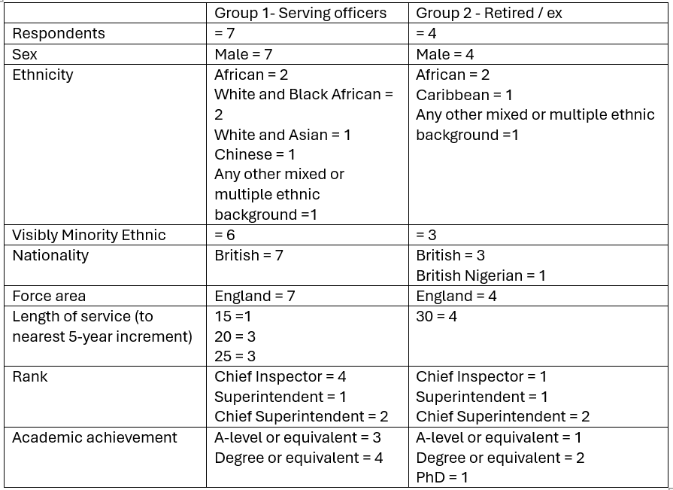

4.2.1 Theme Inconsistent progression, support & structured pathway opportunities.

This theme highlights that survey respondents demonstrated in their opinion and experience that progression is dependent upon varying factors. This includes perceived correct and appropriate experiences, postings which offer both opportunities and structured development. Respondents suggest these are managed or distributed inequitably in terms of application or access. The theme is built upon respondents suggesting lack of progressive and structured career support and opportunities, also stagnation in terms of settling for realised ambition.
Group 1 responses.
Of the seven respondents, three reported having served in more than one police force. Two attributed this to family-related reasons, such as relocating to support childcare arrangements, while one respondent 7 stated that their transfer was motivated primarily by promotion opportunities. Despite having achieved rapid progression to the rank of Chief Superintendent within 20 years of service and holding this rank for four years, the respondent reported no ambition to progress further and intends to retire at their current rank. This may indicate either contentment with their current position or a response to cumulative barriers experienced during previous promotion processes, resulting in the individual reassessing their career aspirations. When considered alongside the broader cohort, this reflects a pattern in which officers, even those who progress quickly, may encounter a perceived ceiling beyond which further advancement is viewed as unattainable or undesirable. This aligns with Abele et al.’s (2012) concept of career stagnation, whereby repeated barriers or organisational constraints lead individuals to disengage from further progression, reinforcing the theme of inconsistent and inequitable promotion pathways identified across the dataset.
Progression
When focussing on how long respondents have held their substantive ranks it ranges from three to six years, all baring two respondents (3&7) are actively seeking promotion to the next ranks suggesting that there is evidence of stagnation. Four of the seven (57%) respondents have not been offered the opportunity to take up a temporary higher rank which does tend to suggest a lack of progression approaches and opportunities. Of the three that were offered temporary promotions each has outlined that it was for either short term temporary cover or that they had been paper sifted out from a forthcoming process. Likewise, whilst all but two respondents appear to be actively seeking promotion, both respondents that have attained the rank of Chief Superintendent do not see themselves progressing beyond this rank despite still having at least 5 years’ service remaining and having achieved much success in their careers thus far.
In terms of additional progression only two (29%) of seven respondents have been offered enhanced and bespoke support for supporting with future promotion boards, such as CPD or mentoring support following their most recent failure at a previous promotion process.
- Group 2 responses.
When contrasting with Group 2 respondents, considering service within one force or more and final ranks achieved it ranged from a minimum of 4 years up to 10 years spent in final rank. 50% of respondents making attempts to or at least having ambition on being promoted to a higher rank prior to retirement.
Only one respondent (1) was actually offered a temporary promotion whilst in their final rank (as a reminder this is the respondent that is a non-visible minority ethnic officer), though this was a short secondment to a major incident overseas. One respondent (4) stated that they had moved force to both gain a broader policing experience and for promotion opportunities.
When considering support following a board failure two were offered bespoke CPD for a future promotion board.
There is commonality between Group 1 and Group 2 in this theme, firstly one respondent from each group stated that they had moved forces for promotion, whilst this does suggest that there are not always opportunities within one’s own force, some are willing to move forces for family and other supportive reasons, but for others progression opportunities are also a factor. That can be influenced by many reasons such as size of force, ambition vs effort in requiring the move which is not always a simple move, the availability and timings of promotion process and of course perceived fairness or organisational justice (Greenberg & Tyler, 1987) that is either absent or present in decision making. Interestingly both officers in Group 1 and Group 2 are or finished the same rank Chief Superintendent.
Again when considering how long some respondents in both groups have held their current / final ranks there is some lengthy periods six years in a rank for an aspiring officer that is still serving is considerable, as is ten years (a third of the officers career) for an officer to spend prior to retirement, both of these officers are outliers in their respective groups, but both attempted several promotion process.
Officers being offered temporary promotions in both groups is low with less than 50% across both groups and in group 2, it was offered only to the non-visible minority ethnic officer, and in the case of group 1 officers all have reverted to their substantive roles following a short temporary spell in higher ranks. Structured and bespoke CPD is also common among both groups with only two in each group being offered meaningful support. This is poor for both groups by todays standard if forces are serious about progression as per the Police Race Action plan (2022), and may be indicative of a glass or bamboo ceiling effect (Cotter, et al., 2001) (Lu, 2024).

4.2.2 Theme Process fairness, transparency, consistency and feedback
This theme draws upon respondents’ experiences of promotion and selection processes being legitimate, objective, clear and transparent. It also outlines whether a perceived unfairness in a process discourages respondents and breed’s mistrust. Additionally, it compares and contrasts standardisation across the UK and seeks to understand if inconsistencies are based on process or a lack of true transparency. The theme is built upon respondents highlighting a lack of faith in the process, inconsistency in feedback provided and a demonstration of differing models for selection in the UK.
Group 1 responses.
Four of the seven respondents had attempted to pass a promotion process from their current ranks to the next rank. One respondent (5) has attempted the process four times and has been unsuccessful on each occasion. Whilst feedback had been provided to all respondents for their most recent attempts at passing a promotion process. Three of the four respondents stated that they felt the feedback was both supportive and constructive in terms of assisting with future promotion processes, but one respondent (5) did not believe that the feedback they received was useful towards a future process. When considering on the whole, including respondents’ perceptions of all promotion processes that they have participated in whether they believed their forces promotion process were fair, objective and transparent five out of seven respondents believed the processes were not.
When asked if respondents believed ethnicity was an influencing factor in promotion processes five of the seven respondents stated they believed it was an influencing factor, with two respondents (1 &3) specifically stating it was not. Interestingly respondent 4 outlined that he believed that due to him being a non-visible minority ethnic officer that he had found this to be more the case of those in decision making roles on selection process and opportunities were more pronounced when those knew of his heritage as opposed to decisions made about his progress when the decision makers were unaware of his heritage and background. Respondent 4 also cites that he had contrasted this where his assessment and performance along with qualifications and competences against peers have seen them be awarded opportunities over him, which he strongly believes is evidence of awareness of his heritage which he has measured over his 20-year service, this scenario was evidenced in the literature review by Verma (2015).
Group 2 responses
In comparison to Group 1, Group 2 respondents responses appear to mirror the same around inconsistencies of process they had undertaken whilst serving. Only one respondent had not attempted promotion in their final substantive rank to the next one. Of the Three respondents that had attempted a promotion board in their final rank (all unsuccessful), one respondent (respondent 2 whom held their final rank for 10 years ) had 3 attempts at promotion, highlighted they were provided with feedback but did not consider it supportive and constructive, although the other participants did receive feedback and believed it was supportive and constructive. Two believed their forces’ promotion processes were fair (of which participant 1 was non VME) and two did not believe it was fair. Only one of the four respondents (respondent 2) believed that their ethnicity was a factor in being unsuccessful in their promotion process, largely due to having failed it three consecutive times with no real trust in the feedback or support therefore calling into doubt the integrity of the process.
It is apparent from respondents that there are varying processes with several layers of mostly subjective rather than objective barriers. The variety includes the largely standardised system of application followed by presentation and interview. There are also some forces which are arguably more objectively based from the outset, respondent 3 states in his force the selection process includes completing a portfolio of evidence which is submitted and evaluated as to whether the candidate can proceed to a promotion panel. Some are based on other factors such as operational competence for example one process includes a briefing exercise, followed by a media exercise then interview (respondent 4). The majority however include having support from both immediate line management and also in some cases a senior leadership teams endorsement, this comes with a potential opportunity for nepotism and endorses the social inclusion factor (Clarke & Smith, 2024) highlighted in literature review, in other words if the candidate is viewed on opinion to be ready for promotion and largely is liked collectively then they may get support to proceed, control is certainly at this stage subjective and whilst one force uses a portfolio of evidence the question is how much weight that does that portfolio have in the overall score.

4.2.3 Theme Social sponsorship, attainment and informal power
This theme seeks to understand respondents’ perceptions that some progression may be both influenced and supported by informal networks and advantage with those in positions to ‘sponsor’ some candidates demonstrating that not all support is perceived to be fair or equal, regardless of allies, merit or competence. The theme draws upon key respondent analysis of academic and operational attainment and influence vs an open lack advocation and opportunities and covers inferiority complex.
Group 1 responses
One of the seven respondents stated that they spend time socially with peers / senior leaders outside of the work setting. All of the respondents that had been provided with opportunities to act in a higher rank appear to be for short term periods or covering others briefly.
When reviewing academic attainment four of the seven respondents hold a degree or equivalent, the remaining three have A-level or equivalent. All respondents appear to have achieved the relevant functional policing qualifications relative to their field, for example Senior Investigating Officer (SIO) for detective respondents, and Tactical Firearms Command (TFC) and Public Order Public Safety (POPSA) for uniformed officers. These are generally commensurate with role rather than rank; however, one respondent (3) has several within his discipline. This is interesting as only two respondents (1&7) believe that either academic or policing qualifications are important factors in supporting progression. Whilst five of seven have stated they have had support in either achieving or supporting efforts to gain academic qualifications, only one respondent of the two that has outlined no support for obtaining academic qualifications (participant 2) states they would consider obtaining academic qualifications in the future if offered, although three more respondents suggested they would welcome future support in academic qualifications. Two of the three that have suggested they would not want further academic qualifications are both degree or equivalent holders. Respondent four stated the following regarding qualifications “We talk about representing the community but then insist on qualifications that most of the community don’t have”. Clearly this comment is reflective through the rank structure including the lowest ranks but it’s impact resonates at the top, highlighting a perhaps a flawed belief for a need for academic achievement is key to professionalisation (McMahon, 2021) (College of Policing, 2020) of the police service as a whole but also those in leadership roles, however others (Schafer, 2010) (Manning, 2011) argue that personal attributes matter as much as academic attainment particularly around leadership and trust.
Group 2 responses
Contrasted with Group 1 respondents, three of the four group 2 respondents suggested that they spent time socially with peers / senior leaders Only one respondent (1) spent time in an acting higher rank prior to retirement.
Respondents were proportionally higher qualified with all three of the visible minority ethnic officers achieving a degree or equivalent, and one (respondent 4) holding a PhD, participant 1 the non-visible minority officer was educated to A-level standard. Respondent 4, academically the most qualified states they held no significant policing qualifications such as Senior Investigating Officer / Public Order Public Safety Advisor, Tactical Firearms Commander, although by contrast respondent 1 is as functionally qualified as the others citing 9 judges commendations, this highlights experiential competency based recognition for participant 1 hold more weight over their academic attainment, however given the age of participant 1 (85) this may be reflective of the time. Respondents 2 & 4 appear to have obtained functional qualifications in line with their roles (Tactical Firearms Commander / Senior Investigating Officer).
Likewise participants 1 and 2 do not believe either academic or policing qualifications were important during their service, whereas respondents 3 & 4 believe both are important in their career progression, this supports to some extent respondent 2s narrative throughout, that despite having a degree that is irrelevant and would not materially have changed things in terms of progression as they don’t appear to have been accepted or ‘sponsored’ in their force regardless of qualification or experience.
All bar respondent 1 were supported academically, although this again may be a snapshot in time and relevance to policing where service is considered with respondent 1 serving much earlier than the other three, supported by the suggestion that respondent 1 never sought or would accept support to obtain academic qualifications, only two respondents (2&3) would have cared to obtain further academic qualifications, although again this could be due to the belief by respondent 1 that they are not as important, and participant 4 holding a PhD and effectively have maxed out on academia.
Fuller (2019, p. 64) believed that ensuring he was as qualified as the next person was an assurance that no one could accuse him of being under-qualified as a reason for not being chosen or selected for progression, as such he attempted to make himself impregnable to what is described as ‘implied inferiority’ (Yeakey & Henderson, 2003) either academically or operationally. This is a common internal feeling among Black and Asian people when considering that some officers must combat racial bias, within hierarchical structures or institutions and is described as imposter phenomenon or imposter syndrome where there is a fear of self-doubt and ability to deliver on potential (McGee, et al., 2022).
This theme has highlighted that despite those that see academic qualifications as necessary for progression, informal power is viewed as being a more dominant factor, and supports the information in the literature review that qualifications (Vuma, 2025) and merit (Bradford, et al., 2014) are not alone a recipe for success.

4.2.4 Theme Cultural acceptance, role modelling and barriers
This theme explores cultural belonging and acceptance, it is shaped by respondents outlining and identifying some wider organisational observations around tokenism, role modelling, lack of appropriate and visible leadership alongside cultural resistance and perceived barriers.
Group 1 responses
All except one candidate see themselves as role models to other officers from diverse backgrounds, the one that did not was the respondent which does not consider themselves to be visibly minority ethnic (4). When considering their own role models, some relate to their own forces, others specify that there are none from an ethnic minority background (respondent 3) others specify operational competence and 'decent' human beings along with caring about people (respondent 4) as suitable traits, others specifically only cite visibly minority ethnic role models (respondent 7) suggesting a lack of appropriate role models available.
Four responded that they felt the need to be more competent because of their ethnicity, this again links back to proving oneself or inferiority complex raised in the previous theme, whilst not a respondent in this research, this is articulated by a serving Black Female Chief Superintendent Tanya Wilkins whom comments:
“I do feel a need to prove my competence and capability, to justify how I’ve achieved the rank of Detective Superintendent. It isn’t because I’m Black or because I’m a woman, it’s because I’ve worked hard. When I start a new posting, as I’ve just done recently, I’ve got to go in there giving it 110%, but sometimes my 110% doesn’t feel as worthy as someone else’s” (BHM, 2023)

When asked about whether diverse representation in policing should match that of society, all respondents agreed that it is important to have diverse police leadership, and that communities trust a police service that is representative of society. The respondents highlighted the benefits of a representative police service including, better engagement with marginalised communities, increased trust and confidence and information flow along with enhanced legitimacy and perspective that is relatable to communities and individuals, wider more empathetic thinking. None of the respondents could clearly outline any distinct disadvantages of not having diverse workforce other than the opposite of the benefits but offered additionally that diverse communities would feel over-policed and under-protected and that the same creativity and innovation would be stifled as the same ideas would not flow to the top of the organisation. This links back to the findings of the literature review around community trust and legitimacy (Brunson & Gau, 2015) (Davies, et al., 2020).
Considering respondents views on barriers to promotion in addition to what has been discussed so far, they suggested a lack Role models and cultural dissonance around positive discrimination and implied inferiority based on an opportunity given to those that are Black or Asian along with a lack of diverse panels. One respondent was direct stating:
“Racism, in that in my experience many officers do not want to be led by a black senior leader. Policing can be quite right-wing in their thinking and black officers are typically treated with suspicion” (respondent 7).

The respondent is verbalising his views on structural links between race and power in the context of framework such as critical race theory (Delgado & Stefancic, 2017) which suggest that racism is embedded systemically in organisations rather than purely an individual trait or bias.
Group 2 responses
Respondent 1 was the only respondent that did not feel the need to work harder to demonstrate a higher level of competence due to their ethnicity alone, the other three respondents felt they needed did need to, as a reminder respondent 1 is a non-visibly minority ethnic officer. When comparing groups around role modelling group 2 respondents only two of the four considered themselves as role models and the non VME respondents role models were based on those deemed competent, whereas the 3 VMEs either believed there were no role models or sought anti-racist colleagues due to the absence of VME role models supported by the literature review findings (Walcott, 2021).
When asked about barriers to promotion for Black and Asian officers’ respondent 1(non-VME) suggests there were no barriers during his service and stated that he knew of three Chief officers with an ethnic background, albeit there are no details provided such as if they were VME or not.
Another participant (respondent 2) suggests a lack of trust whilst respondents 3 & 4 posit both a true lack of awareness of diversity and a broader in-depth policing experience by panel members, which does not allow officers from a diverse background to showcase their strong experience and knowledge.
In a similar view to group 1, all of group 2 respondents believe policing should be representative of society, although 2 respondents (1&2) do not believe communities are more liable to trust officers that are reflective of society, respondents 3&4 support the theory. Respondents largely concur that a reflective police service support better bi-directional understanding between communities and the police, which also provides opportunities for more empathetic rather than sympathetic understanding. Largely there is a shared view that policing would be organisationally blinded to the nuances of diverse communities without a representative service and a lack of such would only increase an adversarial response from marginalised communities, although participant 1 suggests the public do not care for DEI in adverse incidents. When asked for additional thoughts on the impact of police representation on communities Respondent 3 suggests that representation alone is not enough, the people need to be right to and have ability to think and learn what makes representation so important rather than it being driven into people’s consciousness.

4.3 Synthesis of findings with Literature review

The key areas from the survey findings that are evident and aligned with the literature review include -
- Representation alone does not guarantee increases in confidence or legitimacy in the community – It also has to be the right people rather than a tokenistic solution.

- There is lack of trust and confidence in areas where representation is low or not reflective. All respondents generally agree with this and the benefits a representative police service provides include both legitimate and procedural justice (Bradford, et al., 2014)

- Social inclusion as a factor for success when it comes to being ‘sponsored’ or supported for promotion pathways. Evidence suggested that some Black and Asian officers that are not socially included as part of informal groups may not be offered the same opportunities for mentoring (Bourdieu, 1986)

- Perception that Black and Asian candidates are not as competent as others – this resonates through the survey findings with the majority feeling that they needed to work harder to prove themselves.

- A mixed picture of varying process and inconsistent structured feedback leads to mistrust and hostility towards processes, and therefore race becomes a factor in that mistrust as candidates are left searching for other reasons for failure. This leads to stagnation and lack of faith, there is evidence of disengagement in further progression that could be attributable to a lack Organisational justice (Greenberg & Tyler, 1987)

4.4 Summary

Below is a holistic summary and interpretation of the theme respondent findings.

- Inconsistent progression, support and structured pathway opportunities
There are clearly inconsistencies on how people are given opportunities to progress, and that includes structured development support in either feedback or mentoring. Some officers appear to plateau at specific ranks this research has indicated that Chief Superintendent appears to be the ceiling rank where this occurs. There is also a suggestion from both Group 1 and 2 participants that failed attempts at promotion processes sees them settle or realise the ceiling height at which they see themselves attaining hence remaining in final ranks for substantial periods of time.
- Process fairness, transparency, consistency and feedback.
There is a clear feeling that promotion processes are not structured to be objective and transparent, this is supported by 71% of group 1 respondents stating that in their experience the process they had undertaken were not fair, this may be by design or objectivity. Likewise, the same percentage believed that their ethnicity was an influencing factor on not being successful.

- Social sponsorship and informal power
This theme shows that group 1 participants are less likely to spend time with peers than the generation before them, with only one spending time socially with peers. It may be due to changing times or that they are not within the accepted ingroups due to ethnicity, however it may also be a contributing factor why failure rates appear high among the group 1 cohort. Neither group on the whole believe that academic qualifications are necessary for or guarantee success and most importantly this is suggesting that education is nothing without informal support.
- Cultural acceptance role modelling and barriers
The majority of Group 1 respondents believe they are role models but largely also cite a lack of appropriate local role models for themselves, this may also relate to an increased diverse workforce placing an expectation upon them to self-reflect as role models over group 2. The majority of both groups (Group 2, 75%) suggested that they need to work harder because of their ethnicity.

Barriers included a lack of trust and understanding, acceptance of difficulties faced by Black and Asian leaders or negativity around enhanced support based on misinformed understanding of supportive mechanisms such as positive discrimination and targeted opportunities as well as cultural leadership apprehension.

Chapter 5 Conclusion(s) and recommendation(s)

5.1 Introduction
The purpose of this research was to answer the research question: does race influence the appointment of senior police leaders within UK police forces.
The overall aim of this research was to understand why there is a comparatively low proportion of Black and Asian officers in senior rank positions (ACC and above) in policing. To determine if race is an influencing factor in selection processes, and how racial underrepresentation impacts on society.
The research objectives were to carry out the following:
- Critically evaluate the wider impact of under representation in Police leadership on society and policing from a cultural and legitimacy perspective.
- Analyse the current representation of Black and Asian officers in senior police ranks (ACC and above)
- Examine current selection and promotion processes for senior police leadership including perceptions of fairness, transparency, and bias.
- Investigate perceptual barriers for progression to senior levels within policing for Black and Asian officers.
- Propose recommendations for improving racial equity in senior police leadership position
This concluding chapter will review the specific research objectives and provide a summary conclusion of each objective and propose suitable recommendations. The contribution of this research will also be highlighted from a holistic perspective and provide over-arching observation from a research point of view.

5.2 Research objectives; summary of findings and conclusion

Research objective 1: Critically evaluate the wider impact of under representation in Police leadership on society and policing from a cultural and legitimacy perspective.
Summary: The literature review highlighted that under representation in the police service and its leadership is a concern from a community perspective if it wants to be seen and perceived to be a truly legitimate and trusted policing service in the UK (Bradford, et al., 2014).
This ensures that decisions on how communities are treated individually and collectively are based on a shared understanding of community needs both culturally and procedurally from an inward to outward facing viewpoint. This is based on the understanding that if the police service understands the community, it is better placed to provide solutions that are specific to that community, but it must also be relatable and the only way it is can be, is if it is truly representative (Davies, et al., 2020). A lack of representative leadership leads to the community feeling suspicious about decisions being made to them rather than with them.
The empirical research does support the literature review findings almost unanimously with respondents highlighting largely the same concerns, but from an internal practitioner perspective the respondents are able to identify organisational disadvantages. They suggest that a lack of representation is destabilising to communities and decision making would be operationally blinded to the causes of community issues, but also and perhaps more critically to the cultural and social evolution of the police service as a whole, largely in the areas of strategic thinking and vision to solution-based approaches to community problems.

Conclusion 1
It is perhaps clear to understand how a lack of representation impacts upon the society is translated into the mistrust of police service, but what this study has revealed is that a lack of representation is actually as significant on the police services own identity from a self-legitimacy perspective, in other words does the police service have its own imposter syndrome within from a social construct perspective when it holds up a mirror to itself, the effects of which have potentially been latent and undiscovered until this study.
Research objective 2: Analyse the current representation of Black and Asian officers in senior police ranks (ACC and above)
Summary: The literature review demonstrates that the proportion of Black and Asian officers at ACC and above (where ethnicity is known) is less than 5% of the cohort and is significantly lower than other public sector areas, such as the NHS (2024) were 54% of the senior roles are from a Black and Minority Ethnic background and the civil service where 11% are from similar backgrounds. It also points to significant periods in recent history where a lack of representative police leadership has invited much criticism and scrutiny (Macpherson, 1999) (Casey, 2023) over the way it has responded to critical events in policing. Those events there have served to be drivers to increase police diversity and representation through several initiatives to build trust and confidence in the service, yet despite those attempts which have been numerous when compared with other sectors overt need to increase representation the numbers still remain very low in leadership roles.
The empirical study revealed that despite the intentions to increase and support Black and Asian candidates through to the highest ranks in policing those well intended pathways or programmes appear to have largely been unsuccessful, several respondents have highlighted a lack of support and mentoring needed to successfully progress despite repeated attempts.

Conclusion 2
The issue here is one of ownership. Is a lack of police leadership representation an issue for policing UK or individual forces, the responsibility is too collective as the numbers are viewed across the workforce, but not geographical alignment. Better coordination and understanding of what each forces requirements are would help in identifying targeted increases

Research objective 3: Examine current selection and promotion processes for senior police leadership including perceptions of fairness, transparency, and bias.

Summary: The literature review identifies a concern around promotion process that are met with real concern by several institutions linked to policing (The Police foundation, HMICFRS, CoP), this is also borne out when linked to the statistical data around the actual numbers of current chief officer ranks (95% White) (The Home Office, 2025). There are also concerns about sub-cultures that exist in terms of social sponsorships and fitting ingroups in terms of cultural acceptance.
The empirical research in addition also offers insights into and variety across the UK in their selection processes structures, which appear largely to be treated with scepticism due to not only inconsistency, but also the structured feedback and support that is offered post process. The independence of panels which are largely in force is also contributing factor.

Conclusion 3
A lack of a national independent objective framework at Chief Inspector to Chief Superintendent ranks and structure for promotion processes contributes to mistrust and unfairness in process that does not seems to recognise previous achievements such as an evidence based portfolio approach.
Research objective 4: Investigate perceptual barriers for progression to senior levels within policing for Black and Asian officers.
Summary: The literature review provided some context around some of the structural reasons why Black and Asian officers such as access to mentors, coaching pathways a lack of role modelling, but it also outlined some insights into undercurrents that may also be at play including social sponsorship, closed groups, clubs or outgroups that may not be offered to Black and Asian officers, and whilst these may be more prevalent covertly than in plain sight, the empirical findings echo those of the literature review. This includes the exercise of informal power, for example those in positions to offer temporary promotions may do so based on relationships over merit (Inc Academic attainment). This has the effect of some possibly suffering from imposter syndrome or implied incompetence from peers with most feeling they need to work harder to demonstrate competence and be accepted by peers. The largest insight offered by respondents, however is a lack of local role modelling at senior ranks and support networks.

Conclusion 4
The standout factor in both the literature review and the empirical as a main barrier is a lack of role modelling, which may be problematic more in less diverse forces than in metropolitan areas, put simply if officers do not see themselves replicated in leadership roles, they do not believe it is achievable.

5.3 Recommendations

Recommendation 1
Conclusion 1 outlined that whilst a lack of representation is perhaps more obvious to understand how the impact of under representation is felt by the communities served by policing and wider society given the wide range of research available, it also notes that there is the possibility of a gap in knowledge around how the workforce feel about their own legitimacy, credibility and confidence in policing in this area, specifically Black and Asian officers. As the respondents in the empirical study were a small sample size Recommendation 1 is that a national piece of work should be commissioned to gain a wider understanding in this area, it should be by a single body representative of policing (CoP), rather than left to individual forces. The benefits of this recommendation are several fold. Firstly it provides authenticity to the workforce that one body is taking note of how under representation affects the workforce, and secondly it will build upon the findings of this paper in terms of respondent feedback and insight. It will also build upon some themes and causation that have not been captured in this paper as again only limited to a small sample pool, despite the appetite for more respondents. It would also provide credibility to evidence-based unified research and understanding providing more insight.

Recommendation 2
Conclusion 2 identified that a broad overview of representation is viewed from a national perspective, but that responsibility to increase representation appears to be more aspirational than targeted for understandable reasons, save for the most metropolitan areas. Recommendation 2 is to have forces consider their own community demographics and ensure that their Chief Officer make up is reflective of their own areas where possible, this could include officers on secondments to forces from a Black and Asian background, for example in a temp chief officer role. Where this is not achievable, then forces should consider the appointment of non-executive directors advisors that are subject matter experts in this area for critical and strategic decision advisors around policy and operational policing. The benefits of this are that forces can have expertise from dedicated sources, but still maintain independence from the force and whilst not employed in a Chief Officer role, they would contribute to high level decision making in an advisory capacity.

Recommendation 3
Conclusion 3 highlight independence and autonomy of forces around selection processes of pivotal ranks (Chief Inspector to Chief Superintendent), which have been a key part of this research, and featured heavily in the literature review. Trust with promotion processes at these ranks is diminished by a lack of transparency. Recommendation 3 is to introduce a new promotion framework that offers independence and more objectivity at all ranks. As there are no legal exams above the rank of Inspector, consideration should be given to either introducing them (especially at Superintendent rank where more policing powers are given) or an anonymised portfolio of work showing operational merit and competence. This should include a diverse and representative panel that is independent of the force, perhaps regional and, also include serving and ex-police officers. It should also consider structured pathways at commencement of service, for officers displaying leadership potential from a Black and Asian background, with the option of academic qualifications where desired.

Recommendation 4
Conclusion 4 brings sharply into focus a lack of role models being one of the largest barriers for progression. Therefore recommendation 4 is the introduction of a regional or national mentoring framework that is specifically for Black and Asian officers’ and the mentors should from similar backgrounds, whilst there are some initiatives such as the College of Policing’s Pushfar program non are specific enough to the needs highlighted throughout this paper. The benefits are that it will provide both officers and mentors with specific support that will support progression. Whilst the pool of mentors is likely to be small from serving police officer that should also be extended to ex/retired officers and whilst relationships are better in person geographical difficulties are now easily overcome with technology such as Teams meetings.

Closing statement
Whilst there is no firm evidence that race is an influencing factor in the appointment of senior leaders in policing from this study, systemically the service could take further steps to prevent the opportunity to safeguard against this perception and reduces opportunities if it does exist, as currently it is far too open to either informal influence around selection or manipulation and at least the absence of independence at key ranks leads those Black and Asian officers that are aspiring to the highest ranks to believe that race is an influencing factor.

List of Figures

Figure 1: Confidence in the local police crime survey for England and Wales 2024
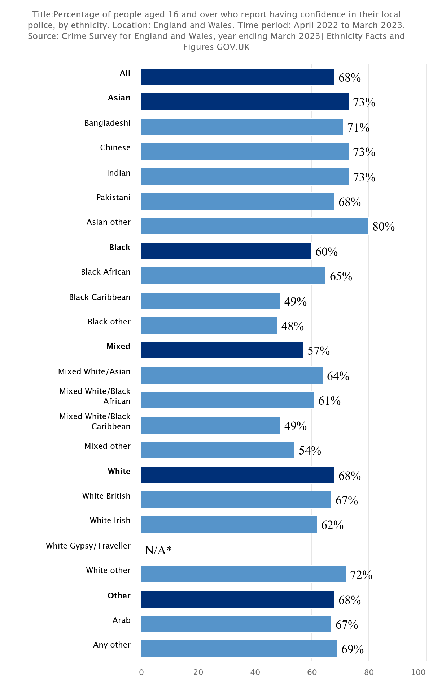
(Crime Survey for England and Wales, 2024)

Figure 2: Perception and experience of police and criminal justice system, England and Wales; year ending March 2025
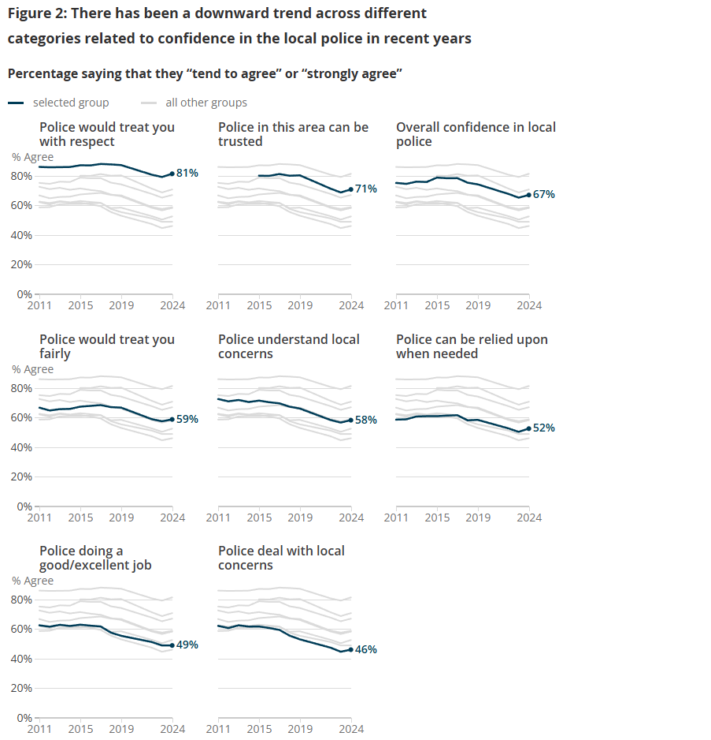
(Office for National Statistics, 2025)

Figure 3: Home Office Police workforce 2025.

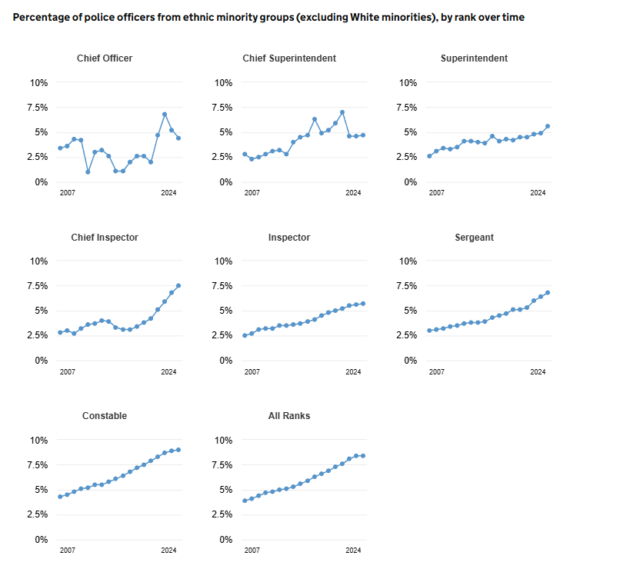
(Home Office, 2025)

Figure 4: Promotions trends of Inspectors to Chief Inspectors and Superintendent 2020-2025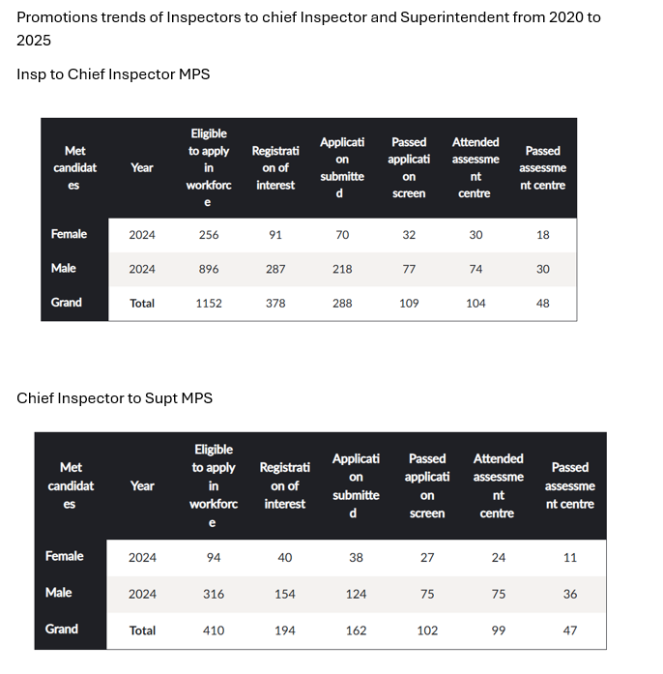
(Metropolitan Police Service, 2025)

Figure 5: List of associations and support groups for survey participant identification.
National Support Groups
- National Black Police Association (NBPA): The umbrella organisation for local Black Police Associations across all 43 UK police forces.
- National Association of Muslim Police (NAMP): A national body providing support and advice for Muslim officers and staff.
- National Sikh Police Association (NSPAUK): Represents Sikh police officers and staff throughout the UK.
- National Women of Colour in Policing (WoCiP): Launched in 2022 to support women from ethnic minority backgrounds in policing.
- Gypsy, Roma & Traveller Police Association (GRTPA): Supports officers and staff from GRT backgrounds.
Local Force Associations (Examples)
- Metropolitan Police (MetBPA): The Metropolitan Black Police Association.
- West Midlands Police (BAPA): Black and Asian Police Association.
- North Wales Police (BAPA): Black and Asian Police Association.
- South Wales Black Police Association (SWBPA).
- West Yorkshire Black Police Association (WYBPA).
- Hertfordshire Black and Asian Police Association (HBAPA).
- City of London Police (City BPA).
- Durham Ethnic Minority Support Association (DEMSA).
Other Support Networks
- SEMPER (Scotland): Supporting Ethnic Minority Police Staff for Equality in Race.
- Chinese & East Asian Staff Association (CASESA): Based in the Met Police.
- SAME: Support Association for Minority Ethnic staff (found in Thames Valley and British Transport Police).

Figure 6: Braun and Clarkes six phases of thematic analysis.
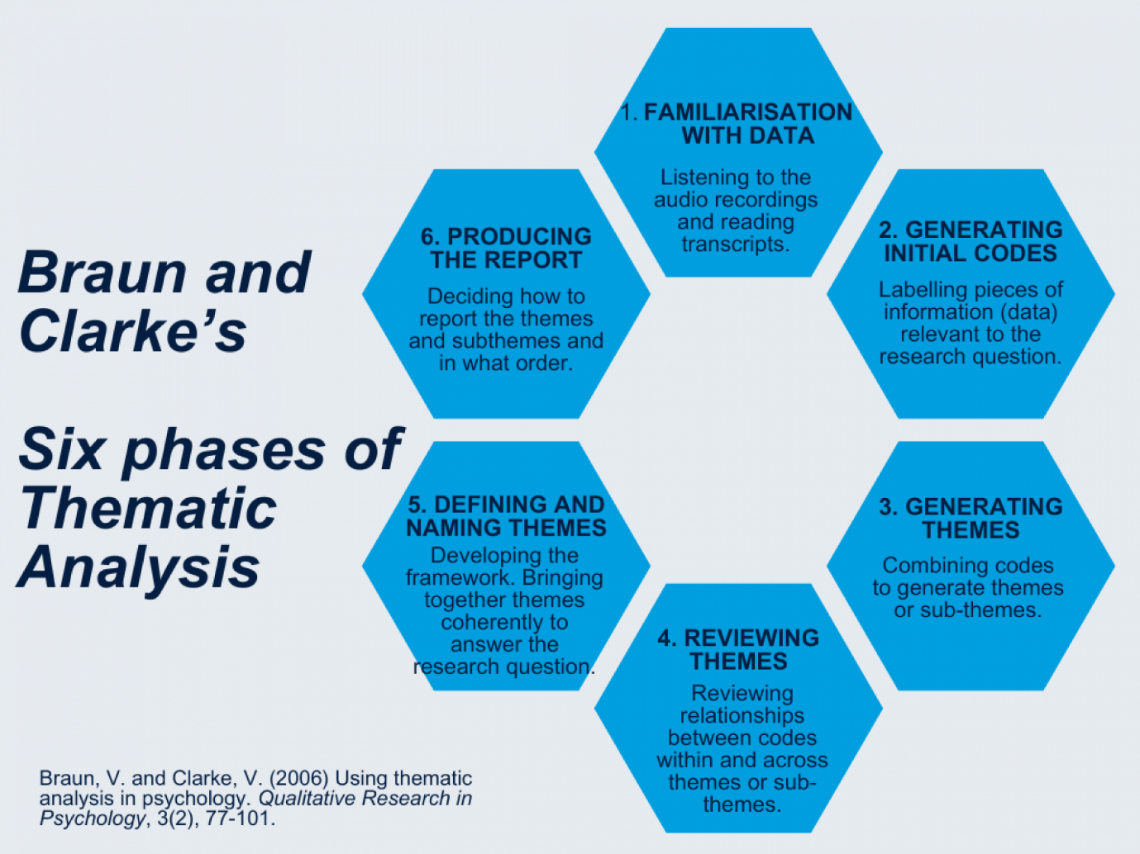
(Braun & Clarke, 2006)

Figure 7: Empirical respondent demographic data.

Appendices

Appendix A: Survey question sets – Group 1 & Group 2.
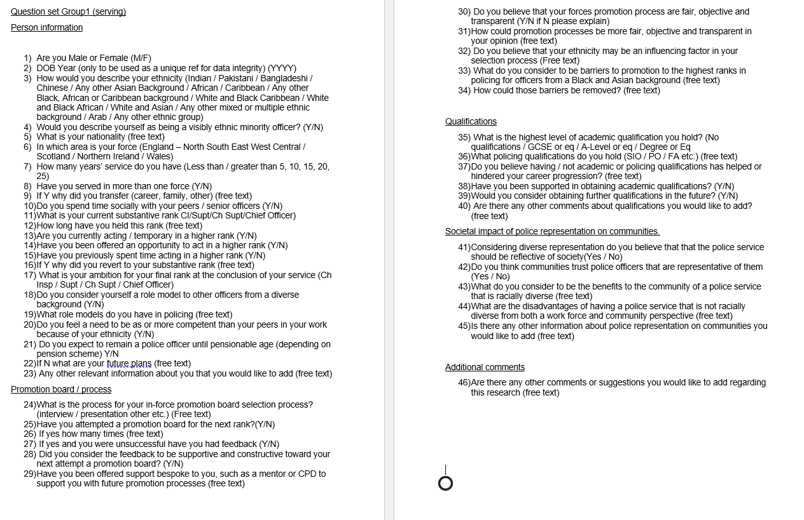

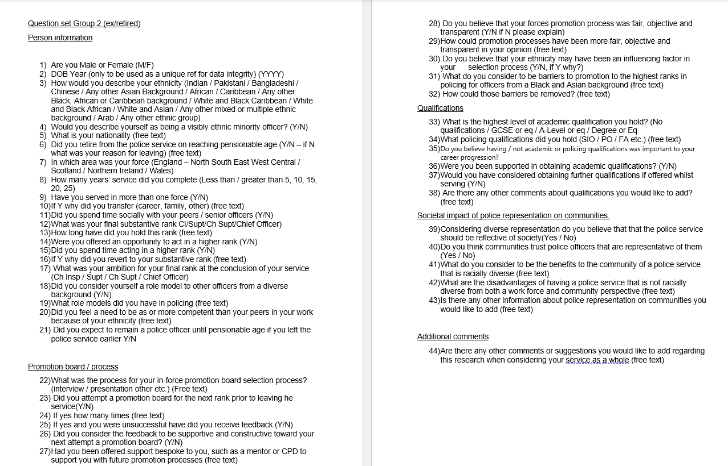

References
Abele, A., Spurk, D. & Volmer, J., (2012). Career Stagnation; Underlying Dilemas and Solutions in Contemporary Work Environments. In: C. A. Gorman, N. P. Reilly & M. J. Sirgy, eds. Work and Quality of Life. Dodrecht: Springer, pp. 107-132.
Afful, I., (2018). The impact of values, bias, culture, and leadership on BME under-representation in the police service. International Journal of Emergency Services, 7(1), pp. 32-59.
Angiolini, E., (2024). The Angiolini Inquiry Part 1 Report, London: House of Commons.
Association of Police and Crime Commissioners, (2024). PCC elections bring increased diversity in policing governance in England and Wales. [Online]
Available at: https://www.apccs.police.uk/pcc-elections-bring-increased-diversity-in-policing-governance-in-england-and-wales/
[Accessed 30 November 2025].
Aust, F., Diedenhofen, B., Ullrich, S. & Musch, J., (2013). Seriousness checks are useful to improve data validity in online research. Behaviour Research Methods, 45(2), pp. 527-535.
BHM, (2023). Detective Superintendent Tanya Wilkins: West Yorkshire Police’s Trailblazing Black Female Leader. [Online]
Available at: https://www.blackhistorymonth.org.uk/article/section/cjs-careers/62362/
[Accessed 3 March 2026].
Biggam, J., (2021). Succeeding with Your Masters Dissertation; a step-by-step handbook. 5th ed. Dunstable: McGraw Hill.
Bishu, S. G. & Kennedy, A. R., (2020). Trends and Gpas: A Meta-Review of Representative Bureaucracy. Review of Public Personnel Administration, 40(4), pp. 559-588.
Bourdieu, P., (1986). The forms of Capital. In: Handbook of Theory and Research for the Sociology of Education. New York: Greenwood, pp. 241-258.
Bradford, B., Murphy, K. & Jackson, J., (2014). Officers as Mirrors: Policing, Procedural Justice and the (Re)Production of Social Identity. The British Journal of Criminology, 54(4), pp. 527-550.
Braun, V. & Clarke, V., (2006). Using thematic analysis in psychology. Qualitative Research in Psychology, 3(2), pp. 77-101.
Brunson, R. K. & Gau, J. M., (2015). Officer Race Versus Macro-Level Context: a Test of Competing Hypotheses About Black Citizens' Experiences With and Perceptions of Black Police Officers: A Test of Competing Hypotheses About Black Citizens With and Perceptions of Black Police Officers. Crime and Delinquency, 61(2), pp. 213-242.
Cambridge, (2026). Cambridge Dictionary.org. [Online]
Available at: https://dictionary.cambridge.org/dictionary/english/survey
[Accessed 4 January 2026].
Casey, L., (2023). The Casey Review, An independent review into the standards of behaviour and internal culture of the Metropolitan Police Service, London: Metropolitan Police.
Cashmore, E. & McLaughlin, E., (2013). Out of Order? Policing Black People. 2nd ed. New York: Routledge.
Clarke, A., (2020). British Bobby Physiognomies: a Qualitative Approach to Comprehending the Reasons for Such Poor Representation of Bmes within the NPCC Ranks of the London Metropolitan Police Service., s.l.: ProQuest Dissertations and Theses.
Clarke, A. & Smith, C., (2024). Reproducing a White Elite: The Chief Officers' 'Club' in the London Metropolitan Police Service. Work, employment and society, 38(4), pp. 911-929.
College of Policing, (2020). Policing Education Qualifications Framework Initial entry routes, London: College of Policing.
College of Policing, (2025). Fast Track Inspector to Superintendent (FTIS) programme. [Online]
Available at: improve the number and diversity of those accessing the pipeline to chief officer ranks
[Accessed 3 December 2025].
Cordelia, O.-E., (2024). Comment made at Black Inclusion The past, present and future conference. London: s.n.
Cotter, D. A., Hermsen, J. M., Ovadia, S. & Vanneman, R., (2001). The glass ceiling effect. Social forces, 80(2), pp. 655-681.
Craig, L. S. et al., (2024). Challenges and Lessons Learned in Managing Web-Based Survey Fraud for the Garnering Effective Outreach and Research in Georgia for Impact-Alliance-Community Engagement Alliance Survey Administrations. JMIR Public Health Surveillance, 10(1), p. e51786.
Crawford, R. & Disney, R., (2014). Reform of police pensions in England and Wales. Journal of Public Economics, Volume 116, pp. 62-72.
Crenshaw, K., (1989). Demarginalizing the intersection of race and sex: A Black feminist critique of antidiscrimination doctrine, feminist theory, and antiracist politics. University of Chicago Legal Forum, pp. 139-167.
Crime Survey for England and Wales, (2024). Confidence in the local police, London: Gov.uk.
Davies, T., Bradford, B., Yesberg, J. A. & Posch, K., (2020). Visibly better? Testing the effect of ethnic appearance on citizen perceptions of the police. Policing and Society, 31(9), pp. 1133-1148.
Delgado, R. & Stefancic, J., (2017). Critical Race Theory: An introduction. 3rd ed. New York: New York University Press.
Dodds, V., (2018). 'It’s nowhere near good enough': broken promises on police diversity. The Guardian, 5 December.
Ewing, R. H., (1945). Representative Bureaucracy: An interpretation of the British Civil Service by J. Donald Kingsley. Social Forces, 24(2), pp. 241-242.
Farmer, P. et al., (2004). An Anthropology of Structural violence. Current Anthropology, 45(3), pp. 305-325.
Fuller, M., (2019). "Kill the Black one first". London: Bonnier Books.
Gold, E., (2023). Positive Action in Policing Recruitment and Promotion, London: Sergeant' Inn Chambers.
Greenberg, J. & Tyler, T., (1987). Why procedural justice in organizations?. Social Justice Research, 1(2), pp. 127-142.
Grieve, J. D., (2021). Rocking the boat. Policing and Society, 31(10), pp. 1265-1266.
HMICFRS, (2023). Leading Lights: An inspection of the police service’s arrangements for the selection and development of chief officers, Birmingham: HMICFRS.
Home Office, (2024). Hate crime, England and Wales, year ending March 2024, London: Gov.uk.
Home Office, (2025). Police workforce, England and Wales: 31 March 2024, London: s.n.
Home Office, (2026). From Local to National: A New Model for Policing, London: HH Associates.
Hong, S., (2016). Representative bureaucracy, organizational integrity, and citizen coproduction; does an increase in police ethnic representativeness reduce crime?. Journal of policy analysis and management, 35(1), pp. 11-33.
Humberside Police Federation, (2026). Stop Racism Against Police. [Online]
Available at: https://polfed.org/humber/stop-racism-against-police/
[Accessed 15 February 2026].
Imamura, K., (2025). Meritocracy versus diversity. Journal of Economic Theory, p. 228.
Institute for Government, (2024). Diversity in the civil service, London: Institute for Government.
Institute For Government, (2025). The abolition of police and crime commissioners. [Online]
Available at: https://www.instituteforgovernment.org.uk/explainer/police-and-crime-commissioners#:~:text=Why%20are%20police%20and%20crime,that%20PCCs%20will%20be%20abolished.&text=Home%20Office%2C%20'Police%20and%20crime,be%20redirected%20into%20neighbourhood%20policin
[Accessed 30 November 2025].
Jacob, C. E., (1969). Democracy and the Public Service. The American Political Science Review, 63(1), pp. 200-201.
Kennedy, B., Bishu, S. & Kennedy, A., (2025). Expanding the Boundaries of Representative Bureaucracy. The American Review of Public Administration, 55(3), pp. 199-213.
Lammy, D., (2017). The Lammy Review: An Independent Review into the Treatment of, and Outcomes for, Black, Asian and Minority Ethnic Individuals in the Criminal Justice System, London: Ministry of Justice.
Loftus, B., (2008). Dominant culture interrupted: Recognition, resentment and the politics of change in an English police force. The British journal of criminology, 48(6), pp. 756-777.
Logan, L., (2020). Closing Ranks: My Life as a Cop. London: Society for Promoting Christian Knowledge.
London Assembly, (2020). Action Plan - Transparency, Accountability and Trust in Policing. [Online]
Available at: https://www.london.gov.uk/publications/action-plan-transparency-accountability-and-trust-policing#increasing-the-number-of-police-officer-recruits-from-londons-black-communities-146060-title
[Accessed 3 March 2026].
Lu, G., (2024). A creative stereotype perspective on the Bamboo Ceiling: Low perceived creativity explains the underrepresentation of East Asian leaders in the United States. Journal of Applied Psychology, 109(2), p. 238.
Macpherson, W., (1999). The MacPherson Report; The inquiry into the matters arising from the death of Stephen Lawrence, London: The Home Office.
Manning, P., (2011). Democratic Policing in a Changing World.. Boulder: Paradigm.
Maxwell, K., (2020). Forced out: a detective's story of prejudice and resilience. London: Granta.
McGee, E. O. et al., (2022). Racism camouflaged as impostorism and the impact on Black STEM doctoral students. Race and Ethnicity Education, 25(4), pp. 487-507.
McMahon, K. P., (2021). Professionalism in Policing: Do Increased Education Requirements Improve Police Performance and Procedural Justice?, Blacksburg: Virginia Tech.
Metropolitan Police Service, (2025). Promotions trends of Inspectors to Chief Inspector and Superintendent from 2020 to 2025, London: Metropolitan Police Service.
Michalski, R. S., (1983). A theory and methodology of inductive learning. Artificial Intelligence, 20(2), pp. 111-161.
Morrison, A., (2023). Black chiefs to meet amid debate on benefit of cop diversity. AP News.
Mosher, F., (1968). Democracy and the public service. New York: Oxford University.
Murdoch, M. et al., (2014). Impact of different privacy conditions and incentives on survey response rate, participant representativeness, and disclosure of sensitive information: a randomized controlled trial. BMC Medical Research Methodology, Volume 14, p. 90.
National Police Chiefs' Council; The College of Policing;, (2022). Police Race Action Plan - Improving policing for Black people, London: The College of Policing Limited.
NHS England, (2024). NHS Workforce Race Equality Standard 2024 data analysis report for NHS trusts, London: NHS UK.
Oberai, H. & Anand, I. M., (2018). Unconscious bias; thinking without thinking. Human Resource Management International Digest, 26(6), pp. 14-17.
Office for National Statistics, (2025). Perceptions of the police and criminal justice system in England and Wales, using accredited official statistics from Crime Survey for England and Wales (CSEW)., s.l.: Office for National Statistics.
Perrett, S., (2021). A Divided Kingdom? Variation in Polarization, sorting, and dimensional alignment among the British public.. The British Journal of Sociology, 74(4), pp. 992-1014.
Pitkin, H. F., (1967). The Concept of Representation. Berkley: University of California.
Pitt, E. & Winstone, N., (2018). The impact of anonymous marking on students' perceptions of fairness, feedback and relationships with lecturers.. Assessment and Evaluation in Higher Education, 43(7), pp. 1183-1193.
Police Oracle, (2026). Police Oracle. [Online]
Available at: https://www.policeoracle.com/article-library/at-least-11000-hate-crimes-were-committed-against-officers-in-the-past-three-years/
[Accessed 15 February 2026].
Police Professional, (2014). Wiltshire chief constable defends rank removal plans, London: Police Professional,
Puddle, J., Rutter, J. & Rolfe, H., (2025). The State of Us: Community strength and cohesion in the UK, London: British Future and the Belong Network, the cohesion and integration network, The Together Coalition.
Reiner, R., (2013). Who Governs? Democracy, plutocracy, science and prophecy in policing. Criminology & Criminal Justice, pp. 161-180.
Risi, J. & Graif, C., (2024). Community representation and policing; Effects on Black civilians. Criminology (Beverly Hills), 62(3), pp. 454-502.
Rogoff, B., (2026). Culture and participation: A Paradigm shift. Current opinion in Psychology, Volume 8, pp. 182-189.
Rowe, M., (2020). Policing the police: challenges of democracy and accountability. Bristol: Policy Press.
Saltzstein, G. H., (1989). "Black Mayors and Police Policies". The Journal of Politics, 51(3), pp. 525-544.
Sandhu, P. & Prebble, S., (2021). Black and blue one woman's story of policing and prejudice. London: Atlantic Books.
Saunders, M., Thornhill, A. & Lewis, P., (2023). Research methods for business students. 9th ed. s.l.:Pearson.
Schafer, J. A., (2010). "Effective leaders and leadership in policing; traits, assessment, development and expansion". Policing: An International Journal, 33(4), pp. 644-663.
Schafer, J. A., Huebner, B. M. & Bynum, T. S., (2003). "Citizen perceptions of police services, race, neighbourhood context, and community policing". Police Quarterly, 6(4), pp. 440-468.
Schuck, A. M. & Rabe-Hemp, C. E., (2022). Breaking the Code of Silence: The Importance of Control Systems and Empathy Toward Outgroups. Criminal Justice and Behaviour, 49(11), pp. 1637-1655.
Shoub, K. & Christiani, L., (2023). Context Matters: The Conditional effect of Black Police Chiefs on Policing Outcomes. Urban Affairs Review, 59(6), pp. 2043-2056.
Silvestri, M., (2019). In search of Diversity: An embodied account of police leadership. In: Police leadership: changing landscapes. Basingstoke: Palgrave MacMillan, pp. 99-120.
Steinberg, D. A. & McDowell, D., (2024). Race, Representation, and the Legitimacy of International Organizations. International Organisation, 87(3), pp. 575-599.
Sterzing, P. R., Gartner, R. E. & McGeough, B. L., (2018). Conducting Anonymous, Incentivized, Online Surveys with Sexual and Gender Minority Adolescents; Lessons Learned from a National Polyvictimization Study. Journal of interpersonal violence, 33(5), pp. 740-761.
Stubbs, G., (2023). "Whenever big changes come, big talks don't" - An examination of the police experience of recruitment and promotion positive action processes.. International Journal of Law, Crime and Justice, Volume 74, p. 100614.
The Equality Act 2010 (s159), (2010). The Equality Act 2010 (s159). London: UK Gov.
The Guardian, (2019). UK's first black police chief asks why there have been no others. [Online]
Available at: https://www.theguardian.com/uk-news/2019/may/25/uks-first-black-police-chief-michael-fuller-memoir-hay-festival
[Accessed 22 October 2025].
The Home Office, (2025). Police workforce, London: The Home Office.
The London School of Economics, (2024). The truth about "two-tier policing". [Online]
Available at: https://blogs.lse.ac.uk/politicsandpolicy/the-truth-about-two-tier-policing/
[Accessed 27 October 2025].
The Police Foundation, (2022). A New Mode of Protection. The Strategic Review of Policing England and Wales, London: Rapspiderweb.com.
The University of Law, (2023). New findings reveal the harmful effects of under-representation in UK policing, Manchester: The University of Law.
Theobald, N. A. & Haider-Markel, D. P., (2009). Race Bureaucracy, and Symbolic Representation: Interactions between Citizens and Police. Journal of public administration, 19(2), pp. 409-426.
Trochmann, M. B. & Gover, A., (2016). "Measuring the impact of police representativeness on communities". Policing; an international journal of police strategies and management, 39(4), pp. 773-790.
Verma, K. K., (2015). Different ladders for police progression?: reviewing black and minority officers' progression in the police service. [Online]
[Accessed 3 December 2025].
Virdi, G., (2018). Behind the blue line; my fight against racism and discrimination in the police. London: Bite back Publishing.
Vuma, P. R., (2025). The marginalisation of highly qualified SAPS members in promotion and leadership appointments. International Journal of Research in Business and Social Science, 14(10), pp. 590-601.
Vygotsky, L. S., (1978). Mind in society; The development of higher psychological processes. Cambridge, MA: Harvard University Press.
Walcott, S., (2021). Radical reform is required if the police service is to look like the society it serves. [Online]
Available at: https://www.police-foundation.org.uk/2021/02/radical-reform-is-required-if-the-police-service-is-to-look-like-the-society-it-serves/#:~:text=Even%20passing%20the%20initial%20assessment,subject%20to%20internal%20conduct%20allegations.
[Accessed 18 Jan 2026].
Weber, M., (1921). An Outline of Interpretive Sociology. Economy and Society, Volume 2.
Wendel, M. L. et al., (2022). "Their help is not helping”: Policing as a tool of Structural Violence against Black Communities. Psycol Violence, 12(4), pp. 231-240.
Willink, K. G. & Shurki, S. T., (2018). Performative interviewing: affective attunement and reflective affective analysis in interviewing. Text and Performance Quarterly, 38(4), pp. 187-207.
Yardley, E., (2026). Ontology, epistemology, and paradigms - What are they, and how much should you write about them in your PhD thesis?. [Online]
Available at: https://www.thedegreedoctor.com/
[Accessed 27 February 2026].
Yeakey, C. C. & Henderson, R. D., (2003). Surmounting all odds; education, opportunity and society in the new millennium. USA: Information Age Publishing, Inc.
Yong-Chan, R. & Menifield, C. E., (2024). Examining community policing policy implementation and racial disparities in officer-involved lethal encounters. Policing, 47(6), pp. 949-965.
YouTube, (2023). Casey Report: Mark Rowley refuses to call Met Police 'Institutionally' racist., San Francisco: YouTube.

Declaration about the use of AI

I acknowledge the use of Microsoft Copilot on 6 April 2026 to help summarise my thematic codes to broader theme areas. I confirm that I have not presented any AI generated text as my own work. I confirm I have copies of my drafts, notes, and other resources I used before, and after the use of AI tools which I may be asked to provide in evidence.

Abstract
Purpose
The purpose of this research was to understand why so few police officers from a Black and Asian background are represented at the highest ranks in policing in comparison to the workforce mix, and how that lack of representation affected not only policing but society too in terms of trust and legitimacy.
This study was important as to date there are very few studies that cover this area, particularly on a national scale, but also in comparing policing to other public sector areas such as the civil service and the NHS where numbers of diverse workforce mix are much higher in leadership roles.
The research question was to understand if race influenced appointment of senior police leaders in the UK. It had the following objectives that formulated the basis of the research aims;
- Critically evaluate the wider impact of under representation in Police leadership on society and policing from a cultural and legitimacy perspective.
- Analyse the current representation of Black and Asian officers in senior police ranks (ACC and above)
- Examine current selection and promotion processes for senior police leadership including perceptions of fairness, transparency, and bias.
- Investigate perceptual barriers for progression to senior levels within policing for Black and Asian officers.
- Propose recommendations for improving racial equity in senior police leadership position
Methodology
A review of existing literature was supported with empirical research. Surveys were sent to all police forces in the UK and several support groups including Black Police Association (BPA), National Association of Muslim Police Officers National Police (NAMP) Police Federation (PFEW) National Association of Retired Police Officers (NARPO). The empirical research surveys invited responses from both serving and retired Black and Asian officers (and officers from any other minority background) that had reached Chief Inspecting ranks or above to understand their views on promotion process fairness, impartiality and barriers. It also invited their views on how society is impacted by representation in a diverse culture.
Findings
The findings identified that society benefits from a diverse police service from a legitimate and trust perspective. They also highlighted how representation was lowest at the highest ranks in policing despite increases at the lowest feeding ranks. Whilst there was no direct evidence to suggest that race influenced the appointment of senior officers there were systemic flaws identified in the promotions framework that indicated that the absence of objectivity may allow covert racism to be present. A lack of relevant role modelling was also significant in findings.
Implications
The author understands that this may be the first study of its kind and whilst it officers an insight into fairness, transparency and barriers officers from diverse backgrounds face, the respondent sample size did not yield the desired returns, therefore the author believes that a further study initiated by a professional body (College of Policing, National Police Chiefs Council) may enhance this study and reveal deeper findings across a larger cohort. It is hoped that through implementing the recommendations highlighted this study will assist with a review of the police promotions framework, mainly in the area of objectivity, fairness and meritocracy.

