Ryan Lang 1603678
1603678@student.uwtsd.ac.uk
Retailer WCF
M6X01093 Distributed Enterprise Applications

Abstract
This report looks at the concepts, principles, and practices to follow for the creation of distributed software components for use in enterprise services. Distributed applications can be used to sell goods over the internet and there are many concerns such as security that need to be addressed when using distributed applications in this way.

Table of Contents
1. Introduction 1
2. Application Walkthrough 1
3. Analysing the System 7
3.1 Security 7
3.2 Purchasing 8
3.3 Backup 8
3.4 Connecting the client and server 9
3.5 Databases 10
3.6 Request-response 11
3.7 Deploying the system 11
4. References 12

1. Introduction
A simple e-commerce system has been created using the Windows Communication Foundation (WCF) platform. A client application to connect to the WCF service has also been created. This system will be used to illustrate the principles of distributed applications being used to sell goods online.

2. Application Walkthrough
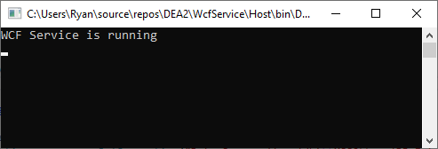
Figure 1: The WCF service running
The WCF service is hosted in a console application. This example is a self-hosted WCF service. The WCF service has an SQL database which is used for storing data. No data will be stored on the client side.

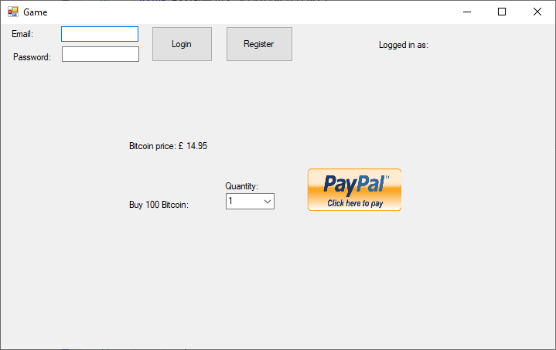
Figure 2: The client application
The client application has a way of logging in, registering an account, and making a purchase. Trying to make a purchase without logging in lets the user know they need to login. The application connects to the WCF service and all data is stored on the service. This application is a simple example of an e-commerce system that uses Bitcoin as an example of something you can buy. The price is retrieved from the WCF service.
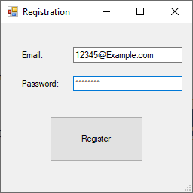
Figure 3: Registration Form
The user can register an account. The email and password are stored.
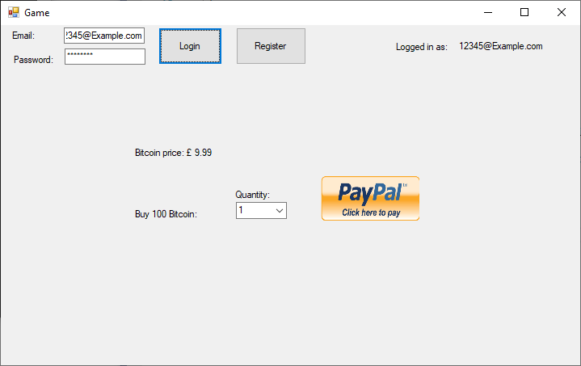
Figure 4: Logged into the system
After registering the account the details can now be used to login to the system.

Figure 5: Purchase confirmation
The quantity of how much to buy can be selected and the price is automatically calculated for the user. Clicking ‘Yes’ simulates a purchase.

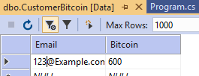
Figure 6: Table for customers purchase
The purchase has been stored in a table.
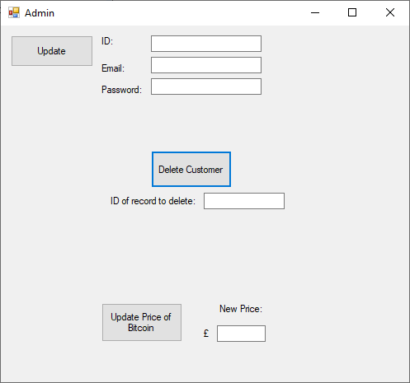
Figure 7: Admin application
A separate application has been created for administrator use. It allows customer details to be updated, deleted, and for the price of ‘Bitcoin’ to be updated.

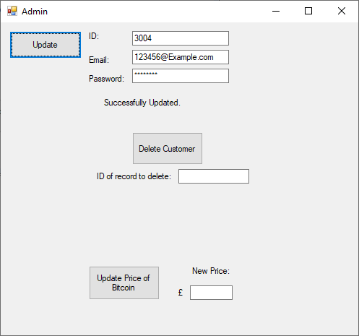
Figure 8: Updating customer details
A customers details have been updated.
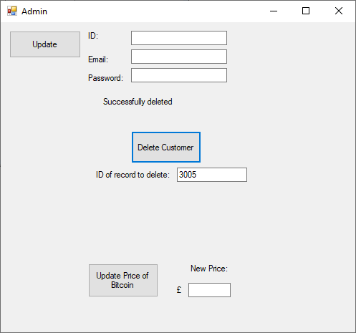
Figure 9: Deleting a customer
A customer has been deleted and a confirmation has been displayed.
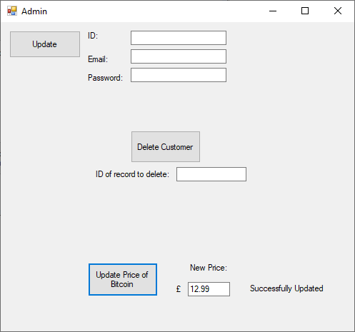
Figure 10: Updating the price
The price of ‘Bitcoin’ has been updated to ‘£12.99’.
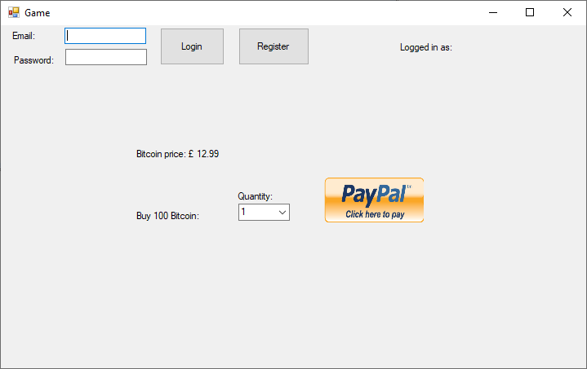
Figure 11: The updated price in the client application
When the client application is loaded the new price is displayed.

3. Analysing the System

3.1 Security
The created system has serious issues that would prevent it from being able to be deployed into any real business. The main issue is the security of the system. Sensitive data should be handled as securely as possible. Passwords in an application should not be readable by a person [1]. Although the text when entered is hidden, the way that it is transferred and stored by the WCF service has the password as plain text. It is important that passwords or any sensitive data are not transferred across a network as plain text or a man-in-the-middle attack would result in the data getting stolen.
Sensitive data such as passwords should be changed to be unreadable, with one of the ways of doing this being encryption. The password that is entered will work as a seed for an encryption key, which is applied to an encryption algorithm that produces data that is useless without knowing the password to be able to decrypt the data [2]. This is a two-way function because when you encrypt something you will be doing so with the intention of decrypting it later. Some encryption methods are outdated and have been cracked, meaning that the data can be decrypted without the key [3]. A modern approach to encryption should be used to ensure the best security. There are different encryption algorithms that can be used such as AES (Advanced Encryption Standard) and RSA (Rivest-Shamir-Adlemen) [4].
Hashing can be used on plain text to make it unreadable [5]. This is an algorithm that can map data to a fixed length called a hash value [6]. While encrypting is a two-way function, hashing is a one-way function. The purpose of hashing is to check if data has not been altered. Hash values are unique. If we take the password ‘password1’ and use a hashing algorithm on it then a unique hash value will be generated [7]. By using the same password again and running it through the same hash algorithm the same hash value will be generated. By doing this we can check if the correct password has been entered to log the user in. Hashing algorithms include: MD5; SHA (Security Hashing Algorithm); and TIGER.
Let’s say that a hacker gets a database full of hashed passwords. Every password that is identical will have the same hash value. So if thousands of users set their password as ‘password’ then the hashed value will be identical for all of these users passwords. This exact scenario happened to LinkedIn where passwords were stored as unsalted hash values and they were stolen by hackers [8]. This is where salting becomes effective. Salting will add a bit of text onto the end of a password before running it through the hashing algorithm [6] [8]. If every salt is unique then the hundred users who set their password as ‘password’ will have the hash values of their passwords be different.

3.2 Purchasing
This example simulates the purchase of a digital currency. Bitcoin is used as an example, but the application applies to many existing systems. Lots of websites allow the purchase of gift cards to be credited to account or other digital currencies. A lot of video games allow the purchase of premium currency, such as Fifa allowing ‘Fifa coins’ to be bought. When they are bought they will need to be stored so that the users account has this digital currency. In the created example the purchase is updated to a table on the WCF service.
The application has a ‘PayPal’ button to make the purchase. This purchase is simulated, but it is possible to use other distributed services to handle the purchasing of items. If a website has another checkout service being used on the site the user does not need to connect to another website to finish their purchase, the checkout service is simply called by the server. These services can be physically located in different countries, but they still are able to function as one integrated distributed system [9]. Using a third party service also removes responsibility of how the data during the transaction is handled.

3.3 Backup
This system has no built in way of backing up data; once the data is lost then it is gone. On an actual system there will need to be a way of backing up the entirety of data being stored on the service. The data in the SQL server can be backed up, but if the main server goes down then the service will no longer be available.
Server clustering is a way of solving the issue of downtime and outages [10]. A group of servers can work together on a system to provide high availability. When a server is down then another server is able to take over ensuring the user can still use the service. This is how websites with millions of visitors are able to stay online without ever having to be taken offline.

3.4 Connecting the client and server
The example being locally hosted makes it fairly easy to get the client and server connected. The WCF service host application is allowing metadata exchange on the localhost and data is being transferred using the TCP protocol. By reading the metadata the client application is able to retrieve data that it needs to use the service [11]. The client application is connected and able to consume the WCF service because of it retrieving the data from the MEX endpoint.
A WCF endpoint is the fusion of the address, binding, and contract [12]. The address is where the WCF service is available. In the example systems case it is accessible on the localhost machine. The bindings specific how the service is accessible. In the created example the WCF service has HTTP bindings and the host console application connects to the WCF service and shares it using TCP bindings.
A WCF service will communicate with applications according to the contracts [13]. Contracts will define the features of the service and how it delivers those features [12].
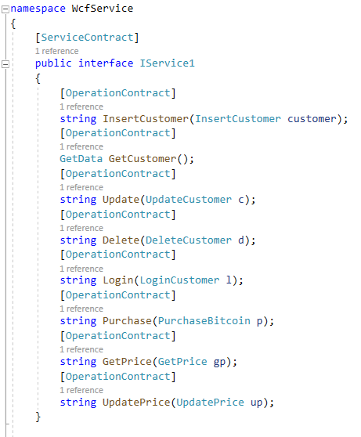
Figure 12: The Service Contract
The service contract in the system shows what operations are exposed by the service to the client. The operation contracts are part of the service contract as shown in figure 12, and these contracts contain methods the client will be able to use [14]. A method that is marked ‘[OperationContract]’ will be exposed to the client within the service contract.
In the created example there is a service contract with an interface with all of the functions for both the admin and user client applications. For a real world application the functions would need to be separated, because it does not make sense to expose admin specific functions to a user. This can be done by having two separate interfaces within the WCF service application with different service contracts for the different client applications.

3.5 Databases
CRUD (Create, Read, Update, Delete) are the four basic functions when storing data in a database [15]. In the created system all of these functions are implemented and functioning. A record of the customers email and password is created in the database when they register. The price when the application starts is read from the database. The admin application is able to update and delete records. CRUD operations apply to both SQL and NoSQL databases.
In this example an SQL database is used to store data. SQL databases have the advantages of being able to do complex queries on stored data, however cannot be distributed in the way that NoSQL databases can be. Companies that handle big data will use NoSQL databases because they are horizontally scalable and data can be delivered to a large number of users. In the created example the use of SQL is fine, but there is also the option of a NoSQL approach such as MongoDB.
MongoDB is a NoSQL approach that does not follow the model of relational databases [16] [17]. MongoDB does not use a schema so any data can be added whether it is text, images or even video [15]. On an e-commerce site there can be millions browsing at the same time so using an SQL database will not be appropriate because it will not have the performance necessary to cater to so many people. NoSQL databases can distributed to improve performance and reliability of the database system.
Sharding can be used to partition very large databases into smaller parts known as data shards. This allows the database to be distributed across a cluster, which will increase its reliability with less down time, and improve the performance.

3.6 Request-response
Using WCF the server and client will communicate using an MEP (message exchange pattern). In the created example request-response is used. A message is sent from the client and then a reply is received [18]. The message being sent in the application is the request for data or the data to add to the database which is processed by the WCF service and then a response is given to the client. The response in this example being confirmation that the requested action worked or did not work.

3.7 Deploying the system
The created example would not be deployable in its current state, however if the security issues were to be fixed and more data collected from the user, it would work as a good example of a video game that has premium currency purchasable. The forms could be opened from the main application that functions offline and a check could be ran to see if the user is connected before presenting them the e-commerce part of the application.
Using the example of an online video game with users, integrating the existing system would pose a few challenges. The users existing data would need to be read by the service and the existing system would need to be updated to use the functions this service offers.
The admin form should be password protected so that only those that are authorised are able to use it. If the system was a website system then having an admin page accessible from a browser would require the necessary security to be implemented. There is also the option of not having any administrator functions accessible from a client and having to do all administrator tasks on the server machine, which would add another level of security.

4. References

[1] | L. Zhang, Y. Liu and Q. Ji, “The password security analysis of network forums,” in 2015 IEEE 16th International Conference on Communication Technology (ICCT), Hangzhou, 2015.
[2] | J.-P. Aumasson, Serious Cryptography, No Starch Press, 2017.
[3] | L. Zhang, J. Yu, Z. Deng and R. Zhang, “The security analysis of WPA encryption in wireless network,” in 2012 2nd International Conference on Consumer Electronics, Communications and Networks (CECNet), Yichang, 2012.
[4] | Y. Liu, W. Gong and W. Fan, “Application of AES and RSA Hybrid Algorithm in E-mail,” in 2018 IEEE/ACIS 17th International Conference on Computer and Information Science (ICIS), Singapore, 2018.
[5] | M. Singh and D. Garg, “Choosing Best Hashing Strategies and Hash Functions,” in 2009 IEEE International Advance Computing Conference, Patiala, 2009.
[6] | P. Gauravaram, “Security Analysis of salt||password Hashes,” in 2012 International Conference on Advanced Computer Science Applications and Technologies (ACSAT), Kuala Lumpur, 2012.
[7] | T. Mailund, The Joys of Hashing: Hash Table Programming with C, Apress, 2019.
[8] | S. Kharod, N. Sharma and A. Sharma, “An improved hashing based password security scheme using salting and differential masking,” in 2015 4th International Conference on Reliability, Infocom Technologies and Optimization (ICRITO) (Trends and Future Directions), Noida, 2015.
[9] | L. B. Goel and R. Majumdar, “Handling mutual exclusion in a distributed application through Zookeeper,” in 2015 International Conference on Advances in Computer Engineering and Applications, Ghaziabad, 2015.
[10] | C.-R. Yan, J.-Y. Shen, Q.-K. Peng and D. Pan, “Parallel Web mining for link prediction in cluster server,” in 2005 International Conference on Machine Learning and Cybernetics, Guangzhou, 2005.
[11] | S. L. Linfoot and T. Coughlin, “A cross-standard metadata formatting structure,” IEEE Transactions on Consumer Electronics, vol. 59, no. 3, pp. 550-555, 2013.
[12] | W. Zhang and G. Cheng, “A Service-Oriented Distributed Framework-WCF,” in 2009 International Conference on Web Information Systems and Mining, Shanghai, 2009.
[13] | M. Liu, WCF 4.5 Multi-Layer Services Development with Entity Framework, Packt Publishing, 2012.
[14] | W. Zhang and J. Li, “Research and Application of WCF Extensibility,” in 2010 International Conference on Web Information Systems and Mining, Sanya, 2010.
[15] | C.-O. Truica, F. Radulescu, A. Boicea and I. Bucur, “Performance Evaluation for CRUD Operations in Asynchronously Replicated Document Oriented Database,” in 2015 20th International Conference on Control Systems and Computer Science, Bucharest, 2015.
[16] | Y. Widyani, H. Laksmiwati and E. D. Bangun, “Mapping spatio-temporal disaster data into MongoDB,” in 2016 International Conference on Data and Software Engineering (ICoDSE), Denpasar, 2016.
[17] | Y.-S. Kang, I.-H. Park, J. Rhee and Y.-H. Lee, “MongoDB-Based Repository Design for IoT-Generated RFID/Sensor Big Data,” IEEE Sensors Journal, vol. 16, no. 2, pp. 485-497, 2016.
[18] | G. Yunhua and Y. Yonghua, “A Message Service System Based on WCF Duplex Communication,” in 2012 International Conference on Computer Science and Service System, Nanjing, 2012.

