

Postgraduate/Distance Learning Assignment coversheet & feedback form

THIS SHEET MUST BE THE FIRST PAGE OF THE ASSIGNMENT YOU ARE SUBMITTING (DO NOT SEND AS A SEPARATE FILE)

For completion by the student:
Student Name:
Eleonora D’Uva
Module code: HPCA7015  Module title: Foundations in Cultural Astronomy and Astrology | Student ID number: 2014860 | Educational support needs: No
Module tutor: Nick Campion

Assignment due date: 4 December 2020
If your module has multiple submissions please indicate which piece of work this is.

2nd
I confirm that this is my original work and that I have adhered to the University policy on plagiarism.
Signed …………Eleonora D’Uva…………………………………………………
Email submission: if you are submitting this form via email, please tick this box □
(as a substitute for your signature) to confirm that you agree to the above declaration.

Assignment Mark
WILL BE
Final Mark GIVEN ON
TURNITIN

NB. All marks are provisional until confirmed by the Final Examination Board.

PLEASE NOTE: ALL COMMENTS WIL BE POSTED ON TURNITIN

For completion by Marker 1 :

Comments:
Marker’s signature: |  | Date:
For completion by Marker 2/Moderator:

Comments:
Marker’s Signature: | Date:
AGREED INTERNAL MARK (where necessary): Comment on process of arriving at agreed mark:
External Examiner’s comments (if relevant)
External Examiner’s Signature: | Date:

‘Essay based on a Sky Journal’
Word count 2009

1

Methodology
For twenty-eight consecutive days I observed the sky at 16.40 for thirty to forty-five minutes facing South and South-West directions. I observed in the town centre, focusing on sunsets in the city of Darmstadt, Germany. The position of the building and its height (fifth floor) allowed for a view free from other buildings, as shown in the figures 1 and 2 below. As landscapes, the lodge from where I made the observations faces the St. Ludwig Kuppelkirche: in the East direction, the tower of the Mathildenhöhe is visible above the roofs. The Hügelstraße runs in the East-West direction.
I concentrated on vision and avoided music and sounds that weren’t those coming from the town itself. I
made the observations with a notebook and a smartphone for pictures.
The quote I’m discussing is ‘Be clearly aware of the stars and infinity on high. Then life seems almost enchanted after all.’ by Vincent van Gogh¹.
Although the choice could be ambiguous since the observations concentrated on sunset, I am always aware of the presence of the stars even during the day. Thanks to the notes of the sky journal I realized that the sunset is the moment when I wait for changes in the sky and the possibility to be amazed by the stars above.
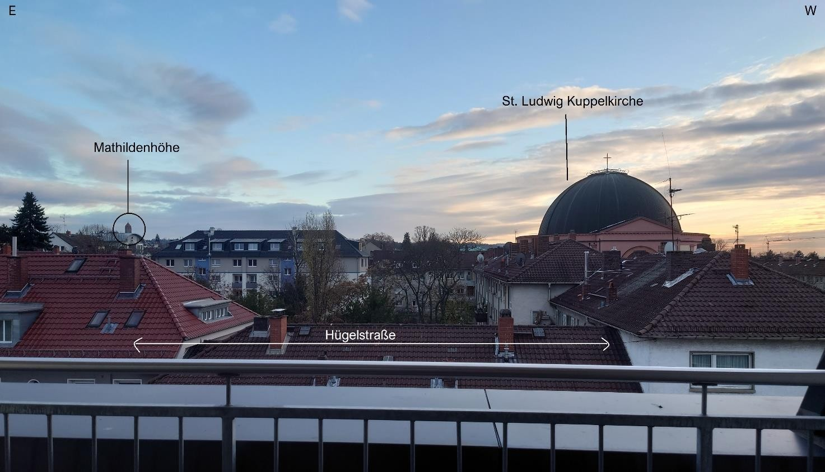
Figure 1 – Reference points and buildings

¹ Vincent van Gogh and Ronald de Leeuw. The Letters of Vincent Van Gogh. London: Penguin Books, 1997, p.392.

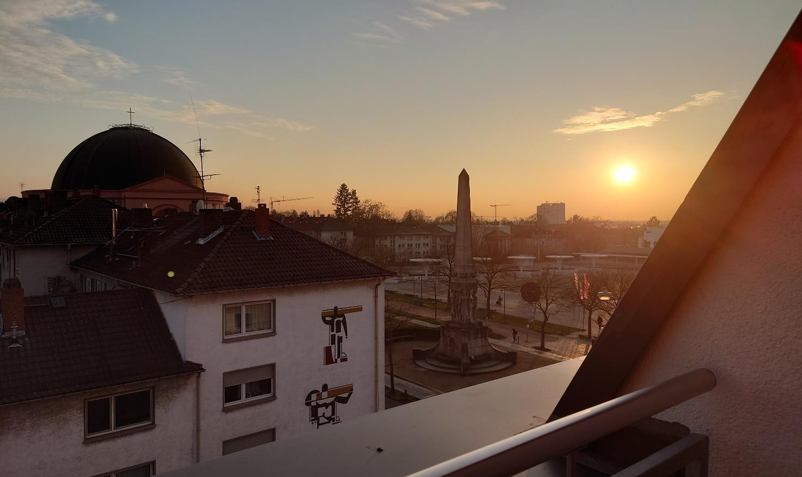
2

Figure 2 – Sunset in relation to the St. Ludwig Kuppelkirche and Hügelstraße

Weather
While most of the observations were made under clear sky conditions, evenings of the last week (November 23 to 29) were difficult due to poor weather. On said days, I noticed fog and mist around sunrise and sunset hours and light grey cloudy sky. The sunset time (or perceived sunset time) seemed to start earlier on those evenings.
The previous evenings were characterised by blue sky, sometimes with sparse clouds, fading into red and orange colours into twilight.

Themes
I noticed the following recurring situation for most of the days. Emotions coming from tasks or feelings I experienced during the day had an impact on my perception of the sky at first. Then, during the observation this was reversed as I kept focusing on the colours, reflections and sounds around me. It became apparent that I was using the sky as a medium for self reflection and expression, as if it were mirroring my thoughts.
I found three recurring themes I’m going to discuss. These are place comparisons, nostalgia, the
cloudiness.

Place comparison
The first theme I’m going to discuss is comparison between places.
It was the first time I observed the sky living in an urban environment. I grew up in a village in the countryside and had always been aware of the sky, during either day or night. The house is also located far

from the road or other buildings; therefore, I have always been able to get a full view and to choose different spots to make observations. I noticed that the air quality is better, and constellations are well visible to the naked eye, while in towns and cities I previously lived in the only visible object was the Moon.

As I was given the opportunity to observe the sky, I became aware from the first evenings that I was
grateful I live in a low-rise area, for this allows me to have about a 180 degree view of the surroundings from 3 the lodge. I started to reason if this was somehow correlated to having lived for long in a rural area and if my
choice of current living arrangements was done because I felt the option of having some sort of view of the sky was an important value. I found that whenever I’m not able to see features or objects in the sky, the preponderant feeling is frustration. Being able to let the view wander over roofs or trees and through the sky is important as I feel interconnected with nature and shift towards positive emotions as hope and anticipation for a new day before the sun sets. I found it is important to know and be aware of changes and objects in the sky even when it’s impossible to look at them, however the ability to actually see it’s what creates a sense of reassurance.
In their paper, Monika Derrien and Patricia Stokowski analysed the relationship of people with the night sky, focusing among others on how childhood and past experiences can affect the way a person connects to and imagines the sky². It is interesting to note how the sky can be a mirror of our minds and how people from different parts of the world share common beliefs or experiences. A recurring motif that can be inferred from the study is seeing the sky as a soothing, friendly, protective presence to turn to in difficult times. I experienced this as well, as observing the changes in the sky had a calming effect on days I felt most lonely. Another point was made in the article on place comparisons for people who had lived in both rural and urban areas and if the sky played a role when deciding where to live. It’s evident that many interviewees directly correlated the possibility to look at the (night) sky to rural settings to high quality of life. I agreed with this reasoning, not much and not only for the quality of air or light pollution, but mainly because I noted that I felt relieved when having a greater vision span. I believe this is similar to what Van Gogh wants to highlight; it’s a different choice of words, but the ‘enchanting life’ equals the ‘quality of life’. Paraphrasing, if someone is aware that they can always find a bright night sky, then they are also able to enhance their quality of life. In this context, ‘quality of life’ is to be intended as a psychological rather than materialistic aspect of life. We can go searching for a presence that comforts our spirit and evokes positive or happy memories. This is also true in the paper, when people suggested that, even if they couldn’t see the stars in a city, they might still be able to travel within an hour or less to a place where they could enjoy the night sky, as they would to meet a friend.

Nostalgia
The second most recurring theme is nostalgia. It became evident soon that the place was affecting the way I approached the sky on most nights. This is the reason I included a more detailed description of the surroundings at the start of the essay. I made sky observations in the past in the countryside and I realised that the range of sounds and relationship with the surroundings is completely different in a town centre. In the countryside I was mostly alone and surrounded by nature, while for the past month I noticed a level of interactions with other people. Sunset is the time when people return home and switch on lights, while their day ends. I found in those moments my feelings align with James Applewhite’s ‘A Poetry of Sunset’, as he reflects on the contrast of light and darkness in our minds, as the sun sets to let us see the infinity of the night sky and stars³. Applewhite’s words echo Van Gogh’s and take a further step, in comparing the stars to the interconnections of human minds. In this way, it is not difficult to be constantly aware of the stars above.

² Monika M. Derrien and Patricia A. Stokowski, ‘Discursive Constructions of Night Sky Experiences: Imagination and Imaginaries in National Park Visitor Narratives’, Annals of Tourism Research, 85 (2020), 103038.
³ Applewhite, James. ‘A Poetry of Sunset’, North Carolina Literary Review, no. 27, 2018, p.105.

Sunset is the moment of the day when we become conscious of the ever present stars and dark sky, that during the day the sun conceals.

As the lights switched on, buildings received a shade of orange and pink from the setting sun. Most are painted in neutral colours that enhance this phenomenon, but the St. Ludwig Kuppelkirche is painted to a
colour similar to the rosy shade of the sky, although I wasn’t able to find any actual hint that it was done 4
intentionally. I found similarities between my notes and T. E. Hulme's poetry ‘A City Sunset’ regarding how
the red-ish colours seemed to play with the various geometries of the buildings, both of those nearby and those further away⁴. The cross on the top of the St. Ludwig Kuppelkirche and the tower of the Mathildenhöhe are painted gold and the colour appeared more saturated and the shapes stood out more clearly in contrast to the sky. This was evident in the final part of sunset, when I could see the sun at the end of the street. Although the Hügelstraße is not the main east-west axis of the town, I found similarities to how Hulme could clearly see the sun, as a golden arrogant mass before darkness fell. Being able to observe people on the street too, unlike the poet I didn’t experience people were lured by the colours nor any other aspects of the sunset. This made me understand how often humans don’t take the time to look upwards to the sky and reflect on its magnificence and infinite possibilities it has to offer to the eye.

Cloudiness and fog
When I noticed that it was going to be cloudy for a few days, I considered stopping observations and concentrating on the ones made until that day. However, it was interesting to note how my perception of the sky completely changed during those evenings, so I decided to continue for a handful of days. I perceived that sunset was happening earlier than the actual time, as the sky changed from a light grey colour to a grey- blue shade and to dark blue. After the sun set, a light fog appeared. I was still able to see the buildings, and I noticed that lights illuminating the St. Ludwig Kuppelkirche at night were suddenly on. On clear sky evenings the lights switch on gradually. While I understand the technological reason behind this, it still was surprising as it was a sudden change in the scenery I experienced on so many previous nights.
The cloudiness of the day had already had an impact on my feelings and mood, and on those foggy evenings I approached the sky observation with sadness and melancholy. I found my emotions were similar to the ones experienced by William Cowper during the 1783-4 winter, as described by Alexandra Harris⁵. As the fog wrapped up the buildings, I felt enveloped by the darkness, although I kept looking up with hope of being able to see a star. I experienced this though I was aware that the sky was too covered in clouds to allow for such a vision. Still, being aware of the presence of the stars above helped my mind overcome negative thoughts and embrace hope that I would be able to experience the night sky the next day. On those evenings, Van Gogh’s words assumed a new meaning: as clouds and fog blocked the view, awareness was the only thing I had to recognise the existence of the stars and still be amazed. The fact that Van Gogh wrote ‘almost’ made me reason on how my mind considered this awareness as a solace, which I correlated with Cowper being confident that, despite his condition and mood, nature would continue its cycles.

Conclusion
The sky journal proved to be an interesting exercise of introspection and reflection about my relationship with the sky. Although I was expecting one of the main themes to be nostalgia or melancholy, given past experiences, being able to develop a theme about cloudiness and fog was a surprise. It’s been an event with

⁴ Thomas Ernest Hulme and Karen Csengeri, ‘The Collected Writings of T.E. Hulme’, Oxford : Oxford ; New York:
Clarendon Press ; Oxford University Press, 1994.
⁵ Alexandra Harris, ‘Weatherland : Writers and Artists Under English Skies’, 2016, pp.177-178.
a specific time frame, compared to the other two, which were periodically returning depending on the emotions of the day. I wasn’t anticipating a comparison between my childhood home and my current home either, and on those nights I noticed I was considering the sky as a friend, not just a mirror of my thoughts. It is extraordinary that people from around the world share similar ideas and beliefs about the (night) sky and are able to develop a deep relationship with it.
5

Bibliography
Applewhite, James. ‘A Poetry of Sunset’, North Carolina Literary Review, no. 27, 2018.
Derrien, Monika M, and Stokowski, Patricia A, ‘Discursive Constructions of Night Sky Experiences: Imagination and Imaginaries in National Park Visitor Narratives’, Annals of Tourism Research, 85 (2020), 103038.
Harris, Alexandra, ‘Weatherland : Writers and Artists Under English Skies’, 2016.
Hulme, Thomas Ernest and Csengeri, Karen, ‘The Collected Writings of T.E. Hulme’, Oxford : Oxford ; New York: Clarendon Press ; Oxford University Press, 1994.
Gogh, Vincent van and de Leeuw, Ronald. ‘The Letters of Vincent Van Gogh’. London: Penguin Books, 1997.

