

Student Name : Ronak Jerambhai Devani
Student ID : 2531597

Module Name : Financial Management
Module Code : LCMB7002

Lecturer’s Name : Dr Shengfeng Mei

Work Count : 4758
Submission Date: 24th April 2026

Term 1

Selected Company : Toyota Motor Corporation
Topic: Strategic CFO Challenge
→ A Financial Performance Analysis and Strategic Financial Management Plan for Toyota Motor Corporation

Table of Contents
1. Introduction 4
2. Financial Health Check 4
2.1 Analyse the Firm’s Past Five-Year Financial Statements 4
Analysis of Statement of Financial Position from 2020 to 2024 4
Analysis of Statement of Income from 2020 to 2024 4
Analysis of Statement of Cash Flows from 2020 to 2024 5
2.2 Perform a Full Ratio Analysis 6
Profitability Ratios 6
Liquidity Ratios 6
Efficiency Ratios 7
Gearing Ratios 7
Investment Ratios 8
Cash Flow Ratios 8
2.3 Identify Trends 8
2.4 Identify Strengths 9
2.5 Identify Threats 9
3. Working Capital Management Analysis 9
3.1 Assess the Cash Operating Cycle 9
3.2 Strategies to Improve Liquidity By Working Capital Reforms 10
Optimisation of Receivables and Inventory Management 10
Extension of Payables and Cash Flow Management 11
3.3 Compare Short-term vs Long-term Financing Options 11
Short-term Financing 11
Long-term Financing 11
4. Strategic Financial Restructuring Plan 12
4.1 Financial Restructuring Options 12
Divestiture of Non-core Assets 12
Strategic Mergers and Partnerships 12
Equity Injection and Capital Restructuring 12
4.2 Impact on Financial Performance 13
Impact on Shareholder Value 13
Impact on Debt Structure 13
Impact on Operational Flexibility 13
4.3 International and Ethical Considerations 13
International Factors (Taxation and Currency Risk) 13
Inflation and Economic Conditions 14
Corporate Social Responsibility (CSR) and Ethics 14
5. Investment Appraisal and Capital Budgeting 15
5.1 Project A Analysis 15
5.2 Project B Analysis 16
5.3 Project C Analysis 17
5.4 Recommended Project 18
Financial Justification 18
Non-financial Considerations 18
5.5 Capital Rationing Decision 19
Optimal Project Combination 19
Justification of Selection 19
6. Conclusion 20
6.1 Summary 20
6.2 Final Evaluation 20
6.3 Future Outlook 21
References 22
Appendices 27
Appendix 1: Ratio Tables 27
Appendix 2: Investment Appraisal Calculations 28
Project A 28
Project B 29
Project C 30
Appendix 3: Graphs 33
AI Acknowledgement 36

1. Introduction
Toyota Motor Corporation is a leading manufacturer of automobiles in the world, with its headquarters in Japan, which has a reputation for manufacturing dependable and innovative automobiles. The company has business units in various regions, a wide variety of products, and some of them are hybrid and electric cars (Toyota, 2026a). This resulted in Toyota growing in financial terms to attain high growth in sales revenues of over ¥45 trillion in FY2024, which is indicative of a high demand in the world market and a high level of efficiency in its operations (Toyota, 2024). Its technological development and sustainable focus promote growth and competitiveness in both the short and long term.

2. Financial Health Check

2.1 Analyse the Firm’s Past Five-Year Financial Statements

Analysis of Statement of Financial Position from 2020 to 2024
Financial position: Toyota has experienced good growth in the period 2020-24. The total assets grew by 2024, compared to 2020, by ¥90,114,296 million to ¥52,680,436 million, which shows growth in operations and investments. There was a rapid increase in current assets, which were caused by an increase in cash balances (¥4,190,518 million in 2020 to ¥9,412,060 million in 2024) and receivables as an indication of enhanced liquidity and sales improvement. Also, non-current assets grew thanks to more property, plant, and equipment, which helped with production capacity (Toyota, 2024). Liquid assets increased to ¥54,874,958 million, up by ¥23,438,585 million and this was primarily because the long-term liabilities increased. But, the equity of shareholders rose ¥20,737,682 million to ¥35,239,338 million, which shows growth of retained earnings. All in all, Toyota is financially stable, its liquidity has been enhanced, and the capital investment level is high in order to achieve growth in the long term.

Analysis of Statement of Income from 2020 to 2024
The income statement of Toyota shows it to have outstanding recovery and growth between 2020 and 2024. Total revenues increased from ¥29,929,992 million in 2020 to ¥45,095,325 million in 2024, driven by higher vehicle sales and global demand. Operating income increased dramatically by ¥2,442,869 million to ¥5,352,934 million, showing increased cost effectiveness and pricing policy. Enhanced profitability is reflected in net income attributable to shareholders, which expanded to ¥4,944,933 million in 2024, as compared to 2020 at ¥2,076,183 million. This is encouraged through the growth of sales volumes, the favourable movements of the exchange rates, and the reduction of costs in the form of cost reduction endeavours (Toyota, 2024). Moreover, managed operating costs to growth of revenue better increased margins. Altogether, Toyota demonstrates good financial results, an increase in profitability and efficiency of operations, which preconditions the company to achieve sustainable development in the long-term perspective, irrespective of the uncertainty of the global economy.

Analysis of Statement of Cash Flows from 2020 to 2024
The 2020-2024 cash flow performance of the Toyota Motor Corporation indicates a rising strength in operations and a high level of investment and a wavering financing. Cash flow operation rose to ¥2.73 trillion in 2021 and 3.72 trillion in 2022 and then decreased to 2.96 trillion in 2023 and then rebounding well in 2024. This variation indicates changes in working capital - particularly significant increases in receivables and inventory outflows in 2023-2024 - and overall growth is enhanced by increasing net income (¥2.14 trillion in 2020 to ¥5.07 trillion in 2024) and the uniform non-cash expenses such as depreciation. Cash flow investment continued to be negative and deteriorated, reaching a value of approximately - 3.15 trillion in 2020 and -4.19 trillion in 2024 (Toyota, 2024). This is indicative of the aggressive capital expenditures and electrification, technology and financial services asset investments by Toyota which implies long-term growth orientation at the expense of short-term cash outflows (Toyota, 2023). The cash flow financing was unpredictable: it was positive in 2024, 2023 at ¥0.40 trillion and 2.50 trillion respectively, but negative in previous years, with -2.47 trillion in 2022. This fluctuation is primarily motivated by the issue of debts and repayment, increasing dividends (up to approximately ¥880 billion in 2024), demonstrating shareholder yields and debt handling. Toyota consistently had good net cash growth on annual basis with the highest growth of ¥1.90 trillion in 2024 indicating good liquidity in spite of high investment expenditure and cyclic financing choices.

2.2 Perform a Full Ratio Analysis

Profitability Ratios
The analysis shows that profitability will be on the increase in 2024, where the Return on Equity will increase to 14.39% as compared to 8.52% in 2023. The Net Profit Margin and Operating Margin are also increasing significantly indicating improved cost management and efficiency. Gross Margin has also improved to 25.49 which shows increased production profitability. ROCE grew to 11.43 indicating an efficient use of capital. Altogether, the business has a favorable financial performance trend that will see an increase in profitability and operational efficiency in 2024 than previous years.

Liquidity Ratios
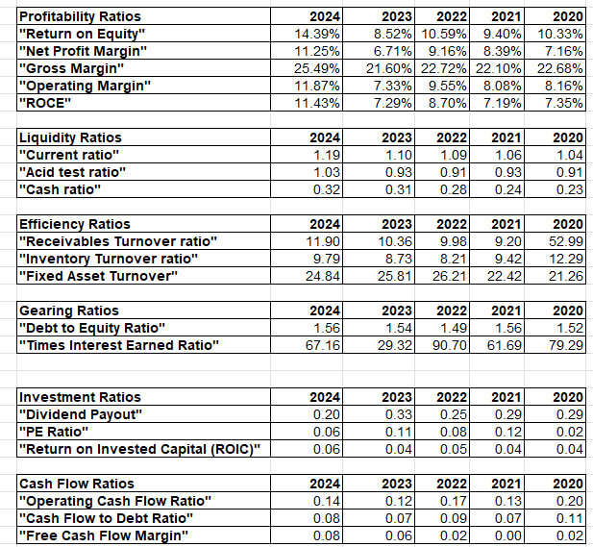
Figure 1: Ratios
(Source: MS-Excel)
The liquidity ratios evaluate how a firm is able to fulfill its short-term liabilities. They play a critical role when it comes to the assessment of financial health and efficiency of working capital (Gunawan, 2023). Liquidity position is steadily improving over the years. The current ratio rose in 2024 to 1.19 compared to 1.04 in 2020, which means that it is more likely to be solvent in the short term. In 2024, the acid test ratio increased to 1.03 as the company started being more capable of covering its obligations without resorting to inventory. Cash availability also increased with a rise in the cash ratio which rose to 0.32 as compared to 0.23. In general, the liquidity position of the company has improved slowly by slowly.

Efficiency Ratios
Efficiency ratios are used to assess the efficiency with which a company uses its assets to earn revenue. They are important to measure the performance of operations (Majka, 2024). Better collection efficiency is reflected in the receivable’s turnover ratio of 11.90 in 2024 compared to 9.20 in 2021, though 2020 seems to be abnormally high. Overall, inventory turnover was lower in 2024, at 9.79 compared to 12.29 in 2020, indicating slower inventory movement. The turnover of fixed assets marginally declined, as it was 26.21 in 2022 and 24.84 in 2024, which shows slightly less efficient use of assets.

Gearing Ratios
The gearing ratios are used to determine the level of both financial leverage and debt financing. They play a major role in determining the financial risk and capital structure (Oranefo and Egbunike, 2023). Toyota has a marginally higher leverage as its debt-to-equity ratio changed marginally between 2023 and 2024, 1.54 to 1.56. The interest earned increased greatly as time-interest earned increased by a margin of 29.32 to 67.16, indicating a better capacity to cover interest charges. This advances on the increased operating profits, indicating fewer financial risks in spite of the increased debt levels (Toyota, 2021).

Investment Ratios
The investment ratios are measures of returns to shareholders and market perception. They play an important role in the determination of the attractiveness of investment (Beck et al., 2022). The investment ratios are a performance that is changing. In 2024, the dividend payout dropped to 0.20 compared to 0.33 in 2023, which is an indicator of a more retained earnings policy. The PE ratio declined to 0.06, indicating a lower market valuation or earnings expectations. Nevertheless, ROIC increased to 0.06 in 2024, and it is more efficient in using capital. Generally, the company has a conservative distribution policy and average returns on invested capital. It could be a sign of a careful attitude of investors or high growth in earnings, which implies the company is oriented on long-term value creation (Companiesmarketcap, 2026).

Cash Flow Ratios
The cash flow ratios consider the capacity of a company to produce cash to settle debts. They play an essential role in assessing financial flexibility and liquidity (Arifaj et al., 2023). The cash flow ratios represent mixed improved performance. The operating cash flow ratio has decreased by 0.20 in 2020 to 0.14 in 2024, indicating a decreased efficiency to generate short-run cash. The debt coverage capacity was also low as the cash flow to debt ratio decreased. Nevertheless, the margin of free cash flow has increased to 0.08 in 2024, compared to an almost zero in 2021, which indicates a greater availability of cash following expenditure. In general, there is slow recovery in cash management.

2.3 Identify Trends
The financial trend of Toyota during 2020-2024 is favourable, as the company is experiencing rising profits and enhancing liquidity. There is stable growth in the net profit margins and return on equity, which depicts the improved earnings performance. The liquidity ratios are slowly improving, which is an indicator of enhanced financial stability in the short term (Hasidi et al., 2024). As well, efficiency ratios are enhanced, indicating better utilisation of assets. Gearing, however, is also rather high, which implies relying on debt. In general, the trend shows financial expansion with operational effectiveness and increased revenues.

2.4 Identify Strengths
The strengths of Toyota are high growth in profitability; the ratio of return to equity is increasing to 14.39% in 2024, and net margins have improved. The business has good liquidity, as evidenced by growing cash flows and effective working capital management (Seretidou et al., 2025). A high interest cover means that it is capable of paying off debts. Moreover, better efficiency ratios indicate that there is effective utilisation of assets. These strengths portray that Toyota has a good financial position and operational efficiency, as well as the ability to maintain long-term growth.

2.5 Identify Threats
Toyota has a number of financial threats, such as a relatively high debt-to-equity ratio of 1.56, which may mean its reliance on external funding. The suggestive negative dividend payout and P/E ratios can be an indication of a wary investor attitude. Profitability may be negatively affected by changes in world markets, exchange rates, and increased costs (Zhang et al., 2025). Also, the decrease in the cash flow ratios in comparison to the previous year’s raises concerns of potential pressure on liquidity (Toyota, 2026b). Unless well addressed, these factors can become a threat to the stability and future performance.

3. Working Capital Management Analysis

3.1 Assess the Cash Operating Cycle
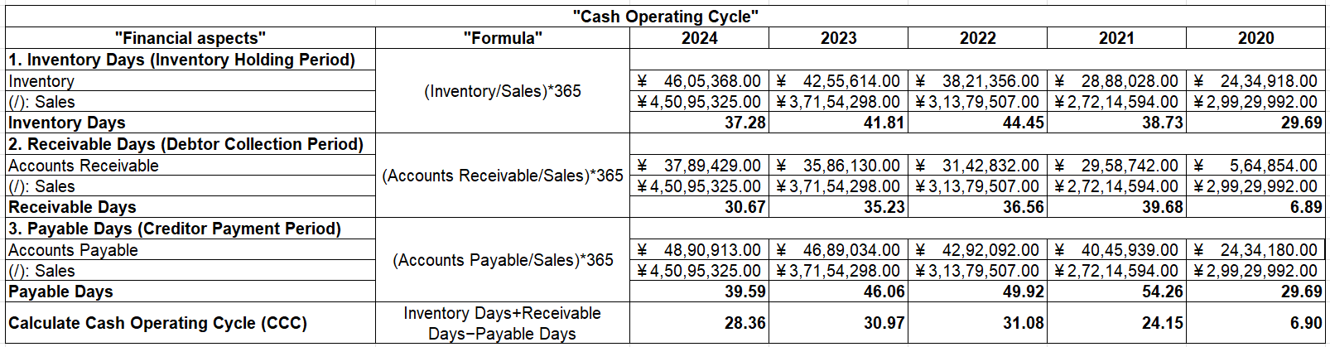
Figure 2: Toyota’s Cash Operating Cycle (CCC)
(Source: MS-Excel)
The cash operating cycle (CCC) is a measure of how long a company takes to convert investments in its inventories and debts to sales cash flows. It is noteworthy because it indicates efficiency in working capital and how to manage liquidity (Asman et al., 2022). The shorter CCC reflects the efficient operation and faster recovery of cash. Toyota’s CCC shows a declining trend from 31.08 days in 2022 and 30.97 days in 2023 to 28.36 days in 2024. Such an improvement implies a better capital working efficiency. Inventory days reduced to 37.28 days in 2024 compared to 44.45 days in 2022, which is a reflection of the presence of better inventory turnover through the management of the demand and supply chains. The number of days in receivables also decreased, with 36.56 days of 2022 turning into 30.67 days of 2024, being evidence of the efficient control on credits and faster credit collection among customers (Toyota, 2024). Although this enhances the relationship of suppliers, it reduces the trade credit advantage. On the whole, the decrease in CCC can be attributed to the better management of inventory and receivables. However, the low payable period is an indicator that opens up to maximisation of the cash outflows and further improvement of the liquidity.

3.2 Strategies to Improve Liquidity By Working Capital Reforms

Optimisation of Receivables and Inventory Management
To enhance its liquidity position, Toyota can enhance its receivables management by implementing tougher credit policies and more aggressive collections. Further shortening of the number of days in receivables to a minimum of 30.67 days can hasten cash inflows. To address the changes, the firm can adopt online payment systems and provide discounts to buyers before payment. Moreover, better credit risk evaluation will decrease bad debts and promote cash flow stability. Another way to optimise inventory management is to implement advanced forecasting algorithms and just-in-time (JIT) systems (Pal, 2024). As much as inventory days have been decreased to 37.28 days in 2024, more effort can be made by matching production and demand in the most effective way. This will lower the holding cost and release cash that is bound up in inventory. Another way of reducing the risk of excess stock and obsolescence is efficient inventory control systems and automation.

Extension of Payables and Cash Flow Management
The liquidity can be improved after Toyota organizes the expansion of its payable period, which is now very low (0.10 days in 2024). It would be wise to negotiate with suppliers about longer credit terms so that the company can hold cash longer without any impact on operations. This would greatly enhance the cash operating cycle and the position of working capital. Moreover, centralised treasury management and cash pooling may be effective cash flow management strategies that can maximise the liquidity in global operations (Yan et al., 2024). Short-term financial instruments are also available to the company as it can invest excess cash to make additional returns. Following stricter management of operating costs and offsetting the cash receipts and outgoings will sustain adequate liquidity. All these reforms make financial flexibility more flexible, and they empower Toyota in regard to short-term obligations.

3.3 Compare Short-term vs Long-term Financing Options

Short-term Financing
Bank overdraft, trade credit and short-term loans are sources of short-term financing, which are usually repaid within one year. It has relevance in managing the working capital requirements and mitigating any temporary liquidity crunches. Short-term financing is often more adaptable and not complicated to secure, thus is used in financing day-to-day operations (Hempel et al., 2024). It usually has increased interest rates and refinancing risk, which has potential effects on the financial stability if not handled appropriately.

Long-term Financing
Long-term financing comprises equity capital, long-term loans and bonds, which are repayable within several years. It helps in financing capital investments and strategic growth. Long-term financing is a more stable option and less stressful in terms of regular repayments (Hempel et al., 2024). It also enables firms to match long-term assets utilisation with financing. But it can entail increased start-up expenses, increased regulatory burden, and dilution of ownership in the event of equity financing. Comparatively, short-term financing can be used to cater to operational requirements, whereas long-term financing is used in strategic growth. The moderate method will help maintain an optimal capital structure and financial sustainability.

4. Strategic Financial Restructuring Plan

4.1 Financial Restructuring Options

Divestiture of Non-core Assets
Toyota can enhance financial efficiency through selling off the businesses which are non-core or non-performing. By this move, the company will be able to concentrate on its main automotive and mobility business and free up capital that is held up in businesses that do not make it profitable. Divestiture proceeds can either be used to cut down debt or reinvest in areas that have high growth potential, like electric vehicles and autonomous technologies (Potharla, 2025). This improves general profitability and the effectiveness of capital allocation.

Strategic Mergers and Partnerships
Strategic mergers or joint ventures will help Toyota build its competitive advantage and technological strength. The technology companies or electric vehicle makers can be partners that can speed up the innovation and decrease the expenses used in research and development (Takeuchi et al., 2023). Mergers may also open up new markets and economies of scale, enhancing the effectiveness of operations. This method is especially topical in the shift towards comfortable mobility and digitization.

Equity Injection and Capital Restructuring
Toyota can use equity financing to fortify its capital base and lessen debt. New shares or retention earnings would help to improve the debt-to-equity ratio. As of 2024, the ratio is 1.56. A higher equity base will increase financial stability and decrease financial risk (Toyota, 2024). Furthermore, a reorganization of the current debt, through refinancing at a reduced interest rate, would allow a decrease in the financing costs and the level of profitability. This will result in a prospective and viable capital structure.

4.2 Impact on Financial Performance

Impact on Shareholder Value
Restructuring of finances can greatly increase the shareholder value because of the improved profitability and return on equity. The efficiency and divestitures drive earnings, resulting in increased returns to investors (Liu, 2024). Strategic alliances may lead to long-term growth, increasing market value. But the issuance of equity can weaken the stock in the short term, but it will enhance long-term financial stability and investment confidence.

Impact on Debt Structure
Toyota's debt structure can be optimally restructured through restructuring measures like being injected with equity and refinancing. Lowering the use of debt minimizes financial risk and increases creditworthiness. Remaking loans with a favourable interest rate reduces the interest costs, making it more profitable (Istan, 2024). Mergers and acquisitions might lead to a high level of debt but with well-managed management situations, the leverage will be at a sustainable level just to uphold financial stability in the long term.

Impact on Operational Flexibility
Reorganization of the finances enhances the flexibility in the operations due to the liberation of funds and the increase in liquidity. Selling non-core assets enables the management to direct their attention to their strategic priorities and the better cash flow enables investment in innovations and expansion (Liu, 2024). The lower financial commitments are better placed to allow it to be more flexible in reacting to market changes. This will help Toyota to keep up with trends in the industry, especially in the changing automotive industry.

4.3 International and Ethical Considerations

International Factors (Taxation and Currency Risk)
Toyota is an international company that has to factoring consideration of the international financial considerations, including taxes and currency changes. High volatility of the exchange rate can affect revenues and profitability, especially when the activity overseas is very big. Currency risk needs proper management through effective hedging strategies (Yuan, 2024). There are also variations on tax policies depending on various nations, and that affects the choices of financial planning and restructuring, which need proper tax optimisation plans which will help reduce the liability without violating taxation policies.

Inflation and Economic Conditions
Inflation and fluctuating economic conditions impact costs and pricing policies, as well as consumer demand. The rise in production costs due to inflation may lead to low profit margins if there is no effective management. To counter these effects, Toyota needs to embrace cost management practices and pricing models (Bhattacheryay, 2023). Investment decisions are also affected by economic uncertainties, which demand a lot of financial planning to ensure stability and growth.

Corporate Social Responsibility (CSR) and Ethics
In making financial restructuring decisions, ethical issues and corporate social responsibility issues are very important. Toyota must ensure that its restructuring plans do not harm employees, suppliers or communities. Green practices such as investing in clean technologies are in tandem with global expectations and regulatory requirements (Katamba et al., 2024). Being transparent, ethically managed and earning the trust of its stakeholders boosts corporate image and helps it to succeed in the long term.

5. Investment Appraisal and Capital Budgeting

5.1 Project A Analysis
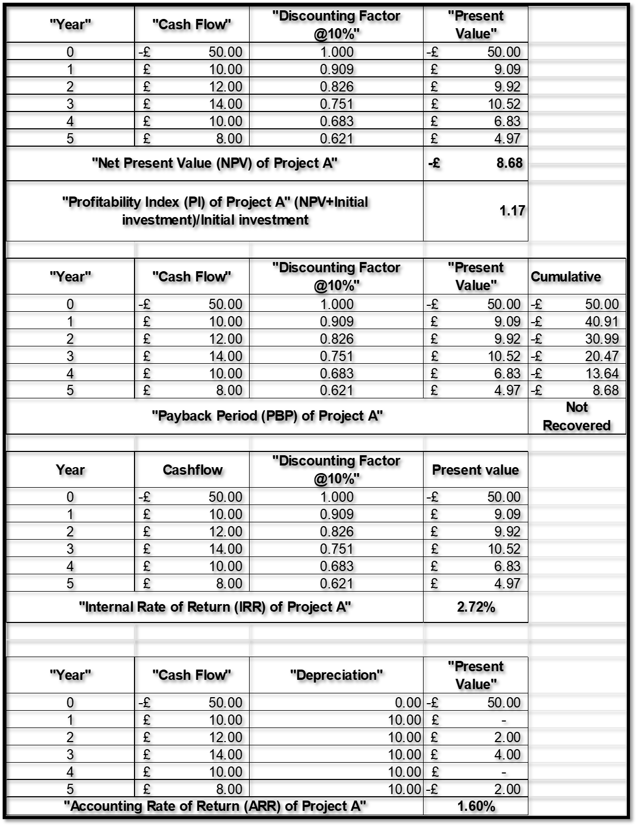
Figure 3: Project A
(Source: MS-Excel)
In Project A, the Net Present Value (NPV) is a negative value of -£8.68 million, which does not mean it will bring earnings more than the necessary rate of 10%. The payback period indicates that the project cannot justify its entry cost (Initial investment) in a span of five years in spite of the fact that the Profitability Index (PI) stands at 1.17. The Internal Rate of Return (IRR) is 7.72, which is much lower than the cost of capital and therefore financially unattractive. On top of this, the Accounting Rate of Return (ARR) is low at 1.60%. This low performance can be attributed to low and downward cash inflows in the long run.

5.2 Project B Analysis
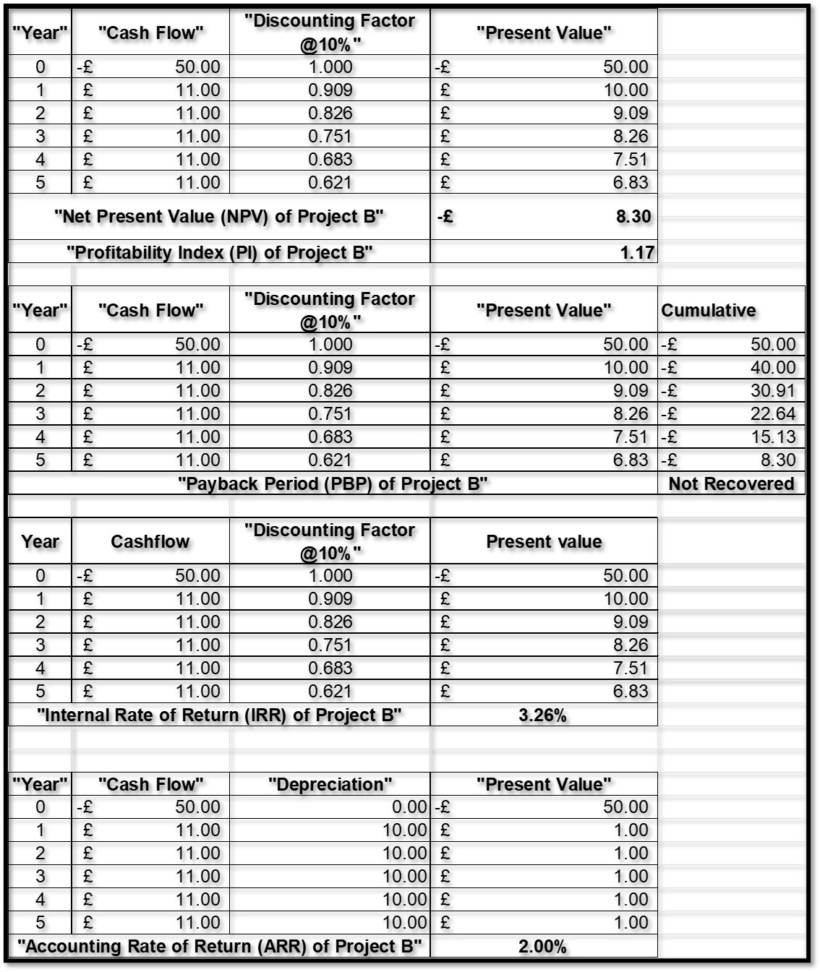
Figure 4: Project B
(Source: MS-Excel)
Project B also has a negative NPV of -£8.30 million, meaning it does not satisfy the minimum return. The PI of 1.17 indicates marginal efficiency, yet the project does not become payback over the period of investment. This IRR is 3.26, which is a bit higher than Project A but still lower than the 10% discount rate, and therefore shows poor profitability. The ARR is 2.00% with low accounting returns. Despite the fact that the cash flows remain at a constant level of £11 million a year, this is not enough to finance the start-up, and therefore the project is not financially feasible.

5.3 Project C Analysis
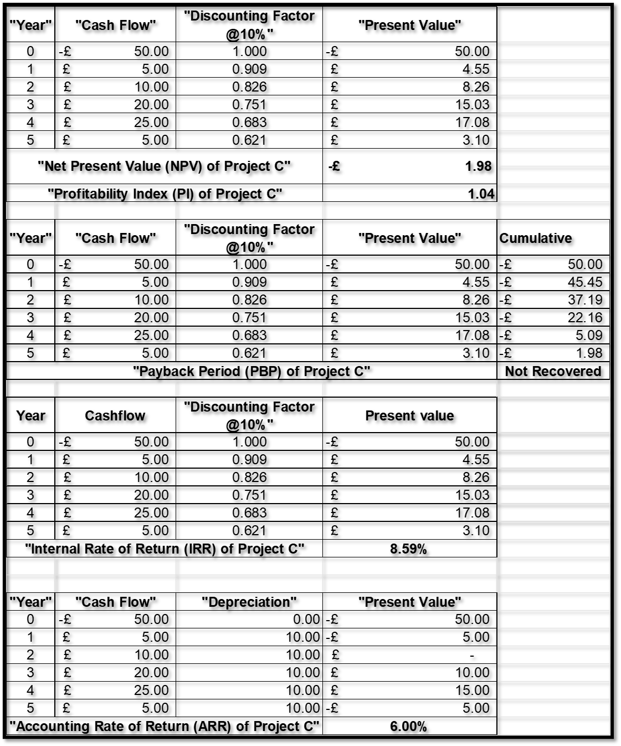
Figure 5: Project C
(Source: MS-Excel)
Project C is relatively better-liked, and its negative NPV is lower, -£1.98 million, indicating that it is closer to the breakeven point. PI of 1.04 indicates low value creation. As the payback period is not reached in five years, the IRR of 8.59% is quite high compared to Projects A and B, and it is close to the needed IRR of 10. The ARR is also higher at 6.00%, indicating better profitability. The fact that the project enjoys rising cash inflows in its old age, especially the increased cash inflows of 20 million and 25 million, renders it comparatively attractive even though the project underperforms in terms of its financial performance.

5.4 Recommended Project

Financial Justification
Project C is the most appropriate investment compared to the other two projects, although its NPV is negative, it will be -£1.98 million. Project C has the lowest financial loss and the most significant performance indicators as compared to A (-£8.68 million) and B (-8.30 million). It has an IRR of 8.59%, which compares much more with the required rate of return (10%), indicating a high potential of profitability. Project C is, as well, the best accounting project, as the ARR is at its highest, 6.00%. Toyota has the financial capacity to take up ventures where its returns are slightly low since it has produced a high level of profitability performance, as showcased by increasing net profit margin and return on equity of 11.25% and 14.39% in 2024, respectively. Besides, the rising liquidity situation of Toyota, which has a current ratio of 1.19, helps it to afford such investments. Findings of Project C Show that the cash inflows have increased over the years and this is consistent with the long-term strategy of Toyota to grow and invest in innovation.

Non-financial Considerations
Project C would be of more strategic value in terms of its potential to expand in the long-term, which is not a financial aspect. The fact that the cash flows are growing points to the possibility that the project can be associated with developing technologies or market penetration, considering that Toyota focuses on electric vehicles and sustainable mobility. This helps in customer retention and enhances branding in competitive environments. Also, they will need to take into account political and economic risks. The lagging returns of project C could lead to risk of inflation, change in regulations and currency fluctuations. Nevertheless, these uncertainties are minimized by the global nature of Toyota and its risk management strategies. Projects A and B, on the contrary, provide a lesser payoff and lesser strategic value, that mean they are less appealing.
All in all, Project C is advisable because it would offer a relatively improved financial performance and aligns well with the long-term strategic goals of Toyota, although it has slight financial constraints.

5.5 Capital Rationing Decision

Optimal Project Combination
In capital rationing, the parameter is that these are only £100 million, and therefore the aim is to choose the mix of projects that will yield the highest returns. The investment outlay is an initial 50 million pounds per project, meaning that Toyota can choose any two projects. According to NPV, the best project is Project C (-£1.98 million), then Project B (-£8.30 million), and Project A (-£8.68 million). Project B and Project C are the best combination because they could yield a more favourable financial result than the other combinations. The combined NPV of Projects B and C is -£10.28 million, which is superior to the combination of Projects A and B (-£16.98 million) and Projects A and C (-£10.66 million). Moreover, Project C has a good growth potential, whereas Project B has good cash flows, which are stable and consistent.

Justification of Selection
The choice of Projects B and C is made in order to have a balance between risk and return. Project B offers predictable miles of cash with a stable cash inflow of £11 million annually, to eliminate unpredictability and liquidity. Project C, in its turn, will be more profitable in the later years, which will help increase long-term profitability. The combination is in line with the financial position of Toyota, which has a high profitability and stronger liquidity, which allows the company to withstand the risks of moderate investment. Strategically, the two-project diversification minimises reliance on one investment and diversifies the risk. Besides, this is more business friendly as it promotes flexibility in operations and sustainable development. Other considerations like market growth, technological innovations, and customer satisfaction add more reasons to the selection (Leonis et al., 2024).
All in all, Projects B and C are the most appropriate to maximise value subject to capital limitations, and they harmonise with the financial strength and strategic goals of Toyota.

6. Conclusion

6.1 Summary
As can be seen in the analysis of Toyota Motor Corporation, its financial performance has been high since the year 2020 to 2024, as evidenced by the steady growth in revenues, profitability and asset base. The company has had a greater growth in the ratio of its financial position; total assets, and shareholders' equity have grown, indicating growth in expansion and retained earnings. Ratio analysis indicates a trend of increasing profitability, especially in terms of return on equity and net profit margin, liquidity and operational efficiency. The working capital analysis shows that the cash operating cycle improved from 31.08 days in 2022 to 28.36 days in 2024 due to the improvement of inventory and receivables management. Nevertheless, the very low payable period implies a possibility to optimise cash outflows. The financial restructuring plan outlines some of the key approaches to improve the financial conditions and operational efficiency: divestiture, strategic partnerships, and equity restructuring. Moreover, the outcomes of the investment appraisal process indicate that, despite the fact that all projects possess a negative NPV, Project C stands out more favourably in terms of the higher IRR, as well as the long-term opportunity to grow and prosper. The project B and C combination offers the optimal mix of stability and future returns according to capital rationing.

6.2 Final Evaluation
Altogether, Toyota is financially sound, and its revenues and costs are growing profitably; its level of liquidity is consistent, and its operational management is sound. The company shows a good capability of producing returns and managing financial risk with its high interest coverage and rising efficiency ratios. The company has a sustainable capital structure in spite of moderate reliance on debt. This investment analysis recommends cautious capital budgeting because the current projects may not entirely yield the required returns, hence projects should be selected carefully.

6.3 Future Outlook
Moving forward, Toyota can continue to grow by making effective investments in innovation, especially with electric cars and sustainable technologies. Liquidity can also be enhanced by enhancing working capital management, particularly through increasing payable periods. Furthermore, it will be supported by financial restructuring and balancing the finance mix as well to enhance long-term stability (Katamba et al., 2024). Other external issues that need to be dealt with by the company include economic uncertainty, inflation, and fluctuations in the currency. With the help of its good financial foundation and global scope, Toyota can keep on creating the wealth of its shareholders and ensuring a competitive edge in the changing automotive marketplace.

References
Arifaj, A.H., Berisha, V., Morina, F. and Avdyli, E., 2023. Exploring the impact of cash flow, company size, and debt on financial performance in corporations. Investment Management & Financial Innovations, 20(3), p.264. https://pdfs.semanticscholar.org/b297/a823988fa5f3b58516df9f08c16c2c20d0e5.pdf
Asman, F.N., Fernandez, D., Jamaludin, N.A., Omar Zaki, H. and Ghazali, A.W., 2022. Cash conversion cycle and firm’s performance. International Journal of Academic Research in Business and Social Sciences, 12(11), pp.2682-2692. https://www.academia.edu/download/106769993/cash-conversion-cycle-and-firms-performance.pdf
Beck, K.L., Chong, J. and Niendorf, B.D., 2022. Investment returns from reputation investing: do good firms provide good returns?. American Journal of Business, 37(3), pp.109-119. https://www.emerald.com/ajb/article-pdf/37/3/109/226512/ajb-06-2021-0070.pdf
Bhattacheryay, S., 2023. Multinational working capital management a study on Toyota Motor Corporation. International Journal of Finance & Economics, 28(1), pp.236-256. https://www.researchgate.net/profile/Suranjan-Bhattacheryay-2/publication/348843827_Multinational_working_capital_management_a_study_on_Toyota_Motor_Corporation/links/604d719a458515e529a7a20a/Multinational-working-capital-management-a-study-on-Toyota-Motor-Corporation.pdf
Companiesmarketcap. 2026. Toyota (TM) - Market capitalization. Available at: https://companiesmarketcap.com/inr/toyota/marketcap/#google_vignette [Accessed 13th April 2026]
Grundy, T., Johnson, G. and Scholes, K., 2022. Strategic Financial Management. Bachelor of Business Administration Programme Code: BBA Duration–3 Years Full Time, 2(1), pp.1-575. https://www.amity.edu/gwalior/naac/1_1_3/syllabus/1.1.3%20abs%20new.pdf#page=529
Gunawan, E., 2023. Liquidity Ratio Analysis in Financing Short Term Liabilities. International Journal of Health, Economics, and Social Sciences (IJHESS), 5(2), pp.157-162. https://jurnal.unismuhpalu.ac.id/index.php/IJHESS/article/download/3611/2789
Hasidi, M.H., Baheri, J. and Hajar, K.I., 2024. Financial performance evaluation using profitability and liquidity ratio analysis. Jurnal Ilmiah Manajemen Kesatuan, 12(4), pp.1347-1358. https://jurnal.ibik.ac.id/index.php/jimkes/article/download/2742/1966
Hempel, S., Li, Y. and Tibay, S., 2024. Firms' financing choice between short-term and long-term debts: Are they substitutes?. https://www.federalreserve.gov/econres/notes/feds-notes/firms-financing-choice-between-short-term-and-long-term-debts-are-they-substitutes-20240503.html
Istan, M., 2024. Analysis of the influence of assets structure, earning volatility, and financial flexibility on capital structure and corporate performance in manufacturing sector companies on the IDX. Икономически изследвания, (1), pp.49-65. http://repository.iaincurup.ac.id/1725/6/1%20Korespondensi%20Economic%20Studies_Muhammad%20Istan_Versi%20Pedoman%20Terbaru.pdf
Katamba, D., Wickert, C.M. and Nkiko, C.M., 2024. Humanism as an Institutional Driver of Corporate Social Responsibility (CSR) Activities. In Corporate Social Responsibility Disclosure in Developing and Emerging Economies: Institutional, Governance and Regulatory Issues (pp. 21-44). Cham: Springer International Publishing. https://research.vu.nl/files/383294522/Humanism_as_an_Institutional_Driver_of_Corporate_Social_Responsibility_CSR_Activities.pdf
Leonidou, E., Battisti, E., Ahmad, M.I. and Campo, R., 2024. Financial and non-financial factors for the success of hybrid offerings: evidence from multinational enterprises in an emerging market. International Marketing Review, 41(3-4), pp.827-846. https://www.emerald.com/imr/article-pdf/41/3-4/827/9612448/imr-04-2022-0103.pdf
Liu, S., 2024. The Impact of Capital Structure on Corporate Financial Performance: A Case Study of Alibaba and E-commerce Industry. In SHS Web of Conferences (Vol. 207, p. 03019). EDP Sciences. https://www.shs-conferences.org/articles/shsconf/pdf/2024/27/shsconf_icdeba2024_03019.pdf
Majka, M., 2024. Understanding Efficiency Ratios. https://www.researchgate.net/profile/Marcin-Majka-2/publication/381402363_Understanding_Efficiency_Ratios/links/666b64b9de777205a32c2aa5/Understanding-Efficiency-Ratios.pdf
Nasution, Y.A. and Yusleny, Y., 2023, February. Financial Performance Measurement Using Profitability Ratios And Liquidity Ratios. In Proceeding Medan International Conference on Economic and Business (Vol. 1, pp. 1730-1741). https://proceeding.umsu.ac.id/index.php/Miceb/article/download/282/303
Oranefo, P.C. and Egbunike, C.F., 2023. Gearing ratio and operating cash flow performance of quoted manufacturing firms in Nigeria. International Journal of Financial, Accounting, and Management, 4(4), pp.395-410. https://www.neliti.com/publications/620973/gearing-ratio-and-operating-cash-flow-performance-of-quoted-manufacturing-firms
Pal, S., 2024. Optimizing just-in-time inventory management: A deep dive into AI-enhanced demand forecasting. NOVYI MIR Research Journal, 9, pp.62-70. https://www.researchgate.net/profile/Subharun-Pal/publication/378977234_Optimizing_Just-In-Time_Inventory_Management_A_Deep_Dive_into_AI-Enhanced_Demand_Forecasting/links/65f4a532286738732d4d4e90/Optimizing-Just-In-Time-Inventory-Management-A-Deep-Dive-into-AI-Enhanced-Demand-Forecasting.pdf
Potharla, S., 2025. From Debt to Divestiture: How Indian and Global Firms Reshaped through Corporate Restructuring. Available at SSRN 5348941. https://papers.ssrn.com/sol3/Delivery.cfm?abstractid=5348941
Seretidou, D., Billios, D. and Stavropoulos, A., 2025. Integrative analysis of traditional and cash flow financial ratios: Insights from a systematic comparative review. Risks, 13(4), p.62. https://www.mdpi.com/2227-9091/13/4/62
Sukenti, S., 2023. Financial management concepts: a review. Journal of Contemporary Administration and Management (ADMAN), 1(1), pp.13-16. https://journal.literasisainsnusantara.com/index.php/adman/article/download/4/31
Takeuchi, I.Y., Ohmae, H.T. and Ichijo, K.K., 2023. Navigating Competition through Alliances: An Analysis of Toyota's Strategy in the Japanese Auto Industry. Journal of Strategic Management, 7(6), pp.1-12. https://stratfordjournalpublishers.org/journals/index.php/journal-of-strategic-management/article/download/1733/2251
Toyota. 2020. FINANCIAL SUMMARY FY2020. Available at: https://global.toyota/pages/global_toyota/ir/financial-results/2020_4q_summary_en.pdf [Accessed 13th April 2026]
Toyota. 2022. FINANCIAL SUMMARY FY2022. Available at: https://global.toyota/pages/global_toyota/ir/financial-results/2022_4q_summary_en.pdf [Accessed 13th April 2026]
Toyota. 2023. FINANCIAL SUMMARY FY2023. Available at: https://global.toyota/pages/global_toyota/ir/financial-results/2023_4q_summary_en.pdf [Accessed 13th April 2026]
Toyota. 2024. FINANCIAL SUMMARY FY2024. Available at: https://global.toyota/pages/global_toyota/ir/financial-results/2024_4q_summary_en.pdf [Accessed 13th April 2026]
Toyota. 2026a. Company | Toyota Motor Corporation Official Global Website. Available at: https://global.toyota/en/company/index.html [Accessed 13th April 2026]
Toyota. 2026b. Overview | Profile | Company | Toyota Motor Corporation. Available at: https://global.toyota/en/company/profile/overview/index.html [Accessed 13th April 2026]
Yan, X., Chen, L. and Ding, X., 2024. Optimal cash management with payables finance. Operations Research, 72(5), pp.1806-1826. https://pubsonline.informs.org/doi/abs/10.1287/opre.2022.0196
Yuan, Y., 2025. Toyota Motor’s Exchange Rate Risk Management: Residual Risk and Response Strategies after Forward Hedging. Highlights in Business, Economics and Management, 65, pp.152-157. http://hbemdata.org/index.php/ojs/article/download/25/22
Zhang, Y., Silva, B., Moreau, É. and Tāne, H., 2025. Financial ratio analysis: A literature review working paper. https://mpra.ub.uni-muenchen.de/125289/1/Financial%20Ratio%20Analysis%20A%20literature%20Review%20Working%20Paper.pdf

Appendices

Appendix 1: Ratio Tables
Profitability Ratios | 2024 | 2023 | 2022 | 2021 | 2020
"Return on Equity" | 14.39% | 8.52% | 10.59% | 9.40% | 10.33%
"Net Profit Margin" | 11.25% | 6.71% | 9.16% | 8.39% | 7.16%
"Gross Margin" | 25.49% | 21.60% | 22.72% | 22.10% | 22.68%
"Operating Margin" | 11.87% | 7.33% | 9.55% | 8.08% | 8.16%
"ROCE" | 11.43% | 7.29% | 8.70% | 7.19% | 7.35%
Liquidity Ratios | 2024 | 2023 | 2022 | 2021 | 2020
"Current ratio" | 1.19 | 1.10 | 1.09 | 1.06 | 1.04
"Acid test ratio" | 1.03 | 0.93 | 0.91 | 0.93 | 0.91
"Cash ratio" | 0.32 | 0.31 | 0.28 | 0.24 | 0.23
Efficiency Ratios | 2024 | 2023 | 2022 | 2021 | 2020
"Receivables Turnover ratio" | 11.90 | 10.36 | 9.98 | 9.20 | 52.99
"Inventory Turnover ratio" | 9.79 | 8.73 | 8.21 | 9.42 | 12.29
"Fixed Asset Turnover" | 24.84 | 25.81 | 26.21 | 22.42 | 21.26
Gearing Ratios | 2024 | 2023 | 2022 | 2021 | 2020
"Debt to Equity Ratio" | 1.56 | 1.54 | 1.49 | 1.56 | 1.52
"Times Interest Earned Ratio" | 67.16 | 29.32 | 90.70 | 61.69 | 79.29
Investment Ratios | 2024 | 2023 | 2022 | 2021 | 2020
"Dividend Payout" | 0.20 | 0.33 | 0.25 | 0.29 | 0.29
"PE Ratio" | 0.06 | 0.11 | 0.08 | 0.12 | 0.02
"Return on Invested Capital (ROIC)" | 0.06 | 0.04 | 0.05 | 0.04 | 0.04
Cash Flow Ratios | 2024 | 2023 | 2022 | 2021 | 2020
"Operating Cash Flow Ratio" | 0.14 | 0.12 | 0.17 | 0.13 | 0.20
"Cash Flow to Debt Ratio" | 0.08 | 0.07 | 0.09 | 0.07 | 0.11
"Free Cash Flow Margin" | 0.08 | 0.06 | 0.02 | 0.00 | 0.02
(Source: Excel)

Appendix 2: Investment Appraisal Calculations

Project A
"Year" | "Cash Flow" | "Discounting Factor @10%" | "Present Value"
0 | -£ 50.00 | 1.000 | -£ 50.00
1 | £ 10.00 | 0.909 | £ 9.09
2 | £ 12.00 | 0.826 | £ 9.92
3 | £ 14.00 | 0.751 | £ 10.52
4 | £ 10.00 | 0.683 | £ 6.83
5 | £ 8.00 | 0.621 | £ 4.97
"Net Present Value (NPV) of Project A" |  |  | -£ 8.68
"Profitability Index (PI) of Project A" (NPV+Initial investment)/Initial investment |  |  | 1.17
"Year" | "Cash Flow" | "Discounting Factor @10%" | "Present Value" | Cumulative
0 | -£ 50.00 | 1.000 | -£ 50.00 | -£ 50.00
1 | £ 10.00 | 0.909 | £ 9.09 | -£ 40.91
2 | £ 12.00 | 0.826 | £ 9.92 | -£ 30.99
3 | £ 14.00 | 0.751 | £ 10.52 | -£ 20.47
4 | £ 10.00 | 0.683 | £ 6.83 | -£ 13.64
5 | £ 8.00 | 0.621 | £ 4.97 | -£ 8.68
"Payback Period (PBP) of Project A" |  |  |  | Not Recovered
Year | Cashflow | "Discounting Factor @10%" | Present value
0 | -£ 50.00 | 1.000 | -£ 50.00
1 | £ 10.00 | 0.909 | £ 9.09
2 | £ 12.00 | 0.826 | £ 9.92
3 | £ 14.00 | 0.751 | £ 10.52
4 | £ 10.00 | 0.683 | £ 6.83
5 | £ 8.00 | 0.621 | £ 4.97
"Internal Rate of Return (IRR) of Project A" |  |  | 2.72%
"Year" | "Cash Flow" | "Depreciation" | "Present Value"
0 | -£ 50.00 | 0.00 | -£ 50.00
1 | £ 10.00 | 10.00 | £ -
2 | £ 12.00 | 10.00 | £ 2.00
3 | £ 14.00 | 10.00 | £ 4.00
4 | £ 10.00 | 10.00 | £ -
5 | £ 8.00 | 10.00 | -£ 2.00
"Accounting Rate of Return (ARR) of Project A" |  |  | 1.60%
(Source: Excel)

Project B
"Year" | "Cash Flow" | "Discounting Factor @10%" | "Present Value"
0 | -£ 50.00 | 1.000 | -£ 50.00
1 | £ 11.00 | 0.909 | £ 10.00
2 | £ 11.00 | 0.826 | £ 9.09
3 | £ 11.00 | 0.751 | £ 8.26
4 | £ 11.00 | 0.683 | £ 7.51
5 | £ 11.00 | 0.621 | £ 6.83
"Net Present Value (NPV) of Project B" |  |  | -£ 8.30
"Profitability Index (PI) of Project B" |  |  | 1.17
"Year" | "Cash Flow" | "Discounting Factor @10%" | "Present Value" | Cumulative
0 | -£ 50.00 | 1.000 | -£ 50.00 | -£ 50.00
1 | £ 11.00 | 0.909 | £ 10.00 | -£ 40.00
2 | £ 11.00 | 0.826 | £ 9.09 | -£ 30.91
3 | £ 11.00 | 0.751 | £ 8.26 | -£ 22.64
4 | £ 11.00 | 0.683 | £ 7.51 | -£ 15.13
5 | £ 11.00 | 0.621 | £ 6.83 | -£ 8.30
"Payback Period (PBP) of Project B" |  |  |  | Not Recovered
Year | Cashflow | "Discounting Factor @10%" | Present value
0 | -£ 50.00 | 1.000 | -£ 50.00
1 | £ 11.00 | 0.909 | £ 10.00
2 | £ 11.00 | 0.826 | £ 9.09
3 | £ 11.00 | 0.751 | £ 8.26
4 | £ 11.00 | 0.683 | £ 7.51
5 | £ 11.00 | 0.621 | £ 6.83
"Internal Rate of Return (IRR) of Project B" |  |  | 3.26%
"Year" | "Cash Flow" | "Depreciation" | "Present Value"
0 | -£ 50.00 | 0.00 | -£ 50.00
1 | £ 11.00 | 10.00 | £ 1.00
2 | £ 11.00 | 10.00 | £ 1.00
3 | £ 11.00 | 10.00 | £ 1.00
4 | £ 11.00 | 10.00 | £ 1.00
5 | £ 11.00 | 10.00 | £ 1.00
"Accounting Rate of Return (ARR) of Project B" |  |  | 2.00%
(Source: Excel)

Project C
"Year" | "Cash Flow" | "Discounting Factor @10%" | "Present Value"
0 | -£ 50.00 | 1.000 | -£ 50.00
1 | £ 5.00 | 0.909 | £ 4.55
2 | £ 10.00 | 0.826 | £ 8.26
3 | £ 20.00 | 0.751 | £ 15.03
4 | £ 25.00 | 0.683 | £ 17.08
5 | £ 5.00 | 0.621 | £ 3.10
"Net Present Value (NPV) of Project C" |  |  | -£ 1.98
"Profitability Index (PI) of Project C" |  |  | 1.04
"Year" | "Cash Flow" | "Discounting Factor @10%" | "Present Value" | Cumulative
0 | -£ 50.00 | 1.000 | -£ 50.00 | -£ 50.00
1 | £ 5.00 | 0.909 | £ 4.55 | -£ 45.45
2 | £ 10.00 | 0.826 | £ 8.26 | -£ 37.19
3 | £ 20.00 | 0.751 | £ 15.03 | -£ 22.16
4 | £ 25.00 | 0.683 | £ 17.08 | -£ 5.09
5 | £ 5.00 | 0.621 | £ 3.10 | -£ 1.98
"Payback Period (PBP) of Project C" |  |  |  | Not Recovered
Year | Cashflow | "Discounting Factor @10%" | Present value
0 | -£ 50.00 | 1.000 | -£ 50.00
1 | £ 5.00 | 0.909 | £ 4.55
2 | £ 10.00 | 0.826 | £ 8.26
3 | £ 20.00 | 0.751 | £ 15.03
4 | £ 25.00 | 0.683 | £ 17.08
5 | £ 5.00 | 0.621 | £ 3.10
"Internal Rate of Return (IRR) of Project C" |  |  | 8.59%
"Year" | "Cash Flow" | "Depreciation" | "Present Value"
0 | -£ 50.00 | 0.00 | -£ 50.00
1 | £ 5.00 | 10.00 | -£ 5.00
2 | £ 10.00 | 10.00 | £ -
3 | £ 20.00 | 10.00 | £ 10.00
4 | £ 25.00 | 10.00 | £ 15.00
5 | £ 5.00 | 10.00 | -£ 5.00
"Accounting Rate of Return (ARR) of Project C" |  |  | 6.00%
(Source: Excel)

Appendix 3: Graphs
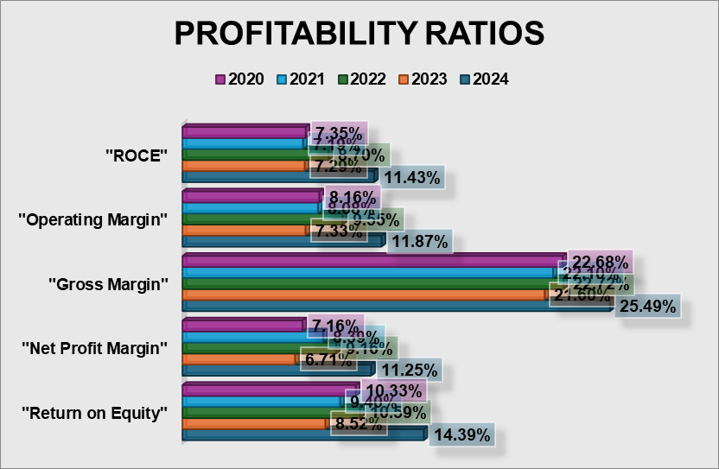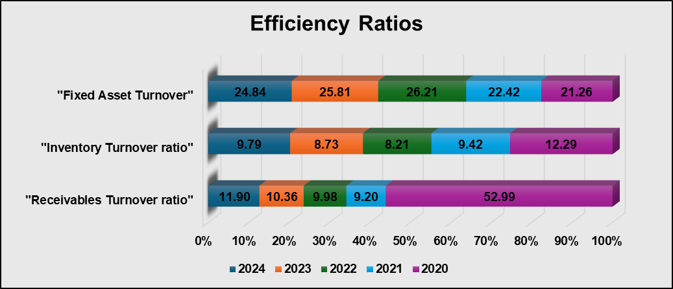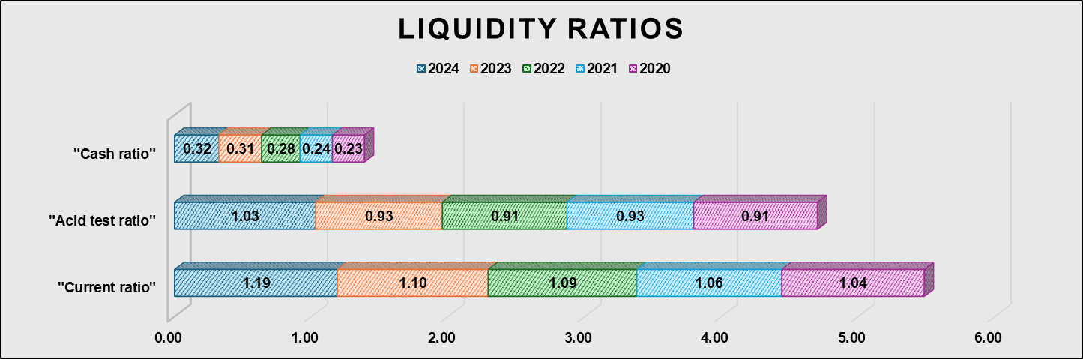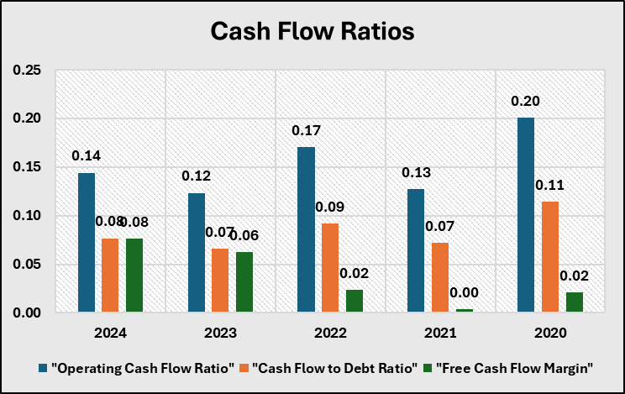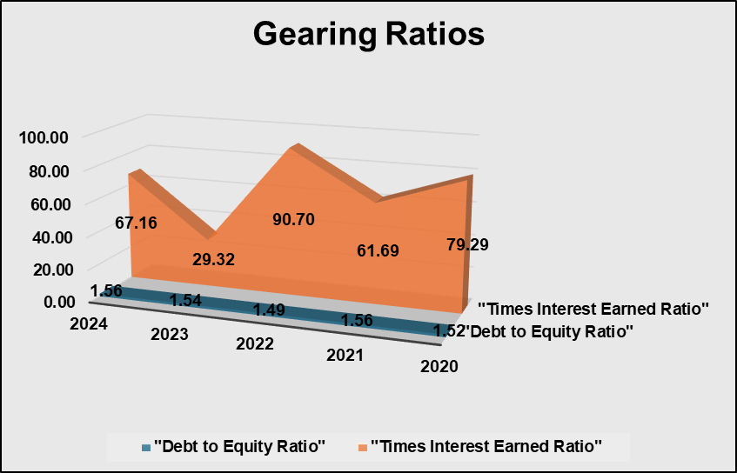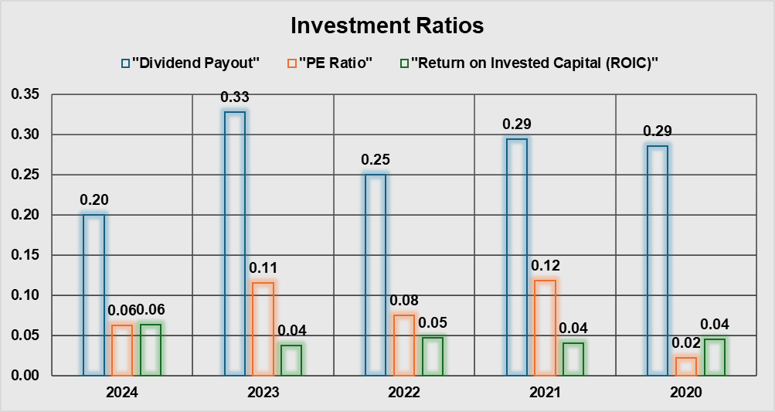
(Source: Excel)

AI Acknowledgement
AI tools like ChatGPT are used to generate the contents. Generated material that was checked clearly, edited and validated to ensure that it was accurate.

