Report Case Study: The Seacrest Lodge

Student name: Anat Dranciuc-Georgescu
Student Id: 2125394
Module: Financial Management for the Hotel Industry (BMIH5007)
Lecturer name: Tristan Hawkins
Word Count: 1978

Executive Summary
In this report, The Seacrest Lodge will be analysed threw its financial reports for 2021 to 2023, how the company improved its revenue streams, where the main causes of collapse were identified, what management risk could be avoided and what can the owner do to turn around the company’s future.

Introduction

According to Financial Management for the Hotel Industry (2024), The Seacrest Lodge, with restaurant, bar and event facilities located on a picturesque coastline, was once a thriving destination for vacationers seeking relaxation and luxury. However, in recent years, the resort has experienced a decline in revenue, occupancy rates, and customer satisfaction. The owner is concerned about the future viability of the business and has enlisted experts to assess if the business can be salvaged through a turnaround strategy.
After assessing the company’s situation, the following results are as shown. From 2021 to 2023, the company has had a decline in property and equipment investments of about 200.000 pounds, a constant debt of 150.000 pounds, another decline in revenue of 100.000 pounds from 2021 to 2022 and from 2022 to 2023, another drop of 150.000 pounds (Figure1).
As such, the company changed its average room rate from 260 pounds in 2021 to 210 pounds in 2023, a total of 50 pounds lost per room price, as for the occupancy rate, in 2021, it was at 65%, and it dropped down 15% in 2023 with an occupancy rate of 50% (Figure2).
As stated by Premier Inn Hotels Limited(2020) “ cash and equivalents include cash at the bank, cash in hand and deposits also money market funds which are all short-term, easy to use to buy and sell, and are not significantly risks of changes in value” however for Seacrest Lodge its cash and equivalents dropped significantly from 2021 to 2022 by 20.000 pounds and another drastic decrease in 2023 of 60.000 pounds (Figure2).
Martin (p.8, 2019) points out that several factors can improve and maintain the net profit of a hotel, such as upgrading the overall quality of the hotel to satisfy customer's needs and desires, sales techniques such as upselling and conversion or enquiries, budgeting and forecasting performances of the hotel, different revenue streams and options that the company can access and of course, fixed costs and expenses that need to be monitored.
In The Seacrest Lodge case, focusing first on improving the quality of the hotel and keeping the customers that it has is imperative, accepting feedback from its customers for improvements is another way of turning the business around in a good and prosperous financial solution.
To cultivate customer loyalty, hotels must provide exceptional customer service and deliver outstanding customer experiences. According to Hyken (2022), it is imperative for hotels to not only offer top-notch customer service, but also ensure that guests have positive interactions when engaging with the hotel's website for bookings, receiving promotional emails, accepting thank you gifts, and browsing through social media platforms for reviews.
The business must invest in upgrading its brand image and its hotel facilities as well as keeping an eye on its employees to make sure that its customers receive the best experience and would want to visit them more often than the competitive resorts that are in the same area.
Forsey (2023) argues that reputation management, the act of controlling public perceptions of a business or enterprise, has become increasingly crucial in today's digital age where online discussions about businesses are prevalent.
After the company has gathered a bit of information regarding what the hotel is missing and what upgrades it needs to rise above the low percentage of customers or stabilize itself back on the market the second is moving on its marketing approach to attract new customers.
Wijayasinha (2021) points out that understanding factors and trends in the category, customers' buying behaviour, and the competitive landscape will assist in developing realistic goals, crafting compelling messaging that resonates with the target audience, and identifying the appropriate channels for reaching them and that it is essential to anticipate potential risks in advance, as not everything may unfold as planned. Having a rigid plan with significant fixed costs, such as deposits or minimum spending, can restrict flexibility and lead to challenges when unexpected circumstances arise, such as shifting market conditions or the emergence of new competitors.
In The Seacrest Lodge situation, a vigorous marketing plan can offer a competitive edge when implemented with a strategic and measured approach to effectively attract customers. Achieving set targets successfully allows for the replication of the strategy in future endeavours.
As Smith (2024) discusses, marketing planning is a critical ongoing activity that should be spearheaded by the head of marketing throughout the year, optimizing based on current circumstances, exploring new opportunities, and adapting to changes in customer behaviour, emerging competition, and other factors.
Another solution for The Seacrest Lodge would be to switch its marketing targets towards families with children and, allow those customers to have eco-friendly activities since the location of the business is near a coastline the company can benefit from the positive reaction of clients who find them eco-friendly and can attract more guests. Activities such as cleaning the coastline, fishing, and learning from the local community can boost the business's net profits immensely.
Dodds's (2024) publication highlights the significance of travelling with children as a crucial method for promoting the transition towards more sustainable travel practices. She emphasizes that exposing children to sustainability issues at a young age can cultivate their advocacy for pressing global concerns, including waste management, climate change, and equity. Through active participation in sustainable activities, children can enhance their problem-solving abilities and foster independence. Involving parents and other family members in these endeavours can further support children in comprehending the significance of self-sustaining practices.
Retail Dogma (2023) points out that there are two techniques commonly used in increasing a company’s sales, one is upselling which involves the original product being switched to an upgraded, higher-valued product, and the second method is cross-selling, and it involves adding other relevant products to the original product.
In the current company’s situation upselling with only be possible after investing in the hotel rooms, having perhaps a variety to choose from, a classic bedroom, a deluxe and perhaps a king-size bedroom. As for cross-selling, the owner should have to invest in its restaurant and event facilities to be able to offer more to its customers. A breakfast in bed and an afternoon tea for the customers who book the night, perhaps thinking of adding a spa in the renovation process or a gym depending on the size of the lodge and its amenities already available.
Education leaves (2021) addresses the complexity of risk management, highlighting the various steps involved. These include identifying when a risk occurs, determining the root cause or potential triggers, conducting a thorough analysis, prioritizing the risk, implementing preventive measures, monitoring its progression, mitigating further damage, seeking support from stakeholders such as investors, and minimizing its impact.
As for The Seacrest Lodge, the main risk identified would be the constant long-term debt that has been at the same amount from 2021 till 2023 and perhaps its operating expenses if the owner does not agree with updating its business. While these may be some risks that can occur, the business can face a complete closure due to a lack of customers, competitors having better hotel facilities or just the decision of the owner to give up the business in the first place.
The Hospitality Pro (2023) points out that to improve a company’s revenue management practices it must take into account the following aspects such as dynamic pricing which involves adjusting prices based on demand seasonality and so on, strategic segmentation as in dividing potential customers into different groups based on age, preferences and so much more, channel management such as using social media, travel agency platforms and travel companies to maximize their customer rage and revenue, forecasting and analytics is a key factor in revenue management strategies due to the fact it analyses all hotel’s data and competitors as well and checks for trends within the hospitality industry, and upselling and cross-selling.
In the company's case, dynamic pricing would be more suitable since it gives the hotel the flexibility of offering its customers a good holiday and the company the possibility to start paying its debt and invest in the property and its amenities (Figure 3).
Elphick (2024) points out that dynamic pricing can be an important strategy for a hotel seeking to optimize occupancy and maximize profit. By monitoring market conditions in real-time, hotels can effectively manage room inventory to prevent vacancies and ensure rooms are sold at their highest potential value, improving forecasting by analysing historical data alongside current market conditions, gaining a competitive edge by responding swiftly to market fluctuations and gaining insight into traveller booking behaviour to enhance targeting strategies.

However, in The Sacred Lodge case, the owner needs to be aware of the potential drawbacks associated with dynamic pricing. These risks include customer confusion due to frequent price changes, potential challenges in stakeholder management as revenue managers may prioritize revenue maximization over brand integrity, lack of technological systems that ensure accurate and up-to-date data, concerns about brand perception and the impact of pricing strategies on brand value, and the potential long-term implications on relationships with travel agents and companies if pricing variability makes budgeting and booking difficult.
Kun (2024) discusses the idea that forecasting is always a prediction, as no individual possesses the ability to foresee the future. Consequently, accuracy may be compromised, particularly in unforeseen circumstances like the emergence of Covid-19. The primary challenge of forecasting lies in the realm of uncertainty, exacerbated by the absence of historical data. This absence renders forecasting a difficult and intricate task. Furthermore, segmenting the forecast can enhance its precision. By separating the forecast into distinct segments, such as guest origin, distribution channels, room types, and market segments, a more nuanced and detailed forecast can be achieved.
In the Seacrest Lodge situation, there are several options to analyse, firstly, it is imperative to monitor market trends diligently, as they are subject to constant flux. Even in instances where sales may appear stagnant, a close examination of the market may reveal underlying demand. Utilizing intelligence software, such as a Revenue Management System, can facilitate this monitoring process. Secondly, it is essential to consider events and holidays in forecasting. Not all holidays and events recur annually, with some even changing dates and days of the week. Regularly reviewing the forecast is a fundamental aspect of forecasting. Given the rapid pace of market fluctuations and trends, it is imperative to remain current and conduct regular reviews, preferably every week.
Lastly, analysing the competitive set can provide valuable insights. Rather than solely focusing on market trends, periodic evaluations of competitors can shed light on any updates or renovations that may impact demand. By incorporating these strategies, one can refine their forecasting process and improve its accuracy.
In conclusion, SimilarWeb (2024) points out that the most accessed website is Booking.com followed closely by Travel.com and TripAdvisor all these websites can be utilised by the company to maximize its range of clients.
On another note, Ecobnb(2021) point out that one can always opt for a carbon offset adventure. Many travel agencies dedicate their efforts to crafting trips that have minimal impact on the environment. Through eco projects, these agencies work to counterbalance the emissions generated during travel. This serves as an exemplary sustainable option for families. Numerous volunteer programs cater to both children and adults, offering a blend of suitability and enjoyment. Engaging in activities such as beach clean-ups or volunteering at animal sanctuaries and rescue centres can be a heartwarming experience. Environmental volunteering ranks high among sustainable family trips, allowing them to support the planet while enjoying a fulfilling experience. For those seeking to reconnect with nature and minimize their reliance on fossil fuels, cycling offers a sustainable solution. With bikes and tents in tow, they can embark on a memorable journey.
There are a lot of options that the business can consider when deciding which methods to take to save the hotel, the ones discussed above are just a few.

Appendix:

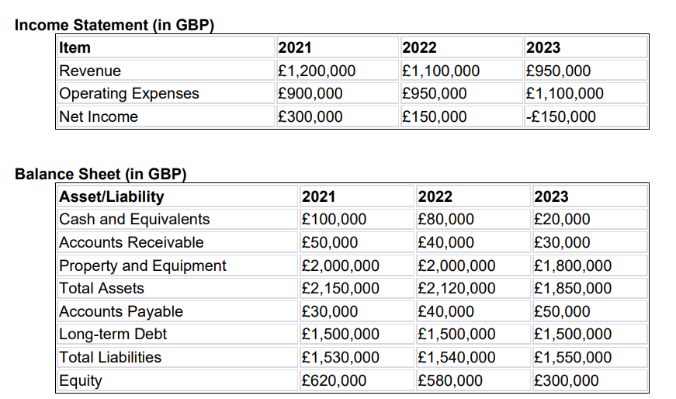Figure1

• Average Room Rate (ARR): • 2021: £260 • 2022: £240 • 2023: £210
• Occupancy Rate: • 2021: 65% • 2022: 60% • 2023: 50% Figure2
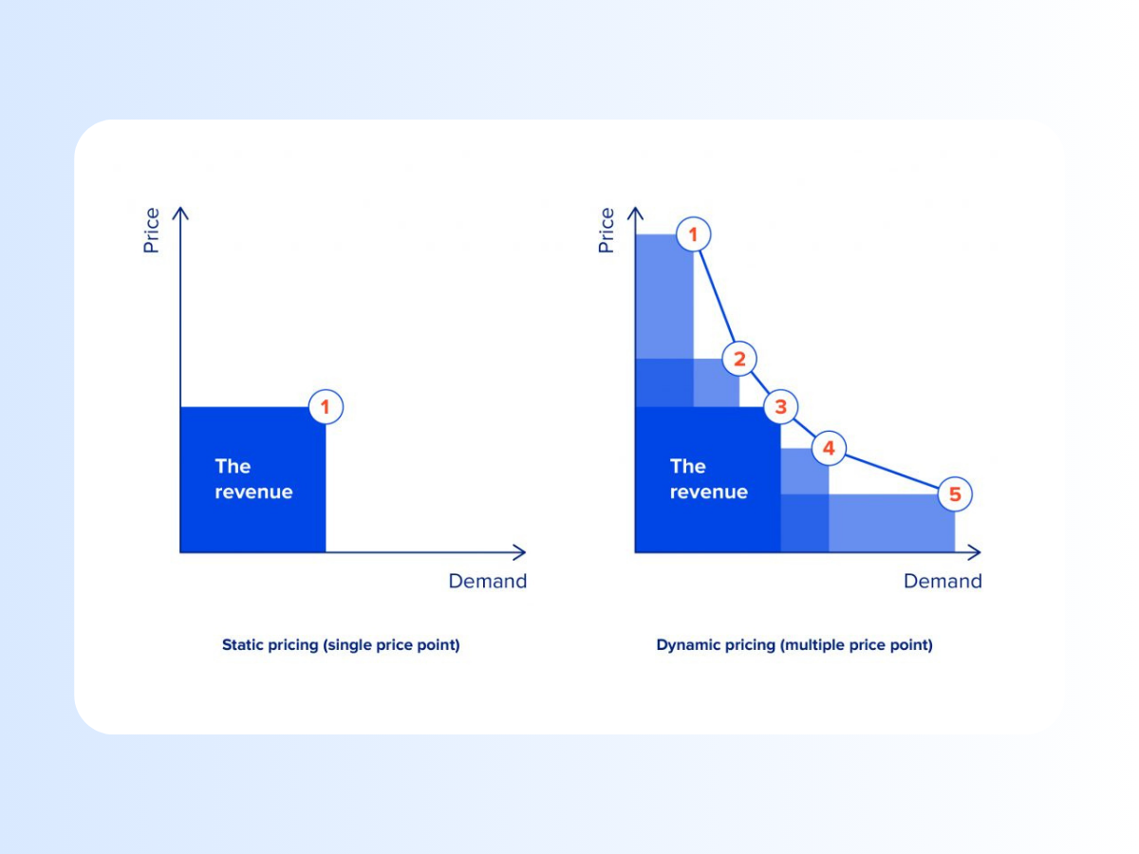 Elphick (2024) Figure3 Kun (2024) Figure4
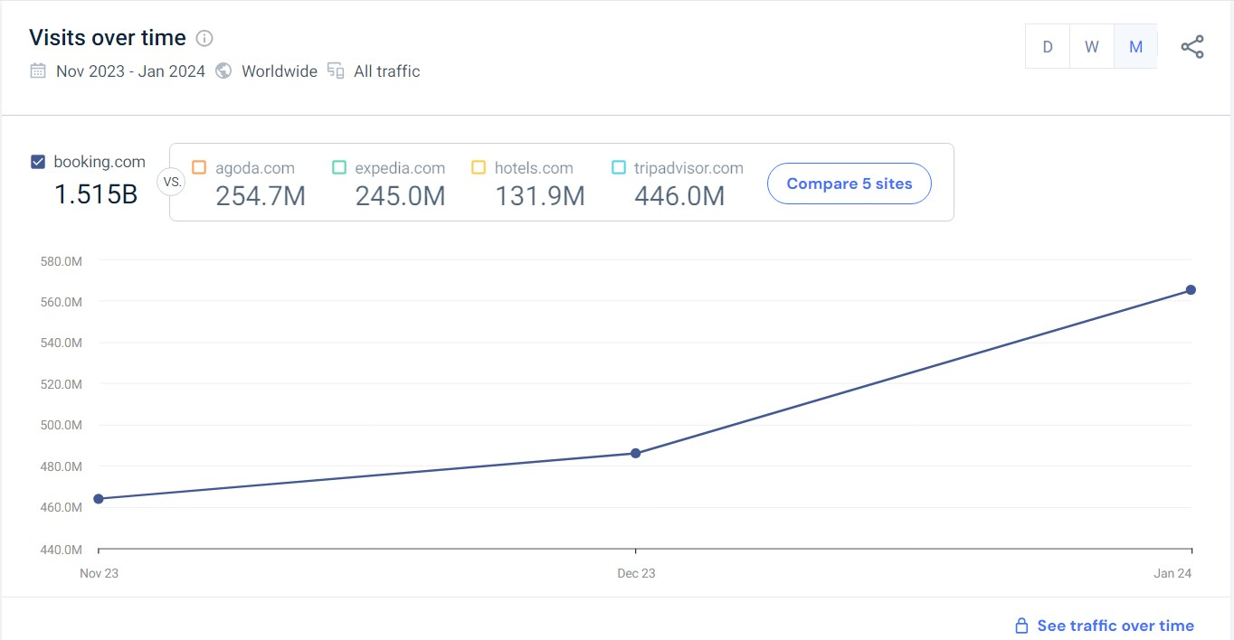SimilarWeb(2024) Figure5

Reference list:

Brad Smith (2024) Everything You Need to Know About Marketing Objectives. [Online] Available at: https://www.wordstream.com/blog/ws/2020/06/15/marketing-objectives (Accessed: 29 February 2024).
Dean Elphick (2024) Hotel dynamic pricing: Definition, examples, and best software to use. [Online] Available at: https://www.siteminder.com/r/hotel-dynamic-pricing/ (Accessed: 29 February 2024).
Ecobnb (2021). The 7 Best Sustainable Trips for Families. [Online] Available at: https://ecobnb.com/blog/2021/09/best-sustainable-trips-families/ (Accessed: 5 February 2024).
Educationleaves(2021) What is Risk Management? | Risk Management process - YouTube.[Online] Available at: https://www.youtube.com/watch?v=IP-E75FGFkU (Accessed: 29 February 2024).
Financial Management for the Hotel Industry, (2024) Module Handbook Winter. [Online] Available at: https://moodle.uwtsd.ac.uk/course/view.php?id=10466 (Accessed: 28 February 2024).
Forsey, C. (2023). Reputation Management: How to Protect Your Brand Online in 2023. [Online] Available at: https://blog.hubspot.com/marketing/reputation-management [Accessed 02/03/2023].
Hyken, S. (2023). The key difference between Customer Service and Customer Experience. [Online] youtube.com. Available at: https://www.youtube.com/watch?v=cFHifG1aNnE
Martin, A. (2019) The Practical Guide to Understanding and Raising Hotel Profitability (1st ed.).[Online] Available at: https://www.taylorfrancis.com/books/mono/10.4324/9780429266416/practical-guide-understanding-raising-hotel-profitability-adrian-martin (Accessed: 29 February 2024). Mia Kun (2024) What is Hotel Forecasting - Models and Best Practices. Available at: https://www.hotelminder.com/what-is-hotel-forecasting-models-and-best-practices (Accessed: 29 February 2024).
Premier Inn Hotels Limited (2020). Annual Report and Financial Statements for the Year Ended 27 February 2020. [Online] Available at: https://cdn.whitbread.co.uk/media/2021/02/12122648/pihl-accounts-final-signed.pdf (Accessed: 28 February 2024).
Rachel Dodds. (2023) Can we do better? Sustainable family travel. [Online] Available at: https://theacademic.com/sustainable-family-travel/ (Accessed: 5 February 2024).
Retail Dogma (2023) Upselling Vs. Cross Selling: Techniques to Increase Sales | - YouTube. [Online] Available at: https://www.youtube.com/watch?v=g9cE9PHIcv8 (Accessed: 29 February 2024).
Roshni Wijayasinha (2021) Seven Tips For Creating A Successful Marketing Plan. [Online] Available at: https://www.forbes.com/sites/forbescommunicationscouncil/2021/03/01/seven-tips-for-creating-a-successful-marketing-plan/?sh=32581a9c27c0 (Accessed: 29 February 2024).
Similar Web (2024) Demographics. [Online] Available at: https://pro.similarweb.com/#/digitalsuite/websiteanalysis/audience-demographics/*/999/3m?webSource=Total&key=airbnb.com (Accessed: 5 February 2024).
The Hospitality Pro (2023) Revenue Management Strategies for hotels | @TheHospitalityPro | Business | Tutorial - YouTube. [Online] Available at: https://www.youtube.com/watch?v=S6GKJ37rRLo (Accessed: 29 February 2024).

