Health, Wellbeing and lifestyle
Health
The idea of children’s health has changed throughout the years. The definition of health has changed from being based on disease and disabilities to the understanding of many different factors that lead to children living a healthy lifestyle. Children’s health is dynamic, and it is continuously changing. Each child is different therefore each child’s health is different and the way that they react to new health challenges may differ to their needs (Ruth, 2024)
According to NHS England (2023) health can be broken down into different areas. These include mental and emotional health, physical health and healthy lifestyle. Emotional and mental health is ensuring that each individuals wellbeing and happiness is maintained throughout. Physical health is linked to children’s musculoskeletal health which is a very important aspect of a child’s abilities within the home life and settings. It is important that a child has a healthy lifestyle as this can have an impact on their future by developing a disease, this can include heart disease, and lung cancer. This can be avoided by ensuring a healthy diet, exercise and sleep. These are essential things that individuals need to be healthy (NHS England, 2023).
To ensure a child’s mental health is supported, it is important that their basic needs are met. Parents and practitioners have a responsibility to support and ensure that children’s basic needs are met. It is also important that they support the child’s development of their mental and physical health (Musgrave, 2017)
Children are entitled to have a positive health. It is stated that if a child is mentally and physically healthy, they are more likely to live a full and positive life (Underdown, 2007).
According to the UNCRC article 24 every child is entitled to the highest standard of healthcare and facilities for the treatment of illnesses. They state that no child should be deprived of their rights to access health care services (United Nations, 1989)

Introduction
Within this poster it discusses the meaning of health, wellbeing and lifestyle and how they have an impact on a child’s learning and development. This poster also discusses the role of the practitioner in supporting health, wellbeing and lifestyle and how they can promote children and families to be healthier.

Mental health
A child’s mental health can be impacted in many ways during childhood. There are many different signs that a child’s mental health is being affected. Some signs are that they are struggling to sleep, changes in their behaviour, withdrawing from social situations. Some children will experience these signs, and they will need professional support while other children will experience these symptoms, but they do not need any professional support only the support of family and practitioners within the setting. Parents know their children the most therefore it is important that they follow their instincts and get their child the support if they feel like they need it. If a parent is suffering with their own mental health this can sometimes have an impact on a child’s mental health therefor it is important to ensure that the parents support themselves to be able to support their child (NHS, 2021).
The role of the practitioner
When promoting children’s health, it is important that practitioners consider children’s age and ensure that the activities are age related to ensure that the children understand what the practitioner is trying to teach them. Children copy what they see their parents\practitioners doing therefore it is important that they provide a positive role model in promoting health within the settings. When working with children it is important that the practitioners listen to the child, this can encourage the child to talk about their feelings, and they will know that they always have someone to talk to (NHS, 2021).

Wellbeing
The definition of wellbeing is when individuals feel comfortable, healthy and happy, but it is important to consider that being happy is more than being happy from time to time. Wellbeing includes children’s happiness, sense of purpose and how they feel (Mental Health Foundation, 2015). According to NHS England (2022) wellbeing isn’t just about ill health it also includes how people feel about themselves and their lives. Wellbeing can be influenced by physical and mental health, and it also has an impact on the outcomes of different health conditions.
According to NHS (2022) there are 5 different steps to achieving a positive mental wellbeing. The five steps relate to other people, be physically active, learning new skills, give to others and paying attention to the present moments. By connecting with other people individuals are creating good relationships with others and they are building a sense of belonging for themselves, it also allows individuals to share their positive experiences, and it provides emotional support and will allow individuals to support each other. Being physical is an important aspect to wellbeing, it can help raise an individual’s self-esteem, it can cause changes within the brain which will allow individuals to feel more positive. When children learn new skills, this will boost their confidence and their self-esteem it will also allow the children to connect with each other within the setting by trying new things together and supporting each other while they try new things. some research state that some acts of kindness can improve a individual’s wellbeing by allowing individuals to feel rewarded and have a feeling of purpose and it allows individuals to connect with others (NHS, 2022).
Play is an important aspect of children’s emotional, physical, social and cognitive development and it is in important aspect of a child’s wellbeing. Play allows children to learn what their body can do, and it allows children to learn about being with others and how to play and interact with other children. Some children struggle to create bonds and relationships with other children but if children learn to make relationships at a young age this will provide them with an important life skill. It is important that practitioners are modelling and supporting children in learning and further developing their social skills. These skills are important for children to learn at a young age before they begin full time school (Mainstone-Cotton, 2017).

Having good attachments will promote a child’s wellbeing because this will allow children to feel comfortable within the setting and feel safe to explore and try new things by having the support from practitioners and parents. Attachment between children and parents can have an impact on children’s physical, psychological, behavioural and developmental wellbeing. A negative attachment is a major consideration when children suffer from behavioural difficulties, feeding problems, toileting problems, accidents, attention deficit hyperactivity disorder. It is important that a positive attachment is the focus when working with children and raising children to provide children with positive outcomes (Rees, 2007).
Role of practitioners
Practitioners can support children’s well-being by giving children opportunities to create new friends and play with different children within the setting. Practitioners can promote physical activity within the setting by planning activities that will allow children to be active for example the children could do an obstacle course, yoga, dancing, running outdoors. There are many different things that can encourage children to be active outdoors. Practitioners can encourage children to develop new skills by planning activities that will allow children to learn a new skill an continue to do the new skill for a period of time to allow children to improve within the skill (NHS, 2022).

Lifestyle
A healthy lifestyle is linked to a child’s diet, amount of exercise within their daily routines, amount of sleep children have every night.
It is important that children have enough exercise from a young age to promote healthy habits. It is important that children aged 1-2 get at least 3 hours of exercise per day. This can be spread out throughput the day. These activities can include moving around, running, jumping, playing is also classed as a light physical activity and in most early childcare setting learning is promoted through play, therefore the children would be playing for most of the day within the setting. If a child under 5 is overweight, there is a chance that they can improve their health by being prompted to change some things and be encouraged to eat better meals and participate in more physical activities (NHS , 2022).
Having a healthy diet is an important aspect of a child’s lifestyle. Their diet will have an impact on their growth and development therefore it is important that children are given healthy and nutritious meals and snacks during childhood and adolescents. Children can suffer from having nutritional deficiencies during their childhood, this can include too much foods that are high in fat, sugar and salt. These can be seen as treats for example crisps, chocolates, lollies. If children don’t have a varied diet, they are more at risk to long term health consequences. Some signs that a child has a poor diet can include being underweight, overweight and obese, some children may suffer from constipation or changes in bowel habits and poor physical growth. Some children may show signs of behavioural issues, sleep problems and problems with emotional and psychological development and poor concentration within school. All these symptoms can link to a child’s poor diet at home. If a child has a healthy diet during childhood and adolescents the eating pattern that they have been following would encourage them to continue the same eating pattern during adulthood therefore it is important to ensure that all children are offered healthy choices during childhood (The Royal Children's Hospital Melbourne, 2019).

Sleep is an important aspect of ensuring children have a healthy lifestyle. If children have enough sleep at night, they are more likely to be more creative and can concentrate on tasks within school for a longer period. Children are more likely to be able to create and maintain positive and good relationship with other children within the nursery setting. If children don’t get enough sleep, it can impact the way children concentrate and docus on tasks and they may not be able to think clearly when completing tasks. If children don’t get enough sleep they may suffer from higher levels of hormones that control children’s hunger, it may increase their consumption of foods these may include fatty and sweet foods (National Heart, Lung, and Blood Institute, 2022).
Role of the practitioners
Practitioners can promote healthy eating within a setting by introducing learning opportunities and activities. This can be done by growing fruit and veg within a vegetable patch in the garden within the setting. Children can be encouraged to set up the tables at lunch time by selecting certain children per mealtime in the setting. Encouraging children to serve up their own food at mealtimes and encouraging them to eat healthy by offering vegetables with the meals. Mealtimes can be a enjoyable and social experience for the children, therefore if practitioners are interacting with the children, they are promoting children’s language and social skills during the mealtimes (Early Years Alliance, 2019).

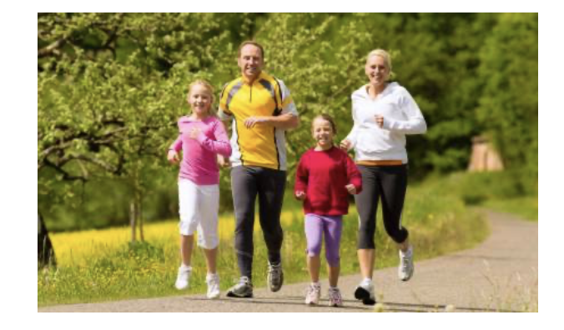

(PE Blog, 2017)

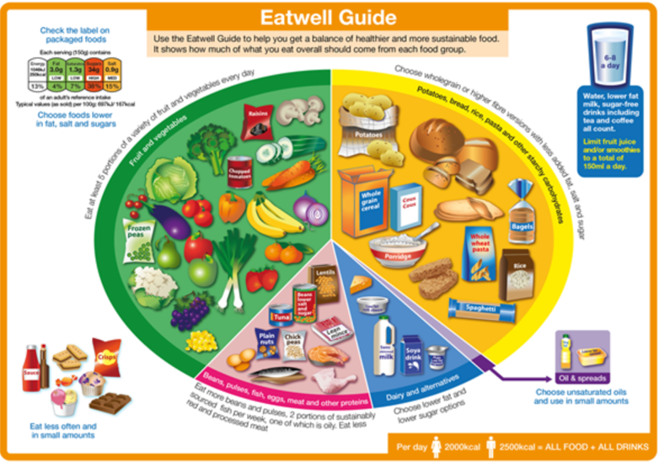
Conclusion
Health, wellbeing and lifestyle are all similar and they interlink with each other. Each aspect has an impact on a child’s future due to their upbringing and the way that they eat and how much physical activity that the children have during their childhood. All three aspects are very similar in the way that they affect children development and health. It is important that practitioners are aware of the three aspect and how they can promote this within a setting to ensure children have the best encouragement for a heathy lifestyle.

(Food Standards Scotland, 2019)

I have not used AI

Reference list
Early Years Alliance (2019). Healthy and Active Lifestyles - top tips for early years settings. [online] early years alliance. Available at: https://www.eyalliance.org.uk/healthy-and-active-lifestyles-top-tips-early-years-settings.
Food Standards Scotland (2019). The Eatwell Guide | Food Standards Scotland. [online] Gov.scot. Available at: https://www.foodstandards.gov.scot/consumers/healthy-eating/eatwell.
Mainstone-Cotton, S. (2017). Promoting young children’s emotional health and wellbeing : a practical guide for professionals and parents. London ; Philadelphia: Jessica Kingsley Publishers.
Mental Health Foundation (2015). What is well-being, how can we measure it and how can we support people to improve it? [online] www.mentalhealth.org.uk. Available at: https://www.mentalhealth.org.uk/explore-mental-health/blogs/what-well-being-how-can-we-measure-it-and-how-can-we-support-people-improve-it.
Musgrave, J. (2017). Supporting children’s health and wellbeing. London: Sage Publications.
National Heart, Lung, and Blood Institute (2022). How Sleep Works - Why Is Sleep important? [online] National Heart, Lung, and Blood Institute. Available at: https://www.nhlbi.nih.gov/health/sleep/why-sleep-important.
NHS (2021). Children’s mental health - Every Mind Matters. [online] nhs.uk. Available at: https://www.nhs.uk/every-mind-matters/supporting-others/childrens-mental-health/#ways-to-support-a-child-or-young-person.
NHS (2022). 5 Steps to Mental Wellbeing. [online] NHS. Available at: https://www.nhs.uk/mental-health/self-help/guides-tools-and-activities/five-steps-to-mental-wellbeing/.
NHS (2022). Physical activity guidelines for children (under 5 years). [online] NHS. Available at: https://www.nhs.uk/live-well/exercise/physical-activity-guidelines-children-under-five-years/.
NHS England (2022). Wellbeing. [online] NDRS. Available at: https://digital.nhs.uk/data-and-information/publications/statistical/health-survey-england-additional-analyses/ethnicity-and-health-2011-2019-experimental-statistics/wellbeing-copy.
NHS England (2023). NHS England» Improving personal health and wellbeing. [online] www.england.nhs.uk. Available at: https://www.england.nhs.uk/supporting-our-nhs-people/health-and-wellbeing-programmes/nhs-health-and-wellbeing-framework/elements-of-health-and-wellbeing/improving-personal-health-and-wellbeing/.
PE Blog. (2017). 5 ways to promote a more active lifestyle in children - PE Blog. [online] Available at: https://blog.peoffice.co.uk/5-ways-to-promote-a-more-active-lifestyle-in-children/.
Rees, C. (2007). Childhood Attachment. British Journal of General Practice, [online] 57(544), pp.920–922. Available at: https://www.ncbi.nlm.nih.gov/pmc/articles/PMC2169321/.
Ruth (2024). Defining child health in the 21st century. Pediatric Research. [online] doi:https://doi.org/10.1038/s41390-024-03423-w.
The Royal Children's Hospital Melbourne (2019). Kids Health Info: Nutrition – school-age to Adolescence. [online] The Royal Children’s Hospital Melbourne. Available at: https://www.rch.org.au/kidsinfo/fact_sheets/Nutrition_older_children/.
Underdown, A. (2007). Young children’s health and well-being. Maidenhead, Berkshire, England ; New York: Open University Press.
United Nations (1989). Convention on the Rights of the Child. [online] OHCHR. Available at: https://www.ohchr.org/en/instruments-mechanisms/instruments/convention-rights-child.

