Sending data from iPhone app to server (and then use PHP to email it or add to database etc)
(demo file: SendFeedback)

Suppose we want to get feedback from someone who attended our Open Day.

Let’s set up a front end with a label, text field and a button.

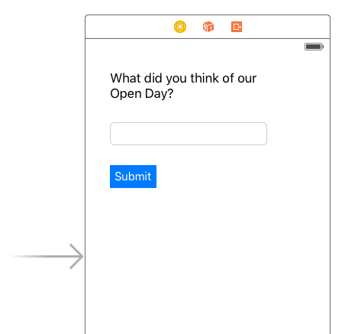

If you want, round the corners of the button by adding a Key Path:
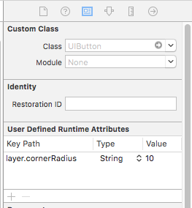

Also add a Label that will later hold a message eg “Thank you for entering your feedback”. Don’t put any text in it for now:
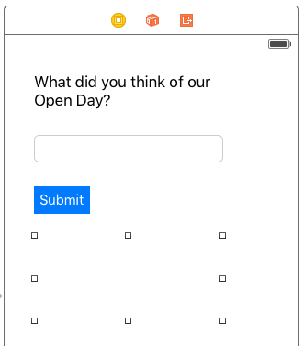

Link the labels and the button to ViewController.swift by using the usual CTRL-click/drag:
The labels should be Outlets (Feedback and ThankYou) and the button an Action (as we want to do something when the button is clicked) (SubmitFeedback)

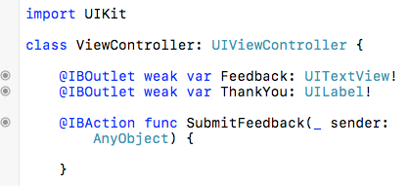

When the user clicks on the button, we want the Feedback to be retrieved and transmitted to the server. This happens in the Action for SubmitFeedback.

First, let’s get the Feedback entered by the user:

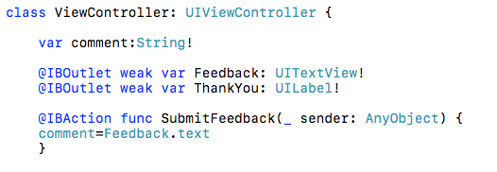

We are going to send the comment to a PHP page (It will eventually send me an email with the Feedback on, but more on that later).The PHP page is located here: http://www.welshdreamer.com/processdata.php

Here is the code for calling the webpage:

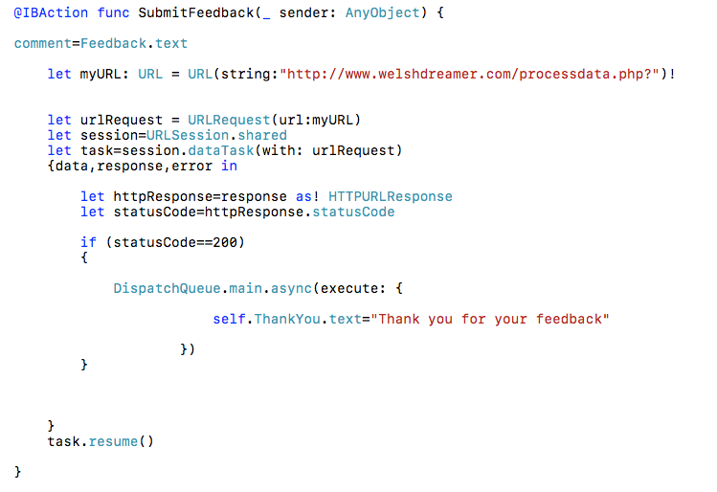

Don’t forget to add to your Plist.info

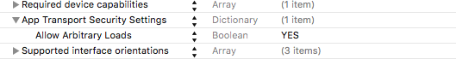

We also need to send the data to the URL. I am going to append “comment” to the URL string.

If my comment is only one word, this works fine, however, if it has spaces in it, or special characters like &, this will not work properly.

As it is very likely that spaces will be included, we need to encode the URL. This puts characters such as %20 in place of spaces using a command called addingPercentEncoding, and web servers can easily read and process this.

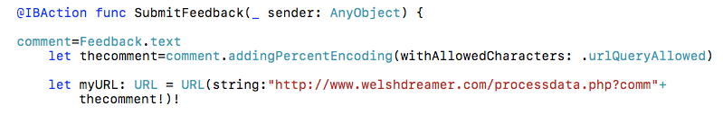

This now sends the data to the server.

On the server side, I now need a bit of PHP to retrieve the data and I have decided that it will send me an email:

<?header("Access-Control-Allow-Origin: *"); //make page publicly accessible to scripts

$comm=$_GET["comm"]; //get the comm variable from URL (contains //feedback entered in app

$fromemail = "contact@welshdreamer.com"; //to avoid being filtered as spam, I’ve used an email //address associated with this domain

$headers = "MIME-Version: 1.0\r\n"; //stuff to set up email
$headers .= "Content-Type: text/html; charset=ISO-8859-1\r\n";
$headers .= "From: <" . $fromemail . ">\n";
$headers .= "sender: <" . $fromemail . ">\n";
$toemail="gaynor.thomas@uwtsd.ac.uk"; //sometimes filtered by University
$subject="Feedback from Open Day";

mail($toemail, $subject, $comm, $headers,"-f$fromemail"); //send email. $comm is the feedback

?>

Once the PHP is in place on the server, the app should now email me (gaynor.thomas@uwtsd.ac.uk) and then provide a “Thank you for your feedback” on the screen.

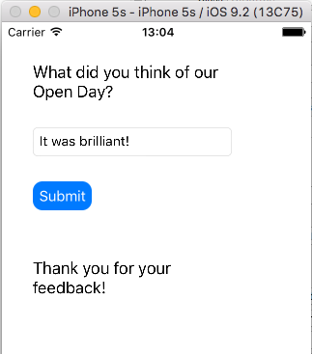

The email:
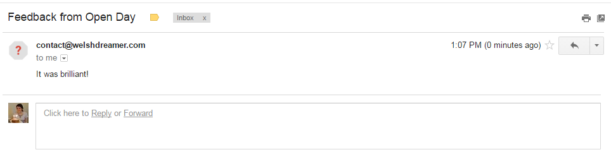

You may have noticed that there is a bit of delay before the “Thank you for your feedback!” message arrives. This is because it takes time to contact the server, send the email, and send a message back.

To improve the user experience, I am going to add a classic “spinning pinwheel” to show that the app is doing something.

Add an “Activity Indicator View” and place on the screen near the ThankYou label:

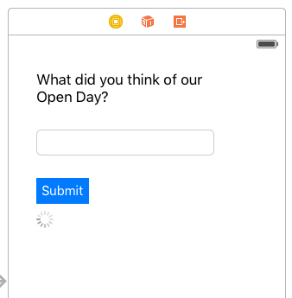

Tick the attributes “Animating” and “Hides When Stopped”

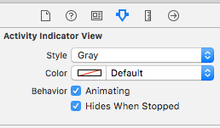

Connect it to your ViewController.swift (CTRL-click/drag)

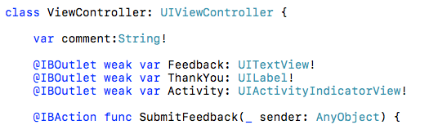

You will find when you run your app, that it’s visible by default! Turn it off in the viewDidLoad() function:

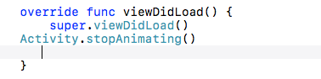

Now, enable the pinwheel when the Submit button is clicked, and disable it when the call comes back from the server:

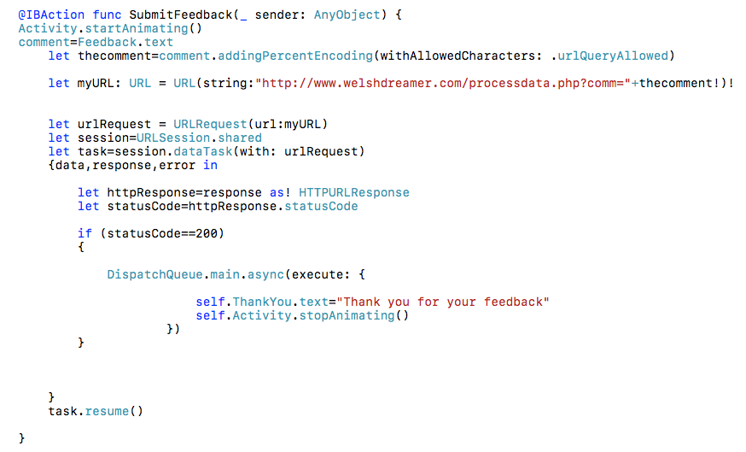

You should find that pinwheel appear and spins, then disappears and the “Thank you for your feedback” message is displayed:

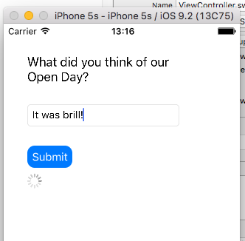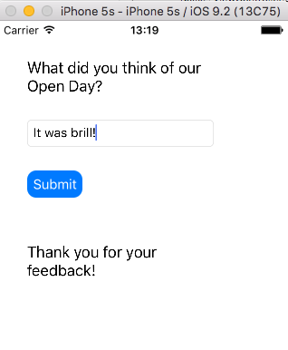

EXERCISE – Let the person enter their email too (an extra TextField) in case they want a reply from the administrator (add this to the URL parameters, and then body of the email, not the $fromemail as it’s not an email originating from this server)

