“A critical analysis of the impact of personalised service on increasing customer satisfaction: A study based on the role of sales and marketing department of Ibis London Canning Town”.

Student Name: Apurba Das
Student ID: 2107164

Project Supervisor: Maggie-Lan Zhang

Module Number: BMIH6006/6008
Module Name: Hotel Placement Research Project

Word count: 8048

Submission Date: 31 May 2024

Executive Summary
The report presented herein aims to analyse personalised services and their impact on customer satisfaction at the Ibis London Canning Town Hotel, located in the liveliest area of London. The objectives of this report are an Evaluation of the role of personalised customer service in increasing customer satisfaction at Ibis London Canning Town, identification of the issues related to the implementation of personalised customer satisfaction at Ibis London Canning Town, and recommendation to improve its personalised services to increase customer satisfaction. The themes developed for this report are based on the objectives of this report, such as the implementation of personalised services, impact on customer satisfaction, and implementation issues.
Ibis London Canning Town dives into success with personalised customer service driven by technology and strategy that is in favour of the customer. A part of Accor Hospitality, it enjoys a strong brand, prime locations, excellent customer service, technological innovation, and sustainability programs—all these, it builds upon its capital of personalised guest experiences through data and technology for high customer satisfaction and loyalty. Ibis falls into the enigma stage because of the proper combination of technology with human formula. However, high competition, seasonal demand fluctuations, and dependence on business travellers can be pointed out as weaknesses in Ibis. With such a competitor analysis, Ibis will have a competitive advantage because of personalised services and technological advancements. SWOT analysis depicts the brand's strength, quality of service, opportunities through digital marketing, threats from economic uncertainty, and negative reviews.
The major themes identified are customer-centric, technological integration, and customer satisfaction. Customer-centricity: adaptation to ever-changing needs with real-time data, feedback, and customisation of services. Technological integration will leverage AI, machine learning, and automation to ensure seamless guest experiences that are both operationally efficient and guest-satisfaction-oriented. In this context, customer satisfaction is achieved through personal interaction, consistent quality, loyalty programs, feedback, and emotional ties. This analysis underlines the need for continuing staff training, real-time feedback, and cultural competence to strike a poise with technology and human touch to make excellent personalised service, thereby keeping it competitive in the hospitality sector.
The report concludes that personalised service based on integrating technology and human contact will increase customer satisfaction at Ibis London Canning Town. Following the adoption of this strategy, the hotel will further enhance guests' experiences to stay competitive in the hospitality sector at a much higher level than ever.
Contents
Executive Summary 2
Introduction 5
Literature Review 7
Personalisation in the Hotel Industry 7
Personalisation’s Impact on Customer Satisfaction 7
Research Gaps 8
Research Methods 9
Case Study Methodology 9
Benefits 9
Limitations 9
Techniques 10
Reflective Writing 10
Case Study Discussion 11
Brand Overview of Ibis Hotels 11
Ibis London Canning Town Overview 12
Analysis of Services and Features of Ibis London Canning Town 13
Competitor Analysis (Price vs Quality) 14
SWOT Analysis of Ibis London Canning Town 15
Theme Analysis 18
Theme- 1: Customer-Centricity for Meeting Evolving Consumer Needs 19
Theme-2: Technological Integration for Identifying and Addressing the Issues in Implementation of Personalised Service 20
Theme-3: Impact on Customer Satisfaction of the Implementation of Personalisation- Related Customer Service 22
Areas of Improvement 24
Conclusion and Recommendation 25
Key Recommendation 25
Reflective Account 25
Description 25
Feelings 26
Evaluation 26
Analysis 27
Conclusion 28
Action Plan 28
References 31

Table of Figures
Figure 1: Accor Revenue 9
Figure 2: Ibis Hotel Numbers and Growth 10
Figure 3: Accor's Loyalty Program Details 17
Figure 4: AI Services in the Hotel Industry 19
Figure 5: Relationship Between Customer Satisfaction and Service of Accor 21
Figure 6: Gibbs’ Reflective Cycle 25
Figure 7: TripAdvisor Rating and Tag of Ibis London Canning Town 26
Figure 8: Ibis London Canning Town Reviews in Different Categories 27
List of Tables
Table 1: SWOT Analysis of Accor 15
Table 2: Thematic Analysis 16
Table 3: Action Plan 30

Introduction
The urge to remain competitive in the modern hospitality industry is becoming more challenging daily because of rapidly changing customer expectations and demands. This forces different businesses to stay adaptive to improve revenues and success rates. According to Ali et al. (2021), one of the key success drivers in the hotel industry is customer satisfaction. London Canning Town is in the bustling city of London, and every year, many guests from abroad and at home visit there, as per Bowen and Whalen (2017). My first placement was at this town at the Ibis London Canning Town, located at 8 Silvertown Way, London E16 1ED, in the United Kingdom. This report aims to discover the influence of personalised service on customer satisfaction since many different types of customers visit this hotel. Evaluation of the role of personalised customer service in increasing customer satisfaction at Ibis London Canning Town, identification of the issues related to the implementation of personalised customer satisfaction at Ibis London Canning Town, and recommendation to improve its personalised services to increase customer satisfaction are the main objectives of this report.
Besides, this placement research report is interested in studying the effectiveness of personalised service in enhancing customer satisfaction at Ibis London Canning Town. Considering this, the following report will cover the role of customised customer service at the hotel, the challenges associated with these services, and improvements that can be made to boost customer satisfaction. The basis for the study is associated with the significant levels of competition in the provision of hotels. As much as most hotels have high service standards, customers are increasingly moving towards personalised services.
As per the study by Xu, Peak and Prybutok (2015), customers are ready to pay up to 40% more for personalised services, which shows an immense influence of personalisation on satisfaction and loyalty. This report at Ibis London Canning Town seeks to identify ways in which customer engagement and satisfaction can be improved through personalised services to enhance the reputation and competitive advantage of the hotel. Literature indicates that technological changes significantly influence service personalisation, particularly in artificial intelligence. This technology has dramatically affected the hotel industry in optimising operations, improving service delivery, and customising recommendations. Improved customer experiences, reduced costs, and increments in revenue all lead to higher competitiveness- these are all advancements (Aslam, Hamid and Arshad, 2015). The report critically evaluates Ibis London Canning Town's actions regarding implementing customer-centric strategies for service personalisation within the sales and marketing department. Major topics to consider are customer-centric approaches, technological integration, and the role of the sales and marketing department in implementation. The article can critically analyse these themes in a thought-provoking manner that is expected to produce recommendations for improving or enhancing personalised services to maximise customer satisfaction at Ibis London Canning Town.

Literature Review

Personalisation in the Hotel Industry
Personalisation is the need of the hour for every player in the hotel industry to enhance customer experiences and stay ahead of their competition. Hotels are a service industry where technology has converted personalisation services into more individualistic and efficient service delivery through data collected from hotel customers. Prentice, Lopes and Wang (2020) stated that with AI technologies, it is only possible to gather and analyse information obtained from hotel customers so that hotels can predict effectively, meet needs, and fulfil individual preferences (Bisoi, Roy and Samal, 2020).
This technological advancement organises and optimises operating procedures and aspects of personalised recommendations and significantly improves service deliverance by any guest experience (Srivastava, Kishore and Dhingra, 2021). This can be attributed to the room made for someone, communication done with the consideration of one person, and suggestions that are tailor-made for activities and services appropriate for the same (Rawal et al., 2022). Hotels like the Ibis London Canning Town can use AI to be more personalised with their guests during their current stay (Tomczyk et al., 2022). Data about guests may be utilised to evaluate personalised offers for amenities and even room preferences that can be meted out based on specific demands, making the stay more satisfying and memorable.
Personalisation goes further still: human interaction remembers and acts upon the preference of every single guest (Hellou et al., 2021). Buhalis and Sinarta (2019) said personalised service involves remembering names, preferences, and previous interactions with guests, effectively providing a "feel of value." Such hands-on service, combined with technological advancement, would make a well-rounded personal experience that can set one hotel apart from others in the same market (Lei et al., 2024). Indeed, personalisation has been known to be imperative as consumers even pay up to 40% more for personalised services. This underlies the criticality guests attribute to a customised experience in terms of value, one of the most critical drivers for hotels in the quest for customer satisfaction and loyalty (Buhalis and Amaranggana, 2015). Therefore, personalisation has become a business strategy and now an inbuilt determinant—that Ibis London Canning Town was keeping a competitive advantage within the hospitality business.

Personalisation’s Impact on Customer Satisfaction
The personalisation of services in the hotel industry greatly determines customers' satisfaction. In a hotel, however, an experience designed to fit precisely around the needs and expectations of the customer has an influential association with overall satisfaction and, therefore, loyalty toward it (Kasiri et al., 2017). Willingness to pay dramatically more for personalised services shows that the most importance is attached to such an experience. That premium stands by personalisation's positive influence on customer satisfaction (Zhang et al., 2020).
Personalisation is essential in getting customer satisfaction by making experiences uniquely memorable (Secchi, Roth and Verma, 2018). If a guest feels that their personal needs and preferences are served best, an optimistic view would be created regarding the hotel, which is essential for customer loyalty and return visits (Oyner and Korelina, 2016). Moreover, personalisation services contribute to the sense of being appreciated and recognised—elements of satisfaction—and can thus relieve a few pain points but improve the experience of the total journey. For example, the success of this type of venture could be measured in the way a local attraction becomes reified for the guest, the more minor specifics inside the room that make the stay more memorable for some guests, and communications that are relevant to the guest (Shin and Jeong, 2022).
Other than the mentioned benefits, some operational benefits to customer satisfaction exist that implementing personalised services can bring (Min, Lim and Magnini, 2014). Improved service efficiency rendered to hotels may be brought by adopting technology in hotels, thus shortening time in their response while optimising the accuracy of service, which will benefit guests and increase satisfaction in the hotel (Piccoli, Lui and Grün, 2017). Therefore, personalisation elevates customer satisfaction through guests' better experiences by providing personalised services, appreciation, and recognition, such as resolving pain points and effective operational efficiency (Truong et al., 2020). Ibis London Canning Town can look at personalisation as one of the strategic approaches that will result in greater customer satisfaction and loyalty, contributing to success in a competitive market.

Research Gaps
Although the personalisation of hotel services has seen tremendous improvement, much research still needs to be done. One of the significant research gaps is the limited exploration of challenges and barriers in implementing personalisation. Identifying these critical issues ensures that hotels can quickly introduce personalisation into everyday operations. Another gap calls for more research into human interaction's role in personalisation—necessary, as technologies can only be enablers when those interactions are fitted into creating a seamless guest experience. Filling these research gaps will provide priceless insights for hotels intending to improve their personalised service and the satisfaction of their customers.

Research Methods

Case Study Methodology
The case study is a qualitative research design that gives an in-depth inquiry into one phenomenon within its context in real life (Collis and Hussey, 2014). Using a case study, the hotel to be studied in this report will be Ibis London Canning Town. The method shall concentrate on learning personal customer services by analysing the strategies the hotel uses to help improve the level of customer satisfaction (Rashid et al., 2019). This approach enables a thorough investigation of the role played by the hotel's sales and marketing department in offering personal services. The research method will gather vast data within a specific period to realise context-dependent and rich views (Hancock, 2021). Data will be collected through interviews, surveys, document analysis, and analysis of operational data so that detailed information can be learned about the practices followed at the hotel and customer feedback.

Benefits
Atmowardoyo (2018) in his research stated that the significant advantage of using a case study approach is to get an in-depth, rich context account of complex phenomena. Consequently, the subject of intense analysis by the study Ibis London Canning Town will reveal in detail some strategies and practices leading to effective delivery of personalised services. These insights are relevant not only to the hotel itself but also to other practitioners in the industry who may borrow such strategies to excel in their operation of customer services (Cote, 2023). Case studies also have efficient implications for industry (Sheehy, 2022). The findings by Ibis London Canning Town will represent best practices for other hotels so that these results can provide actionable recommendations on how to offer personalised services. This high degree of practical relevance makes case study methodology of particular value in applied research in the hospitality industry.

Limitations
One of the cons of the case study methodology is that the findings could be more generalisable. Since this focuses on a specific case, the findings are only context-specific and cannot be generalised under a different setting or study population (Wang, 2023). These strategies may have worked for Ibis London Canning Town but would only work for some hotels or other hospitality establishments. There can be some bias wherein my perceptions, prejudices, and interpretations could reflect upon and impact the data analysis process, which holds implications for the findings' validity and reliability (Mcleod, 2019).

Techniques
To make a case study approach, data from the abovementioned methods will mainly be collected from semi-structured interviews with some key employees in the sales and marketing department of Ibis London Canning Town regarding their strategies and the challenges they meet to offer their customers personalised services. Surveys will be given to guests; data on customised service and general satisfaction will be obtained from comments. Among these, secondary data would be gathered through existing documents—such as forms used to get customer feedback, protocols used while providing customer services, and annual reports. In addition, corresponding emphasis should be given to operational data from the customer interface, statistics on the elapsed time in service delivery, and customer preferences to establish patterns and trends (Priya, 2021).

Reflective Writing
Reflective writing involves critically reflecting on one's experiences, assumptions, and educational journeys throughout the learning process during placement. In this report, it will be used to analyse my biases and their impact on the findings (Sewell, 2022). My Ibis London Canning Town placement was helpful for me to learn not only about different departments but also the hotel's operational and customer service aspects. I will use Gibb's reflective cycle model to present my experiences in that hotel.

Case Study Discussion

Brand Overview of Ibis Hotels
Accor Hospitality owns Ibis Hotels, a company based in Paris, France. Accor is among the top-rated biggest companies in the hospitality arena, with over 5,500 properties worldwide and in more than 110 countries. For 2023, the revenue generated for Accor hospitality accumulated to €5.1 billion (Statista, 2024).
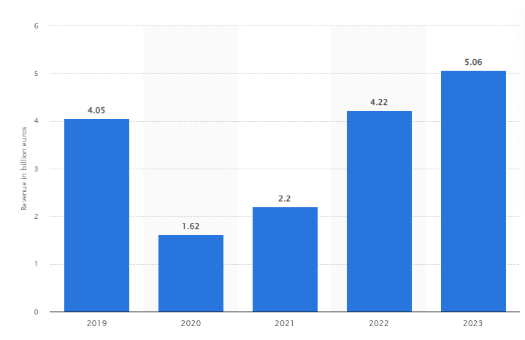
Figure 1: Accor Revenue
Source : (Statista, 2024)
Accor brand portfolios are also owned across categories of accommodation properties, from luxury to affordable. Accor brand names include Raffles, Orient Express, Emblems Collection, Faena, Banyan Tree Hotels and Resorts, Sofitel Legend, Fairmont Sofitel, The House of Originals, Rixos One Fine Stay, Mantis, M Gallery, Art Series, Pullman, Swissôtel, Angsana, Mövenpick, Grand Mercure, PeppersThe Sebel, Adagio premium, Handwritten Collection, Mantra, Novotel, Mercure, Adagio, Tribe, Breakfree, ibis Styles, ibis Budget hotel, F1 greet, Adagio access, 21c Museum Hotels, 25 Hours, Delano. The most significant portion of the Accor portfolio, one of the planet's fastest-growing budget hotel chains, comes from Ibis hotels, which represent the main cash cow of Accor.
Ibis Hotels is among the most popular brands in the Accor hotel group. This brand attracts numerous people to enjoy the quality of residence it offers at an excellent value. Since 1974 (Accor, 2024). Ibis has developed into the most significant international chain of economy hotels, with over 1,200+ hotels spread across 67 countries worldwide (Accor, 2020). The focus was on offering consistency and reliability so that guests would be sure to get a similar range of comfort and convenience in every place.
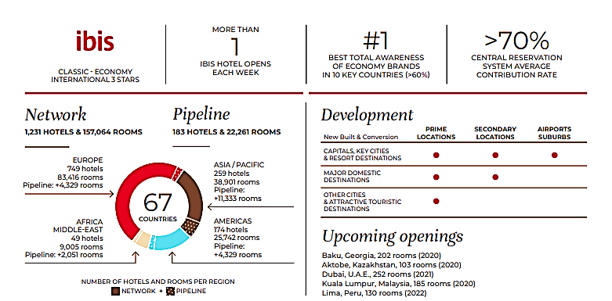
Figure 2: Ibis Hotel Numbers and Growth
Source: (Accor, 2020)
There are three basic sub-brands under Ibis Hotels: Ibis, Ibis Styles, and Ibis Budget. They target three separate market segments. The standard Ibis are modern rooms with basic amenities that target businesspeople and tourists travelling on a budget. Ibis Styles features distinctive, style-driven designs with an all-inclusive package targeted at guests who expect a more dynamic and creative stay experience (Cheng, 2020). Ibis Budget targets budget travellers by providing the most straightforward and functional rooms at the lowest possible rates. The primary dimensions of the Ibis brand are innovation and sustainability. In 2011, the "Sweet Bed by Ibis" concept was developed to guarantee guests a superior quality of sleep through the best quality of sleep; it is among the best value propositions that the brand has (Ibis, 2024). Moreover, Ibis is very dedicated to the current sustainable practices and participates in the Accor Planet 21 program, which works on waste reduction, saving energy, and green construction.
At the centre of the Ibis Hotels' strategy is customer satisfaction. These include training the staff to ensure high service standards for its guests and obtaining feedback from guests about its offerings. Technology, such as online checking-in and Mobile Key, enhances customer experience through convenience and reduced wait times (Rachmawati et al., 2020). Ibis Hotels further houses a good e-commerce facility that enables the booking of rooms and the availability of information on their stay by customers online (Hendriyatmoko and Poernomo, 2023). Not just a famous brand, but the main principle that Ibis Hotels maintains is to offer a reliable, comfortable, and pocket-friendly stay to the guests seeking a location in one of London's bustling areas.

Ibis London Canning Town Overview
Ibis London Canning Town is set in one of London's most energetic and fast-evolving areas. This 196-room Hotel is contemporary and designed for both business and leisure guests. All rooms have amenities, including free Wi-Fi, a flat-screen TV, the famous "Sweet Bed by Ibis," and an en-suite bathroom (Ibis Hotel, 2024). There is a trendy bar and restaurant for dining and drinking international and local dishes, making it convenient for travellers to find accommodation and dining under one roof (Accor, 2024b).
Another advantage of the hotel is its location, close to Canning Town Tube and DLR, giving access to Central London and other relevant destinations. Besides, the hotel is close to the O2 Arena, ExCeL London, and Canary Wharf, which will also lure short-term visitors for some other purpose, no matter how serious or business-related. The friendly and professional staff, always ready to ensure that visitors feel comfortable enough during their stay, is one of the principles of good customer service at Ibis London Canning Town. The hotel offers 24-hour reception, baggage storage, facilities against all odds, and so much more, and diverse needs are matched with quality service (Travel Weekly, 2024). Modern amenities, a lovely location, and excellent service have made Ibis London Canning Town one of the most popular choices for travellers who want the quality level of accommodation vs the price ratio.

Analysis of Services and Features of Ibis London Canning Town
Ibis London Canning Town is a fine example of the brand's commitment to providing consistent top-quality service with a personalised customer service element. Customer service has been identified as the key to customer satisfaction and what differentiates the hotel from its competition. Data and technology enable the hotel to predict guest preferences and deliver personalised experiences, resulting in higher satisfaction and loyalty. The hotel employs several guest-facing strategies to provide personalisation with an impact (TripAdvisor, 2024). Some critical touch points are using the guest's information to personalise room settings, such as the room's temperature or setting up the room before guests arrive with their favourite amenities. Attention to detail ensures that guests are valued and recognised, thus bringing comfort and a personal touch to the stay. Even the staff is sensitised about remembering to repeat visitor names and calling them out by name, remembering their preference. This human touch creates a feeling of being welcome and duly at home, which is crucial for the guests' overall experience. Ibis London Canning Town brings together human effort and technology to improve operations and increase its range of services (London Hotel Deal, 2022). This is achieved by online check-in and mobile keys that reduce time wasted during check-ins and give convenient access to his room; generally, the process is enhanced efficiencies. Nevertheless, the hotel follows the concept since, through customer feedback, it manages to develop further and improve services.
However, there have been challenges associated with the offering of individualised services. Notably, how technology would be fused with human interaction to achieve these goals has been a significant issue. While technology can improve efficiency and convenience, its application must be counterpoised by personal touches that have long served to create a warm and hospitable environment (Ibis Canning Town London, 2024). The technology could only take away a little from the individual guest's personal experience if there were needed to be more human touches that created their stay. Balance is essential when ensuring staff members are equipped and well-trained to deliver personal service yet capture technological improvements. This involves managing diverse cultural backgrounds that present different preferences (ABBA Voyage, 2023). Understanding and catering to these varied requirements calls for a sophisticated way services are provided.
In the case of Ibis London Canning Town, it was observed that customer satisfaction with personal service is high, making a package of technology and human interaction efficient enough to make the stay memorable and pleasurable, leading to customer loyalty and repeated visits. The continual improvement of personalised services to overcome the challenges associated with integrating technology and cultural diversification further increases the competitive edge of the hotel and ensures sustained customer satisfaction (Visit London, 2022). A great driver of customer satisfaction is the commitment of Ibis London Canning Town to offer such customised service. Using data and technology to anticipate and deliver on the individual guest's preferences while keeping the staff's personal touch will set Ibis London Canning Town apart in a competitive market. Finally, this would promote more personalised services to the hotel, ensuring a memorable and gratifying stay for the guests whilst handling challenges such as technology integration and cultural diversity.

Competitor Analysis (Price vs Quality)
Ibis London Canning Town competes in a very competitive marketplace, and its differentiation from others operating in the same region may also be considered. A competitor analysis shows sources of illuminative insights on how its price and quality positioning are different from those of competitors.
One of its direct competitors is Premier Inn London Docklands (Excel), which prices rooms similarly. In these terms, such a brand is consistent in what concerns the quality of products and service and can represent a competitive start for Ibis in the budget hotel market (Premier Inn, 2024). However, Ibis London Canning Town is the only one that provides a uniquely tailored service through technology and guest data, creating a service unlike any other based on the deliverance of the one experience they desire.
Another competitor is Travelodge London Docklands, which targets budget travellers: the rooms there are often cheaper than Ibis's and of relatively essential quality, containing a spare number of services (TripAdvisor, 2024b). Contrary to that is Ibis London Canning Town, which offers a more modern and comfortable stay with added features, including "Sweet Bed by Ibis," free Wi-Fi, and a more comprehensive dining option—all of this comes with a slightly higher price that is genuinely justified.
Another critical competitor at a mid-range level is Holiday Inn Express London—ExCeL, which focuses more on business clients. Its price is above Ibis's but offers more facilities, including meeting rooms and a business centre (Holiday Inn Express, 2024). As the Holiday Inn Express is superior to the needs of business clients, Ibis London Canning Town offers an all-around experience that is better for business or leisure clients.
Ibis London Canning Town will stand out primarily because it extensively applies technology to ensure a better guest experience. Many features in this hotel make the user experience much more convenient and individual than any other budget hotel, starting with online check-in, mobile keys, and room preference settings. When matched with a strong brand reputation for consistency and reliability, all these user-centric features will give Ibis London Canning Town a compelling competitive advantage in the market.

SWOT Analysis of Ibis London Canning Town
A SWOT analysis provides a snapshot of detailed strengths, weaknesses, opportunities, and threats related to Ibis London Canning Town, reflecting valued results in its strategic position for working on areas.
Strengths  - Strong Brand: Ibis is a product related to the Accor group's hotels. According to Brand Directory (2023), the current brand value of Ibis Hotel is around $463 million. The Accor logo on the brand name can make a majorly strong impression, being a very potent trigger for people to identify themselves with the sense of tradition and quality assured by a chain that is so high (Fountain, 2017).  - Prime Location: It is near primary transport links within the city and exciting places. For example, LCY—London City Airport is 3.2 km away, Ibis London Canning Town is nearby, and O2 Arena is nearby (Bhasin, 2016).  - Customer Service Excellence: Ibis London Canning Town is well known for its excellent customer service and well-trained staff, who cater to each guest in a warm, friendly, and personalised manner, thus increasing guest satisfaction. Most customer ratings are good, and on TripAdvisor, the property is tagged as excellent with an average of 4.5 stars (TripAdvisor, 2024a).  - Technological Innovation: The hotel's application of technology, especially in online check-ins and mobile keys, enhanced its efficiency and eventually improved the guests' experience through personalisation.  - Sustainability Programs: This hotel is part of Accor's Planet 21 program, which ensures the hotel's sustainable operations and thus attracts more environmentally concerned travellers (Eco Hotel, 2024). | Weakness  - High Competition: The Hotel operates in an intensively competitive marketplace, where other budget and mid-range hotels, such as Holiday Inn, Premier Inn, and other brands that provide such services, are strong competitors (Calles, 2023).  - Demand Fluctuations: Seasonal demand variations can cause irregular occupancy rates and revenue flow (Miller, 2022).  - Dependence on Business Travelers: Most of the hotel's clientele depends on business travellers. Any business hiccups, especially economic downturns, can adversely affect occupancy and, by extension, revenue.
Opportunities  - Digital Marketing Investment: Investment in digital marketing and overall online visibility will enhance the hotel's visibility and attract more guests. Personalised interactions through digital channels help improve guest experiences.  - Market development: The company will explore new opportunities to open more branches within strategic locations in London, thereby gaining a larger market share and attracting newer customers (Accor, 2024c).  - Enhanced sustainable practices: Sustainability development and participation would benefit the hotel more in its attractiveness to eco-friendly travellers.  - Guest Data Use: Guest data can be used to target marketing campaigns and offers precisely, increasing customer loyalty and driving repeat visits. | Threats  - Economic Uncertainty: Economic downturns, driven by the COVID-19 pandemic or geopolitical events, significantly impact travel and hotel occupancy rates.  - Competitive Price Pressure: Intense competition in the budget hotel segment may lead to price warfare if hotel rates are reduced, which can impact the margin.  - Negative Reviews and Online Reputation: Negative guest reviews and online reputation can ruin a hotel's image and reduce future guests. Many negative reviews regarding Ibis London Canning Town on TripAdvisor exist, such as one guest rating 2 stars because there is lots of noise on the streets beside the hotel that causes sleeping trouble (TripAdvisor, 2024a).  - Technological Disruptions: Fast technological advancement leads to enormous disruption in technology.
Table 1: SWOT Analysis of Accor
Source: (Self-made)

Theme Analysis
Personalisation is growing as a critical concept, more so in the hotel industry, that many scholars believe will improve customer experience and thus their satisfaction and loyalty (Rahimian et al., 2021). With the market environment changing at breakneck speed, organisations must first understand the dynamic nature of customer requirements before they can afford to operate. Keeping two ears on the ground and listening for any cessation in trending consumer behaviour allows for reacting with the required speed and efficacy. Further, a consumer-focused approach and continued customer interaction are vital to meeting customers' needs (Kranzbühler et al., 2018). Companies that act to satisfy customers through personal experiences and constantly react to the development of relations with customers can better adjust to changing requirements in the market (Milton, 2024). There was nothing Today when considering the sustainability imperatives of the environment that was far more important for a business to focus on than sustainability initiatives—themes developed from the objectives of this report mentioned in the initial idea form. The objectives of this report entail the evaluation of the role of personalised customer service in increasing customer satisfaction at Ibis London Canning Town, the identification of the issues related to the implementation of personalised customer satisfaction at Ibis London Canning Town, and the recommendation to improve its personalised services to increase customer satisfaction. The themes are discussed below-
Themes | Sub-themes | Key Factors
Evolving customer needs of personalisation with customer-centricity | Dynamic Adaptation to Guest Preferences | - Real-Time Data Utilization  - Feedback Mechanisms  - Customisation of Services  - Training and Development  - Flexibility in Operations
Technological Integration for Identifying and Addressing the Issues in Implementation of Personalised Service | AI and Machine Learning Driven Customizations Will Help to Provide Seamless Services. | - Data Analytics  - Artificial Intelligence  - Automation  - Smart Technologies  - Integration of Systems
Impact on Customer Satisfaction of the Implementation of Personalisation- Related Customer Service | Impact of Personal Touch on Loyalty of Customer Satisfaction | - Personal Interactions  - Consistent Quality  - Loyalty Programs  - Feedback and Improvement  - Emotional Connection
Table 2: Thematic Analysis
Source: (Self-made)

Theme- 1: Customer-Centricity for Meeting Evolving Consumer Needs
Customer-centricity means that the business is customer-focused, deriving value through the personalisation of experiences. The parent company of Ibis, Accor, takes on the same tone. The industry has driven growth through quality services that enhance the experience at its facilities (Inversini, De Carlo and Masiero, 2020). Accor conducts regular market research to keep in touch with demography trends and changing consumer tastes, which would help hotels such as Ibis London Canning Town understand their customers better and alter services accordingly.
Feedback from visitors is critical to the customer-centric approach at Accor. The hotels ensure that such feedback is collected and analysed to learn a few things about customer needs, tastes, and expectations. Data analytics tools are used to segment customers, identify patterns, and deliver services in a personalised way that fits the individual's preferences (Reilly, 2018). Accor aims to ensure a seamless and tailored experience by gathering deep insights into the profile of every guest. For example, room configuration, leisure activity preferences, or other personalised services would be typical.
The Accor’s loyalty program shows the company's ability to adjust to changing customers' needs. It gives guests more reason to return, providing the possibility of additional personalised services that enhance satisfaction and retention.
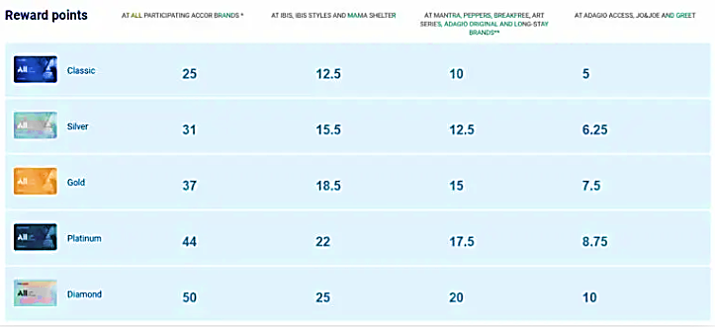
Figure 3: Accor's Loyalty Program Details
Source: (Chen, 2024)
These loyalty points per stay provide a complimentary stay after accumulating 100 points, influencing customers to stay loyal to Accor and take more stays with the brand. Therefore, the creative service's functioning demonstrates the living reality of learning and catering to changing consumer needs. Ibis London Canning Town embraces analogous practices (Rini and Ferdinand, 2021). It uses data on guests to personalise room settings by adjusting the temperature and then preconfiguring the rooms with amenities the guest prefers.
They are trained to remember repeat visitors and greet them with a reference to their preferences. This gives them a human touch, a warm feeling like home, satisfying customers. Along these broad strategies, for the Ibis London Canning Town, customer-centricity includes a proactive approach to engaging guests. This involves constant interaction with the guest so that one can know more about the needs and preferences of the customer (Josep-Francesc Valls, 2018). Moreover, this further extends into interaction in the electronic marketplace or through social media, email, or the hotel's mobile app. The state of continual communication helps provide prompt responses to any problems and requests, thus enhancing the overall guest experience.
Employees become deeply customer-centric through their training programs at Ibis London Canning Town. They are trained to be intuitive about the guest's needs and to provide the required service in a way that delights the customer (Datiko, 2024. According to Reilly (2018), necessary training is done on empathy, active listening, and the ability to solve a problem—all acumen important for delivering an exceptional service experience to the customer. Staff development is perfected from time to time so that they can perfectly meet the changing needs of their guests. The hotel design and its facilities, diversified layouts, free Wi-Fi access, comfortable seating, and diversified menus all reflect vital concerns for the comfort and satisfaction of the customer.

Theme-2: Technological Integration for Identifying and Addressing the Issues in Implementation of Personalised Service
Technology is used in the present-day hospitality industry to integrate personalisation into service delivery that meets the individual needs and requirements of the guests. At Ibis London Canning Town, applying AI and machine learning-driven customisations created a fantastic user experience (Neuhofer, Buhalis and Ladkin, 2015). The technologies empower people to deliver seamless, efficient, and highly personalised services, driving the importance of staying competitive while seeking customer satisfaction.
Such customised services in the hospitality industry are driven by data analytics. For example, Ibis London Canning Town collects and hence analyses data related to some guests' preferences and behaviours. The opposite room setting is thus noticed in booking patterns besides helping with dining preferences and feedback on past occurrences (Buhalis et al., 2019). In this line of argument, the hotel can predict future needs and customise its services based on data analysis. For instance, the guest's favoured room temperature or any amenities that a guest might wish for can be stored and automatically set for his next reservation.
AI is the most critical lever that would give a human touch to every guest at the Ibis London Canning Town Hotel (Nam et al., 2020). The AI algorithms use big data to develop patterns and trends that eventually provide tailor-made recommendations and services (Limna, 2023). For instance, AI-driven recommendations exist for people based on their behaviours and preferences, such as dining options, local attractions, or special offers (including Buhalis and Moldavska, 2021).
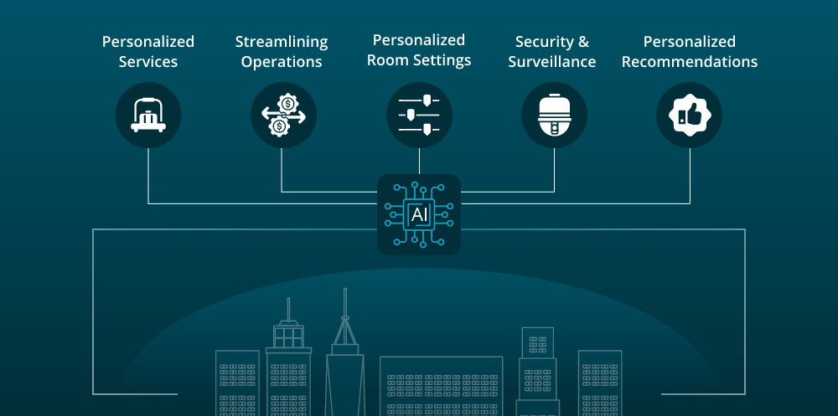
Figure 4: AI Services in the Hotel Industry
Source: (Takyar, 2023)
It also manages information in the best way possible. An AI chatbot handles customer support and service-order queries for a day to ensure that guests have access to timely and accurate responses to their questions.
Another critical aspect of the technology integration in Ibis London Canning Town is that repetitive activities have been automated (Kansakar, Muni, and Shabani, 2019). They manage reservations, check-ins, and checkouts with automated systems that smoothen the operation and reduce waiting time (Buhalis and Amaranggana, 2015). It is essential that a customer can check in online and access their room through mobile keys, bypassing the time taken to check in and reducing the waiting time (Melián-González and Bulchand-Gidumal, 2016). Not only does this expedite the process, but it also frees up staff to deal with more personal aspects of service. Housekeeping automation also takes care of setting up rooms according to guests' specific requirements so that they can feel more comfortable and relaxed (Shin, Perdue and Kang, 2019).
Ibis London Canning Town will implement intelligent technologies, which are slowly developing, to personalise any guest's stay further. All rooms have intelligent televisions, thoughtful speakers, and IoT devices for managing house functions like lighting, temperature, and entertainment devices in general, all controllable via smartphones or even voice commands (Leung, 2019). This extends maximum convenience to the guest and is the most straightforward tool for configuring a preferred environment. Examples include intelligent room service systems where one can order food and beverages using a tablet for timely delivery.
Different technological systems must be integrated into Ibis London Canning Town dispensing services. The property management system (PMS) is integrated with customer relationship management (CRM) software, and any other operational tool used in the hotel feeds them constantly to each other. This way, upon arrival, it is possible for any department to offer services that are well-coordinated and that are based on updated information regarding a given guest (Mercan et al., 2020). For instance, typical recommendations from the front desk can be made based on having checked or retrieved the guest's eating habits previously. Housekeeping can also verify the room set-up arrangements for this particular guest. The technological integration at Ibis London Canning Town, powered by AI and machine learning, remarkably allows service personalisation. The hotel is enabled by data analytics, AI, automation, intelligent technologies, and integrated systems, ensuring seamless and hyper-customised services to its guests (Sarmah, Kamboj and Rahman, 2017). On top of this, such enhancements will increase operational efficiency in ensuring that every guest is valued and taken care of, increasing customer satisfaction and loyalty. This technological advancement will help to reduce the implementation issues of personalised services through modern technology.

Theme-3: Impact on Customer Satisfaction of the Implementation of Personalisation- Related Customer Service
A personal touch in the hospitality industry is always needed to ensure customers have the experience that will bring them back. Ibis London Canning Town also highly upholds personalised customer service, which provides a loyal experience (Herbas Torrico and Frank, 2017). The following paper discusses how personal interactions, consistent quality, loyalty programs, feedback and improvement, and emotional connections shape the level of satisfaction among customers. Accor says customer satisfaction is higher as the brand has fewer renovation days, lower rates than competitors, higher charter P21 service standards, and better locations. The graph below shows this-
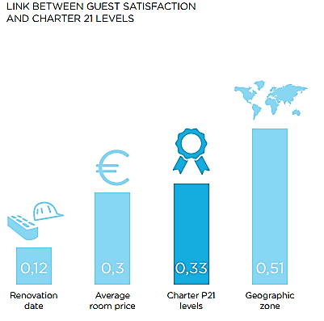
Figure 5: Relationship Between Customer Satisfaction and Service of Accor
Source: (Accor, 2018)
Human-based personal interactions are the essence of personalised customer service in Ibis London Canning Town. Staff is well trained to remember the names of guests, their preferences, and special occasions taking place, which makes the guests feel appreciated and noted, which is a good base for creating solid relations (Volchek, 2020). For instance, a returning guest might be greeted with his favourite drink once he arrives or find his favourite newspaper in the room. These are things done to show the hotel's level of ensuring service beyond guest expectations and have a bearing on customer satisfaction.
Ibis London Canning Town must consistently provide quality service to meet customer satisfaction. Therefore, the hotel must take extreme quality measures because the guests expect no less, and the hotel ensures this through rigorous quality control (Oulasvirta and Blom, 2008). The staff is under continuously updated best practices and service standards. Regular audits and mystery shopping exercises can be carried out, targeting improvement areas. It builds trust and reliability in the services offered; hence, one never visits again.
The loyalty programs increase loyalty, significantly raising guest satisfaction and retention at Ibis London Canning Town. Accor’s loyalty program for loyalists provides tailor-made rewards and benefits, including room upgrades, late checkout, and exclusive discounts, which maintain and increase guest loyalty (Hsiao et al., 2015). These benefits not only preserve loyalty but also enhance the overall guest experience. They incentivise the guest to return and develop an emotional connection to the hotel through material benefits that meet the guest's desire.
Another critical success factor in attaining customer satisfaction at Ibis London Canning Town is soliciting and taking action on guest feedback. Its solicitation is through surveys in comment cards and digital platforms (Tuominen and Ascenção, 2016). The input is analysed for common issues and areas for improvement. Suppose the hotel takes such opportunities to redress the problems in time, incorporating cross-cutting changes arising from suggestions by guests (Guagno, 2017). In that case, the total commitment of the hotelier to perpetual improvement processes comes true, and the guests become more satisfied, not only because their issues have been addressed but also because they value their input. Hence, they are loyal.
Emotional bonding can be an avenue to long-term loyalty. Ibis London Canning Town is focused on an experience that connects to people's emotions—from personalised gestures to celebrations of special moments and a feeling of belonging (Han, Kiatkawsin and Kim, 2019). For example, it is common for a guest celebrating his birthday to be brought a cake or even a card signed by the personnel. Such emotional connections make the guests feel unique and valued, making them more satisfied and willing to return.
The human touch in Ibis London Canning Town's customer service unit impacts the satisfaction and loyalty of customers. Personal interaction, quality consistency, effective customer loyalty programs, capturing proactive feedback, improvement, and emotional connection all create memorable, personalised guest experiences (Tsai, 2013).

Areas of Improvement
For Ibis London Canning Town to continually improve customer satisfaction, the hotel must engage in an ongoing process of updating staff training to achieve a balance between technological improvement and human interaction with customers. Real-time visitor feedback can be coupled with advanced algorithms for guest profiles to enable accurate personalisation of services, significantly enhancing the guest experience. Investing in staff cultural competence training to cater to the diverse guests' needs will also ensure that technology integration takes full effect across departments.

Conclusion and Recommendation
This Hotel Placement Report in the Ibis London Canning Town explains how personalised services affect guest satisfaction and how, in a very competitive hospitality business, techniques focused on the customer and advanced technology are embraced for the positive experience of guests and the development of their loyalty. Further, the themes in this paper—customer centricity to meet evolving consumer needs, technology-integrated services associated with customisation services, and customer satisfaction linked to customised customer service—underline the same imperative: design services to preference at an individual level.
At Ibis London Canning Town, personalised services allow for detailed data analysis, including AI-driven customisations and proactive guest engagement. The hotel creates uniqueness in each guest's experience based on their evolving needs by conducting detailed information analysis. This way, expectations from the guest are usually met, if not exceeded, leading to satisfaction and increased visits to the same hotel.
Furthermore, attention to quality in maintenance and building emotional relationships through personal connections and loyalty programs raises customer loyalty. Guests' feedback is collected and analysed continually to refine and enhance further service delivery in line with the guests' varied needs. Personalised service strategies have been very influential in customer satisfaction. Ibis London Canning Town offers a great guest experience, which enables it to be ahead of its competitors by combining technology with a human touch. This overall positioning not only improves the hotel's reputation but also secures its position in the competitive landscape of the hospitality industry.

Key Recommendation
The personalisation of hotel services has higher customer satisfaction, and to ensure highly personalised services for Ibis London Canning Town, the hotels need to look into these areas for further improvement-
- Make Employee Training More Effective: Invest in continued training programs emphasising cultural competence, empathy, active listening, and problem-solving skills. This will help the employees balance technological advantage with personal human encounters, making the experience for the guests supreme.
- Use of Real-Time Data: Implement systems that allow for collecting and analysing data about guests in real time. Advanced algorithms, run with AI-driven personalisation, are much more precise in anticipating and adapting to individual guest preferences, which drives satisfaction and loyalty.
- Make Feedback Mechanisms Stronger: Design robust feedback collection procedures through countless channel sources, including digital platforms, in-person surveys, and comment cards. Analyse feedback as frequently as necessary to identify improvement areas and act quickly on red flags so that service enhancement is continuous.
- Make Digital Interactions Personal: Customise the pre-arrival, during-stay, and post-stay customer experience through a hotel mobile app, email, and social media. Utilise AI-powered chatbots that respond to real-time standard inquiries leaving staff free to devote their energies to more sophisticated and customised guests' needs.
- Make technology Friendly: It will integrate multiple technological systems—PMS, CRM, and IoT devices, to name a few—for seamless and cohesive functionalities to offer personalised services. This would also result in the information regarding the guests being spread in different departments with coordinated, customised services based on the same data.
- Customer Loyalty Programs Enhancements: Personalize Accor’s loyalty program by making it more individual for the participants, including their personal preferences, endowed right into Perks. To enhance Accor's loyalty program, create exclusive experiences, such as events, offers, and communication that would make guests feel valued and appreciated.
- Make Operations Efficient: Automate routine activities, such as check-ins and checkouts, to save staff from dull jobs and enable them to extend more personalised service. This applies to optimising housekeeping and room services for efficiency and quality improvement.

Reflective Account
Reflective writing provides one with the avenue to review critically what they were going through during a given period, as well as the lessons learned. While on placement within Ibis London Canning Town, with its Sales and Marketing department, I had the opportunity to witness and be part of numerous strategies to personalise service at the hotel. To meet this end, the adoption of Gibbs' Reflective Cycle entails description, feelings, evaluation, analysis, conclusion, and action plan on how the hotel was able to personalise services and the effect this had on customer satisfaction (Main, 2023).
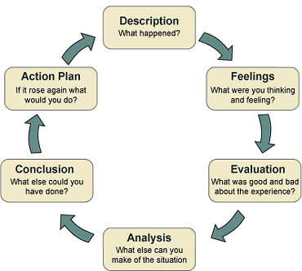
Figure 6: Gibbs’ Reflective Cycle
Source: (Main, 2023)
The overall reflection of this placement and the report is discussed further in steps of Gibbs’ Reflective Cycle-

Description
My internship at the Ibis London Canning Town was based in the Sales and Marketing Department of Ibis London Canning Town. Key responsibilities included observing in-house strategies for personalised services, training staff, and analysing customer feedback. Other practical involvements included implementing marketing campaigns that emphasised the hotel's dedication to personalised service. This hands-on experience has shown me how the different departments collaborate to enhance customer satisfaction through personalised service.

Feelings
First, I was overwhelmed by the dynamism of the operations and the high expectations it has for delivering personalised services. The pace at which the hospitality industry works and the need to continuously meet and exceed customer expectations was daunting (Ziyae, Sadeghi and Golmohammadi, 2021). I faced some critical troubles during my placement, especially in personalising services and getting along with the working practices of Ibis London Canning Town. However, getting to understand the operations and witnessing the commitment of the personnel, I began to appreciate the details under which a guest experience is personalised.

Evaluation
It was a very educative experience to see how vital the tailored service is for customer satisfaction. What struck me the most was what goes into data analytics and customer feedback related to individual preferences. For example, I learned to monitor the ratings and reviews online regularly, especially on platforms like TripAdvisor. There are rare, mostly positive reviews regarding the property, especially the location's proximity, cleanliness, quality of service, and value for a money consideration. Also, some negative reviews were garnered due to the lack of soundproofing windows, as some guests witnessed street noises. It is considered a Traveller's Choice Property on TripAdvisor with an average rating of 4.5 stars-
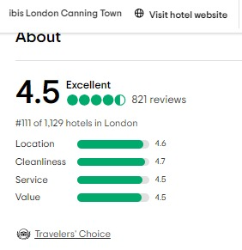
Figure 7: TripAdvisor Rating and Tag of Ibis London Canning Town
Source: (TripAdvisor, 2024b)
Although there are mostly good reviews, there are some bad reviews as well, and the figure below shows the numbers of reviews in different ranges-
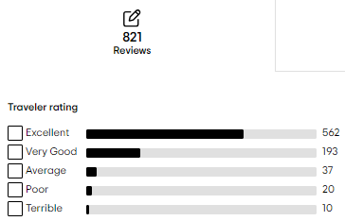
Figure 8: Ibis London Canning Town Reviews in Different Categories
Source: (TripAdvisor, 2024b)
Monitoring and reviewing this feedback regularly using various analytical tools will help improve the property's service further. As an intern in the hospitality industry, I realised the importance of these tools. When introduced in class, these tools were complicated, but practice became extremely valuable for me. The trials made me remember how to be adaptive and, most of all, how to work in hospitality.

Analysis
During my internship in the Sales and Marketing Department of Ibis London Canning Town, there were many activities in a dynamic environment, and expectations were very high—I felt like I was being thrown deep into fast operations. However, much later, I would appreciate that personalised services to customers' satisfaction were the key theme. Through participation in data analysis and feedback concerning the customers, I have perceived how these elements inform the strategies of tailored services. This hands-on experience has underlined the importance of continuous change and functional collaboration as departments worked to meet ever-changing customer needs, clearly reinforcing a critical component in improving the guest experience and increasing loyalty.

Conclusion
I learned much about the hospitality industry and how personalised services influence customer satisfaction. On the other hand, technology integration, being templated with human interaction, creates a guest experience that needs to be remembered. All the challenges, especially in data analytics, showed where more training is required. The experience has strengthened my understanding of how vital a customer-focused approach is to the hospitality sector.

Action Plan
The action plan of this reflective account entails-
Skills I want to develop | Way of developing the skills | Resources Required to develop the skills | How to measure the success | Time frame
Communication Skill | - Attend relevant workshops and training to enhance communication skills, such as public speaking and active listening.  - Attend team meetings and discussions to hone the skills of clear and concise communication.  - Solicit feedback on the effectiveness of communication from colleagues and superiors. | - Workshops and training programs on communication.  - Opportunities for public speaking and team presentations.  - Feedback and survey tools. | - Improvement in communication-related feedback scores from peers and supervisors.  - More confidence and more effective in presenting in front of an audience.  - A positive outcome of this process is team projects and collaborations. | 6-9 Months
Interpersonal Skill | - Participate in team-building activities and group projects. This helps build a spirit of teamwork and relationships among followers.  - Attend training sessions on conflict resolution and emotional intelligence.  - Attend industry-related social and networking functions. | - Team-building workshops and activities.  - Conflict resolution and emotional intelligence training.  - Networking and interacting with others in the industry. | - It improved coworker and team relations.  - Positive peer feedback about teamwork and collaboration.  - Better ability in conflict resolution. | 3-6 Month
Technological Skill | - Consider enrolling in courses related to data analytics, AI, and any other travel and hospitality technology you have available.  - Get involved in applied projects and internships using computer-based tools and software.  - Stay updated with technologies by attending webinar conferences and going through online resources. | - Online courses and training.  - Hands-on Practice Technological tools and software.  - Industry journal subscriptions and memberships at conferences related to the market. | - Completed Relevant Courses or Certifications.  - She demonstrated adept use of technological tools in projects and assignments. Supervisory feedback on technological competencies is very heartening. | 9-12 Months
Cultural Skill | - Attend cultural sensitivity and diversity training.  - Participate in practical as well as exchange programs and cultural events.  - Work with diverse teams in projects to be able to appreciate different perspectives. | - Diversity and inclusivity training with sensitivity to different cultures.  - Opportunities for cultural exchange programs.  - Tools for collaboration with diverse teams. | - This leads to increased understanding and respect for other cultures.  - Positive feedback from diverse colleagues and customers.  - Improved capability to effectively interact and work with people from different cultural backgrounds. | 9-12 Months
Table 3: Action Plan
Source: (Self-made)

