

Module: Financial Management
Module code: LCMB7002
Assignment Title: Assessment component: Financial performance
Lecturer: Isaiah Oino
Student Name: MONIKA SINGH
Student ID: 2504360

Table of Contents
1. Financial Health Check 3
1.1 Analysis of the firm's financial statements 3
1.2 Financial ratios analysis 4
1.3 Utilizing corporate failure prediction models to assess default risk 9
2. Working Capital Management Analysis 10
2.1 Cash operating cycle 10
2.2 Strategies to improve liquidity through working capital reforms 11
2.3 Compare short-term vs long-term financing options 12
3. Strategic Financial Restructuring Plan 13
3.1 Recommended Financial Restructuring Options 13
3.2 Impact on Shareholder Value 14
3.3 Impact on Debt Structure and Financial Risk 14
3.4 Impact on Operational Flexibility 15
3.5 International Considerations 16
4. Investment Appraisal and Capital Budgeting 16
4.1 Overview of the proposed investment projects 17
4.2 Investment Appraisal Techniques 17
4.3 Capital Rationing and Final Investment Selection 19
4.4 Financial Performance and Risk Considerations 19
5. References 20
6. Appendices 24

1. Financial Health Check

1.1 Analysis of the firm's financial statements
Income Statement
General Electric's financial performance has been downhill in the past five years. The net sales have registered an intensive decline, with net sales of 2020 net sales of £614,680m and net sales of £394,879m in 2024, suggesting that the revenues are decaying constantly. The gross profit was positive, but the gross margins fluctuated with decreasing sales and high cost of sales. Operating expenses control was most deficient in 2023 and resulted in 2023 and 2024 operating losses. High net income of £38572m in 2020 offset heavy losses of £98238m in 2023 and £24029m in 2024, indicating endemic cost inefficiency and exposed core operations.
Balance Sheet Statement
The General Electronics balance sheet reveals a shrinking and declining financial position in 2020-2024. In 2024, total assets declined to the levels of 2020 of £510,290m in terms of asset disposals, declining inventory, and falling spending on property, plant, and equipment, reflecting downsizing rather than growth. Liquidity is on the wane as the cash balances have gone down by over 50% since 2022, yet current assets fell more quickly than current liabilities. Total liabilities have fallen, in large part due to reduced short-term borrowing rather than the increased operating power. Equity shareholders were also gravely impacted because of accumulated losses and negative treasury stock, which weakened financial strength and susceptibility to further shocks.
Cash Flow Statement
The cash flow statement indicates decreasing cash flows as compared to good operating cash flows. The net cash outflow of operations in 2024 represented a significant decrease of £14822m from 2023, or only 1.38 times less. Significant impairments and depreciations address cash weakness. The cash outlay investment remained in the negative with constant spending on capital and non-material assets, although less over the recent years, and demonstrates low investment potential. The financing activities reflect a reliance on short-term credit facilities, net outflows in most years, and additional cash was withdrawn as further purchases of treasury stock took place. The cash balances generally decreased, which increased the liquidity risk.

1.2 Financial ratios analysis
Profitability ratios
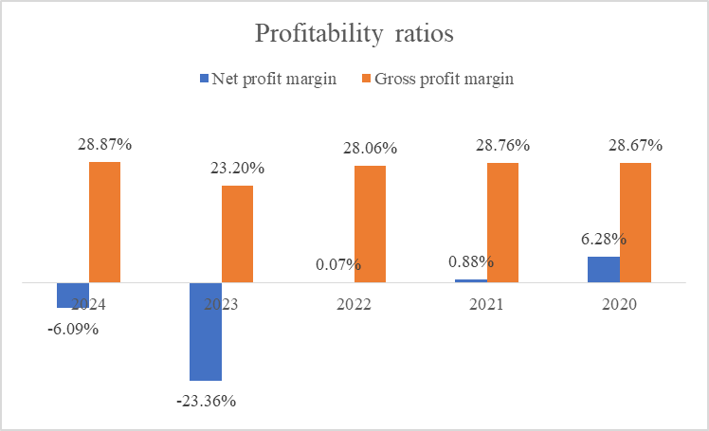
Figure 1: Profitability Ratios
(Source: Self-developed)
General Electric ratios reveal contrasting trends and conceal the profitability of the company. The net profit margin would suffer a steep drop to -23.36% in 2023 and then improve slightly to -6.09% in 2024. It is an indicator of skyrocketing losses because operating and non-operating expenses are surging beyond the capabilities of the company to convert revenue back to profitability. On the other hand, the gross profit margin environment was relatively stable at 28.06%-28.87% with the highest gross profit 28.87% in 2024, which is a sign of stable cost of sales management despite the price shrinkage. The deviation in the direction of the trend, the gross margin is steady, but the net margin is crushing, indicates that inefficiencies in the operations, overheads, and financing expenses are eroding profitability (Rafid et al. 2024). Its strengths include production efficiency, but its weaknesses include threats, uncontrolled costs, reduced sales, and the financial burden, and it is high time to reorganize and control the costs.
Liquidity ratios
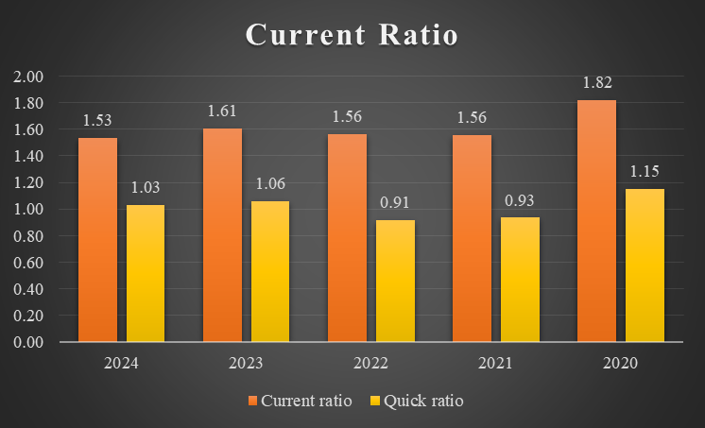
Figure 2: Current Ratios
(Source: Self-developed)
General Electronics liquidity ratios show a medium-term look of financial stability, although the five-year trend is also declining. Current ratio decreased to 1.53 in 2024 as compared to 1.82 in 2020 that the ratio of current assets to current liabilities is compromised, yet the figures show that the company can meet its immediate liabilities. The quick ratio shows a comparable correlation, decreasing to 1.03 in 2024, compared to 1.15 in 2020, meaning that the inventories are used to meet the current liabilities. Even though the firm is well liquid in the short-run, the downward trend is a sign of increasing strain on cash and cash-like assets (Susellawati et al. 2022). One strength is a positive working capital, but possible risks include potential pressure on cash flows, a slow-moving inventory, and overreliance on receivables, which interrupts operational flexibility and exposes the company to risk during market downturns or unexpected financial events.
Efficiency ratios
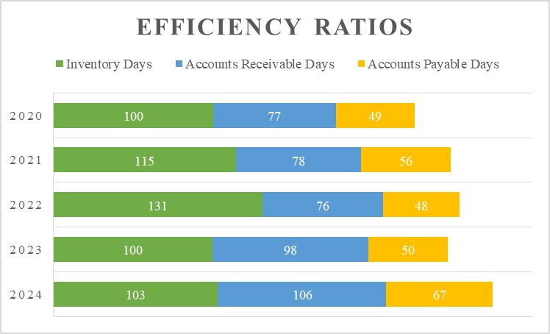
Figure 3: Efficiency Ratios
(Source: Self-developed)
The efficiency ratios of General Electronics indicate a declining operational efficiency over the five years. Inventory days were 100 days in 2020 and 103 days in 2024, highest in 2022 because it is slow turning inventory holding up working capital. The 2020 accounts receivable days of 77 days had become 106 days in 2024, which is slower collections and a potential credit risk, yet the accounts payable days became 49 days in 2020 to 67 days in 2024. This suggests that the company is also managing the cash flow by postponing the payments to suppliers. The trends suggest the efficiency of using working capital was lost, as well as liquidity pressure (Rashid, 2021). There are threats that the firm can mobilize payables effectively; threats are an increase in the holding costs of inventory, potential bad debts, and a lack of operational efficiency that can influence cash flow, profitability, and the firm's capacity to fund growth.
Gearing ratios
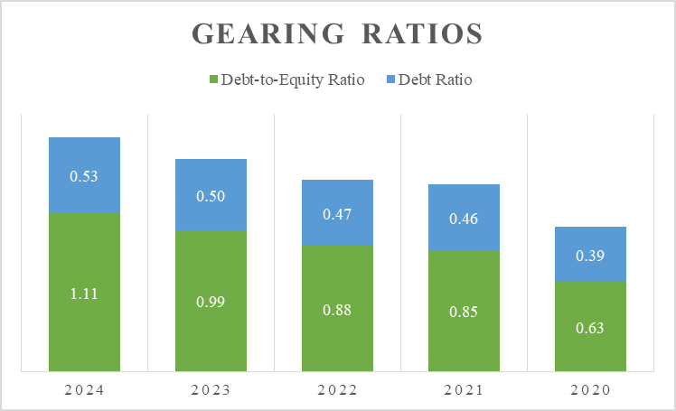
Figure 4: Gearing Ratios
(Source: Self-developed)
The gearing ratios of General Electronics indicate that a five-year horizon increases the risk of the financial risk. The debt-to-equity ratio increased from 0.63 in 2020 to 1.11 in 2024, indicating an increased utilization of liabilities relative to shareholder equity. Similarly, the debt ratio increased from 0.39 in 2020 to 0.53 in 2024, indicating that debt funds now account for over half of the company's assets. These trends present an increase in financial leverage, which is catastrophic during a recession period and limits the ability to plan strategies. The strength is that the company can borrow money to finance the operations, a risk that would escalate interest payments, solvency, and vulnerability to economic shocks (Praslicka et al. 2021). Extremely high leverage may also ruin trust in investors and limit future borrowing. An urgent move to deleverage and improve equity retention and debt restructuring is required to rejuvenate the financial health and future growth.
Investment ratios
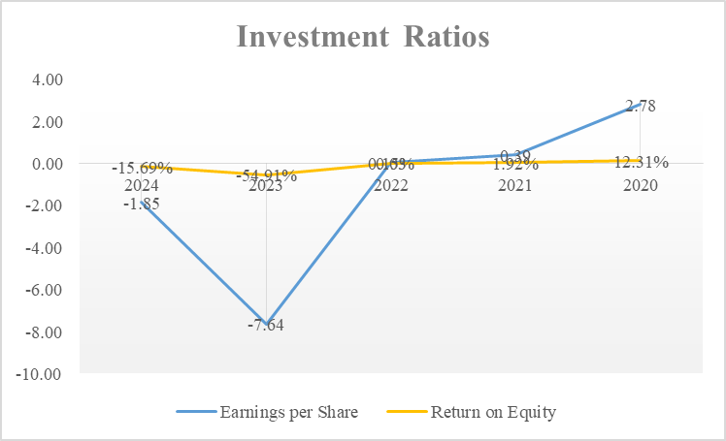
Figure 5: Investment Ratios
(Source: Self-developed)
Investment ratios of General Electronics indicate abnormally low shareholder returns. In 2024, earnings per share (EPS) declined to -1.85 a decline in 2020 at 2.78, with one of -7.64 in 2023 as the lowest point, as a result of sustained net losses and share destruction. The trend is captured in return on equity (ROE), which stood at 12.31% in 2020 and -15.69 in 2024, with the extreme low of -54.91% in 2023, indicating poor utilisation of equity capital and huge losses relative to the net assets of the company. The capacity to generate positive returns in the past is also a virtue, but threats are eroding investor confidence, diminishing market valuation, and raising capital problems (Olayinka, 2022). The negative trends serve as indicators of the need to revive profitability and undertake strategic investment decisions to regain equity value and EPS.
Cash flow ratios
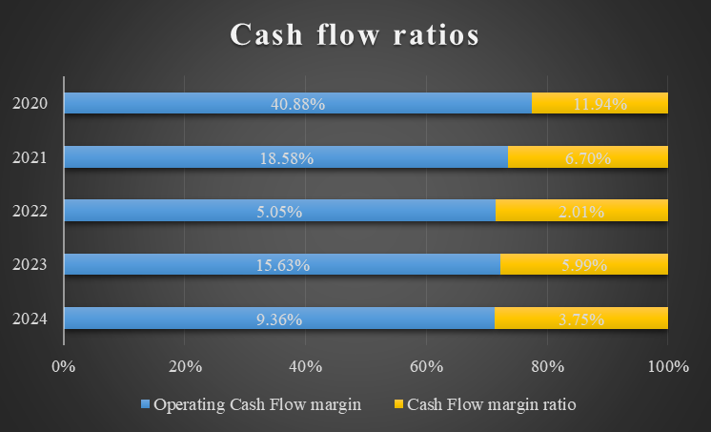
Figure 6: Cash Flow Ratios
(Source: Self-developed)
General Electronics' cash flow ratios reveal that, comparatively, the cash generation has declined relative to the liabilities and revenue in the 5 years. The current change is that the operating cash flow margin fell to 9.36% in 2024, compared to 40.88% in 2020, and shows a declining ability to cover current liabilities with operating cash, the lowest of 5.05 in 2022. Similarly, the cash flow margin ratio declined by 11.94 in 2020 and 3.75 in 2024, indicating a declining operational cash relative to sales. These trends indicate that operations are efficient; liquidity strains and liquidity satisfactions when operations have positive net cash flows (Litvinenko et al. 2025). This company has the ability, even due to economic and temporal transformation, that the company is still able to produce certain cash to operate, but the threats are less flexibility to finance investments, service debt, or withstand an economic shock.

1.3 Utilizing corporate failure prediction models to assess default risk
In order to estimate the risk of default of General Electronics, we can deploy the Altman Z-Score model. Z-Score denotes that it is a product of both profitability and leverage, as well as liquidity and efficiency, to predict the risk of bankruptcy. Explain the interpretation of the Z-score (adjusted) of publicly traded manufacturing firms:
“Z = 1.2(Working Capital / Total Assets) + 1.4(Retained Earnings / Total Assets) + 3.3*(EBIT / Total Assets) + 0.6*(Market Value of Equity / Total Liabilities) + 1.0*(Sales / Total Assets)”
According to 2024, the working capital is positive, despite the decline, the retained earnings are reduced by the occurrence of the constant losses, the EBIT is negative (-£15,297m), the total assets are on the decline, and the market value of equity is exhausted. These would give a Z-Score significantly below the safe value of 1.8, taking financial distress as the result. The model indicates a high level of default risk, which was due to negative profitability, poor equities, and a response to reducing operating effectiveness (Zhao et al. 2024). The restructuring, control over costs, control over debt, and overall improvement of cash flow should be functioning actively to reduce the insolvency risk and restore the confidence of the investors.

2. Working Capital Management Analysis

2.1 Cash operating cycle
The cash operating cycle (COC) of General Electronics reveals that the working capital is increasingly becoming ineffective at managing the cash flow over the five years. COC is the comparison of the mean duration the firm puts on average its outlay of cash against its inflow of cash, which is the Inventory Days plus Accounts Receivable Days less Accounts Payable Days. In 2020, this cycle took 128 days, in 2024, a peak of 159 days, and in 2022, 142 days. This is an effective indication of slowing down inventory and receivables to cash conversion by the company, but this is partly neutralized by the delay in settling with suppliers.
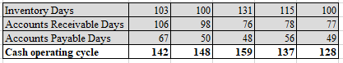
Figure 7: Cash operating cycle (COC)
(Source: Self-developed)
The fact that inventory days are increasing to 103 and the highest is 131 in 2022 means that inventory turnover is slower, and there may be overstocking, which is an unnecessary tie-up of working capital. AR days went up by a considerable margin to 106 as compared to 77, and indicated collections that were delayed and the risk of credit that was growing. Accounts payable days slightly improved to 49 to 67, but that is not much to offset the fact that it increased the inventory cycle and the receivable cycle. A lengthy, hairy COC can cripple liquidity, overcharge finance, and lead to inflexibility of operations. Efficient working capital management, fast receivables collections, and inventory optimization should reduce the cash conversion cycle, maintain the cash flow level, and ensure sustainable operations.

2.2 Strategies to improve liquidity through working capital reforms
General Electronics must undertake certain working capital reforms to improve liquidity, which will maximize current assets and current liabilities, and will simplify cash flow, and reduce reliance on external financing. The first is inventory management optimization. The company should also adopt the concept of just-in-time (JIT) inventory management, demand forecasting through AI-based analytics, and rationalizing the slow-moving stocks or stocks that are obsolete (Ogunyankinnu et al. 2024). A decrease of the current inventory days of 103 will free up cash and decrease holding costs.
Second, there has to be an improvement in the accounts receivable management. Tighter credit, discounting early payment, and an enhanced number of debt collections can cause a reduction in the length of collections and improved cash inflows. The frequency of consumer creditworthiness will minimize bad debts.
Third, accounts payable should accompany liquidity and supplier relationships. A decrease in penalties on extended terms of payment can be negotiated, and the money can be held longer, while still maintaining the confidence of the supplier (Kovach et al. 2023). However, overdelays possess the potential to spoil supplier credibility and shipment continuity.
Fourth, it is important to monitor and provide cash flow forecasting. The rolling cash flow forecasts would then be adopted instead of making decisions reactively, and the latent liquidity shortages can be identified and financing decisions made before it is too late (Barnabas and Oloyede, 2024).
Fifth, working capital funding can be used to complement operational reforms. Rather than using an ordinary source of funds, short-term credit facilities must be used tactfully in order to reduce interest cost and financial risk (Zahid et al. 2024). Finally, to be more agile, technology-enabled integrated working capital platforms could be taken into consideration, and the real-time perspective of payables, receivables, and inventory would be achieved.

2.3 Compare short-term vs long-term financing options
Financing General Electronics, it is significant to concentrate on short and long term financing in balancing liquidity, cost, and strategic development.
Short-term financing includes bank overdrafts, lines of credit, trade credit, and commercial paper; all due within a year. Its most significant advantage is on the part of adaptability, wherein money can easily be sourced to cater to the immediate cash flow needs, such as payroll, remittance of suppliers, or acquisitions. The interest must be generally lower than long-term debt, and it is adjustable to modified operational requirements. Moreover, short-term financing does not cut back on equity (Peng et al. 2025). However, short-term financing may also pose threats like frequent refinancing, sensitivity to interest rates, and potential liquidity stress in the event of reduced revenues, as seen in the declining cash flow sections and increasing cash conversion cycle in General Electronics. High utilization may also be a sign of fiscal instability to investors and creditors.
The long-term financing is concerned with bonds and term loans, as well as with issuing equity. It is also prudent to fund investments in capital, strategic acquisitions, or company restructuring, and to align terms of match repayment with the life of assets (Akinsola and Hamzah, 2025). The advantages are a guarantee of fiscal stability and regular repayment since the management does not have to keep financing itself. Equity financing will also be beneficial to the balance sheet, and it will reduce gearing risks that are highly critical to a firm with a growing debt-to-equity ratio like General Electronics. However, long-term debt is normally linked to higher interest rates, restrictive terms, and even watering down authority in case of equity issues (Zgaga et al. 2024).
An ideal measure would be the balancing of financing practically. Short term financing should provide operational liquidity to meet immediate working capital needs, and long term financing should fund long term investments and capital restructuring (Nicolas, 2022). At General Electronics, the efficient use of long-term debt to fund restructuring and enhanced working-capital management methods to reduce short-term cash requirements will stabilize finances, erase default risk, and boost investor confidence. This type of mixed approach is sure to achieve operational malleability and sustainability in growth over the long run.

3. Strategic Financial Restructuring Plan

3.1 Recommended Financial Restructuring Options
In order to earn back financial stability and create better long-term value, General Electronics must implement a number of pronged financial restructuring approaches that are based on divestiture, equity injection, debt reinstatement, and strategic alliances.
Disposition of underperforming expenses
Disposition of underperforming and unrelated expenses would free up funds that are committed in its low-growth line of business to reinvestment back in the high-growth sectors (Mavlutova et al., 2021). This will make operations easier, more effective and enhance the strategic orientation of the firm about core competencies, which will also create cash to settle debts.
Equity Injection
The capital would be injected through equity injection by way of rights issues or strategic investors, which would enhance further capital to make the company solvent and low in leverage. The new equity will improve liquidity, reduce financial risk, and enable the existing shareholders to invest in the growth activities, although in the short term it will result in dilution of the existing shareholders (Palacín-Sánchez et al., 2023). The strategic investors can also provide management skills to the company or can provide new markets and this will enhance long-term competitiveness.
Restructuring of debts
Restructuring of debts is necessary to minimize the risk of finances and enhance the flexibility of operations. Interest costs, risks of unsuccessful refinancing and credit worthiness can be increased by renewing loan terms, which can be done in conjunction with extending maturities and converting debt into equity (Potharla, 2025). Restructuring the debt profile will make sure that there is enough cash flow to cover the debt commitments and justify the strategic investments, which will counter the weaknesses identified by the high gearing ratios of the company.
Strategic Alliance
It may also be a strategic alliance or selective mergers, which do not necessitate full-scale acquisitions but have the potential to expand the market, collaborate with other firms on a basis of technology or cost benefits (Imhanzenobe, 2021). Such collaborations allow spreading the risks and provide flexibility in its operations, and enhance the competitiveness of the firm within local and foreign markets.
All the restructuring options in its combination are focused on achieving a balance between financial stability and strategic growth, enhancing shareholder confidence, and mitigating systemic financial risk (Oyeyipo et al., 2023). Divestiture and equity injection, debt restructuring and strategic alliances coupled together see General Electronics has the capacity to build its capital structure, enhance efficiency in its operations, and generate long-term value to the stakeholders.

3.2 Impact on Shareholder Value
The negative EPS in 2023 and 2024 indicates the dwindling profitability, which directly reduces the shareholder value and confidence in the market. Earnings quality and rate of return on capital will be enhanced through financial restructuring, including the disposal of low-performing assets, to restore the share price (Yang et al., 2022). By reducing debt, financial risk and cost of capital decrease, whereas equity injections, although dilutive in the short run, stabilise the firm to allow it to grow. The recovery of sustainable profitability will help increase the cash flows in the future and minimize the chances of becoming extinct, which will strengthen investor confidence. A proper restructuring and open communication is thus of paramount importance in restoring the shareholder confidence and long-term value.

3.3 Impact on Debt Structure and Financial Risk
These gearing leverage ratios show that General Electronics has a high debt financing, and this has significant implications for the financial risk and flexibility of the company if it financially restructures itself. A greater leverage increases the potential returns as well as the financial risk, as the interest payments are to be paid as a constant weight in the cash flows that will affect the debt structure of the business (Umar, 2023). This may limit the capability of a company to invest in growth or address any surprise market declines, inhibiting the flexibility of operations.
The debt ratio is 0.53 in 2024, indicating that more than 50% of the assets of the company are funded by the liabilities. Although debt offers a tax advantage in deductibility of interest, the high dependence on debt subjects the organization to the risk of an increase in the interest rate or the refinancing risk. In toxic economic situations, increased debt can enhance the risk of covenant violations or debt pressures. This may have an influence on credit ratings, which increases the expense of future financing and may result in restricted entry into capital markets. The need to service debt, therefore, may affect the making of strategic decisions, and this may also affect long-term investment and innovation opportunities.

3.4 Impact on Operational Flexibility
The financial restructuring has a direct impact on the operational flexibility of General Electronics, where financial resources become unbound, and restrictions are minimized, which is the capability of the firm to change in response to a change in the market. The sale of non-core or non-performing assets makes the management simpler since the organisation's structure becomes less complex and the management can focus on the main activities that enhance the speed at which core operations are carried out and the implementation of strategies (Hamzat et al., 2025). Through the facilities of such sales, the company can suggest funds into technology, innovation, and high-growth markets and become more agile and competitive.
The balance sheet is also robust because of the equity injection, as there is no heavy dependency on debt and the fixed interest payment. Reduced leverage would reduce the pressure on cash flow, which means that the company can use the money on expansion, research and development,t and sustainability initiatives instead of meeting the debt servicing (Jouali et al., 2024). Equally, restructuring of the debt by renegotiation or refinancing will bring in extra liquidity and minimize refinancing risk, and it can allow flexibility to take opportunities in the market or absorb market shocks.
Strategic partnerships or strategic mergers also improve flexibility in operations as operations can get access to complementary resources, new markets, and improved technologies without the excessive commitment of capital. This enables the company to grow operations rapidly in relation to demand fluctuations as well as share risks with partners.
The cumulative effect of the suggested restructuring actions is that strategic and operational freedom is improved, thus General Electronics can respond to the changing environment of the market in an efficient manner, continue with growth strategies, and be resilient to any financial or economic shocks.

3.5 International Considerations
The international and ethical considerations should be considered during a financial restructuring exercise to build a long-lasting commitment to make sure that it meets compliance, sustainability, and long-term stakeholder trust. One of the factors is taxation, where cross-border divestitures, mergers, or equity infusions can attract capital gains or have an impact on interest deductibility, and therefore, proper planning is necessary to ensure that tax exposure is minimal yet the main aim is to meet the local and international regulations (Khatniuk et al., 2024). Several things can affect the cash flows, payment of debts, and profitability: the multinational operations are exposed to currency risk, and the exchange rates can influence the native operations. There are ways to be hedged or financed in the same currency. The cost of risk in borrowing and real returns is influenced by inflation and interest rate volatility, which makes it important to have fixed-rate debt and diversification by geographical location.
As an ethical consideration and CSR, restructuring processes, including the sale of assets or downsizing, should be approached ethically, and with fairness and transparency as well as consideration to the employees (Nurcahyono et al., 2025). Being environmentally and socially responsible maintains reputational capital and makes the firm compliant with the ESG guidelines, which will increase long-term investor and stakeholder trust.

4. Investment Appraisal and Capital Budgeting
Investment appraisal and capital budgeting are important in ensuring that organisations use the limited financial resources that are under their custody in projects that are likely to lead to the maximisation of long-term value. Capital budgeting decisions are characterized by the large-scale investments in the initial stages and long-term impacts on profitability, liquidity, and financial performance in general (Nunden et al., 2022). Consequently, managers use various techniques of quantitative appraisal to estimate and evaluate alternative investment opportunities by itself to apply before allocating funds.
The given analysis is performed based on the assumptions of straight-line depreciation to zero and a discount rate of 10% level. Moreover, each decision-making would include capital rationing, whereby the maximum amount of capital that will be invested is £60 million. This is to determine the most economically feasible project/projects, and that which takes into account the company's financial performance and the risk nature of the particular investment.

4.1 Overview of the proposed investment projects
The company has three investment projects to consider, which are mutually exclusive and vary in scale and cash flow patterns. Project A has a starting capital of £40 million and a five-year net cash inflow of moderate and decreasing profits, which says it has a rather even-handed risk and returns. Project B entails a lower initial investment of £30 million, and it generates constant and predictable annual cash flows, implying a low risk and good liquidity ratios. On the other hand, Project C will have the initial investment of £50 million, but with faster cash inflows, it represents better growth potential and increased risk. These variations make the projects applicable for evaluation with the help of various investment appraisal techniques.

4.2 Investment Appraisal Techniques
The investment appraisals are necessary methods that can enable the managers to determine the viability of long-term projects in terms of funding and ensure that the projects that yield maximum organisational value are selected. Payback Period (PBP), Accounting rate of return (ARR), Net Present value (NPV), Profitability index (PI), and Internal rate of return (IRR) were used in Projects A, B, and C in order to make sound capital budgeting decisions.
Payback Period
Payback Period (PBP) is a ratio used to determine the speed at which the initial investment is paid back by inflows of cash in the project, as it is an important measure of liquidity and risk (Sinaga et al., 2023). The payback period of Project A is 3.4 years, and Project C has a payback period of 3.6 years, which means that they recover their investment relatively fast. Project B, on the other hand, has a payback period of five years, which translates to the initial investment being recovered only in the lifetime of the project. Both Projects A and C are better options in terms of liquidity and risks since the shorter the payback period, the less exposure to risk. Nevertheless, PBP does not account for the time value of money and cash flows that take place beyond the payback period; therefore, its application as a decision tool by itself is restricted (Cotter, 2023).
Accounting Rate of Return (ARR)
The Accounting Rate of Return (ARR) is used to assess profitability in terms of the average accounting profit of an investment (Sam, 2025). Project C is the one to record the largest ARR of 38%, then Project A with the middle ARR of 27%, and lastly Project B with the lowest ARR recording 15%. This implies that project C will be the most profitable when it comes to accounting. ARR is easy to follow and also compatible with financial statement measures, an aspect that is attractive to managers (Le, 2021). However, it tries to rely on accounting profits instead of the cash flows and does not take into consideration the time value of money, which minimizes its effectiveness in long-term investment decision-making.
Net Present Value (NPV)
The Net Present Value (NPV) technique will discount cash payouts in the future at the expense of capital as utilized by the company (Arjunan, 2022). Project C has the largest positive NPV of £ 4.2 million, followed by Project A, which has a small positive NPV of £ 1.306 million. Project B, on the other hand, will yield a negative NPV of £ 7.266 million, showing that it would eliminate the shareholder value should it be ventured into. NPV is now considered the best theoretical tool of the appraisal technique due to creation of value as well as the fact that it uses the time value of money (Liu, 2022). Projects A and C are acceptable based on NPV only, whereas Project B ought to be rejected.
Profitability Index (PI)
Profitability Index (PI) is the present value of inflows of each pound invested, and it proves to be rather beneficial most when capital is rationed (Alshehadeh et al., 2024). Project C is the one with the highest PI of 1.084, and this implies that it creates the most value with each unit of investment. The PI of project A (1.033) is also larger than 1, implying acceptability. Conversely, the PI of 0.758 demonstrates the rejection of Project B. In the scenario of limited capital supply, PI assists in ranking the projects in an efficient way and encourages prioritisation of Projects C and A.
Internal rate of return (IRR)
The Internal rate of return (IRR) is the discount rate at which the value of NPV is zero (Dai et al., 2022). Project C has the highest IRR at 12.72%, and then Project A at 11%, both greater than the required return of 10. The IRR of 0% on Project B is much less than the hurdle rate, and hence it is unappealing. Although IRR is easy to communicate and intuitive, it can bring about prioritization of conflicts and thus should not be used in isolation as opposed to NPV (Sneps-Sneppe, 2023).

4.3 Capital Rationing and Final Investment Selection
Capital rationing takes place when an organisation has constraints on the number of funds that it has to invest in, and the managers are required to decide on the mix of projects that gives the highest total value with a given budget constraint (Hoang et al., 2025). In this scenario, the company has a limiting maxim on the amount of investment that can be made at £60 million, and as such, it cannot pursue all of the proposed projects at the same time. This has led to the need to carefully prioritise based on value-based appraisal methods.
Project C will always do better than the rest when profitability measures have to be looked into. It records the biggest Accounting Rate of Return (38%), Net Present Value (PS4.2 million), Profitability Index (1.084), and Internal Rate of Return (12.72%). Project A is medium-performing, with the NPV of a positive value (PS1.306 million), IRR exceeding the necessary rate (11%), and PI marginally, though significantly above one (1.033), which means that it is acceptable but will not generate as much value. Conversely, Project B does the worst on all measures as it returns a negative NPV, a PI of less than one, and an IRR that is cultivated way below the discount rate, and can therefore be rejected.

4.4 Financial Performance and Risk Considerations
The investment decision should be consistent with the overall financial performance and risk-taking of the company. Profitability-wise, a project that produces more and reliable returns is better since it increases the shareholder value and makes the project financially unsustainable in the long term. Projects A and C are more profitable in case of high positive NPVs and IRRs, which are above the required rate of return, and thus can add value to earnings and value creation. Conversely, the negative NPV of Project B indicates a possibility of principal depreciation and poor financial integration.
This is also aided by liquidity considerations. Project A and C paybacks are shorter and enhance cash recovery and decrease pressure on working capital, whereas the delayed payback of Project B can pressurize the liquidity. In terms of risk, Project B repays with stable and low cash flow, and the cash flow in Project C is volatile with its imbalanced cash inflows, meaning that it is riskier and more likely to increase the returns. Project A is a moderate level of risk-reward. Generally, it would be more appropriate to invest in projects with good profitability and with manageable risks, like Projects C and A.

5. References
Akinsola, O.K. and Hamzah, F., 2025. Legal mechanisms for corporate restructuring: Understanding the legal landscape of mergers, acquisitions, and bankruptcy proceedings.
Alshehadeh, A.R., Elrefae, G.A., El Qirem, I.A., Hatamleh, H.M. and Alkhawaja, H., 2024. Impact of profitability on investment opportunities and its effect on profit sustainability.
Arjunan, K., 2022. A new method to estimate NPV and IRR from the capital amortization schedule and the advantages of the new method. Australasian Accounting, Business and Finance Journal, 16(6).
Barnabas, B. and Oloyede, J., 2024. Cash Flow Optimization: Strategies for Enhancing Short-Term Liquidity. Available at SSRN 5004465.
Cotter, E., 2023. Net Present Value and Payback Period: An Analysis.
Dai, H., Li, N., Wang, Y. and Zhao, X., 2022, March. The analysis of three main investment criteria: NPV IRR and payback period. In 2022 7th International Conference on Financial Innovation and Economic Development (ICFIED 2022) (pp. 185-189). Atlantis Press.
Hamzat, L., Adekoya, Y. and Ajao, A., 2025. Innovations in emerging market debt risk management: Complementary insights for us financial risk modeling. International Journal of Engineering Technology Research & Management (IJETRM). 2025May19, 8(01), pp.167-86.
Hoang, D., Gatzer, S. and Ruckes, M., 2025. The economics of capital allocation in firms: Evidence from internal capital markets. Management Science, 71(8), pp.6392-6425.
Imhanzenobe, J., 2021. Achieving competitive advantage and financial sustainability through acquisition and restructuring strategies. Journal of Accounting and Taxation, 13(3), pp.217-225.
Jouali, Y., El Aboudi, S., EL AFI, R. and Jouali, J., 2024. Anticipating financial distress: Leveraging financial information, financial ratios, and corporate governance for proactive risk management. Edelweiss Applied Science and Technology, 8(4), pp.683-696.
Khatniuk, N., Liakhova, O., Sadovyi, D., Pobiianska, N. and Nersesian, A., 2024. Current paths of tax for business entities: Financial, economic and legal aspects. Edelweiss Applied Science and Technology, 8(6), pp.2381-2393.
Kovach, J.J., Swink, M. and Rodriguez, M., 2023. Delaying supplier payments to increase buyer profits. Journal of Supply Chain Management, 59(1), pp.26-47.
Le, S., 2021, December. The applications of NPV in different types of markets. In 2021 3rd International Conference on Economic Management and Cultural Industry (ICEMCI 2021) (pp. 1054-1059). Atlantis Press.
Litvinenko, A., Litvinenko, A. and Saarinen, S., 2025. Applying forecasting methods to accrual-based and cash-based ratio analysis. Accounting and Management Information Systems, 24(2), pp.328-360.
Liu, Q., 2022, March. Sensitivity analysis and investment decision making under uncertainty based on NPV method. In 2022 7th International Conference on Financial Innovation and Economic Development (ICFIED 2022) (pp. 1861-1865). Atlantis Press.
Mavlutova, I., Babenko, V., Dykan, V., Prokopenko, N., Kalinichenko, S. and Tokmakova, I., 2021. Business restructuring as a method of strengtening company’s financial position. Journal of Optimization in Industrial Engineering, 14(1), pp.129-139.
Nicolas, T., 2022. Short-term financial constraints and SMEs’ investment decision: evidence from the working capital channel. Small Business Economics, 58(4), pp.1885-1914.
Nunden, N., Abbana, S., Marimuthu, F. and Sentoo, N., 2022. An assessment of management skills on capital budgeting planning and practices: evidence from the small and medium enterprise sector. Cogent Business & Management, 9(1), p.2136481.
Nurcahyono, N., Sinarasri, A., Pamungkas, I.D. and Hanum, A.N., 2025. May intellectual capital and corporate governance reduce the probability of financial distress?. Contaduria y Administracion, 70(1), pp.1-25.
Ogunyankinnu, T., Osunkanmibi, A.A., Onotole, E.F., Ukatu, C.E., Ajayi, O.A. and Adeoye, Y., 2024. AI-Powered Demand Forecasting for Enhancing JIT Inventory Models.
Olayinka, A.A., 2022. Financial statement analysis as a tool for investment decisions and assessment of companies’ performance. International Journal of Financial, Accounting, and Management, 4(1), pp.49-66.
Oyeyipo, I., Attipoe, V., Mayienga, B.A., Onwuzulike, O.C., Ayodeji, D.C., Nwaozomudoh, M.O., Isibor, N.J. and Ahmadu, J., 2023. A conceptual framework for transforming corporate finance through strategic growth, profitability, and risk optimization. International Journal of Advanced Multidisciplinary Research and Studies, 3(5), pp.1527-1538.
Palacín-Sánchez, M.J., Alencar-García, A. and Canto-Cuevas, F.J., 2023. Financial distress and corporate restructuring: a case study. Cuadernos de Gestión, 23(2), pp.81-91.
Peng, Y., Zhang, Q., Yan, H., Lei, X. and Ma, S., 2025. Short-term relief or long-term risk? The impact of financial asset allocation on corporate risk in China’s construction and manufacturing firms. Journal of Asian Architecture and Building Engineering, pp.1-14.
Potharla, S., 2025. From Debt to Divestiture: How Indian and Global Firms Reshaped through Corporate Restructuring. Available at SSRN 5348941.
Praslicka, B., Gardner, M.C., Johnson, M. and Toliyat, H.A., 2021. Review and analysis of coaxial magnetic gear pole pair count selection effects. IEEE Journal of Emerging and Selected Topics in Power Electronics, 10(2), pp.1813-1822.
Rafid, M., Soukotta, A., Cakranegara, P.A., Sutiyan, O.S.J. and Nurriqli, A., 2024. Analysis of Liquidity Ratios, Profitability Ratios, and Capital Structures on Financial Distress Conditions in Service Companies during the Covid-19 Period. Jurnal Darma Agung, 30(3), pp.614-622.
Rashid, C.A., 2021. The efficiency of financial ratios analysis to evaluate company’s profitability. Journal of Global Economics and Business, 2(4), pp.119-132.
Sam, R., 2025. Generalizing the P/E Ratio Through the Potential Payback Period (PPP): A Dynamic Approach to Stock Valuation. E Ratio through the Potential Payback Period (PPP): A Dynamic Approach to Stock Valuation (May 20, 2025).
Sinaga, A.S., Sari, M.M., Hutasuhut, A.A., Zahara, S.T., Amanda, A., Fitri, A. and Caesario, M.A., 2023. Comparison of capital budgeting methods: NPV, IRR, PAYBACK period. World Journal of Advanced Research and Reviews, 19(2), pp.1078-1081.
Sneps-Sneppe, M., 2023, May. Use of criteria NPV and IRR for choosing among investment projects. In 22nd International Scientific Conference Engineering for Rural Development Proceedings (pp. 745-750).
Susellawati, S., Sari, D.P., Nabella, S.D. and Fadlilah, A.H., 2022. The effect of profitability, liquidity, leverage, and activity ratios on dividend policy in manufacturing companies in the food and beverage industry sector listed on the Indonesia Stock Exchange in the 2016-2020 period. Jurnal Mantik, 6(2), pp.141-152.
Umar, M.A., 2023. Corporate Restructuring: A strategy for improving organizational performance. International Journal of Strategic Decision Sciences (IJSDS), 14(1), pp.1-11.
Yang, Y., Zheng, Y., Xie, G. and Tian, Y., 2022. The influence mechanism of strategic partnership on Enterprise performance: exploring the chain mediating role of information sharing and supply chain flexibility. Sustainability, 14(8), p.4800.
Zahid, R.A., Khan, M.K. and Kaleem, M.S., 2024. Skilled managers and capital financing decisions: navigating Chinese firms through financing constraints and growth opportunities. Kybernetes, 53(11), pp.4381-4396.
Zgaga, T., Thomann, E. and Goubier, M., 2024. European Union versus core state powers: the customisation of EU fiscal policy. Journal of European Public Policy, 31(9), pp.2850-2877.
Zhao, L., Mollica, V., Shen, Y. and Liang, Q., 2024. Liquidity, informational efficiency and firm default risk: a systematic literature review. Journal of Accounting Literature, 46(3), pp.321-342.

6. Appendices
Profitability ratios | Formula | Variable | General Electronics (£Millions)
Profitability ratios | Formula | Variable | 2024 | 2023 | 2022 | 2021 | 2020
Net profit margin | (Net profit / Total Revenues) | Net profit | -24029 | -98238 | 407 | 5301 | 38572
Net profit margin | (Net profit / Total Revenues) | Revenue | 394879 | 420457 | 542751 | 601602 | 614680
Net profit margin | (Net profit / Total Revenues) | Ratio | -6.09% | -23.36% | 0.07% | 0.88% | 6.28%
Gross profit margin | (Gross profit / Total Revenues) | Gross profit | 113994 | 97560 | 152292 | 173016 | 176256
Gross profit margin | (Gross profit / Total Revenues) | Revenue | 394879 | 420457 | 542751 | 601602 | 614680
Gross profit margin | (Gross profit / Total Revenues) | Ratio | 28.87% | 23.20% | 28.06% | 28.76% | 28.67%
Liquidity ratios | Formula | Variable | General Electronics (£Millions)
Liquidity ratios | Formula | Variable | 2024 | 2023 | 2022 | 2021 | 2020
Current ratio | (Current assets/current liabilities) | Current assets | 242494 | 258851 | 338040 | 337146 | 326843
Current ratio | (Current assets/current liabilities) | Current liabilities | 158291 | 161148 | 216473 | 216787 | 179510
Current ratio | (Current assets/current liabilities) | Ratio | 1.53 | 1.61 | 1.56 | 1.56 | 1.82
Quick ratio | (Current assets-Inventory)/Current liabilities | Current assets | 242494 | 258851 | 338040 | 337146 | 326843
Quick ratio | (Current assets-Inventory)/Current liabilities | Inventory | 79355 | 88273 | 140181 | 134469 | 120430
Quick ratio | (Current assets-Inventory)/Current liabilities | Current liabilities | 158291 | 161148 | 216473 | 216787 | 179510
Quick ratio | (Current assets-Inventory)/Current liabilities | Ratio | 1.03 | 1.06 | 0.91 | 0.93 | 1.15
Efficiency ratios | Formula | Variable | General Electronics (£Millions)
Efficiency ratios | Formula | Variable | 2024 | 2023 | 2022 | 2021 | 2020
Inventory Days | (Inventories/Cost of sales)*365 | Inventories | 79355 | 88273 | 140181 | 134469 | 120430
Inventory Days | (Inventories/Cost of sales)*365 | Cost of Sales | 280885 | 322897 | 390459 | 428586 | 438424
Inventory Days | (Inventories/Cost of sales)*365 | Days | 103 | 100 | 131 | 115 | 100
Accounts Receivable Days | (Accounts Receivables/Net sales/) | Accounts Receivables | 114182 | 112596 | 112346 | 129215 | 129433
Accounts Receivable Days | (Accounts Receivables/Net sales/) | Net Sales | 394879 | 420457 | 542751 | 601602 | 614680
Accounts Receivable Days | (Accounts Receivables/Net sales/) | Days | 106 | 98 | 76 | 78 | 77
Accounts Payable Days | (Accounts Payables/Net sales/) | Accounts Payables | 72031 | 57033 | 71373 | 92707 | 83229
Accounts Payable Days | (Accounts Payables/Net sales/) | Net Sales | 394879 | 420457 | 542751 | 601602 | 614680
Accounts Payable Days | (Accounts Payables/Net sales/) | Days | 67 | 50 | 48 | 56 | 49
Gearing ratios | Formula | Variable | General Electronics (£Millions)
Gearing ratios | Formula | Variable | 2024 | 2023 | 2022 | 2021 | 2020
Debt-to-Equity Ratio | (Total Liabilities​/Total Shareholders’ Equity) | Total Liabilities | 170249 | 176952 | 235757 | 234399 | 196989
Debt-to-Equity Ratio | (Total Liabilities​/Total Shareholders’ Equity) | Shareholders’ Equity | 153105 | 178920 | 268406 | 275949 | 313301
Debt-to-Equity Ratio | (Total Liabilities​/Total Shareholders’ Equity) | Ratio | 1.11 | 0.99 | 0.88 | 0.85 | 0.63
Debt Ratio | (Total Liabilities​/Total Assets) | Total Liabilities | 170249 | 176952 | 235757 | 234399 | 196989
Debt Ratio | (Total Liabilities​/Total Assets) | Total Assets | 323354 | 355872 | 504163 | 510348 | 510290
Debt Ratio | (Total Liabilities​/Total Assets) | Ratio | 0.53 | 0.50 | 0.47 | 0.46 | 0.39
Investment Ratios | Formula | Variable | General Electronics (£Millions)
Investment Ratios | Formula | Variable | 2024 | 2023 | 2022 | 2021 | 2020
Earnings per Share |  | Ratio | -1.85 | -7.64 | 0.03 | 0.39 | 2.78
Return on Equity | (Net Income/Shareholders' Equity) | Net Income | -24029 | -98238 | 407 | 5301 | 38572
Return on Equity | (Net Income/Shareholders' Equity) | Shareholders’ Equity | 153105 | 178920 | 268406 | 275949 | 313301
Return on Equity | (Net Income/Shareholders' Equity) | Ratio | -15.69% | -54.91% | 0.15% | 1.92% | 12.31%
Cash flow ratios | Formula | Variable | General Electronics (£Millions)
Cash flow ratios | Formula | Variable | 2024 | 2023 | 2022 | 2021 | 2020
Operating Cash Flow margin | (Net Cash from Operating Activities​​/Current Liabilities)*100 | Net Cash from Operating Activities​ | 14822 | 25190 | 10926 | 40283 | 73392
Operating Cash Flow margin |  | Current Liabilities | 158291 | 161148 | 216473 | 216787 | 179510
Operating Cash Flow margin |  | Ratio | 9.36% | 15.63% | 5.05% | 18.58% | 40.88%
Cash Flow margin ratio | (Net Cash from Operating Activities​​/Revenue)*100 | Net Cash from Operating Activities​ | 14822 | 25190 | 10926 | 40283 | 73392
Cash Flow margin ratio | (Net Cash from Operating Activities​​/Revenue)*100 | Revenue | 394879 | 420457 | 542751 | 601602 | 614680
Cash Flow margin ratio | (Net Cash from Operating Activities​​/Revenue)*100 | Ratio | 3.75% | 5.99% | 2.01% | 6.70% | 11.94%

Inventory Days | 103 | 100 | 131 | 115 | 100
Accounts Receivable Days | 106 | 98 | 76 | 78 | 77
Accounts Payable Days | 67 | 50 | 48 | 56 | 49
Cash operating cycle | 142 | 148 | 159 | 137 | 128

Capital Budgeting: Project A
Year | Net Cash Flow | Discounted Rate | Discounted Cash Flow | Cumulative Cash Flow | Average accounting Profit
Year 0 | -40 | 1 | -40 | -40 | 10.8
Year 1 | 10 | 0.909 | 9.09 | -30 | 10.8
Year 2 | 12 | 0.826 | 9.912 | -18 | 10.8
Year 3 | 14 | 0.751 | 10.514 | -4 | 10.8
Year 4 | 10 | 0.683 | 6.83 | 6 | 10.8
Year 5 | 8 | 0.62 | 4.96 | 14 | 10.8
NPV (Sum of PV of cash flow) |  |  | 1.306
IRR |  |  | 11%
PBP |  |  | 3.4
ARR (Average accounting Profit/Initial investment) |  |  | 27%
PI (Total PV of Inflows/Initial Investment) |  |  | 1.03265
Capital Budgeting: Project B
Year | Net Cash Flow | Discounted Rate | Discounted Cash Flow | Cumulative Cash Flow | Average accounting Profit
Year 0 | -30 | 1 | -30 | -30 | 6
Year 1 | 6 | 0.909 | 5.454 | -24 | 6
Year 2 | 6 | 0.826 | 4.956 | -18 | 6
Year 3 | 6 | 0.751 | 4.506 | -12 | 6
Year 4 | 6 | 0.683 | 4.098 | -6 | 6
Year 5 | 6 | 0.62 | 3.72 | 0 | 6
NPV (Sum of PV of cash flow) |  |  | -7.266
IRR |  |  | 0.000%
PBP |  |  | 5
ARR (Average accounting Profit/Initial investment) |  |  | 15%
PI (Total PV of Inflows/Initial Investment) |  |  | 0.7578
Capital Budgeting: Project C
Year | Net Cash Flow | Discounted Rate | Discounted Cash Flow | Cumulative Cash Flow | Average accounting Profit
Year 0 | -50 | 1 | -50 | -50 | 15
Year 1 | 5 | 0.909 | 4.545 | -45 | 15
Year 2 | 10 | 0.826 | 8.26 | -35 | 15
Year 3 | 20 | 0.751 | 15.02 | -15 | 15
Year 4 | 25 | 0.683 | 17.075 | 10 | 15
Year 5 | 15 | 0.62 | 9.3 | 25 | 15
NPV (Sum of PV of cash flow) |  |  | 4.2
IRR |  |  | 12.720%
PBP |  |  | 3.6
ARR (Average accounting Profit/Initial investment) |  |  | 38%
PI (Total PV of Inflows/Initial Investment) |  |  | 1.084

