

Blake James McGrath Auchterlonie

Fault Tree Analysis

UWTSD
Ordnance Munitions and Explosives Apprenticeship (BEng)

Lecturer: Dave Holley
April 2026

Academic integrity declaration
I declare that:
- the thesis submitted has been written by me alone.
- the thesis submitted has not been previously submitted to this university or any other.
- that all content, including primary and/or secondary data, is true to the best of my knowledge.
- that all quotations and references have been duly acknowledged according to the requirements of academic research.
I understand that to knowingly submit work in violation of the above statement will be considered by examiners as academic misconduct.

Abstract
This report examines the application of Fault Tree Analysis as a method for identifying single points of failure within a system and calculating the probability of overall process success. Using the example of making a hot drink, the report demonstrates how base event probabilities are assigned and propagated through AND and OR logic gates to determine the likelihood of a top-level function being achieved. This highlights the compounding nature of human factors within the fault trees and the disproportionate impact it can have on system outcomes.

Table of Contents
Academic integrity declaration i
Abstract ii
List of Tables iv
List of Equations v
1 Fault trees 1
2 Calculation of probabilities overall. 3
3 Calculation of probabilities tea 5
4 Calculation of reduced probabilities 6
5 Application of Human Factors 8
6 Conclusion 9
7 References 10
Appendices 11
Appendix A Fault tree analysis 11
Appendix B Calculations 12

List of Tables
Table 1 - Event probability’s 3
Table 2 - Revised event probability’s 6

List of Equations
(1-1) 8
(1-2) 9

Fault trees
The primary goal of a Fault Tree Analysis (FTA) is the identification of single points of failure within a process [1]. Single points of failure are critical components or processes where a single malfunction results in the failure of the entire system. By mapping the logic of a system, a fault tree analysis is able to highlight critical areas. Redundancy is then able to be designed into the system to ensure that complete process failure is less likely to happen [2].

In a function tree, the very top of the diagram is where the end desired function is placed. In the case of the example exercise a hot drink with milk and sugar (Annex A). A precise definition is necessary to ensure the scope of the fault tree remains manageable and relevant. Directly below will be the supporting processes that are needed in order for the top-level function to work. In the case of the example these are hot water, a functional cup, and hot drink ingredients all being present. Each of these subfunctions have a probability of being working and correct. This probability is found by assigning failure probabilities to base events and propagating them upward through AND as well as OR logic gates.

As all three of the functions are required to find the probability of the top-level function, an AND logic gate is used to determine the probability [3]. A AND logic gate uses the following equation below to find the probability of having a Hot drink, Milk, and Sugar. For fault trees a AND gate shows the probability of all of the inputs happening simultaneously.

P(Q) = P(A) ∩ P(B) ∩ P(C) | (1-1)

P(A), P(B), and P(C) represent the independent failure probabilities of three subfunctions. P(Q) represents the output probability of the top-level event. AND gates can be stacked multiple times in series all the way to the base event probability.

These subfunctions can then also themselves be made up of subfunctions. One of the subfunction for having the correct ingredients in the cup in this example is having either white sugar or sweetener. As the probability of having sugar is determined by the available of one, the other, or both, an OR logic gate is used to determine probability [4]. As such an OR gate shows the probability of at least one of the inputs being available. The equation for which can be found below.

P(Q) = P(A) ∪ P(B)  P(Q) = 1-[1-P(A)][1-P(B)] | (1-2)

Calculation of overall probabilities
The table below shows the base event probability of every event for the fault tree for making a cup of tea or coffee.

Event | Probability
Tea availability | 0.98
Coffee availability | 0.98
Chance of leaky Kettle | 0.001
Chance of water supply failure | 0.01
Kettle reliability | 0.99
Plug in operation reliability | 0.89
Switch on reliability | 0.89
Mains supply failure chance | 0.01
Cup availability | 1
Cup reliability | 0.99
Milk availability | 0.95
Milk freshness | 0.95
Sugar availability | 0.88
Sweetener Availability | 0.99
Table 1 - Event probability’s

These base probabilities were then used in conjunction of the AND and OR equations to complete base fault tree for making a hot drink (Annex A). The full list of calculations for the base fault tree can be found in Annex B. By using the fault tree analysis, the probability of successfully creating a hot drink with milk and sugar is 68.42%

In this base fault tree analysis, the step where the greatest probability of error is ensuring that there is power to the kettle element, with a 77.6% chance of this occurring correctly. This is due to the function requiring a AND gate with 4 separate inputs. Two of these inputs, the kettle being plugged in and the electrical outlet being switched on, only having an 89% probability each. As AND gates require all inputs to be available simulations, it reduces the overall probability of the element.

Calculation of probabilities tea
The fault tree in annex A is for any hot drink, if tea is specifically wanted then the probability’s change. In the correct drink section of the fault tree, an OR gate is used for the tea and coffee nodes. This is used to denote that either tea or coffee can be present in order to proceed, and as such P(A type of drink) has a 99.96% chance of being available. However, if only tea is wanted, then the probability of coffee being available does not matter. As such the OR gate is removed, and the probability of P(A type of drink), is changed to P(tea) which has a 98% chance of being available.

This in turn will reduce the probability of P(Ingredients in cup) to 88.34%, and the total probability of making a cup of tea to 67.08%. This is a reduction of 1.3%.

Calculation of reduced probabilities
If the ability to switch on the kettle and select a cup is reduced to 75% and 90% of normal, this will result in the following table of event probabilities.

Event | Probability
Tea availability | 0.98
Coffee availability | 0.98
Chance of leaky Kettle | 0.001
Chance of water supply failure | 0.01
Kettle reliability | 0.99
Plug in operation reliability | 0.89
Switch on reliability | 0.6675
Mains supply failure chance | 0.01
Cup availability | 0.90
Cup reliability | 0.99
Milk availability | 0.95
Milk freshness | 0.95
Sugar availability | 0.88
Sweetener Availability | 0.99
Table 2 - Revised event probability’s
Switch on reliability will now show the lowest probability of any event with only a 66.75% chance of occurring. This will result in the power to the kettle element event only having a 58.22% of occurring, down from 77.6%. The availability of a cup will also be reduced, though not as drastically, to 89.1%.

The two new events will change the over all probability of creating a cup of tea to 45.32%. This is a reduction of 21.76% from the previous percentage completion despite only two of the events reducing slightly in probability.

Application of Human Factors
As the second example shows, human factors can affect fault trees hugely, as only a 25% decrease in an element from acting under fatigue can change the overall operational success greatly. Human error can also trigger multiple branches of a fault tree simultaneously, creating a situation where multiple smaller errors can compound into a final much greater reduction of success. There are some fault tree models which can simulate human factors [5], however human errors tend to be hard to model and are generally unpredictable. As such removing as much human input from the operation is preferable. In the case of this example having a automatic coffee machine that is parentally switched on would remove the switch on reliability element, which would mean that fatigue on the operator would not affect the operation as much.

Conclusion
Fault tree analysis can be used to quality the probability of top-level events as well as identify key points of failure within a system. This allows engineers to build in redundancy before production starts and to better understand how a system works.
Human factors can also play a significant role. A relatively small reduction in the reliability of just two human-dependent events resulted in a substantial drop in overall success probability from 67.08% to 45.32%. This highlights how slips and lapses can have a disproportional effect on the overall success of an operation.

References

[1] | ASEMS, “Fault tree analysis,” ASEMS, [Online]. Available: https://www.asems.mod.uk. [Accessed 13 04 2026].
[2] | Gemba Academy, “What is Fault Tree Analysis? (Enhanced Overview),” [Online]. Available: https://www.youtube.com/watch?v=dIEyaQWrXjs. [Accessed 21 4 2026].
[3] | The Open Educator, “Fault Tree Analysis FTA Explained With Example Calculation,” [Online]. Available: https://www.youtube.com/watch?v=Eq8-m6Faobo. [Accessed 13 4 2026].
[4] | D. S. L. Prof John Andrews, “An Introduction to Fault Tree Analysis”.
[5] | S. H. H. M. C. K. Ji Suk Kim, “Direct fault-tree modeling of human failure event dependency in probabilistic safety assessment,” Nuclear Engineering and Technology, vol. 55, no. 1, pp. 119-130, 2023.

Appendices

Fault tree analysis
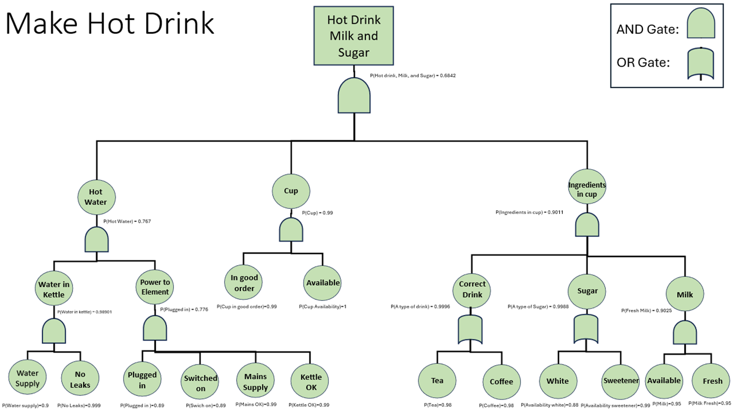

Calculations

Water in kettle
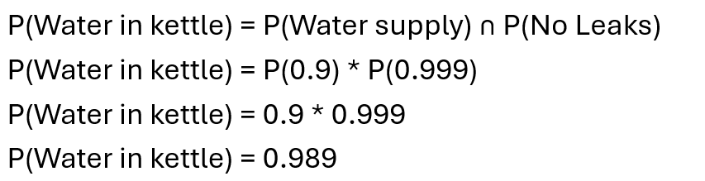

Power to element
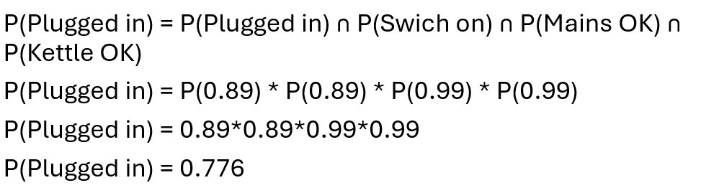

Hot water
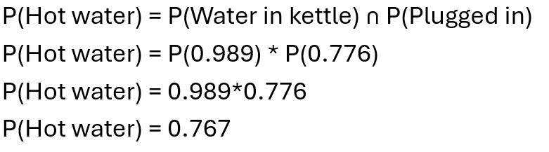

Cup availability
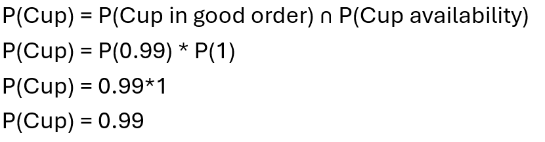

Type of drink
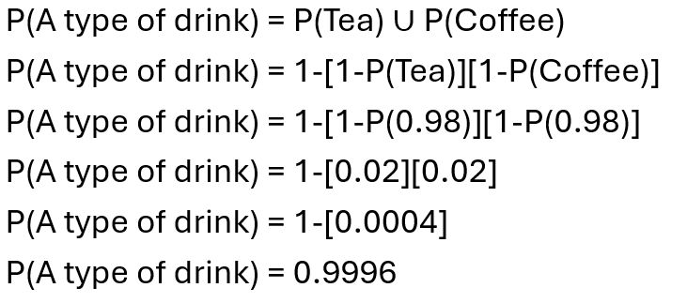

A type of sugar
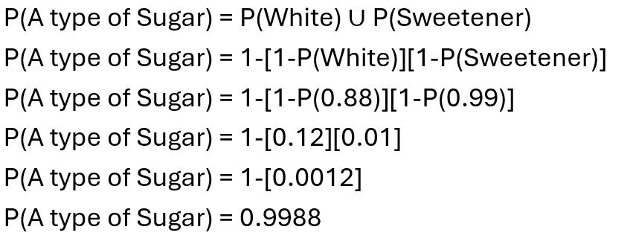

Fresh milk
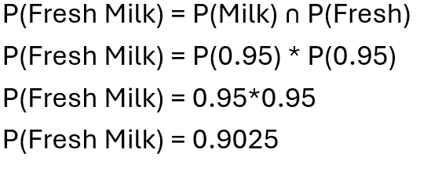

Ingredients in cup
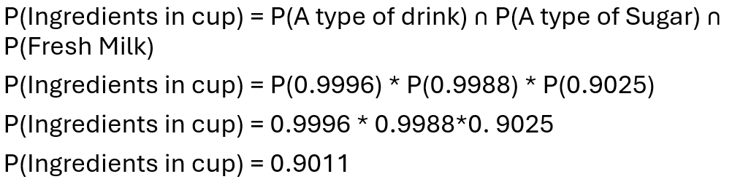

Hot drink, Milk, and Sugar


