This blog is aimed at adult attendees of the Bible Study Group in my local Church.
Prostitution in the Book of Isaiah
In assessing prostitution in the Old Testament, it is necessary to look at other Books within the Bible. Each version of the Bible has different phrasing and interpretations. For consistency, I am predominantly using the Good News Bible. I will include questions for both personal enrichment and as discussion points.
We should recognise that the Old Testament was collectively written by males, concerning activities that involved primarily or exclusively males, for example war and governance,¹ and this is the context of the Book of Isaiah. Isaiah was a prophet who lived in Jerusalem, during the second half of the Eighth century BC. Assyria was rapidly expanding its territory into the region, destroying Aram (Syria) around 734-732 BC, the kingdom of Israel in 722-721 BC and quashing Judah in 702 BC.²
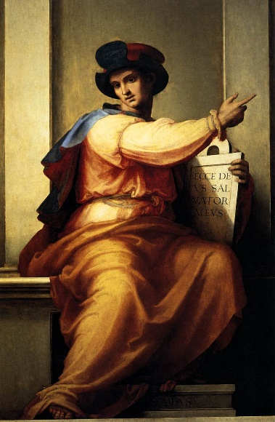
Fra Bartolomeo, ‘Isaiah’ c. 1516
Note the tablet inscription which reads: “ecce deus salvator meus” – “Behold, God is my salvation” (Isaiah 12:2)

The location for a large part of the Hebrew Bible is significant. There were expansions of urban centres, (Judah, Jerusalem, Babylon), however, most women lived within the ‘countryside’.³ Meyers (1988) states that women were not included in the priesthood, nor were they a regular part of the ruling elite.⁴ Their status as a childbearer is emphasised, and often a man’s daughters would leave the household in order to build up another man’s family.⁵ In these instances, they would normally receive no inheritance.
Despite limited possibilities of owning a property, women were expected to look after the property. If she became a widow and had no sons, the property would go to her husband’s family and she would have to return to her own family. Women were generally forced into prostitution because of poverty, or loss of parents/spouse. Women’s rights are expressed in Deuteronomy 22: 28-29. If a man rapes an unmarried girl he must marry her (making a marriage gift to her father), and the only penalty he suffers is that he must not divorce her (evident male ‘privilege’ over divorce).⁶ “Suppose a man is caught raping a girl who is not engaged. He is to pay the girl’s father…. fifty pieces of silver, and she is to become his wife, because he forced her to have intercourse with him. He can never divorce her as long as he lives.”⁷ How do you feel regarding other stories in the Bible concerning women? Does this alter your understanding of female figures like Ruth, Deborah, Esther and Sarah?
The ‘harlot’ was as common in Israelite society as in any other, but their status was of significance. Their legal status was “unmediated and unqualified” by males.⁸ They had the legal status of free citizens, under no husband’s authority. They could sign contracts, something rarely available to other women. There were two types of prostitute: cult prostitutes (Hierodule - a ‘consecrated woman’), who performed paid acts as part of worship, and prostitutes who earned money as part of their work. Those working in the name of worship apparently enjoyed greater social prestige.⁹ Contact with either was discouraged, but especially cultic prostitutes, as they represented the idolatry that Israel had sought to destroy. Why were the women ostracized and yet given such rights?
There were double standards in attitudes towards prostitutes. They were outcasts, seen as figures of shame, (“The city that once was faithful is behaving like a whore”) ¹⁰ but were often frequented by men, who suffered no legal or financial punishments for using their services, only murmurs of disapproval. Men had control over choosing their wife, (Deut. 22: 28-29) with an ‘exclusivity’ over her sexuality, yet men often visited prostitutes.
There is strong imagery in Isaiah 3:16-25 “A warning to the women of Israel” where their finery would be taken away, stripped naked by the Lord. In the King James Bible, they are described as ‘haughty’, suggesting superiority. Amid the temple and in the city of God, they have ‘deserted’ holiness.¹² This is a view that is explored further by Young (1992). Does the metaphor of the prostitute symbolize Israel as a nation? They did not adhere to the warnings of Isaiah and Yahweh, so their salubrious lifestyle will soon face judgement. Being stripped naked could infer the state that Yahweh will reduce Israel to, ‘trampling’ on sin and quelling rebellious nature. Nothing will be hidden, and nothing will remain. As prostitutes were outcasts, the idea that they, and the state, are naked emphasizes that they are at their most vulnerable.
The image of the harlot stretches further than initially appears. Their derision took on a greater form, coming to resemble an entire nation. The well-reported notoriety that prostitutes had was used to express what was outside the norm for the masses. Their literary use signalled the ‘moral collapse’ that Israel underwent, in not adhering to the teachings of Yahweh. The ‘prostitute’ (in an individual and grander sense) was a platform used by Isaiah to convey expected ideals and behaviours within Israel.

References
1. Bird, P.A “Missing Persons and Mistaken Identities: Women and Gender in Ancient Israel” (1997) Minneapolis; Fortress Press, pg. 13
2. Sweeney. M, “The Latter Prophets (Isaiah, Jeremiah, Ezekiel)” (1998) The Hebrew Bible Today: An Introduction to Critical Issues, Pt. II, pg 69-96
3. Meyers. C “Discovering Eve: Ancient Israelite Women in Context” (1988) Oxford; Oxford University Press, pg. 12
4. Meyers. C “Discovering Eve: Ancient Israelite Women in Context” (1988) Oxford; Oxford University Press, pg. 13
5. Bird, P.A “Missing Persons and Mistaken Identities: Women and Gender in Ancient Israel” (1997) Minneapolis; Fortress Press, pg. 28-29
6. Bird, P.A “Missing Persons and Mistaken Identities: Women and Gender in Ancient Israel” (1997) Minneapolis; Fortress Press, pg. 24
7. Deuteronomy 22: 28-29, Holy Bible: Good News Bible (Today’s English Edition)
8. Bird, P.A “Missing Persons and Mistaken Identities: Women and Gender in Ancient Israel” (1997) Minneapolis; Fortress Press, pg. 64
9. Bar-Ilan, M. “Some Jewish Women in Antiquity” (2020) Rhode Island; Brown Judaic Studies, pg. 133-132
10. Isaiah 1: 21, Holy Bible: Good News Bible (Today’s English Edition)
11. Isaiah 3:16-25, Holy Bible: Good News Bible (Today’s English Edition)
12. Young, E.J “The Book of Isaiah: Three Volume Commentary” (1992) Michigan; Eerdmans Publishers, page unknown
Picture Reference
Fra Bartolomeo Painting (c. 1516), “Isaiah”, https://www.artbible.info/art/large/1012.html [accessed: 04/11/2020]

