University of Wales Trinity Saint David (UWTSD)
Unit /Module: End User Computing
Module Code: M6X01097
Lecturer: Beverley Holland
Assignment Title: Investigating Data and Development of EUC within an MIS Submission Date: 02-02-2018
Table of Contents
Introduction 2
Spreadsheet packages used to develop systems and analyse data 3
Advantages and disadvantages of end user development 8
Conclusion 9
References 9

Figure 1 - Main Menu Page 3
Figure 2 - UK Data Service population data (0 to 24 year olds) 3
Figure 3– Health in Wales MMR Data 4
Figure 4 - Health in Wales All Immunisation Data 4
Figure 5 - 3D Map using Health in Wales Immunisation Data 5
Figure 6 - 3D map showing MMR Immunisation data in Bridgend area from Health in Wales data 6
Figure 7 – 3D Map showing population data Bridgend 0 to 24 year olds from UK Data Service 6
Figure 8 - Power View example 7

Introduction

This report investigates the use of data and the development of End User Computing (EUC) within Management Information Systems (MIS) and how spreadsheet packages could be used to develop systems that will analyse data to inform policy makers and enable them to make changes based on data and information.
End user computing is where non-programmers can develop applications to analyse data and provide useful information for environments without Information Technology Professionals input [1].
In the early 1990s EUC was making appearances in businesses where central IT departments started to let departments begin to carry out EUC. Some central IT departments happily offloaded simple tasks to free up time in order for them to work on more complex programming work. Whereas others were not so happy to do so as they were in the mind-set that they would have to pick up the pieces when it all went wrong. It enabled departments to start to analyse data and produce work and not having to wait for lengthy delays in waiting for IT departments to schedule time to complete work. [2]
Today “non-programmers” carry out lots of different tasks using many different computer applications, this is known as EUC [2].
A Management Information System is where information is collected involving computer automated applications to support and improve business operations and human decision making to improve quality and efficiency business [3].
EUC applications such as Microsoft Access and Excel are now wildly used in businesses across the world to manage and manipulate data, allowing organisations to respond to rapid changing technology and business processes. Companies using EUC can respond to challenges and quickly respond to changes to make them highly functioning organisations and compete with other companies. However using EUC’s doesn’t come without challenges and there needs to be effective policies and procedures in place to manage and control the EUCs. Organisations need to ensure that they adopt frameworks and that there are appropriate governance arrangements and risk management in place to manage the EUCs [4].

Spreadsheet packages used to develop systems and analyse data

Microsoft Excel is a popular system used to analyse various datasets using mathematical formulas and different methods of formatting. You can import data from many sources such as the UK Data Service which provides population data. Health Maps in Wales where you can get data such as; Immunisation, hospital admissions, substance misuse and other healthcare related data.
There are vast amounts of data available online that can be used to implement an MIS and it can be developed to interpret and analyse the data to help with strategic planning within an organisation.
Below are some examples of a spreadsheet I developed using datasets from the Health in Wales website, where I wanted to look at Immunisation data in my local county of Bridgend, in order to see what the immunisation uptake is around this particular area. I also gathered population data from the UK Data Service to retrieve information on what the population levels were in each village. It is not uncommon to have to retrieve data from various sources.
Both datasets are important to highlight the population choices around immunisations and to produce a report to inform policy makers in order for them to make changes to their organisational arrangements and set targets or put necessary preventative actions in place, to respond to changes in people’s behaviours. For example, the data could be used to inform healthcare bodies of a potential measles outbreak in a particular area, so that they can respond to the potential threat of an outbreak. This data could be used as part of a publicity campaign to get people to get their children immunised.
Figure 1 below shows the main menu tab with macros developed to navigate to other areas on the spreadsheet. Macros and Visual Basic programming (VBA) are recordings developed to automate repetitive tasks. Macros and VBA are simple programming scripts that can be developed in EUC, you don’t need to be a programmer to create a macro or VBA script.
The disadvantages of using macros is that larger more complex macros can run slower and if you find an error in a larger macro it can take time to find where the error is, having to go through each step line by line. However they are very useful to save time once developed.
ActiveX controls can be used to display command buttons or text boxes which when selected or clicked can run the macro. Macros and VBA coding would be useful in a purchase ordering system to copy data from various spreadsheets to create a monthly report, which would save a considerable amount of time and work more efficiently.
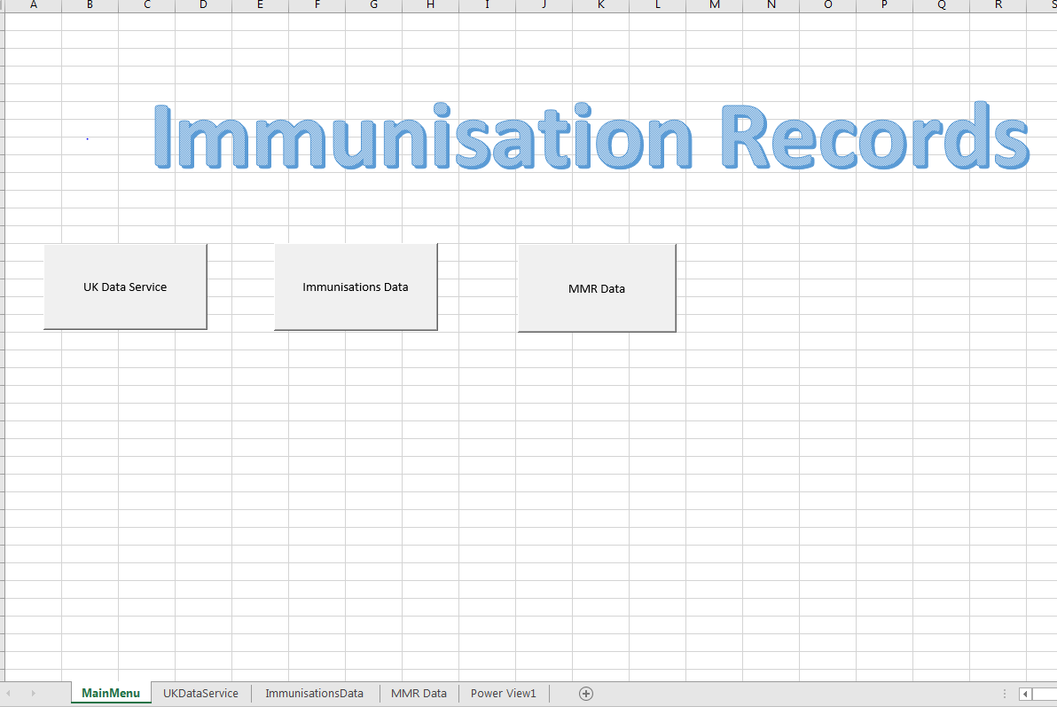
Figure 1 - Main Menu Page

Figure 2 shows data collected from the UK Data Service which displays the population data from age 0 to 24. This is useful data to get an idea of the population within a particular area.
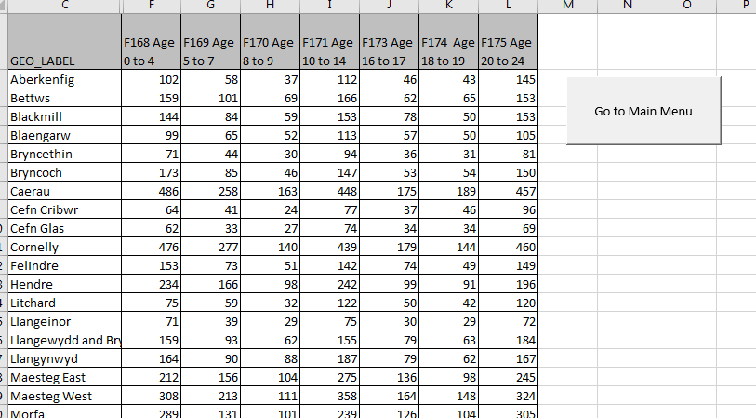
Figure 2 - UK Data Service population data (0 to 24 year olds)

Figures 3 and 4 are examples of data collected from the Health in Wales website. I chose this data to get an idea of how many children have been immunised, particularly looking at the Measles, Mumps and Rubella (MMR) vaccine.
I used the data to find out how many 0 to 16 year olds have been immunised against MMR. If you had a high number of children who have not been vaccinated against MMR, this could result in an outbreak of measles in an area.
As a result of a low uptake in the MMR vaccine in the county of Swansea, it resulted in an outbreak during 2012-2013 and also in the Newport and Torfaen area more recently in 2017. Reviewing these datasets could highlight the possibility of an outbreak in a particular area. This is very useful information and could be used to prevent a severe outbreak as it could be used to publicise a campaign to get people vaccinated which could reduce the impact of a potential epidemic.
The problems I encountered when analysing this data was that the Health in Wales data did not provide me with enough detail and only gave me the number Bridgend 001 to Bridgend 019, I needed the village name. To gather this information I had to find what the number corresponded to using another data sheet from the UK Data Service Lower_Layer_Super_Output_Area_2.
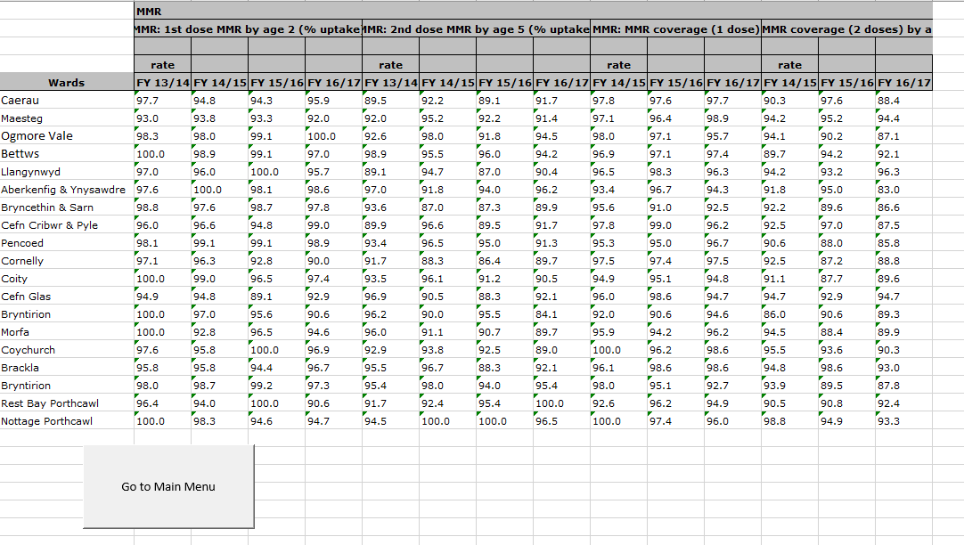
Figure 3– Health in Wales MMR Data
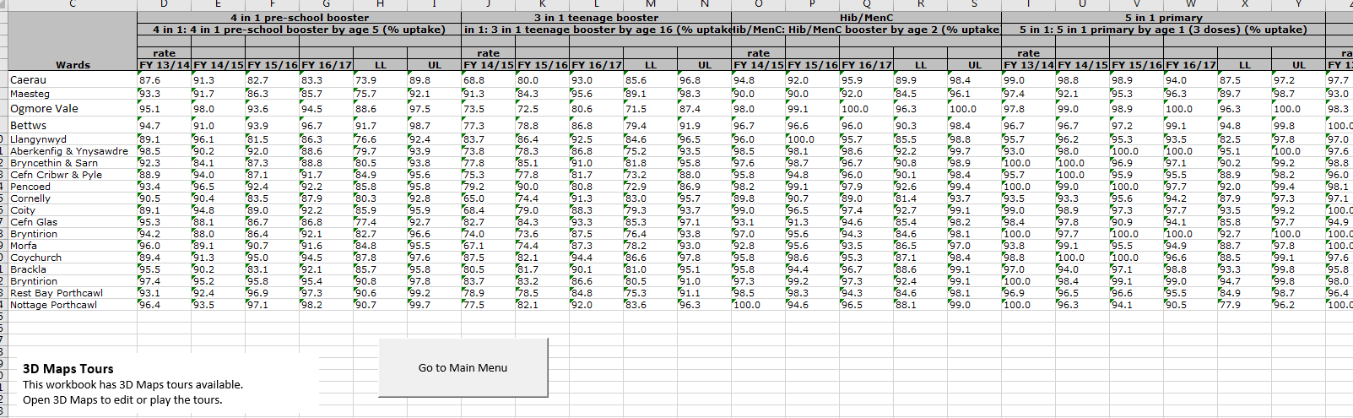
Figure 4 - Health in Wales All Immunisation Data

Figure 5 below is an example of an Excel 3D Map showing how the data from the spreadsheets above can be used to plot on a 3D map to show the uptake of immunisations in the county of Bridgend. To plot this on a 3D map application you need to select a data source. You also have to customise your version of excel if 3D Map isn’t available on the toolbar. This is something that can be done easily by the end user and wouldn’t require an IT professional to do it for you.
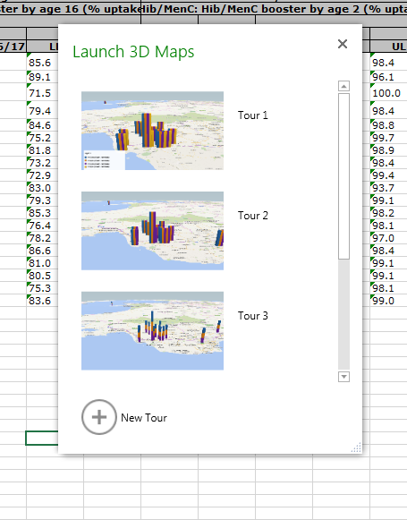
Figure 5 - 3D Map using Health in Wales Immunisation Data

Figure 6 is a close up picture of a problem I noted with the knowledge of Bridgend, where Morfa is plotted in the North Wales area, Caerau is in Cardiff and Bettws is showing in Cwmbran. This is incorrect information, so there are issues here with how 3D maps can be used to display data.
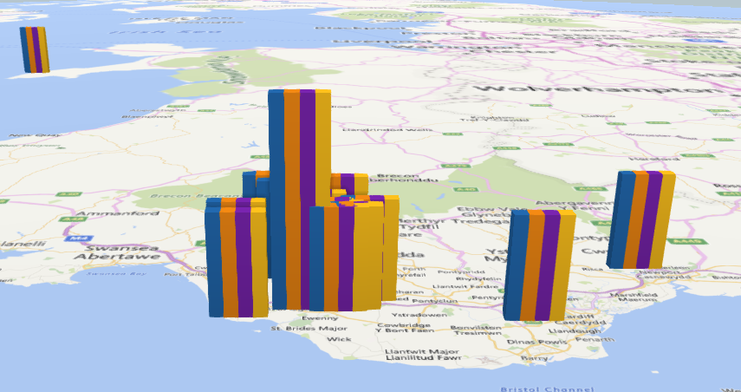
Figure 6 - 3D map showing MMR Immunisation data in Bridgend area from Health in Wales data

Figure 7 below shows the Bridgend population data of 0 to 24 year olds on a map of the UK from UK Data Service dataset. There are errors here with the data and a number of the villages are showing in incorrect locations and it isn’t giving a true reflection of the population data in Bridgend.
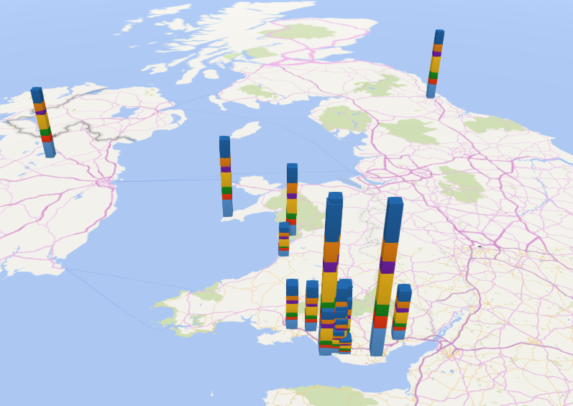
Figure 7 – 3D Map showing population data Bridgend 0 to 24 year olds from UK Data Service

Figure 8 is showing an alternative example of using Power View in Excel to present data in a dashboard format. The example shows a table of immunisation data and a chart showing the population data. It is a good way to visualise the relationship of the data between the population size and the number of immunisations.
When using power view for the first time Excel has to be customised for it to appear on the toolbar.
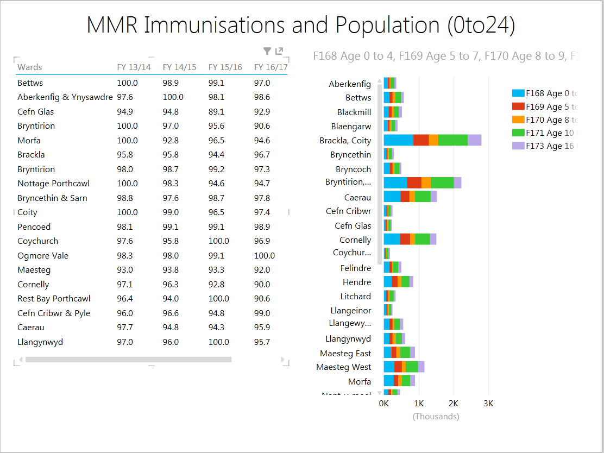
Figure 8 - Power View example

Advantages and disadvantages of end user development

There are many advantages of end user development (EUD) and many central IT departments still want to stay in control of development. Having recently experienced an issue in my organisation where the IT department do not want to roll out SharePoint and want to remain in control of the development. A new member of staff in my department is fully trained on SharePoint and could develop this for our department to help us manage our risk register, but the IT department have refused access in order to develop it for our department.
The advantages of EUD are that it can allow the person who understands what their requirements are to develop the system themselves rather than to explain to an IT specialist, who may understand the IT side but not the data that is required for the particular task. The department developing the system has a greater understanding being the subject expert of what they really want. With an end user developing the application themselves it could reduce the possibility of communication failures. The disadvantage of this is that with no input from an IT professional who may be aware of a better way or tool to use.
EUD makes the end user independent and enables them to get on with the task and not have to wait for the IT specialist to carry out the work which will result in departments working more efficiently. This would enable the central IT department to work on more complex software design and development. IT departments can be vastly under resourced in organisations and they could focus on work, such as, ensuring we are protected against cybercrime and updating our systems to make sure we have adequate protection in place. This would be a far better way to ensure IT departments are able to meet legislative requirements around cyber security.
Depending on the level of the end user who could be a non-programming end user or a more technical end user. The end user may have the ability to create simple programming methods such as macros and VBA coding. Depending on their level of knowledge or expertise they can teach themselves and experiment with data, as long as they are adequately trained and follow the relevant policy and procedures that are implemented.
However there are also disadvantages of EUD and there are hidden costs incurred. These costs could be around the lack of training of the end user and overuse of data. You also lose the discussion with the IT specialist who could advise on other options available that may be better alternative systems. There is also the possibility of errors in the data from poor data quality from inadequate testing, or by using the wrong tool to present data. This is evident in the 3D map that I used to present data where the areas were displayed incorrectly. There could be a better way to present the data which an IT professional could provide advice on [5].
With the extensive use of spreadsheet solutions as a EUD tool there must be customised policies and procedures in place and effective management of these MISs to meet the business needs of the organisation. Deloitte have developed a useful framework to help manage EUD. The framework consists of governance, people, process and technology and sets out the key element and things to consider when developing EUDs [4].
It is difficult to manage EUC but it is important to adopt a standard set of controls, particularly around using a standard set of agreed software within the organisation such as Microsoft applications [6] .

Conclusion

EUC and EUD is continuing to grow at a rapid rate and organisations are benefiting considerably by working more efficiently and responding promptly to market and legislative requirements.
Investing in the effective training of end users to continue to learn how to develop and improve information systems and get the best out of them, this could enable organisations to provide good quality data and information to help them create and deliver on their business and strategic planning.
It is essential that the MISs are managed effectively by following policies and procedures and that governance arrangements are embedded within the organisation, this will result in good quality information systems in organisations.

References

[1] “What is End-User Computing (EUC) - Uses & Examples Study_com.” . [Online] Available at Available at: C:\Users\li124326\Desktop\What is End-User Computing (EUC) - Uses & Examples Study_com.html. [Accessed 29/01/2018]
[2] “Finding the Happy Medium Between IT Development and End User Computing - Craig Roth.” [Online] Available at: C:\Users\li124326\AppData\Local\Mendeley Ltd\Mendeley Desktop\Downloaded\Unknown - Unknown - Finding the Happy Medium Between IT Development and End User Computing - Craig Roth.mht. [Accessed 29/01/2018]
[3] “What is a Management Information System (MIS) - Definition from Techopedia.” [Online]. Available at: https://www.techopedia.com/definition/8240/management-information-system-mis. [Accessed 29/01/2018]
[4] “End user computing Deloitte US Internal Audit Transformation.” [Online] Available at: https://www2.deloitte.com/us/en/pages/audit/articles/end-user-computing-solving-the-problem.html. [Accessed 29/01/2018]
[5] G. B. Davis and J. R. Hamann, “COMMENTARY Information Systems,” no. September, 1988. [Online] Available at: http://web.b.ebscohost.com.ezproxy.uwtsd.ac.uk/ehost/pdfviewer/pdfviewer?vid=1&sid=fb3dd0b3-9fbd-4b7f-b2d4-e8143e768eee%40sessionmgr102. [Accessed 29/01/2018]
[6] J. F. Rockart and L. S. Flannery, “The Management of End User Computing.” [Online] Available at: http://delivery.acm.org.ezproxy.uwtsd.ac.uk/10.1145/360000/358429/p776-rockart.pdf?ip=193.62.89.124&id=358429&acc=ACTIVE%20SERVICE&key=BF07A2EE685417C5%2ED3B0B0D06D8A4908%2E4D4702B0C3E38B35%2E4D4702B0C3E38B35&__acm__=1517263784_62c13b101b3247ccc4dd6ca00d3a6c2f. [Accessed 29/01/2018]

