University Of Wales Trinity Saint David
School of Engineering

CAD Report – Dry
Sump Design Project
ACMA4008

Aled Thomas
2206212
19th February 2024

Table of Contents
1 Introduction 1
1.1 Aims 1
1.2 Objectives 1
2 Problem Identification 2
2.1 Understanding the need 2
2.2 Quality function deployment 3
3 Design Specification 5
4 Concept solutions 6
4.1 Sump design 1 6
4.2 Sump design 2 7
4.3 Sump design 3 8
5 Design isolation 9
6 Final design documentation 10
7 Evaluation 13
8 References 14

Figure 1- Mind map of problem identification via 'Miro'. (Neil Brown Engineering Ltd, 2022) 2
Figure 2- Sump design 1 top view. 6
Figure 3-Sump design 1 underside view. 6
Figure 4- Sump design 2 top view. 7
Figure 5- Sump design 2 underside view. 7
Figure 6- Sump design 3 top view. 8
Figure 7- Sump design 3 underside view. 8
Figure 8- BS8888 Drawing of design 3. 10
Figure 9- Knurled drain Plug for underside of sump pan. 11
Figure 10- Pickup adaptor with gauze filter. 11
Figure 11- Section view of pickup adaptor. 12
Figure 12- The basic P-diagram (Ullman, 2010) 13

Table 1- House of quality for key features. 3
Table 2- Customer requirement table data from market research. 3

Introduction
The sump pan is a component that catches oil falling from the engine and recycles it back to the components of the engine to keep the complicated powerhouse running at its highest possible efficiency. Most cars employ a wet sump system which holds the oil under the engine where it falls. It then recycles it as needed. There is an issue with this system when pushed to its design specification during extreme driving where every second matters and the cars are stressed to their extremes. During these extremes, the oil within the pan is subjected to forces that cause it to flow and slosh. This is potentially dangerous for the engine as the sloshed oil may be unable to be picked up via the pickup pipe for a few seconds. This can cause the engine efficiency issues as it is choked of oil and can cause the engine serious damage from high friction without the oil. (Farkhondeh, 2006) & (Neil Brown Engineering Ltd, 2022)

Aims
To employ the standard design processes within the manufacturing industry to create an efficient design that meets customer’s requirements and functions to the required specifications for its use.

Objectives
- To identify the issues facing the use of the current wet sump system in the racing industry. And understand the needs of the customers who seek a replacement for such a system.
- Using current market feedback of customer requirements, create a design specification and QDF (Using a house of quality table).
- Develop some working concept designs that meet as many of the requirements as possible.
- Isolate the best fitting concept and further develop with a plan to test the system to ensure it meets functionality needs.

Problem Identification

Understanding the need
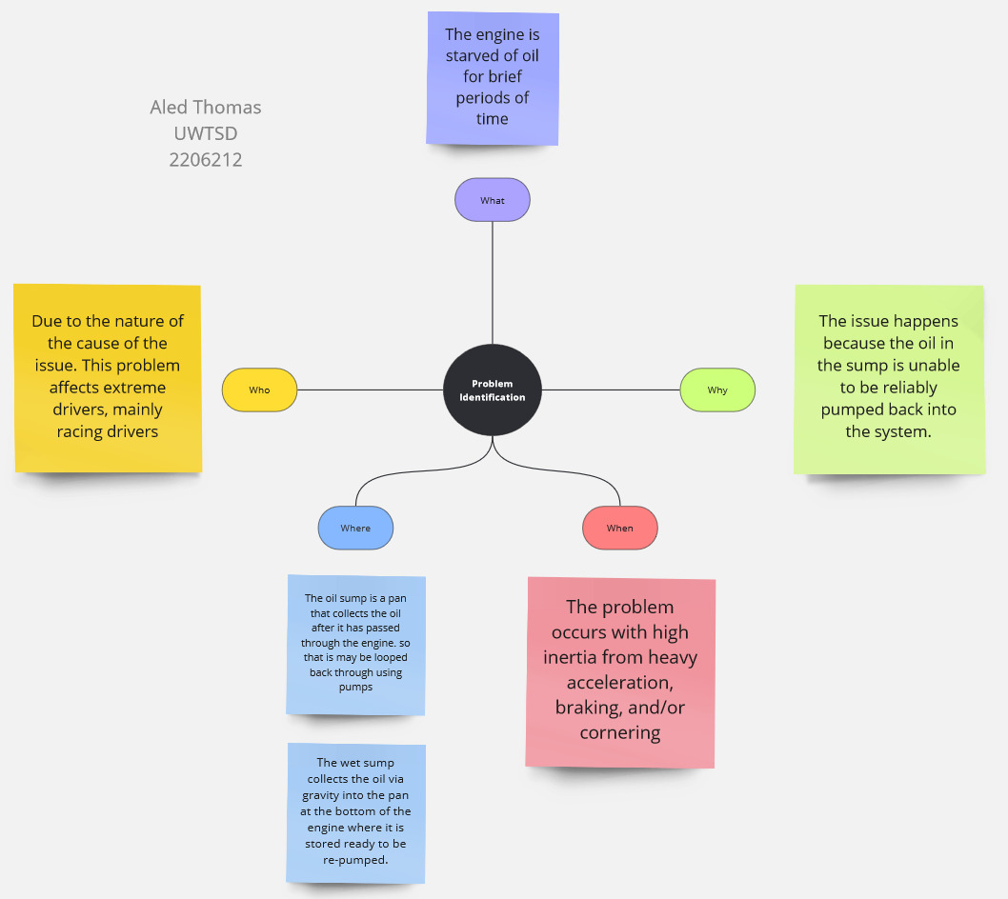
Figure 1- Mind map of problem identification via 'Miro'. (Neil Brown Engineering Ltd, 2022)
The wet sump oiling system collects oil in the sump pan and holds it there while a pickup pipe recycles it back into the lubrication system with a gauze (filter) on the collection end to ensure debris does not enter the oil cycle. In this system, the collection end of the pickup pipe is constantly submerged, as there should always be a certain level of oil in the pan.
But, as the mind map above addresses, the storage of oil within this pan can cause multiple issues when the system is used outside of its design specification. Such as in the case of motorsport, the cars are subjected to wildly more extreme forces, which causes the wet sump system to occasionally fail, as it relies on the oil being settled at the bottom of the pan. This is impossible when the car takes a hard corner at high speed, brakes / accelerates heavily, or flips upside down. The fluid will slosh, or congregate to one side, possibly out of the influential range of the pickup pipe. Thus, starving the engine, for what only needs to be mere seconds before damage can be done.
What is ideally needed is a dry sump oil system. This type of system uses a reservoir tank to store the oil instead of the sump. The sump only catches the oil, which is then promptly extracted from the sump using an oil pump and stored in the aforementioned tank. (Mavrigian, 2015)

Quality function deployment
Table 1- House of quality for key features.
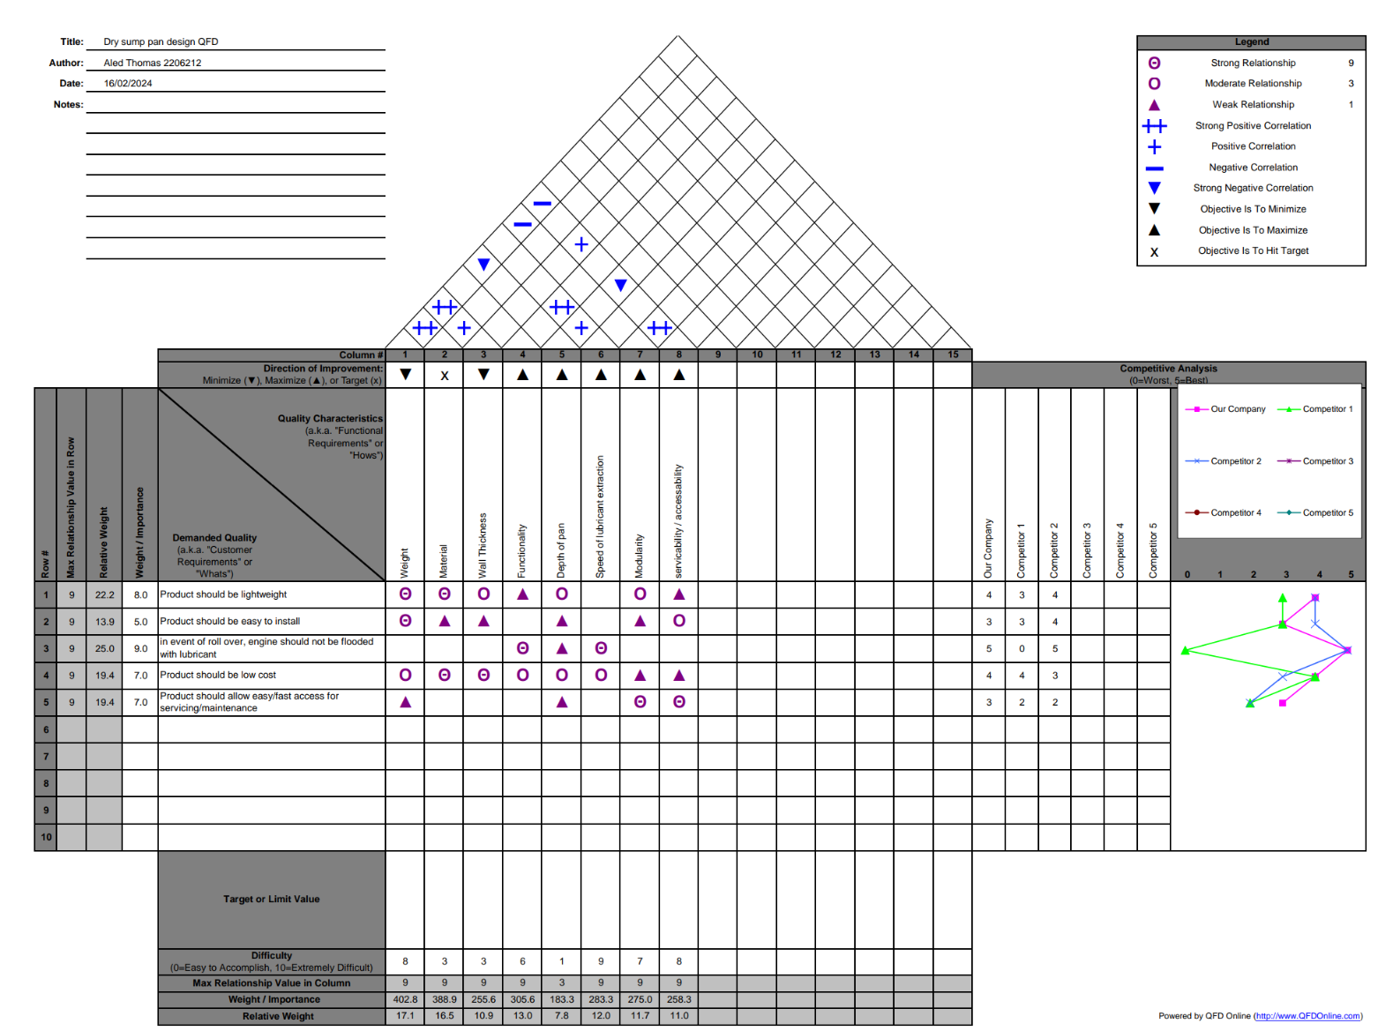
Above is the ‘house of quality’ QFD (quality function deployment) document. It outlines the demanded qualities from customer requirements which were determined from market research.
Table 2- Customer requirement table data from market research.
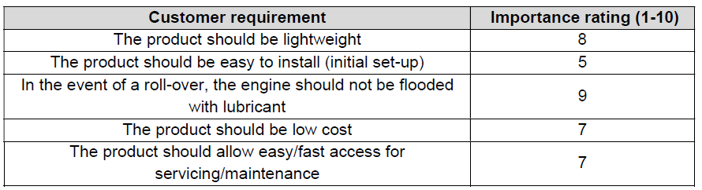
The QFD is used in the initial stages of design to provide a clear basis on the design characteristics against the customer requirements and the relationships between them, so important decisions can be made before starting design. It allows you to show where you need to compromise on one characteristic to ensure you meet a more important one. Two or more characteristics may oppose each other in relation to a change, meaning you may resolve one requirement, while simultaneously negatively affecting another. The QFD also provides a good measure of suitability of a design against competitor’s designs using customer feedback as scoring for each initial requirement. The importance rating of each should be considered to decide whether the design is better than the competition. (Bergquist & Abeysekera, 1995)

Design Specification
Target | Performance requirement | Specification
Weight | Must be low weight | - Material:  Aluminium, High temp plastic  - Thin walls  - Low profile  - Material saving optimised geometry
Ease of install | Must be easy to install | - High clearance around bolt heads  - Low profile  - Low weight
Cost | Must be relatively cheap | - Material saving optimised geometry  - Low cost, stock item alloy material
Serviceability / Maintenance | Must be easily serviceable | - Design to allow for removable items for servicing (gauze plug, drain plug)  - Low profile  - Low weight
Functionality | Must extract oil out of sump as fast as possible.  Must properly drain as much oil as possible.  Slosh of oil currently draining to be minimised | - Sloped angle of tray leading to outlet terminals  - Low profile pan so oil has less distance to travel  - Baffles between sections of pan to minimise sloshing of oil waiting to be extracted  - Extraction slits as wide as baffle sections to maximise flow rate of oil leaving the pan

Concept solutions
Three concept designs were created, each one building on the previous but incorporating and focusing on different target requirements.

Sump design 1
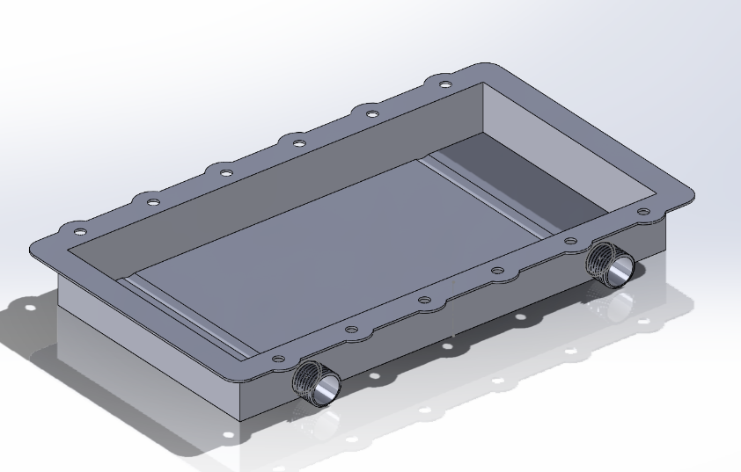
Figure 2- Sump design 1 top view.
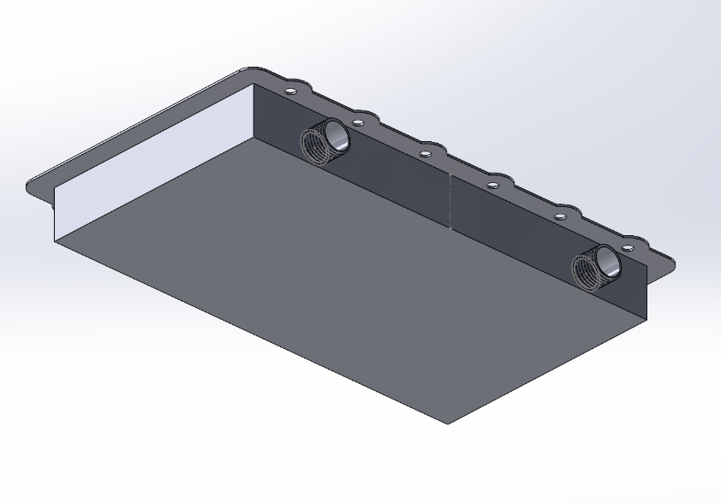
Figure 3-Sump design 1 underside view.

Sump design 2
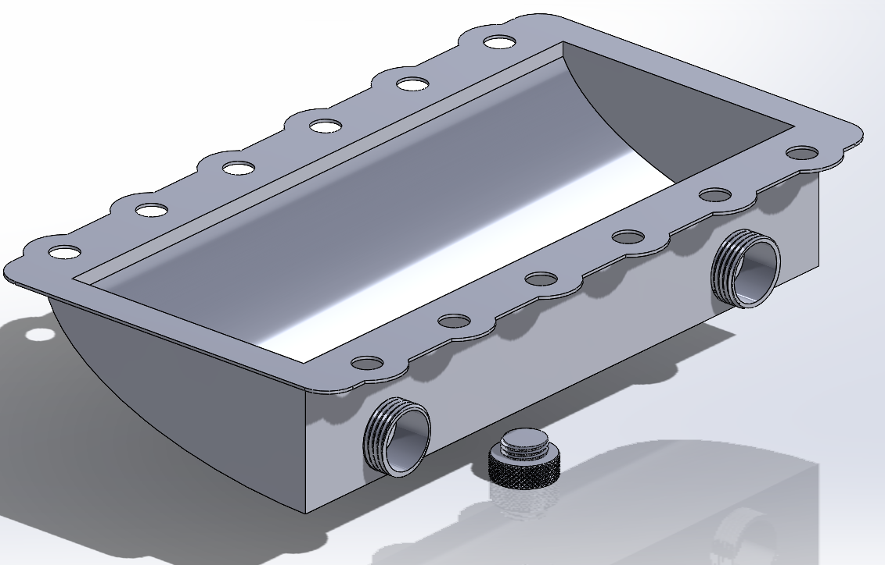
Figure 4- Sump design 2 top view.
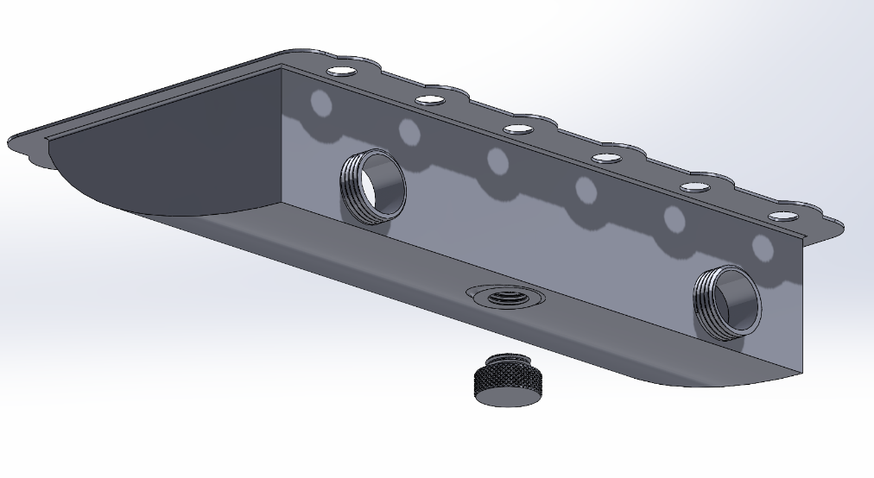
Figure 5- Sump design 2 underside view.

Sump design 3
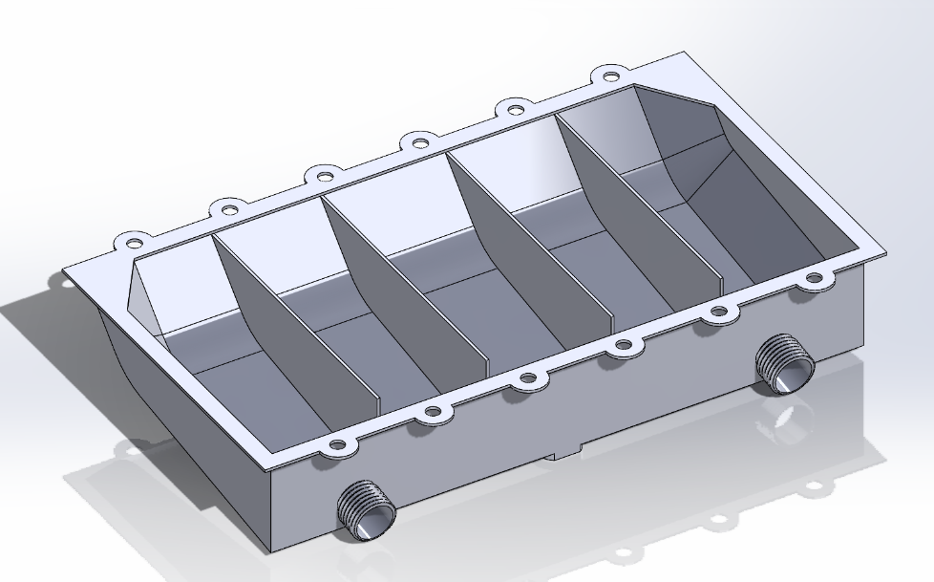
Figure 6- Sump design 3 top view.
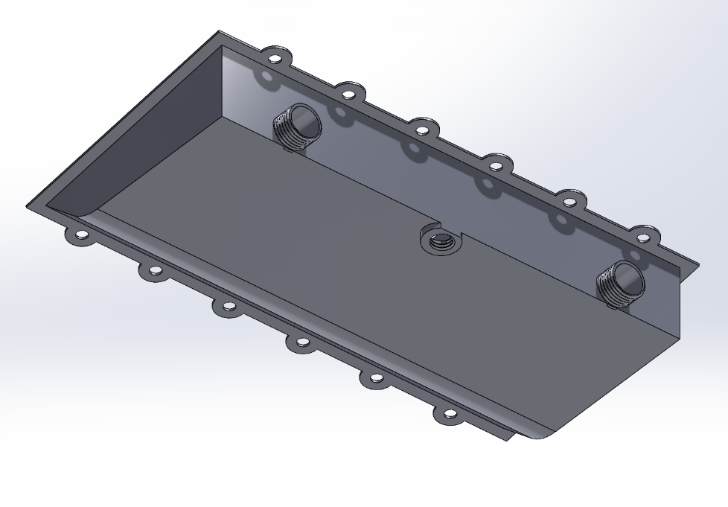
Figure 7- Sump design 3 underside view.

Design isolation
The three designs range in complexity and features and each have their advantages and disadvantages. The best course of action is to ensure they match up with the customer requirements and prioritise the requirements with the highest weights attached to them.
The biggest concern is the engine should not be flooded in the event of a roll over. This will be factored by how quickly the design will evacuate the oil from the pan. Design 1 is a flat bottom pan which will slowly drain the oil as it’s limited to the oil’s viscosity flowing over the flat surface. Meanwhile, design 2 and 3 both have angled pans which allows the oil to gain speed due to gravity, thus draining the oil at a much quicker rate. Also, design 3’s baffles reduce the oil sloshing, keeping it more stable, and the outlet drains are angled at the angle of the slope. Both features allow it to drain quicker.
The next biggest concern is the weight of the design. This is all due to how much material is used in the design. Mainly through the wall thickness. Design 1 uses the most material as it has the most surface area. Design 3 is next due to the extra weight of the baffles, and design 2 is lightest.
Cost and serviceability are the next concerns. Cost is linked to manufacturability and material usage. Design 1 is cheap to manufacture due to its simple shape but uses more material it would be heaviest so least favourable to service. Design 2 and 3 both have drainage plugs built in and are lighter. While design 2 has less material, thanks to the chamfered slopes of design 3, it would be easier to manufacture and cut the cost to help make it slightly more even with design 2.
All designs are easy to install as there is plenty of clearance around the head of the bolts, so ease of installation mainly falls to the weight, which design 2 and 3 are best with.
Overall, design 3 satisfies the biggest requirement the best while not compromising too much on also hitting the other requirements. The baffles, which allow it to drain faster, affect both the weight and cost, these are a small price to pay for the added reliability of the system.

Final design documentation
The chosen design is design 3. It features a material saving top plate with optimised circular sections around the mounting holes for the bolt heads to clamp onto. The body of the pan naturally slopes in two stages with a rounded blend to ease the acceleration of the oil towards the extraction point. For extraction there are two sloped outlet pipes with external threads for the oil to be pumped out of, and one service drain hole to suit a knurled threaded plug to allow for servicing to fully drain the pan before uninstalling. The pan has baffles which keep the oil from sloshing due to acceleration/deceleration and hard cornering, while this does very little in event of a roll over, it does allow the oil to stabilise and drain quicker so that during roll over, there is less oil in the pan and more in the system allowing the engine to continue being lubricated for longer.
The material chosen for the construction is aluminium 6061 as this is readily available, light (with a density of just 2.7g/cm³), and strong, with a good surface finish. The only downside is the corrosion resistance. It will require a plating process to guard from oxidisation. (AZO Materials, 2012)
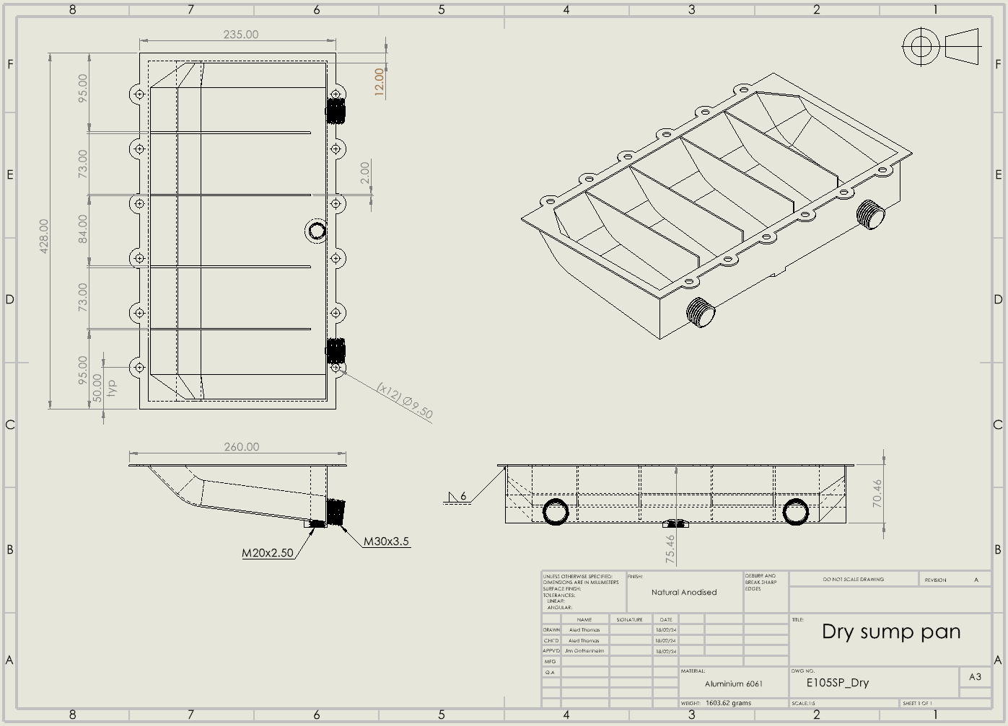
Figure 8- BS8888 Drawing of design 3.
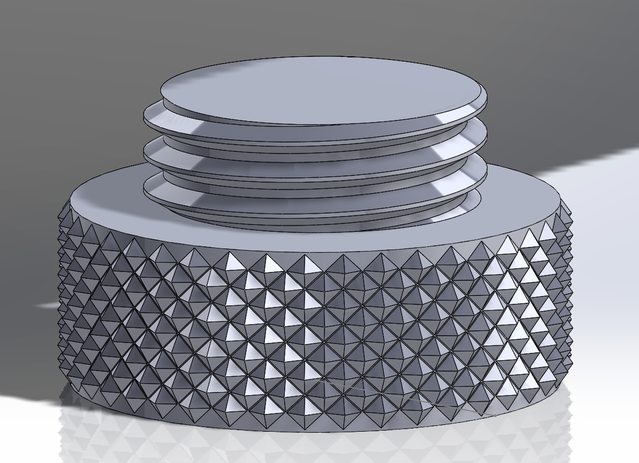
Figure 9- Knurled drain Plug for underside of sump pan.
Knurled drain plug allows for easy maintenance. This plug allows for easy drain of any remaining oil within the pan without uninstalling the pan from the engine.
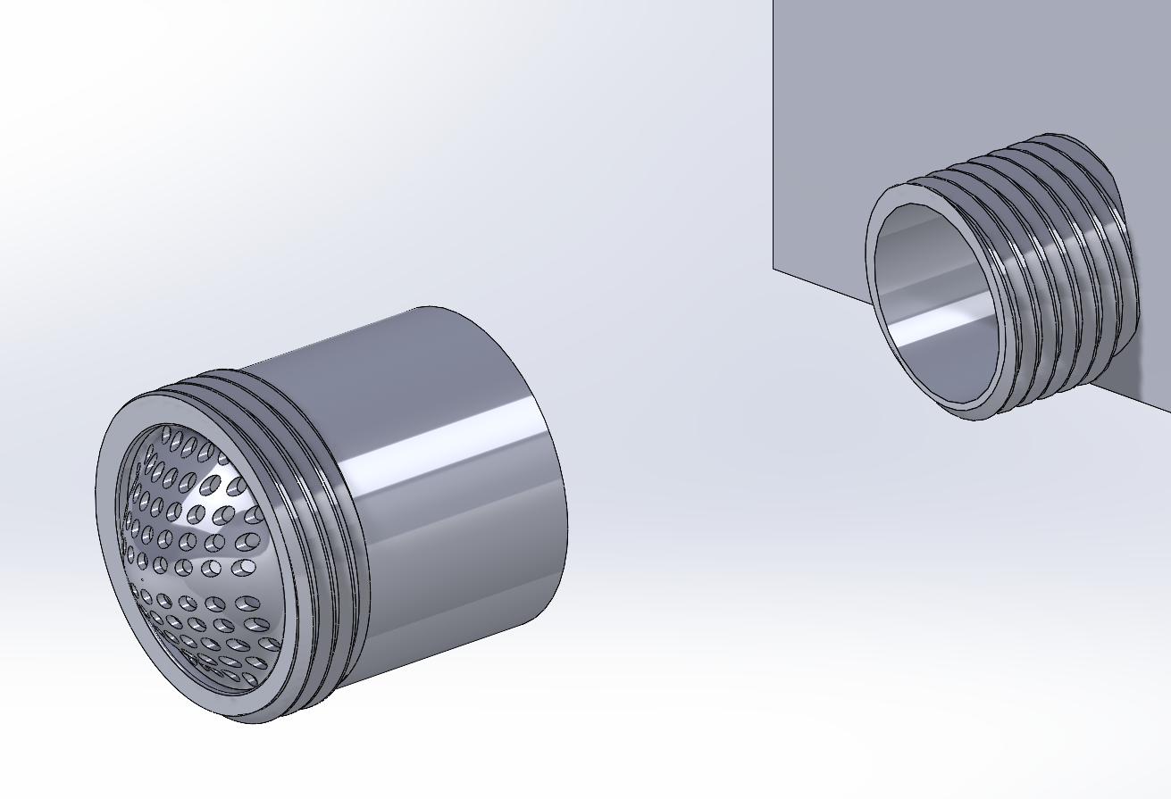
Figure 10- Pickup adaptor with gauze filter.
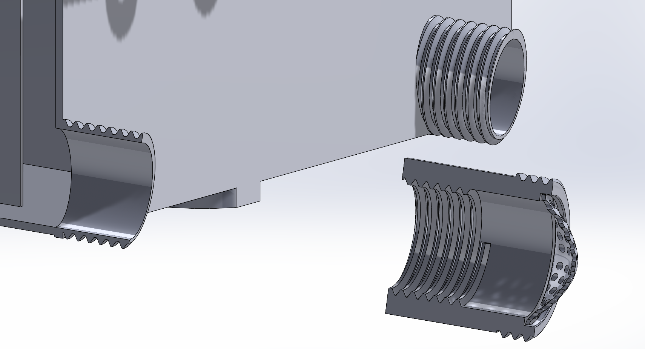
Figure 11- Section view of pickup adaptor.
The pickup adaptor (Fig.10 & Fig.11) is installed between the outlet pipe of the sump tray and the pickup pump, this houses a filter to ensure debris does not enter the system.

Evaluation
In order to meet product evaluation goals, an understanding is required of the evaluation processes, such as, optimization, trade studies, accuracy/tolerances, sensitivity analysis, and robust design.
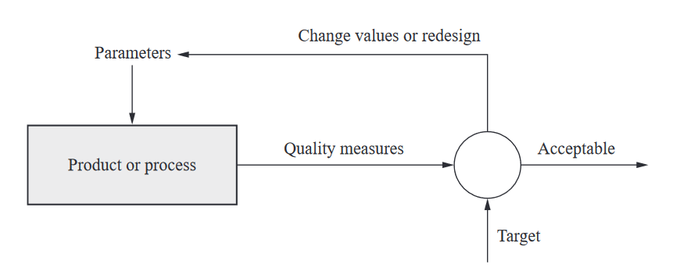
Figure 12- The basic P-diagram (Ullman, 2010)
The P-diagram is a tool to evaluate inputs and outputs during review and give a clear direction on how to approach performance factors of the design.
A trade study is recommended to be conducted; this would allow a diverse multi-disciplinary team to evaluate the design’s costs, performance, weight, and manufacturability. Also, this team would each be able to weight the variables against the original customer requirements to ensure they are properly met.
To rigorously evaluate the performance of the design, multiple prototypes must be assessed via a numerical method that attempts to incorporate the customer’s requirements and design specifications. For example, recording the weight, conducting an ISIR (Initial Sample Inspection Report) on dimensions critical to fit, and conducting shake tests in a lab where the time taken for the oil to drain is recorded. These values will create a mean and a range, this will show the variance within the tolerance and accuracy of the designs manufacturability and give an average value for what can be expected for the performance.
The risk in the failure of the product is assessed by conducting a sensitivity analysis procedure which can build a risk model by studying what can go wrong if the product fails to properly perform its function during use in its extreme environment. The likelihood of events is also taken into account. This can aid by evaluating the design decisions made previously and allow alterations to be made to potentially resolve the issues. (Ullman, 2010)

References
AZO Materials, 2012. Aluminium / Aluminum 6061 Alloy (UNS A96061). [Online]
Available at: https://www.azom.com/article.aspx?ArticleID=6636
[Accessed 19 02 2024].
Bergquist, K. & Abeysekera, J., 1995. Quality Function Deployment(QFD) - A means for developing. International Journal of Industrial Ergonomics, pp. 269-275.
Farkhondeh, E., 2006. Design of a Dry Sump Lubrication System for a Honda® CBR 600 F4i engine for Formula SAE applications, Massachusetts: Massachusetts Institute of Technology.
Mavrigian, M., 2015. Explaining Dry Sump Engine Lubrication. Engine Professional, July, pp. 18-32.
Neil Brown Engineering Ltd, 2022. High performance engine lubrication and why you should upgrade to a Dry Sump System. [Online]
Available at: https://nbe.co.uk/high-performance-engine-lubrication-and-why-you-should-upgrade-to-a-dry-sump-system/
Ullman, D. G., 2010. THE GOALS OF PERFORMANCE EVALUATION. In: The Mechanical Design Process. 4th ed. New York: McGraw-Hill, pp. 281-292.

