Managing Hotel Administration
Learning Log
BMIH6004
Syeda Samia Begum
2130491
Giulia Chifari

Table of Contents
Introduction 1
Reflection on experience and personal development 1
Critical analysis of work-based skills and technical knowledge 2
Reflection on Organisational Issues 3
Conclusion and action plan 4
References 5

I confirm that I have not used any AI tools in the research and creation of this assignment. I confirm that I have not presented any AI generated materials as my own work. I confirm I have copies of my drafts, notes, and other resources I used, which I may be asked to provide in evidence.

Introduction
Hotel administration is a wide range of responsibilities and tasks that are fulfilled by the administrators of a hotel to make functions smooth and ensure better performance of the hotel. Administration operations are – front office operations, like room assignments, handling complaints, managing reservations and cancellations, and guest services (Turner, 2020). In addition, housekeeping, and food and beverage operations are also included in administrator operations. accounting and finance, sales and marketing, and human resource operations also need to be managed by the administrators of the hotel. Shadowing a supervisor of Holiday Inn hotels’s human resource management department, my administrative operations are – recruitment and selection, performance management, payroll administration, training and development and employee motivation and retention (Batinic, 2023).
Learning objectives from the placement within the human resource (HR) department are –
- To Understand the core and supportive functions of the HR department.
- To learn about the Recruitment and selection process (Tullar, 2022).
- To develop skills in employee performance management.
- To know about employee retention and motivation.
- To understand the benefits and compensations of employees (Ansari, 2021).

Reflection on experience and personal development
Gibbs's reflective cycle is applied in this section to analyse the experience of a supervisory position in the HR department.
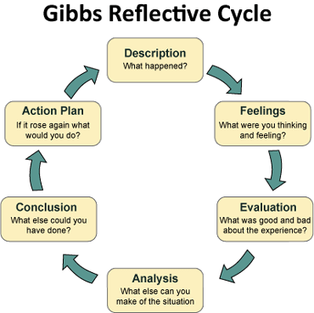
Figure 1: Gibbs reflective cycle.
Source: (Bassot, 2023).
The description is the stage of interpretation of the situation (Williams, Woolliams and Spiro, 2020). I have learnt many things, such as – employee recruitment and selection process, performance management and many other things. The impact of personal and vocational development on my learning and skills development was very high. The feelings stage is the emotion related to the situation (Bolton, 2020). I was happy while working in the hotel’s HR department because I have learnt many things from the placement. By working in this department my skills and knowledge were developed. The evaluation shows the negative and positive things of the situation (Bassot, 2023). My evaluation of the experience is that work-based skills and technical knowledge are important to meet guest service standards. For example – I have learnt how to deal with employees and improve their performance to manage guest services. The positive side of the experience was – learning about employee motivation, compensation and many other core and supportive functions of the HR department which developed my employability. However, the bad side of my experience was – not developing technical skills, like software management for HR management effectively. I also feel that I did not understand payroll activities and Excel Sheet management effectively. I have developed teamwork and communication skills. However, I did not develop my task management and guest services skills. Punctuality and self-discipline personal skills were developed during the experience. Analysis refers to analysing the reason behind the good and bad aspects of the situation (Tullar, 2022). In my analysis of the experience, I was able to develop my HR-related and personal skills because of focusing on the working method of the organisation. However, less research and ability to understand the skills impact my skills, like task management and guest management. I was not handling guests directly so the skill was not developed. The conclusion is a way of analysing what could have been done in the situation (Williams, Woolliams and Spiro, 2020). I could have researched more on practical knowledge to improve my task management activities. I could have taken advice from my senior to develop my task management guest management skills. The action plan will focus on improving my skills and abilities by taking support from my seniors. Moreover, I will use a Continuous development plan to improve my skills and abilities.

Critical analysis of work-based skills and technical knowledge
The importance of work-based skills in managing hotel administration
It is important to gather work-based skills in managing hotel administration to ensure efficiency and solve problems. For example – as an HR administrative, I need to develop work-based skills, like employee performance management to enhance employee performance and productivity to manage guests effectively. I also believe that my work-based skills, such as – team management and decision-making helped me to understand the issues of employees and manage a team effectively which increases organisational productivity (Yup Chung, 2020). I also feel that my adaptability skills and quality improved while playing the role of administrator in the hotel. The skill helped me to adapt to changing trends in employee needs and expectations and ensure employee motivation.
The importance of technical knowledge in managing hotel administration
Without technical knowledge hotel management is tough. For example – in a hotel understanding software management is necessary because all tasks, like reservation, cancellation, employee payroll and all activities are done through computer and software (Ansari, 2021). So, technology proficiency is a must to manage hotel operations effectively. Moreover, I believe that developing ERP, employee performance management software and payroll software is a must for me to play the role effectively.

Reflection on Organisational Issues
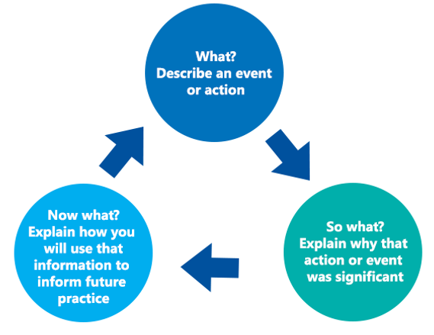
Figure 2: Driscoll reflective model.
Source: (Farrell and Kennedy, 2019).
The Driscoll reflective model will be applied to reflect on organisational issues. The first stage of the model describes the event (Bolton, 2020). Using this stage, I will be describing the organisational issues I faced while working with the organisation. I was playing the role of HR administration and I faced various issues during the placement. I faced internal conflict in making any significant decision about employee recruitment and performance management. The second stage analyses the significance of the action (Mansour Ghazi, 2021). The evaluation of the experience shows that the issues were crucial because the impact of the issue was very high on organisational performance. For example – I believe that because of the conflict in employee performance management strategies, many employees of the guest service department did not get training and development opportunities so their skills in guest management did not develop and guest service fell. It may reduce guest satisfaction and brand image. Moreover, employee performance reduction impacts overall operations by reducing employee productivity. Moreover, because of recruitment process issues, the organisation did not get the right employees on time. The marketing, HR, sales, and service departments' operations were not done effectively which also impacted the overall operations of the organisation negatively (Yup Chung, 2020). The third stage focuses on using the experience in the future where I will be identifying development areas to deal with similar issues efficiently in the future. In the future, I will focus on mitigating the conflict in internal management to ensure an effective environment for employees to develop their skills and abilities and ensure guest service properly.

Conclusion and action plan
Work-based skills and technical knowledge are essential to manage hotel administration. I have learnt how to manage HR activities to ensure organisational betterment. So, I feel that work-based skills and technical knowledge, like technology management, task management and other skills are necessary to manage organisational activities. I will apply the Continuous professional development plan. For example - I will create a skill audit tool to identify my skills gaps. After identifying my skills gap, I will develop strategies like online courses, expert advice and other strategies and time frames to overcome the skills gap and improve my skills and abilities to develop my career. I will develop my time, tasks, resource and employee management skills. I will also take advice from my senior to develop my skills.
Without personal and vocational development and knowledge people cannot work effectively. I believe that I need to improve my personal and vocational skills to develop a career in the future in the hotel industry. In addition, I will do online courses and also work in hotels to develop my personal and vocational knowledge by observing the daily activities of the hotel. I will apply the continuous skill development method because it can help me to develop my skills within a limited time. I will also work in various hotels to improve my vocational and personal knowledge.

References
Ansari, A. (2021). The Role of Interpersonal Communication Skills in Human Resource and Management. International Journal of Science and Research (IJSR), 10(11), pp.916–922.
Bassot, B. (2023). The Reflective Practice Guide : an Interdisciplinary Approach to Critical reflection. Florence: Taylor and Francis.
Batinic, I. (2023). Hotel management and quality of hotel services. Journal of Process Management. New Technologies, 4(1), pp.25–29.
Bolton, G.E.J. (2020). Reflective Practice: Writing and professional development. London: Sage Publications Ltd.
Farrell, T.S.C. and Kennedy, B. (2019). Reflective practice framework . Reflective Practice, 20(1), pp.1–12.
J. Turner, M. (2020). Hotel Management Contracts: a Particularly Rich Research Context. Journal of Hotel & Business Management, 03(01).
Mansour Ghazi, K. (2021). Hotel Maintenance Management Practices. Journal of Hotel & Business Management, 5(1).
Tullar, W.L. (2022). Theory development in resource management. Human Resource Management Review, 1(4), pp.317–323.
Williams, K., Woolliams, M. and Spiro, J. (2020). Reflective Writing. Bloomsbury Publishing.
Yup Chung, K. (2020). Hotel management curriculum reform based on required competencies of hotel employees and career success in the hotel industry. Tourism Management, 21(5), pp.473–487.

