

Software Solutions for Business
(ACCA4026)

Assessment Report

Name: Oana Stoica
Student ID:
Course: CertHE in Computing Skills for the Workplace
Lecturer: Dr. Syafiq Zolkeply

Table of Contents

Task 1 – eCommerce Website Builders / Software Solutions 4
Task 2. Mind-map of contemporary software applications 5
Mind Mapping and Its Benefits 5
Mind Map for Business Operations 6
Task 3. Office Applications for creating, storing, presenting, and analysing information/data 7
Microsoft Word – Features, Benefits, and Limitations 7
Microsoft PowerPoint – Features, Benefits, and Limitations 9
Microsoft Excel – Features, Benefits, and Limitations 10
Microsoft Access – Features, Benefits, and Limitations 12
Feature Testing – IF Function 13
Feature Testing – Pivot Table 13
Task 4. Communication and Collaboration applications 14
Communication Applications – Features, Summary 14
Collaboration Applications – Features and Summary 15
Feature Testing – Communication Application 16
Feature Testing – Collaboration Application 17

Task 1 – eCommerce Website Builders / Software Solutions

Currently, e-commerce is constantly developing, and choosing the right platform to create an online store is an important factor for a business's success. Among the most used e-commerce solutions are Shopify and WooCommerce, each having specific features, advantages, and limitations.
Shopify is a Software as a Service type e-commerce platform that allows users to manage an online store without advanced programming knowledge. This platform offers all the necessary features in one package. This package includes web hosting, security, automatic updates, product management, payment processing, and marketing tools.
Shopify allow integration with social networks, marketplaces, and delivery systems, making it easy to sell products across multiple channels. The main advantage of the platform is its ease of use and the short time needed to launch an online store
Shopify has been named a Leader in the 2024 Forrester Wave™: Commerce Solutions for B2B Vendor Assessment.[1]
Shopify Enterprise is Shopify's commerce platform built for large brands to sell across B2C, B2B, and retail from a single, developer-first foundation. Brands can build the way they prefer—full platform, headless, or modular—and get dedicated technical account managers and consultants, including 300+ hours of technical launch support and elevated platform access such as 20x admin API rate limits, to launch and scale.[2]
Additionally, Shopify stores can be connected to social networks like Facebook, Instagram, TikTok, as well marketplaces like Amazon or E-bay which allows selling products on multiple channels at the same time.
WooCommerce It is one of the most popular software solutions for developing online stores, being launched in 2011 as a plugin for WordPress. Unlike software-as-a-service platforms, it is an open-source solution what it means is that users have access to the source code and can customize almost every aspect of the online store.
The best thing about this website builder is its flexibility — this platform allows you to turn a WordPress site into a fully functional online store, offering the possibility to sell physical products, digital products, subscriptions, or services. [3]
There are a few differences between the two platforms: the first one is easy to use, ideal for a beginner, while the second one requires basic knowledge about WordPress and managing a website. Another difference between the two is the hosting: for the first one, for Shopify, it's included in the subscription—they take care of the servers and maintenance, while for the second one, the user must choose and pay for a hosting service. Also, For Shoppy we have a monthly subscription to which costs for premium apps can be added, while for the second one the plugin is free but there are costs for hosting, domain, and any extensions.
In conclusion, with Shopify you create your account, choose a template, add products, and you can start selling the same day. Shopify is cool, it takes care of hosting, security, and updates.
With WooCommerce you first need to buy a domain and a hosting service, then install WordPress and the WooCommerce plugin, only then can you set up the store. The process takes longer, but you'll have almost complete freedom when it comes to design and features.

Task 2. Mind-map of contemporary software applications

Mind Mapping and Its Benefits

Mind Mapping is a method of visually organizing information developed and popularized by Tony Buzan. [4] It involves representing central ideas from which branches start, containing concepts, keywords, and images, highlighting the relationships between them. The technique is used in education, business, project management, and personal development because it helps organize information and boosts creative thinking. One of the most important benefits of using a mind map is improving the learning and memory process by organizing information into a visible structure. Users can more easily see the connections between concepts and better understand complex ideas. Compared to traditional notes, it encourages the association of information and the activation of visual memory, which helps with long-term retention of knowledge.[5] In the educational environment, this method helps students synthesize content and prepare more efficiently. Mind Mapping contributes to the development of critical thinking and problem-solving skills when users organize information in a way they need to establish relationships between concepts, identify the main ideas, and eliminate redundant information.
Also, the digital applications dedicated to doing mind mapping offer the possibility of real-time collaboration, which makes teamwork and exchanging ideas between participants easier.
However, the efficiency of the technique depends on how it’s used. Very complex slides or ones loaded with too much information can become hard to follow and might reduce the clarity of the Mind Map
Additionally, for some people who are used to traditional note-taking methods, adapting to this technique might take time and practice. However, research shows that when used properly, the method can help improve academic performance and develop cognitive skills.
In conclusion, mind mapping represents an effective method for organizing and presenting information by stimulating memory, creativity, critical thinking, and collaboration. This technique can improve the learning process and efficiency in problem-solving.

Mind Map for Business Operations

Because I work in logistics and administration department, I chose for this assessment task to create a mind map related to my field of work.
To carry out this task, I used MindMeister site and I created a Mind Map with a theme Effective teamwork in LOGISTICS & ADMINISTRATION.
https://mm.tt/map/4022138578?t=qzViX76hAc
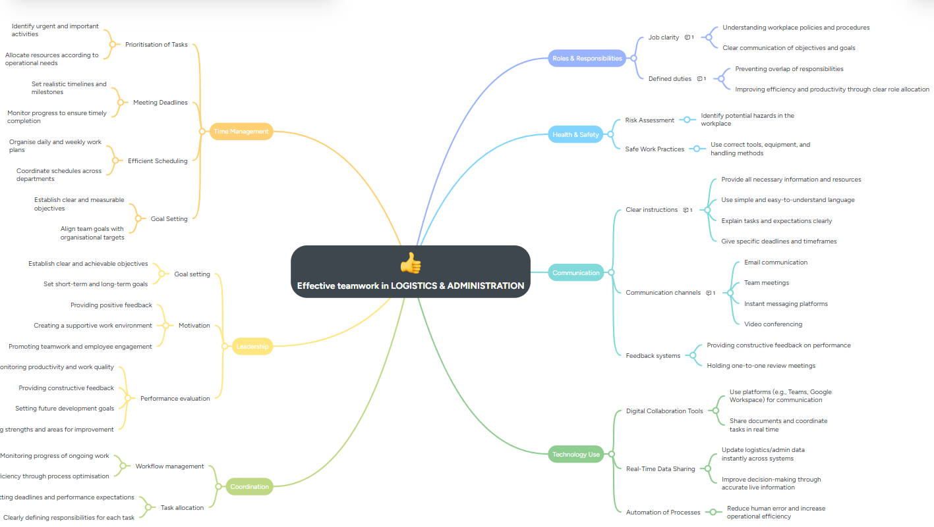

Task 3. Office Applications for creating, storing, presenting, and analysing information/data

Microsoft Word – Features, Benefits, and Limitations

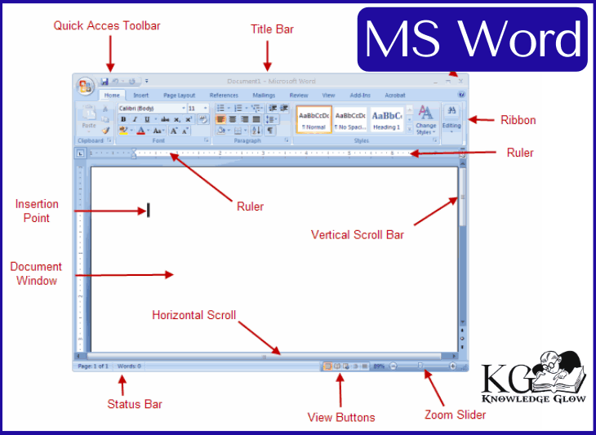
[6]
Microsoft Word is one of the most widely used word processing programs worldwide, developed by Microsoft and included in the Microsoft 365 suite. First launched in 1983, Word has constantly evolved, becoming an essential tool for producing documents in the professional and personal educational field. [7] Because of its intuitive interface and the numerous available features, Microsoft Word is used for creating reports, academic papers, letters, contracts, CVs, and other types of documents. One of the most important features of Microsoft Word is the ability to create and format documents in a professional way. Users can change the text style by choosing fonts, character sizes, colours, and paragraph alignment.
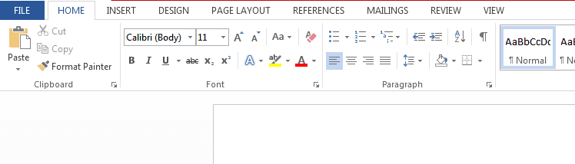
[8]
The program offers numerous options for inserting tables, images, charts, diagrams, SmartArt, hyperlinks, and symbols, aiming to create attractive and easy-to-understand documents. Also, Word includes predefined templates for CVs, letters, reports, and other documents.
Another important feature is represented by the tools for checking and correcting text. Microsoft Word offers spell check and grammar check, autocorrect, and suggestions to improve writing style.
Microsoft Word also makes collaboration between users over the internet easier through integration with the OneDrive service and the Microsoft 365 platform. Multiple people can edit the same document at the same time in real time.
Among the main benefits of Microsoft Word are ease of use, compatibility with numerous file formats, and integration with other applications in the Microsoft ecosystem like Excel, PowerPoint, and Outlook. In addition, Word documents can be saved and exported in PDF format, which makes it easier to share and print them.
Even so, Microsoft Word also has some limitations. Using the full version requires buying a license or a Microsoft 365 subscription, which can be an extra cost for some users.
Also, complex documents can have compatibility issues when opened in other word processing programs, the large number of available features can be overwhelming for beginner users.
In conclusion, Microsoft software remains one of the most powerful and popular applications for word processing. Its complex features, collaboration tools, and integration with other Microsoft services make it an effective solution for creating documents across various fields of activity.

Microsoft PowerPoint – Features, Benefits, and Limitations

Microsoft PowerPoint is one of the most used applications for creating electronic presentations. Being part of the Microsoft Office suite, the program is used in fields like education, business, research, and public presentations because it offers intuitive tools for organizing and sharing information. One of the main features of Microsoft PowerPoint is creating and editing slides. Users can add text, images, shapes, tables, charts, and diagrams to organize information in a clear and easy-to-follow way. PowerPoint offers numerous templates and predefined themes that help you get a professional design without needing advanced graphic skills.
The benefits of using Microsoft PowerPoint are numerous. First, the program makes it easier to communicate complex information through visual presentations, which improves understanding and memory of the content. It also saves time thanks to templates and automatic formatting tools. Compatibility with other Microsoft applications like Word and Excel allows for quick importing of tables and charts, which is useful in professional presentations.
One of the interesting features of PowerPoint is using the copilot. The copilot in PowerPoint uses artificial intelligence to automatically generate a presentation based on a description entered by the user or an existing document, like a Word file. The steps to create a presentation in PowerPoint with the help of Copilot are very easy and starts with Select Copilot icon in the bottom right-hand corner of the slide.
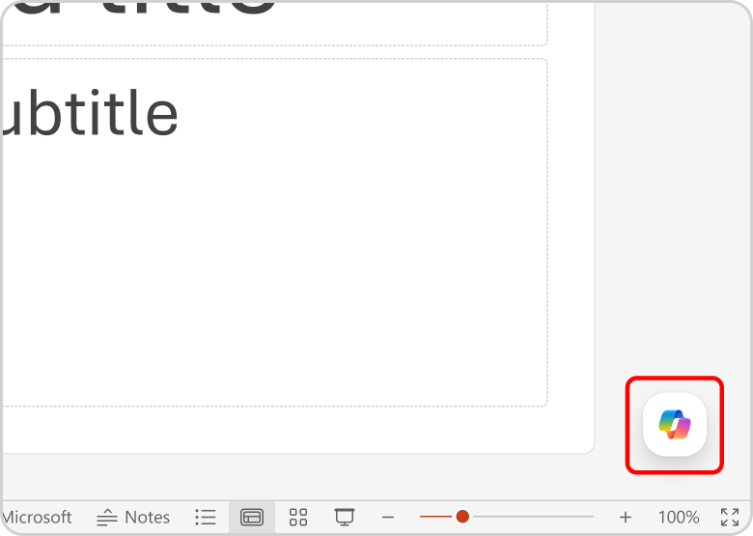[9]
When creating a presentation using a prompt, only a single output language is supported at a time. When creating a presentation by referencing a file, additional context cannot be provided within the same prompt. You must have access to and permission to use the file you're referencing to create a presentation. The output of the Create a presentation feature is AI-generated content and should be human-reviewed and edited accordingly. [10]
Microsoft PowerPoint is also appreciated for its ease of use. The intuitive interface makes it accessible to both beginners and experienced users. At the same time, presentations can be tailored for different audiences, from students to managers and specialists in various fields.
However, Microsoft PowerPoint also has some limitations. Overusing animations or visual effects can distract the audience and reduce the impact of the main message. Also, presentations based on too much text can become boring and hard to follow. In the case of complex presentations, files can be large, which makes sharing or opening them on older devices difficult. Some advanced features are only available to users who have a Microsoft 365 subscription. Additionally, there can be compatibility issues between different versions of the app or between PowerPoint and other presentation programs.
In conclusion, Microsoft PowerPoint is a powerful and versatile tool for creating electronic presentations. Its various features, integration with other Microsoft applications, and ease of use make it an efficient solution for communicating information. Still, to get quality presentations, it's important for users to use visual effects sparingly and focus on clarity and relevance of the content.

Microsoft Excel – Features, Benefits, and Limitations

Microsoft Excel is one of the most popular applications in the Microsoft Office suite, being used for organizing, analysing, and managing data. The program is used in many fields like business, education, accounting, finance, research, and administration thanks to its powerful calculation and analysis tools. Microsoft Excel allows users to work with large amounts of information in an efficient and organized way. One of the main features of Microsoft Excel is organizing data into spreadsheets made up of rows and columns. [11]Each cell can contain text, numbers, formulas, or functions. The program includes hundreds of predefined functions like SUM, AVERAGE, IF, VLOOKUP, XLOOKUP, which simplify performing mathematical, statistical, and logical calculations. Users can also create custom formulas to meet specific requirements.
Excel offers advanced tools for data analysis, sorting and filtering functions allow for quickly identifying relevant information, and pivot tables make it easier to summarize and interpret large volumes of data. Plus, the app lets you create charts and graphs.
Excel supports charts, graphs or histograms generated from specified groups of cells. [12]
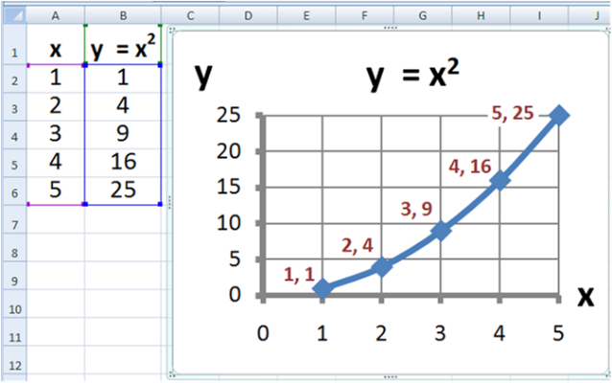[12]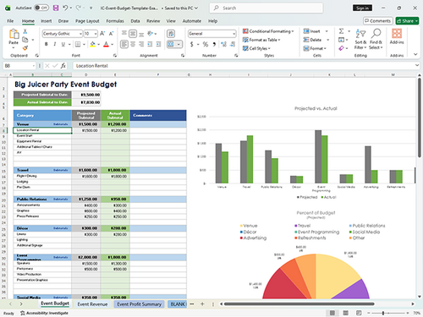[12]
The benefits of using Microsoft Excel are numerous. First, the app saves time by automating calculations and reducing errors that can occur in manual calculations. It also allows for efficient management of large amounts of information, being an essential tool for data analysis and decision-making. The charts and reports generated in Excel make it easier to interpret the results and present them in a clear and professional way. Another advantage is the flexibility of the application; Excel can be used for a wide range of activities, from creating simple lists and personal budgets up to complex financial analysis, inventory management, or project planning. Compatibility with other Microsoft applications like Word and PowerPoint allows for the quick integration of tables and charts into documents and presentations. Plus, storing files in Microsoft OneDrive makes access and collaboration across multiple devices easier.
However, Microsoft Excel also has some limitations. With very large files or complex calculations, the application's performance can drop, and processing time can increase. Also, users without experience might have trouble using advanced functions, complex formulas, or pivot tables. Errors entered a formula or a data set can affect the results of the entire document and identifying them can take time. Another limitation is that Microsoft Excel isn't the best solution for managing very large databases or for simultaneous collaboration among many users; some dedicated applications can offer better performance. In addition, some modern and AI-based features are only available to users who have a Microsoft 365 subscription.
In conclusion, Microsoft Excel is a powerful and versatile tool for organizing, analysing, and presenting data. Thanks to its varied functions, automation possibilities, and integration with other Microsoft applications, it helps boost productivity and make data-driven decisions.

Microsoft Access – Features, Benefits, and Limitations

It’s part of the Microsoft 365 suite of applications and designed for creating, organizing, and analysing data. Even though it can produce impressive tables, queries, forms, and reports, you won’t need a degree in computer science to make it work. [13]
Microsoft Access is a relational database management system (RDBMS), which simply means it stores data in related tables rather than in one long list. This structure makes it easier to keep information consistent and prevent duplication. You can use it to store data in structured tables, run searches and queries to find specific information, generate reports and summaries for decision making and you can use for build applications without much programming knowledge. This program offers numerous benefits to users because first it is easy to use thanks to the intuitive graphical interface and pre-made templates, making it accessible even to people without experience in database management. Also, the application is integrated with other Microsoft product like Excel, Word, and Outlook making it easy to import, export and also share data.
Another advantage is the relatively low cost compared to enterprise systems like Microsoft SQL Server or Oracle Database. For small organizations, Access is an efficient solution for quickly developing data management applications without significant investments in infrastructure or specialized personnel. [14] Additionally, the ability to connect to external data sources and integration with Microsoft Power Platform increases the application's flexibility in modern work environments.
Microsoft Access application also has some limitations. One of the most important is its limited scalability. A Microsoft Access database has a limit of around 2 GB, which makes it unsuitable applications that handle very large volumes of data.
Performance also drops when multiple users access the same database at the same time, which carries the risk of conflicts and file corruption. Compared to dedicated database systems, Access offers limited features when it comes to security, access control, and user management. Another limitation is that the application is mainly intended for the Windows environment, which may reduce compatibility with other operating systems. Additionally, complex applications developed in Access can become difficult to maintain and expand in the long run, especially as the organization grows and requires a more robust infrastructure.

Feature Testing – IF Function

The objective of this test is to demonstrate how the IF function can be used to evaluate a condition and return different results depending on whether the condition is true or false.
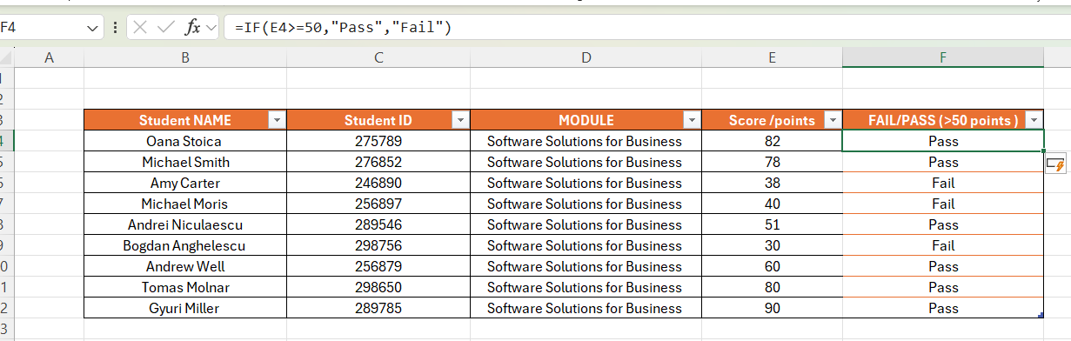
The formula that I used is =IF(E4>=50,"Pass","Fail")
This screenshot displays the completed table after copying the formula down the column. The results correctly classify each student as either Pass or Fail.

Feature Testing – Pivot Table

To test the Pivot Table feature by summarising student performance based on their results.
I used the same dataset containing student names, marks, and the Pass/Fail results. This data is used as the source for creating the Pivot Table.
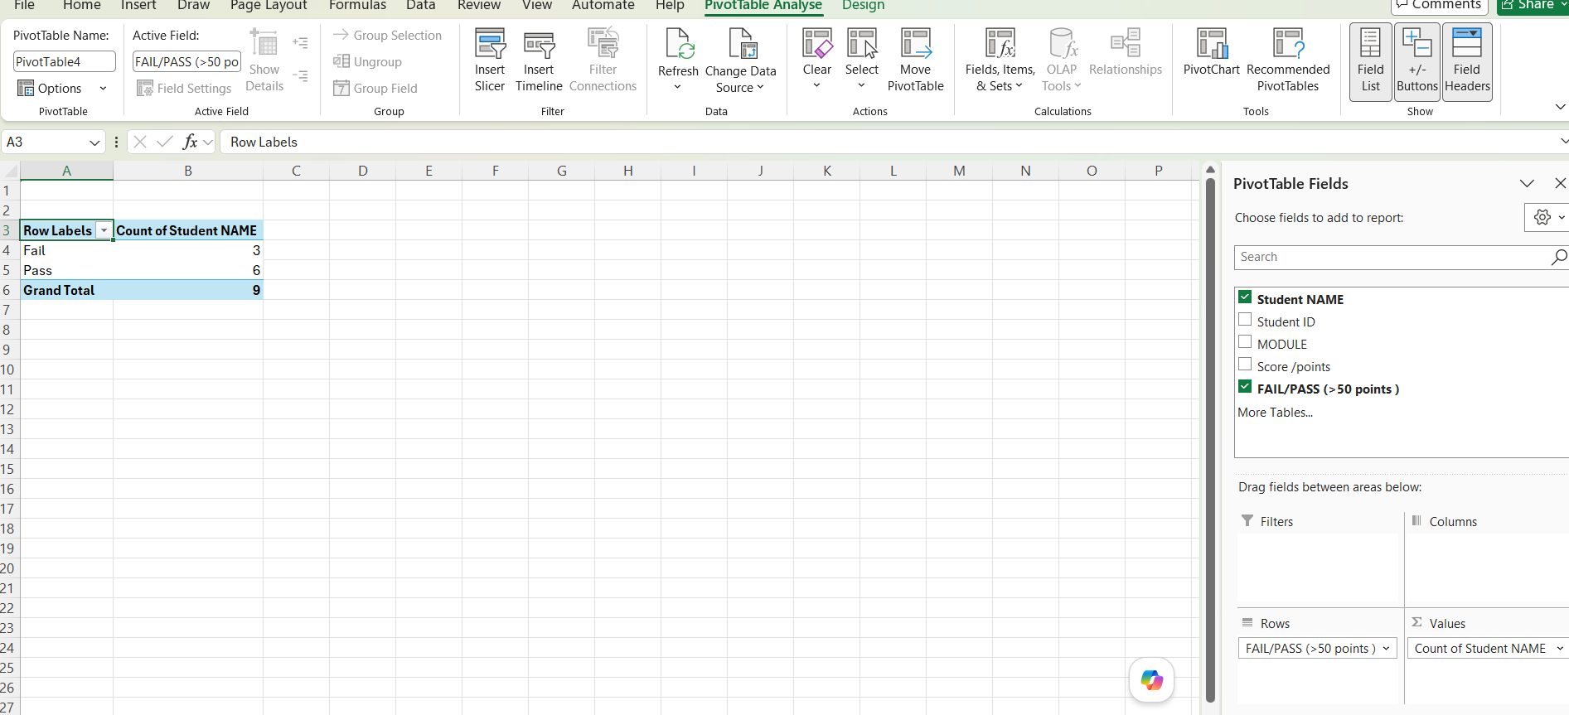

Task 4. Communication and Collaboration applications

Communication Applications – Features, Summary

Microsoft Outlook is one of the most used apps for managing emails and professional communication in modern organizations.[15] Developed by Microsoft and included in the Microsoft 365 suite, the app lets users manage emails, calendars, contacts, tasks, and meetings all in one platform. Thanks to its advanced features and integration with other Microsoft apps, Outlook is an essential tool for communication and organizing activities in the business world.
The main function of Microsoft Outlook is managing email correspondence. Users can send and receive emails, organize messages into folders and categories, and use automatic filters to sort them. The app also allows setting up multiple email accounts in a single interface, making it easier to manage both professional and personal communications. Advanced search and automatic sorting features help users quickly find the information they need and reduce the time spent managing messages.
From a security standpoint, Microsoft Outlook offers advanced features for protecting data and communications. The app uses anti-spam and anti-phishing filters, message encryption, and multi-factor authentication to reduce the risk of cyber-attacks and unauthorized access. These measures are especially important for organizations that handle sensitive or confidential information.
However, Microsoft Outlook also has some limitations. The initial setup can be tricky for users without experience, and using all the features requires some time to learn. Plus, some advanced features are only available to users who have a Microsoft 365 subscription.
In conclusion, Microsoft Outlook is a complete solution for professional communication and organizing activities. Its features for managing emails, calendar, contacts, and tasks, along with integration with other Microsoft applications, help improve productivity and efficiency in the business environment. Thanks to its high level of security and the flexibility it offers, Outlook remains one of the most important communication apps used by organizations worldwide.

Collaboration Applications – Features and Summary

Microsoft Teams is one of the most popular collaboration apps currently used by organizations around the world. Launched by Microsoft in 2017 and included in the Microsoft 365 suite, the platform was developed to make communication and collaboration easier among team members, no matter where they are. With the rise of remote work and the hybrid work model, Microsoft Teams has become an essential tool for companies, educational institutions, and public organizations, helping to boost productivity and efficiency for online activities.
Available as a stand-alone app or as part of Microsoft 365, it allows you to work seamlessly with almost any other Microsoft app.[16]
The main role of Microsoft Teams is to provide a digital space where users can communicate and collaborate in real time. The platform allows sending instant messages, organizing conversations into channels dedicated to projects or departments, and making audio and video calls. Through these features, employees can communicate quickly and efficiently without needing to use multiple different apps. Conversations are organized in a clear way, which makes it easier to find information and keep track of team activities. One of the most important features of Microsoft Teams is the ability to organize online meetings. Users can schedule meetings, invite participants, and hold video conferences with dozens or even hundreds of people. During meetings, features like screen sharing, meeting recording, automatic captions, integrated chat, and breakout rooms are available. These options make it easier to collaborate on projects, organize training sessions, and deliver presentations to clients or business partners. Meetings can also be accessed from both computers and mobile devices, giving users flexibility.
In addition to its advantages, Microsoft Teams also has some limitations. The large number of features can make the app hard to use for inexperienced users, and in large organizations, the high volume of messages and notifications can become difficult to manage. Also, to hold video conferences in high quality, a stable internet connection is needed.
In conclusion, Microsoft Teams is one of the most complete collaboration platforms available today. Its features for communication, organizing online meetings, document sharing, and integration with other apps help improve collaboration and productivity in the business environment. Thanks to its flexibility, security, and extensive integration capabilities, Microsoft Teams continues to be a preferred solution for organizations looking to optimize their workflows and support effective collaboration among employees.

Feature Testing – Communication Application

Microsoft Outlook successfully supported professional communication by allowing users to compose, send, receive, and organize emails.
To test the email communication feature in Microsoft Outlook by sending and receiving an email I will use my student email address
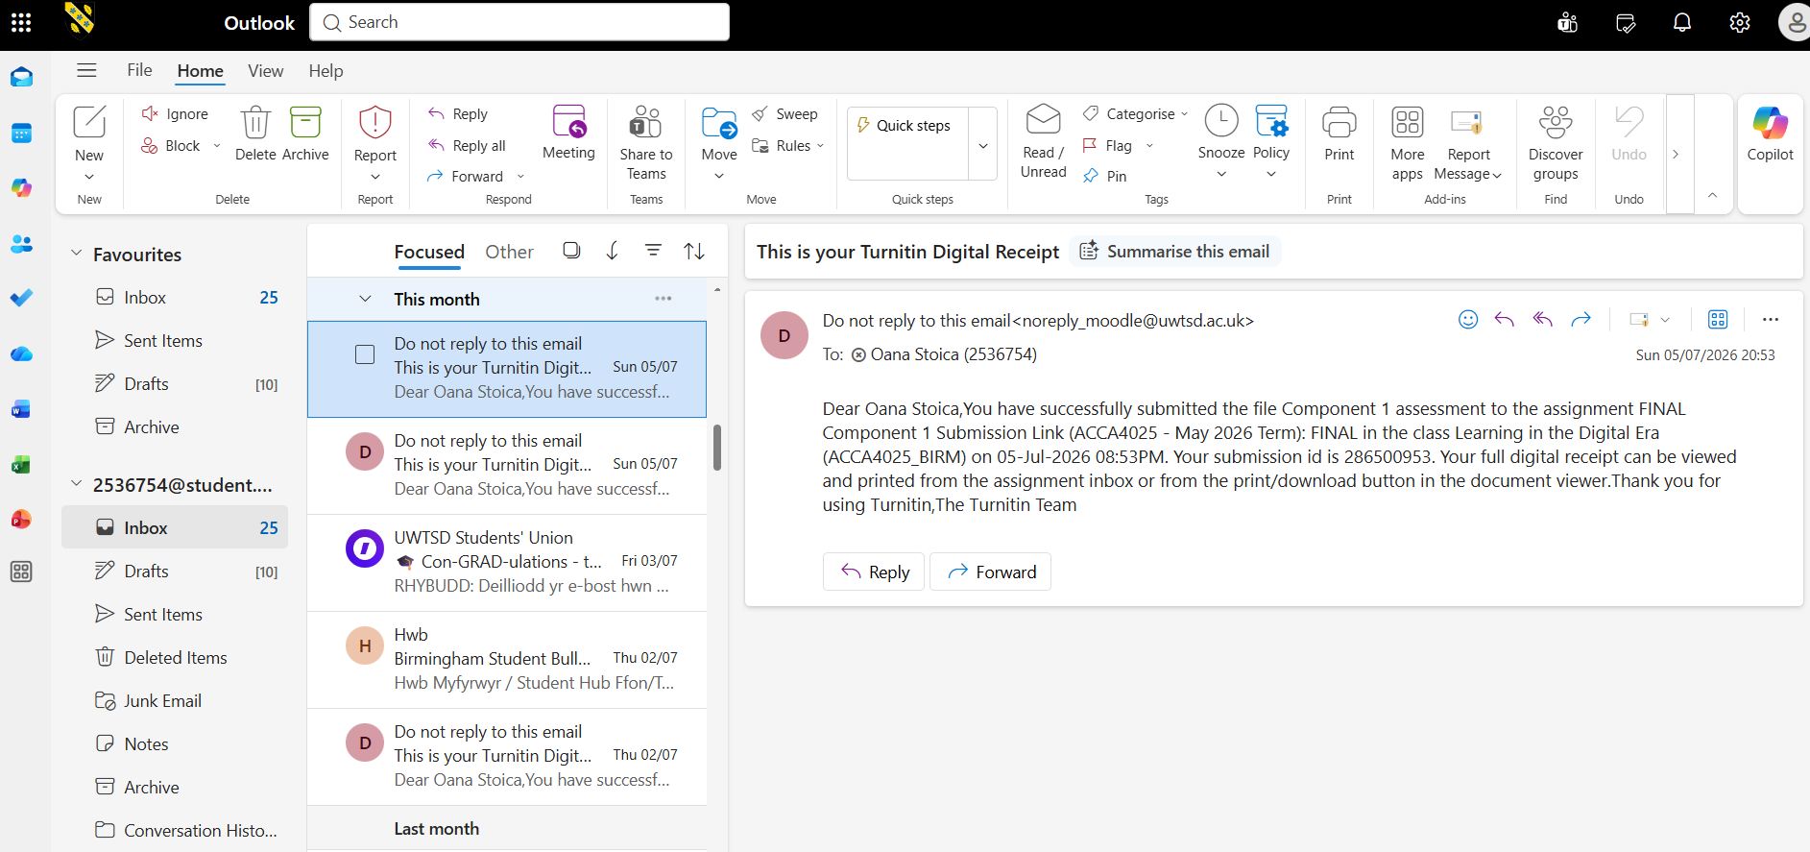
This screenshot shows the Outlook Inbox, displaying received emails. It demonstrates that the application successfully receives and organizes incoming messages.
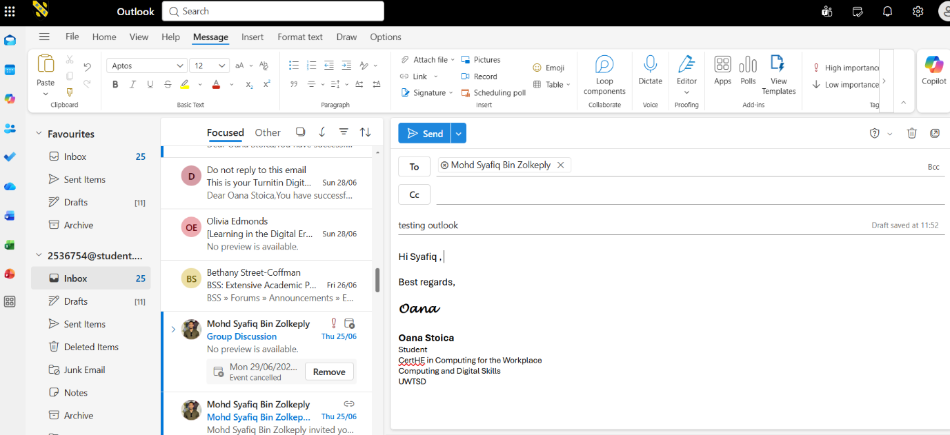
This screenshot shows a new email being composed. The user enters the recipient's email address, subject, and message before sending it. I used at the and my student signature.
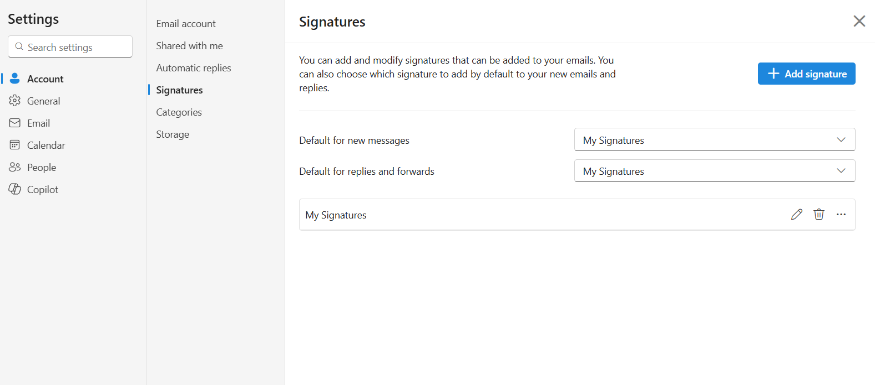
This screenshot displays the email in the Sent Items folder, confirming that the message was successfully sent to the recipient.
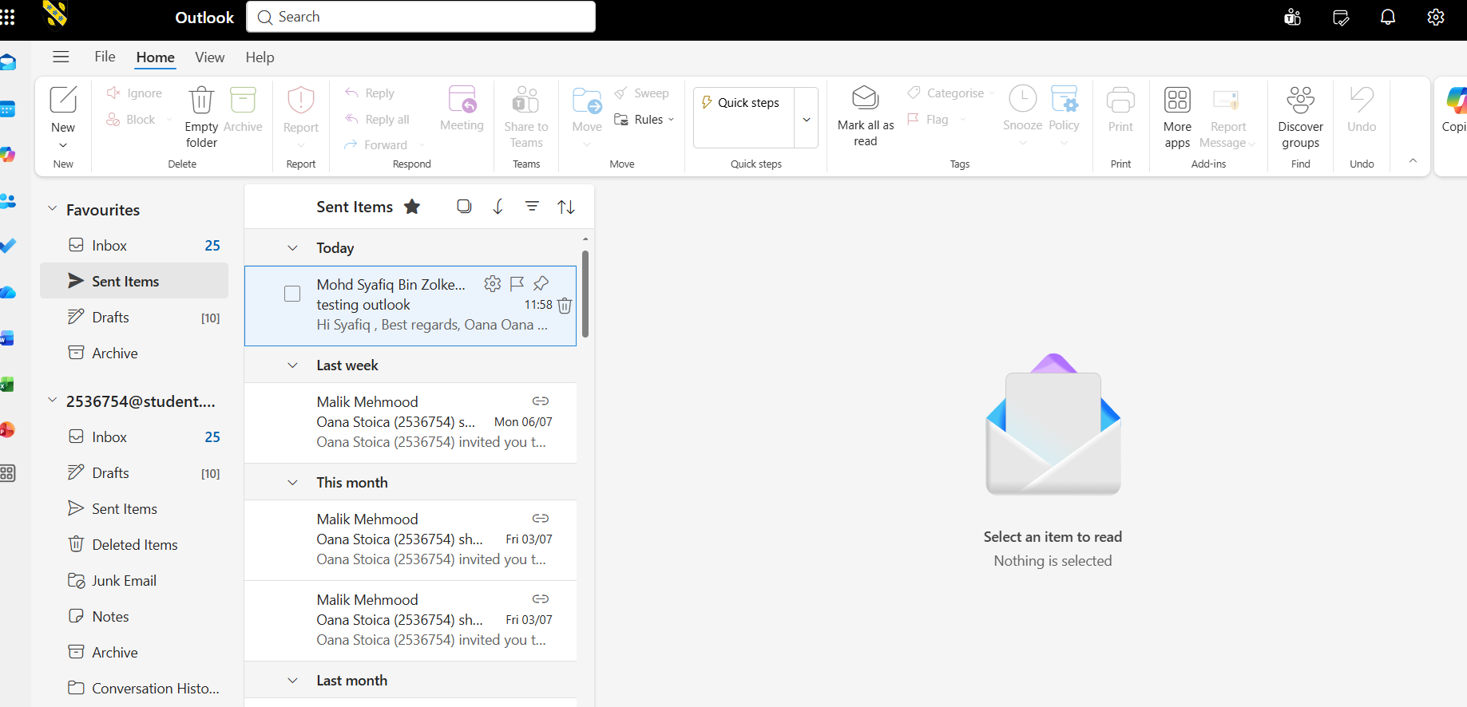

Feature Testing – Collaboration Application

The objective of this test it is to evaluate the Online Meeting and Screen Sharing feature in Microsoft Teams. This feature allows users to communicate, collaborate, and share information in real time, making it an essential tool for remote and hybrid working environments.
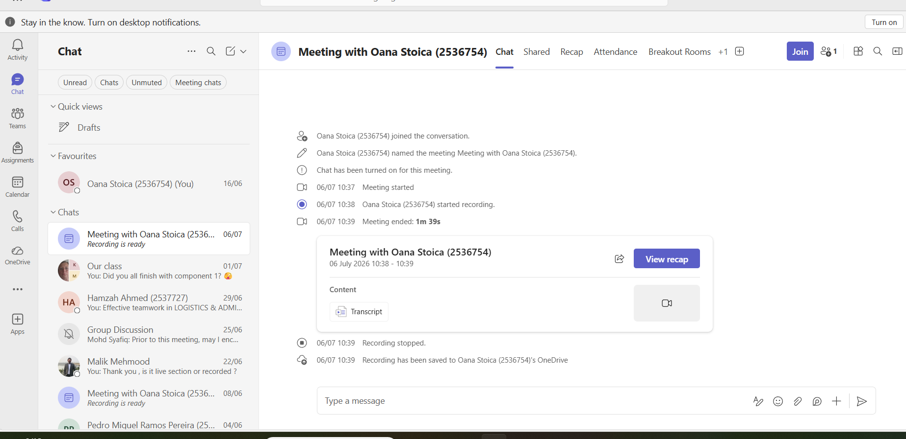
This screenshot shows the Microsoft Teams home page after the user has successfully signed in. The interface displays the navigation menu, including Chat, Teams, Calendar, and Calls, confirming that the application is ready for collaboration.
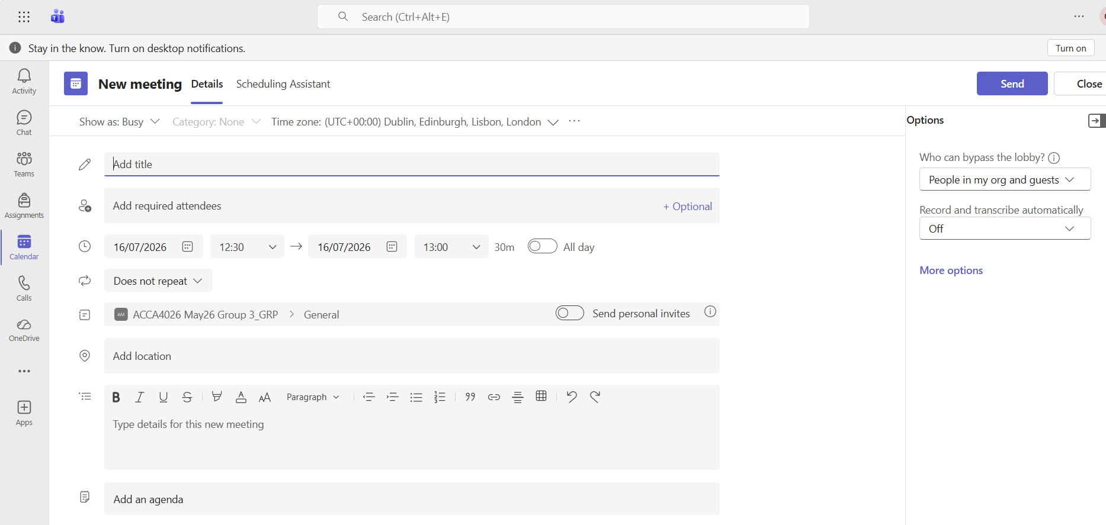
This screenshot shows the meeting creation window. The user enters the meeting title, selects the date and time, and invites participants. This demonstrates how Teams enables users to organise virtual meetings directly within the application.
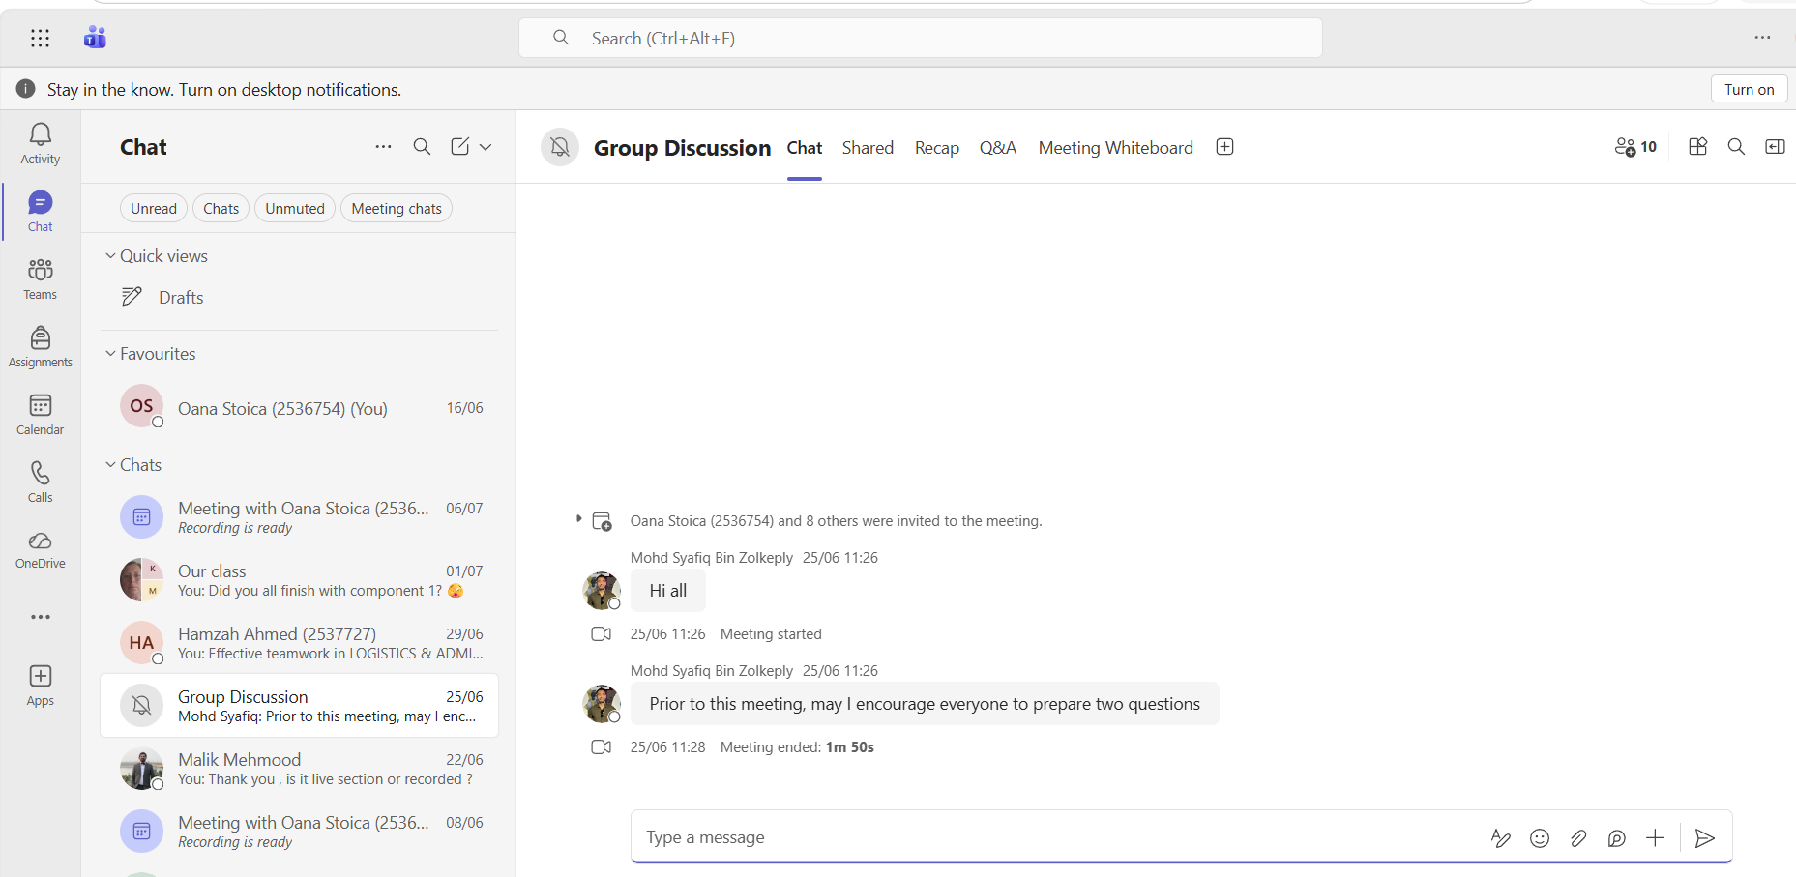
This screenshot shows the meeting chat window, where participants exchange messages, share links, and upload files while the meeting is taking place. The chat remains available after the meeting, allowing team members to review previous discussions and shared resources.
The testing demonstrates that Microsoft Teams is an effective collaboration platform for modern businesses. Its online meeting, screen sharing, file sharing, and chat features enable employees to collaborate efficiently regardless of their location. These capabilities improve communication, support remote and hybrid working, and enhance overall team productivity.

References
[1] shopify.com. "Shopify - Website Builder." www.shopify.com. 2024. [Online]. Available: https://www.shopify.com/resource/forrester-wave-b2b
[2] shopify.com. "Shopify Platform." www.shopify.com. [Online]. Available: https://www.shopify.com/uk/platform/enterprise
[3] udemy.com. "WordPress & WooCommerce Course: Complete Guide to E-Commerce." www.udemy.com. Accessed: 6 2025. [Online]. Available: https://www.udemy.com/course/wordpress-woocommerce-complete-guide/?utm_campaign=MX_FF-CONV_GB_Search-NB_DSA_Beta_la.EN_Bing&utm_source=bing&utm_medium=paid-search&portfolio=Bing-GreatBritain&utm_audience=mx&utm_tactic=nb&utm_term=_._ag_1316117796625315_._ad__._kw_Design+en&utm_content=o&funnel=&test=&utm_campaign_id=638584566&msclkid=d2562c9a1c7c1a164df046d226e962e2&couponCode=PMNVD2025
[4] T. Buzan and B. Buzan,The mind map book, London: BBC, 1993.
[5] M. Davies, "Concept mapping, mind mapping and argument mapping: what are the differences and do they matter?" High Educ, vol. 62, no. 3, pp.279–301, 2011, doi: 10.1007/s10734-010-9387-6.
[6] Komal Gupta. "An Introduction to MS Word." www.knowledgeglow.com. [Online]. Available: https://www.knowledgeglow.com/microsoft-word/
[7] The Knowledge AcademY and y, "What is Microsoft Word: Everything You Need to Know." www.theknowledgeacademy.com. [Online]. Available: https://www.theknowledgeacademy.com/blog/what-is-microsoft-word/
[8] Komal Gupta. "MS Word Features." www.knowledgeglow.com. 2026. [Online]. Available: https://www.knowledgeglow.com/microsoft-word/
[9] Support Microsoft page. "Create a new presentation with Copilot in PowerPoint." support.microsoft.com. 2026. [Online]. Available: https://support.microsoft.com/en-us/powerpoint/copilot/create-a-new-presentation-with-copilot-in-powerpoint
[10] Microsoft support page. "Limitations of creating a presentation in PP with Copilot." support.microsoft.com. 2026. [Online]. Available: https://support.microsoft.com/en-us/powerpoint/copilot/create-a-new-presentation-with-copilot-in-powerpoint
[11] Coursera Staff. "What Is Excel? Formulas, Functions, and More." www.coursera.org. [Online]. Available: https://www.coursera.org/articles/what-is-excel?msockid=24c428e005c9680c20fa3fbf0442697b
[12] "Microsoft excel." www.en.wikipedia.org. [Online]. Available: https://en.wikipedia.org/wiki/Microsoft_Excel
[13] Jon Fisher. "Microsoft Access." https://www.addictivetips.com/microsoft-office/what-is-microsoft-access/. [Online]. Available: https://www.addictivetips.com
[14] "Microsoft Outlook Documentation." https://learn.microsoft.com/en-gb/outlook/. 2026. [Online]. Available: https://learn.microsoft.com
[15] R. Withee, Microsoft Teams, 2nd Ed. Hoboken, NJ: John Wiley & Son, Inc, 2021.

